High-fidelity 3D live-cell nanoscopy through data-driven enhanced super-resolution radial fluctuation

Supplementary information

Romain F. Laine^{1-3,+}, Hannah S. Heil^{4,+}, Simao Coelho⁴, Jonathon Nixon-Abell^{5,6}, Angélique Jimenez⁷, Tommaso Galgani⁸, Aki Stubb^{9,10}, Gautier Follain^{9,11}, Siân Culley^{1,12}, Guillaume Jacquemet^{9,11,13}, Bassam Hajj^{8,} *, Christophe Leterrier^{7,} *, Ricardo Henriques^{1,2,4,}*

¹ MRC-Laboratory for Molecular Cell Biology. University College London, London, UK
² The Francis Crick Institute, London, UK
³ Current affiliation: MicrographiaBio, Translation & Innovation Hub, 84 Wood Lane, London, W12 0BZ
⁴ Optical Cell Biology, Instituto Gulbenkian de Ciência, Oeiras, Portugal
⁵ Janelia Research Campus, Howard Hughes Medical Institute, Ashburn, VA, USA.
⁶ CIMR, Cambridge Univeristy, Cambridge, UK
⁷ NeuroCyto, Aix Marseille Université, CNRS, INP UMR7051, Marseille, France
⁸ Laboratoire Physico-Chimie Curie, Institut Curie, PSL Research University, Sorbonne Université, CNRS UMR168, Paris, France
⁹ Turku Bioscience Centre, University of Turku and Åbo Akademi University, Turku, Finland
¹⁰ Current affiliation: Helsinki Institute of Life Science, Biomedicum Helsinki, University of Helsinki, 00290 Helsinki, Finland
¹¹ Faculty of Science and Engineering, Cell Biology, Åbo Akademi University, Turku, Finland
¹² Current affiliation: Randall Centre for Cell & Molecular Biophysics, King’s College London, Guy’s Campus, London SE1 1UL, UK
¹³ Turku Bioimaging, University of Turku and Åbo Akademi University, Turku, Finland
⁺ Equal contribution
* Corresponding author: bassam.hajj@curie.fr, christophe.leterrier@univ-amu.fr & rjhenriques@igc.gulbenkian.pt

Content:
Supplementary Note 1&2
Supplementary Table 1-3
Supplementary Fig. 1-14
Supplementary Movie 1-5
References

Supplementary Notes

Supplementary Note 1: (e)SRRF and its artifacts
The presence of artifacts in the SRRF reconstruction have been observed previously¹. Here, we highlight an instance where they appear quite clearly (Supplementary Figure 3). We generated a simulated dataset where the underlying fluorophore arrangement follows a fan configuration. Supplementary Figure 3 shows the reconstructions obtained from SRRF and eSRRF, as well as quantitative measures of image quality based on our SQUIRREL method². We observe a clear visual and quantitative improvement of the method. Both resolution-scaled Pearson coefficient (RSP) and resolution-scaled error (RSE) show values associated with improved quality.

Supplementary Note 2: eSRRF processing and analysis concepts
The eSRRF approach reconsiders the concepts presented in SRRF and uses knowledge of the PSF and the imaging set up to enhance the reconstruction. The method consists in a 2-step process (see Figure 1): a spatial analysis performed on each image of the temporal stack, creating the Radial Gradient Convergence (RGC) stack followed by a temporal analysis on the RGC stack.

Supplementary Note 2.1: Spatial transformation: the Radial Gradient Convergence transform
The SRRF concept exploits the radial symmetry of the signal in the image obtained from a discrete number of emitters in the image. This analysis requires the calculation of image gradients in every single pixel of the image³. Additionally, the super-resolved image needs to be reconstructed on a finer pixel grid than the acquisition. Therefore, the first step that we take in the spatial reconstruction is to spatially interpolate the raw image by a factor set by the user-set magnification parameter. This is done using Fourier Interpolation via Fast Hartley Transform using JTransforms 3.1, https://github.com/wendykierp/JTransforms. The data is mirror-padded to represent a 2^{n}x2^{n} 2D data block prior to the FHT and the interpolated image is cropped back down to the original image width and height after the interpolation. We have shown that FHT interpolation at an early step of the analysis reduces the occurrence of macro-pixel patterning (Supplementary Figure 1). A set of interpolated frames are sent to the GPU defined automatically by the reconstruction settings. Subsequent calculations are performed on GPU.

The vertical and horizontal image intensity gradients are then calculated from the interpolated images using the Roberts cross method⁴.
$$G_{a}\left(i+0.5,j+0.5\right)=I\left(i,j\right)-I\left(i+1,j+1\right)$$
$$G_{b}\left(i+0.5,j+0.5\right)=I\left(i,j+1\right)-I\left(i+1,j\right)$$

Where G_{a} and G_{b} represent the 45-degree angle intensity gradients in the interpolated image. By using Robert's cross, the gradients calculated correspond to those in the corner of each pixel in the original image.
The gradients are then rotated by 45 degrees again to be in line with the vertical and horizontal axes of the image using standard 45 degrees rotation matrix calculation, so as to obtain G_{x} and G_{y} in each pixel (i,j). We found that Robert’s cross allows for the estimation of the most local gradients compared to other approaches.

Then the RGC transform is calculated in every pixel of the image. The user-input Radius R in pixels represents the FWHM of the expected PSF, thus, the PSF standard deviation can be estimated as follows:
$$σ=\frac{Radius}{2.354}$$
σ can be used to calculate the convergence weighting factor W as well as the size of the relevant local area over which to calculate the RGC.
For a particular pixel of interest the RGC is calculated by summing the weighted gradient convergence (D_{k}) from all the surrounding pixels in a disk of radius 2σ+1, called Δ. This radius of calculation allows to speed up the process by only using the relevant local information to the pixel of interest and was determined empirically.
The RGC in the pixel (i₀,j₀) is computed as follows:
$$RGC(i_{0},j_{0})=\sum_{i,j}^{Δ}{}W(i_{0},j_{0},i,j)×D_{k}(i_{0},j_{0},i,j)$$

For each pixel in Δ, the distance d to the pixel of interest is computed and used to calculate the weighting factor W:
$$d=\sqrt{{\left(i-i_{0}\right)}^{2}+{\left(j-j_{0}\right)}^{2}}$$
and
$$W(i_{0},j_{0},i,j)=W(d)={\left[d{×e}^{-\frac{d^{2}}{2σ^{2}}}\right]}^{4}$$

Which is based on the 4-th power of the derivative of a Gaussian pattern. Using the derivative of the Gaussian pattern allows us to weigh more highly the pixels where a strong gradient would be expected if a molecule was present in the pixel of interest. The 4-th power was empirically derived to provide the best local gradient sensitivity.

The dot product of the gradient vector in the adjacent pixel and the distance vector between the adjacent and pixel of interest is computed to know the orientation of the gradient vector with respect to the pixel of interest. If the gradient vector is pointing towards the pixel of interest, then the cross product of the distance vector and the gradient vectors is computed to calculate the distance of the tangent, similar to what was previously done with SRRF. This is used to calculate the gradient convergence for a particular location pair:

$$D_{k}(i_{0},j_{0},i,j)=1-\frac{\left|G_{y}(i,j)×(i-i_{0})-G_{x}(i,j)×(j-j_{0})\right|}{d\sqrt{{G_{x}(i,j)}^{2}+{G_{y}(i,j)}^{2}}}$$

This essentially computes the smallest distance between the gradient vector in (i,j) and the point of interest (i₀,j₀), normalized by the distance between these 2 points. D_{k} then becomes 1 if the gradient points exactly at (i₀,j₀), and decreases as the vector points further and further away.
NB: the RGC grid and the gradient grid are effectively on the same sized grid but the gradients are computed on the corner of the pixels whereas the RGC (and interpolated intensities) are computed on the centre of the pixels.

Supplementary Note 2.2: Temporal transformation: temporal cross-correlation analysis

eSRRF provides three different temporal transformation strategies that each perform best in different emitter density and fluctuation regimes (see Supplementary Figure 5). A temporal average projection (AVG) of the RGC map for each pixel (i₀,j₀) provides robust results with low sensitivity to noise, over a wide range of emitter densities.
$$AVG (i_{0},j_{0}) =〈{ RGC_{t}(i_{0},j_{0})}_{}〉,$$
$⟨...⟩$ indicates the average over time. However, an additional resolution improvement can only be achieved by higher-order temporal correlations. The temporal variance projection (VAR) which corresponds to cross-cumulant of 1st order without temporal offset and the 2nd order temporal auto-cumulant (TAC2) which corresponds to the cross-cumulant of 1st order with offset of 1 frame⁵ provide an additional resolution gain with significant improvements in fidelity and contrast by analyzing the temporal fluctuations:
$$VAR (i_{0},j_{o}) =〈δ{RGC_{t }(i_{0},j_{0})}_{}∙ δ{RGC_{t}(i_{0},j_{0})}_{ }〉,$$
$$TAC2 (i_{0},j_{0}) =〈δ{RGC}_{t }(i_{0},j_{0})∙ δ{RGC}_{t+δt }(i_{0},j_{0})〉,$$
with $δ{RGC}_{t }(i_{0},j_{0}) = {RGC}_{t}(i_{0},j_{0})-⟨RGC_{t}(i_{0},j_{0})⟩$.

From an implementation point of view, the GPU calculates both the temporal average of the RGC maps and the temporal average of the square of the RGC maps. The final VAR is then computed on CPU as follows:

$$VAR{(i}_{0},j_{0})=\sqrt{〈{ {{RGC}^{2}}_{t}{(i}_{0},j_{0})}_{}〉-{〈{ RGC_{t}(i_{0},j_{0})}_{}〉}^{2}}$$
A similar approach is taken for TAC2.

Supplementary Tables

Method | Reference | Basic principles | Implementation | GPU acceleration | Image fidelity validated | 3D | In depth
eSRRF | this paper | Radiality and temporal cross-correlation | Fiji | Yes | Yes | Yes | Yes
SRRF | Gustafsson et al., 2016 ⁶ | Radiality and temporal cross-correlation | Fiji | Yes | No | No | Yes
MUSICAL | Agarwal et al., 2016⁷ | Multiple signal classification | Fiji | Yes | No | No | Yes
SOFI | Dertinger et al., 2009⁸ | Temporal cross-correlation | MATLAB | No | No | Yes | Yes
SACD | Zhao et al., 2020⁹ | Deconvolution, temporal cross-correlation | MATLAB | No | No | No | ?

Supplementary Table 1: Comparison of fluctuation-based super-resolution microscopy methods.

Parameter | Description
Magnification M | Define how the camera pixels are split into sub-pixels for the RGC estimation.
Radius R | Define the receptive field size that is used to calculate the RGC, the size should represent the FWHM of the expected PSF.
Sensitivity S | Define the sensitivity factor to fine-tune the PSF sharpening power applied by the RGC.
Number of frames for eSRRF | Define the size of the frame window for the temporal analysis.
Vibration correction | Activate vibration correction based on cross correlation.
Temporal analysis method | Select AVG, VAR and/or TAC2 as a temporal analysis method.
Rolling analysis | Activate rolling analysis and define frame gap size.
3D eSRRF | Activate 3D eSRRF analysis and define offset between axial planes in nm.
Supplementary Table 2: eSRRF parameters

Dataset | Laser intensity | Imaging speed/time | eSRRF parameters
DNA-PAINT of fixed COS-7 cells, indirect immunolabeling of microtubules, Atto655 imager strand | 1 kW/cm² | 33 Hz/25 min | M=5, R=0.5, S=1, VAR, all frames
COS-7 cells expressing Lyn kinase – SkylanS¹⁰ | 39 W/cm² | 33 Hz/15s | M=4, R=1.5, S=4, VAR, 200 frames
Live-cell TIRF microscopy of MAP4 in HeLa cells | 0.65 kW/cm² | 100 Hz/40 s | M=4, R=2, S=4, AVG, 100 frames, rolling analysis gap=50 frames
Live-cell HiLO-TIRF microscopy of ER in COS-7 | 123 mW/cm² | 95 Hz/60 s | M=5, R=2, S=1, AVG,100 fr, rolling analysis gap=10 frames
Live-cell LLS of the ER in Jurkat cells | n/a | 100 Hz/130 s | M=5, R=3.5, S=2, AVG, 100 frames
Live-cell SDC of U2OS cells in PAM | 4.6 W/cm²* | 10 Hz/10s | M=5, R=2, S=1, AVG, 100 frames
Two-color SDC of fixed spheroids (collagen I/lifeact) | 4.6/2.6 W/cm²* | 10 Hz/10s | M=5, R= 2/3, S=1, AVG, 100 frames
In-vivo SDC of zebrafish | 2.6 W/cm²* | 10 Hz/10s | M=5, R= 2, S=1, AVG, 150 frames
Live-cell MFM of mitochondria network in HeLa cells | 21.4 W/cm²* | 50 Hz/20 s | M=4, R=2, S=1, AVG, 100 frames, rolling analysis gap=25 frames
Supplementary Table 3: Laser intensities, imaging speed, total imaging time and eSRRF parameters for the data sets included in this paper. *Intensity at the coverslip surface.

Supplementary Figures

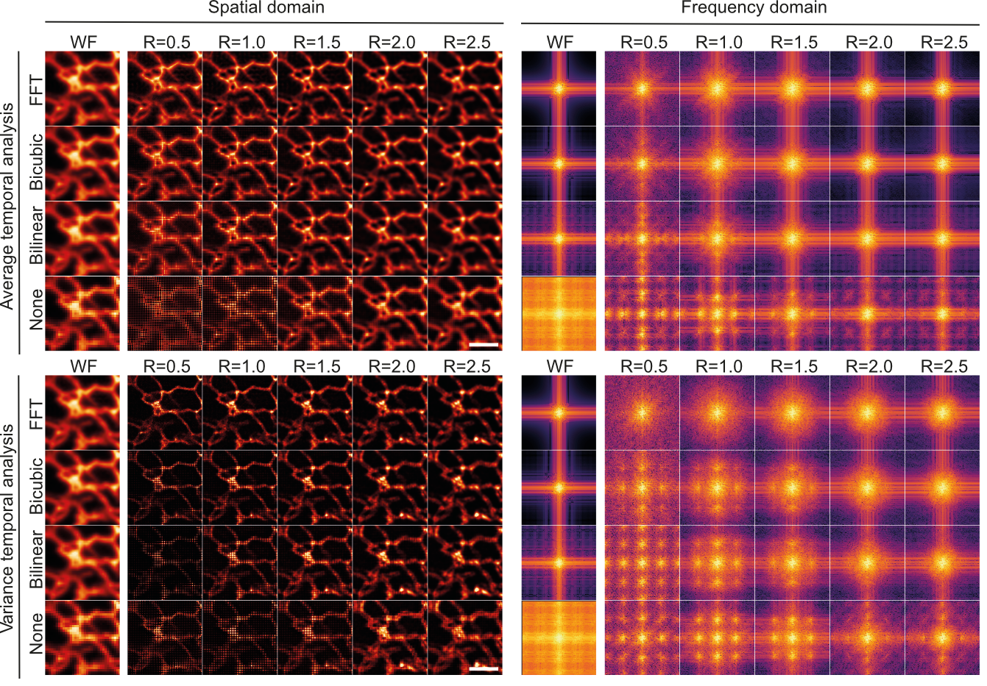
Supplementary Fig. 1: Comparison of interpolation methods in the reconstruction of SRRF images. The presence of macro-pixel artifacts is apparent in both the spatial (left column), and frequency domain (right column) and for AVG (upper row) and VAR temporal analysis reconstruction (lower row) for all interpolation methods apart from the FFT-based interpolation. Data shown corresponds to live COS-7 cells expressing PrSS-mEmerald-KDEL acquired using HiLO-TIRF. Scale bars 2 µm.

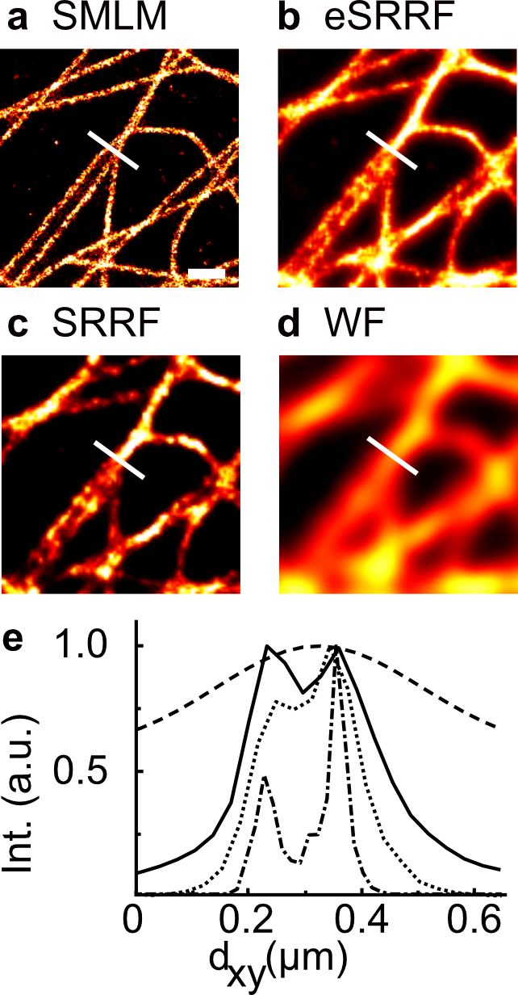
Supplementary Fig. 2: Resolution improvement of eSRRF vs. SRRF. Image sections of the data set presented in Figure 1 after a SMLM image reconstruction, b eSRRF processing, c SRRF processing and as WF data. The white line indicates the position of the line profiles. e Intensity profiles allow to distinguish two filaments in the SMLM reconstruction (dash-dotted line) which can also be resolved with eSRRF (solid line) but the presence of a second filament is unclear in the case of SRRF processing (dotted line) and for the WF data (dashed line). Scale bar: 500 nm.

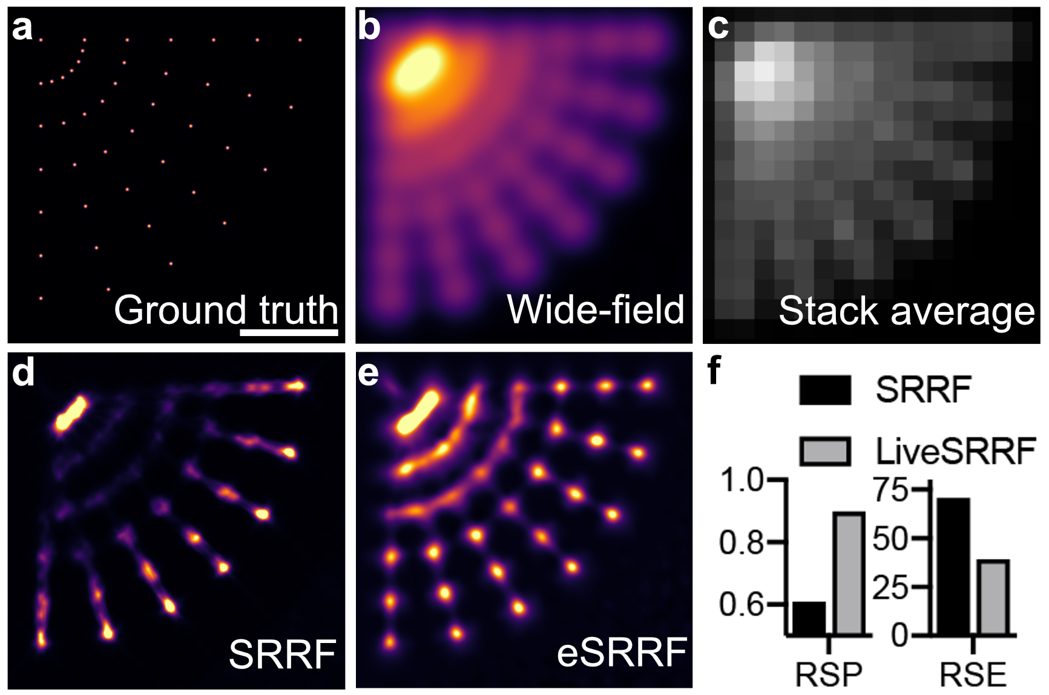
Supplementary Fig. 3: Performance improvement of eSRRF on simulated data. a Simulated ground truth indicating the positions of individual molecules in the image. b Interpolated wide-field image. c, Average of all simulated raw frames d, SRRF image e, eSRRF image. f Quantitative comparisons of SRRF and eSRRF based on RSP and Resolution Scaled Error (RSE) obtained from SQUIRREL. Artifacts like the linearity loss and and over sharpening as they are observed in d are significantly reduced with e, eSRRF processing, Scale bar: 500 nm.

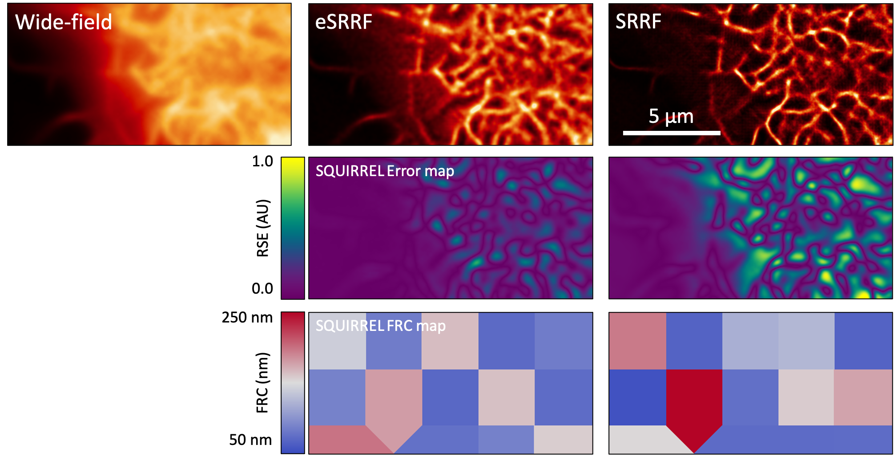
Supplementary Fig. 4: SQUIRREL comparison of SRRF and eSRRF. eSRRF of the actin network (GFP-UtrCH expression, 100 frames at 33 frames/s) in live COS-7 cells shows an improved fidelity with a retained FRC resolution range. The dataset was published before in Culley et al.¹¹

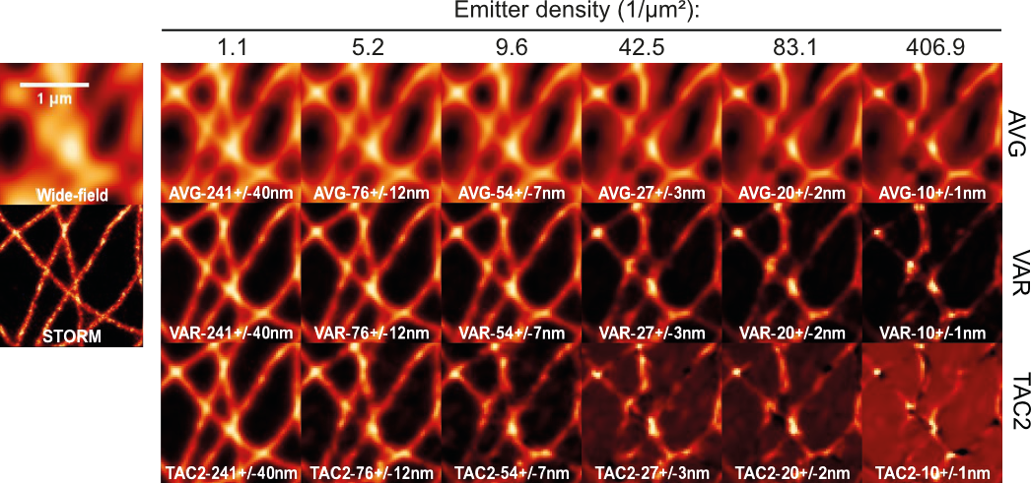
Supplementary Fig. 5: Temporal analyses of eSRRF as a function of the density of emitters in the raw data images. The reconstructed images are shown in increasing emitter density from left to right. The corresponding average nearest-neighbor distance is stated in each panel. The wide-field and STORM equivalents are shown on the left for comparison. Scale bar 1 µm.

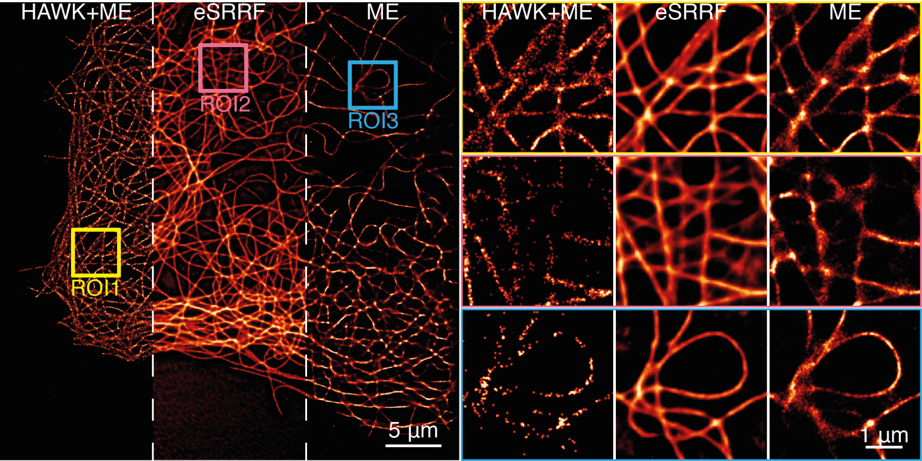
Supplementary Fig. 6: Comparison of eSRRF, HAWK+ME and ME. The Maximum Likelihood Estimation multi-emitter fitting (ME) was performed using ThunderSTORM¹². Data shown corresponds to a DNA-PAINT acquisition of immunolabeled microtubules in fixed COS7 cells under TIRF illumination.

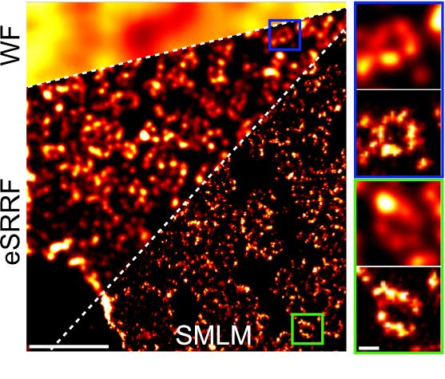
Supplementary Fig. 7: eSRRF allows a fast preview of SMLM dataset reconstruction. Widefield imaging (top left) of the nuclear pore complex. Fast eSRRF reconstruction preview (first 2000 frames shown) reveals the open ring structure (left panel middle area and insets top panels). While fast eSRRF can resolve the central pore which has a diameter of about 140 nm, the full 8-element ring with only 40 nm gaps is only resolved by single-molecule localization analysis of the full 20 000 frames image stack (left panel bottom area and insets lower panels. The FRC resolution (means ± standard deviation) is 44.4±2.5 nm, and 35.1±6.3 for eSRRF and SMLM, respectively.,) (Dataset from Heil et al.¹³), left panel: scale bar 1 µm, insets on the right: scale bar 100 nm.

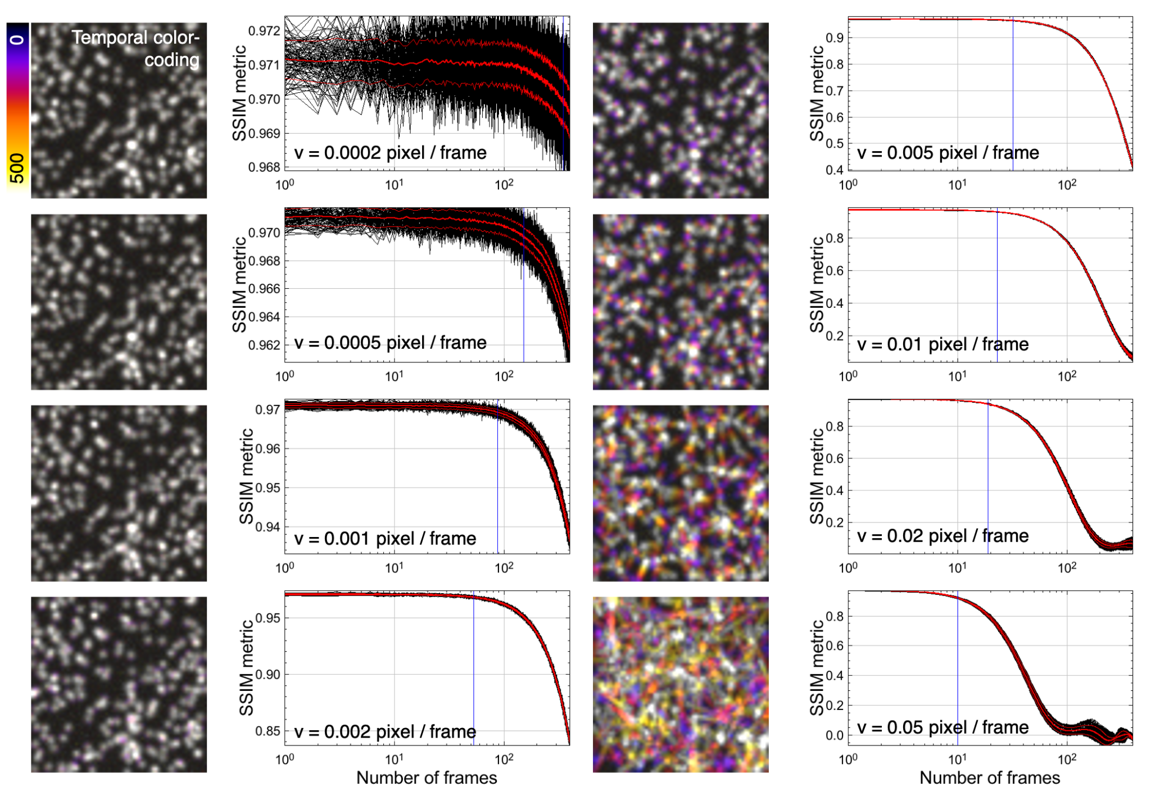
Supplementary Fig. 8: tSSIM analysis of simulated moving particles. Color coded projections of simulated image stacks displaying particles diffusing with various speeds v and the resulting SSIM metric progression over time. The tSSIM metric shows sensitivity as a function of particle displacement per frame. This can be used to estimate the size of the optimal time window for eSRRF processing to avoid movement artifacts.

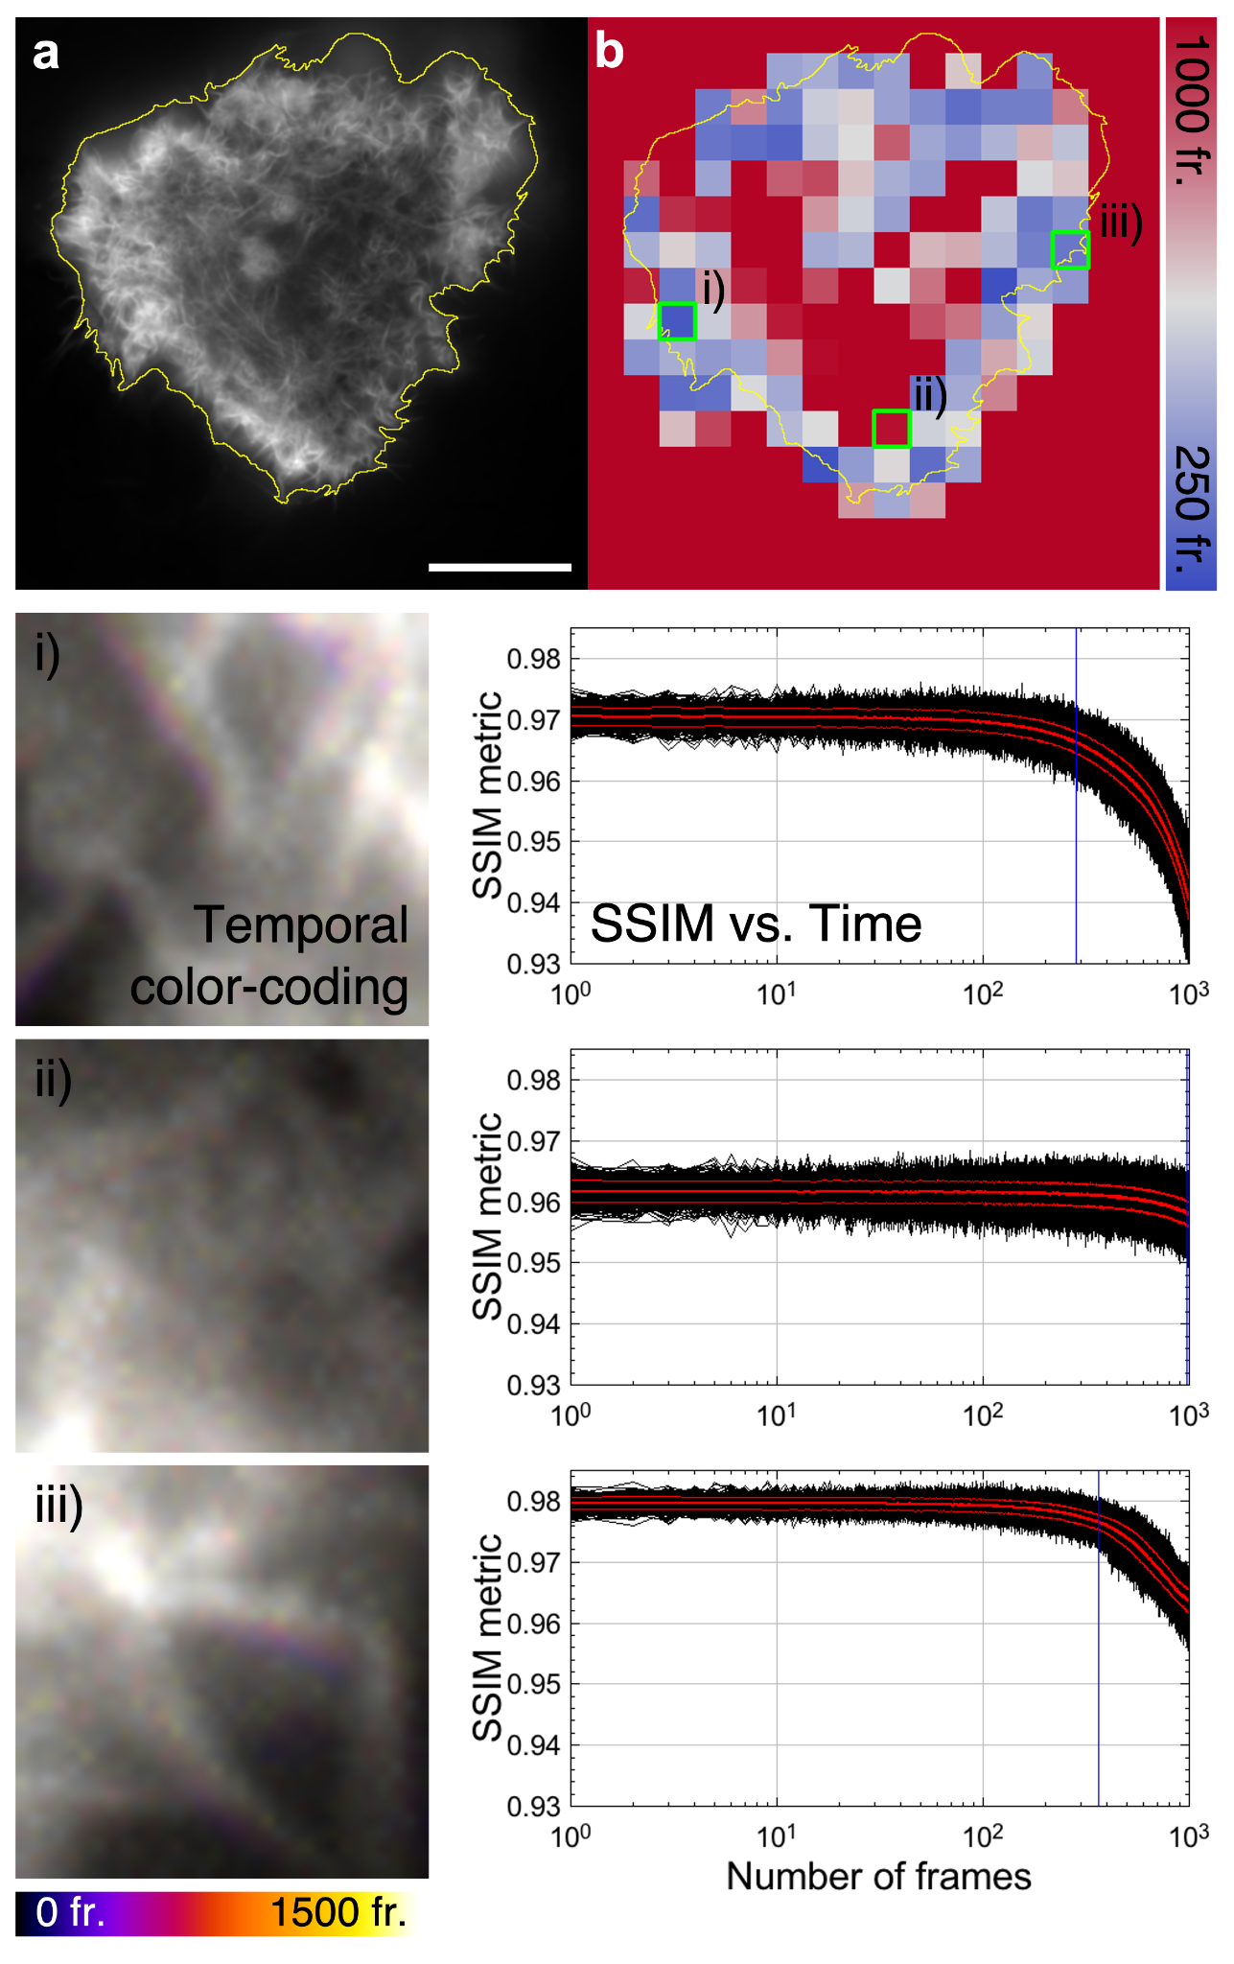
Supplementary Fig. 9: tSSIM analysis performed over small image patches detects local dynamics of actin rearrangement in COS-7 cells. a) The actin network in live COS-7 cells expressing the marker GFP-UtrCH was acquired at 33 fps. b) The tSSIM metric estimates the time range of motion within individual subsections of a). The different subsections highlighted in green display the color-coded projection of regions with i) fast, ii) slow, and iii) moderate speeds as is also reflected by the corresponding progression of the SSIM metric over time. Scale bar 20 µm.

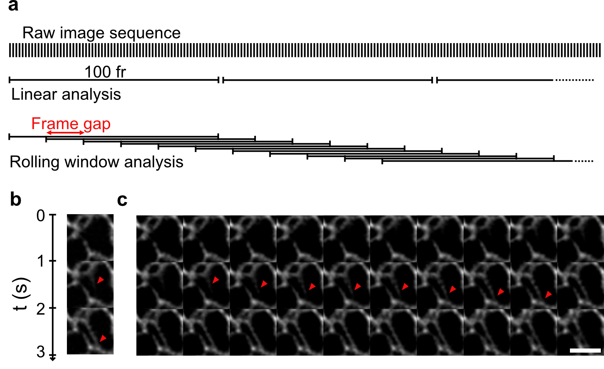
Supplementary Fig. 10: Increasing temporal sampling by rolling window analysis. a) Super-resolved temporal image stack is reconstructed by analyzing consecutive frame windows (linear analysis). A rolling window analysis with a frame gap of less than the window size allows to increase the temporal sampling rate and can translate into a higher temporal resolution without sacrificing spatial resolution. b) This allows to visualize dynamic rearrangement of the endoplasmic reticulum (ER, red arrow) acquired by live-cell HiLO-TIRF of COS-7 cells expressing PrSS-mEmerald-KDEL at a frame rate of 1 Hz with a 100 frame-window linear eSRRF analysis. c) The rolling window analysis with a frame gap of 10 frame allows to increase the temporal sampling to 10 Hz, thus, revealing the substeps of the ER tubule formation (red arrow), image section width 3 µm, FRC resolution (means ± standard deviation): eSRRF: 143±56 nm, Scale bar 2 µm.

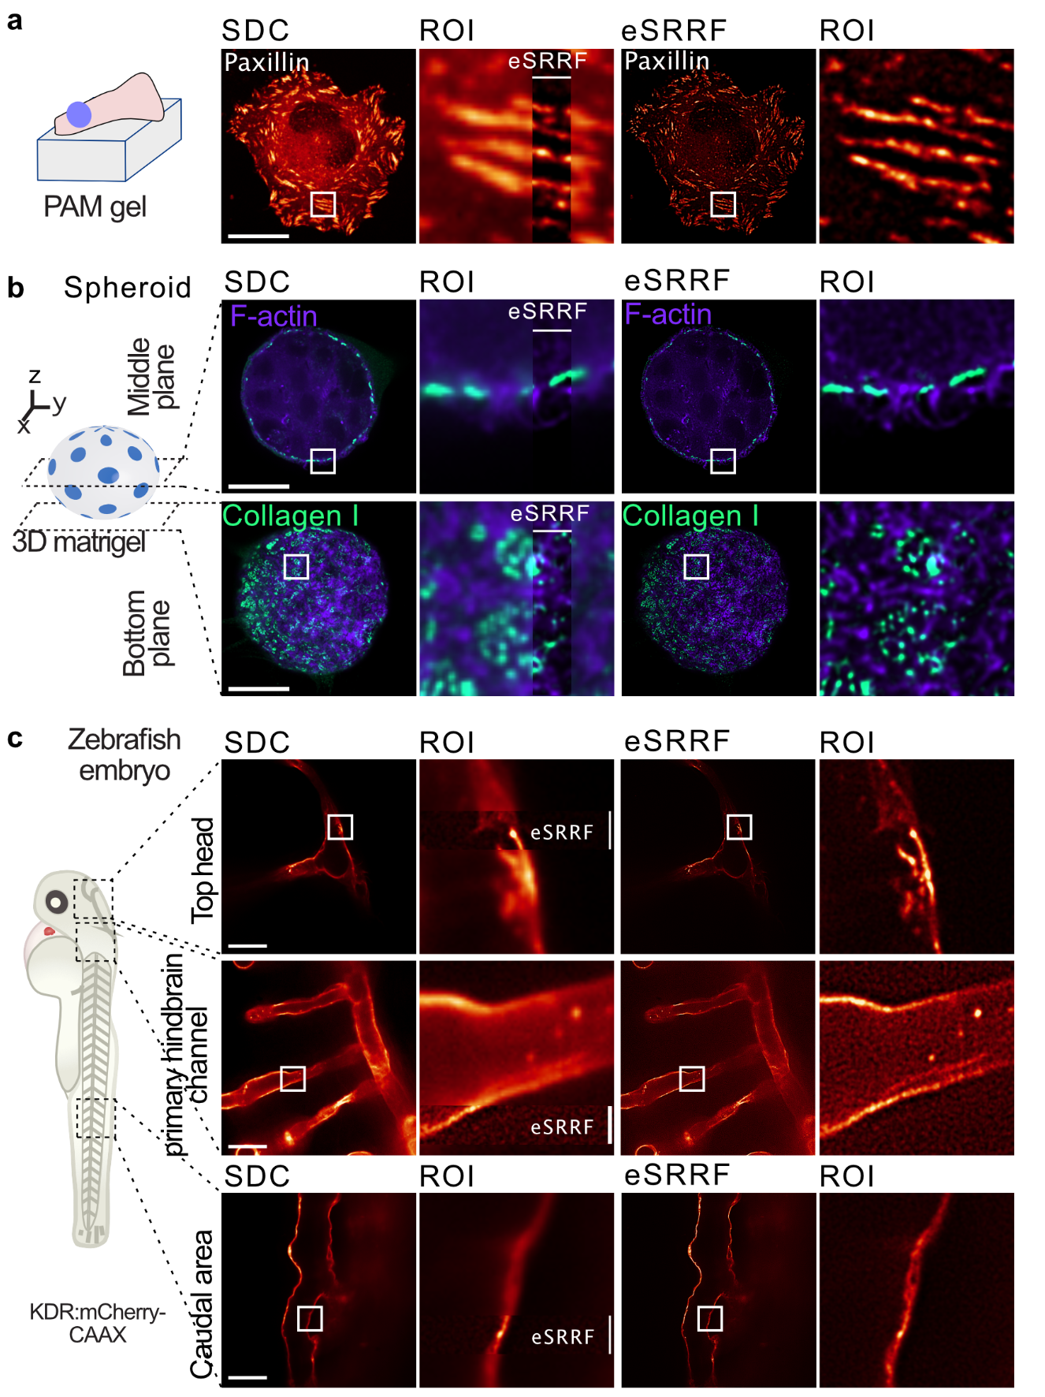
Supplementary Fig. 11: eSRRF enhances spinning-disk confocal imaging deep inside fixed and live cells, spheroid and organisms. a) U2OS cells expressing endogenously tagged paxillin were plated on 9.6 kPa polyacrylamide (PAM) gels and were imaged live using a spinning-disk confocal (SDC). b) DCIS.com lifeact-RFP cells forming a spheroid in 3D matrigel in the presence of fluorescently labeled collagen I. Samples were fixed and imaged using a spinning-disk confocal microscope and processed using eSRRF. Representative fields of view highlighting the spheroids’ middle and bottom planes are displayed. c) Zebrafish embryos expressing mcherryCAAX in the endothelium were imaged live using a spinning-disk confocal. Vessels located at different parts of the embryo were imaged. For all panels, the eSRRF reconstructed images and the original spinning disk images are displayed. Scale bars 25 μm.

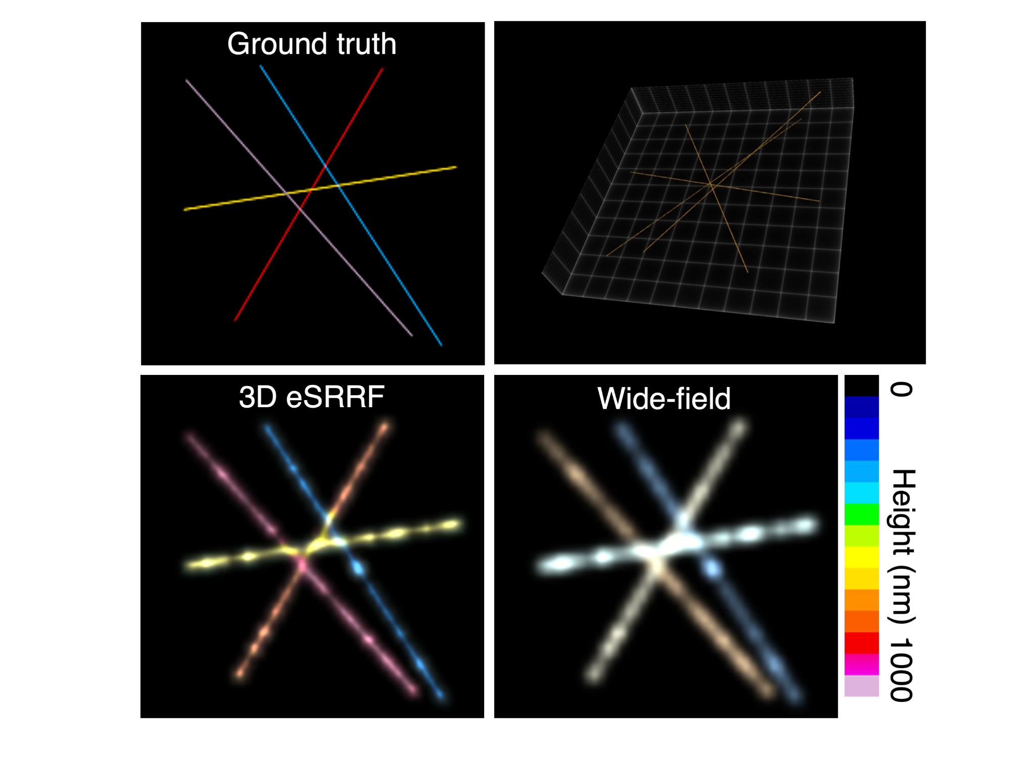
Supplementary Fig. 12: 3D eSRRF on a simulated dataset. The height of the filament is color coded as indicated by the false color scale.

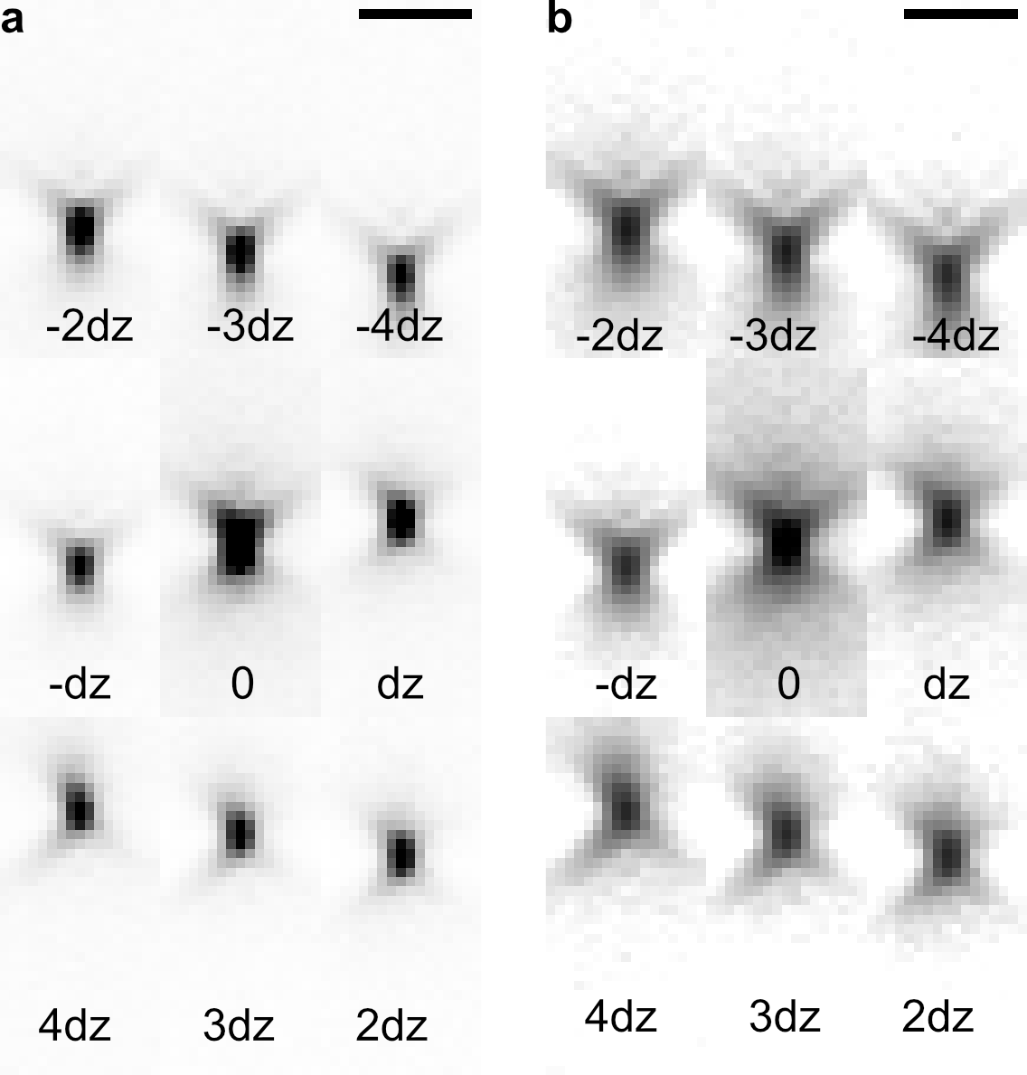
Supplementary Fig. 13: 3D PSF in the nine focus planes of the MFM displays only minor aberrations and good radial symmetry. x-z view of the PSF mapped with the bead calibration dataset displayed in a) linear and b) logarithmic brightness scale (FWHM_{X}=431±19 nm, FWHM_{z}=704±45 nm, means ± standard deviation). The focus offset dz between each focal plane is 390 nm. Scale bars 2 µm.

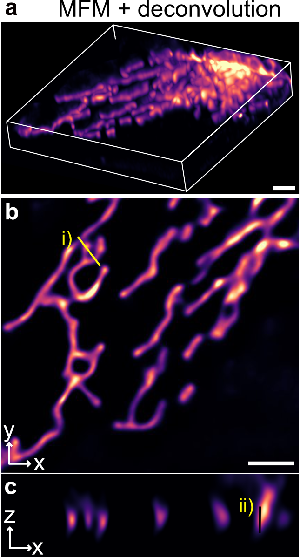
Supplementary Fig. 14: Deconvolved 3D image stack of U2OS cells expressing TOM20-Halo, loaded with JF549 acquired with MFM. a 3D rendering, b single z-slice and c single cropped y-slice. i) and ii) are the line profiles in x,y and z-plane displayed in Figure 4. Scale bars 2 µm.

Supplementary Movies
Supplementary Movie 1: Automated reconstruction parameter search tool implemented in eSRRF. 200 frames of the live-cell TIRF imaging dataset of COS-7 cells expressing Lyn kinase – SkylanS were analysed with eSRRF covering the Radius R and Sensitivity S parameter space defined by R_{start} =1, step size=0.5, number of steps=5 and S_{start} =1, step size=1, number of steps=5. The eSRRF reconstruction for each parameter combination is presented on the left, while the corresponding image resolution and fidelity is marked with a yellow square in the respective FRC and RSP maps. At a low R values pixel artifacts are evident, while at higher R values and low S values no high resolution is achieved. If both, R and S values, are high the reconstruction displays a high degree of nonlinearity. The compromise between resolution and fidelity is represented in the QnR map which displays a maximum at the parameter combination R=2 and S=4 (marked in red).

Supplementary Movie 2: Live-cell HiLO-TIRF of COS-7 cells expressing
PrSS-mEmerald-KDEL marking the ER lumen. WF and eSRRF reconstruction of COS-7 cells expressing a luminal ER marker allows live-cell super-resolution imaging (FRC resolution WF/eSRRF (means ± standard deviation): 254±11/143±56 nm) at a sampling rate of 1 Hz. Rolling window analysis allows to speed up temporal sampling to 10 Hz.

Supplementary Movie 3: Lattice-light sheet imaging of ER in live Jurkat T-cells enhanced by eSRRF. Slice-by-slice processing of the data set allows the reconstruction of a volumetric view (79 x 55 x 35 µm³) of the ER network in live Jurkat T-cells at a rate of 7.6 mHz.

Supplementary Movie 4: Live-cell 3D eSRRF of mitochondria dynamics with MFM. Live-cell volumetric imaging of U2OS cells expressing TOM20-Halo, loaded with JF549 with MFM of a 20 x 20 x 3.6 μm3 at a volume frequency of 1Hz, the grid size is 2 µm.

Supplementary Movie 5: Observing mitochondria dynamics with live-cell 3D eSRRF with MFM. Single z slice image over the whole MFM acquisition time of U2OS cells expressing TOM20-Halo loaded with JF549, before (left) and after eSRRF processing (right). Scale bar 2 µm.

References

1. Marsh, R. J. et al. Artifact-free high-density localization microscopy analysis. Nat. Methods (2018) doi:10.1038/s41592-018-0072-5.
2. Culley, S. et al. Quantitative mapping and minimization of super-resolution optical imaging artifacts. Nat. Methods 15, 263–266 (2018).
3. Parthasarathy, R. Rapid, accurate particle tracking by calculation of radial symmetry centers. Nat. Methods 9, 724–726 (2012).
4. Roberts, L. Machine perception of 3-D solids, optical and electro-optical information processing. (1965).
5. Mendel, J. M. Tutorial on higher-order statistics (spectra) in signal processing and system theory: theoretical results and some applications. Proc. IEEE 79, 278–305 (1991).
6. Gustafsson, N. et al. Fast live-cell conventional fluorophore nanoscopy with ImageJ through super-resolution radial fluctuations. Nat. Commun. 7, 12471 (2016).
7. Agarwal, K. & Macháň, R. Multiple signal classification algorithm for super-resolution fluorescence microscopy. Nat. Commun. 7, 13752 (2016).
8. Dertinger, T., Colyer, R., Iyer, G., Weiss, S. & Enderlein, J. Fast, background-free, 3D super-resolution optical fluctuation imaging (SOFI). Proc. Natl. Acad. Sci. 106, 22287–22292 (2009).
9. Zhao, W., Liu, J. & Li, H. Ultrafast super-resolution imaging via auto-correlation two-step deconvolution. in Ultrafast Nonlinear Imaging and Spectroscopy VIII vol. 11497 42–49 (SPIE, 2020).
10. Moeyaert, B. & Dedecker, P. A comprehensive dataset of image sequences covering 20 fluorescent protein labels and 12 imaging conditions for use in super-resolution imaging. Data Brief 29, 105273 (2020).
11. Culley, S., Tosheva, K. L., Matos Pereira, P. & Henriques, R. SRRF: Universal live-cell super-resolution microscopy. Int. J. Biochem. Cell Biol. 101, 74–79 (2018).
12. Ovesný, M., Křížek, P., Borkovec, J., Švindrych, Z. & Hagen, G. M. M. ThunderSTORM: A comprehensive ImageJ plug-in for PALM and STORM data analysis and super-resolution imaging. Bioinformatics 30, 2389–2390 (2014).
13. Heil, H. S. et al. Sharpening emitter localization in front of a tuned mirror. Light Sci. Appl. 7, 99 (2018).

