Supplementary file
Table S1: The antigenic property of identified target sequence from epitopes on the basis of lowest IC50 value and threshold value of 0.4

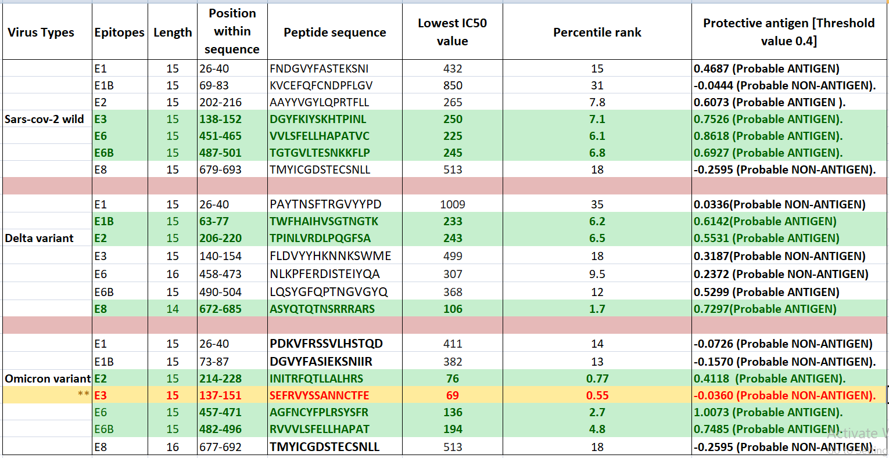
** Green panel indicates the best epitope and orange panel indicate epitope 3 from OMICRON strain has the lowest IC50 value but no antigenic property.

Table S2: Molecular docking study between different epitopes with MHC class II for prediction of best epitope of each coronavirus strain and docking parameters i.e. HawkDock score, binding free energy

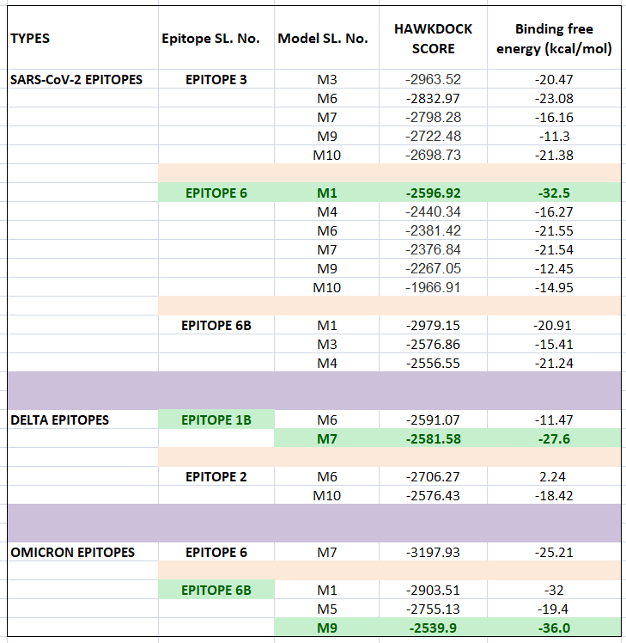
** The green panel in tabulation format indicates best epitope model

Table S3: Binding parameters i.e. VDW, ELE, GB and SA values of different epitopes with MHC class II . Amino acid binding residues between receptor and ligand complex.

