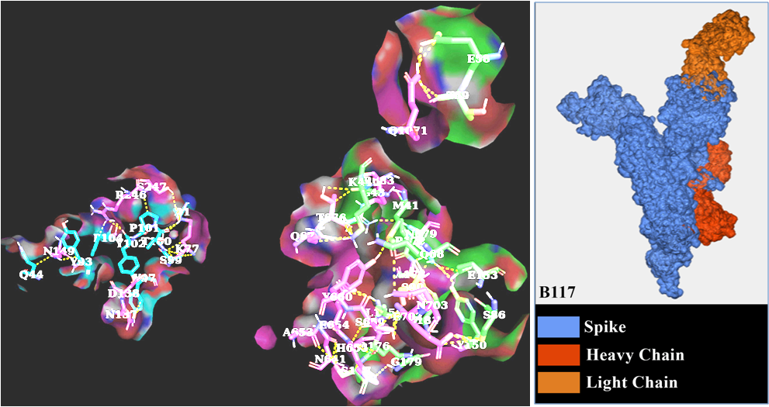
S Figure A1. Antibody and B.1.1.7 spike interactions

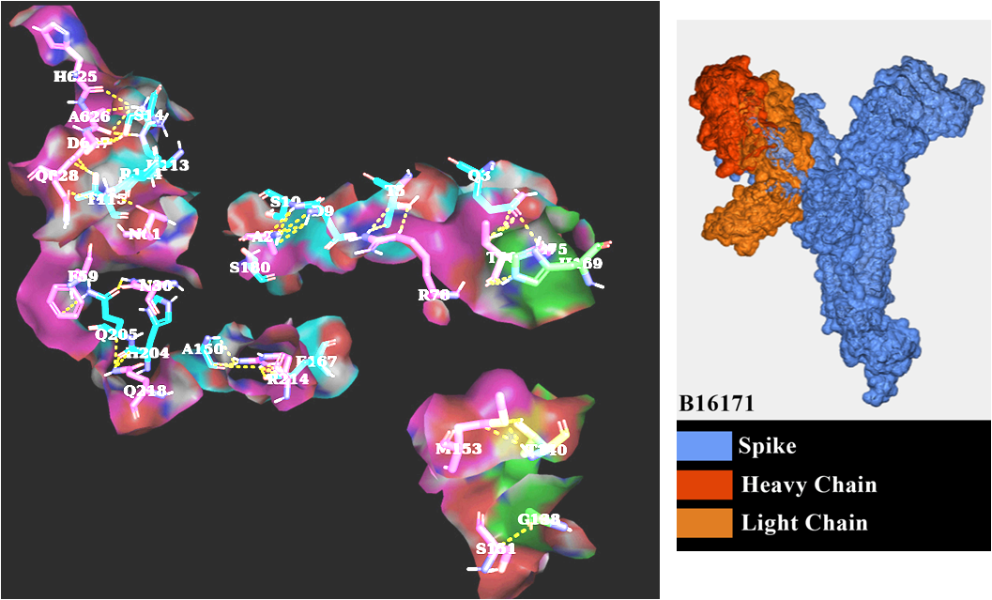
S Figure A2. Antibody and B.1.617.1 spike interactions
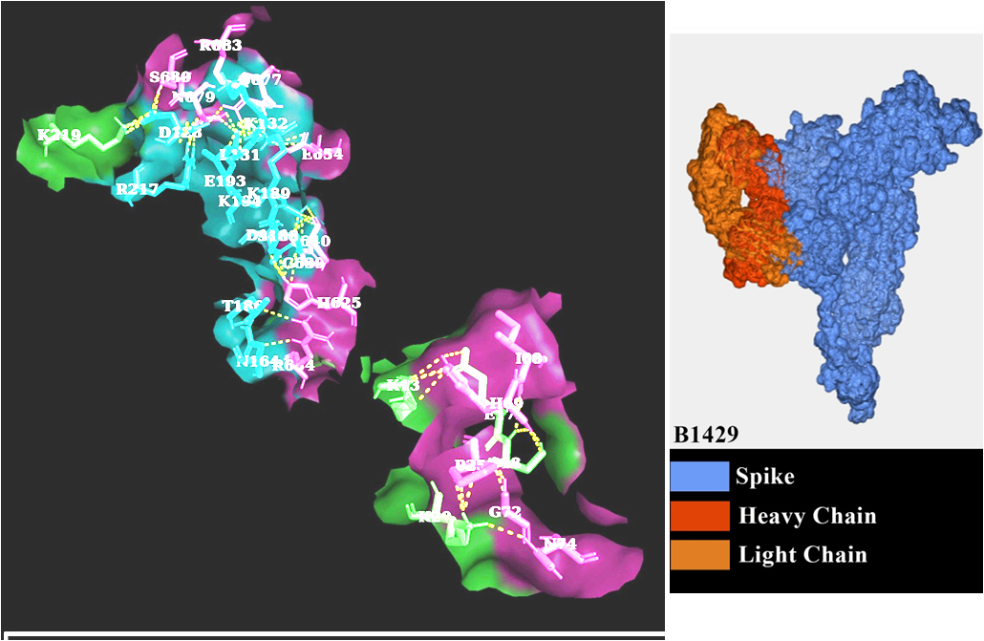
S Figure A3. Antibody and B.1.429 spike interactions

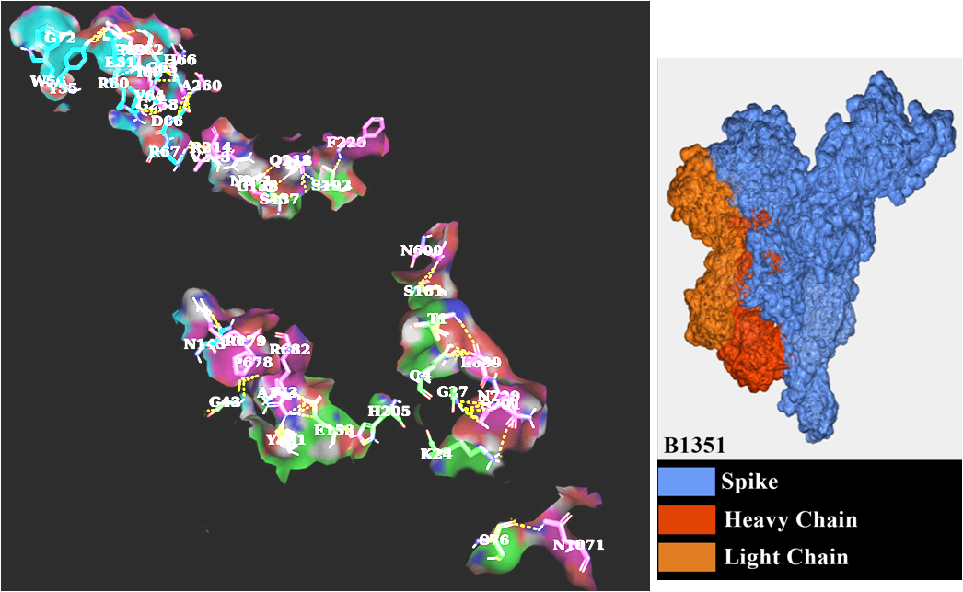
S Figure A4. Antibody and B.1.351 spike interactions
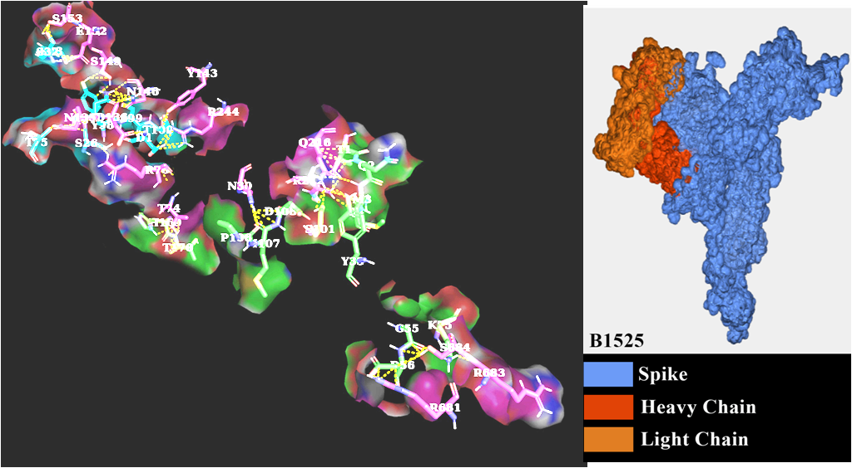
S Figure A5. Antibody and B.1.525 spike interactions
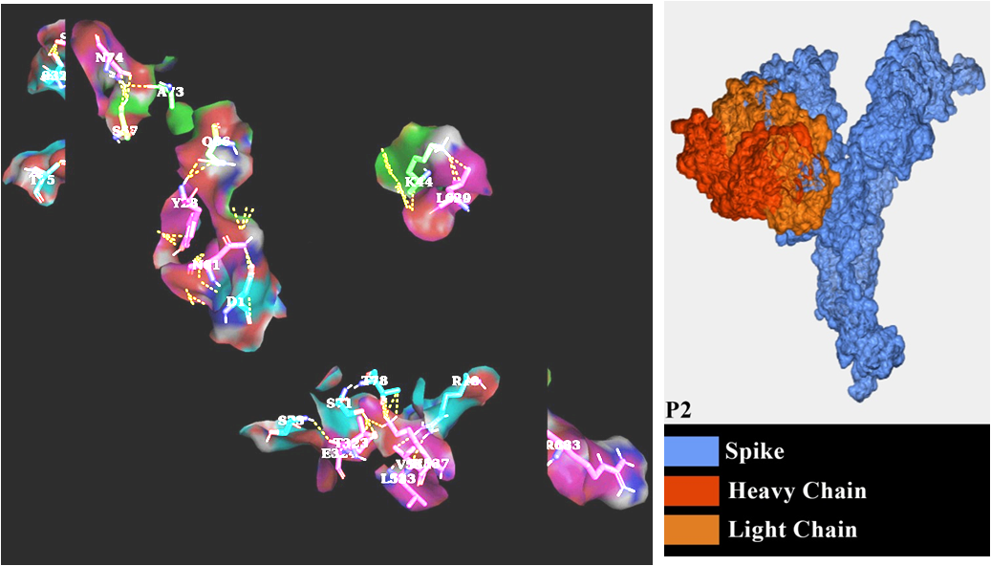
S Figure A7. Antibody and P2 spike interactions

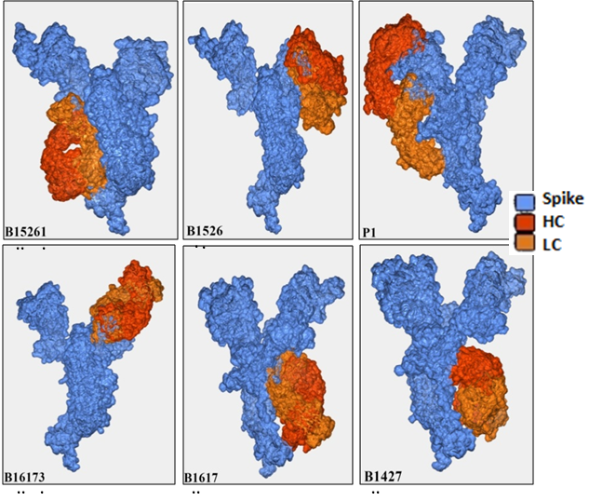
S Figure : Antibody interacts with different variants’ spike.

