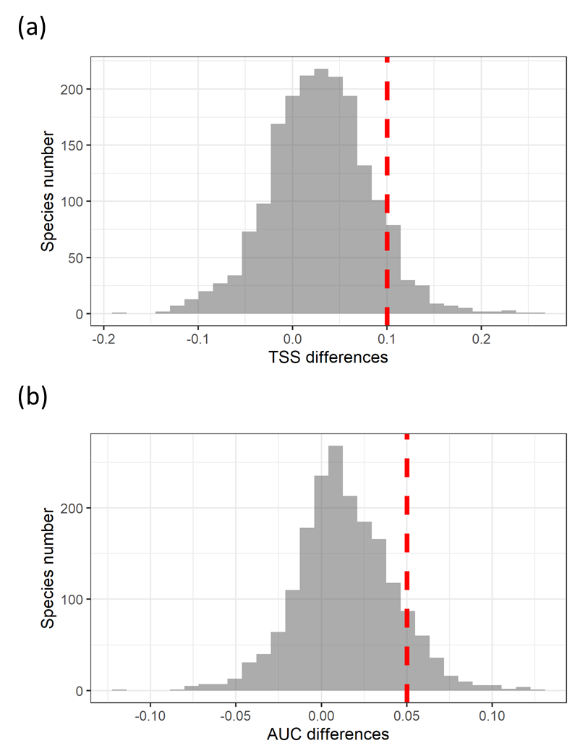

Figure S1: Frequency distributions of model performance differences (a – TSS; b - AUC) between SDM_{sc} and SDM_{climate} for 1870 species.
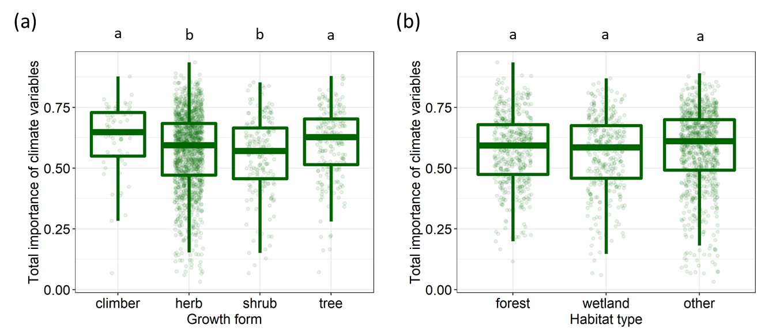
Figure S2: The summed relative importance of soil variables for plants of different growth form (a) and habitat affinity (b). Annotations (abcd) on the top of (b) and (c) indicate pairwise comparisons between groups, with different letters indicating significant differences (p<0.05).
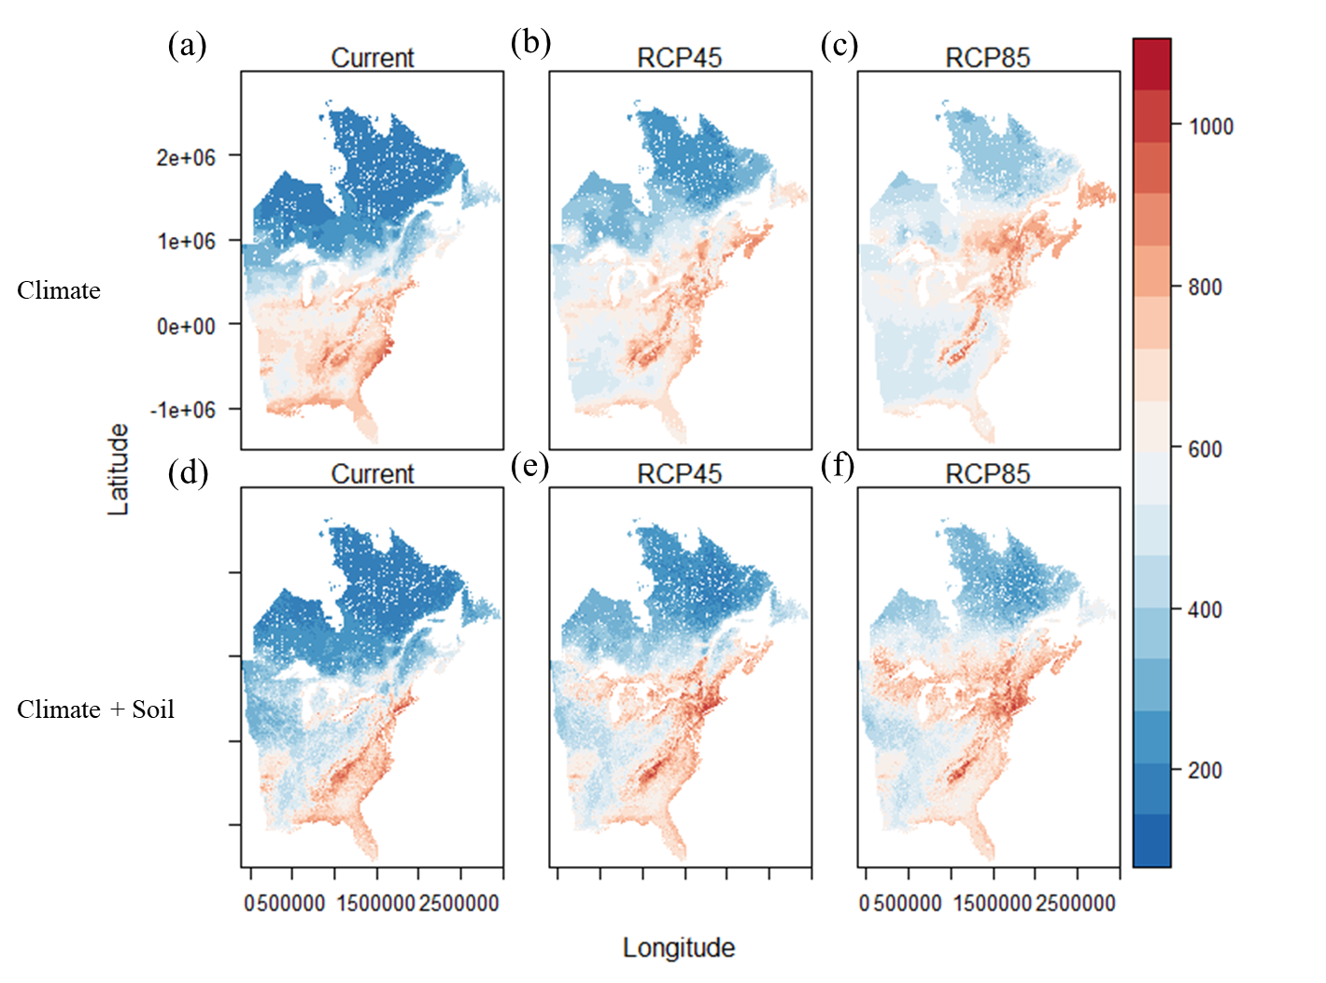

Figure S3: Projected plant species richness across eastern North America under current and future climate scenarios. The first row (a, b, c) shows projections from SDM_{climate}, and the second (d, e, f) from SDM_{sc}.

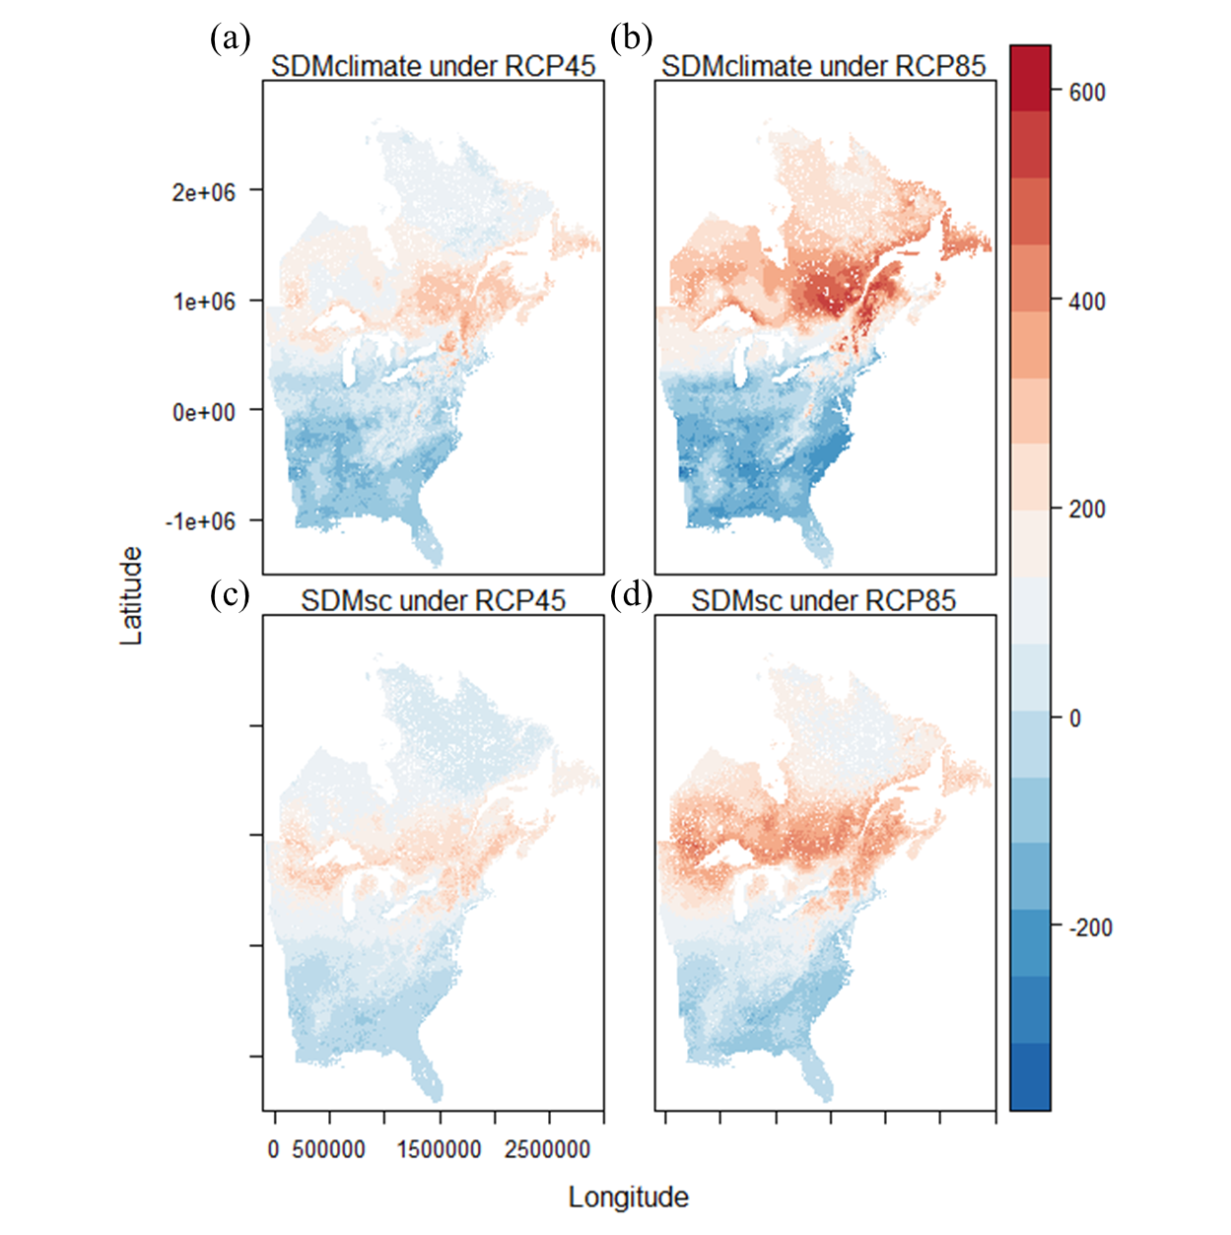
Figure S4: Projected plant species richness change (future richness – current richness) across eastern North America under future climate scenarios. The first row (a, b) shows projections from SDM_{climate}, and the second row (c, d) from SDM_{sc}.

