Appendix
Appendix A1. High-speed IR window Transmission Spectrum
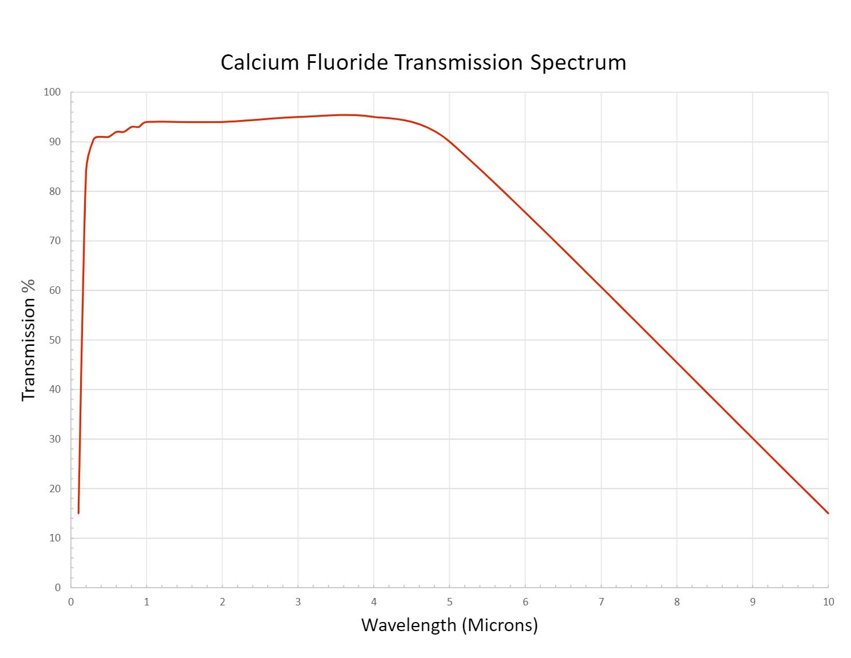

Appendix A2. High-spatial IR filter coating curve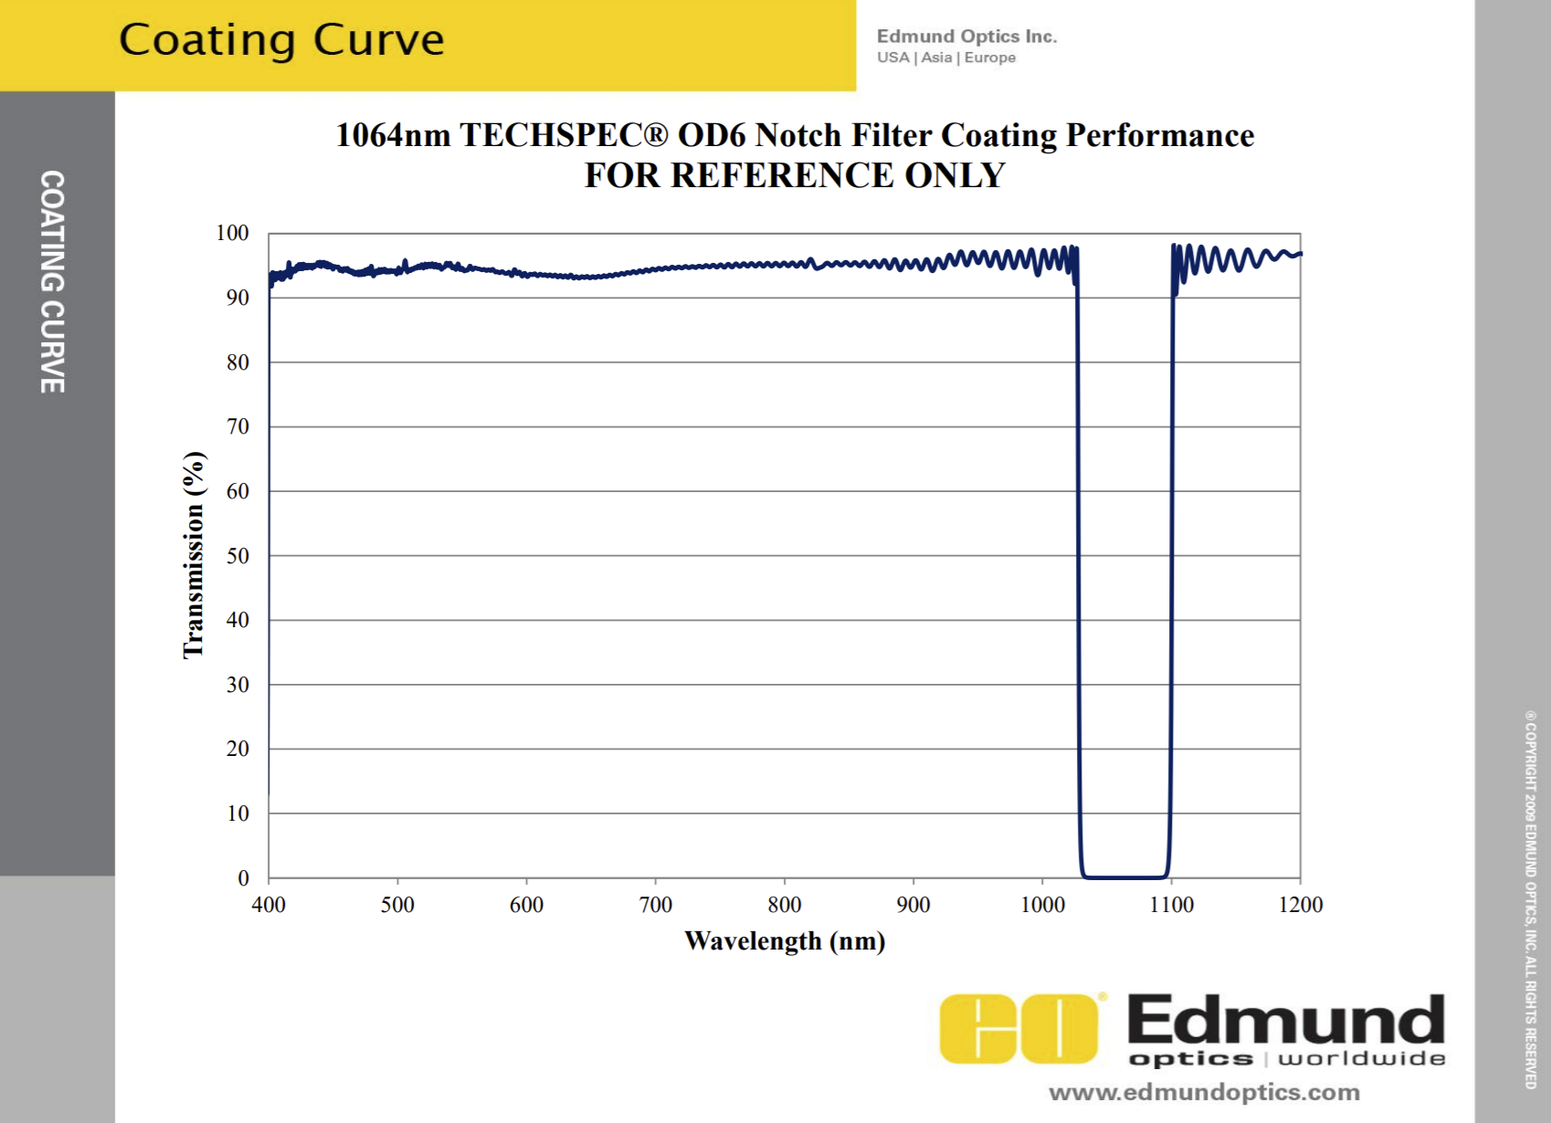

Appendix A3. Measured chemical composition (in wt.%, with Ti in balance) of Ti-6Al-4V plate procured from TMS Titanium®.
Composition (wt.%)
Al | V | Fe | O | C + H + N + Y
6.11 | 3.98 | 0.2 | 0.16 | < 0.02

Appendix A4. Measured chemical composition (in wt.%, with Fe in balance) of 410 SS produced using laser wire-fed DED.
Composition (wt.%)
C | Cr | Ni | Mo | Mn | Si | P | S | Cu
0.11 | 12.5 | 0.1 | 0.03 | 0.45 | 0.39 | 0.01 | 0.01 | 0.14

Appendix B1. (a-d) The relationship between the melt pool dimensions and Tavg, (e-g) The relationship between the melt pool dimension ratios and Tavg. (Trial #11)
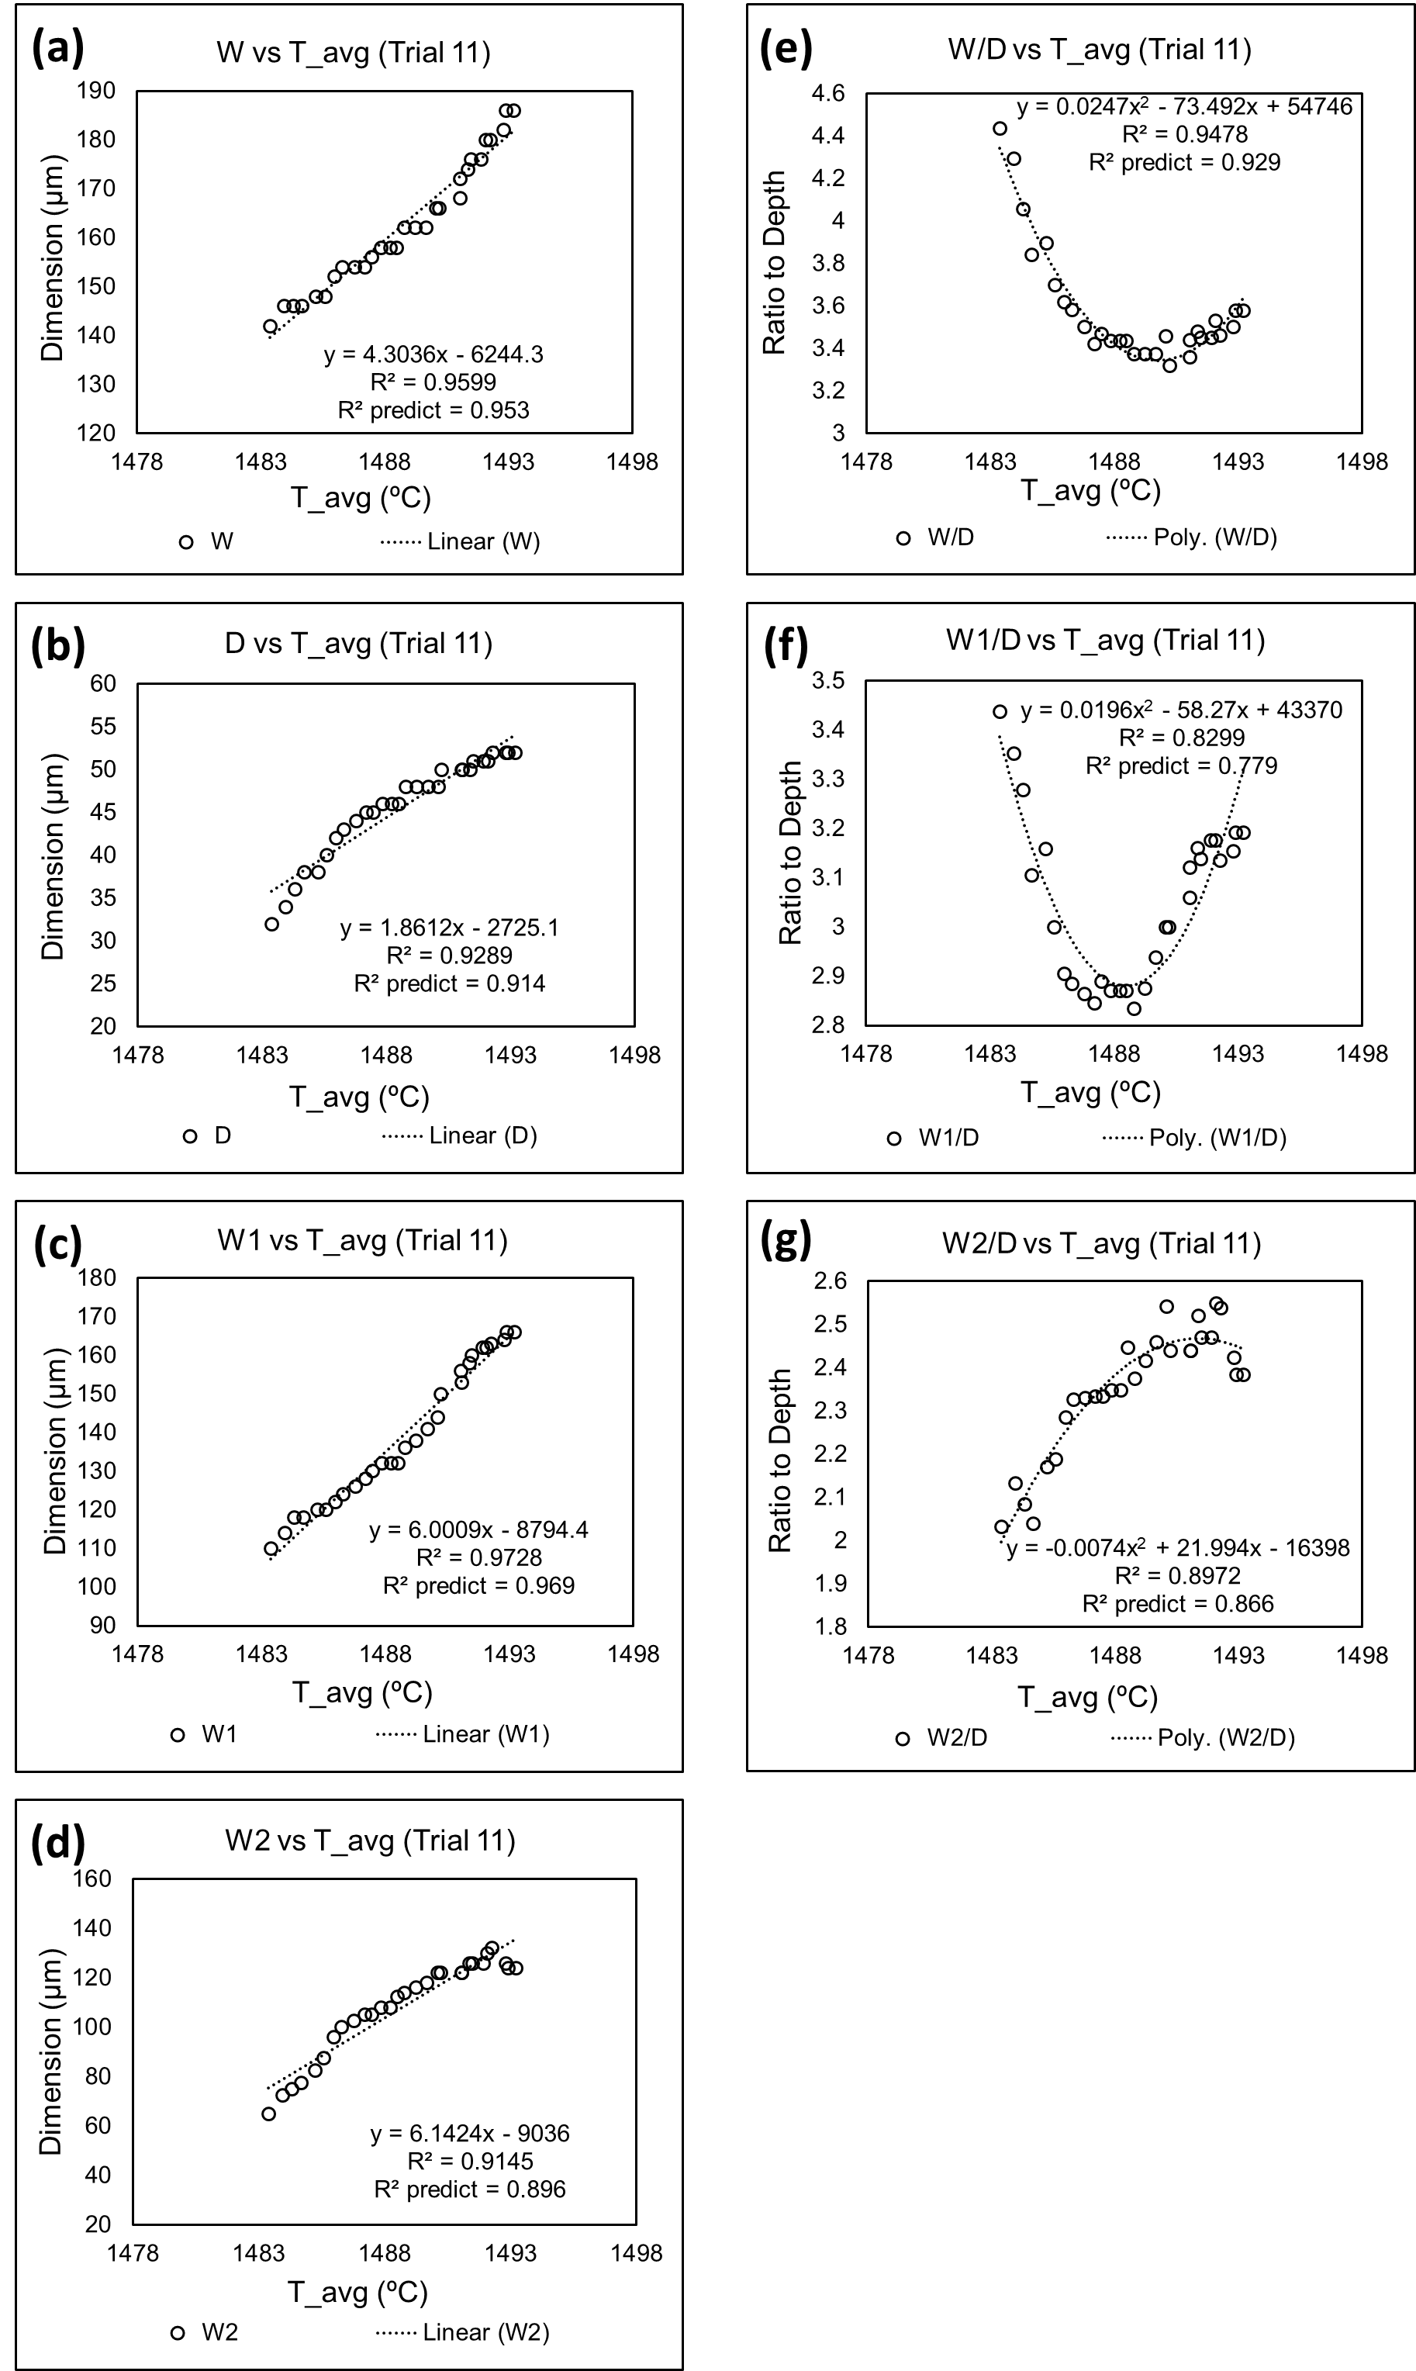
Appendix B2. (a-d) The relationship between the melt pool dimensions and Tavg, (e-g) The relationship between the melt pool dimension ratios and Tavg. (Trial #12)
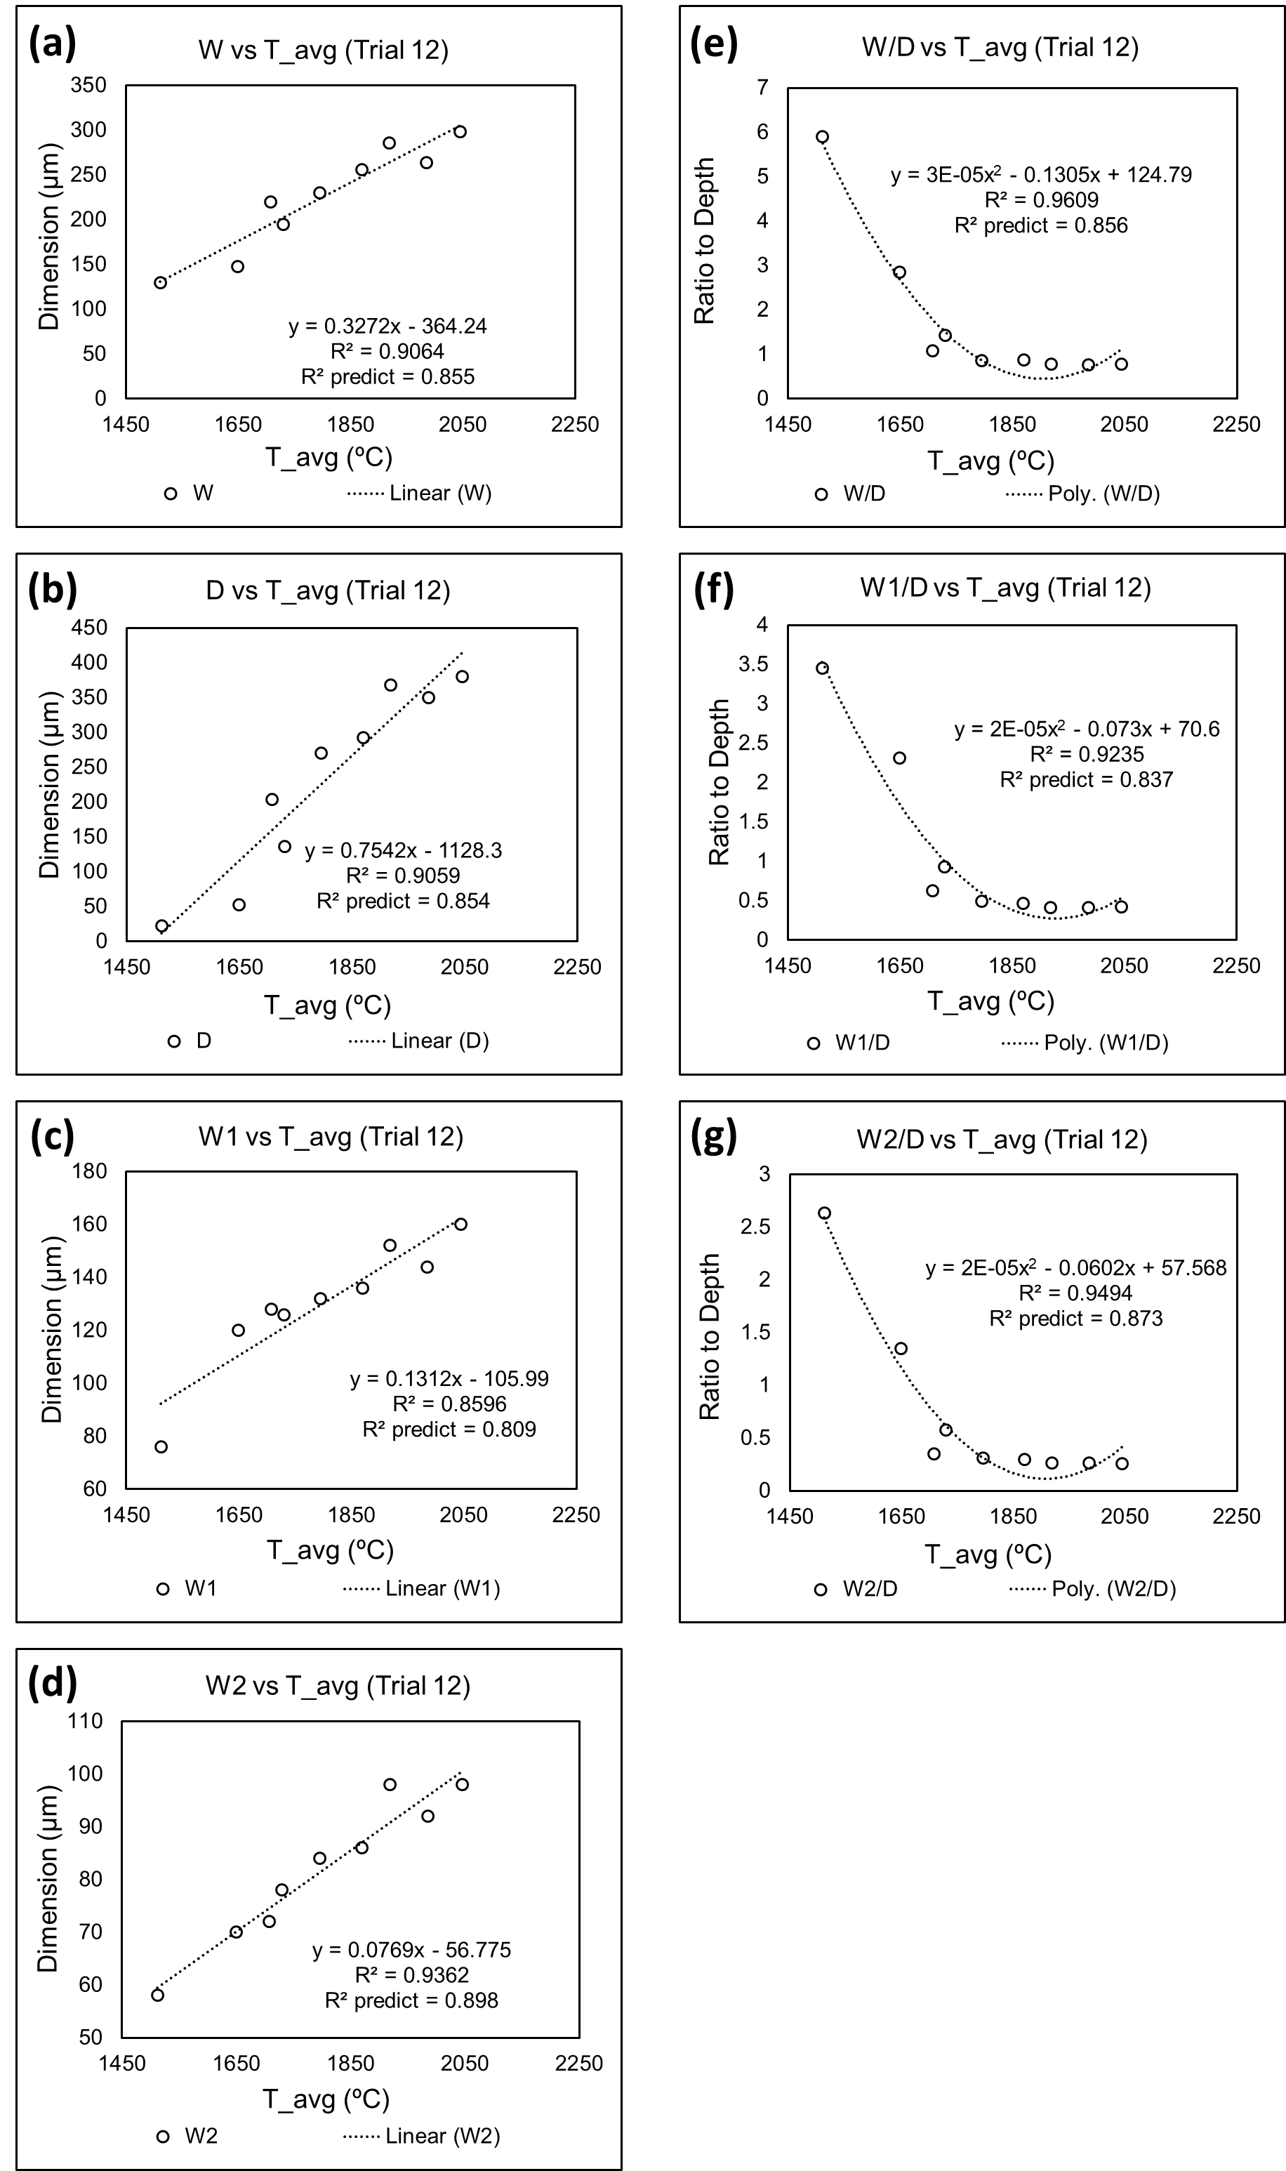
Appendix B3. (a-d) The relationship between the melt pool dimensions and Tavg, (e-g) The relationship between the melt pool dimension ratios and Tavg. (Trial #13)
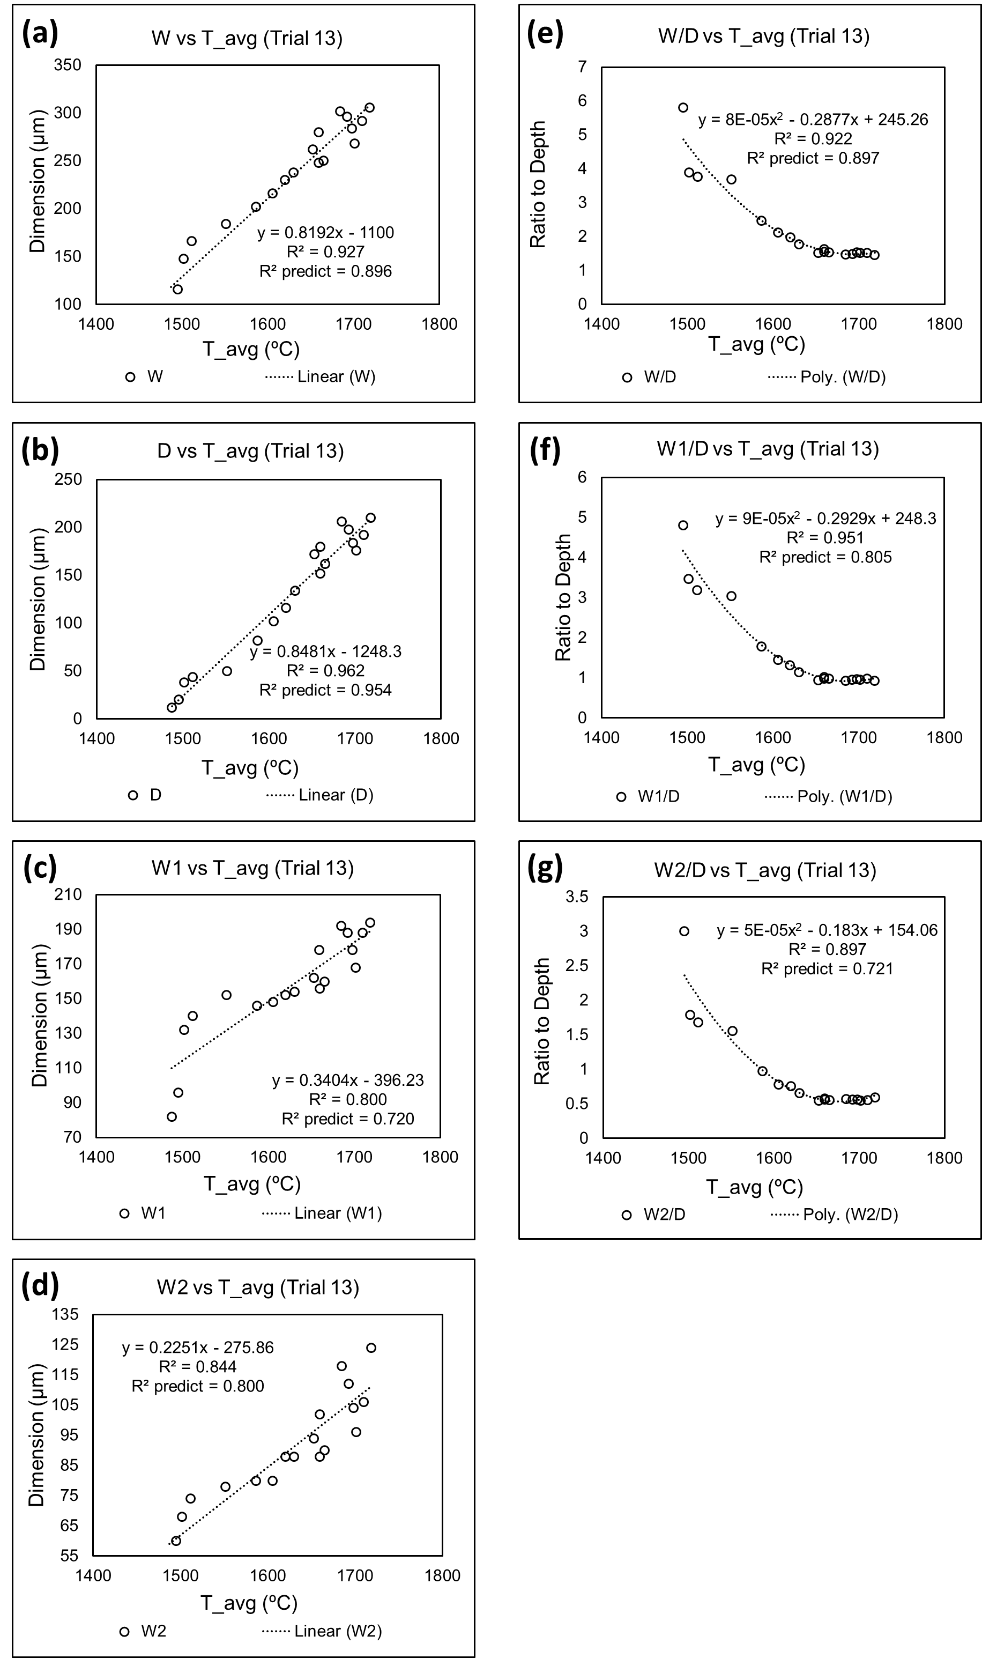
Appendix B4. (a-d) The relationship between the melt pool dimensions and Tavg, (e-g) The relationship between the melt pool dimension ratios and Tavg. (Trial #14)
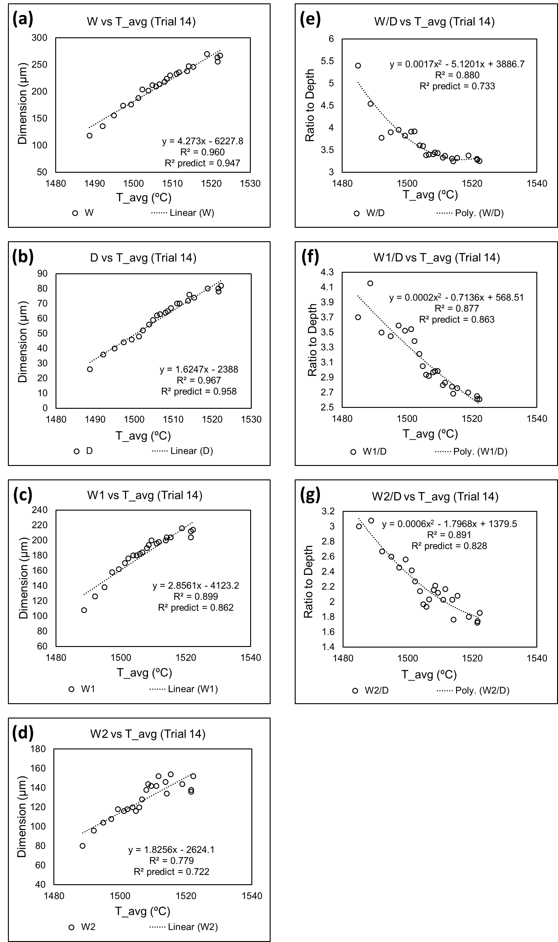
Appendix B5. (a-d) The relationship between the melt pool dimensions and Tavg, (e-g) The relationship between the melt pool dimension ratios and Tavg. (Trial #15)
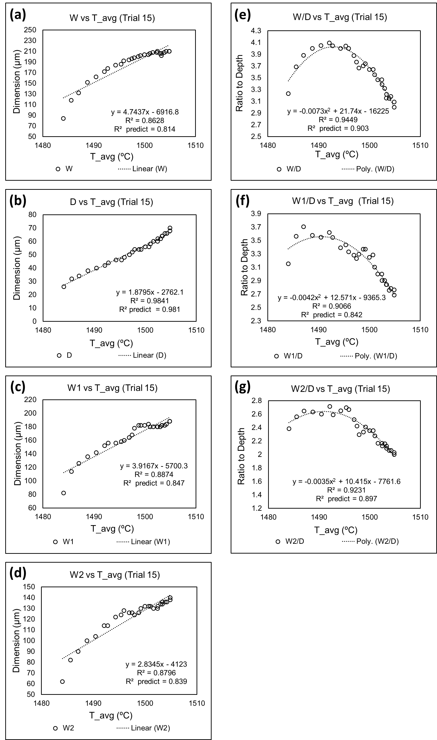
Appendix B6. (a-d) The relationship between the melt pool dimensions and Tavg, (e-g) The relationship between the melt pool dimension ratios and Tavg. (Trial #16)
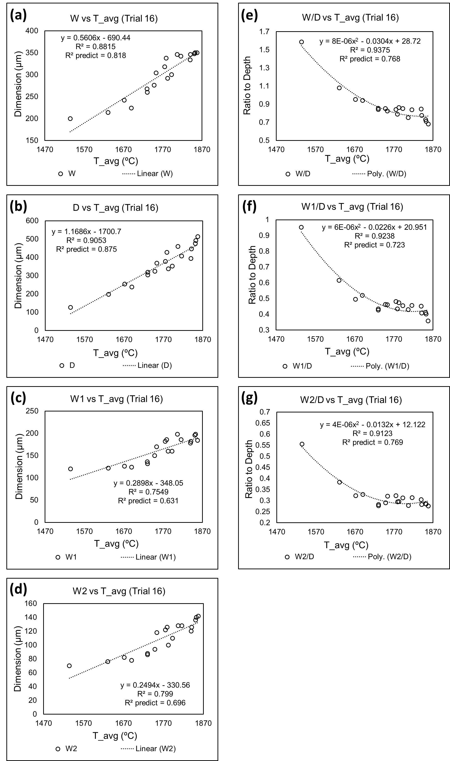
Appendix B7. (a-d) The relationship between the melt pool dimensions and Tavg, (e-g) The relationship between the melt pool dimension ratios and Tavg. (Trial #17)
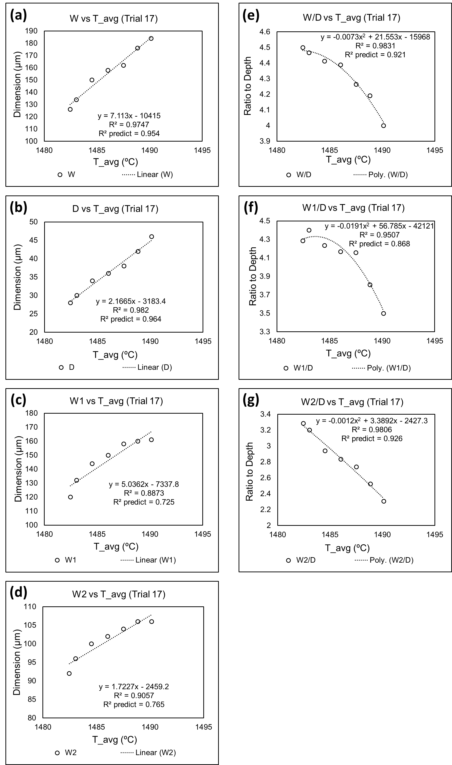
Appendix B8. (a-d) The relationship between the melt pool dimensions and Tavg, (e-g) The relationship between the melt pool dimension ratios and Tavg. (Trial #19)
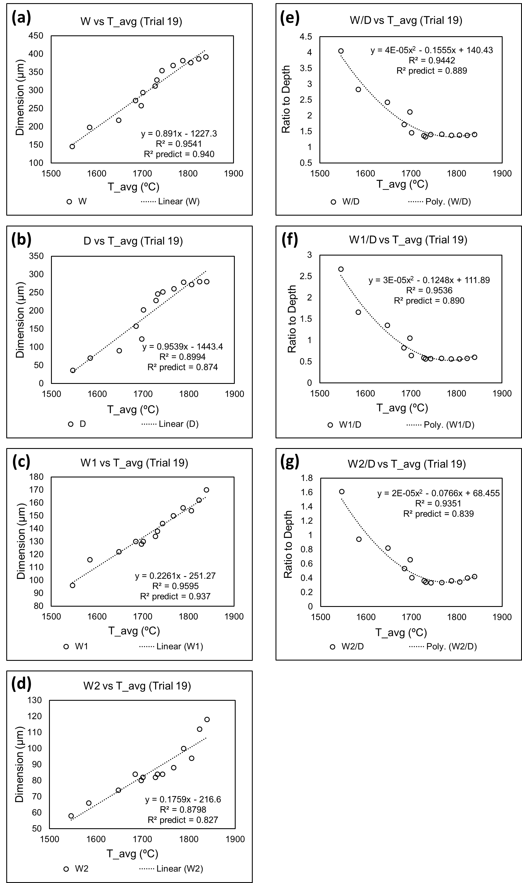
Appendix B9. (a-d) The relationship between the melt pool dimensions and Tavg, (e-g) The relationship between the melt pool dimension ratios and Tavg. (Trial #20) Notice for dimension graphs, conduction mode and keyhole mode are fitted separately.
