Supplementary information includes supplementary figures 1-10, supplementary tables 1-4, supplementary expanded discussion, and supplementary data files 1-8.
Supplementary figure 1: Flowchart of the study design related to the experimental and computational analysis.
The upper respiratory tract microbiomes of thirty individuals (13 healthy and 17 with asthma) were longitudinally followed up for a period of one month. Nasopharyngeal specimens were acquired from both nostrils, which were subsequently pooled into one representative sample per individual for each time point. A total of 239 samples were further processed using metagenomic high throughput sequencing. The generated sequencing reads were annotated and taxonomically classified. A taxonomic threshold was assigned at the species level. Microbiome dissimilarity was measured using two different approaches to account for the compositionality of the data. By measuring the inter-individual and intra-individual microbiome variability we assess support for different scenarios of microbiome dysbiosis in asthma. Their robustness and/or effect on the microbiome was evaluated at ten different species incidence levels spanning from 10% to 100%.

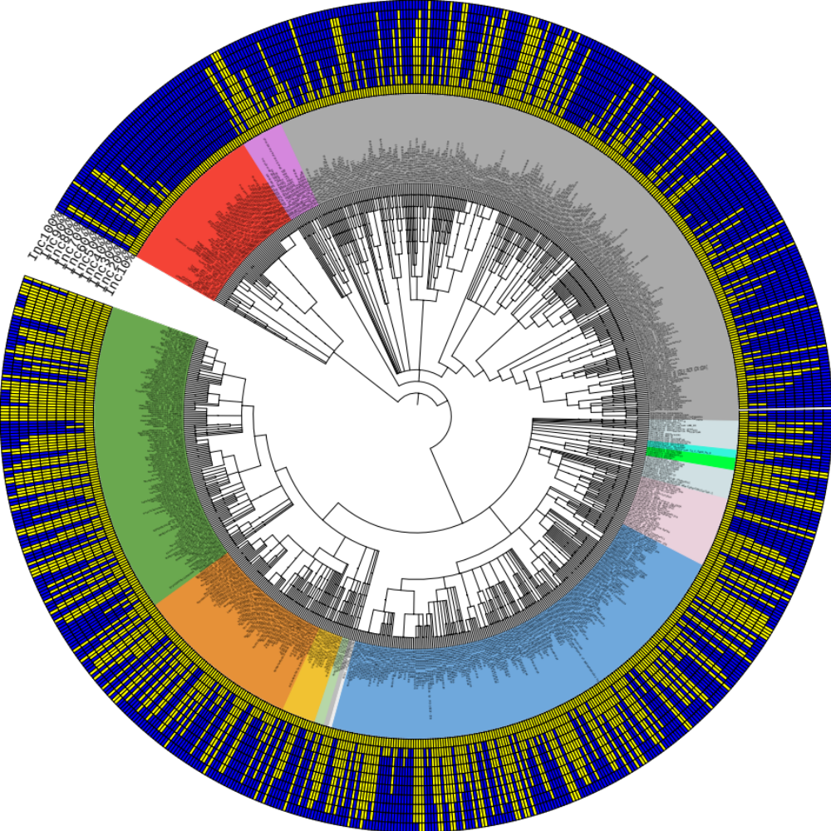
Supplementary figure 2: Taxonomic tree of the microbial species related to the analysed microbiome dataset(s).
The circular cladogram depicts the taxonomic lineages of the microbial and viral species identified in the upper respiratory tract specimens with incidence of 10% and above (n=804). Clade colours represent different types of microbes and viruses: Green; Firmicutes, Orange; Actinobacteria, Light orange; Cyanobacteria, Light green; Chloroflexi, Dark Grey; Thermus, Blue; Proteobacteria, Pink; Bacteroidetes, Light blue; Acidobacteria, Fluorescent green; Spirochaetia, Light Grey; Various families, Grey; Eukaryota (mostly fungi), Pink; Archaea, Red; Viruses. The ten concentric colour-coded binary strips depict species presence at each one of the ten species incidence levels (10%-100%); Yellow-presence, Blue-absence.

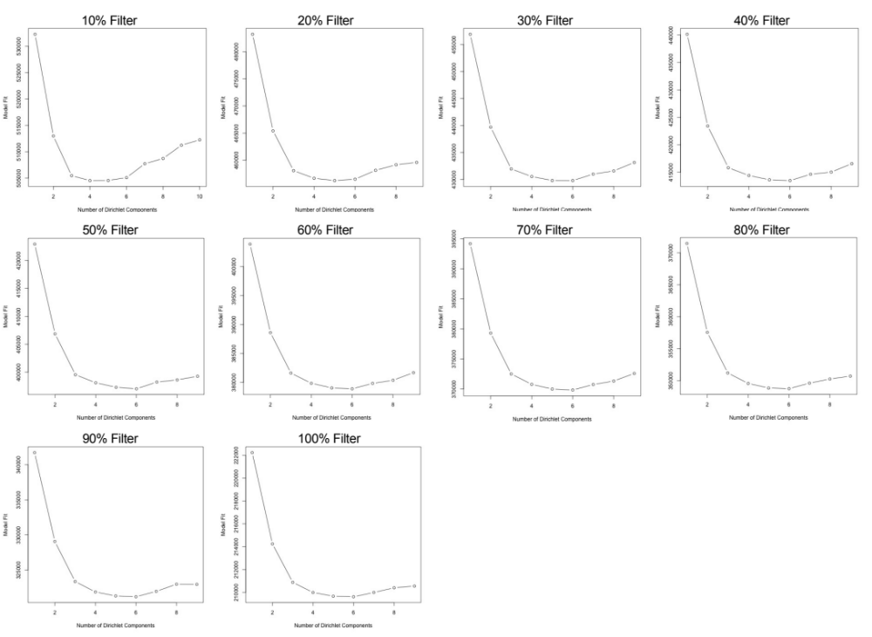
Supplementary figure 3: Laplace approximation to the negative log model evidence related to the assignment of optimal number of microbiome clusters (or metacommunities).
Figure depicts the Laplace approximations for each level of species incidence (10%-100%). The number of Dirichlet components with the lowest model fit represent the optimal number of microbiome clusters (DMM clusters).

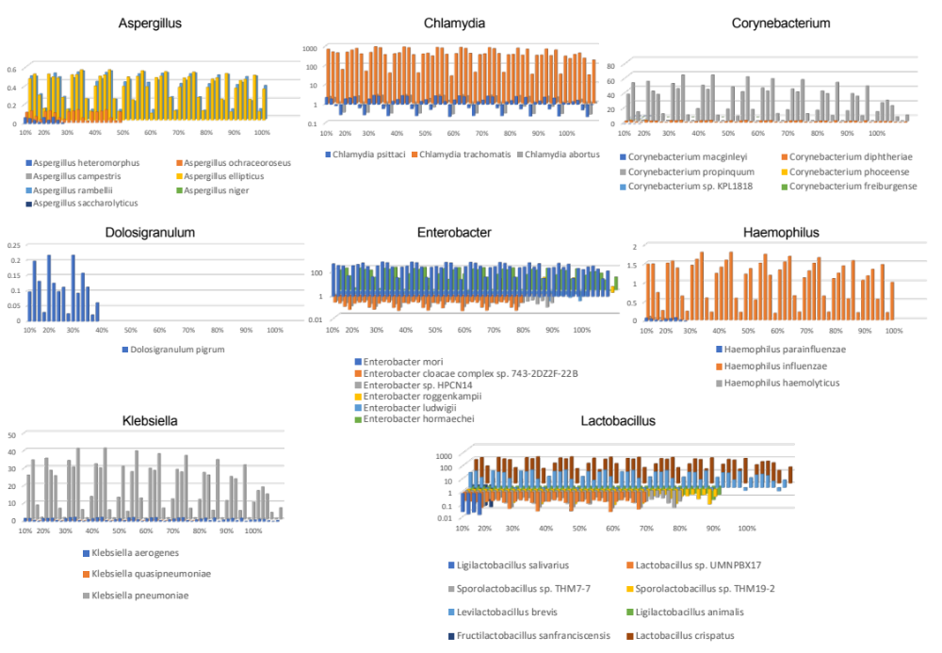
Supplementary figure 4: Microbial species of genera implicated with asthma or asthma exacerbations and identified in this study (part 1). Related to previously published knowledge on microbial genera implicated in respiratory microbiome dysbiosis in asthma.
Graphs depict the alpha metric (absolute quantity) of observed microbial species per microbial genus, for each of the DMM clusters per different species incidence levels (10%-100%). In this set of genera, Lactobacillus was the most diverse genus and with stably high quantities across the 10 species incidence levels, followed by Enterobacter and Chlamydia. Aspergillus was also a stable component of the microbiome with seven species but with low quantities. Haemophilus influenzae was also a stably observed species in low quantities. Dolosigranulum was observed only in up to 40% incidence, whereas Corynebacterium and Klebsiella were stable components but with low quantities.
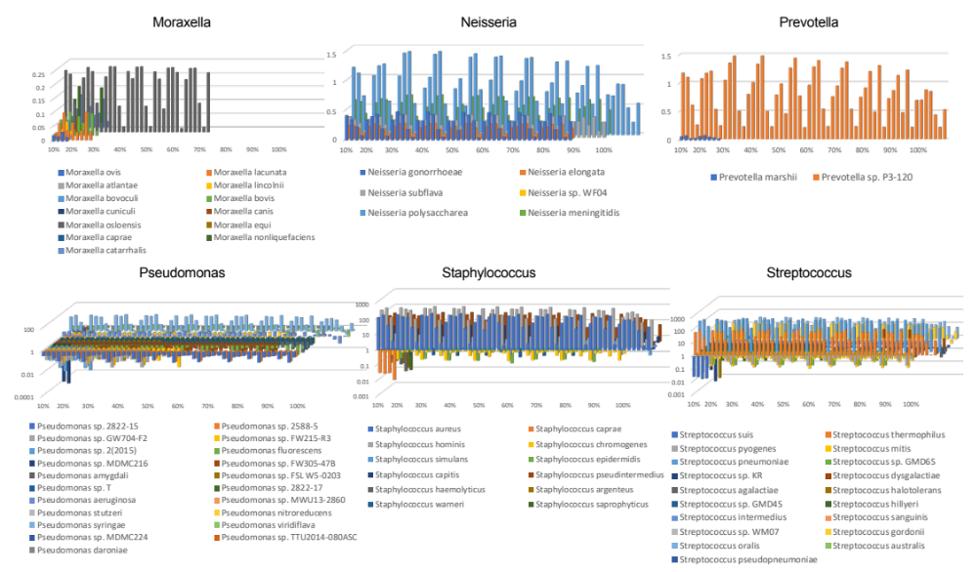
Supplementary figure 5: Microbial species of genera previously implicated with asthma or asthma exacerbations and identified in this study (part 2). Related to previously published knowledge on microbial genera implicated in respiratory microbiome dysbiosis in asthma.
Graphs depict the alpha metric (absolute quantity) of observed microbial species per microbial genus, for each of the DMM clusters per different species incidence levels (10%-100%). In this set of genera, Pseudomonas, Streptococcus, Staphylococcus and Moraxella were the most diverse genera. Staphylococcus and Streptococcus were observed in high quantities, followed by Pseudomonas, Prevotella, Neisseria and Moraxella. Moraxella was observed in up to 70% of species incidence.

Supplementary figure 6: Higher microbiome variability in asthma (Anna Karenina principle). Related to dysbiosis scenario 4.
Principal component plots of the Aitchison distances between microbiomes obtained from healthy individuals (circular) and patients with asthma (crosses). Colours represent the different DMM clusters. Red; cluster 1, yellow; cluster 2, light blue; cluster 3, blue; cluster 4, dark blue; cluster 5, orange; cluster 6. Data are presented for species incidence levels of 30% to 80% that the AKP effects were observed; Within each cluster asthma microbiomes are more variable and oriented towards the perimeter of the cluster.

Supplementary figure 7: Increased microbiome decay rate in asthma. Related to dysbiosis scenario 5.
Violin plots of the microbiome’s decay rate for each individual grouped according to health status. Blue; healthy individuals (n=13), orange; asthma patients (n=17). The decay rates assigned at different species incidence levels are presented (10%-100%).

Supplementary figure 8: Time decay divergence of grouped microbiomes. Related to dysbiosis scenario 5.
Schematic representation of the time decay divergence during the one month follow up between the microbiomes of asthma patients and healthy individuals (species incidence levels 10%-100%). Red nodes; asthma data points, blue nodes; healthy data points. Red line; mean decay rate representative of asthma, blue line; mean decay rate representative of health. Note that the slope of each individual was used to compare the two groups (Table 3).

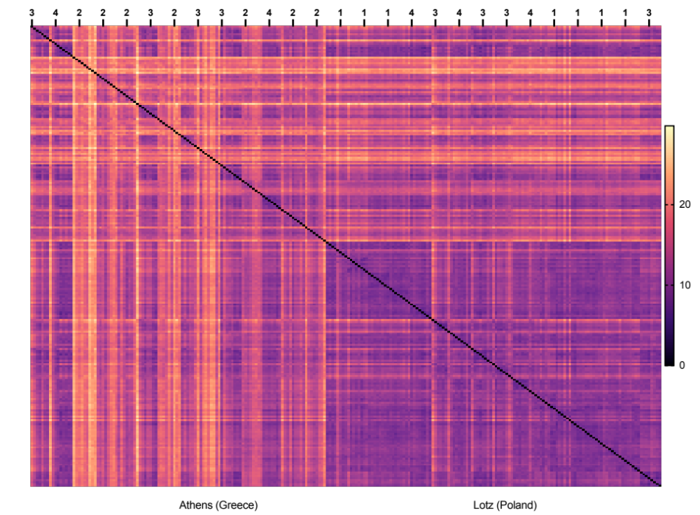
Supplementary figure 9: Aitchison distance pairwise matrix. Related to sequencing batch effects (see methods and expanded discussion in supplementary).
To evaluate the effect of sample-processing batches including the sequencing batches in the microbiome variability we analysed the Aitchison distances between all 239 samples. The figure shows the level of microbiome dissimilarity of the serial measurements per individual across all individuals. The sequencing batches are annotated on the top. The geographical location of the individuals is annotated on the bottom.

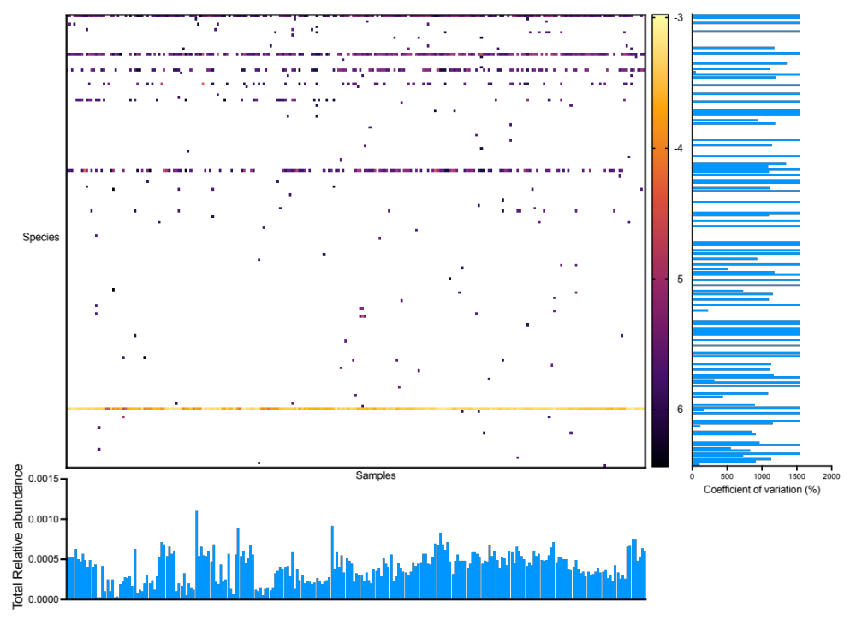
Supplementary figure 10: Environmental/reagent contaminants. Related to the identification of microbial species possibly originating from contamination throughout the experimental pipeline.
Heatmap of the relative abundance (log10) within the microbiome of suspicious species, possibly originating from reagent and/or processing contamination. The horizontal bar plot depicts their total relative abundance in each sample. The vertical bar plot depicts the coefficient of variation of their relative abundance across samples.

Supplementary Table 1: Inverse variance scores of DMM clusters. Related to dysbiosis scenario 2.
 | Species incidence filters
DMM clusters | 10% | 20% | 30% | 40% | 50% | 60% | 70% | 80% | 90% | 100%
1 | 8963.48 | 8625.92 | 8297.29 | 7874.47 | 7547.88 | 7255.35 | 7071.51 | 6615.48 | 6040.75 | 3969.54
2 | 8710.20 | 8686.06 | 12340.25 | 12086.42 | 2915.09 | 11460.59 | 11140.42 | 10395.87 | 9452.26 | 5536.76
3 | 4732.82 | 10086.87 | 12360.46 | 12377.05 | 11271.52 | 11385.79 | 11090.32 | 3301.53 | 3166.70 | 5739.88
4 | 611.33 | 3988.41 | 3537.51 | 3449.19 | 11881.62 | 4118.02 | 4034.46 | 10359.36 | 9424.35 | 2320.09
5 |  | 505.23 | 428.89 | 427.85 | 4176.84 | 447.44 | 440.14 | 358.36 | 351.95 | 311.83
6 |  |  | 4470.80 | 4342.78 | 320.23 | 4020.32 | 3921.08 | 3682.05 | 3360.24 | 2121.22
The table depicts the inverse variance scores for each DMM cluster at the ten different species incidence levels. (10%-100%). The lower the inverse variance score the more variable the cluster (more diffused). Cluster coding does not refer to the same microbiome configuration across the ten species incidence levels.

Supplementary table 2: Sequencing batches. Related to sequencing batch effects.
Geographical location | Code id | Health group | Age (years) | Sequencing batch
Poland | 302 | case | 17 | 1
Poland | 303 | control | 6 | 1
Poland | 310 | case | 15 | 1
Poland | 312 | case | 17 | 1
Poland | 318 | case | 17 | 3
Poland | 326 | control | 18 | 3
Poland | 327 | case | 17 | 3
Poland | 329 | case | 15 | 1
Poland | 331 | control | 18 | 1
Poland | 332 | control | 17 | 1
Poland | 333 | control | 16 | 1
Poland | 334 | control | 18 | 3
Poland | 317 | case | 36 | 4
Poland | 319 | control | 38 | 4
Poland | 328 | case | 25 | 4
Poland | 330 | control | 24 | 4
Greece | 102 | case | 9 | 3
Greece | 105 | case | 9 | 4
Greece | 106 | case | 14 | 2
Greece | 107 | control | 12 | 2
Greece | 108 | control | 12 | 2
Greece | 109 | case | 8 | 3
Greece | 110 | case | 12 | 2
Greece | 111 | case | 8 | 3
Greece | 113 | control | 11 | 2
Greece | 114 | control | 8 | 3
Greece | 115 | control | 12 | 2
Greece | 116 | case | 9 | 4
Greece | 117 | case | 5 | 2
Greece | 119 | case | 14 | 2

Supplementary table 3: Leakage of Microbacterium laevaniformans and Mesorhizobium sp. Primo-A in the core microbiome. Related to contaminants.
Species incidence | Microbacterium laevaniformans coefficient of variation | Microbacterium laevaniformans mean RA | Mesorhizobium sp. Primo-A coefficient of variation | Mesorhizobium sp. Primo-A mean RA
100% | 35.02 | 0.0006166 | 39.14 | 0.0005338
90% | 37.4 | 0.0005639 | 42.65 | 0.0004816
80% | 37.85 | 0.0005563 | 43.32 | 0.0004747
70% | 33.56 | 0.0005325 | 37.59 | 0.0004501
60% | 33.33 | 0.0005293 | 37.36 | 0.0004473
50% | 39 | 0.0005589 | 39 | 0.00055891
40% | 33.7 | 0.0005322 | 38.59 | 0.0004514
30% | 34.69 | 0.0005331 | 39.32 | 0.000452
20% | 35.72 | 0.0005278 | 35.72 | 0.0004445
10% | 32.12 | 0.0005199 | 34.53 | 0.0004361
The table includes the mean relative abundance (RA) and the coefficient of variation across the different DMM clusters for each species incidence level (10%-100%).

Supplementary table 4: Plasmodium ovale contamination. Related to contaminants
species incidence | Plasmodium Coefficient of variation | relative abundance | minimum | maximum
10% | 8.47% | 0.1386 | 4.08% | 160.70%
20% | 9.83% | 0.14 | 3.60% | 148.30%
30% | 9.59% | 0.1408 | 4.79% | 153.30%
40% | 9.68% | 0.1407 | 4.84% | 139.30%
50% | 9.57% | 0.1408 | 7.38% | 153.20%
60% | 9.64% | 0.1411 | 4.71% | 129.10%
70% | 9.64% | 0.1411 | 4.71% | 125.10%
80% | 9.83% | 0.1409 | 4.96% | 134.70%
90% | 9.96% | 0.1409 | 4.94% | 132.40%
100% | 10.05% | 0.1416 | 5.12% | 94.69%
The coefficient of variation and the mean relative abundance amongst the different DMM clusters are presented for the ten different species incidence levels (10%-100%). To compare to the variability contributed by the rest of the microbiome (other species), the minimum and maximum values of the coefficient of variation are presented across the DMM clusters.

Expanded discussion related to this study.

Technical and biological variability

All studies suffer from the contribution of the instrumentation error in the measured variability. Specifically, for microbiome/metagenomic studies technical variability can be introduced at all levels of the processing and analytical pipeline. In this section we control for the effect of technical variability in our data. To achieve this, we evaluated different aspects of the processing, analysis and meta-analysis of the respiratory microbiomes:

Participant visit schedule
In the gut it has been shown that microbiota can follow oscillation patterns of the host. To account for circadian clock synchronisation of the respiratory microbiome, the visit schedule was designed based on specific time points in each day of respiratory specimen acquisition (Supplementary Figure 1).

Standard operating procedure
Prior to the initiation of the study, we designed and disseminated a standard operating procedure (SOP) protocol across the two clinical centres in Athens (Greece) and Lotz (Poland). The SOP described in detail the process of acquiring the respiratory specimen from the nasopharynx and anterior nares in aseptic conditions and with minimal exposure time of the swab or the transport medium in environmental microbes/contaminants. The sample was immediately placed in ice and then stored at -80ºC until shipment to the University of Manchester. All shipments were in dry ice.

Respiratory specimen processing
In the University of Manchester, all specimens were processed by the same laboratory member to avoid handling variability. Since our primary aim was to study the intra-individual variability, all samples from the same individual were processed in the same batch (whole process batch, including sequencing). Individuals were randomly picked based on their age or geographical location. To reduce the effect of time and cross-sample contamination on the experimental procedures we processed a total of 16 samples from two individuals (one healthy and one asthmatic) at each processing batch (specimen processing to whole genome amplification). Therefore, we controlled for the effect of technical variability in the intra-individual and the inter-group (health/asthma) variability.

Sequencing batches
The DNA libraries were sequenced in four different batches of Illumina HiSeq runs (Supplementary table 2). Samples from healthy and asthmatic individuals were equally shared within each sequencing batch and with an effort to be age-matched (age treated as categorical variable). Two out of the four batches included samples obtained from individuals residing in Athens and Lotz. One batch included samples from Athens only, and one from Lotz only. To evaluate sequencing batch effects, we evaluated the Aitchison pairwise distance matrix (Supplementary figure 9). No batch effects were observed. For example, the strong effect of geographical location reported in scenario 1 is not influenced by the sequencing batch. Additionally, most of the individuals demonstrated a strong personalised variability signature, indicated by the serial sample subsets around the diagonal. Apart from the biological implications, this suggests that our strategy to process all samples from the same individual in the same whole-process batch overcame intra-individual technical variability, enriching the time decay rate signal.

Environmental/reagent contaminants
All laboratory processing steps up to the point of generating DNA libraries for Illumina NGS sequencing were performed in a Class II microbiological safety cabinet to reduce environmental contamination. Sterile plasticware and glassware were used throughout, and all reagents used prior and during the DNA isolation were filtered. Ultra clean sterile DNAse/RNAse free water was used throughout including the final elution of DNA as well as for all steps of the downstream molecular analysis.

To control for environmental/reagent contaminants a whole process negative control (WPNC) (specimen transport medium) was included in each experimental batch. The WPNC followed each specimen processing batch throughout the processing of the nasopharyngeal swabs and up to the whole genome amplification step. WPNCs were evaluated my measuring the DNA concentration after whole genome amplification. WPNCs did not produce any measurable readings (estimated concentration<10 pg/µL).

To further evaluate sporadic leakage of environmental/reagent contaminants in the microbiome OTU dataset we followed three approaches. First, the raw OTU species list was compared with the studies from Salter SJ et al 2014¹⁰² and Eisenhofer R et al 2019¹⁰³, adjusting for OTUs that have been reported in upper and lower respiratory tract microbiome studies in health and disease9-15,17,19,20,22,24,34,41,69,104. In the raw OTU dataset (27,230 taxa) we identified weak signals of Alcaligenes, Bradyrhizobium, Leifsonia, Mesorhizobium, Methylobacterium, Ralstonia, and Microbacterium species (168 strains, Supplementary data file 2). Their total contribution to the relative abundance (without normalisation) within each sample ranged from 2.570e-005 to 0.001101 with a mean of 0.0004078. Their relative abundance within each sample ranged from 1.530e-007 to 6.555e-006 with a mean of 2.427e-006. Their coefficient of variation across samples ranged from 45.99% to 1546% with a mean of 1250%. (Supplementary figure 10) These data suggest that they are sporadic fluctuating low quantity contaminants. An exception to this pattern is Microbacterium laevaniformans (NCBI Tax id: 1160710) which was observed with a mean relative abundance of 0.0003976 (range 1.590e-005 to 0.001053, coefficient of variation 45.99%). This species was flagged for the downstream analysis.

For downstream processing of the raw OTU species list we followed two different strategies. First, the sequencing reads were rarefied and new relative abundances were calculated. From the 168 suspicious species, 85 passed the rarefaction step. This dataset was then used to generate the Bray-Curtis dissimilarity compositional matrix followed by masking species based on their incidence level. In the second approach, the raw OTU species list was reduced by masking species based on their incidence ranging from 10% to 100% and the new datasets were used to compare health and asthma including the Aitchison distances, assign DMM clusters, measure the AKP effect and the decay rate. Of the 168 species only seven passed the 10% filtering, six passed the 20%, four the 50%, three the 80%, and two the 90%, resulting in the leakage of Microbacterium laevaniformans and Mesorhizobium sp. Primo-A in the core microbiome (Supplementary data file 1). We further investigated the potential effect of these species in the composition of the DMM clusters. In Supplementary table 3 we follow the two species’ mean relative abundance and the fluctuation around it across the DMM clusters assigned at each species incidence level. Moreover, Aitchison distance is calculated as the centre log transformation of the species counts bypassing the compositional nature of high throughput sequencing data, therefore the quantity of these species does not influence the quantity of the other species within the microbiome. This issue in not addressed using the Bray-Curtis dissimilarity index, which is more sensitive in the presence of contaminants.

Annotation artefacts/ reference database contaminants
Metagenomic studies can suffer from in silico contamination of sequences wrongly classified as microbial in publicly available sequence and genome databases, but also of microbial sequences leaked in the human genome assembly^{105,106}. In our study, we observed contamination by sequences classified as Plasmodium ovale. It has been previously suggested that the most possible cause of this contamination is human contamination in bacterial genomes¹⁰⁵. Plasmodium ovale was horizontally observed in 100% of the samples and with extremely low relative abundance coefficient of variation, especially in relation to the range of coefficient of variation observed across the DMM clusters and for the 10 different species incidence levels (Supplementary table 4). Therefore, its contribution to the microbiomes inter- or intra-variability is minimal if any.

High throughput sequencing and compositionality of data
It has been suggested that using proportions (which does not address heteroscedasticity) or rarefying of counts can lead to misleading results¹⁰⁷. Moreover, the Bray-Curtis dissimilarity index is based on compositional data and does not represent Euclidean distances. This is because the relative abundance of OTUs in the data sums up to 1, which means they reside in a simplex rather than the entire Euclidean space. Therefore, we calculated the Aitchison distance⁸⁶ after cumulation of strains read counts to species and filtration of species at different incidence levels (10%-100%). A total of 804 species and 917,753±494,853 sequencing reads were retained for downstream analysis after filtering at the lowest level of 10%. Since, the Aitchison distance is more appropriate for the measurement of the inter- and intra-individual microbiome variability, we used Aitchison distances for the identification of dysbiotic effects.

Additionally, the masking of species based on their incidence allowed us to evaluate the robustness of our observations and inform their biological relevance. For example, if a specific effect is due to species with variable incidence across the samples (from transient to core).

Microbiome Clustering
Metagenomic studies, including ours, produce species datasets of different size across samples, and as communities are diverse and skewed to rare taxa the matrix is sparse. Most methods used to classify or cluster samples have ignored these features and are often influenced by the effect of the more frequent dominant species. To address the above we have used Dirichlet multinomial mixtures (DMM) for the probabilistic modelling of microbial metagenomics data^{40,91,92} to overcome many problems related to clustering and provide an accurate representation of microbial metacommunities such as the microbial enterotypes in the gut microbiome⁴⁰. This framework allows for clustering by extending the single Dirichlet Prior to a mixture of K Dirichlets, where the optimal number of Dirichlets are determined using Laplace Approximations where the lowest value for a given model is chosen. Overall, we describe a metacommunity from which communities can be sampled. Its parameters then describe both the mean expected community and the variance in the communities, allowing for a model-based alternative for both clustering and classification of microbial communities⁴⁰. DMM was applied at ten different species incidence levels (10%-100%) allowing for the evaluation of the species incidence effect on the metacommunities and the evaluation of dysbiotic effects. For example, DMM at 100% species incidence reflects different types of core microbiomes compared to the 10% where an expanded metacommunity is considered.

Distance from DMM cluster centroids
To compare dispersion patterns between groups of microbiomes (e.g. health versus asthma) we followed two approaches. In the Aitchison logged distance approach, we used the information of the microbiome’s assignment in DMM clusters to compute the centroid of DMM clusters’ members, then we calculated each data point’s distance from the centroid and finally the distances were standardised within clusters to obtain z-scores (1.1. Aitchison distance, in Methods). In an alternative scenario (1.2 Aitchison distance, in Methods) we assume that the shape of the clusters is an attribute of the clusters themselves, and is not due to the characteristics of the samples that make up those clusters. Thus, we assess each sample relative to the other samples from its own cluster. Aitchison distance captures large differences in community composition even if the communities remain in the densest parts of clusters.

In the second approach (DMM likelihood), we account for the DMM’s parameters, which allows us to compute the log likelihood of each cluster member being in the cluster, and the log likelihood values are then standardised to obtain their z-scores within their respective cluster. However, there is a paradox with this approach: even though it considers the DMM’s parameters, if a sample has a low likelihood of being in one cluster it would a priori belong to another cluster. Log likelihood weights distances more heavily if the observation appears in less dense parts of the cluster. For both approaches the lmer4 (z-scored) model is more trustworthy as it accounts for the heteroskedasticity.

The Aitchison logged distance approach consistently captured differences between health and asthma at most species incidence levels, whereas the DMM likelihood approach captured differences in the geographical location and/or age. This demonstrates that analysing dispersion patterns of microbiome data requires the combination of different approaches.

Decay rate and technical variability
Our study would benefit by the inclusion of technical replicates to quantify the technical variability. Due to the budget limitations and the limited amount of biological material, this was not possible. However, we can indirectly evaluate the effect of the technical variability in our results by having a closer look at the time decay plots. In health, the decay rate plots for each individual were parallel to the X axis (time) and in the ordination space the microbiomes from each individual were consistently close to each other regardless of the time interval between measurements. In asthma, individualised microbiomes become more dissimilar with increasing time intervals, and measurements within the first day (B0, B1 3 hours post B0, and B2 8 hours post B0) are very similar with health. The within day variability is the closest we can get to evaluate technical variability in these time series measurements. Therefore, the observed time decay patterns are improbable to raise due to technical variability. Considering all the steps we followed to reduce technical variability and combining the effect of the microbiome drift, suggests that our observations have managed to overcome the effect of the instrumentation error.

Notably, the time decay slope for healthy microbiomes were close to zero, i.e. two microbiome samples from the same healthy individual are likely to be as different after three hours as they are after a month. This suggests that the constant difference we see among healthy microbiomes from the same individual taken at different time points may just be a measure of our sampling error. This is further supported by the fact that the intercept of the regression of asthmatic patients is the same as for healthy patients. Thus, if we take two samples from an asthmatic donor so close together that the microbiome doesn’t have time to change, we would expect the difference to be due only to sampling error. Based on our data it is possible to adjust the sampling time intervals in future studies that aim to study temporal patterns in the respiratory microbiome in asthma.

Continuous versus discontinuous microbiome walk
The microbiome drift (and its relation to diversity) observed in this study could be the result of two different scenarios that characterise the “walk” of the microbiome in time. This walk can be either continuous or not. In a continuous random walk the microbiome is changing continuously. In a non-continuous random walk the microbiome is “pushed” or “kicked” away by some perturbation. For example, the process of obtaining the nasopharyngeal specimen itself could kick the microbiome towards different random directions. This would mean that the measurement obtained by the nasopharyngeal swab is not exactly the same with the status of the microbiome immediately after the measurements. Of note, the effect of such a widely-used microbiome specimen collection method is yet to be modelled. Nevertheless, in both cases, the microbiome drift represents the inability of the system to restrain or control the inherent tendency of the microbiome to destabilise. But, it can possibly affect the prediction of future states inferred from longitudinal data.

Sample size
The small sample size of this study is considered. It has been shown that use of 2 or 3 sequential specimens reduces the number of required subjects by 40%-50% for low- intraclass correlation coefficient (ICC) metrics¹⁰⁸. In our study we use 8 timepoints per individual achieving a good estimation of the individualised microbiome composition. Since relative abundances of major phyla and alpha-diversity metrics have low temporal stability, detecting associations of moderate effect size with these metrics will require large sample sizes. However, beta diversity is reasonably stable over time, and smaller sample sizes can detect associations with community composition¹⁰⁸. In our study, with a total of 30 individuals which were interrogated at eight time points, we analysed 239 microbiomes and obtained convincing evidence of statistical significance using various models. The small sample size cannot possibly reflect the wide variability of phenotypes observed in asthma. Nor all asthma phenotypes are expected to be characterised by AKP and microbiome drift. As mentioned in the discussion section there are cases were drastic alterations in the physiology of the airways probably determine or select for the microbes on that tissue site. In our study we report on microbiome dysbiotic effects in asthma which are not influenced by generic host related factors such as sex, age and geographical location.

Supplementary data files

Supplementary data file 1: Related to dysbiosis scenario 2. Contains the Dirichlet multinomial mixture clusters for ten different species incidence levels (10%-100%). For each species, the DMM alpha score in the specific DMM cluster is presented.

Supplementary data file 2: Related to dysbiosis scenario 3. Shannon diversity for 239 microbiomes at ten different species incidence levels (10%-100%).

Supplementary data file 3: Related to dysbiosis scenario 4. Aitchison distances for 239 microbiomes from their cluster centroids. Ten different species incidence levels (10%-100%) are included.

Supplementary data file 4: Related to dysbiosis scenario 4. Cluster memberships for each sample. Ten different species incidence levels (10%-100%) are included.

Supplementary data file 5: Related to dysbiosis scenario 5. Intra-individual time decay rates for ten different species incidence levels (10%-100%).

Supplementary data file 6: Description of cohort. Related to study participants. The file includes demographic, epidemiological, allergy-related skin prick test results, and lung function spirometry data.

Supplementary data file 7: Subject characteristics. Related to the analysis in this paper. These include: subject code id, health status, geographical location, sex, and age (years) at baseline.

Supplementary data file 8: Related to microbial species previously reported as contaminants. Taxonomic lineages and relative abundance for species identified as environmental contaminants.

