Table 1. Moment tensor solution parameters of the 20 July 2017 main shock reported by various agencies and this study.
Reference | Mw | Depth (km) | Nodal Plane 1 |  |  | Nodal Plane 2 |  |  | Beachball
Reference | Mw | Depth (km) | Strike (°) | Dip (°) | Rake (°) | Strike (°) | Dip (°) | Rake (°) | Beachball
AUTH | 6.5 | 7 | 275 | 41 | -88 | 93 | 49 | -91 | 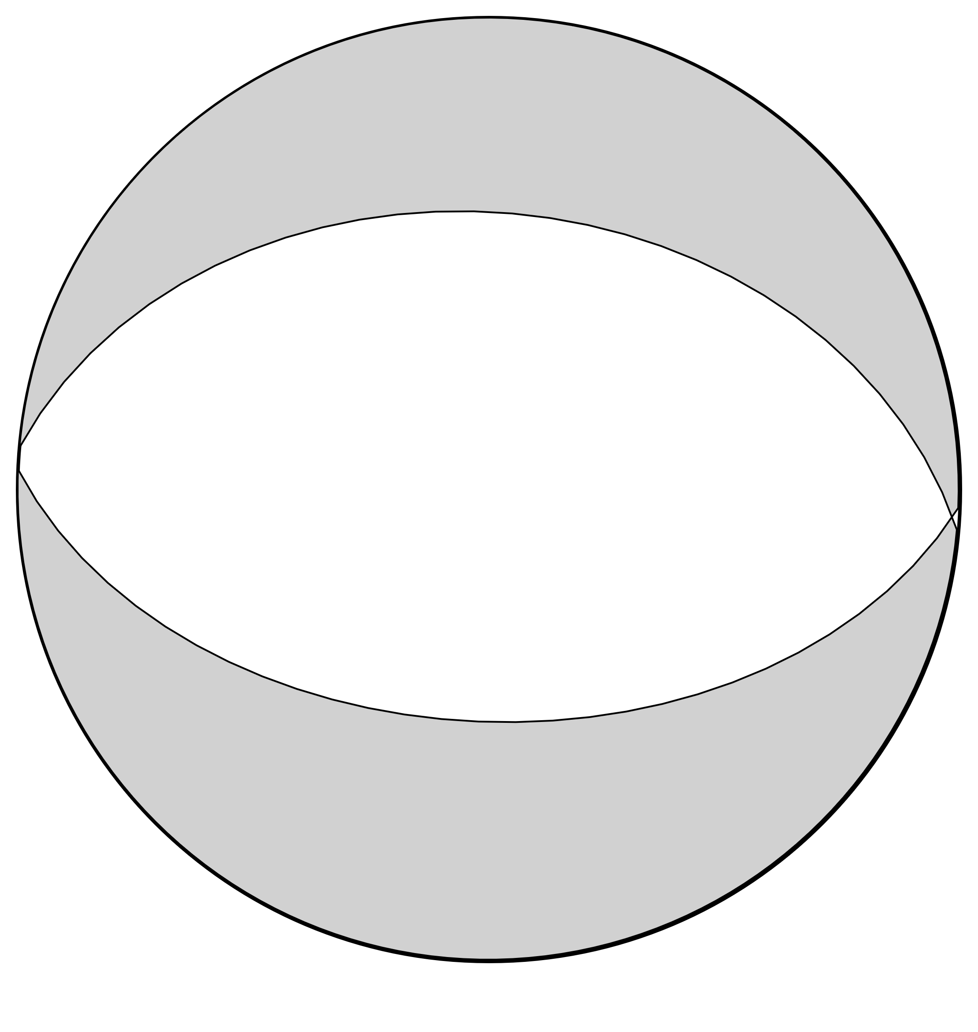
CPPT | 6.7 | 10 | 290 | 26 | -58 | 76 | 68 | -104 | 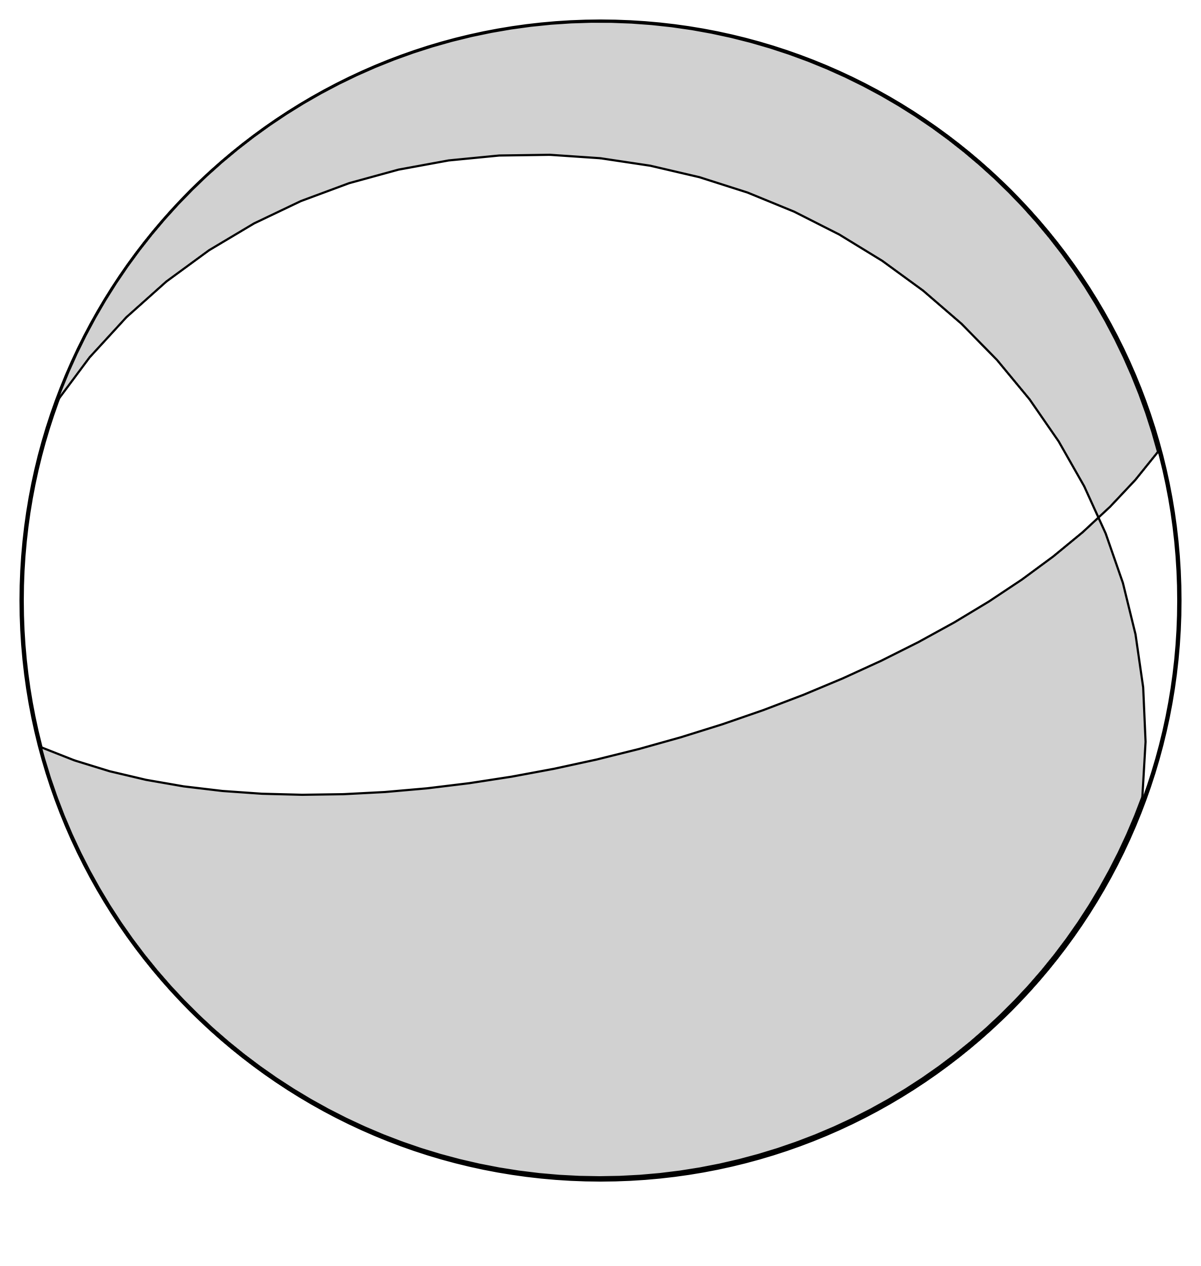
GCMT | 6.6 | 12 | 275 | 36 | -85 | 89 | 54 | -94 | 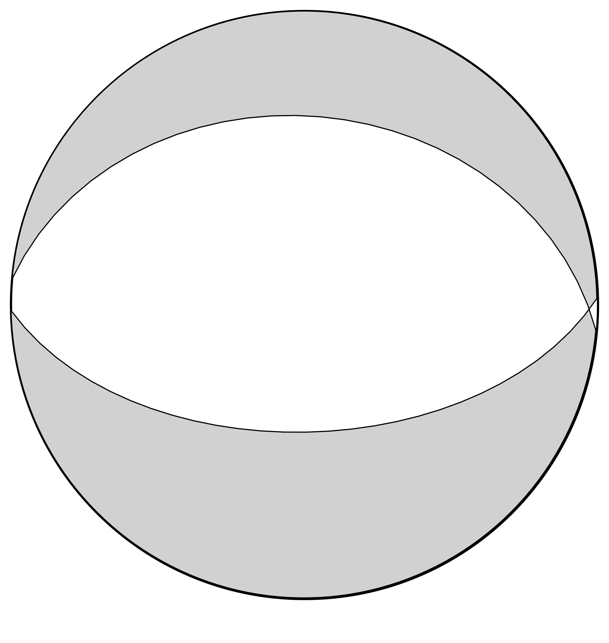
GFZ | 6.6 | 11 | 270 | 56 | -94 | 98 | 35 | -82 | 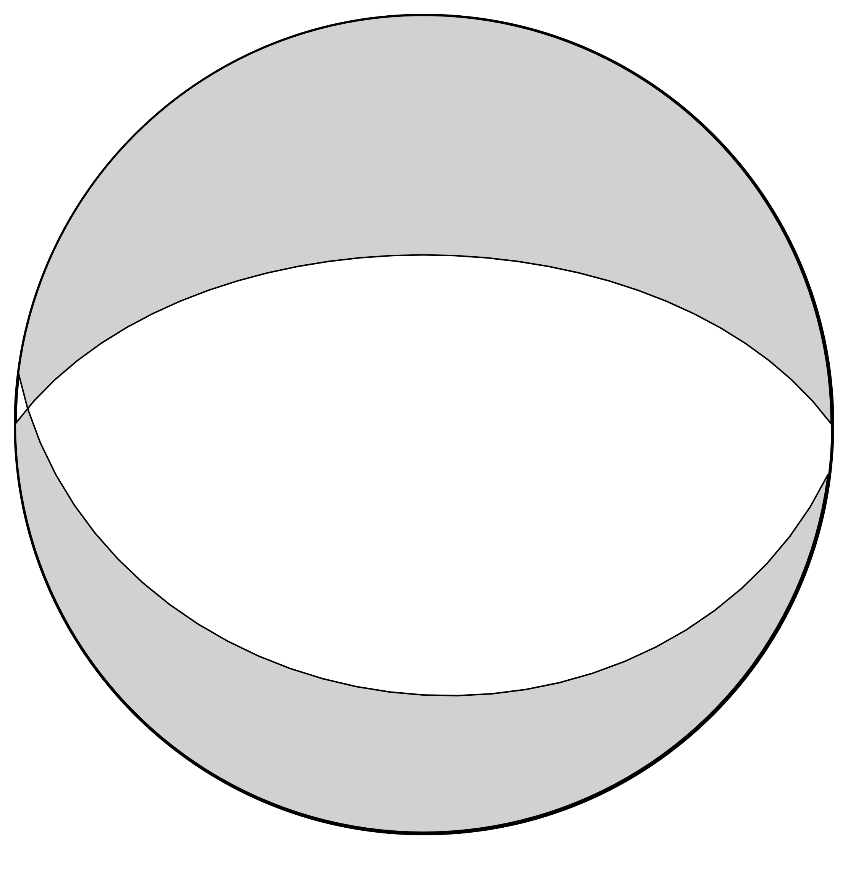
INGV | 6.7 | 11 | 296 | 49 | -55 | 68 | 52 | -124 | 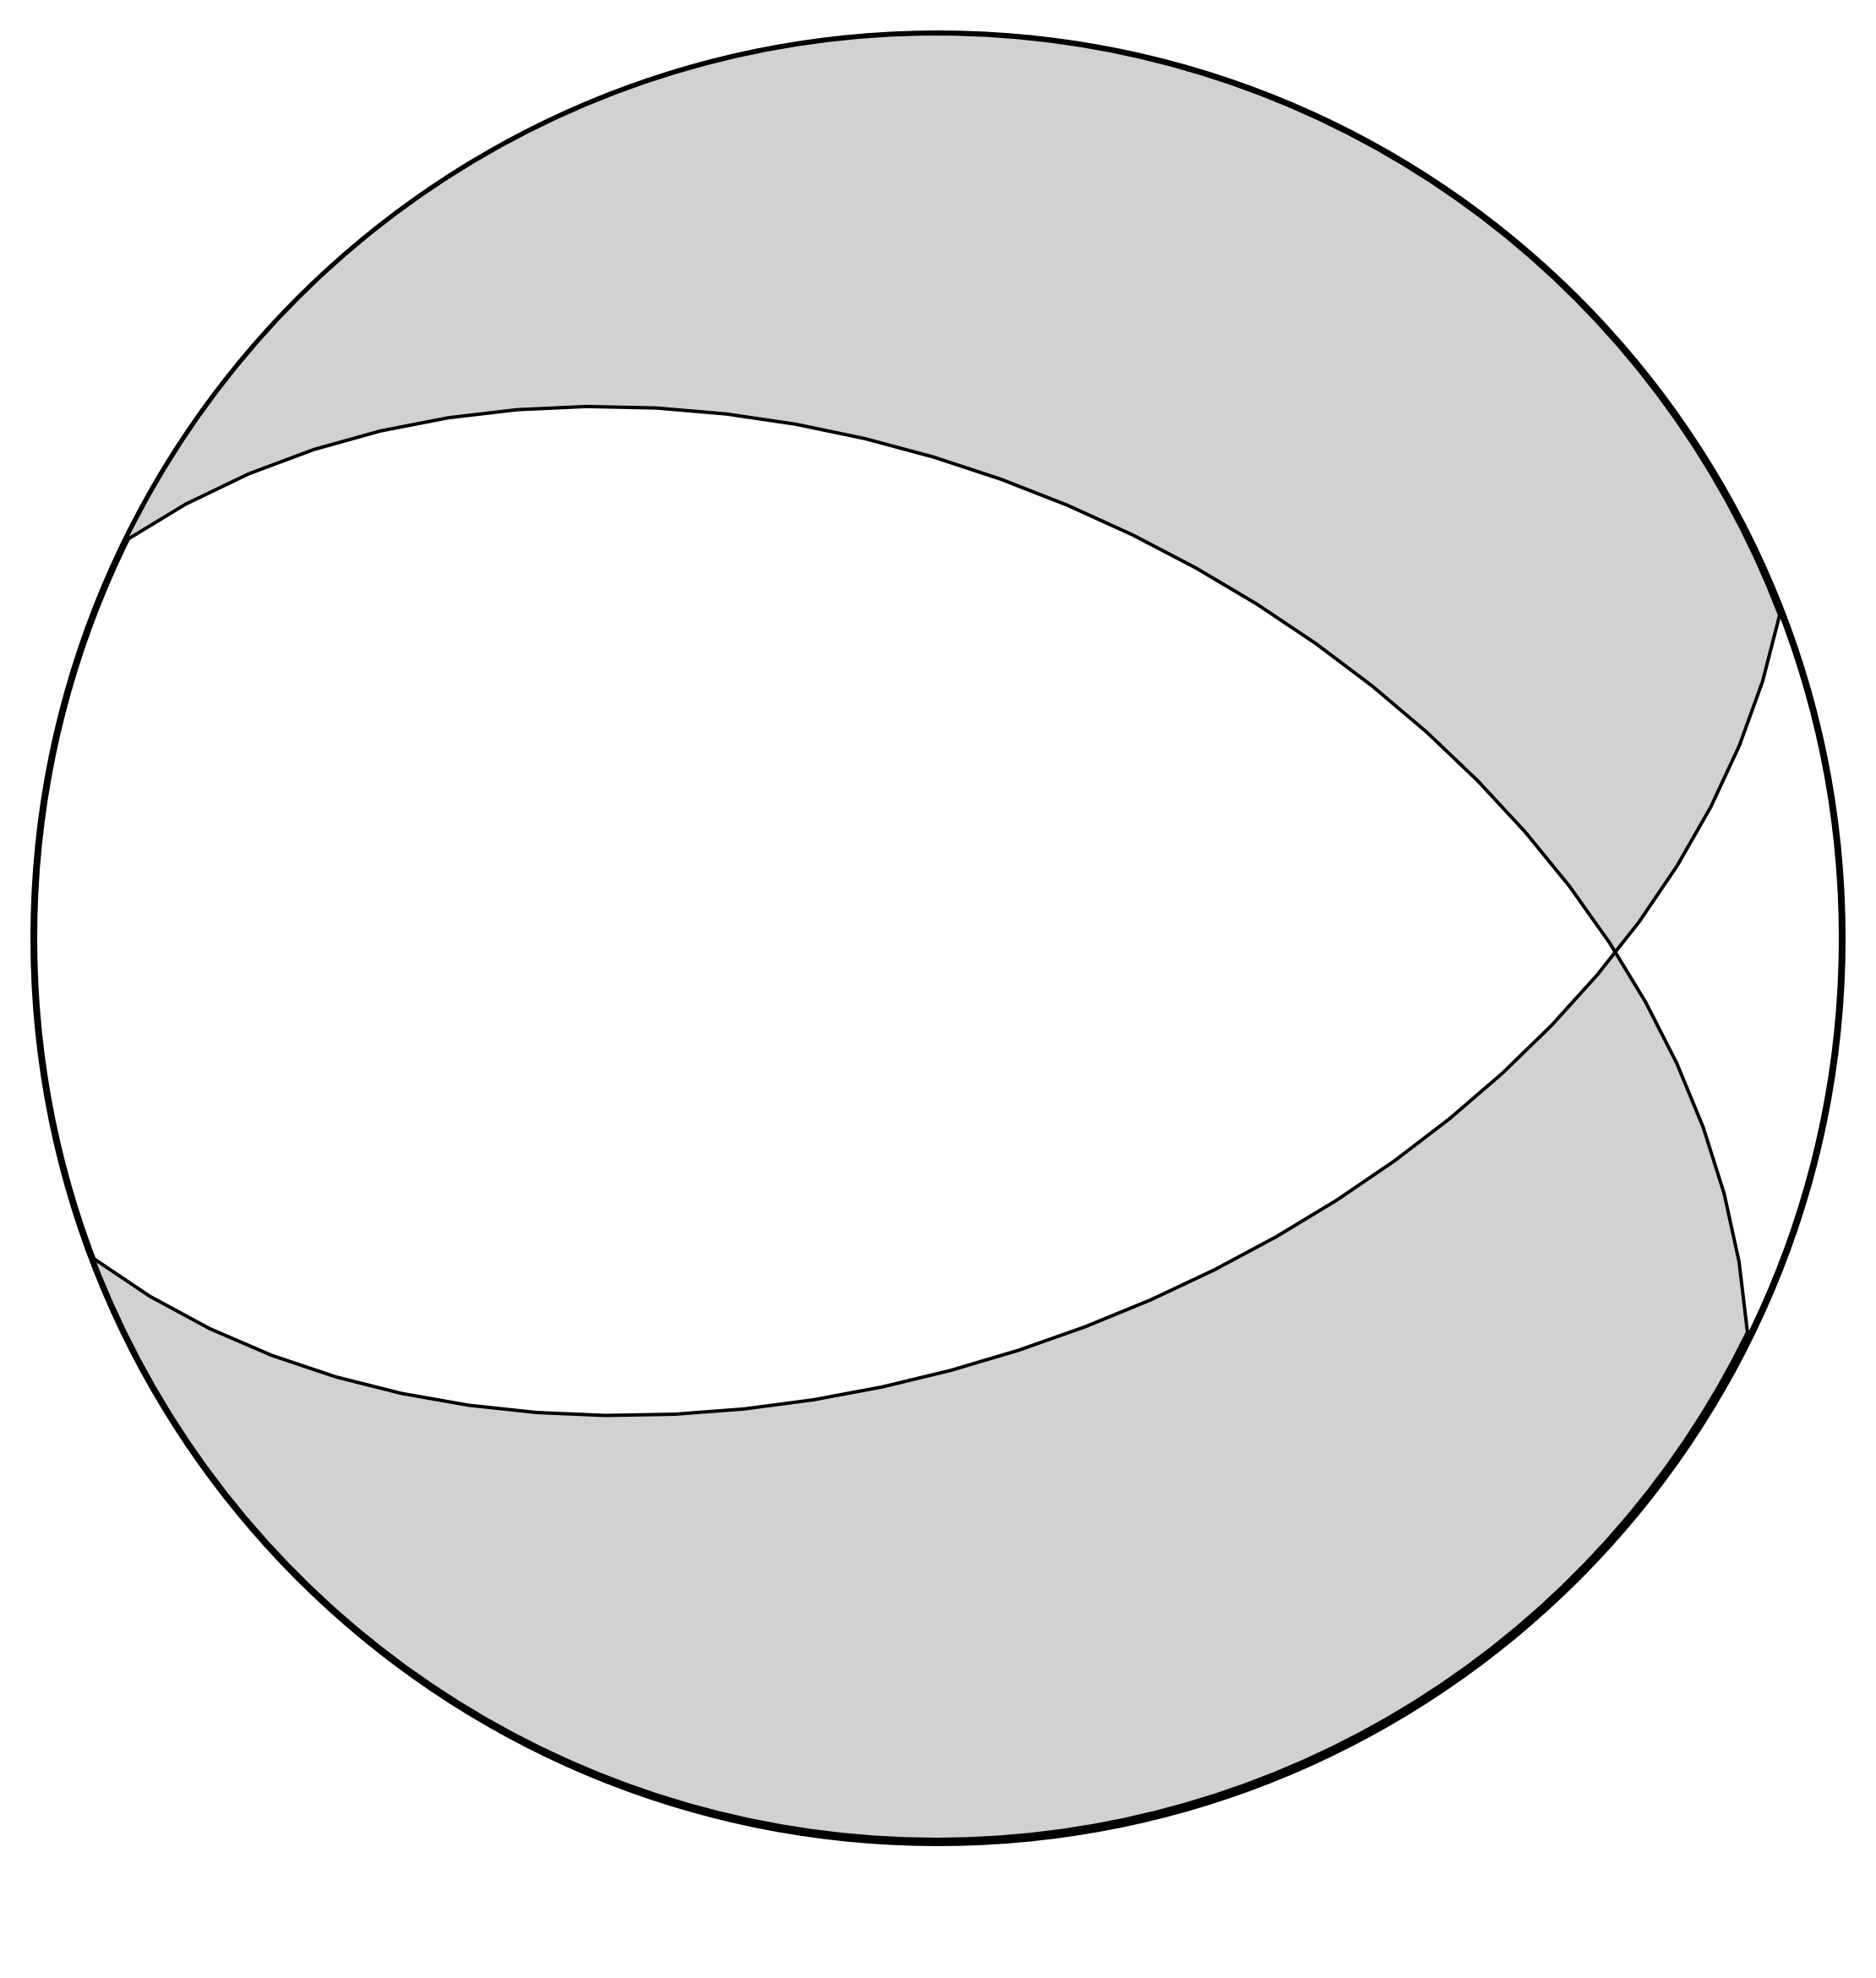
IPGP | 6.6 | 9 | 284 | 32 | -71 | 82 | 60 | -102 | 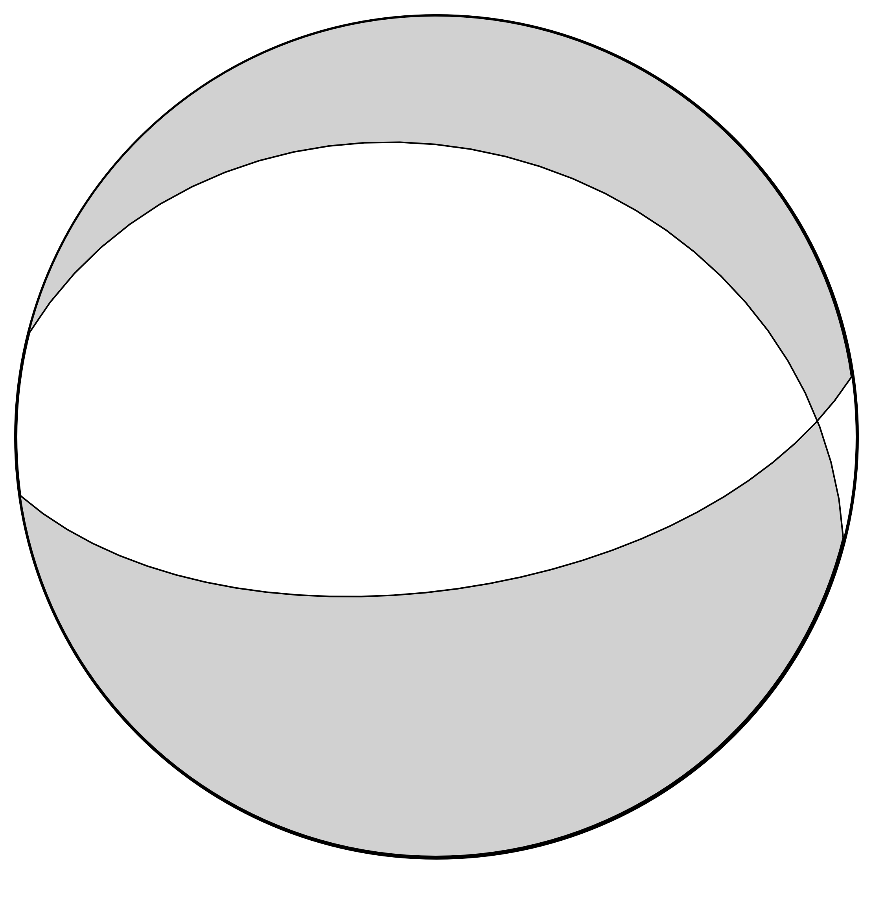
KOERI | 6.6 | 6 | 286 | 53 | -72 | 78 | 40 | -112 | 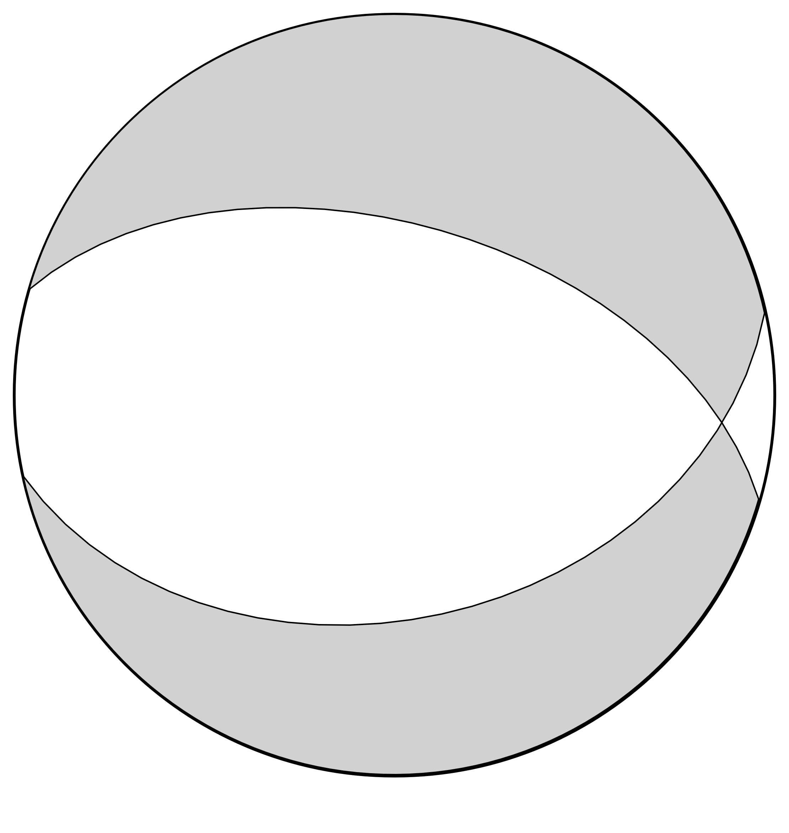
NOA | 6.6 | 6 | 265 | 43 | -102 | 102 | 48 | -79 | 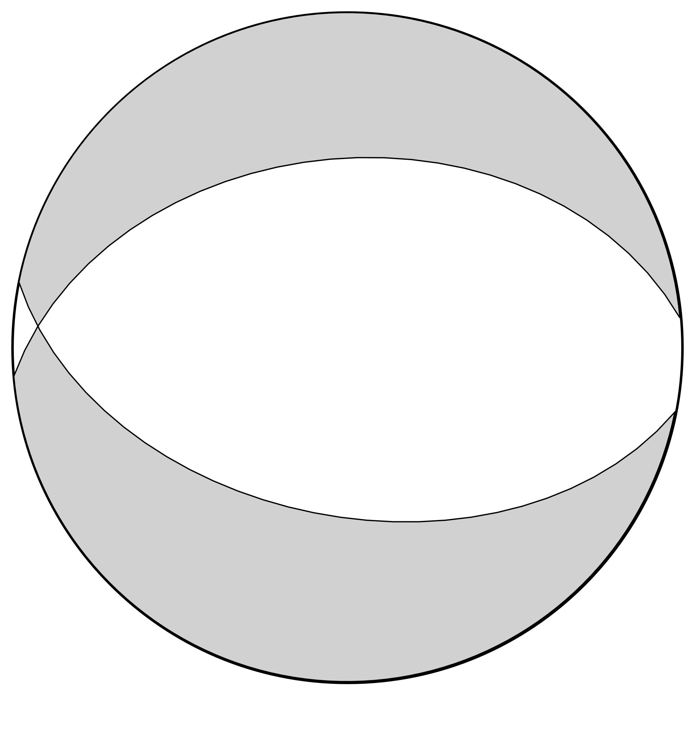
UOA | 6.6 | 11 | 267 | 38 | -110 | 112 | 55 | -75 | 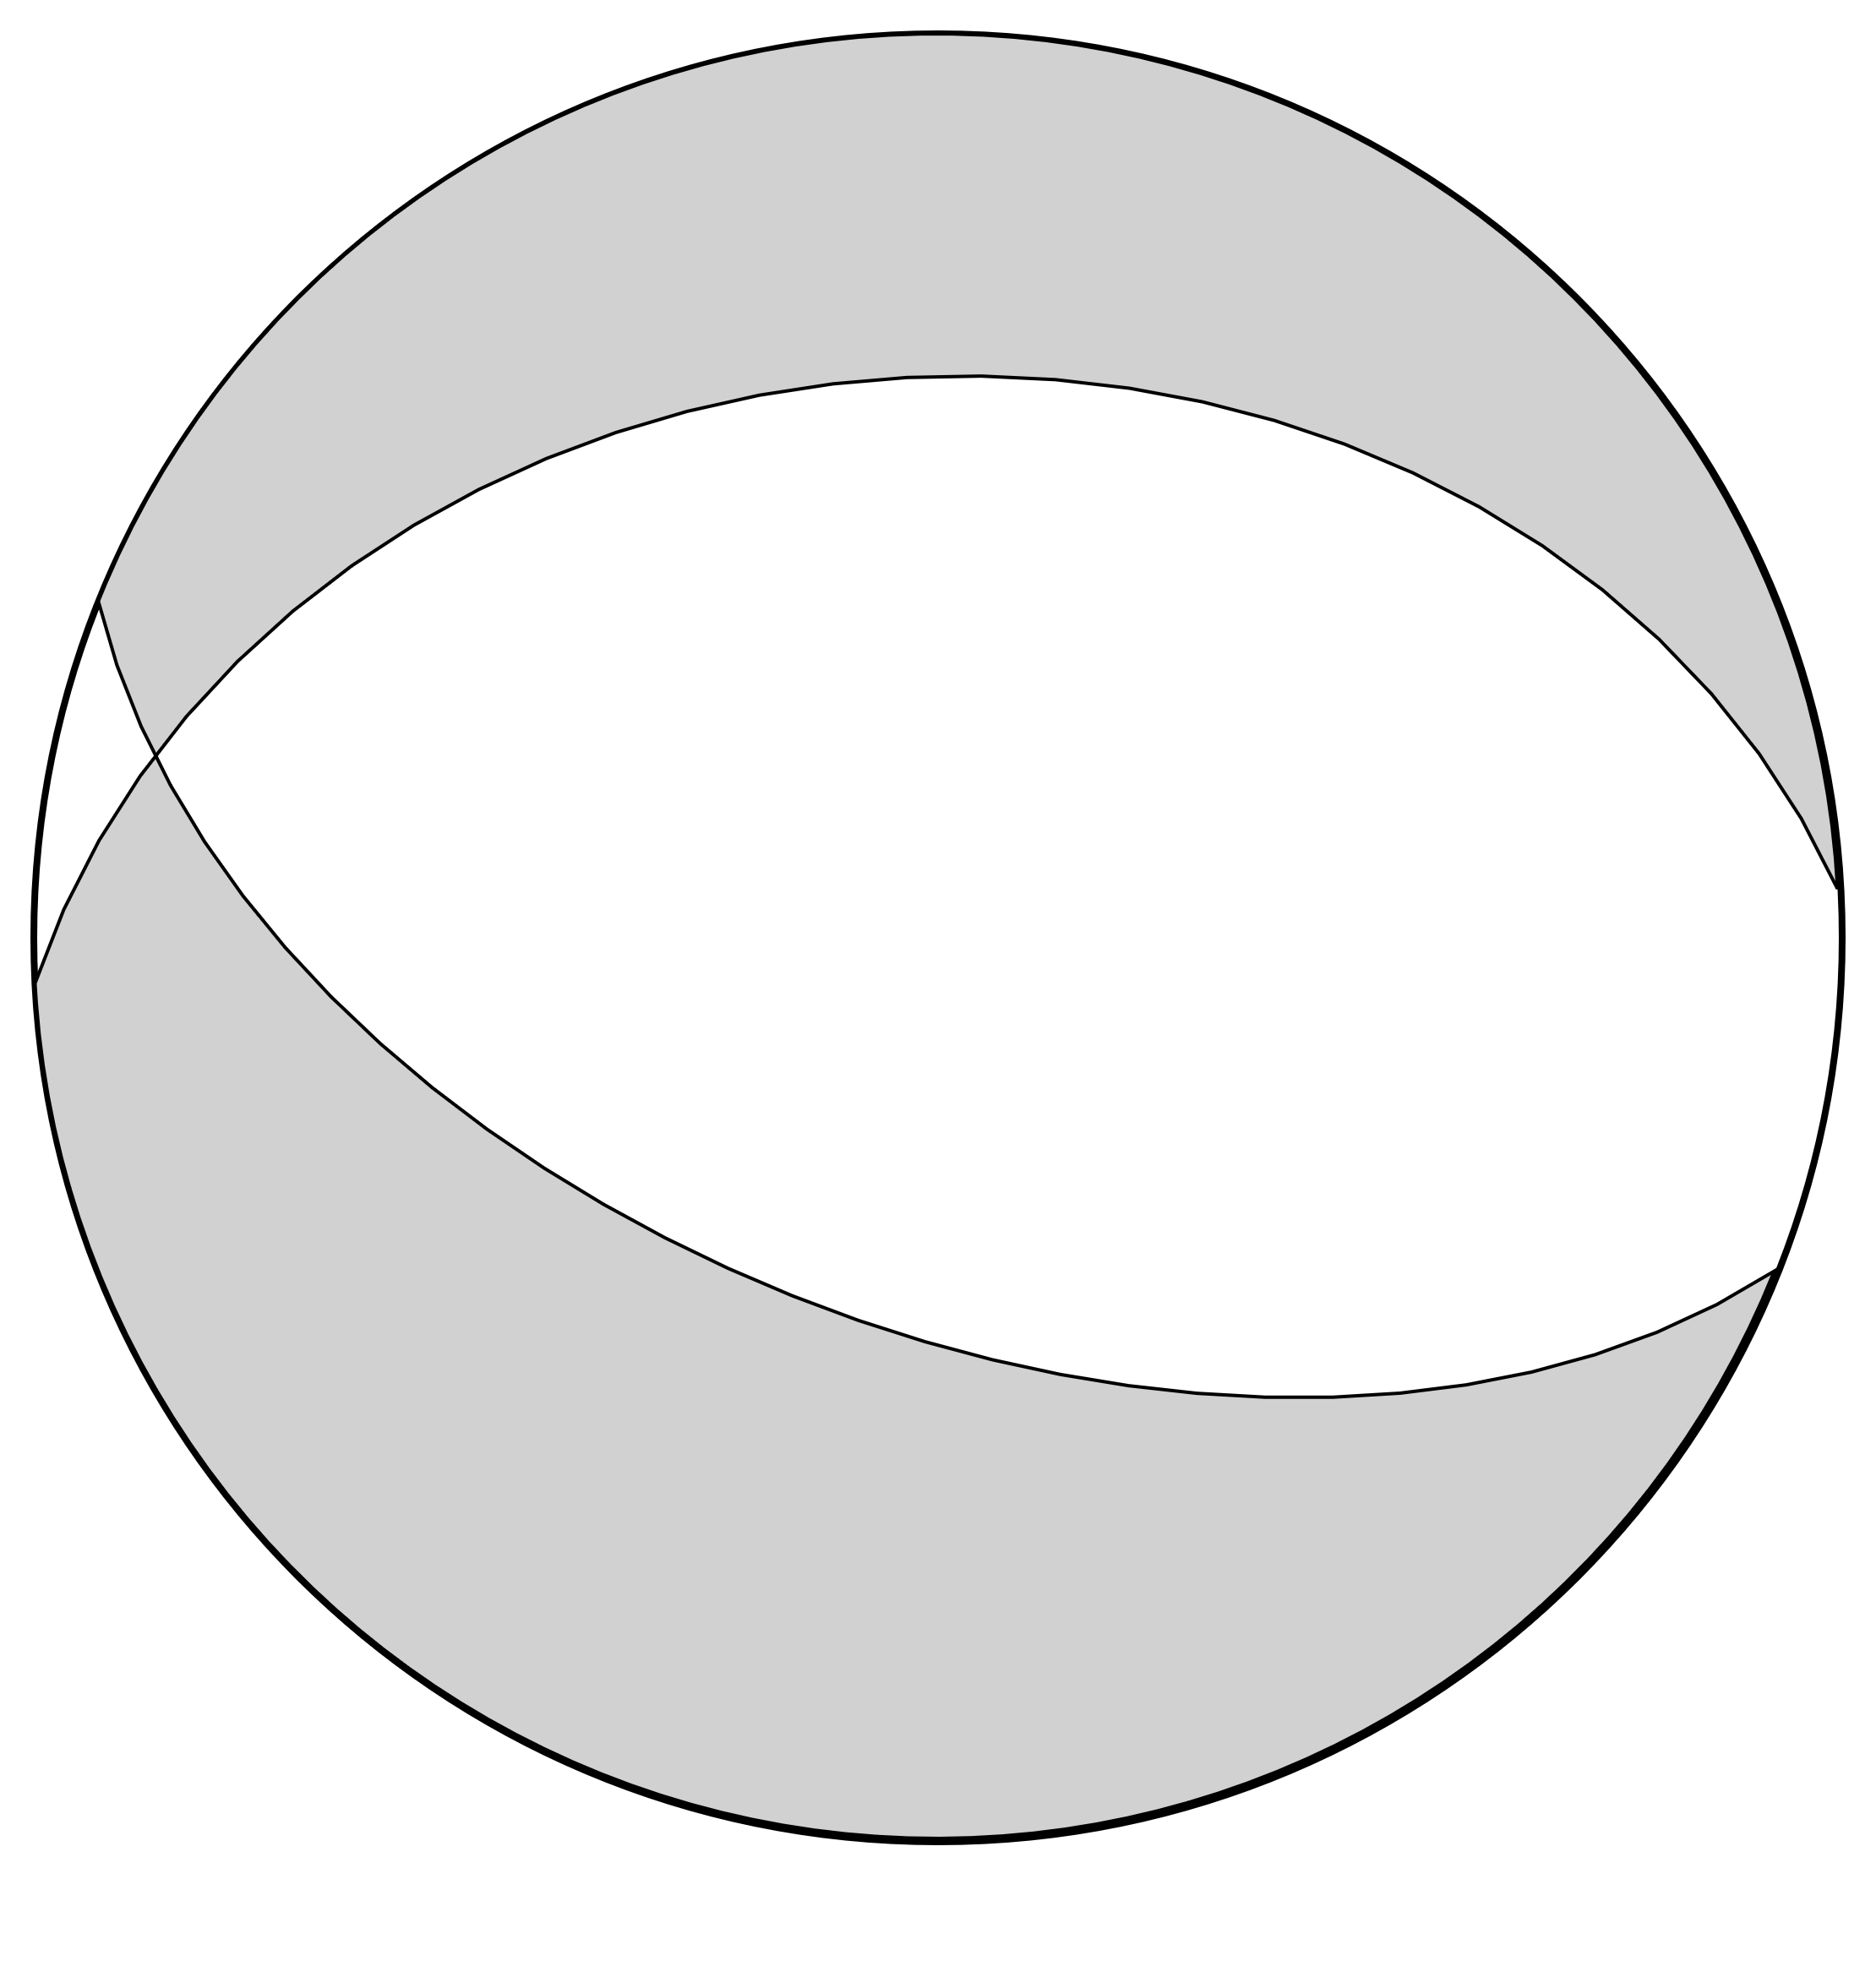
USGS | 6.6 | 11.5 | 285 | 39 | -73 | 84 | 53 | -103 | 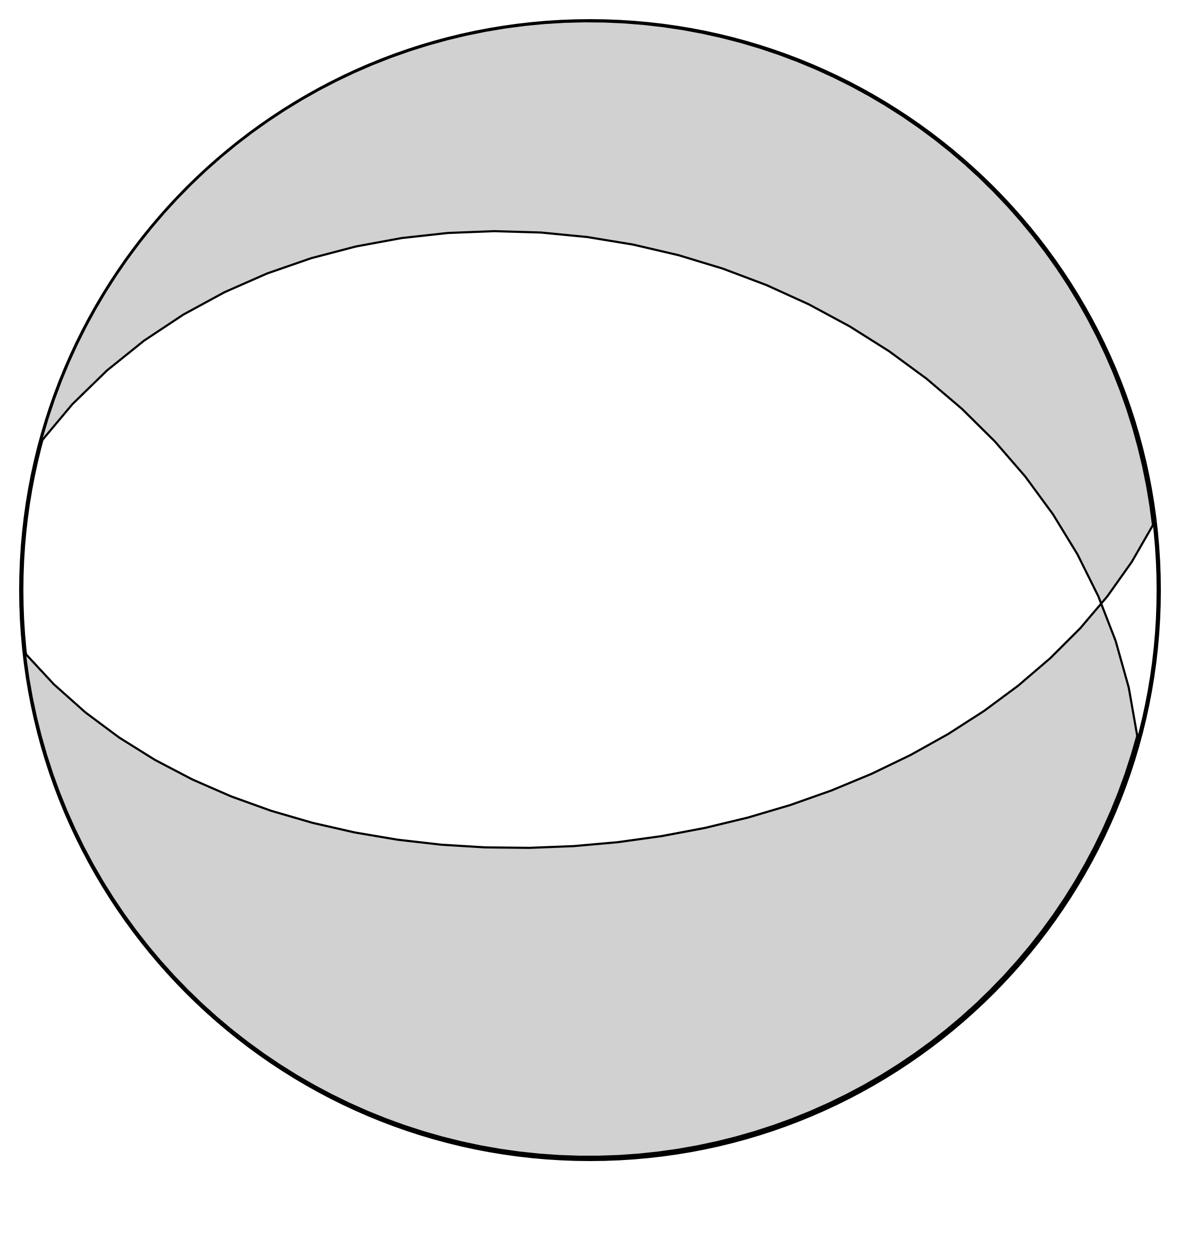
This Study | 6.5 | 8 | 295 | 35 | -60 | 80 | 60 | -109 | 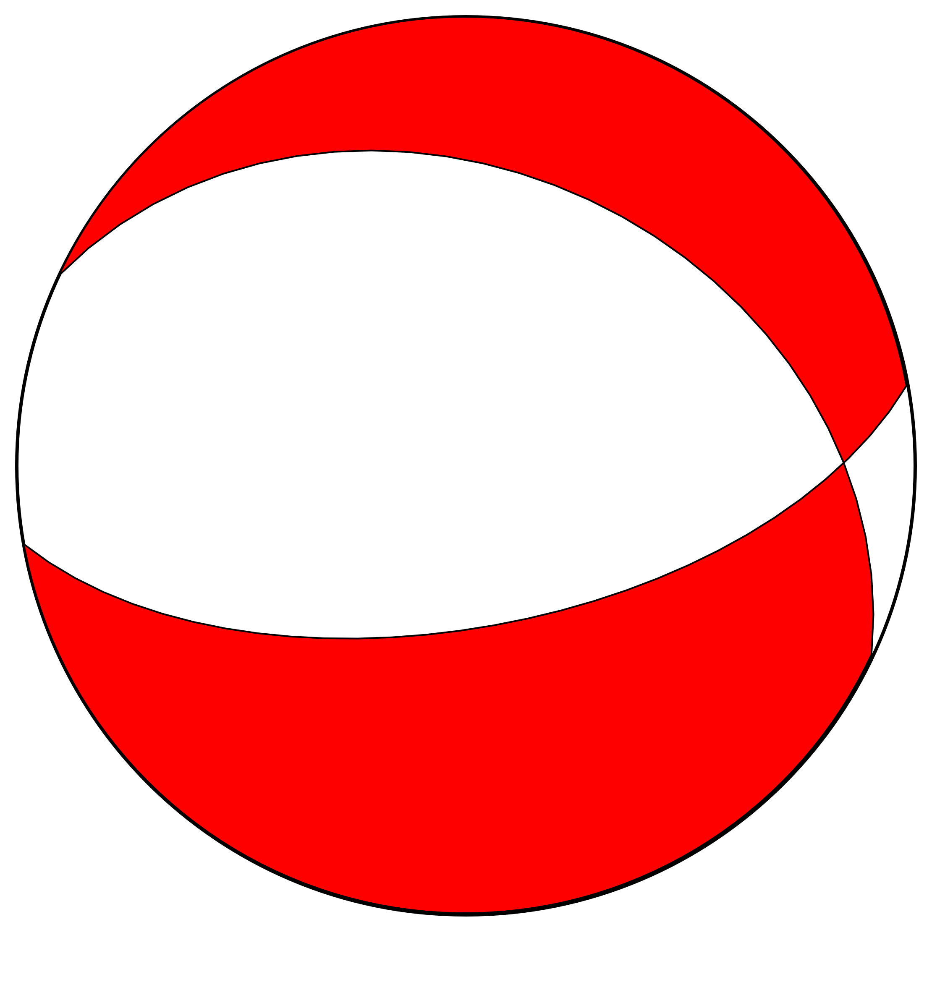
Solutions reported by the agencies have been obtained from The European-Mediterranean Seismological Center (EMSC).
AUTH: Aristotle University of Thessaloniki; CPPT: French Polynesian Tsunami Warning Center; GCMT: The Global Centroid-Moment-Tensor (CMT) Project; GFZ: German Research Center for Geosciences; INGV: National Institute of Geophysics and Volcanology; IPGP: Paris Institute of Earth Physics; KOERI: Boğaziçi University Kandilli Observatory and Earthquake Research Institute; NOA: The Geodynamic Institute and the National Observatory of Athens; UOA: University of Athens; USGS: United States Geological Survey

