Hydrogen bonding propagated phase separation in quasi-epitaxial single crystals: a Pd-Br molecular insulator

Takefumi Yoshida,*^{a,!} Shinya Takaishi,*ª Laurent Guérin,^{b} Tatsuhiro Kojima,^{c} Hiroyoshi Ohtsu,^{d} Masaki Kawano,^{d} Tatsuya Miyamoto,^{e} Hiroshi Okamoto,^{e} Kenichi Kato,^{f} Masaki Takata,^{g} Yuka Hosomi,^{h} Shoji Yoshida,^{h} Hidemi Shigekawa,^{h} Hisaaki Tanaka,^{i} Shin-ichi Kuroda,^{i} Hiroaki Iguchi,ª Brian K. Breedlove,ª Zhao‐Yang Li^{j} and Masahiro Yamashita*^{j,a}

aDepartment of Chemistry, Graduate School of Science, Tohoku University, 6-3 Aramaki-Aza- Aoba Aoba-ku, Sendai, Miyagi, Japan
bInstitut de Physique de Rennes, Université de Rennes 1, 263 Av. du Général Leclerc, 35042, Rennes cedex, France
cDepartment of Chemistry, Graduate School of Science, Osaka University, Toyonaka, Osaka, 560-0043, Japan
dDepartment of Chemistry, School of Science, Tokyo Institute of Technology, 2-12-1 Ookayama, Meguro-ku, Tokyo, 152-8550, Japan
^{e}Department of Advanced Materials Science, Graduate School of Frontier Sciences, The University of Tokyo, Kashiwa 277-8561, Japan
f RIKEN SPring-8 Center, 1-1-1 Kouto, Sayo-cho, Sayo-gun, Hyogo, 679-5148, Japan
gInstitute of Multidisciplinary Research for Advanced Materials, Tohoku University, 2-1-1 Katahira, Aoba-ku, Sendai, Japan
^{h}Faculty of Pure and Applied Sciences, University of Tsukuba, Tsukuba 305-8573, Japan
^{i} Department of Applied Physics, Graduate School of Engineering, Nagoya, University, Furocho, Chikusa-ku, Nagoya 464-8603, Japan
^{j}School of Materials Science and Engineering, Nankai University, Tianjin 300350, China.

!present address: Innovation Research Center for Fuel Cells, The University of Electro-Communications, Chofu, Tokyo 182-8585, Japan.

!present address: Innovation Research Center for Fuel Cells, The University of Electro-Communications, Chofu, Tokyo 182-8585, Japan.

Table S1. Crystal data of 1.
 | 1
Temperature / K | 93
formula | C₁₀H₂₄ Br₃N₄Pd
crystal system | Orthorhombic
space group | I222
a / Å | 5.2223(4)
b / Å | 6.9660(5)
c / Å | 22.6349(17)
V / Å³ | 823.42(11)
Z | 2
R₁ (I > 2σ (I)) | 1.74%
wR₂ (I > 2σ (I)) | 3.85%
Flack parameter | 0.05 (3)

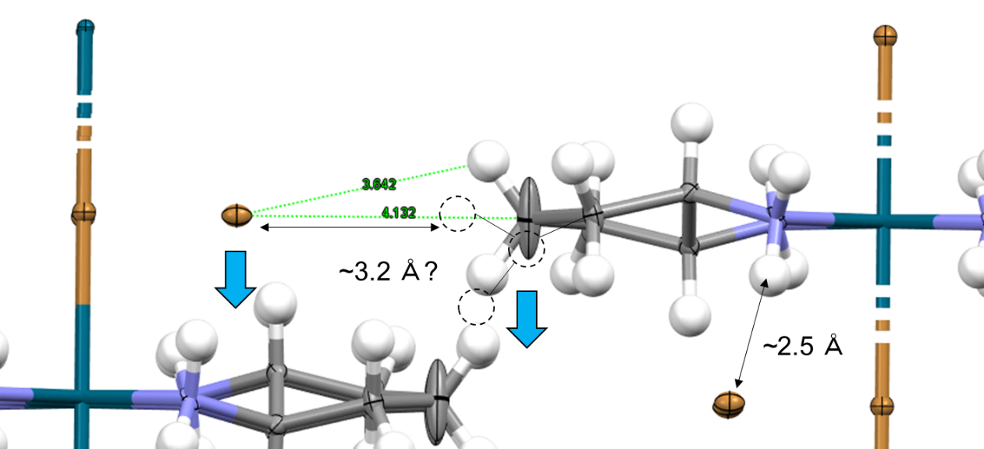
Fig. S1. Crystal structure of 1 at 93 K. C–H···Br···H–C hydrogen bonding.

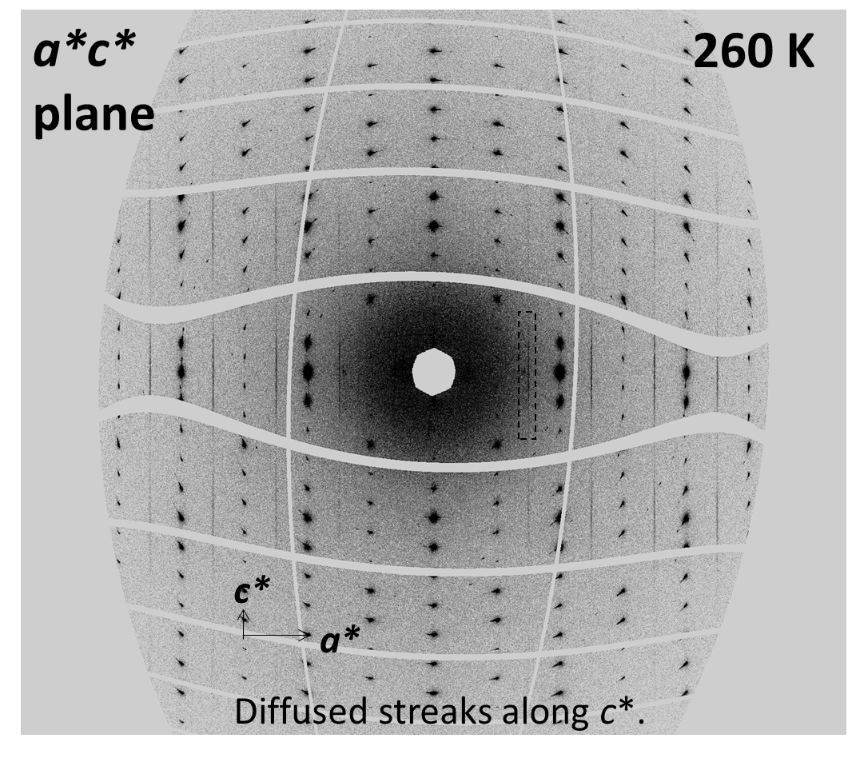
Fig. S2. Reconstructed diffraction image and Diffused streaks of 1 along c* at 260 K.

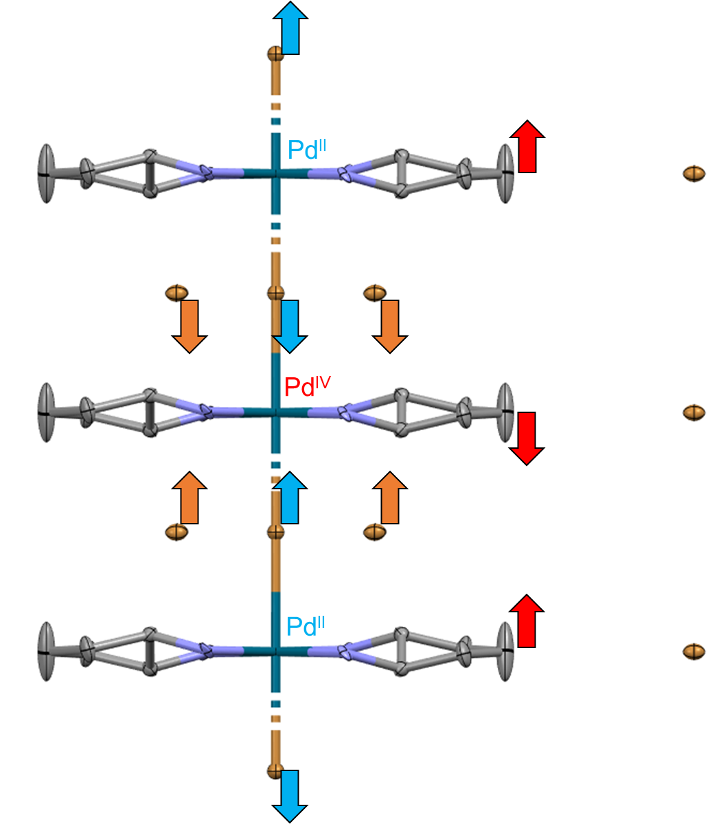
Fig. S3. Crystal structure of 1 in the CDW state (RT).

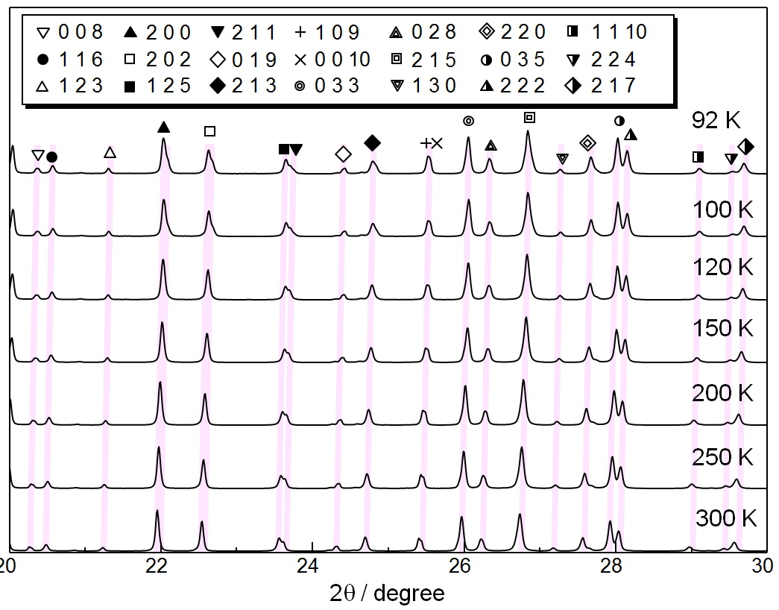
Fig. S4. Synchrotron powder X-ray diffraction pattern (PXRD) of 1 at various temperatures.

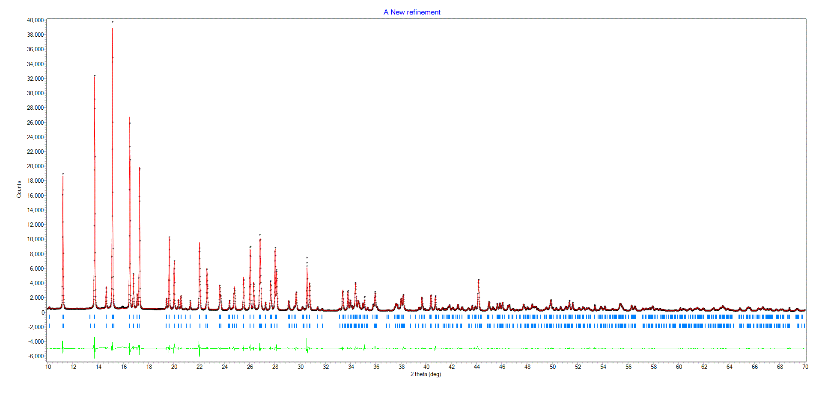
Fig. S5. The results of two-phase Le Bail fitting for synchrotron powder X-ray diffraction pattern of 1 at 92 K.
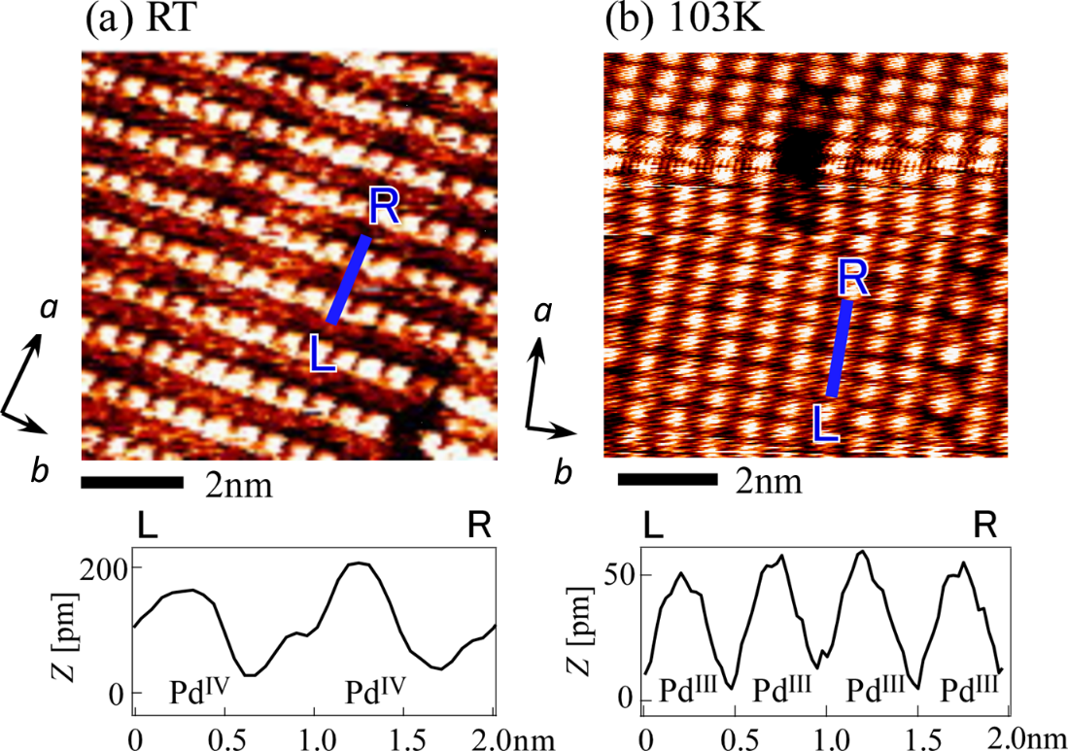
Fig. S6. STM images of 1 at (a) RT (CDW) (b) 103 K (MH).

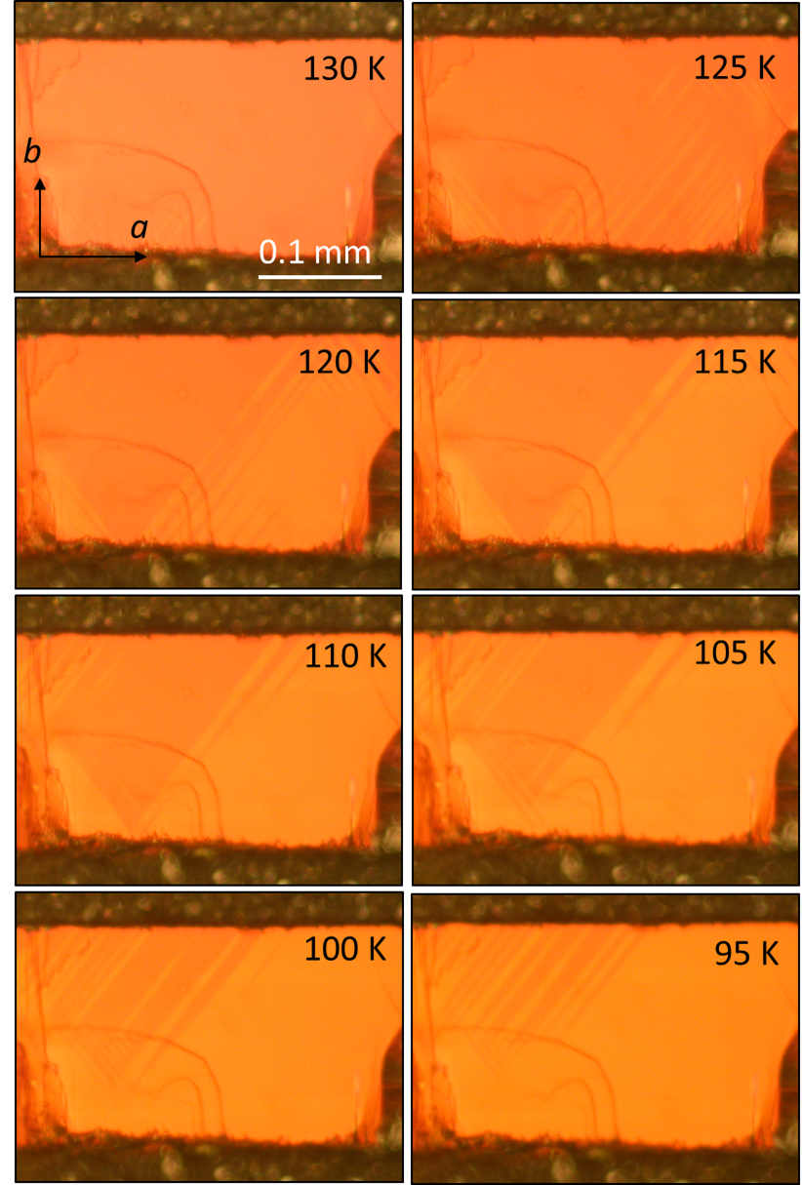

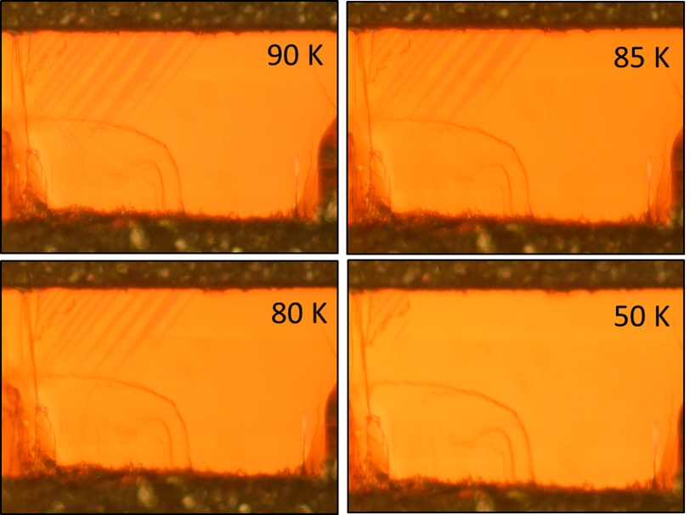
Fig. S7. Images of a single crystal of 1 at various temperatures.

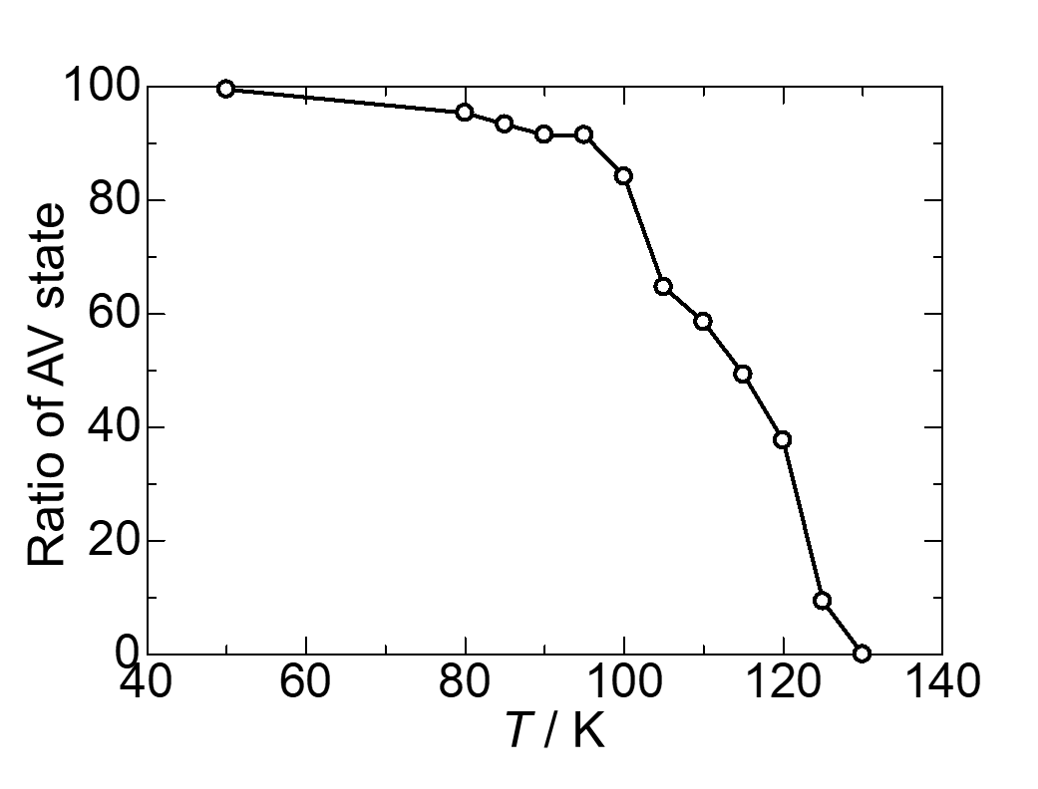
Fig. S8. Ratio of the AV-MH state of 1 at various temperatures.

To check the population of the domain inside of crystal, we studied the diffraction parttterns, including diffuse scattering of exactly same crystal of movie 2, 3 (135 K), integrated equivalence diffraction and diffuse scattering (integrate as spot), averaged intensity of Bragg diffraction (I_{B}), and diffuse scattering (I_{D}) and calculated I_{D}/I_{B} value to ignore scaling on each crystal position. (When we integrated by (2a, b, c) unitcell (superlattice), (h = odd, k, l) is correspond to Bragg spots (i_{B}), whereas (h = even, k, l) is correspond to diffuse scattering (i_{D}). I = $(\sum{{i_{n})}/n}$). As the results, top: (I_{D}, I_{B}, I_{D}/I_{B}) = (16.6, 9465, 0.18); bottom: (I_{D}, I_{B}, I_{D}/I_{B}) = (4.15, 3397, 0.12) at RT. However, top: (I_{D}, I_{B}, I_{D}/I_{B}) = (0.40, 5866, 0.007); bottom: (I_{D}, I_{B}, I_{D}/I_{B}) = (5.3, 5801, 0.09) at 100 K. At RT, I_{D}/I_{B} values were slimier to each position because the crytal only had a CDW domain. In contrast, at 100 K, decrease in the I_{D}/I_{B} value at the top (96% off) was much larger than that at the bottom (25% off). These results indicate that domain (not only surface but also the interior) at the top is mainly in an MH state, whereas the bottom is still in a CDW state. The result is consistent with the results of movie. Therefore, the possibility of phase separation along the c axis can be excluded.
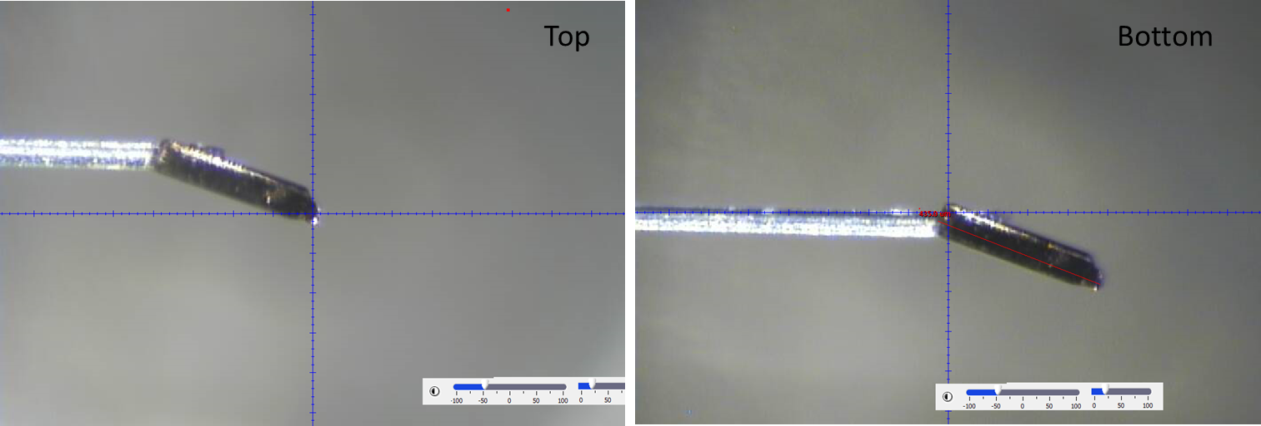
Fig. S9. Images of single a crystal of 1.

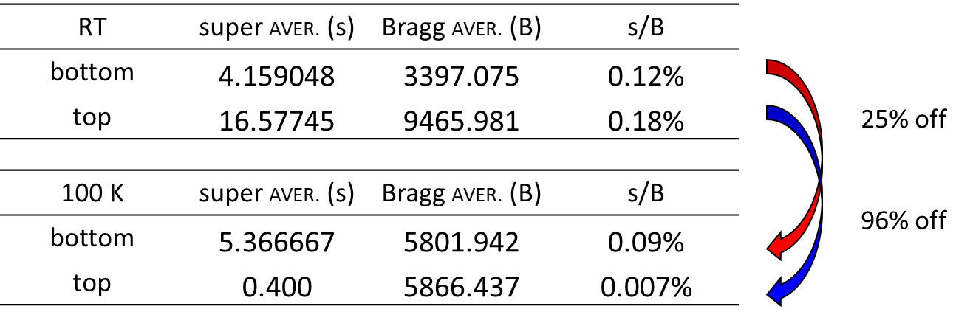
Table S2. Integrate equivalence diffraction and diffuse scattering.

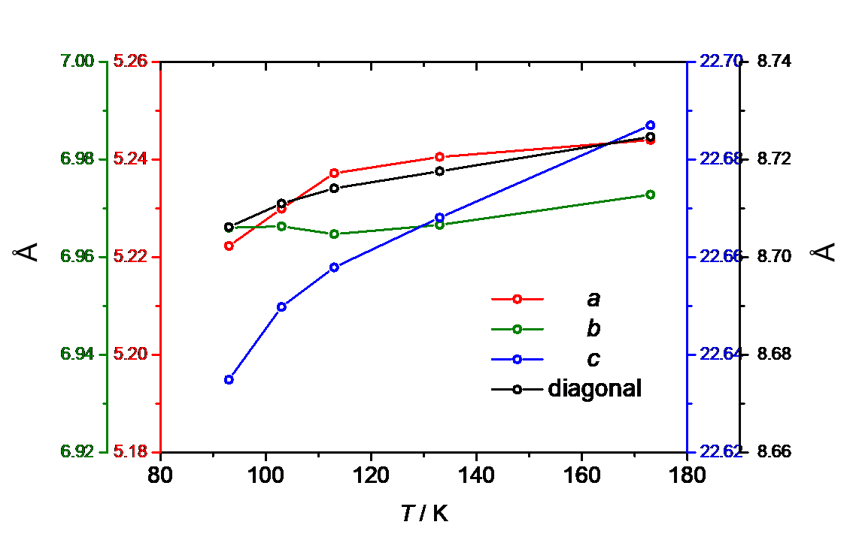
Fig. S10. Unit cell parameters for 1 at various temperatures (diagonal = (a² + b²)^{1/2}).

Equations S1

100 μm / (a = ~5 Å or b = ~7 Å) = 2.0 × 10⁴ units or 2.0 × 10⁴ units.

10 μm / (c= ~22 Å) = 4.5 ×10³ units.

|Δa| × 2.0 × 10⁴ units = 0.24 μm, |Δb| × 2.0 × 10⁴ units = 0.14 μm, |Δc| × 4.5 × 10³ units = 7.2 nm

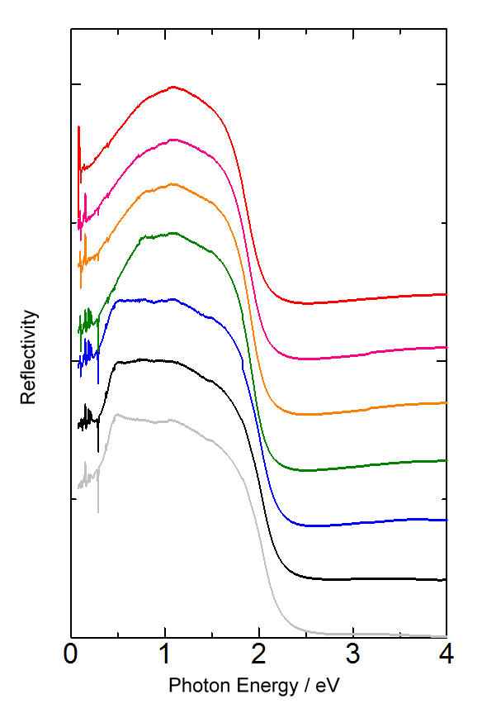
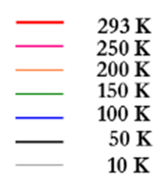
Fig. S11. Reflectivity spectra of 1 at various temperatures.

Fig. S12. χ vs. T plots for 1.

