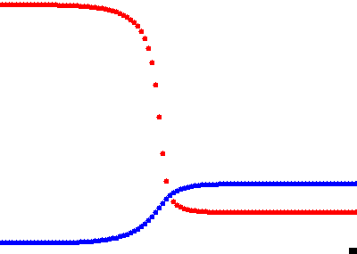 | 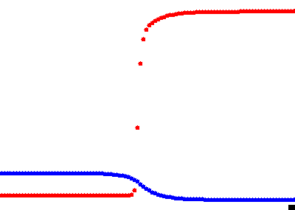
β=10, D_{u}=0.02 (T=50) | β=18, D_{u}=0.02 (T=50)
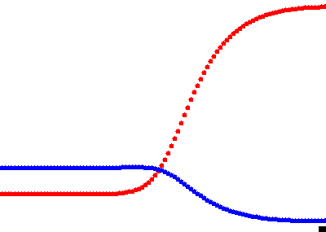 | 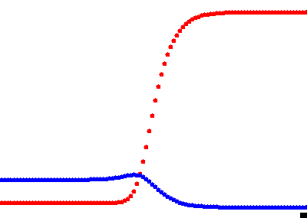
β=10, D_{u}=1 (T=10) | β=18, D_{u}=1 (T=10)
Supplementary Fig. 2A: Original model with f₁(u) and g₁(u). red: u(x,t) (CIN); blue: v(x,t) (DA). Other parameters: A=4.2, σ=0.75, κ=1.5, γ=4.7, D_{v}=1. Length of simulation in time units is indicated in parentheses.

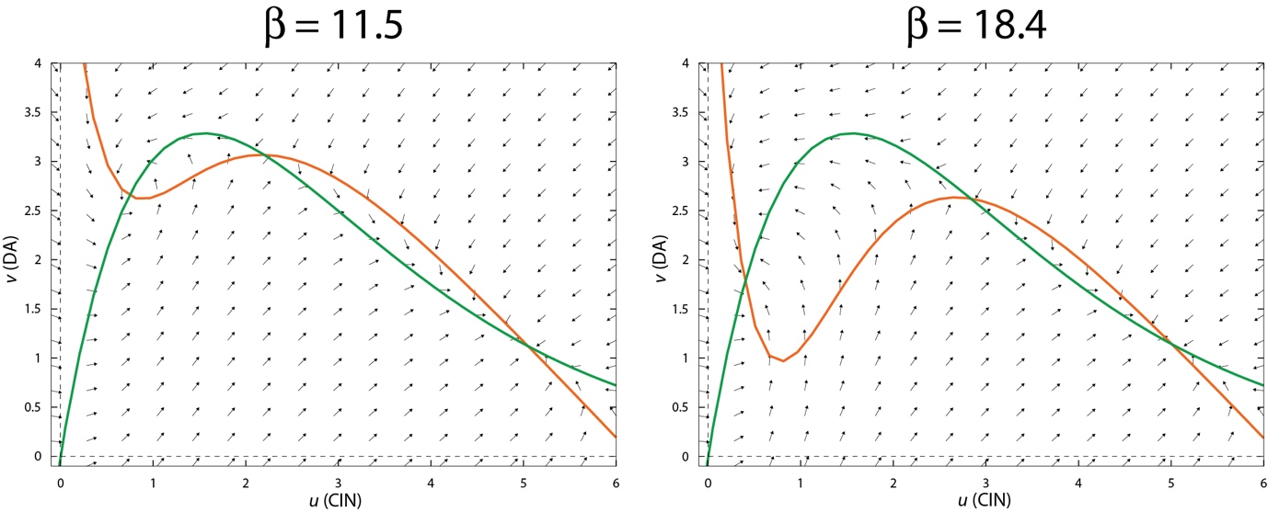
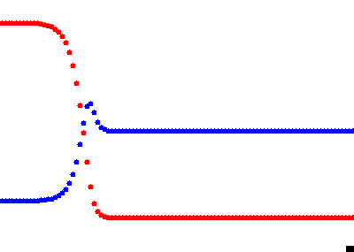 | 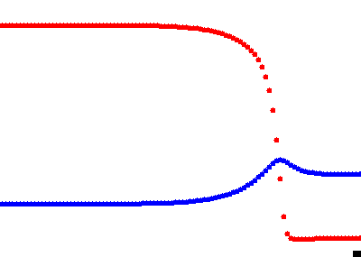
β=11.5, D_{v}=0 (T=300) | β=18.4, D_{v}=0 (T=100)
Supplementary Fig. 2B: Original model with f₁(u) and g₁(u) with D_{v}=0. red: u(x,t) (CIN); blue: v(x,t) (DA). Other parameters: A=6.2, σ=0.43, κ=1.5, γ=13.4, D_{u}=0.1. Length of simulation in time units is indicated in parentheses.

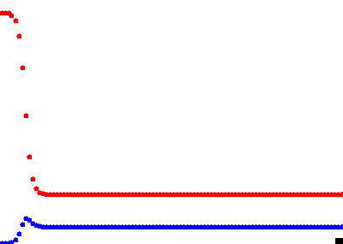 | 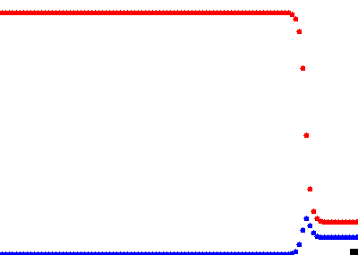
b=0.435 | b=0.7
Supplementary Fig. 3: Tractable model with f₂(u) and g₂(u) and D_{v}=0. red: u(x,t) (CIN); blue: v(x,t) (DA). Other parameters: a=0.3, s=0.2, D_{u}=0.01.

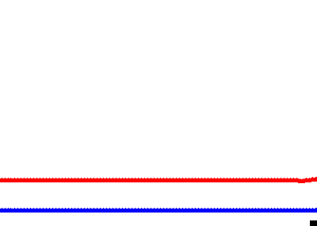
Supplementary Fig. 4: Turing instability in tractable model with f₂(u) and g₂(u). red: u(x,t) (CIN); blue: v(x,t) (DA). Other parameters: a=0.3, b=0.435, s=0.2, D_{u}=0.06, D_{v}=1 .

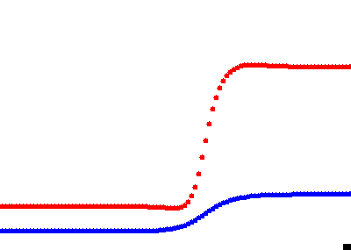 | 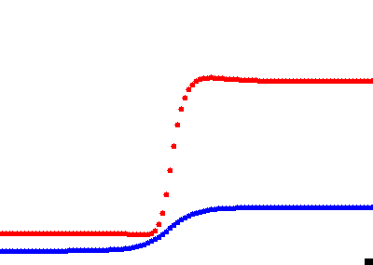
β=13.5 | β=15.5
Supplementary Fig 5. Full model with f₁(u) and g₁(u) with σ=0.1. red: u(x,t) (CIN); blue: v(x,t) (DA). Other parameters: A=4.3, κ=1.5, γ=4.7, D_{u}=0.2, D_{v}=1.

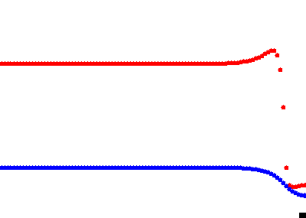 | 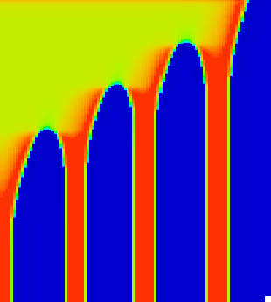
D_{u}=0.01
 | 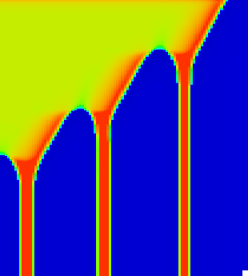
D_{u}=0.015
 | 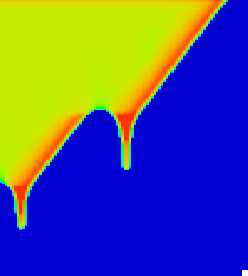
D_{u}=0.02
Supplementary Fig. 6: Stable and unstable Turing patterns in full model with f₁(u) and g₁(u). red: u(x,t) (CIN); blue: v(x,t) (DA). Other parameters: A=4.3, β=16.2, σ=0.1, κ=1.5, γ=5, D_{v}=1.

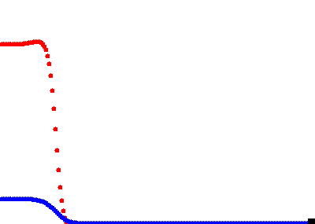 | 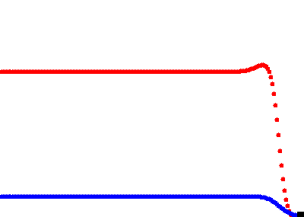
s=0.1 | s=0.25
Supplementary Fig 7. Tractable model with f₃(u) and g₃(u). red: u(x,t) (CIN); blue: v(x,t) (DA). Other parameters: b=0.14, D_{u}=0.1, D_{v}=1.

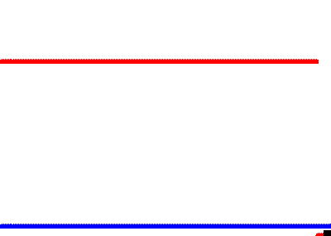 | 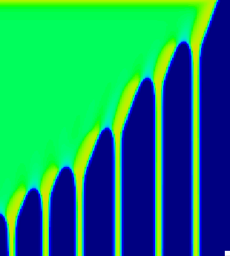
D_{u}=0.02
 | 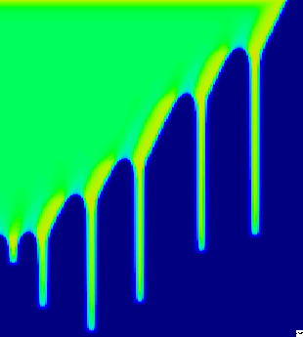
D_{u}=0.022
 | 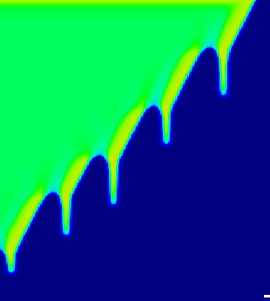
D_{u}=0.024
Supplementary Fig. 8: Stable and unstable Turing patterns in tractable model with f₃(u) and g₃(u). red: u(x,t) (CIN); blue: v(x,t) (DA). Other parameters: s=0.25 b=0.14, D_{v}=1.

