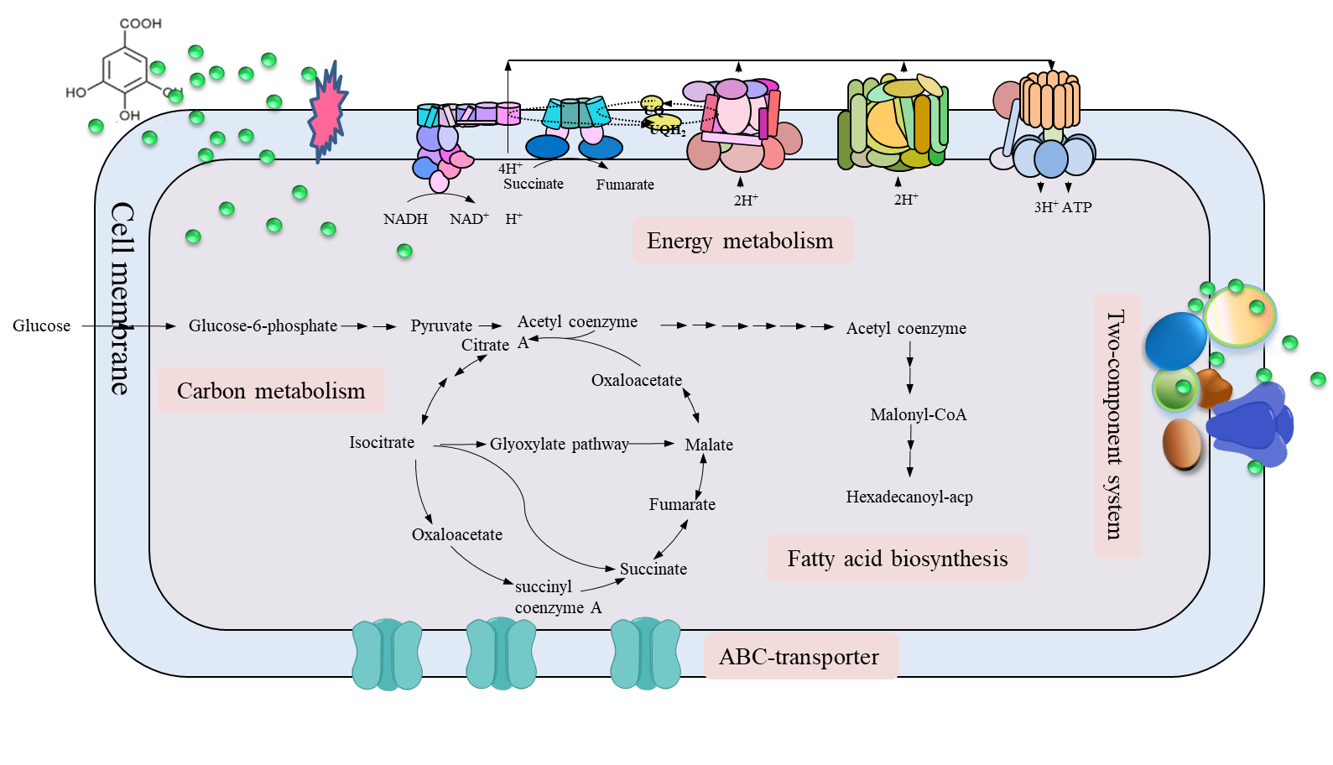
Response mechanism of E. coli under gallic acid stress.

