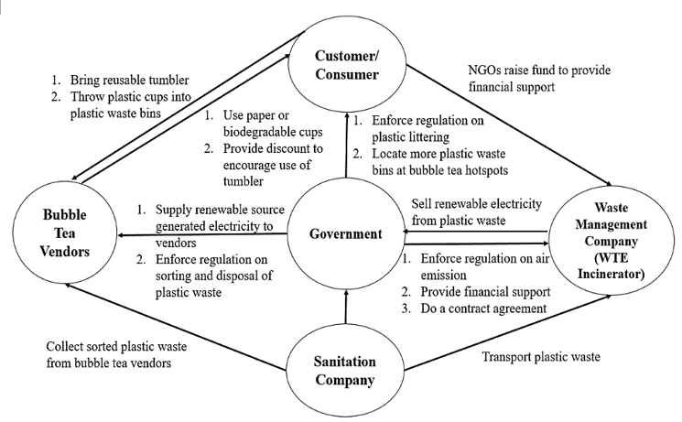
Proposed environmental sustainability framework for plastic waste management in Bubble Tea Streets of Subang Jaya.

