SUPPLEMENTARY MATERIALS
Radiomics and gene expression profile to characterize the disease and predict outcome in patients with lung cancer

Margarita Kirienko^{1,5}, Martina Sollini^{1,2}*, Marinella Corbetta¹, Emanuele Voulaz^{1,2}, Noemi Gozzi², Matteo Interlenghi^{3,4}, Francesca Gallivanone³, Isabella Castiglioni^{3,6}, Rosanna Asselta^{1,2}, Stefano Duga^{1,3}, Giulia Soldà^{1,2}*, Arturo Chiti^{1,2}

- Department of Biomedical Sciences, Humanitas University, Via Rita Levi Montalcini 4, 20090 Pieve Emanuele, Milan, Italy
- IRCCS Humanitas Research Hospital, Via Manzoni 56, 20089 Rozzano – Milan, Italy
- Institute of Molecular Bioimaging and Physiology, National Research Council (IBFM-CNR), Milan, Italy
- DeepTrace Technologies s.r.l., via Conservatorio 17, 20122, Milan, Italy
- Fondazione IRCCS Istituto Nazionale Tumori, Via G. Venezian 1, 20133 Milan, Italy
- University of Milan-Bicocca, Department of Physics “G. Occhialini”, Piazza della Scienza 3, 20126, Milan, Italy

ORCID (alphabetical order)
Asselta: 0000-0001-5351-0619
Castiglioni: 0000-0001-7191-5417
Chiti: 0000-0002-5806-1856
Corbetta: 0000-0002-3774-7760
Duga: 0000-0003-3457-1410
Gallivanone: 0000-0001-6559-6157
Gozzi: 0000-0003-0126-7893
Interlenghi: 0000-0002-3066-4276
Kirienko: 0000-0002-3923-1151
Soldà: 0000-0003-0972-610X
Acknowledgement:
We thank Daniela Pistillo, PhD for her support in accessing and managing biobank data. M. Sollini is supported by the Investigator Grant 2019-23959 funded by AIRC (Italian Association for Cancer Research) won by A.C.

*Corresponding Authors

Martina Sollini, MD PhD
Department of Biomedical Sciences, Humanitas University, Via Rita Levi Montalcini 4, 20090 Pieve Emanuele – Milan, Italy
IRCCS Humanitas Research Hospital, Via Manzoni 56, 20089 Rozzano – Milan, Italy E-mail: martina.sollini@hunimed.eu
ORCID: 0000-0003-2214-6492

Giulia Soldà, PhD
Department of Biomedical Sciences, Humanitas University, Via Rita Levi Montalcini 4, 20090 Pieve Emanuele – Milan, Italy
IRCCS Humanitas Research Hospital, Via Manzoni 56, 20089 Rozzano – Milan, Italy
E-mail: giulia.solda@hunimed.eu
ORCID: 0000-0003-0972-610X

List of contents
Supplementary Table 1: Image acquisition and processing parameters.
Supplementary Figure 1: Patients with ADK tumors seem to be more prone to relapse.
Supplementary Figure 2. Overall survival and time-to-relapse analyses.
Supplementary Figure 3: Top known-driver or likely-pathogenic mutations detected in the analyzed lung cancer samples
Supplementary Figure 4. Principal Component Analysis (PCA) plot on RNAseq data.
Supplementary Figure 5: Unsupervised clustering of lung cancer patients based on radiomics features.

Supplementary Table 1: Image acquisition and processing parameters.
Imaging | PET, CT
Region of interest | Whole body (from the skull base to the mid-thigh); standard protocol
Patient preparation | Fasting for at least 4 hours before injection; Blood glucose levels below 200 mg/dl were requested
Radioactive tracer | 18F-fluorodeoxyglucose (18F-FDG); Intravenous administration  Injected activity range (350-550 MBq)  Uptake time range 55-65 minutes
Contrast agent | None
Acquisition and reconstruction & Scanners | Acquisition parameters Biograph – Siemens Discovery 690 – GE  PET CT PET CT  Min/bed position  (static/dynamic) 2.5 (static) – 2 (static) –  Crystal LSO – LYSO –  Reconstruction Iterative – Iterative, TOF Sharp IR –  Attenuation correction On CT data On CT data  Matrix (pixels) 128×128 512×512 256×256 512×512  Resolution (mm) 5.3×5.3 0.98×0.98 2.73×2.73 1.37×1.37  Slice thickness (mm) 2.0 4.0 3.27 3.27  Slices – 6 – 64  Voltage (kV) – 130 – 140  Tube current (mA) – 95 – 140
Analysis
Approach | The images were analysed as a volume (3D).
Process structure | Image acquisition -> reconstruction -> anonymisation -> export -> segmentation -> texture analysis -> feature calculation -> report
Software | Calculation of PET parameters was performed using an in-house image processing tool, running on MATLAB [16]. CT radiomic features extraction was performed using HeterogeneityCAD tool implemented in 3-D slicer, according to [17].
Data availability | All the original patient DICOM files are stored in the institutional PACS. Anonymised DICOM files and the results of the feature calculations are stored on the department hard disk.
Data conversion
Procedure | No SUV normalization was applied to PET images.
Image post-acquisition processing
Procedure | width of the Gaussian filter (FWHM) to spatially smooth intensities
Segmentation
ROI | The volume of interest (VOI) included the primary tumour lesion. Textural features were calculated on both CT and PET images.
Procedure | The primary lung cancer lesions were delineated on PET images applying a fully automatic segmentation method, combining an automatic threshold-based algorithm for the definition of the tumor volume and a k-means clustering algorithm for estimation of the background [13]. CT target lesion was delineated using 3-D Slicer application FastGrowCut implementing a competitive region growing algorithm using cellular automata [14].
Resampling
Voxel dimensions | 2*2*2 mm; PET: cubic interpolation, CT: trilinear interpolation
Discretisation
Discretisation method | PET: 64 bins; CT: 25 HU per bin
Feature calculation
Feature set | Geometry-based and histogram-based PET features  Partial Volume Corrected - Standardized Uptake Value (PVC-SUV) [g/cc]  maximum Standardized Uptake Value (SUV max) [g/cc]  Metabolic Tumor Volume (MTV) [cc]  Surface [cm^2]  Spherical Disproportion  Sphericity  Surface-to-Volume ratio (S/V) [cm^-1]  Maximum [g/cc]  Minimum [g/cc]  Mean [g/cc]  Median [g/cc]  Mean Absolute Deviation (MAD) [g/cc]  Root Mean Square (RMS) [g/cc]  Energy [(g/cc)^2]  Entropy (En)  Kurtosis  Skewness  Standard Deviation [g/cc]  Uniformity  Variance [(g/cc)^2]  Grey level co-occurrence  Energy  Contrast  Entropy  Homogeneity  Correlation  SumAverage  Variance  Dissimilarity  AutoCorrelation  Neighbourhood grey level difference matrix  Coarseness  Contrast  Busyness  Complexity  Strength  Grey level run length matrix  Short-run emphasis  Long-run emphasis  Low grey level run emphasis  High grey level run emphasis  Short-run low grey level emphasis  Short-run high grey level emphasis  Long-run low grey level emphasis  Long-run high grey level emphasis  Grey level non-uniformity for run  Run length non-uniformity  Run percentage  GLV  RLV  Grey level zone length matrix  Short-zone emphasis  Long-zone emphasis  Low grey level zone emphasis  High grey level zone emphasis  Short-zone low grey level emphasis  Short-zone high grey level emphasis  Long-zone low grey level emphasis  Long-zone high grey level emphasis  Grey level non-uniformity for zone  Zone length non-uniformity  Zone percentage  GLV  ZSV

Supplementary Figure 1: Patients with adenocarcinoma tumors seem to be more prone to relapse.
On the y axis, counts of adenocarcinoma (AC) or squamous cell carcinoma (SQC) tumors are reported, subdivided between relapsing and non-relapsing patients (P= 0.032; if corrected for age, sex, and smoking status, P=0.026).
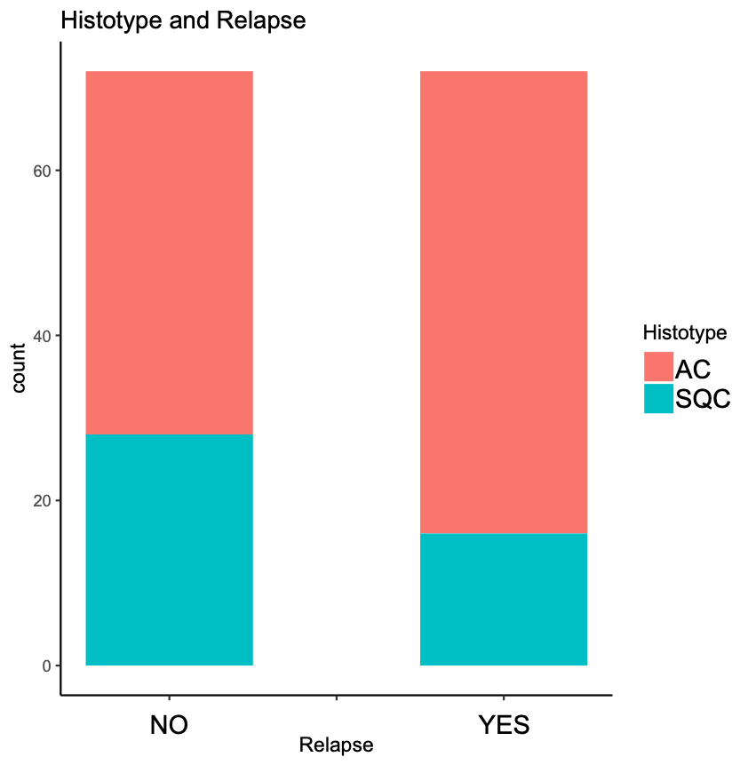

Supplementary figure 2. Overall survival and time-to-relapse analyses.
Kaplan–Meier curves for overall survival (left) or time-to-relapse (right) of 151 lung-cancer patients, classified according to their histotype (AC: adenocarcinoma; SQC: squamous cell carcinoma). Log-rank test P value is indicated.

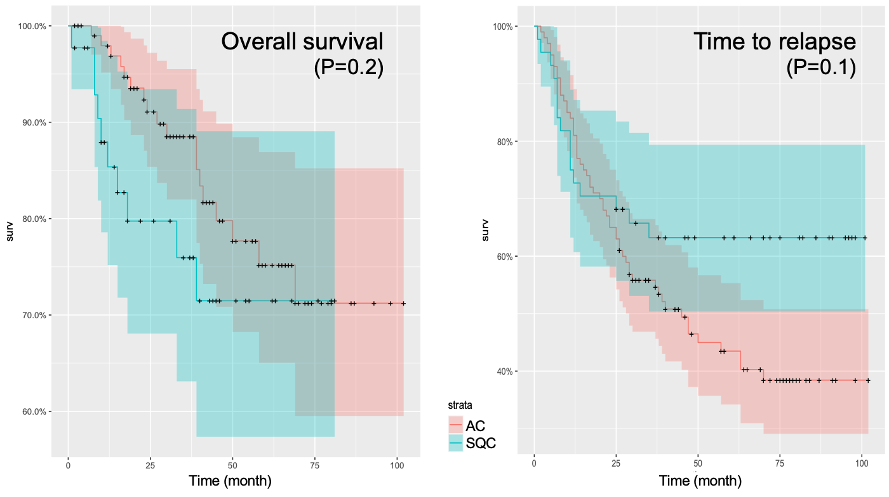

Supplementary Figure 3: Waterfall plot representing the top 142 known-driver or likely-pathogenic mutations detected in the 74 analyzed lung cancer samples. Each column represents a sample and each row a gene. Mutations are colored according to the predicted functional consequence. The plot was generated using the GenVisR Bioconductor package [1].

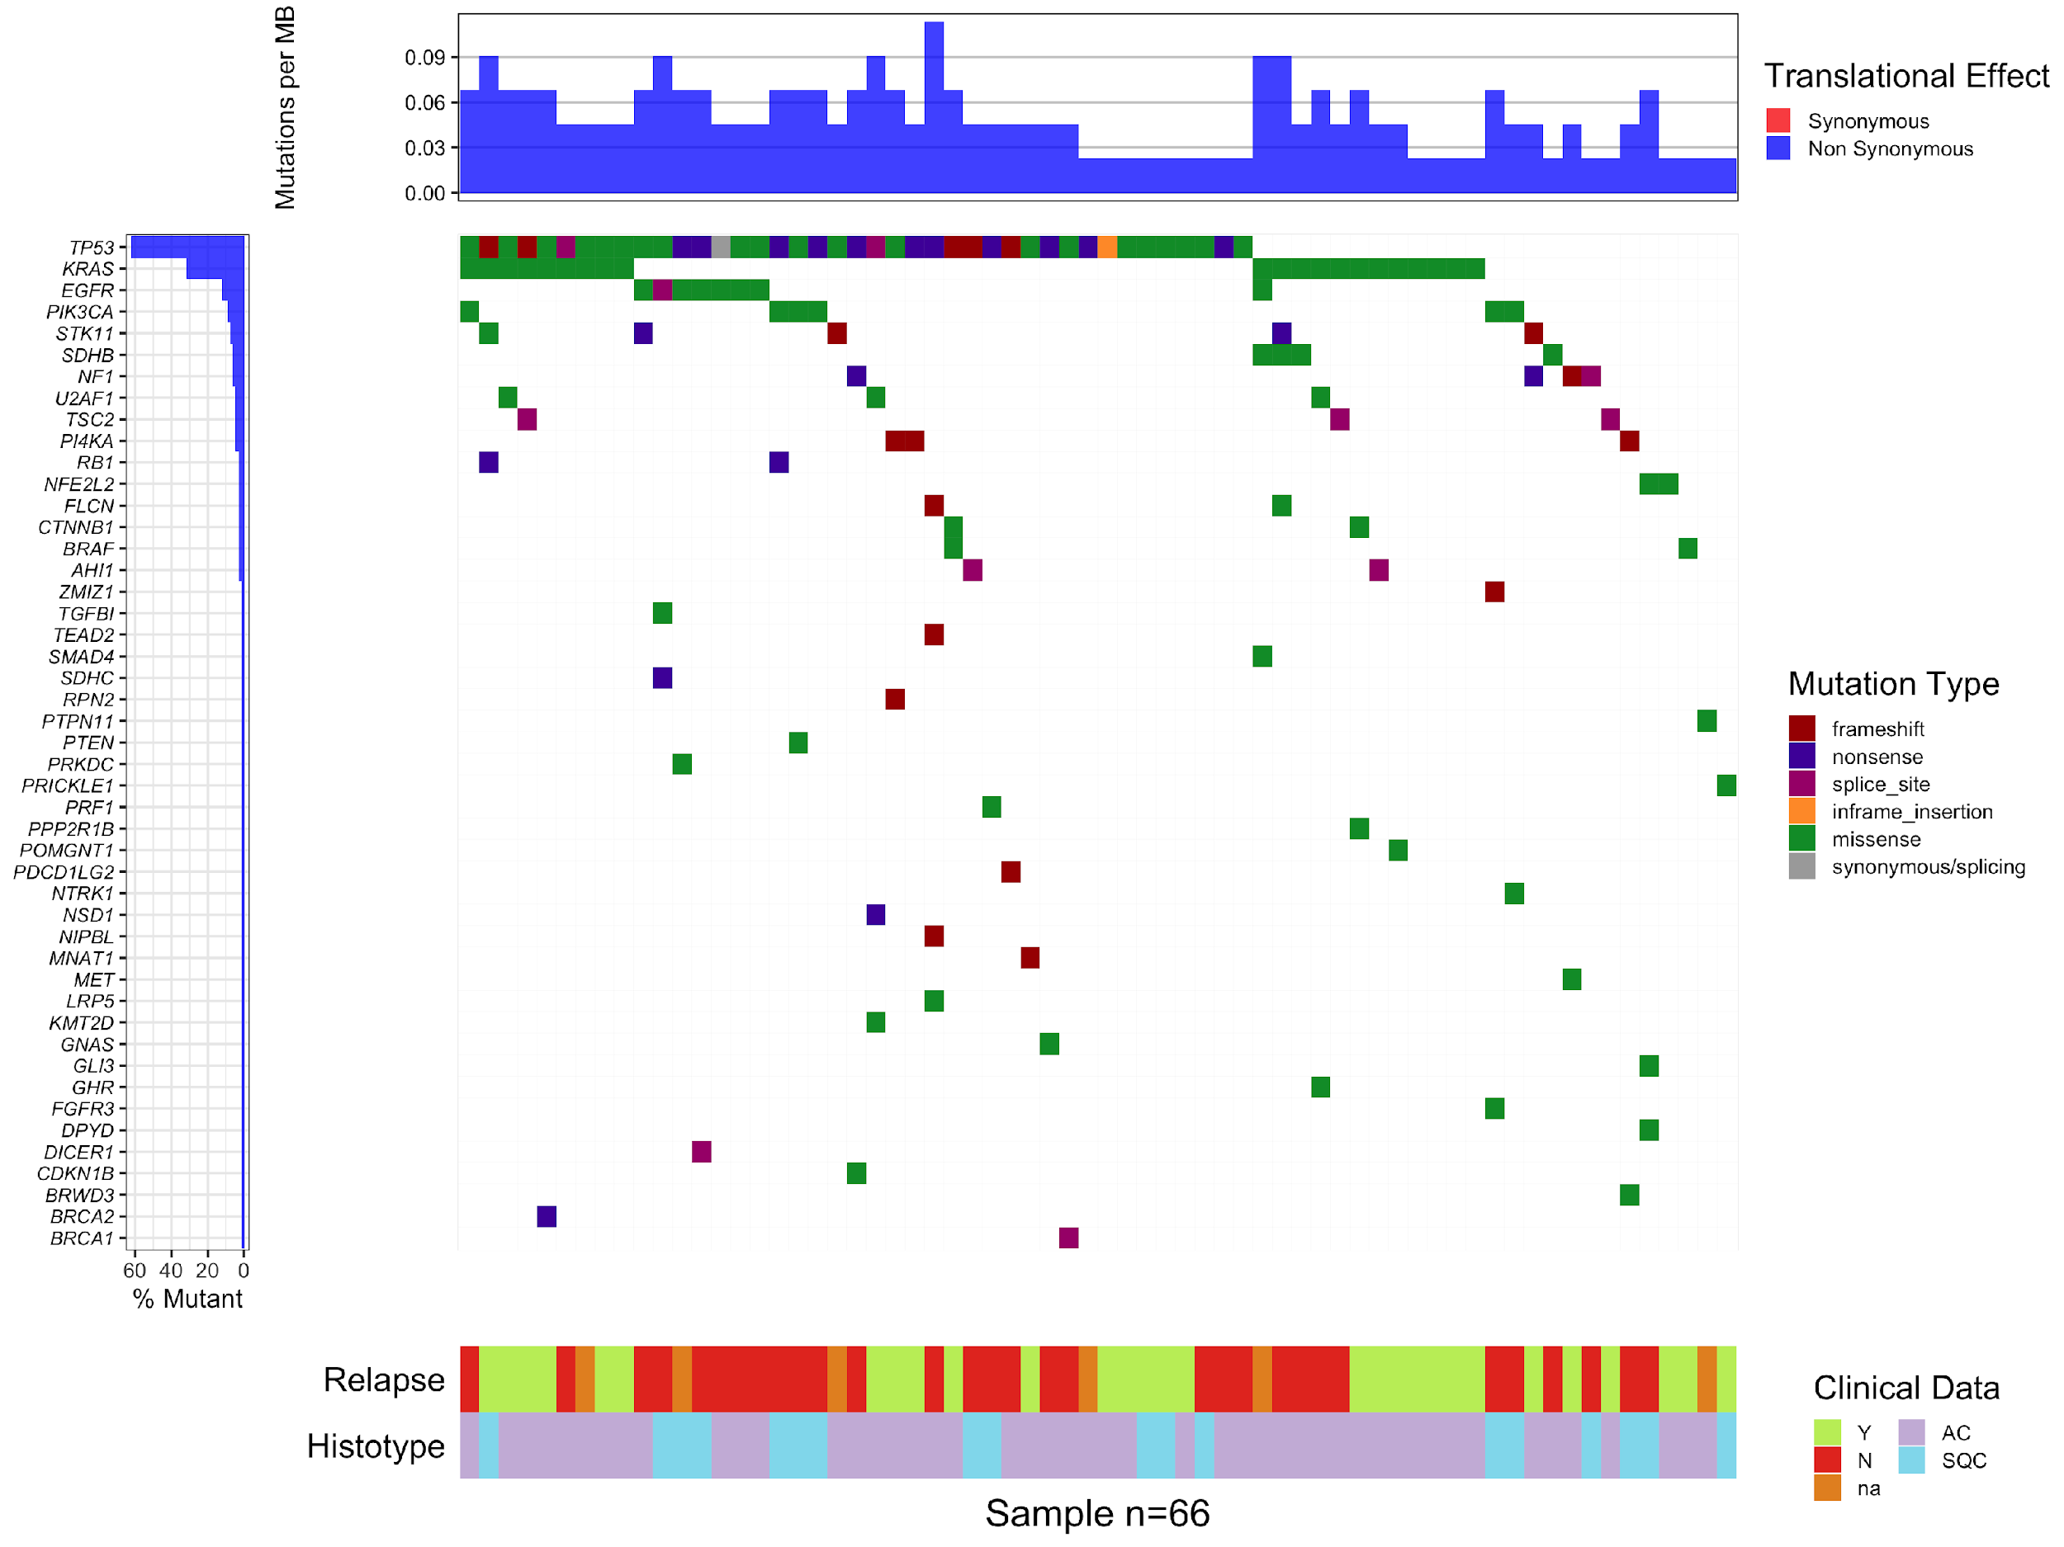

Supplementary Figure 4. Principal Component Analysis (PCA) plot on RNAseq data. PCA was calculated with DESeq2 Bioconductor package, using the plotPCA function on the variance-stabilized transformed data. The plot was generated with ggplot and shows the distribution of the 80 samples based on the their first two principal components. The histotypes (normal; squamous cell carcinoma, SQC; and adenocarcinoma, AC) are indicated with different colors and shapes.
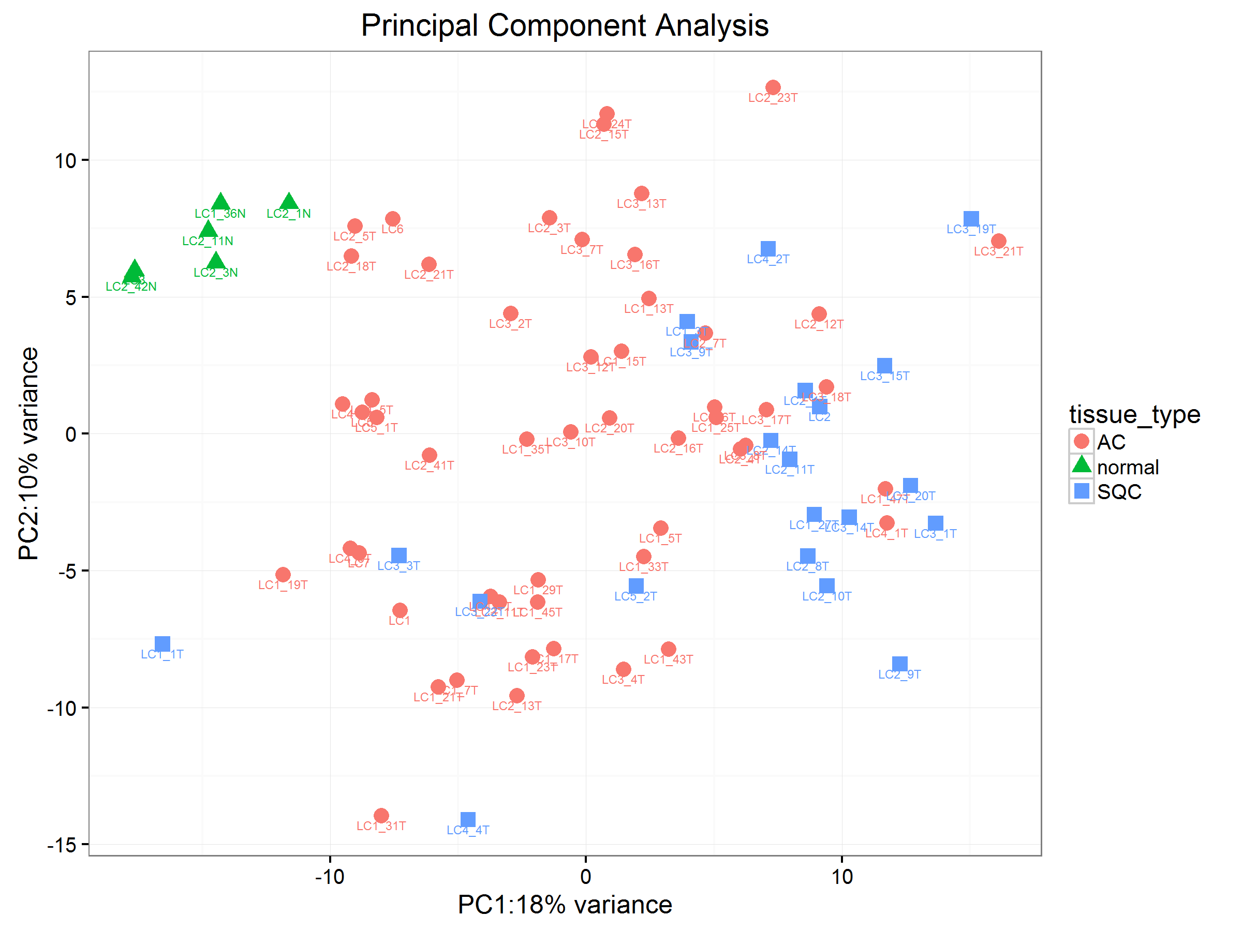

Supplementary Figure 5: Unsupervised clustering of lung cancer patients based on radiomics features. On the y axis 56 radiomic features are reported, whereas on the x axis the 149 squamous cell carcinoma (SQC) and adenocarcinoma (AC) patients, for whom all radiomics features were available, are displayed. Only those features showing a correlation at P<0.05 with the histotype were included in the plot.

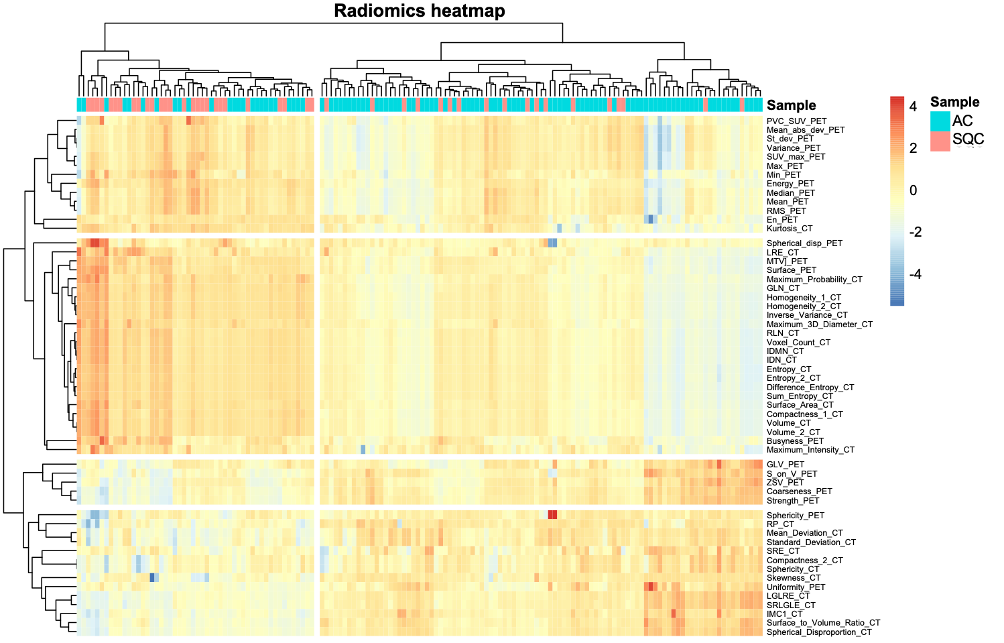

Reference
1. Skidmore ZL, Wagner AH, Lesurf R, Campbell KM, Kunisaki J, Griffith OL, et al. GenVisR: Genomic Visualizations in R. Bioinformatics. Bioinformatics; 2016;32:3012–4.

