Supplementary Materials

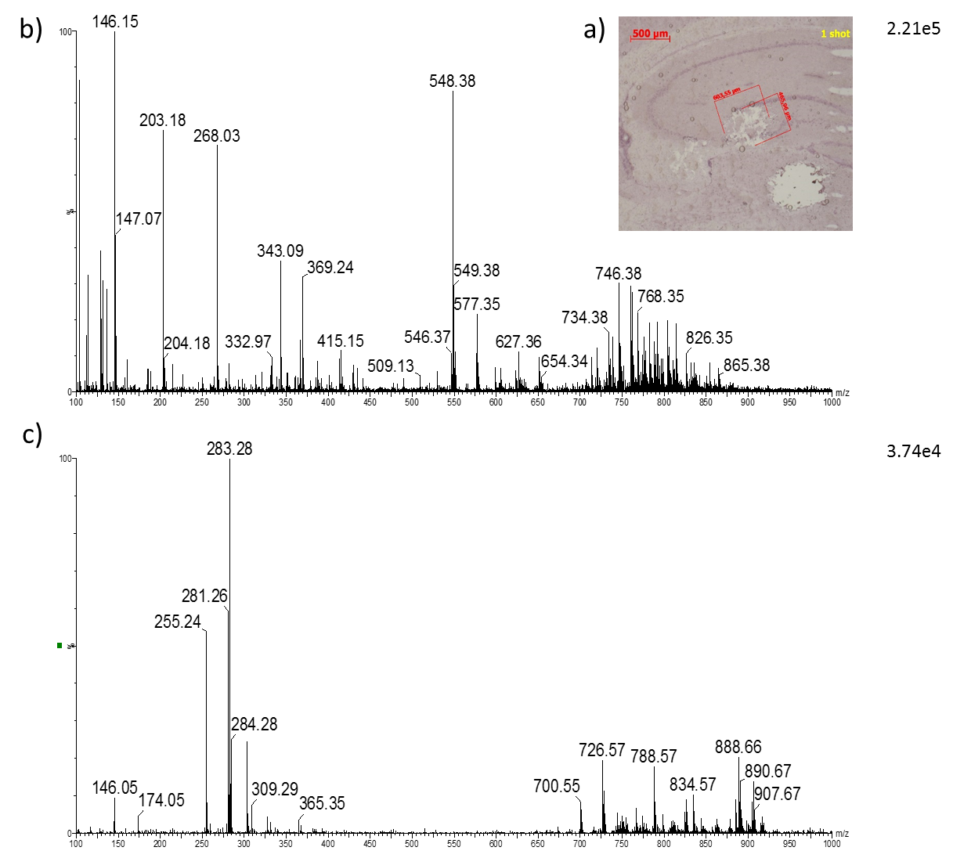
Fig. S1. Single Shot SpiderMass spectrum of the FFPE rat brain tissue section. The laser energy was 4 mJ/pulse with 1 min IPA/glycerol spray, a) Optical image of the single shot impact on the tissue. Acquired SpiderMass single shot spectrum in b) positive ion mode and c) negative ion mode.

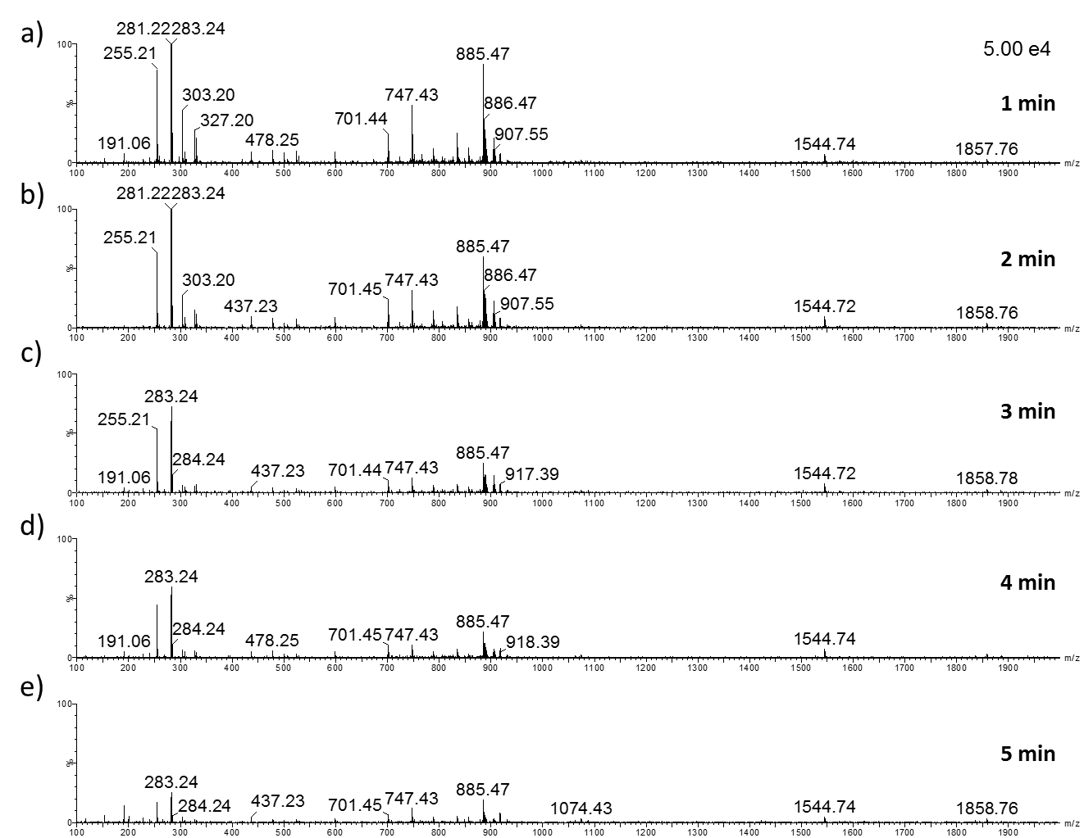
Fig. S2. Acquired SpiderMass spectra in negative ion mode with variable time of the spray of mix IPA/glycerol spray onto the FFPE rat brain tissue and acquisition of the spectra in negative resolution mode. All of the spectra intensities have been scaled to 5.00 e⁴. A, B, C, D and E correspond to 1, 2, 3, 4 and 5 minutes of spray, respectively. The laser energy was 4 mJ/pulse and one laser shot was realized. The ablated area was about 0.15 mm² after 1 laser shot.

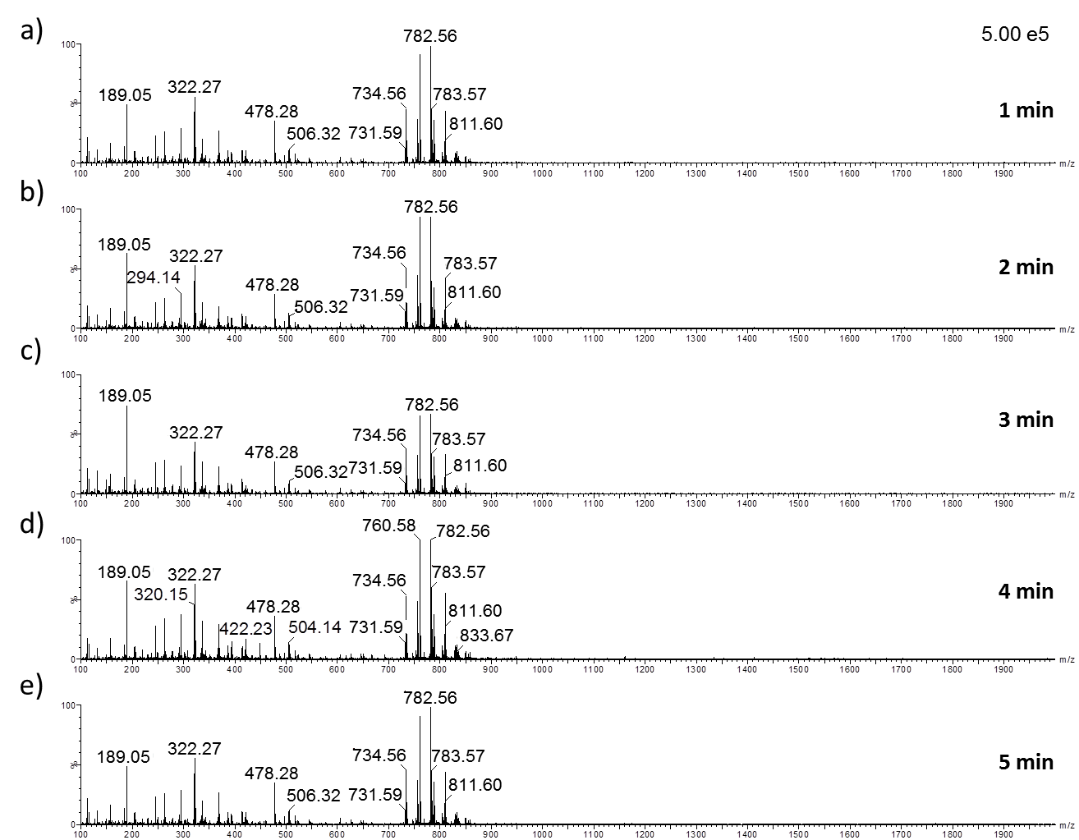
Fig. S3. Acquired SpiderMass spectra in positive ion mode with variable time of the IPA/glycerol spray onto the FFPE rat brain tissue and acquisition of the spectra. All of the spectra intensities have been scaled to 5.00e⁵. A, B, C, D and E correspond to 1, 2, 3, 4 and 5 minutes of spray, respectively. The laser energy was set to 4 mJ/pulse and one laser shot was realized. The ablated area was about 0.15 mm² after 1 laser shot.

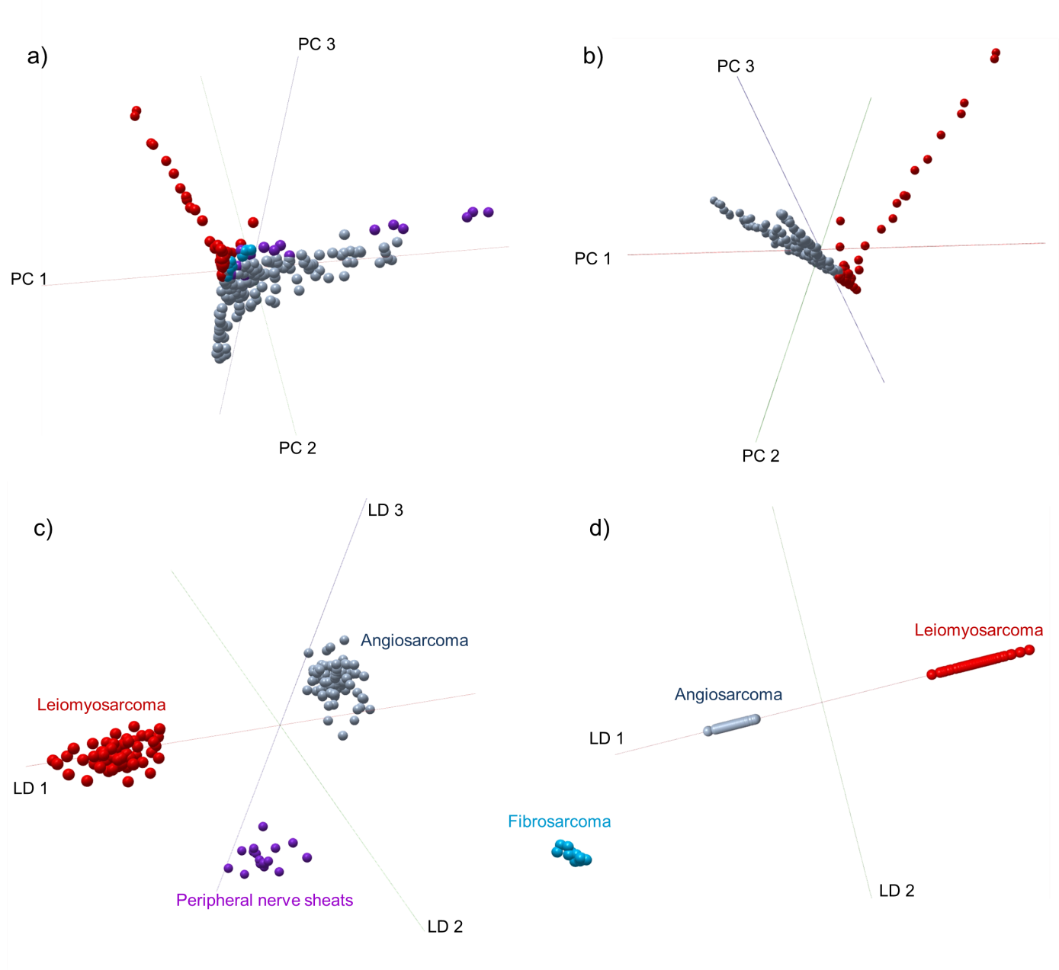

Fig S4. Multivariate statistical analysis of FFPE canine sarcoma samples; Angiosarcoma (gray), Leiomyosarcoma (red), Fibrosarcoma (blue), Peripheral nerve sheats (violet). a) PCA plot of 4 canine sarcoma types described with PC1 41.7 %, PC2 21.6% and PC 3 10.3 % variance. b) PCA plot of Angiosarcoma and Leiomyosarcoma samples described with PC1 35.7 %, PC2 26.1% and PC 3 12.4 % variance c) LDA model representation with a three-class scheme. LD1 separates the Leiomyosarcoma from Angisarcoma. LD 2 shows discrimination between the Angiosarcoma and Fibrosarcoma, while LD3 discrimination between Peripheral nerve sheats and the rest of the subtypes. d) 2-class LDA model representation discriminating Angiosarcoma from Leiomyosarcoma.

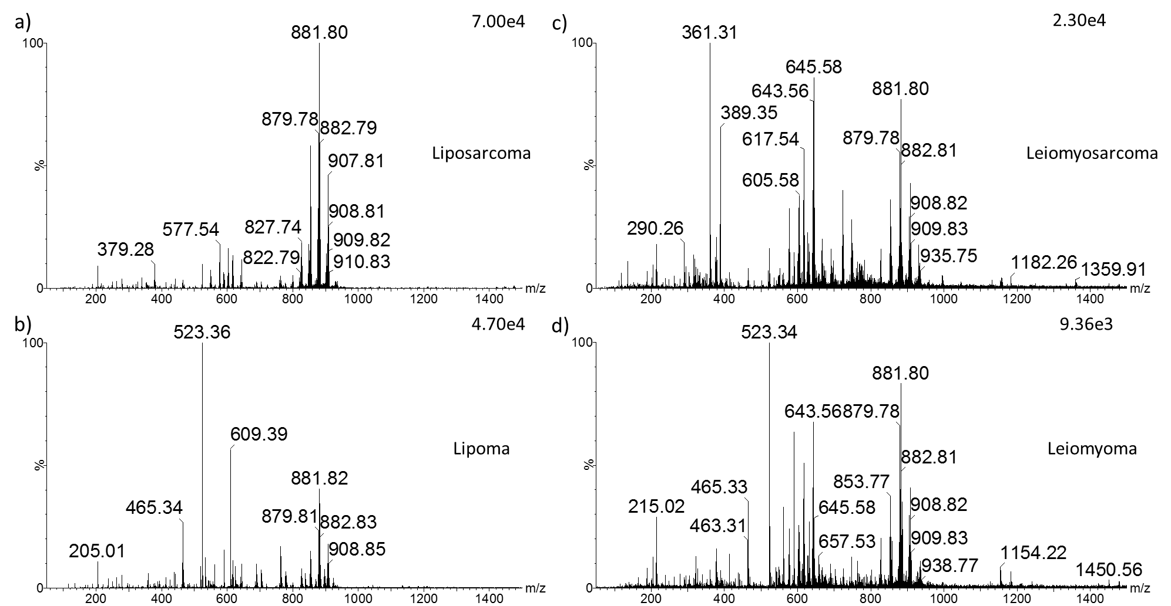
Fig. S5. Acquired SpiderMass spectra of the FFPE Human Sarcoma tissues from 2018 in positive ion mode after 10 s IPA/glycerol spray. Profile spectra of a) liposarcoma b) lipoma, c) leiomyosarcoma and d) leiomyoma.

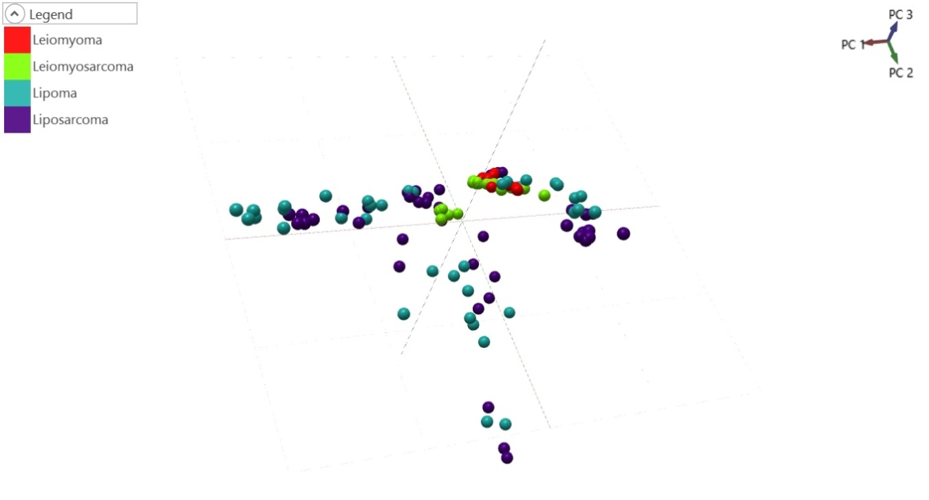
Fig S6. PCA 3D Loading. Percentage of variance explained in PC1 45.5 %, PC2 25.12 %, PC3 14.4 %. Based on 4 sarcoma types (Lipoma (Turqoise), Liposarcoma (Purple), Leiomyoma (Red) or Leiomyosarcoma (Green)).

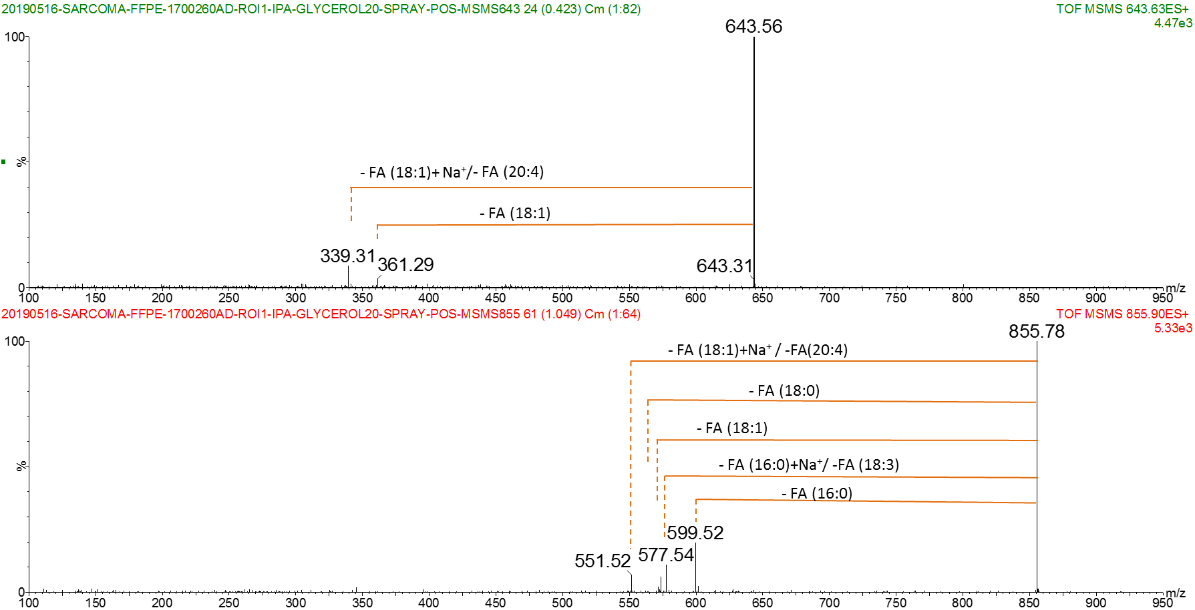
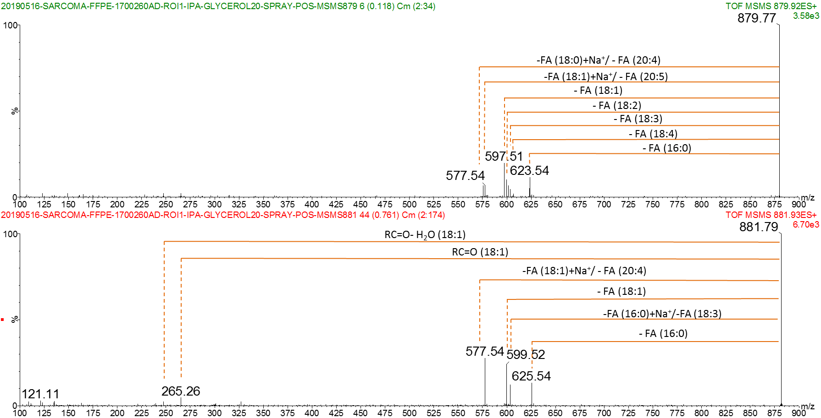

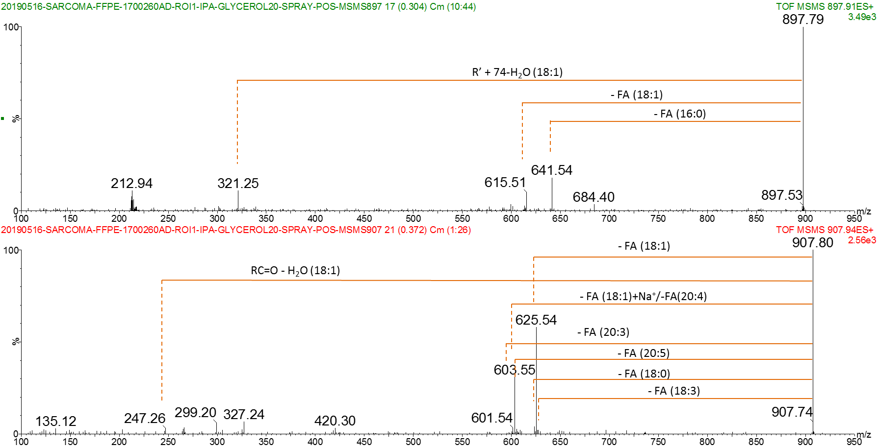
Fig. S7. MS/MS fragmentation spectra of most abundant Triglycerides in human sarcoma FFPE tissue

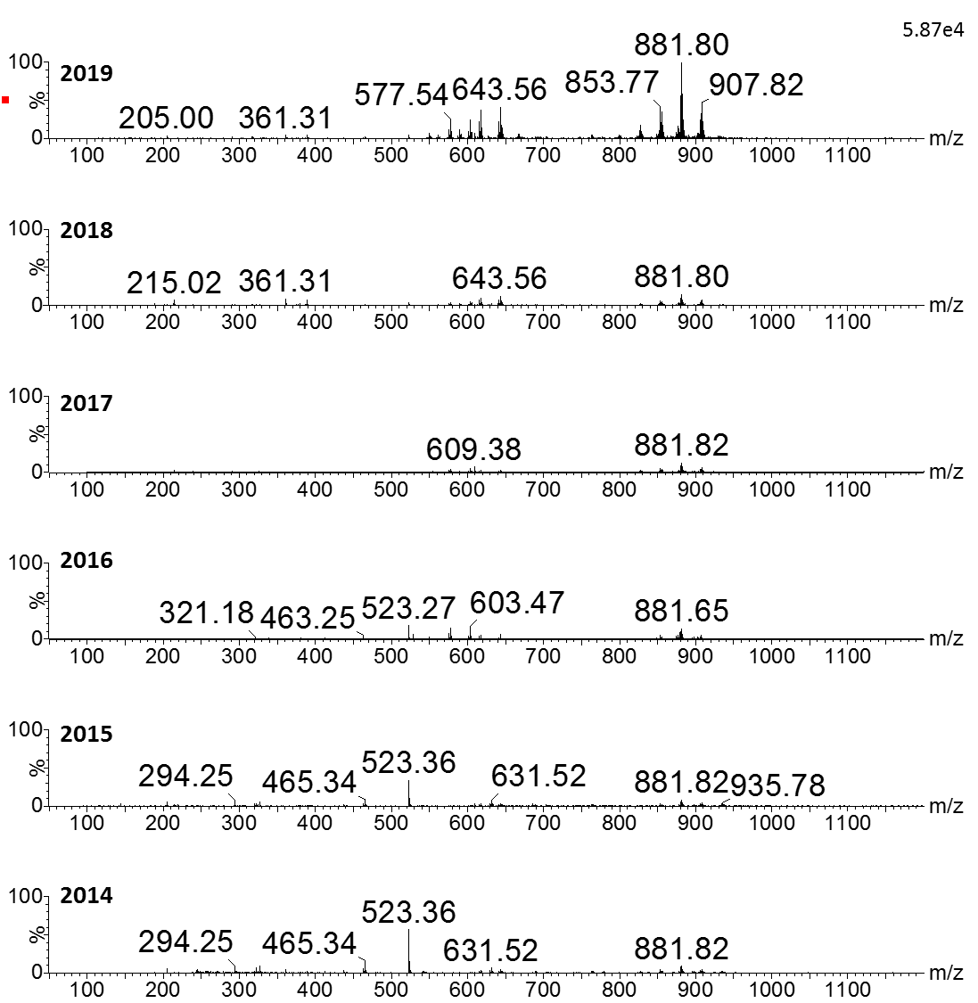
Fig. S8. Effects of conservation on the MS spectra acquired from Leiomyosarcoma samples. SpiderMass representation spectra (of 10 laser shots) acquired from the samples preserved since 2014 to 2019. The spectra have been scaled to 5.87e⁴ intensity.

Table S1. MS/MS identification of molecular species from rat brain FFPE tissue in negative and positive ion mode.
Precursor ion in negative ion mode | Detected ion fragments | Tentative annotation
m/z 673.47 | m/z 435.22 - Loss of FA (16:0) | PA (16:0_18:1)
 | m/z 409.20 - Loss of FA (18:1)
 | m/z 281.23 - FA (18:1)
 | m/z 255.22 - FA (16:0)
 | m/z 152.98 - Glycerol-3-Phosphate (loss of H₂O)
m/z 699.49 | m/z 435.22 - Loss of FA (18:1) | PA (18:1_18:1)
 | m/z 281.23 - FA (18:1)
 | m/z 152.98 - Glycerol-3-Phosphate (loss of H₂O)
m/z 701.50 | m/z 437.24 - Loss of FA (18:1) | PA (18:1_18:0)
 | m/z 435.22 - Loss of FA (18:0)
 | m/z 283.25 - FA (18:0)
 | m/z 281.23 - FA (18:1)
 | m/z 152.98 - Glycerol-3-Phosphate (loss of H₂O)
m/z 723.50 | m/z 457.20 - Loss of FA (20:4) | PA (18:0_20:4)
 | m/z 437.24 - Loss of FA (18:0)
 | m/z 303.21 - FA (20:4)
 | m/z 283.25 - FA (18:0)
 | m/z 152.98 - Glycerol-3-Phosphate (loss of H₂O)
m/z 747.50 | m/z 463.19 - Neutral loss of FA (18:0) | PA (22:6_18:0)
 | m/z 437.24 - Loss of FA (22:6)
 | m/z 327.21 - FA (22:6)
 | m/z 283.25 - FA (18:0)
 | m/z 152.98 - Glycerol-3-Phosphate (loss of H₂O)
m/z 788.51 | m/z 701.47 - Loss of serine from precursor ion | PS (18:1_18:0)
 | m/z 437.24 - Loss of FA (18:1) and serine
 | m/z 435.22 - Loss of FA (18:0) and serine
 | m/z 283.25 - FA (18:0)
 | m/z 281.23 - FA (18:1)
 | m/z 152.98 - Glycerol-3-Phosphate (loss of H₂O)
m/z 834.52 | m/z 747.45 - Loss of serine from precursor ion | PS (18:0_22:6)
 | m/z 481.20 - Loss of FA (18:0) and serine
 | m/z 437.24 - Loss of FA (22:6) and serine
 | m/z 327.21 - FA (22:6)
 | m/z 283.25 - FA (18:0)
 | m/z 152.98 - Glycerol-3-Phosphate (loss of H₂O)
m/z 885.53 | m/z 601.24 - Neutral loss of FA (18:0) | PI (18:0_20:4)
 | m/z 599.28 - Loss of FA (20:4)
 | m/z 437.24 - Loss of FA (20:4) and inositol
 | m/z 303.21 - FA (20:4)
 | m/z 283.25 - FA (18:0)
 | m/z 259.23 - Inositol phosphate ion
 | m/z 241.00 - Inositol phosphate ion (loss of H₂O)
 | m/z 152.98 - Glycerol-3-Phosphate (loss of H₂O)

Precursor ion  In positive ion mode | Detected ion fragments | Tentative annotation
m/z 734.56 | m/z 184.01 - Choline phosphate ion | PC (32:0) M+H⁺
m/z 756.54 | m/z 679.26 - Loss of trimethylamine | PC (32:0) M+Na⁺
m/z 756.54 | m/z 573.28 - Loss of choline phosphate ion M+Na⁺ | PC (32:0) M+Na⁺
m/z 756.54 | m/z 146.93 - Phosphono acetaldehyde M+Na⁺ | PC (32:0) M+Na⁺
m/z 760.58 | m/z 184.01 - Choline phosphate ion | PC (34:1) M+H⁺
m/z 782.56 | m/z 723.28 - Loss of trimethylamine | PC (34:1) M+Na⁺
 | m/z 599.29 - Loss of choline phosphate ion M+Na⁺
 | m/z 146.93 - Phosphono acetaldehyde M+Na⁺
m/z 788.61 | m/z 184.00 - Choline phosphate ion | PC (36:1) M+H⁺
m/z 810.60 | m/z 751.31 - Loss of trimethylamine | PC (38:4) M+H⁺
 | m/z 184.01 - Choline phosphate ion

Table S2. FFPE Canine Sarcoma patient information. Patient number, number of tissues blocks or samples, diagnosis, origin and breed
Patient # | # FFPE blocks/samples | Diagnosis | Origin | Breed
Patient 1 | 2 | Angiosarcoma | Liver | Labrador
Patient 2 | 2 | Angiosarcoma | Liver | Cross- breed
Patient 3 | 2 | Angiosarcoma | Skin | Bichon
Patient 4 | 2 | Angiosarcoma | Skin | Beagle
Patient 5 | 2 | Angiosarcoma | Skin | American Stafforshire Terrier
Patient 6 | 2 | Angiosarcoma | Skin | Beaucheron
Patient 7 | 2 | Angiosarcoma | Skin | Cross- breed
Patient 8 | 2 | Angiosarcoma | Skin | N/A
Patient 9 | 2 | Angiosarcoma | Skin | Boxer
Patient 10 | 2 | Angiosarcoma | Skin | Boxer
Patient 11 | 1 | Angiosarcoma | Skin | Australian Shepherd
Patient 12 | 4 | Angiosarcoma | Skin | Brittany
Patient 13 | 2 | Angiosarcoma | Skin | English Springer Spaniel
Patient 14 | 4 | Angiosarcoma | Skin | Jack Russel Terier
Patient 15 | 1 | Angiosarcoma | Liver | Labrador
Patient 16 | 2 | Angiosarcoma | Liver | Poodle
Patient 17 | 1 | Angiosarcoma | Spleen | Cocker Spaniel
Patient 18 | 1 | Angiosarcoma | Tongue | French Buldog
Patient 19 | 3 | Angiosarcoma | Intestine | Korthals Griffon
Patient 20 | 1 | Angiosarcoma | Serous Membrane | Shar Pei
Patient 21 | 4 | Angiosarcoma | Liver | Jack Russel Terier
Patient 22 | 1 | Angiosarcoma | Muscle | Giant Schnauzer
Patient 23 | 6 | Leiomyosarcoma | Vaginal | Saint Bernard
Patient 24 | 4 | Leiomyosarcoma | Nasal | Polish Tatra Sheepdog
Patient 25 | 6 | Leiomyosarcoma | Intestine | Beaucheron
Patient 26 | 7 | Leiomyosarcoma | Bladder | Poodle
Patient 27 | 2 | Fibrosarcoma |  | German Shepherd
Patient 28 | 2 | Peripheral nerve sheaths |  | Labrador
Patient 29 | 2 | Peripheral nerve sheaths |  | Poodle

Table S3. FFPE Human Sarcoma clinical patient information. Patient number, number of tissues blocks or samples, diagnosis and origin.
Patient # | #FFPE Blocks/samples | Diagnosis | Origin
Patient 1 | 2 | Liposarcoma, dedifferentiated | retroperitoneum
Patient 2 | 1 | Liposarcoma, well-differentiated | retroperitoneum
Patient 3 | 3 | Liposarcoma, well-differentiated | axillary
Patient 4 | 1 | Liposarcoma, pleomorphic | neck
Patient 5 | 1 | Liposarcoma, dedifferentiated | peritoneum
Patient 6 | 1 | Liposarcoma well differentiated | retroperitoneum
Patient 7 | 1 | Liposarcoma myxoid | left thigh
Patient 8 | 1 | Liposarcoma well differentiated and dedifferentiated | back
Patient 9 | 1 | Lipoma spindle cell | left shoulder
Patient 10 | 1 | Lipoma, pleomorphic | neck
Patient 11 | 1 | Lipoma spindle cell | lower lip
Patient 12 | 1 | Lipoma | axillary
Patient 13 | 1 | Lipoma | right thigh
Patient 14 | 1 | Lipoma | left buttock
Patient 15 | 3 | Lipoma | neck
Patient 16 | 1 | Leiomyosarcoma, pleomorphic | right arm
Patient 17 | 1 | Leiomyosarcoma, pleomorphic | left thigh
Patient 18 | 1 | Leiomyosarcoma, pleomorphic | scalp subcutaneous metastasis
Patient 19 | 1 | Leiomyosarcoma, pleomorphic | scalp subcutaneous metastasis
Patient 20 | 1 | Leiomyosarcoma, pleomorphic | abdominal wall
Patient 21 | 2 | Leiomyosarcoma spindle cell | uterus
Patient 22 | 1 | Leiomyosarcoma | groin metastasis
Patient 23 | 1 | Leiomyosarcoma | lombo-aortic  (psoas muscle)
Patient 24 | 1 | Leiomyosarcoma | groin
Patient 25 | 1 | Leiomyoma | uterus
Patient 26 | 1 | Leiomyoma | uterus
Patient 27 | 3 | Leiomyoma | uterus
*Patient 28 | Blind sample 1 | Lipoma
*Patient 29 | Blind sample 2 | Leiomyoma
*Patients randomly selected for blind testing of the built FFPE classification model with provided final diagnosis.
Table S4. MS/MS identification of the most abundant Triglycerides in human sarcoma FFPE tissue
Precursor ion | Detected ion fragments | Tentative annotation
m/z =643.56 | m/z 339.3 – neutral loss FA (20:4)/ FA (18:1 )+Na | [DG (18:1_18:1)+Na]⁺  [DG (18:1_20:4)+H]⁺
m/z =643.56 | m/z 361.3- neutral loss FA (18:1) | [DG (18:1_18:1)+Na]⁺  [DG (18:1_20:4)+H]⁺
m/z =879.78 | m/z 575.5 – neutral loss FA (20:4)  m/z 597.5 – neutral loss FA (18:0)  m/z 599.5 – neutral loss FA (18:2)  m/z 601.5 – neutral loss FA (18:3)  m/z 603.5 – neutral loss FA (18:4)  m/z 623.5- neutral loss FA (16:0) | [TG (18 :2_18:2_18 :2) +H]+  [TG (18 :0_18:3_18:3) +H]+  [TG (16:0_18:2_20:4) +H]+  [TG (18:0_18:2_18:4) +H]+  [TG (16:0_18:0_18:3) +Na]+
m/z =881.75 | m/z 247.23 - RC=O- H2O (18:1)  m/z 265.23 - RC=O- (18:1)  m/z 577.5 – neutral loss FA (20:4) )/ FA (18:1 )+Na  m/z 599.5 – neutral loss FA (18:1)  m/z 603.5 – neutral loss FA (18.3) )/ FA (16:0)+Na  m/z 625.5 - neutral loss FA (16:0) | [TG (16 :0_18 :1_20 :4) +H]+  [TG (18 :1_18 :1_18 :3) +H]+  [TG (16 :0_18 :1_18 :1) +Na]+
m/z = 853.75* |  | Most likely a TG species  TG (52:5)H⁺  TG(50:2) Na⁺
m/z =855.75 | m/z 551.5 - neutral loss FA (20:4) )/ FA (18:1 )+Na  m/z 571.5 – neutral loss FA (18:0)  m/z 573.5 – neutral loss FA (18:1)  m/z 577.5 – neutral loss FA (18:3) )/ FA (16:0)+Na  m/z 599.5 – neutral loss FA (16:0) | [TG (16 :0_18:3_18:1) +H]+  [TG (16:1_18:0_18:3) +H]+  [TG (16:0_16:0_20:4) +H]+  [TG (16 :0_16 :0_18 :1) +Na]+
m/z = 897.79* | m/z = 321.2 - R’ + 74-H₂O (18:1)  m/z 615.5- neutral loss FA (18:1)  m/z 641.5 – neutral loss FA (16:0) | Inconclusive  most likely a TG species
m/z 900.75* |  | PC(44:1)  PS(44:2)  PE(46:5) Na⁺
m/z 907.75 | m/z 247.2 - RC=O - H₂O (18:1)  m/z 601.5 – neutral loss FA (20:3)  m/z 603.5 – neutral loss FA (20:4)/ FA  (18:1)+Na  m/z 605.5 – neutral loss FA (20:5)  m/z 623.5- neutral loss FA (18:0)  m/z 625.5 - neutral loss FA (18:1)  m/z 627.5 - neutral loss FA (18:2) | [TG (18 :1_18:2_20:3) +H]+  [TG (18 :0_18:2_20:4) +H]+  [TG (18 :0_18:1_20:5) +H]+  [TG (18:1_18:1_20:4) +H]+  [TG (18 :1_18 :1_18 :1) +Na]+
*tentative or inconclusive identification

