Supplementary Information

Multi-ethnic phenome-wide association of complement component 4 variation with psychiatric and brain phenotypes in youth

Leanna M. Hernandez, PhD, Minsoo Kim, BS, Pan Zhang, PhD, Richard A.I. Bethlehem, PhD, Gil Hoftman, MD, PhD, Robert Loughnan, BS, Diana Smith, BS, Susan Y. Bookheimer, PhD, Chun Chieh Fan, PhD, Carrie E. Bearden, PhD, Wesley K. Thompson, PhD⁵ Michael J. Gandal, MD, PhD

Supplementary Fig. 1. Relationship between predicted C4A/C4B expression and observed C4A/C4B expression across ancestries.

Supplementary Fig. 2. C4 descriptives by ancestry.

Supplementary Fig. 3. Phenome-wide association between predicted C4A gene expression and behavioral phenotypes in youth of AFR ancestry.

Supplementary Fig. 4. Phenome-wide association between predicted C4A gene expression and behavioral phenotypes in youth of Latinx ancestry.

Supplementary Fig. 5. Phenome-wide association between predicted C4A gene expression and behavioral phenotypes in youth of EUR ancestry.

Supplementary Fig. 6. Sex-differences in the association between predicted C4A gene expression and behavioral phenotypes in the ABCD cohort.

Supplementary Fig. 7. Phenome-wide association between predicted C4A gene expression and behavioral phenotypes in female youth.

Supplementary Fig. 8. Phenome-wide association between predicted C4A gene expression and behavioral phenotypes in male youth.

Supplementary Fig. 9. Phenome-wide association between predicted C4A gene expression and behavioral phenotypes in the ABCD cohort at the 1-year follow-up.

Supplementary Fig. 10. Phenome-wide association between predicted C4A gene expression and behavioral phenotypes in female youth at the 1-year follow-up.

Supplementary Fig. 11. Phenome-wide association between predicted C4A gene expression and behavioral phenotypes in male youth at the 1-year follow-up.

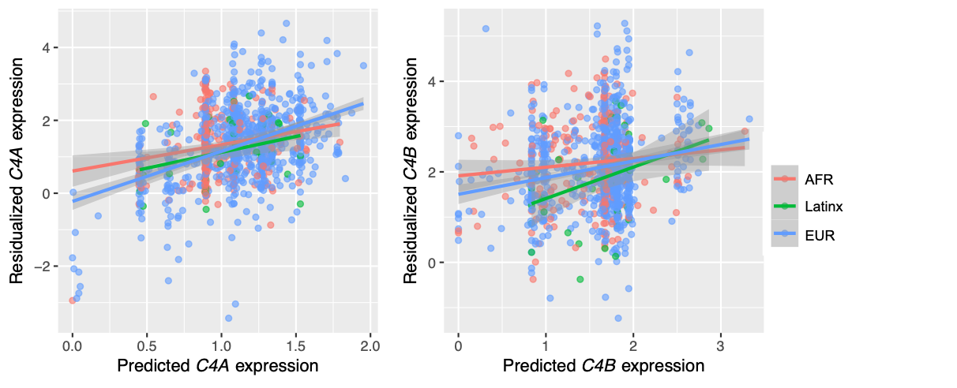

Supplementary Fig. 1. Relationship between predicted C4A/C4B expression and observed C4A/C4B expression across ancestries. Predicted C4A/C4B expression (i.e., GREx) was significantly associated with measured brain expression in 340 AFR, 863 EUR, and 50 Latinx samples from the PsychENCODE dataset.

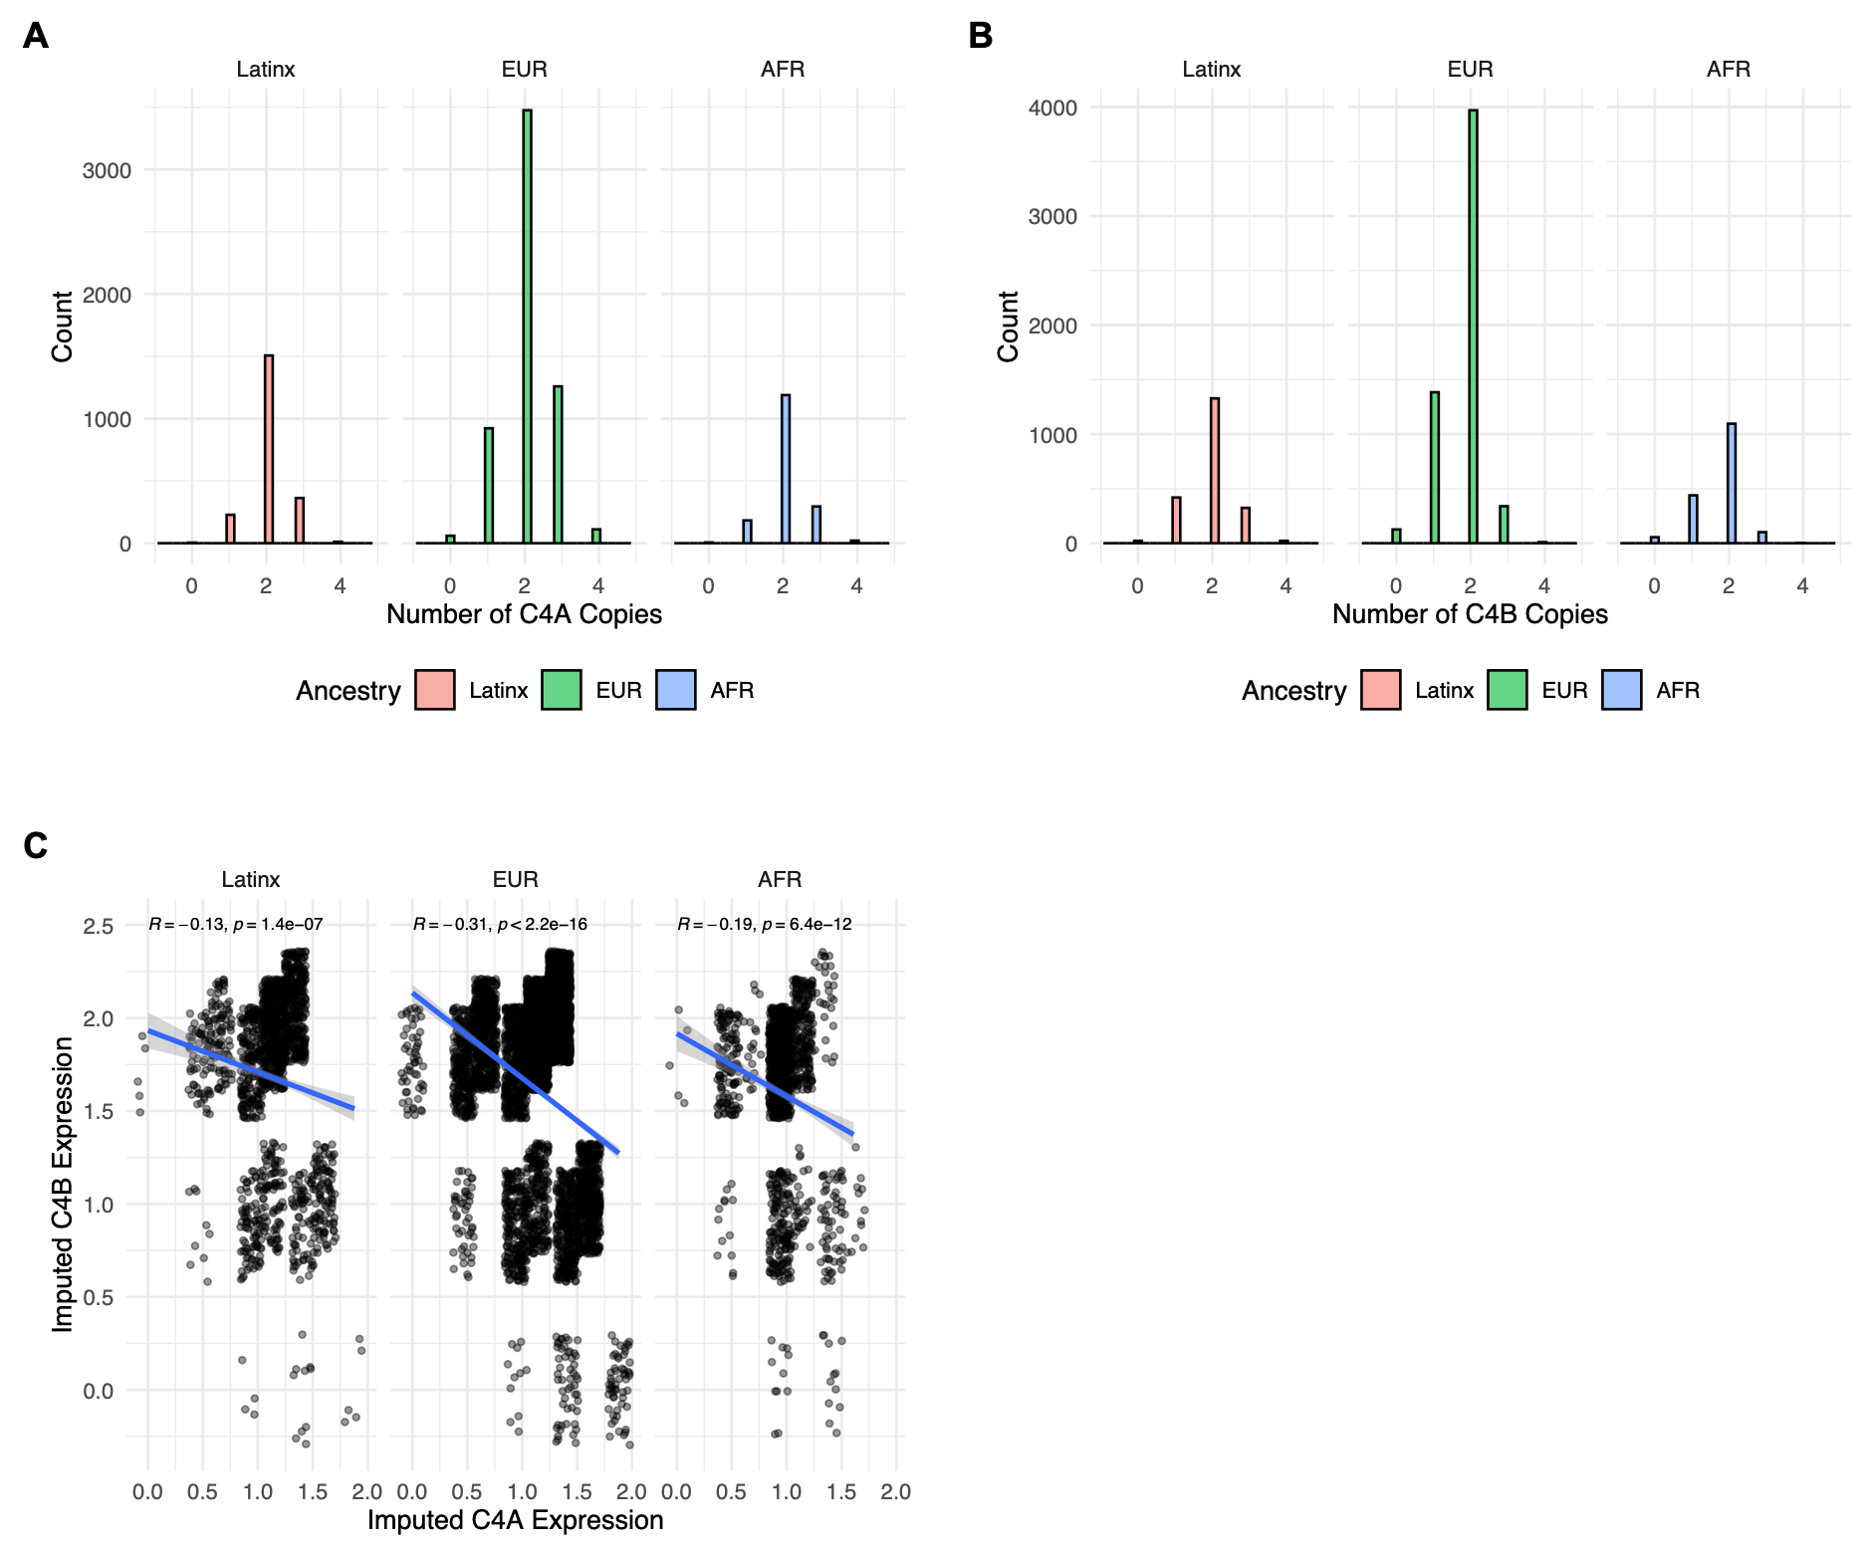

Supplementary Fig. 2. C4 descriptives by ancestry. A) Histograms showing the number of C4A copies by ancestry group. B) Histograms showing the number of C4B copies by ancestry group. C) Spearman rank order correlations between genetically imputed C4A and C4B brain expression.

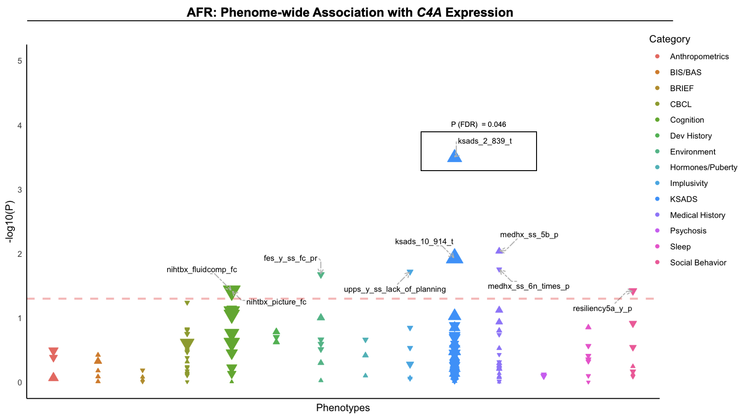

Supplementary Fig. 3. Phenome-wide association between predicted C4A gene expression and behavioral phenotypes in youth of AFR ancestry. Phenotypes are grouped into broad categories by color. The magnitude of effect (i.e., absolute 𝛽) is represented by size of the data points. Negative or positive associations with genetically predicted C4A expression are indicated by the direction of arrows. The threshold for P < 0.05 is indicated by a horizontal red line; labeled points indicate nominally significant associations (P < 0.05).

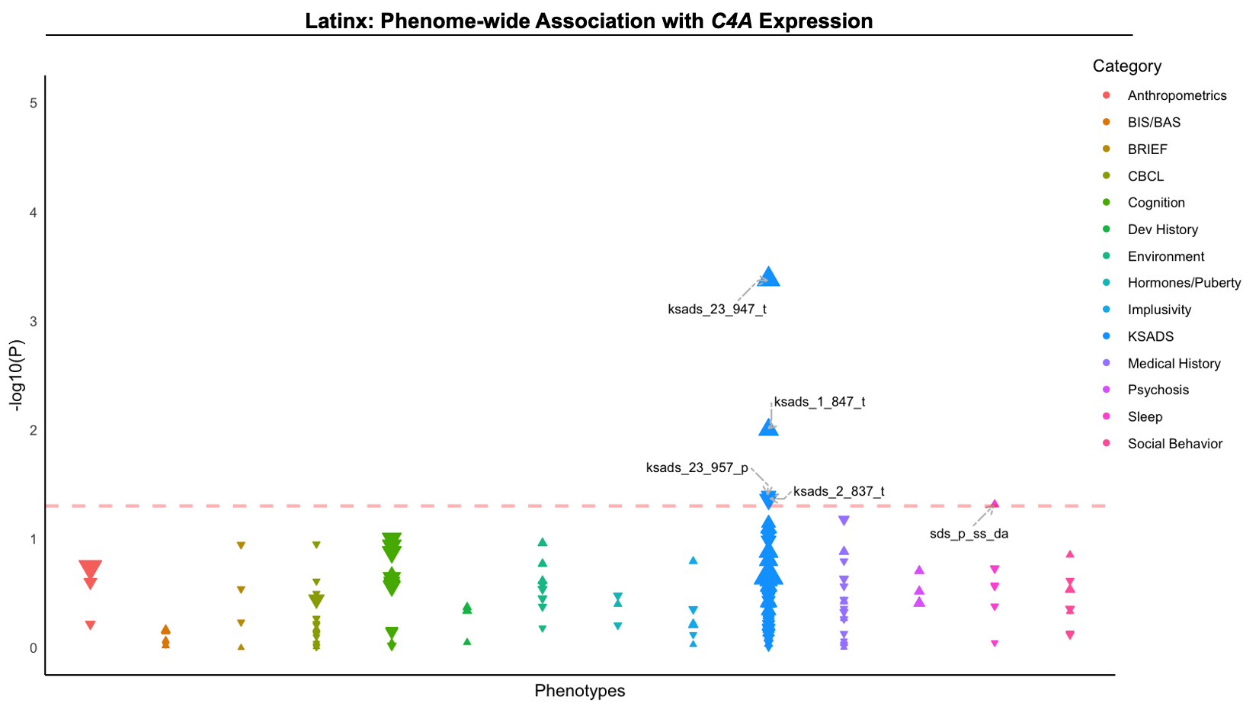

Supplementary Fig. 4. Phenome-wide association between predicted C4A gene expression and behavioral phenotypes in youth of Latinx ancestry. Phenotypes are grouped into broad categories by color. The magnitude of effect (i.e., absolute 𝛽) is represented by size of the data points. Negative or positive associations with genetically predicted C4A expression are indicated by the direction of arrows. The threshold for P < 0.05 is indicated by a horizontal red line; labeled points indicate nominally significant associations (P < 0.05).

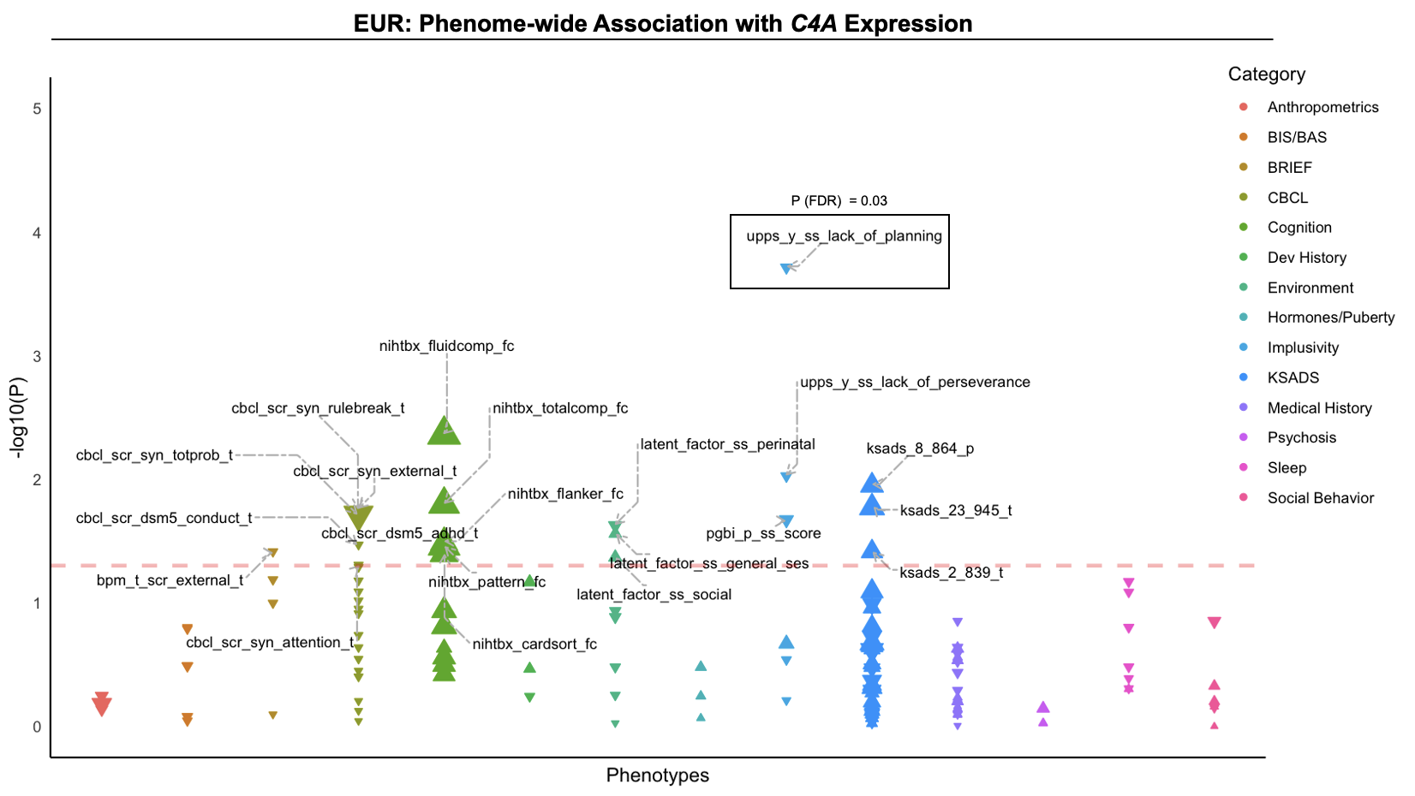

Supplementary Fig. 5. Phenome-wide association between predicted C4A gene expression and behavioral phenotypes in youth of EUR ancestry. Phenotypes are grouped into broad categories by color. The magnitude of effect (i.e., absolute 𝛽) is represented by size of the data points. Negative or positive associations with genetically predicted C4A expression are indicated by the direction of arrows. The threshold for P < 0.05 is indicated by a horizontal red line; labeled points indicate nominally significant associations (P < 0.05).

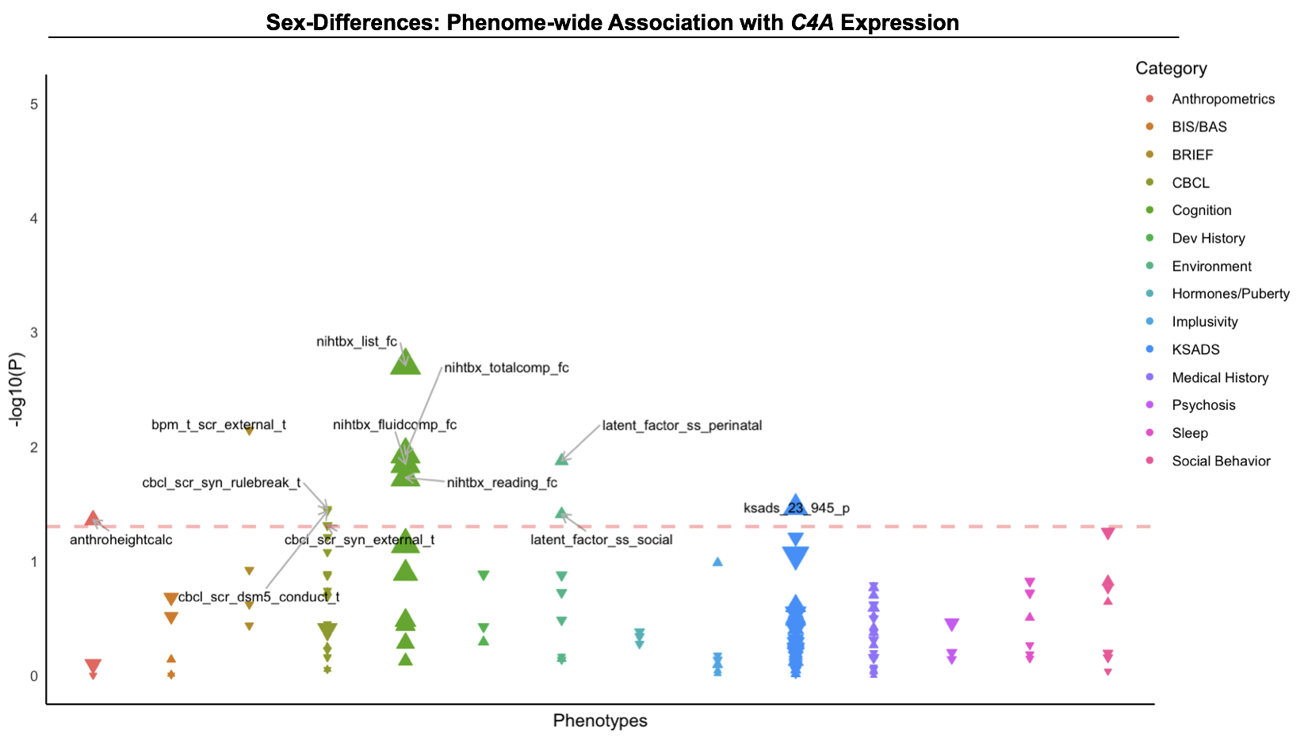

Supplementary Fig. 6. Sex-differences in the association between predicted C4A gene expression and behavioral phenotypes in the ABCD cohort. Phenotypes are grouped into broad categories by color. The magnitude of effect (i.e., absolute 𝛽) is represented by size of the data points. Negative or positive associations with genetically predicted C4A expression are indicated by the direction of arrows. The threshold for P < 0.05 is indicated by a horizontal red line; labeled points indicate nominally significant associations (P < 0.05).

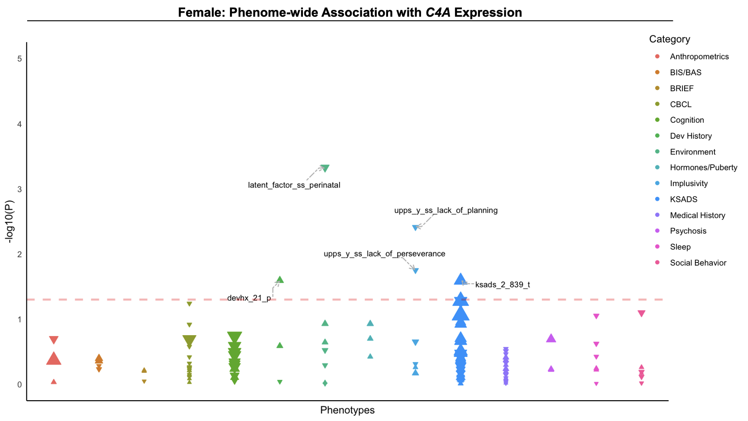

Supplementary Fig. 7. Phenome-wide association between predicted C4A gene expression and behavioral phenotypes in female youth. Phenotypes are grouped into broad categories by color. The magnitude of effect (i.e., absolute 𝛽) is represented by size of the data points. Negative or positive associations with genetically predicted C4A expression are indicated by the direction of arrows. The threshold for P < 0.05 is indicated by a horizontal red line; labeled points indicate nominally significant associations (P < 0.05).

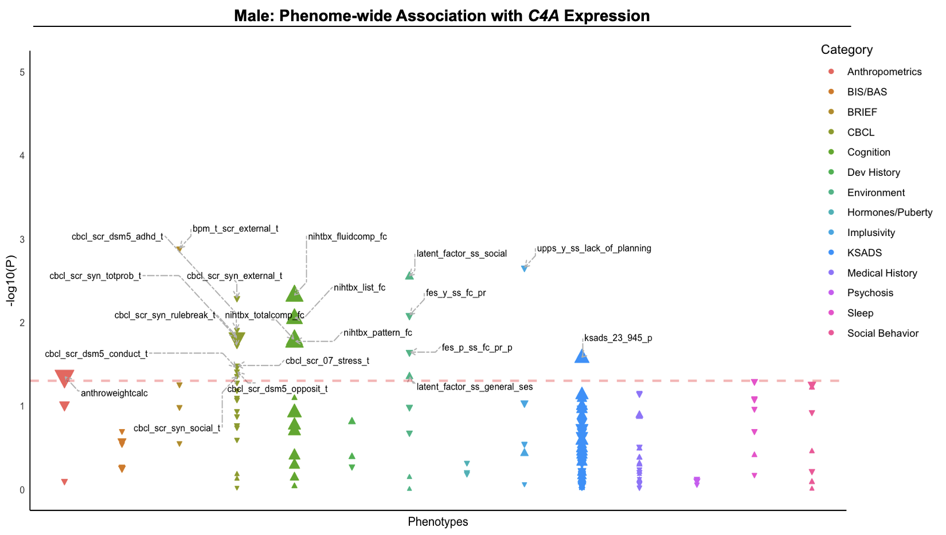

Supplementary Fig. 8. Phenome-wide association between predicted C4A gene expression and behavioral phenotypes in male youth. Phenotypes are grouped into broad categories by color. The magnitude of effect (i.e., absolute 𝛽) is represented by size of the data points. Negative or positive associations with genetically predicted C4A expression are indicated by the direction of arrows. The threshold for P < 0.05 is indicated by a horizontal red line; labeled points indicate nominally significant associations (P < 0.05).

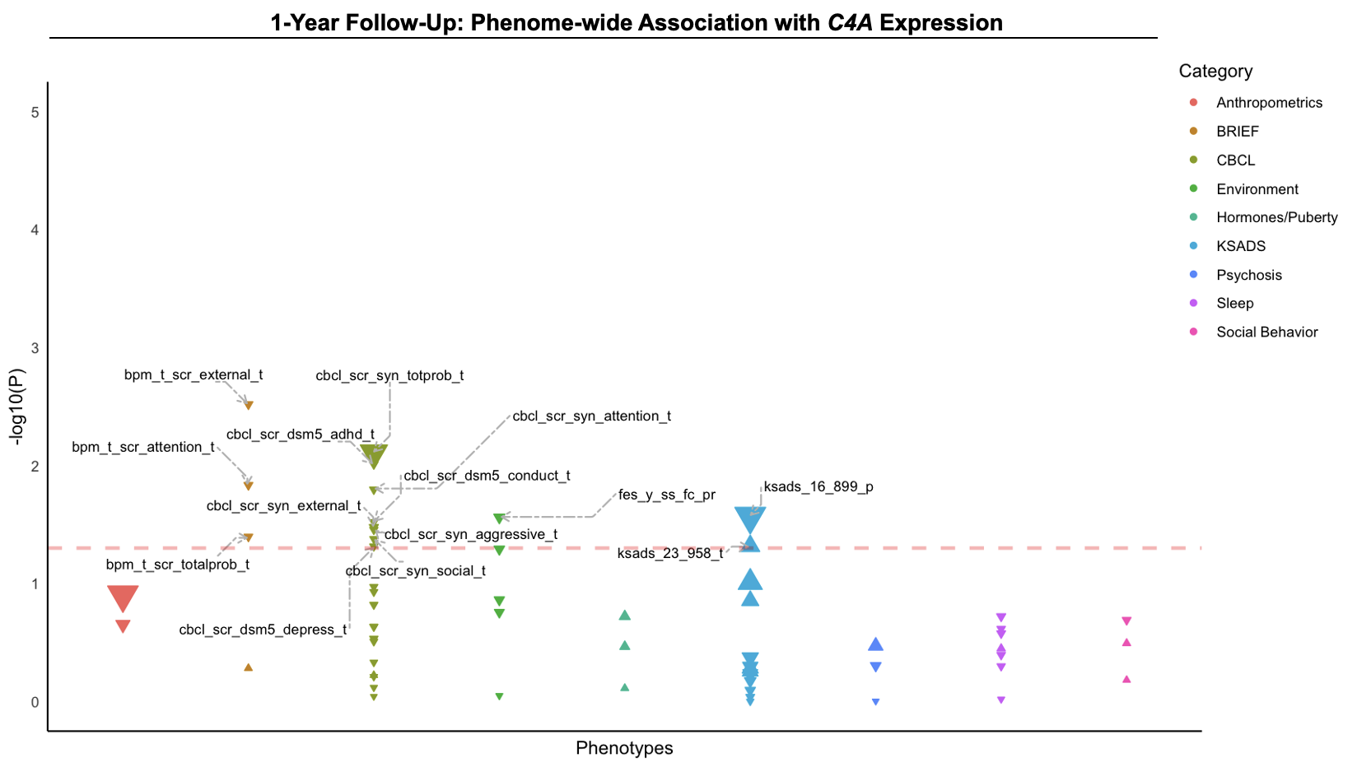

Supplementary Fig. 9. Phenome-wide association between predicted C4A gene expression and behavioral phenotypes in the ABCD cohort at the 1-year follow-up. Phenotypes are grouped into broad categories by color. The magnitude of effect (i.e., absolute 𝛽) is represented by size of the data points. Negative or positive associations with genetically predicted C4A expression are indicated by the direction of arrows. The threshold for P < 0.05 is indicated by a horizontal red line; labeled points indicate nominally significant associations (P < 0.05).

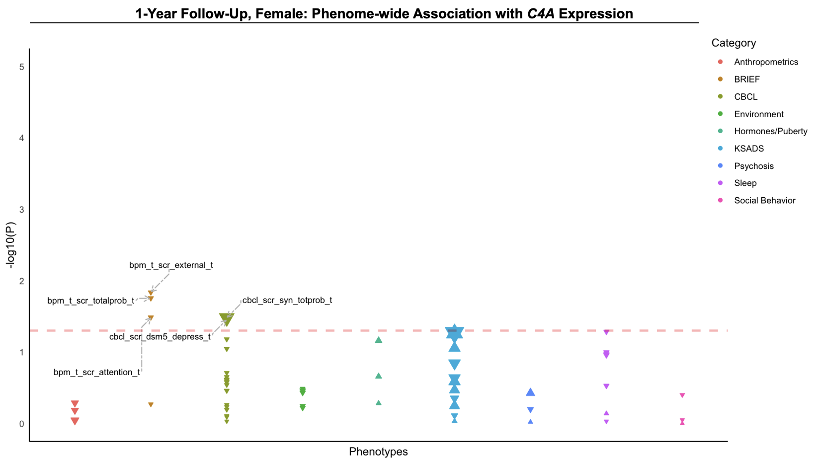

Supplementary Fig. 10. Phenome-wide association between predicted C4A gene expression and behavioral phenotypes in female youth at the 1-year follow-up. Phenotypes are grouped into broad categories by color. The magnitude of effect (i.e., absolute 𝛽) is represented by size of the data points. Negative or positive associations with genetically predicted C4A expression are indicated by the direction of arrows. The threshold for P < 0.05 is indicated by a horizontal red line; labeled points indicate nominally significant associations (P < 0.05).

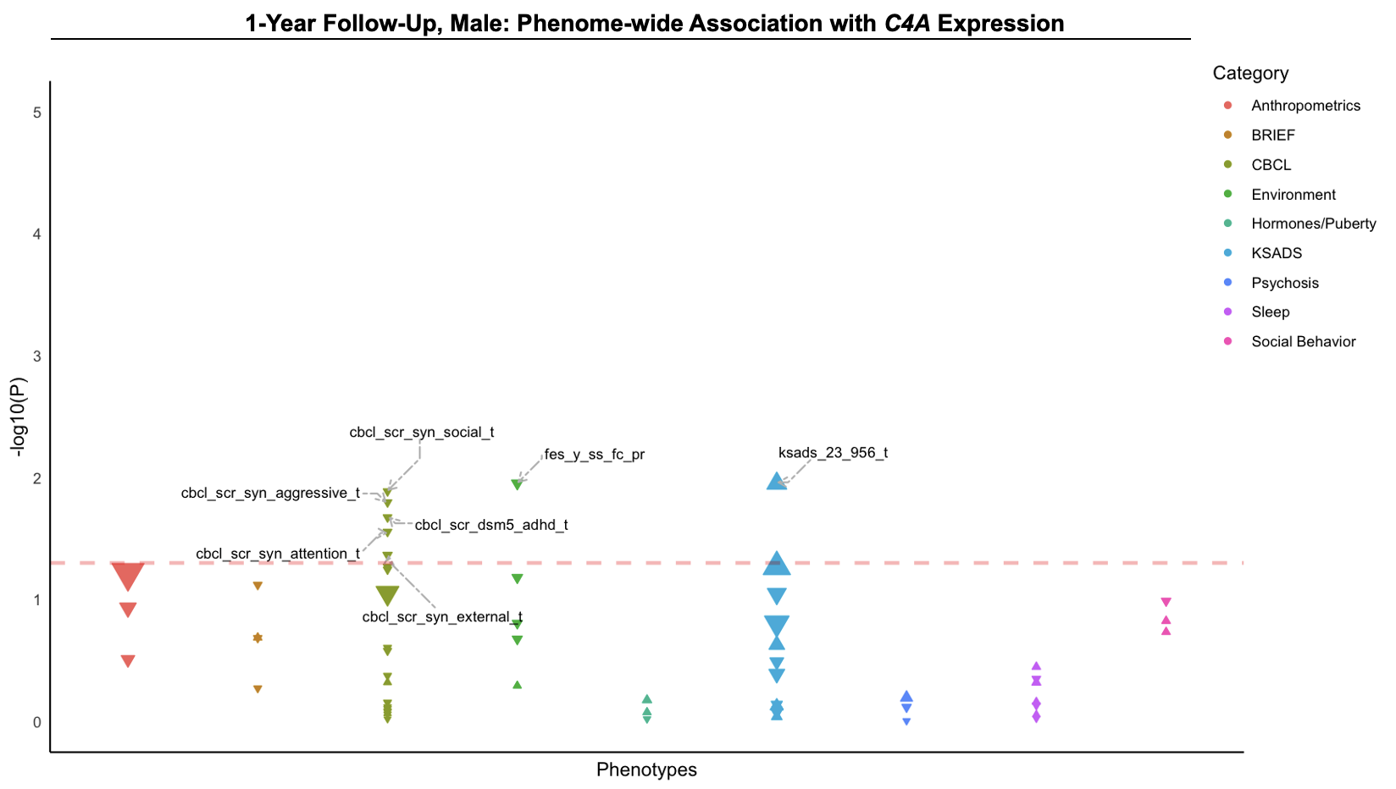

Supplementary Fig. 11. Phenome-wide association between predicted C4A gene expression and behavioral phenotypes in male youth at the 1-year follow-up. Phenotypes are grouped into broad categories by color. The magnitude of effect (i.e., absolute 𝛽) is represented by size of the data points. Negative or positive associations with genetically predicted C4A expression are indicated by the direction of arrows. The threshold for P < 0.05 is indicated by a horizontal red line; labeled points indicate nominally significant associations (P < 0.05).

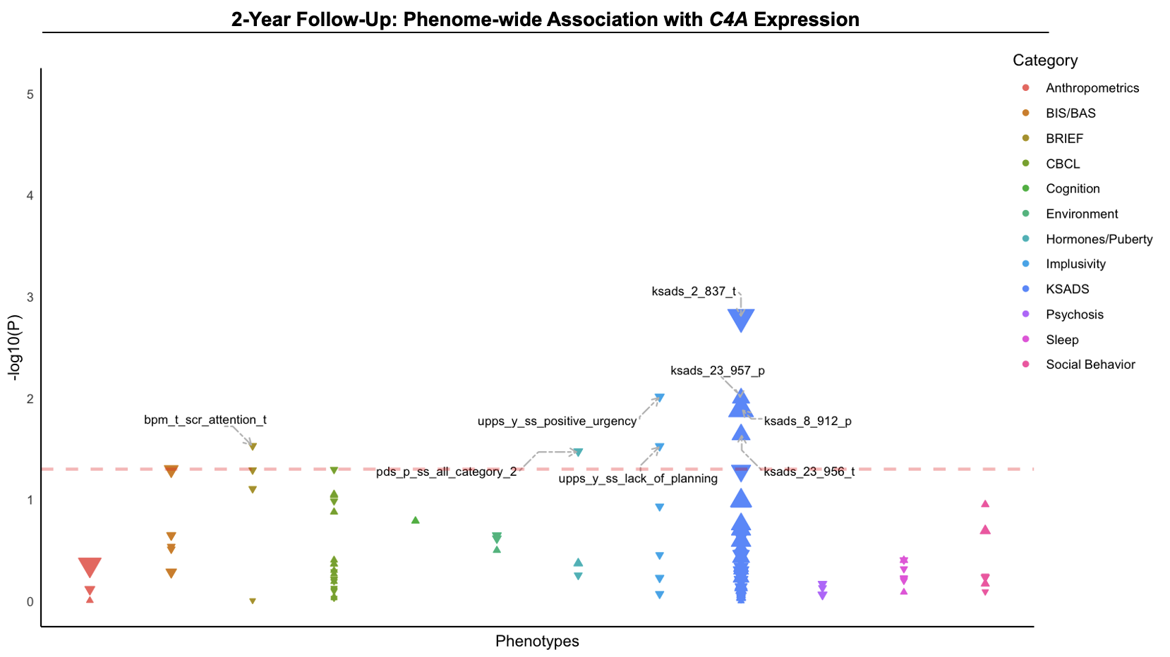

Supplementary Fig. 12. Phenome-wide association between predicted C4A gene expression and behavioral phenotypes in the ABCD cohort at the 2-year follow-up. Phenotypes are grouped into broad categories by color. The magnitude of effect (i.e., absolute 𝛽) is represented by size of the data points. Negative or positive associations with genetically predicted C4A expression are indicated by the direction of arrows. The threshold for P < 0.05 is indicated by a horizontal red line; labeled points indicate nominally significant associations (P < 0.05).

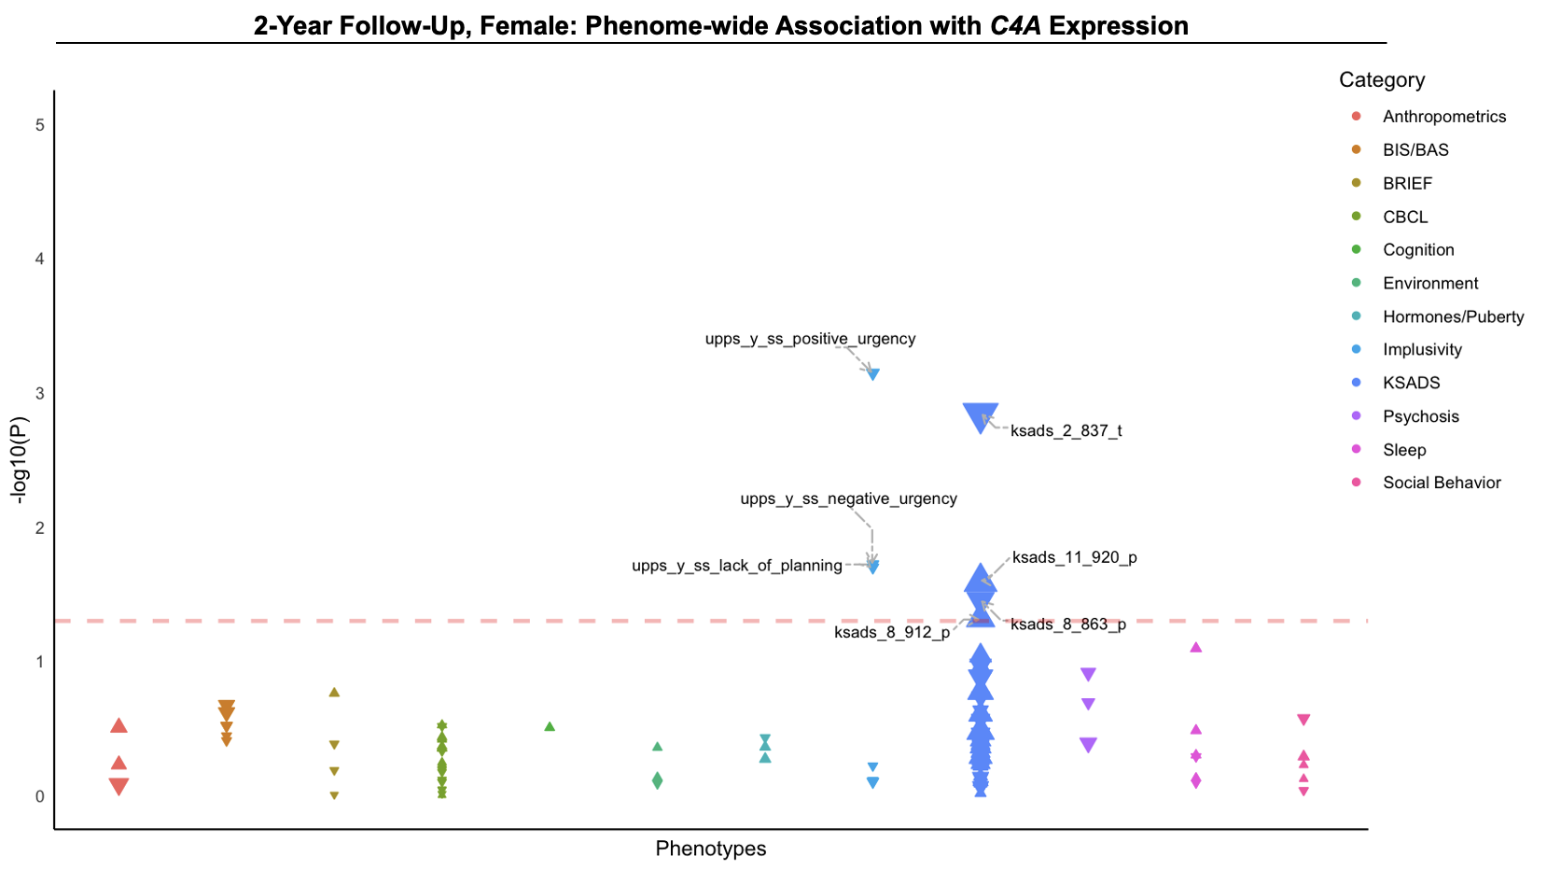

Supplementary Fig. 13. Phenome-wide association between predicted C4A gene expression and behavioral phenotypes in female youth at the 2-year follow-up. Phenotypes are grouped into broad categories by color. The magnitude of effect (i.e., absolute 𝛽) is represented by size of the data points. Negative or positive associations with genetically predicted C4A expression are indicated by the direction of arrows. The threshold for P < 0.05 is indicated by a horizontal red line; labeled points indicate nominally significant associations (P < 0.05).

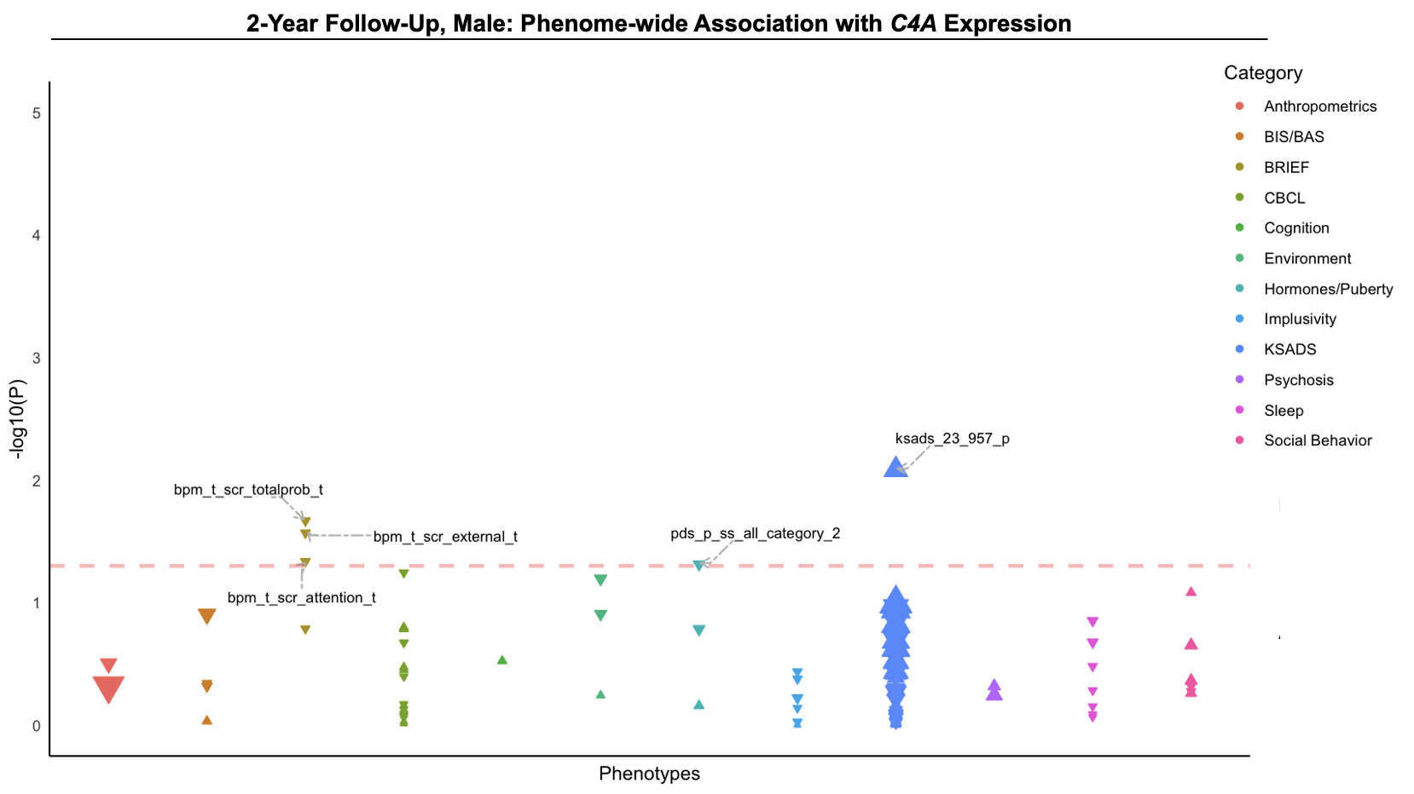

Supplementary Fig. 14. Phenome-wide association between predicted C4A gene expression and behavioral phenotypes in male youth at the 2-year follow-up. Phenotypes are grouped into broad categories by color. The magnitude of effect (i.e., absolute 𝛽) is represented by size of the data points. Negative or positive associations with genetically predicted C4A expression are indicated by the direction of arrows. The threshold for P < 0.05 is indicated by a horizontal red line; labeled points indicate nominally significant associations (P < 0.05).

