Supplementary Materials

CMIP5 model evaluation
we evaluated the mean annual cycle of simulated rainfall from the 24 CMIP models that are common across preindustrial, historical, and different RCP scenarios (see Supplementary Table 1) against the observed mean annual cycle of rainfall for the period 1900 – 2018 over the three sub-regions of Victoria to check if CMIP5 models used in this study are fit for purpose. Supplementary Figure 1 shows large inter-model spread in skill in all three regions, consistent with the results of previous studies in this region (e.g., Grose et al. 2015a,b; Moise et al. 2015; Timbal et al. 2015; Bhend and Whetton 2017; Rauniyar and Power 2020). The majority of models were able to simulate the timing of seasonal rainfall pattern over MBVic and SEVic regions (Supplementary Figure 1a and b), while over the SWVic region all 24 models simulated the same reasonably well (Supplementary Figure 1c). Five out of 24 models (i.e., CCSM4, CESM1-BGC, CanESM2, NorESM1-M, and inmcm4) show a reversed annual cycle (i.e., a summer peak in rainfall) over SEVic while the number reduces to four (i.e., CCSM4, CESM1-BGC, CNRM-CM5, and NorESM1-M) for the MBVic region. The first harmonic for these models explains more than 70% of total annual variance, meaning the models have significant problems with the annual cycle. In addition, ACCESS1-3 model shows a double peak in annual rainfall over the MBVic and SEVic regions as the fractional contribution (~60%) of second harmonic to the total annual variance is substantially larger than the contribution (~15%) of first harmonic. Similarly, CCSM4 exhibits the double peak over the SWVic region with more than 68% of variance is explained by the second harmonic. Nevertheless, the multi-model ensemble mean exhibits a seasonal evolution similar to its observed with winter maxima in all three regions but tends to underestimate the observed peak during the cool season months (Supplementary Figure 1). The variance explained by the first harmonic is more than 92% of total variance in SWVic while the same is 70% and 60 % for MBVic and SEVic regions.
The amplitude of annual cycle is also well simulated by models in SWVic region while it is underestimated in other regions. The underestimation of peak-to-peak amplitude of multi-model mean compared to the observation is found to be the largest in SEVic (45%), followed by MBVic (20%) and is the smallest in SWVic (13%) region. The observed peak-to-peak amplitudes values are 32-, 33-, and 48-mm month⁻¹ for MBVic, SEVic, and SWVic regions. Right column of Supplementary Figure 1 shows that this is due to overestimation of rainfall during the warm season, but underestimation during the cool season. Furthermore, the multi-model mean tends to slightly delay (by a month) the start of the rainy season over all three regions compared to the observations. Our analysis shows that the annual cycle of rainfall under historical conditions is slightly drier in the cool season and wetter in the warm season compared with pre-industrial runs of the same models. We recomputed all the statistics by excluding the models with reversed annual cycle, however we did not find any substantial differences in the values shown in Tables 2 and 3.

Supplementary Figures
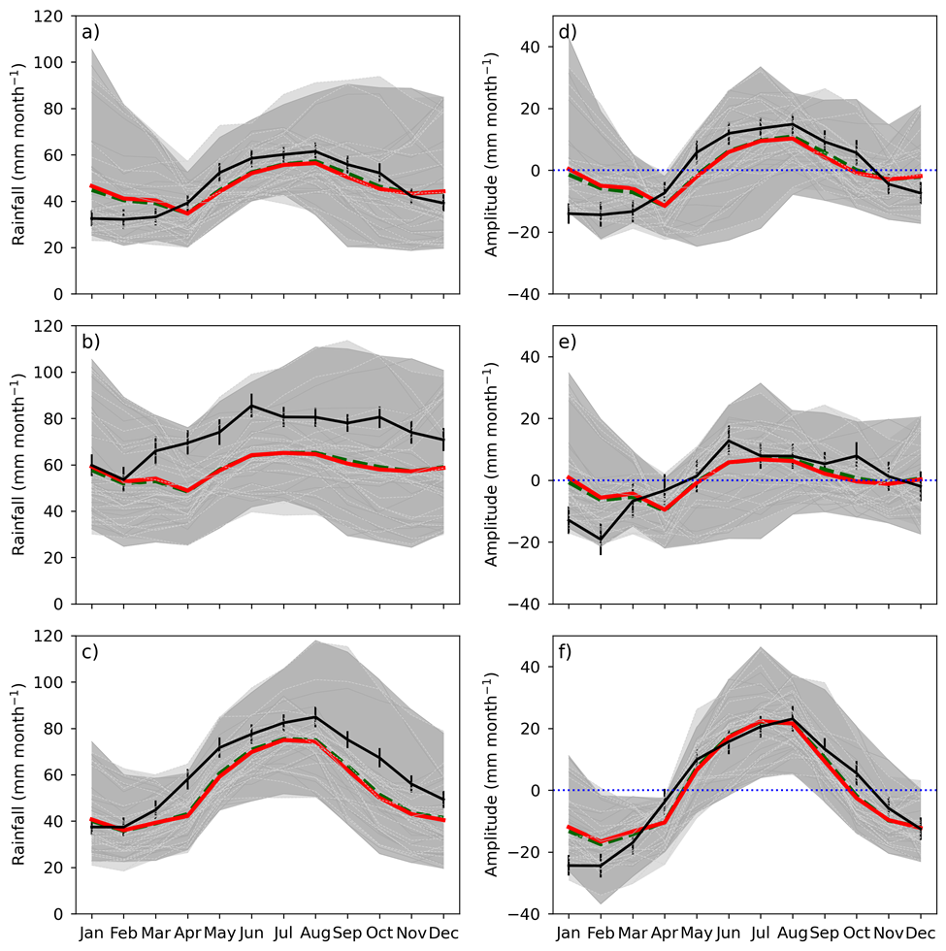
Supplementary Figure 1 CMIP5 simulated (left column) mean annual cycle of rainfall using the 1900 – 2018 period and (right column) corresponding amplitudes relative to the long-term annual mean climatology for (a, d) MBVic (b, e) SEVic and (c, f) SWVic regions. Observations based on AWAP are shown by the black line. Multi model ensemble mean for the same period under histALL simulation patched with RCP8.5 (HIST/RCP8.5) scenario is shown by the red line and ensemble mean of piCTL models with at least 500 years of simulation is shown by the green dashed line. Individual HIST/RCP8.5 and piCTL models are shown in dark and light gray colours. Shaded areas indicate the minimum and maximum values of HIST/RCP8.5 models (dark gray) and piCTL models (light gray), respectively. Error bar shows the 5th and 95th percentiles confidence interval estimated using bootstrapping of monthly average rainfall.

Supplementary Table 1
List of models under different CMIP5 experiments that are used in this study. Most of the analysis in this paper are based on 24 models (name in bold) that have at least 500 years of piCTL runs (x under piCTL column) as well as have simulations under historical all-forcing, RCP4.5 and the RCP8.5 scenarios. 35 models have at least 200 years of simulations under preindustrial condition (model names in bold and in italic). Similarly, 48 models provide historical simulation using all-forcing for the period 1900 – 2005, but out of this only 18 and 16 models have historical simulations under natural-only and GHG-only forcings. 40, 38 and 28 models provide rainfall histroical simulations for the period 1900 – 2005 and have future projections for the period 2006 – 2100 under high (RCP8.5), mediuam (RCP4.5) and low (RCP2.6) emission scenarios.

Model Names | piCTL | Historical |  |  | RCPs
Model Names | piCTL | ALL | NAT | GHG | 8.5 | 4.5 | 2.6
ACCESS1-0 | x | x |  |  | x | x
ACCESS1-3 | x | x |  |  | x | x
bcc-csm1-1 | x | x | x | x | x | x | x
bcc-csm1-1-m | + | x |  |  | x | x | x
BNU-ESM | x | x | x |  | x | x | x
CanESM2 | x | x | x | x | x | x | x
CCSM4 | x | x | x | x | x | x | x
CESM1-BGC | x | x |  |  | x | x
CESM1-CAM5 | + | x |  |  | x | x | x
CESM1-CAM5-1-FV2 |  | x
CESM1-FASTCHEM | + | x
CESM1-WACCM | + | x
CMCC-CESM |  | x |  |  | x
CMCC-CM | + | x |  |  | x | x
CMCC-CMS | x | x |  |  | x | x
CNRM-CM5 | x | x | x | x | x | x | x
CNRM-CM5-2 |  | x
CSIRO-Mk3-6-0 | x | x | x | x | x | x | x
CSIRO-Mk3L-1-2 | x
EC-EARTH |  | x |  |  | x
FGOALS-g2 | x | x | x | x | x | x | x
FGOALS-s2 | x | x |  |  | x | x | x
FIO-ESM |  | x |  |  | x | x | x
GFDL-CM2p1 |  | x
GFDL-CM3 | x | x | x | x | x | x | x
GFDL-ESM2G | x | x |  |  | x | x | x
GFDL-ESM2M | x | x | x | x | x | x | x
GISS-E2-H | + | x | x | x | x | x | x
GISS-E2-H-CC |  | x |  |  | x | x
GISS-E2-R |  | x | x | x | x | x | x
GISS-E2-R-CC |  | x |  |  | x | x
HadCM3 |  | x
HadGEM2-AO |  | x |  |  | x | x | x
HadGEM2-CC |  | x |  |  | x | x
HadGEM2-ES | x | x | x | x | x | x | x
inmcm4 | x | x |  |  | x | x
IPSL-CM5A-LR | x | x | x | x | x | x | x
IPSL-CM5A-MR | + | x | x |  | x | x | x
IPSL-CM5B-LR | + | x |  |  | x | x
MIROC-ESM | x | x | x | x | x | x | x
MIROC-ESM-CHEM |  | x | x | x | x | x | x
MIROC5 | x | x |  |  | x | x | x
MPI-ESM-LR | x | x |  |  | x | x | x
MPI-ESM-MR | x | x |  |  | x | x | x
MPI-ESM-P | x | x
MRI-CGCM3 | x | x | x | x | x | x | x
MRI-ESM1 |  | x
NorESM1-M | x | x | x | x | x | x | x
NorESM1-ME | + | x |  |  | x | x | x
Total Numbers = | 35 | 48 | 18 | 16 | 40 | 38 | 28

Supplementary References:

Bhend, J, Whetton P (2017) Evaluation of simulated recent climate change in Australia. Aust. Meteorol Oceanogr J 65: 4–18. https://doi.org/10.22499/2.6501.003
Grose M, Abbs D, Bhend J et al (2015a) Southern Slopes Cluster Report, Climate change in Australia projections for Australia’s natural resource management regions. Cluster Reports, eds. Ekström, M. et al., CSIRO and Bureau of Meteorology, Australia. https://www.climatechangeinaustralia.gov.au/media/ccia/2.2/cms_page_media/168/SOUTHERN_SLOPES_CLUSTER_REPORT_1.pdf
Grose M, Timbal B, Wilson L, Bathols J, Kent D (2015b): The subtropical ridge in CMIP5 models, and implications for projections of rainfall in southeast Australia. Aust. Meteorol Oceanogr J 65:90–106. https://doi.org/10.22499/2.6501.007
Moise A, Wilson L, Grose M et al (2015) Evaluation of CMIP3 and CMIP5 models over the Australian region to inform confidence in projections. Aust. Meteorol Oceanogr J 65:19–53. https://doi.org/10.22499/2.6501.004
Rauniyar SP, Power SB (2020) The impact of anthropogenic forcing and natural processes on past, present, and future rainfall over Victoria, Australia. J Clim 33:8087–8106. https://doi.org/10.1175/JCLI-D-19-0759.1

