Supplementary information

ELX: An Empirical Two-Stage Combinatorial Approach to Identify Pleiotropic Genetic Effects by using Genome-Wide Association Summary Statistics
Ming-Ju Tsai^{1,2*}, Xing Chen^{3*}, and Yi-Hsiang Hsu^{1,2,3,4§}

¹Hinda and Arthur Marcus Institute for Aging Research, Hebrew SeniorLife, Boston, 02131, MA
²Department of medicine, Beth Israel Deaconess Medical Center and Harvard Medical School, Boston, MA
³Molecular and Integrative Physiological Sciences, Harvard School of Public Health, Boston, MA
⁴BROAD Institute of MIT and Harvard, Boston, MA
* These authors contributed equally to this work
§Corresponding author

Corresponding author:
Yi-Hsiang Hsu MD, ScD
1200 Centre Street, Marcus Institute for Aging Research at Hebrew SeniorLife, Boston, MA 02131, USA
Tel: 617 444-5340
Email: yihsianghsu@hsl.harvard.edu

Performance of dLC and eLC approach in Simulation Series II with lower genetic effect size
In Simulation Series II, we concentrated on evaluating the performance of multivariate methods in simulated datasets with smaller genetic effect size. The results from using individual-level data and aggregated data are shown, respectively, in Tables S3 and S4. Similar to the observations in Simulation Series I, dLC and eLC are superior or similar to other approaches in all scenarios, whereas GEE, LME, and OB suffer a large reduction in power under mixed genetic effects. Interestingly, PCA tends to perform poorly as difference of effects increases, compared to our proposed methods and MANOVA. In addition, the power of our proposed methods does not seem be influenced by the method used in calculating covariance matrix Σ or type of data available, as it is in Simulation Series I. The proposed methods also have strong power to detect pleiotropy compared to univariate approaches with/without adjusting for multiple tests.

Statistical methods for analyzing GAW16 dataset
Additive effects of a genotype model were assumed in univariate GWAS analyses. A SNP was excluded if one of the following conditions were met: call rate in the population was <95%, p-value from a test of Hardy-Weinberg Equilibrium (HWE) was <1x10⁻⁶, or the minor allele frequency (MAF) was <1%. LME with kinship package was used to examine univariate associations and test hypotheses of HDL and TG against genetic variants across the human genome. We then applied our two-stage approach to jointly analyze HDL and TG to investigate whether our strategy is superior at identifying those true pleiotropic SNPs in this simulation dataset. For combining approach (dLC/eLC), we used the pooled univariate Z test statistics of HDL and TG from LME model to approximately estimate the variance-covariance matrix. The genome-wide significance level for each analysis was defined by False Discovery Rate method (FDR) [1][12]. Those SNPs reaching genome-wide significance were then further investigated by our proposed method to identify their independent effect with each phenotype of interest. Bonferroni correction method was adopted to correct multiple testing issues in Stage 2.

Estimating covariance matrix of test statistics from individual-level family data
Referring to the notations in the Methods section, the point estimate β from a univariate LME model can be calculated as the standard least-square approach with familial correlation matrix $∑_{i}$ :
$$β={\left(\sum{X^{T}Σ_{i}^{-1}X}\right)}^{-1}\sum{X^{T}Σ_{i}^{-1}Y}$$
Therefore, the covariance between two correlated point estimates $β_{1},β_{2}$ for two correlated traits on the same genetic variant can be estimated as:
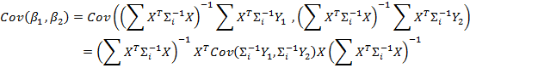
where $X$ is a vector of a specific SNP genotype data for all subjects, $Y_{1},Y_{2}$ are the phenotypes vectors for two traits of interest, and $∑_{i}$ is the familial correlation matrix estimated from kinship relationship. Therefore, the covariance matrix of β₁ and β₂, can be constructed as
$$\left[\begin{matrix}Var(β_{1}) & Cov\left(β_{1 }, β_{2}\right) \\ Cov\left(β_{1 }, β_{2}\right) & Var(β_{2})\end{matrix}\right]$$
These algorithms can be easily extended to a multivariate scenario.

Estimation of bona fide p-value of eLC
The optimal c value can be computed from a reasonably large interval [0, $τ$] by applying a simple procedure suggested by Xu et al. [2]. Specifically, the empirical null distribution of S_{eLC} can be estimated by generating M (a large number) independent Z from multivariate normal distribution with mean 0, and variance-covariance matrix $Г$ ($Г$ can be easily derived from Σ or estimated from data). For each simulated Z, we can compute S_{eLC} as a function of specific c ( 0 ≤ c ≤$τ$ ). Thus, a reference set R consisting of M realized S_{eLC} (S(c); 0 ≤ c ≤$τ$ ) can be established under the null hypothesis. Let the s(c) be the observed value of S_{eLC} from the real data, then its p-value p(c) = Pr(S(c) > s(c)) can be calculated based on the null reference set R.
Then another reference set D containing difference p(c) with respect to the value of c can also be obtained by enumerating different values of c in the given interval. Let p(m)=min{0 ≤ c ≤$τ$ }p(c) in reference set D, representing the smallest p-value among all the tests by far. However, p(m) is not the correct p-value for such a test. To infer the accurate cut-off threshold of this procedure, we can permute the data or generate N (a large number) fresh independent Z again by using the mean and variance-covariance structure, the random counterparts of p(c) and p(m), annotated as P(c) and P(m), therefore can be estimated to establish the null distribution. Then a bona fide p-value, Pr(P(m) < p(m)), of the test can be computed correspondingly.

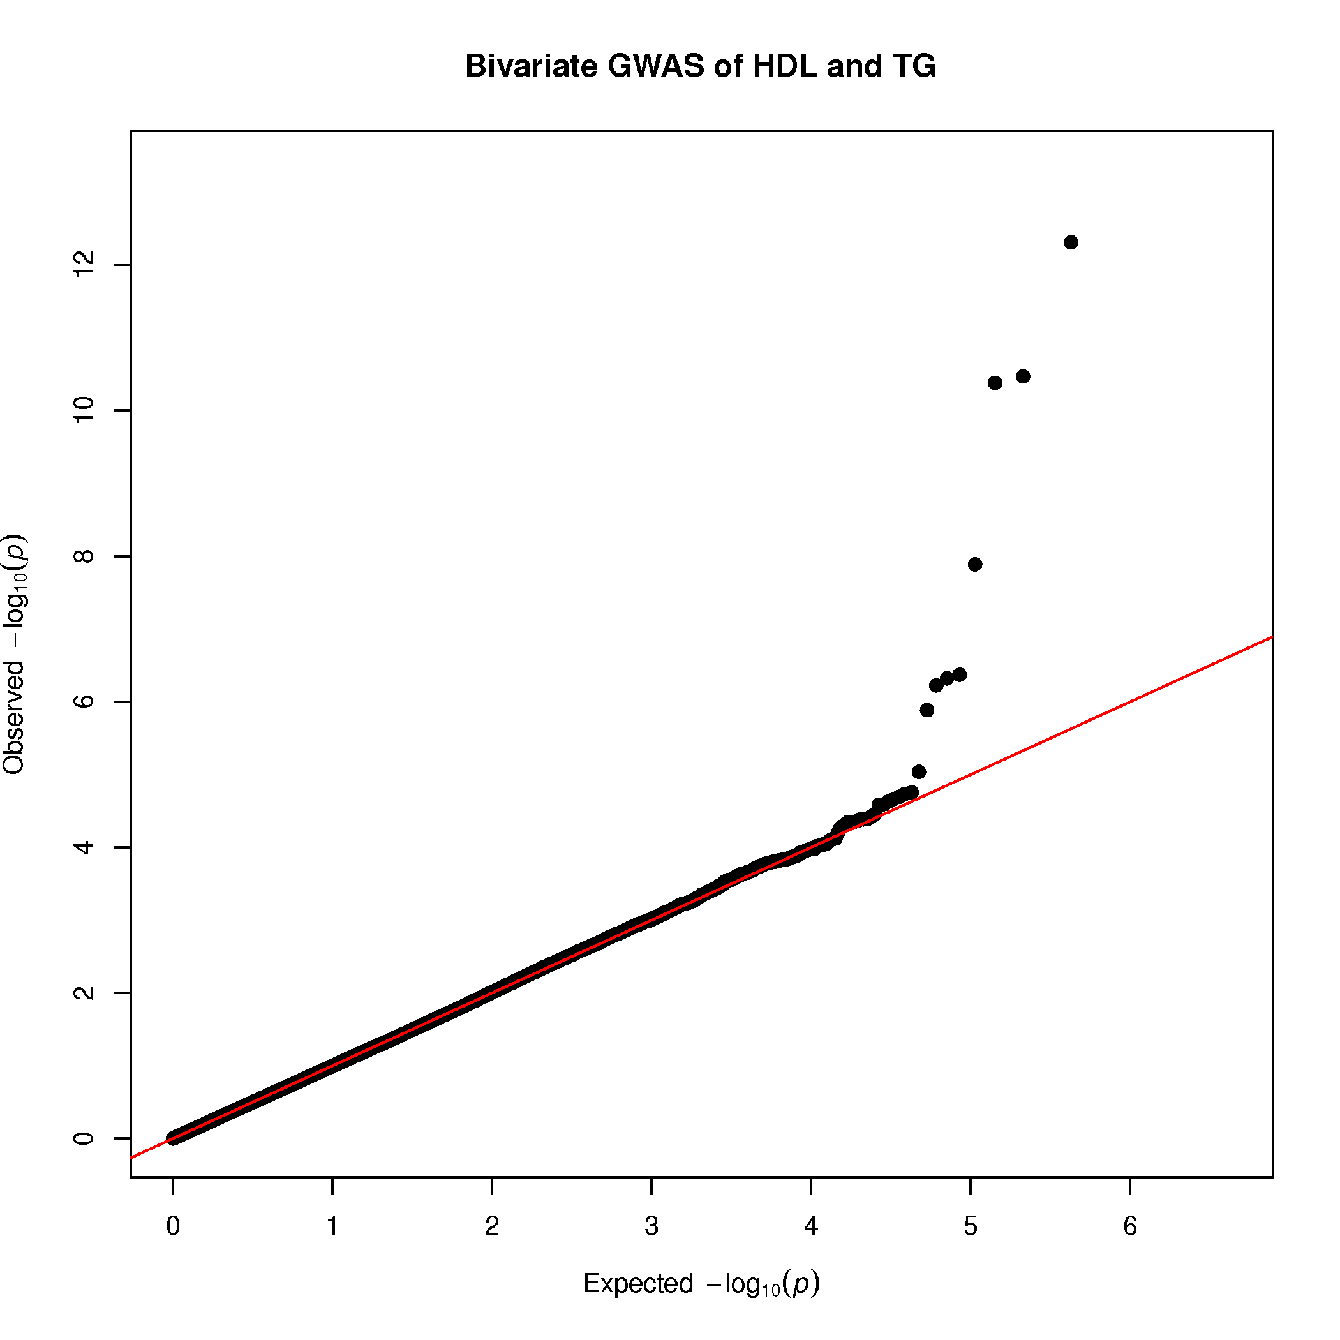
Figure S1. Q-Q plot of bivariate GWAS results of HDL and TG in the GAW16 dataset
Figure S2. Scatter diagram of -10log-transformed p-values from bivariate GWAS analyses of HDL and TG using individual-level data and aggregated data. The direct linear combination approach (dLC) was used.

Monte-Carlo Simulation datasets
In particular, a single continuous trait was first generated with an assigned effect size. The second trait was then simulated by artificially adding random noise on the first generated trait. Therefore, the genetic variant is directly associated with the first trait but indirectly linked with the second trait, as illustrated in R2 and R3 in Figure 2. In all simulations, only quantitative traits and unrelated subjects were generated.
Bivariate quantitative phenotypes were randomly drawn from a bivariate normal distribution to represent the pleiotropic relationship R1 in Figure 1:
Y=$\left[\begin{matrix}Y_{1} \\ Y_{2}\end{matrix}\right]$~ N$\left(\left[\begin{matrix}β_{1}X \\ β_{2}X\end{matrix}\right], \left[\begin{matrix}1 & ρ \\ ρ & 1\end{matrix}\right] \right)$
where $β_{i}$ is the additive genetic effect size for trait i, X is the additive score of the coded allele, and $ρ$ is the residual correlation between $Y_{1}$ and $Y_{2}$,respectively.
Various simulation scenarios with respect to $ρ$ were further generated. Briefly, $ρ$ was selected at -0.75, -0.25, 0.01, 0.25, and 0.75 to mimic the correlations we have observed in real GWAS data analyses in the Simulation Series I. A smaller range of $ρ$ at -0.5, -0.25, 0.01, 0.25 and 0.5 was also employed in Simulation Series II with lower genetic heritability. Notably, a mixture of protective and deleterious genetic effects was introduced when negative $ρ$ was used in generating data. For instance, we assigned β₁=- β₂ as the alternative hypothesis when $ρ$ was -0.25.
In addition to bivariate scenarios, we also generated three moderately correlated quantitative traits to evaluate the performance of various approaches when more than two traits were combined. For simplicity, the genetic heritability was equivalently set at 0.5% for each of the three traits. And the pairwise phenotypic residual correlation was chosen at 0.25, -0.15, and -0.20. The data were then generated under the null hypothesis H_{o}: β₁=β2=β₃=0 and two alternative hypotheses, H₁: β₁=-β₂=-β₃ >0 and H₁: β₁=β₂=-β₃ >0, respectively.
Each replicate was analyzed by using OB, dLC, and eLC approaches individually. We estimated the covariance matrix Σ through approximation from summary data and individual-level data. Other multivariate methods were also compared, including LME with a random effect accounting for phenotypic correlations, GEE, MANOVA, and PCA, in which the first component was used as a dependent variable in the subsequent linear model. All analyses were conducted in R software (http://r-project.org/). Power and type I error rates of each approach were calculated as the proportion of replicates with a p-value less than a given significant threshold in the corresponding scenarios. Specifically, power was derived with 1000 replicates with the significance level at p-value equal to 10⁻⁴ for each true scenario in Simulation Series I, and 10⁻² for those in Simulation Series II. Type I error rates were estimated in the settings that β₁=β₂=0 with 1000 replicates at nominal significance levels of 0.05 and 0.01. In the context of adjusting multiple testing for two univariate association tests of two phenotypes, standard Bonferroni corrections were applied with the significance level at 5*10⁻⁵ and 5*10⁻³ for Simulation Series I and II separately.

Supplementary Tables

Supplementary Table S1. Parameters setting of MCS dataset
 |  | Phenotype 1 (Y₁) |  | Phenotype 2 (Y₂)
Scenario | H₁ | H₂ | β | H₂ | β
Series I: Higher effect size
A | β₁ = |β₂ | >0 | 0.02 | 0.34 | 0.02 | 0.34
B | β₁ > |β₂| > 0 | 0.02 | 0.34 | 0.01 | 0.24
C | β₁ > 0, β₂ = β₁ + ε | 0.02 | 0.34 | Random noise
D* | β₁ = |β₂| = |β₃| > 0 | 0.02 | 0.34
Series II: Lower effect size
A | β₁ = |β₂| > 0 | 0.005 | 0.17 | 0.005 | 0.17
B | β₁ > |β₂| > 0 | 0.005 | 0.17 | 0.001 | 0.075
C | β₁ > 0, β₂ = β₁ + ε | 0.005 | 0.17 | Random noise
D** | β₁ = |β₂| = |β₃| > 0 | 0.005 | 0.17
Four scenarios are A) Pleiotropy with equal effect, B) Pleiotropy with unequal effect, C) Non-pleiotropy, and D) Pleiotropy on multiple phenotypes in each series.
*Equal heritability in this scenario is assigned as 0.02 for all three quantitative traits.
** Equal heritability in this scenario is assigned as 0.005 for all three quantitative traits.

Supplementary Table S2. Power of multivariate approaches using individual-level data with the parameters of Series I
Scenario | ρ¶ | PCA | MONOVA | GEE | LME | OB | dLC | eLC | Y₁* | Y₂*
A | -0.75 | 0.83 | 0.73 | 0.00 | 0.00 | 0.00 | 0.74 | 0.77 | 0.69 | 0.67
 | -0.25 | 0.96 | 0.93 | 0.00 | 0.00 | 0.00 | 0.93 | 0.92 | 0.65 | 0.68
 | 0.01 | 0.82 | 0.98 | 0.99 | 0.99 | 0.99 | 0.98 | 0.97 | 0.69 | 0.68
 | 0.25 | 0.96 | 0.93 | 0.97 | 0.96 | 0.96 | 0.93 | 0.93 | 0.66 | 0.66
 | 0.75 | 0.82 | 0.74 | 0.83 | 0.81 | 0.81 | 0.75 | 0.76 | 0.66 | 0.68
B | -0.75 | 0.59 | 0.64 | 0.03 | 0.00 | 0.03 | 0.65 | 0.66 | 0.69 | 0.19
 | -0.25 | 0.82 | 0.76 | 0.00 | 0.00 | 0.00 | 0.77 | 0.75 | 0.66 | 0.21
 | 0.01 | 0.74 | 0.91 | 0.95 | 0.94 | 0.95 | 0.91 | 0.90 | 0.67 | 0.19
 | 0.25 | 0.85 | 0.78 | 0.84 | 0.83 | 0.84 | 0.79 | 0.79 | 0.65 | 0.20
 | 0.75 | 0.59 | 0.65 | 0.58 | 0.58 | 0.58 | 0.65 | 0.66 | 0.68 | 0.20
Scenario A indicates that pleiotropy with equal effect size (H₁: β₁ = |β₂| = 0.34)
Scenario B indicates that pleiotropy with unequal effect size (β₁ = 0.34; |β₂| = 0.24)
*: p-values were adjusted using Bonferroni corrections in these univariate analyses
¶: opposite effect direction was assigned when negative phenotypic correlation ρ was used

Supplementary Table S3. Power of multivariate approaches using individual-level data with the parameters of Series II
Scenario | ρ¶ | PCA | MONOVA | GEE | LME | OB | dLC | eLC | Y₁* | Y₂*
A | -0.50 | 0.53 | 0.43 | 0.02 | 0.00 | 0.02 | 0.44 | 0.42 | 0.31 | 0.31
 | -0.25 | 0.61 | 0.51 | 0.01 | 0.00 | 0.01 | 0.52 | 0.51 | 0.28 | 0.32
 | 0.01 | 0.49 | 0.61 | 0.74 | 0.73 | 0.73 | 0.61 | 0.63 | 0.28 | 0.27
 | 0.25 | 0.57 | 0.46 | 0.58 | 0.56 | 0.57 | 0.46 | 0.45 | 0.26 | 0.27
 | 0.50 | 0.50 | 0.39 | 0.51 | 0.50 | 0.50 | 0.40 | 0.40 | 0.27 | 0.30
B | -0.50 | 0.24 | 0.30 | 0.11 | 0.01 | 0.10 | 0.30 | 0.27 | 0.29 | 0.04
 | -0.25 | 0.30 | 0.28 | 0.07 | 0.02 | 0.07 | 0.28 | 0.30 | 0.27 | 0.04
 | 0.01 | 0.28 | 0.36 | 0.39 | 0.38 | 0.38 | 0.36 | 0.36 | 0.28 | 0.04
 | 0.25 | 0.29 | 0.28 | 0.30 | 0.29 | 0.29 | 0.29 | 0.31 | 0.29 | 0.04
 | 0.50 | 0.24 | 0.28 | 0.24 | 0.24 | 0.23 | 0.28 | 0.28 | 0.28 | 0.04
Scenario A indicates that pleiotropy with equal effect size (H₁: β₁ = |β₂| = 0.17)
Scenario B indicates that pleiotropy with unequal effect size (β₁ = 0.34; |β₂| = 0.075)
*: p-values were adjusted using Bonferroni corrections in these univariate analyses
¶: opposite effect direction was assigned when negative phenotypic correlation ρ was used

Supplementary Table S4. Power of multivariate approaches using aggregated-level data with the parameters of Series II
Scenario | ρ¶ | OB | dLC | eLC | Y₁* | Y₂*
A | -0.50 | 0.02 | 0.44 | 0.43 | 0.31 | 0.31
 | -0.25 | 0.01 | 0.52 | 0.50 | 0.28 | 0.32
 | 0.01 | 0.74 | 0.62 | 0.63 | 0.28 | 0.27
 | 0.25 | 0.58 | 0.46 | 0.45 | 0.26 | 0.27
 | 0.50 | 0.50 | 0.39 | 0.41 | 0.27 | 0.30
B | -0.50 | 0.11 | 0.30 | 0.27 | 0.29 | 0.04
 | -0.25 | 0.07 | 0.29 | 0.31 | 0.27 | 0.04
 | 0.01 | 0.39 | 0.35 | 0.35 | 0.28 | 0.04
 | 0.25 | 0.29 | 0.29 | 0.30 | 0.29 | 0.04
 | 0.50 | 0.23 | 0.29 | 0.29 | 0.28 | 0.04
Scenario A indicates that pleiotropy with equal effect size (H₁: β₁ = |β₂| = 0.17)
Scenario B indicates that pleiotropy with unequal effect size (β₁ = 0.34; |β₂| = 0.075)
*: p-values were adjusted using Bonferroni corrections in these univariate analyses
¶: opposite effect direction was assigned when negative phenotypic correlation ρ was used

Supplementary Table S5. Power of multivariate approaches on multiple correlated phenotypes using individual-level and aggregated data
Individual-Level Data
H₁ | PCA | MANOVA | GEE | OB_{i} | dLC_{i} | eLC_{i} | Y1* | Y2* | Y3*
β1 = β2 = -β3 = 0.34 | 0.99 | 0.99 | 0.12 | 0.01 | 0.99 | 0.99 | 0.66 | 0.62 | 0.63
β1 = -β2 = -β3 = 0.34 | 0.98 | 0.99 | 0.10 | 0.12 | 0.99 | 0.99 | 0.64 | 0.62 | 0.61
β1 = β2 = -β3 = 0.17 | 0.65 | 0.58 | 0.13 | 0.04 | 0.58 | 0.71 | 0.23 | 0.24 | 0.26
β1 = -β2 = -β3 = 0.17 | 0.17 | 0.90 | 0.12 | 0.21 | 0.72 | 0.80 | 0.25 | 0.26 | 0.24
Aggregated Data
H₁ | PCA | MANOVA | GEE | OB_{z} | dLC_{z} | eLC_{z} | Y1* | Y2* | Y3*
β1 = β2 = -β3 = 0.34 | - | - | - | 0.01 | 0.99 | 0.99 | 0.66 | 0.62 | 0.63
β1 = -β2 = -β3 = 0.34 | - | - | - | 0.12 | 0.99 | 0.99 | 0.64 | 0.62 | 0.61
β1 = β2 = -β3 = 0.17 | - | - | - | 0.04 | 0.59 | 0.71 | 0.23 | 0.24 | 0.26
β1 = -β2 = -β3 = 0.17 | - | - | - | 0.22 | 0.74 | 0.79 | 0.25 | 0.26 | 0.24
*: p-values were adjusted using Bonferroni corrections in these univariate analyses

Supplementary Table S6. Proportion of SNPs with multivariate p-values smaller than univariate p-values in all simulation scenarios under the relevant alternative hypotheses
 |  | eLC_{i} |  | eLC_{z}
Scenario | ρ¶ | All | Significance* | All | Significance*
A₁ | -0.75 | 0.06 | 0.09 | 0.06 | 0.08
 | -0.25 | 0.90 | 0.92 | 0.88 | 0.91
 | 0.01 | 0.99 | 0.99 | 0.99 | 0.99
 | 0.25 | 0.89 | 0.92 | 0.91 | 0.94
 | 0.75 | 0.07 | 0.10 | 0.07 | 0.10
B₁ | -0.75 | 0.10 | 0.13 | 0.07 | 0.08
 | -0.25 | 0.62 | 0.69 | 0.57 | 0.64
 | 0.01 | 0.90 | 0.93 | 0.96 | 0.97
 | 0.25 | 0.61 | 0.67 | 0.61 | 0.67
 | 0.75 | 0.08 | 0.09 | 0.08 | 0.10
A₂ | -0.50 | 0.05 | 0.12 | 0.06 | 0.14
 | -0.25 | 0.26 | 0.42 | 0.27 | 0.44
 | 0.01 | 0.55 | 0.70 | 0.57 | 0.73
 | 0.25 | 0.24 | 0.45 | 0.24 | 0.46
 | 0.50 | 0.05 | 0.11 | 0.04 | 0.08
B₂ | -0.50 | 0.14 | 0.44 | 0.13 | 0.45
 | -0.25 | 0.09 | 0.34 | 0.10 | 0.34
 | 0.01 | 0.46 | 0.62 | 0.47 | 0.61
 | 0.25 | 0.32 | 0.54 | 0.32 | 0.55
 | 0.50 | 0.18 | 0.27 | 0.18 | 0.27
*The significance level is defined as p-value = 1e-4 and 0.01 for Series I with higher effect size and Series II with lower effect size, respectively.
eLC_{i}: eLC using individual-level data
eLC_{z}: eLC using aggregated data
Scenario A₁ indicates that pleiotropy with equal and larger effect size (H₁: β₁ = |β₂| = 0.34).
Scenario B₁ indicates that pleiotropy with unequal and larger effect size (β₁ = 0.34; |β₂| = 0.24).
Scenario A₂ indicates that pleiotropy with equal and smaller effect size (H₁: β₁ = |β₂| = 0.17).
Scenario B₂ indicates that pleiotropy with unequal and smaller effect size (β₁ = 0.17; |β₂| = 0.075).
¶: opposite effect direction was assigned when negative phenotypic correlation ρ was used

Supplementary Table S7. Power of eLC after filtering SNPs with multivariate p-values smaller than univariate p-values using individual-level and aggregated data

 |  | eLCi |  | eLCz
Scenario | ρ¶ | Full | Filter | Full | Filter
A₁ | -0.75 | 0.74 | 0.06 | 0.74 | 0.06
 | -0.25 | 0.93 | 0.86 | 0.93 | 0.85
 | 0.01 | 0.98 | 0.98 | 0.98 | 0.97
 | 0.25 | 0.93 | 0.86 | 0.93 | 0.87
 | 0.75 | 0.75 | 0.07 | 0.74 | 0.07
B₁ | -0.75 | 0.65 | 0.08 | 0.65 | 0.05
 | -0.25 | 0.77 | 0.53 | 0.75 | 0.48
 | 0.01 | 0.91 | 0.85 | 0.94 | 0.91
 | 0.25 | 0.79 | 0.53 | 0.79 | 0.53
 | 0.75 | 0.65 | 0.06 | 0.65 | 0.06
A₂ | -0.50 | 0.44 | 0.05 | 0.44 | 0.06
 | -0.25 | 0.52 | 0.22 | 0.52 | 0.23
 | 0.01 | 0.61 | 0.43 | 0.62 | 0.45
 | 0.25 | 0.46 | 0.21 | 0.46 | 0.21
 | 0.50 | 0.40 | 0.04 | 0.40 | 0.03
B₂ | -0.50 | 0.30 | 0.05 | 0.30 | 0.05
 | -0.25 | 0.28 | 0.05 | 0.29 | 0.06
 | 0.01 | 0.36 | 0.13 | 0.35 | 0.13
 | 0.25 | 0.29 | 0.05 | 0.29 | 0.06
 | 0.50 | 0.28 | 0.04 | 0.29 | 0.03
Filter criteria was defined as p-value = 0.01
eLC_{i}: eLC using individual-level data
eLC_{z}: eLC using aggregated data
Scenario A₁ indicates that pleiotropy with equal and larger effect size (H₁: β₁ = |β₂| = 0.34).
Scenario B₁ indicates that pleiotropy with unequal and larger effect size (β₁ = 0.34; |β₂| = 0.24).
Scenario A₂ indicates that pleiotropy with equal and smaller effect size (H₁: β₁ = |β₂| = 0.17).
Scenario B₂ indicates that pleiotropy with unequal and smaller effect size (β₁ = 0.17; |β₂| = 0.075).
¶: opposite effect direction was assigned when negative phenotypic correlation ρ was used.

