Supplementary Information

Table S1. Glucose and ethanol concentrations and corresponding percent of theoretical ethanol yields after 2 days of 37 °C fermentations of 150, 180, and 200 g/L glucose by S. cerevisiae D5A and K. marxianus CBS 6556.
Glucose  concentration (g/L) | Yeast  strain | Ethanol  concentration (g/L) | Percent of  theoretical  ethanol  yield | Glucose  remaining  (g/L)
150 | D5A | 70.63 | 90 | 0.15
150 | CBS 6556 | 66.23 | 86.08 | 13.63
180 | D5A | 84.39 | 90 | 0.15
180 | CBS 6556 | 73.51 | 79.20 | 37.33
200 | D5A | 81.09 | 78.33 | 42.62
200 | CBS 6556 | 79.98 | 77.91 | 48.35

Table S2. Ethanol concentrations and yields and glucose concentrations resulting from application of D5A at 37 °C and CBS 6556 at 37 and 43 °C to SSF of CELF pretreated solids at 13, 17, and 20 wt% solids loadings and corresponding glucan levels using Cellic® CTec2 enzyme at a loading of 15 mg protein/g glucan in raw poplar.
Insoluble solid loading (wt%) | Glucan loading (wt%) | Yeast | Temp.  (°C) | Ethanol concentration (g/L) | Percent theoretical ethanol yield (%) | Fermentation time  (days) | Glucose remaining (g/L) after fermentation
13 | 11 | D5A | 37 | 43.00 | 69 | 7 | 0
13 | 11 | CBS 6556 | 37 | 41.80 | 66 | 6 | 11.27
13 | 11 | CBS 6556 | 43 | 40.00 | 62 | 4 | 14.35
17 | 15 | D5A | 37 | 58.21 | 66 | 7 | 5.26
17 | 15 | CBS 6556 | 37 | 53.00 | 59 | 5 | 13.21
17 | 15 | CBS 6556 | 43 | 44.70 | 50 | 2 | 15.39
20 | 18 | D5A | 37 | 70.00 | 65 | 7 | 6.96
20 | 18 | CBS 6556 | 37 | 62.00 | 57 | 3 | 9.95
20 | 18 | CBS 6556 | 43 | 49.00 | 40 | 1 | 21.90

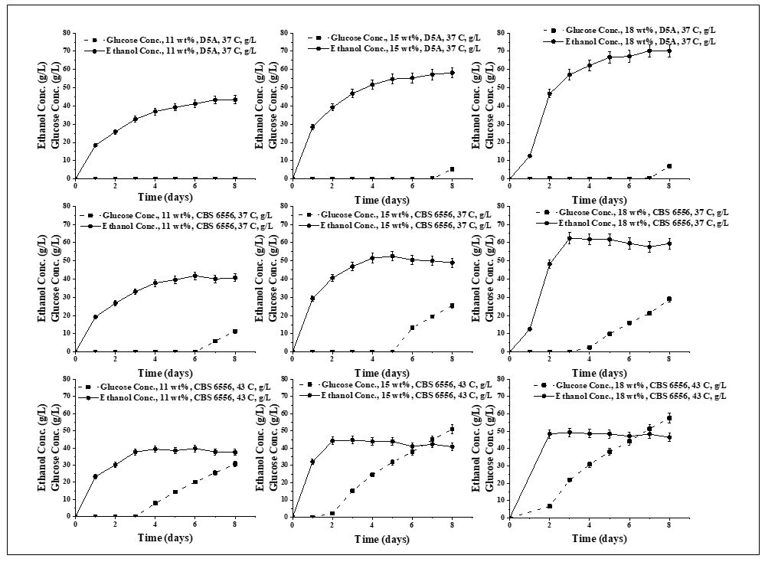
Figure S1. Ethanol and glucose concentrations (g/L) produced by S. cerevisiae (D5A) at 37 °C and K. marxianus (CBS 6556) at 43 °C when used in SSF of CELF pretreated poplar solids at glucan loadings of 11, 15, and 18 wt% with an enzyme loading of 15 mg protein/g glucan.
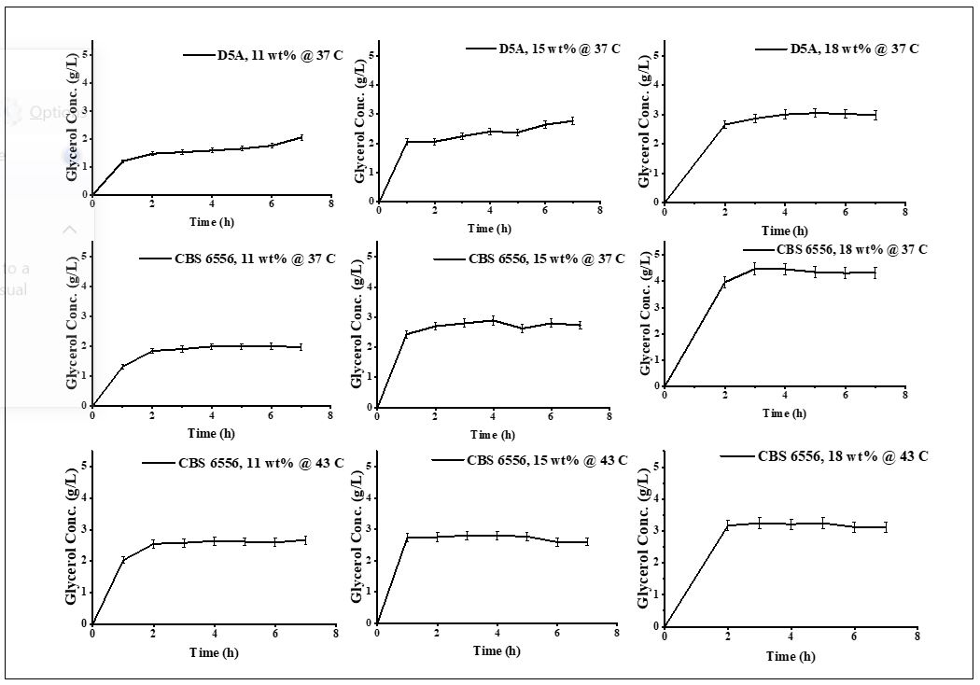
Figure S2. Glycerol concentrations resulting from use of S. cerevisiase (D5A) at 37 °C and K. marxinaus (CBS 6556) at 37 and 43 °C in SSF at glucan loadings of 11, 15, and 18 wt% of CELF pretreated poplar solids for an enzyme loading of 15 mg protein per g glucan.

