Supplemental figures and tables for “Growth genes are implicated in the evolutionary divergence of sympatric piscivorous and insectivorous rainbow trout (Oncorhynchus mykiss)”, by Grummer et al..

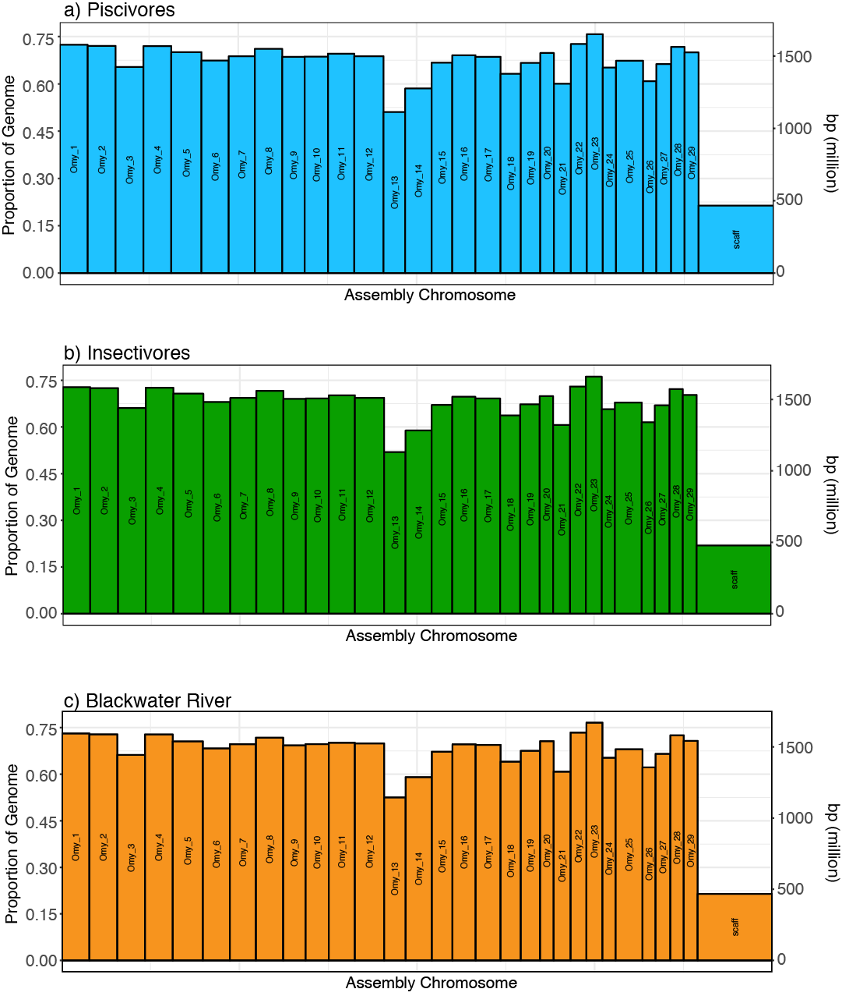

Supplemental Figure S1. Sequencing coverage by chromosome following data filtering and quality controls for Kootenay Lake (panels (a) and (b)) and Blackwater River (c) rainbow trout.

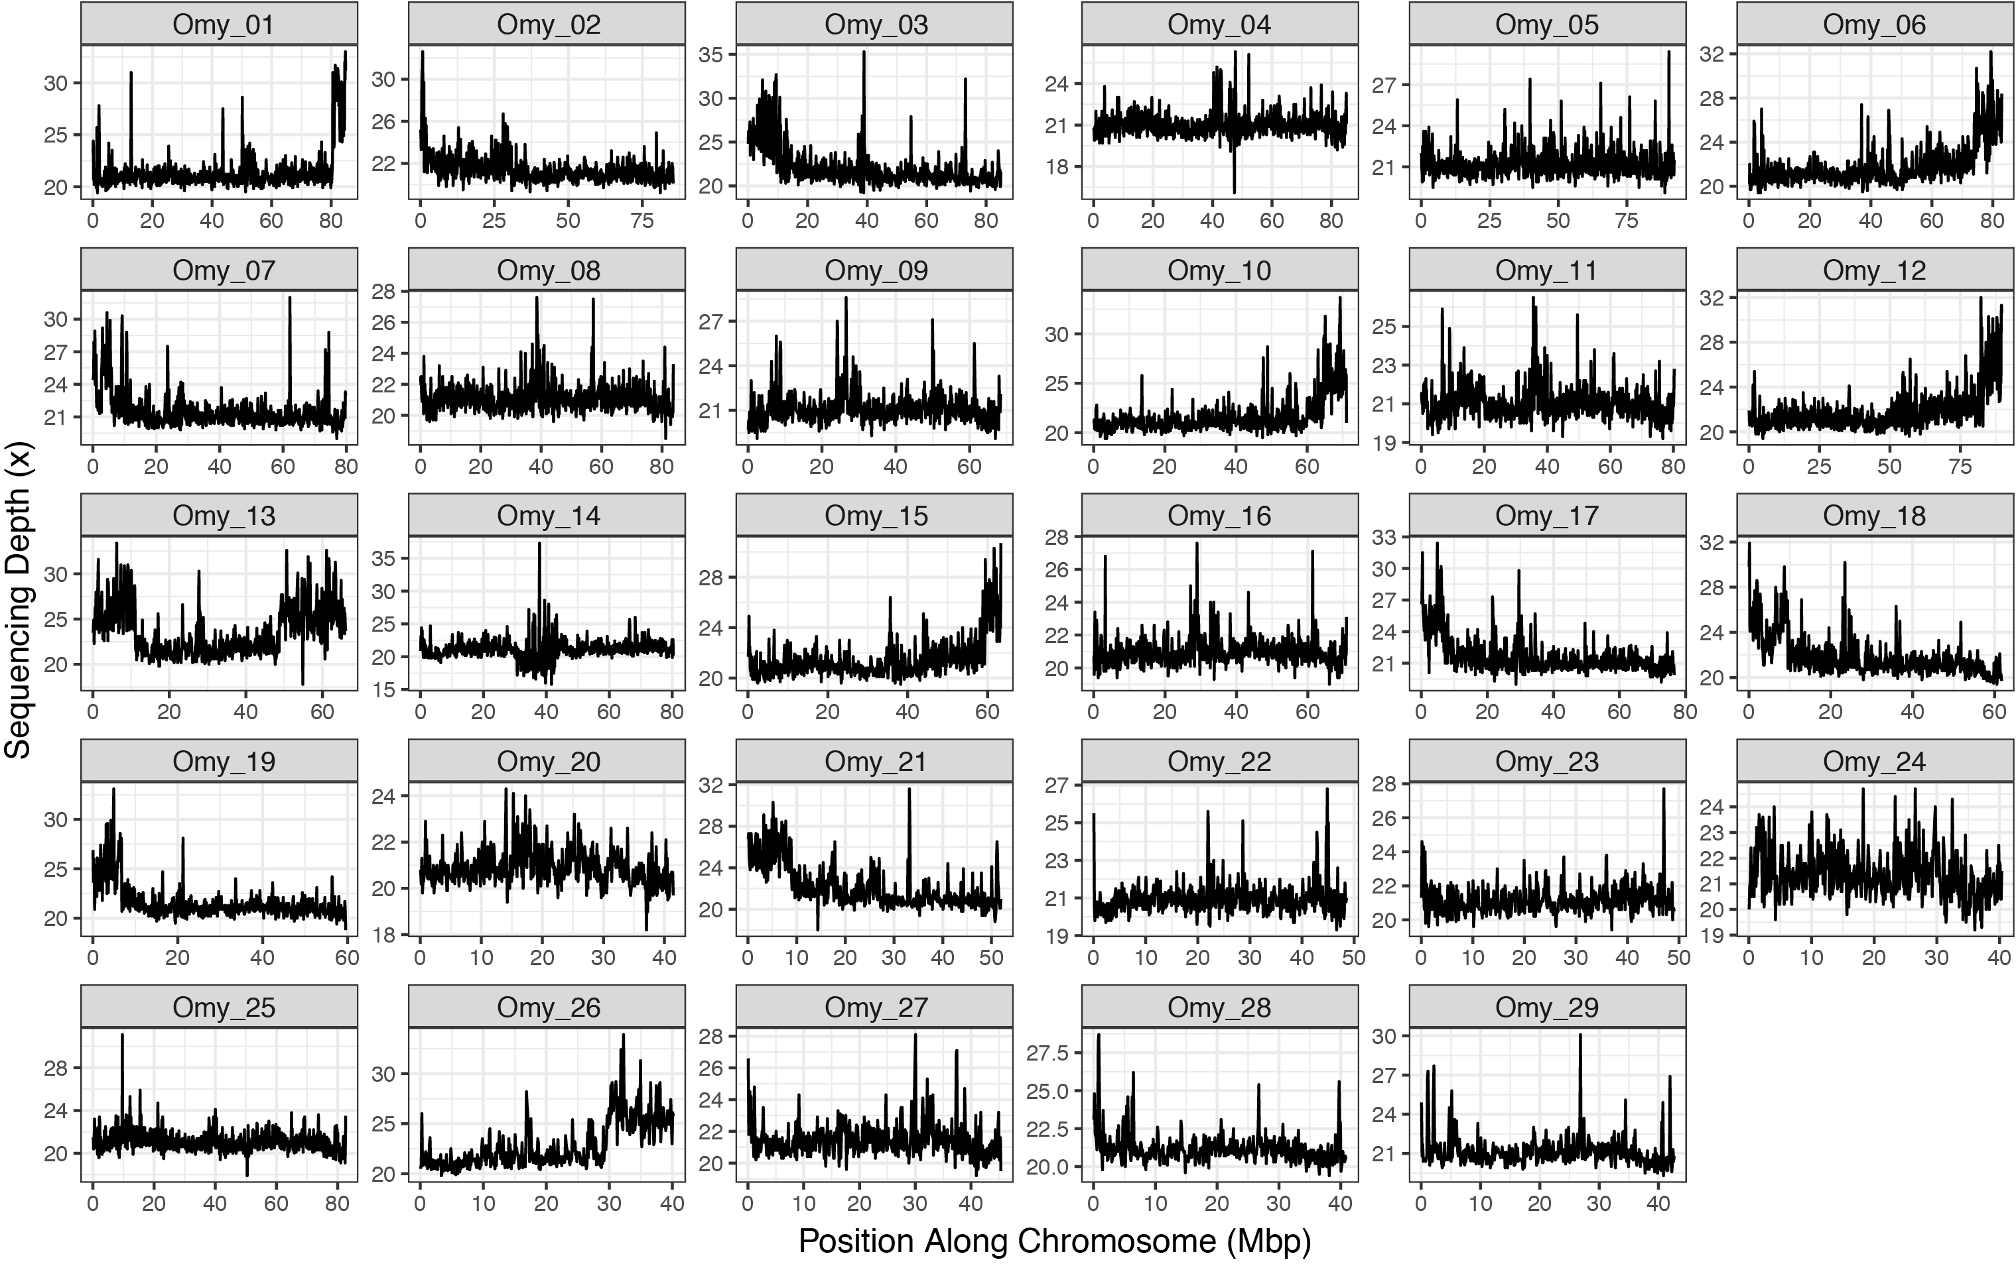
Supplemental Figure S2. Sequencing depth (coverage) by chromosome and per 100,000bp window, averaged across piscivore and insectivore pools. Note the variable x- and y-axes.
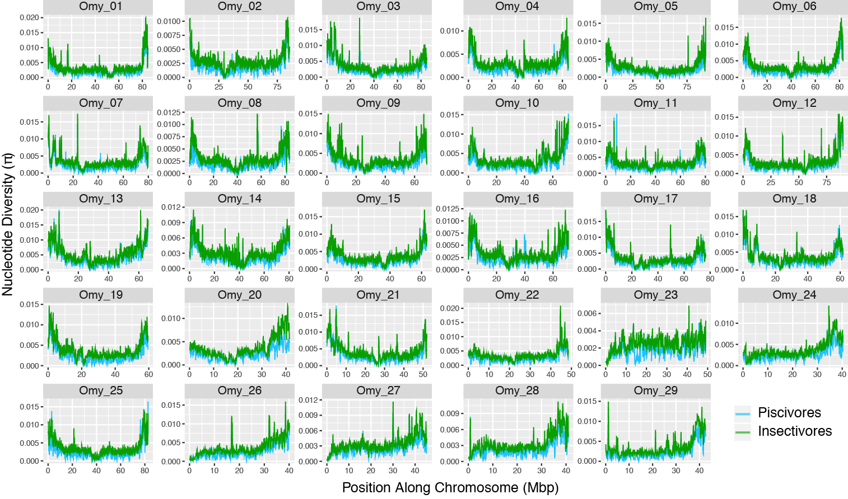
Supplemental Figure S3. Nucleotide diversity by chromosome and per 100,000bp window of piscivorous and insectivorous rainbow trout from Kootenay Lake. Note the variable x- and y-axes.
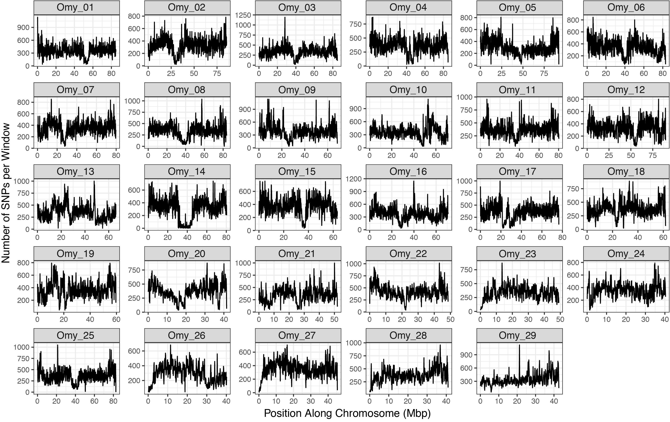
Supplemental Figure S4. SNP density by chromosome and per 100,000bp window between piscivorous and insectivorous rainbow trout from Kootenay Lake. Note the variable x- and y-axes.

Supplemental Figure S5. Distribution of single SNP Weir and Cockerham F_{ST} estimates after MAF and quality filtering for piscivores ("Gerrards") vs. insectivores ("non-Gerrards") in Kootenay Lake.

Supplemental Figure S6. Gene ontology (GO) enrichment analysis results for loci found in genomic windows with F_{ST} estimates greater than 0.2 (n = 7,219 windows) when the target gene set is not included in the background set. Processes are grouped by functional class (colour), and size of each process is scaled by the significance (log₁₀ p-value) of enrichment of that process in relation to all processes in the genome.
Supplemental Figure S7. Gene ontology (GO) enrichment analysis results for loci found in genomic windows with F_{ST} estimates greater than 0.3 (n = 2,737 windows) when the target gene set is not included in the background set. Processes are grouped by functional class (colour), and size of each process is scaled by the significance (log₁₀ p-value) of enrichment of that process in relation to all processes in the genome.

Supplemental Figure S8. Gene ontology (GO) enrichment analysis results for loci found in genomic windows with F_{ST} estimates greater than 0.4 (n = 854 windows) when the target gene set is not included in the background set. Processes are grouped by functional class (colour), and size of each process is scaled by the significance (log₁₀ p-value) of enrichment of that process in relation to all processes in the genome.

Supplemental Table S1. Locality information for individuals included in this study. Eighty individuals were sampled from each of the Blackwater and Gerrard sites, whereas the other sites were represented by 10 individuals each.
Site | Piscivore or Insectivore | Latitude | Longitude
Blackwater River | I | 53.13425 | -123.59189
Gerrard | P | 50.50947 | -117.27607
Corn Creek | I | 49.09290 | -116.61144
Crawford Creek | I | 49.68683 | -116.81820
Cultus Creek | I | 49.32534 | -116.78876
Goat River | I | 49.07408 | -116.50724
Hendryx Creek | I | 49.76851 | -116.85717
La France Creek | I | 49.52654 | -116.78181
Tam O'Shanter Creek | I | 49.79215 | -116.84807
Redfish Creek | I | 49.61315 | -117.04604
Sanca Creek | I | 49.37488 | -116.72954
Summit Creek | I | 49.14942 | -116.60710

Supplemental Table S2. Genomic position and F_{ST} estimates of the twenty most divergent 100,000bp windows between piscivorous and insectivorous rainbow trout in Kootenay Lake.
Chromosome | Position | # SNPs |  | F_{ST}
2 | 30950000 | 61 | 0.746
1 | 20450000 | 221 | 0.658
27 | 45350000 | 37 | 0.654
17 | 56050000 | 331 | 0.647
1 | 20550000 | 175 | 0.641
7 | 2450000 | 273 | 0.635
25 | 56950000 | 218 | 0.634
16 | 60250000 | 125 | 0.633
5 | 53250000 | 221 | 0.632
23 | 16450000 | 356 | 0.628
17 | 36050000 | 271 | 0.623
3 | 64350000 | 212 | 0.622
11 | 56650000 | 371 | 0.621
21 | 33650000 | 605 | 0.620
17 | 34950000 | 362 | 0.619
16 | 35450000 | 306 | 0.617
16 | 35550000 | 216 | 0.616
5 | 55850000 | 181 | 0.611
3 | 64250000 | 306 | 0.611
19 | 36650000 | 437 | 0.609

Supplemental Table S3. Simulation results from local score analyses of FLK and LK test results.

Statistic | FLK | LK
Number of tests where exactly the same region was found | 551
Number of tests where the majority of region overlapped between tests, but not completely | 35
Number of tests when LK found a region that FLK didn't | 16
Number of tests when FLK found a region that LK didn't |  | 30
Percentage of time tests disagreed | 6.90%
Minimum Number of significant outlier regions found in a genome | 1 | 0
Maximum Number of significant outlier regions found in a genome | 13 | 13
Maximum Number of chromosomes with significant outlier regions found in a genome | 11 | 11
Average number of significant regions per genome | 5.92 | 5.79
Average number of significant chromosomes per genome | 5.58 | 5.50
Type I error rate per genome (chromosome-level correction) | 0.190 | 0.183

Supplemental Table S4. Annotated genes in the five windows with highest F_{ST} estimates between piscivores and insectivores.
Chromosome | Window | F_{ST} Rank | Locus | Locus Position | Protein
2 | 30,900,000 - 31,000,000 | 1 | LOC110501635 | 30,387,211 - 30,917,034 | serine/threonine-protein kinase BRSK2-like
2 | 30,900,000 - 31,000,000 | 1 | abtb2 | 30,924,465 - 31,075,877 | ankyrin repeat and BTB/POZ domain-containing protein 2
1 | 20,400,000 - 20,500,000 | 2 | LOC110510928 | 20,482,398 - 20,488,002 | DET1 homolog
27 | 45,300,000 - 45,400,000 | 3 | N/A | N/A | N/A
17 | 56,000,000 - 56,100,000 | 4 | LOC110494505 | 56,058,646 - 56,294,256 | protein FAM19A1-like isoform X1
1 | 20,500,000 - 20,600,000 | 5 | LOC110511054 | 20,501,960 - 20,505,784 | uncharacterized LOC110511054
1 | 20,500,000 - 20,600,000 | 5 | LOC110511247 | 20,518,985 - 20,537,093 | microtubule-associated proteins 1A/1B light chain 3B
1 | 20,500,000 - 20,600,000 | 5 | LOC110511130 | 20,537,411 - 20,574,866 | zinc finger CCHC domain-containing protein 14-like
1 | 20,500,000 - 20,600,000 | 5 | LOC110511358 | 20,587,209 - 20,619,848 | junctophilin-3-like isoform X1

