In Silico Analysis of Aberrant Gene Expression Profiles in Haematologic Malignancies and their Impact on Mismatch Repair Functions
Running title – Interplay of MMR and DEGs in Hematologic Malignancies
Priyanjali Bhattacharya¹, Trupti N Patel^{1*}
¹Department of Integrative Biology, Vellore Institute of Technology, Vellore, India
*Corresponding Address: tnpatel@vit.ac.in, Dr.TNPatel@gmail.com

Supplementary Data
TABLE 1: Details of the samples studied in six GEO profiles via Affymetrix platform.

GEO Profile | Sample Type | Sample Count
GSE5550 | CD34+ hematopoietic stem and progenitor cells | Healthy control - 8 Untreated CML patients – 9
GSE9476 | Leukaemic blasts (patients) and normal hematopoietic cells at different stages of maturation (control) | Healthy donors (peripheral blood) – 10  AML patients - 26
GSE22529 | Peripheral blood B cells | Control - 11  Untreated CLL – 41
GSE28703 | Early versus non-Early T-cell precursor (ETP) | Non-ETP ALL - 40  ETP ALL – 12
GSE2657 | CD3+T cells isolated from peripheral blood samples of untreated HL patients | Control - 2  Patient – 4
GSE36000 | B cell lymphocytes from NHL patients with mutated and unmutated immunoglobulin heavy chain variable (IGHV) genes | IGHV unmutated - 14  IGHV mutated – 24

TABLE 2: Description of the categories used for DAVID and EnrichR based analysis.

Category | Full form | Description
BP | Biological Process | It encompasses broad biological goals which are accomplished by a series of molecular functions
MF | Molecular Function | It describes individual gene activities
CC | Cellular Function | It involves the location of genes, sub-cellular structures, type of macromolecular complex
Jensen Diseases | - | It is a disease database that integrates evidences on human gene-disease associations from literature, cancer mutation data, and genome-wide association studies
KEGG | Kyoto Encyclopaedia of Genes and Genomes | It helps to understand pathways covered by multiple genes
NCI-Nature | National Cancer Institute- Nature Pathway | It is a highly curated collection of pathways created by the Nature Publishing Group (NPG).

Graphical representation of 846 DEGs in six GEO profiles

The figures below (FIGURE 1-6) are the graphical representation of 846 DEGs in six myeloid and lymphoid malignancies under study.
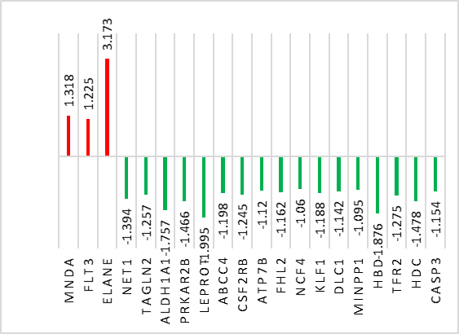
FIGURE 1: Graphical representation of upregulated (red bar), and down regulated genes (green bar) in CML.

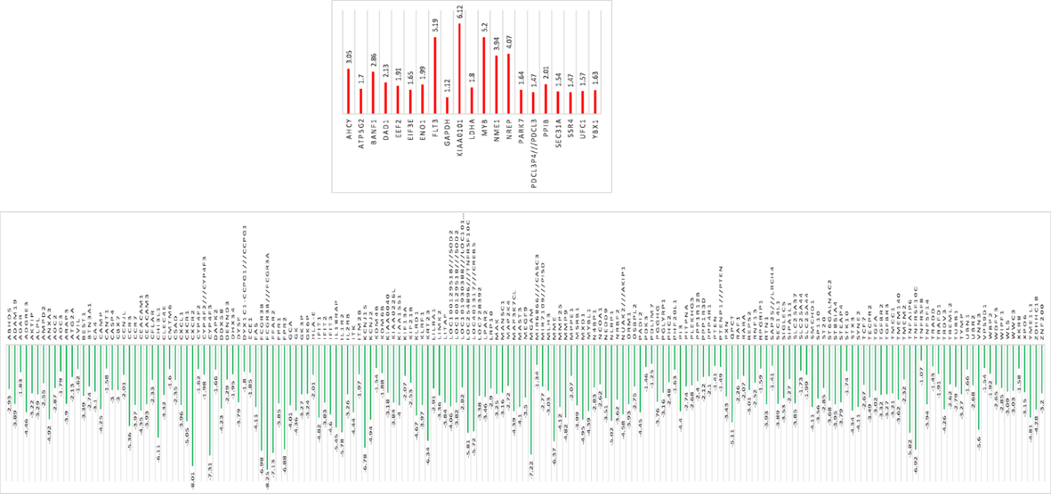
FIGURE 2: Graphical representation of upregulated (red bar), and down regulated genes (green bar) in AML.
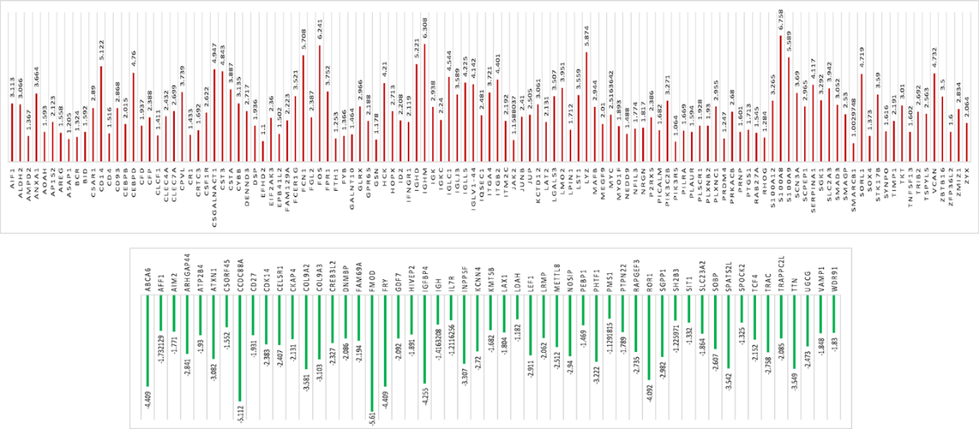
FIGURE 3: Graphical representation of upregulated (red bar), and down regulated genes (green bar) in B-CLL.

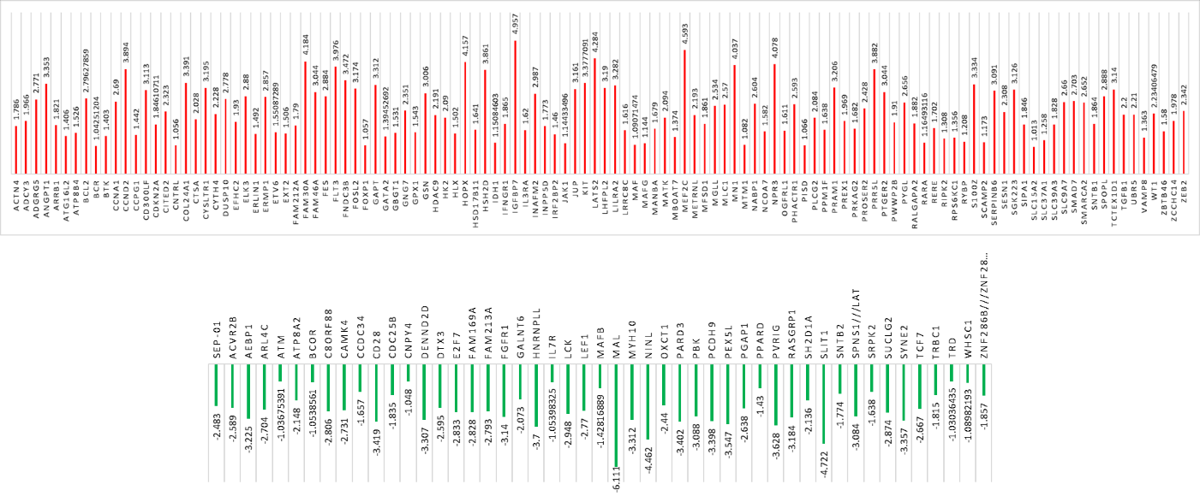
FIGURE 4: Graphical representation of upregulated (red bar), and down regulated genes (green bar) in T-ALL.
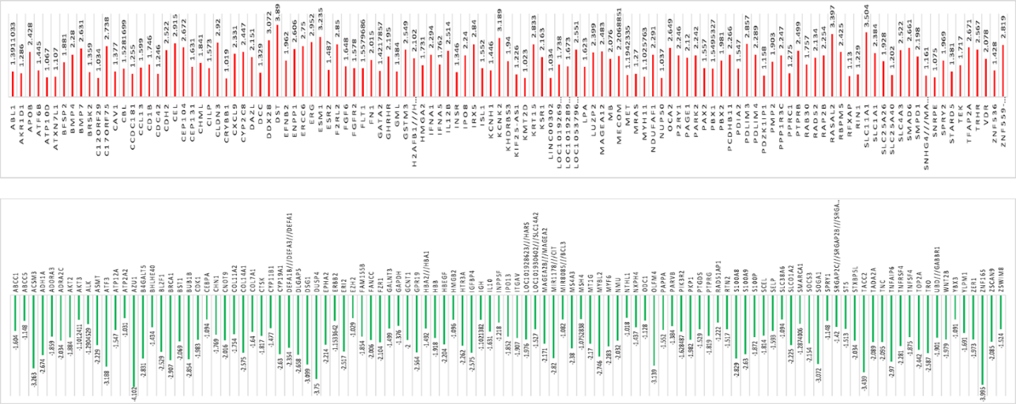
FIGURE 5: Graphical representation of upregulated (red bar), and down regulated genes (green bar) in HL.
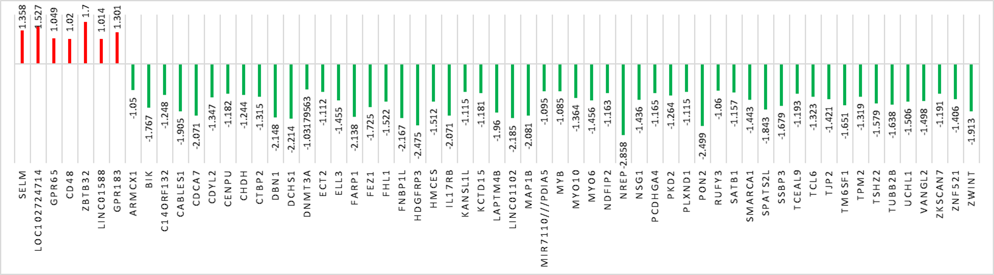
FIGURE 6: Graphical representation of upregulated (red bar), and down regulated genes (green bar) in NHL.
Differential expression and functions of 30 genes common in six blood cancer profiles along with structural and/or molecular instabilities
The disease-wise distribution of 30 DEGs commonly altered in selective blood-cancers with a focus on their expression value (logFC), GO (Gene Ontology) function, and structural/molecular instabilities are enlisted in the tables below (Table 3).

TABLE 3: List of 30 genes, their normal biological functions and types of anomalies that affect these functions in various haematologic malignancies.

Cancer profiles with DEGs | Genes | Normal gene function | Cytogenetic/ Molecular Anomalies
AML, CML, T-ALL | FLT3 | Differentiation, proliferation, and survival of haematopoietic progenitor cells | +/+
AML, HL | GAPDH | Glyceraldehyde-3-phosphate dehydrogenase activity | +/+
AML, NHL | NREP | Regulation of TGFα beta receptor signalling pathway | -/+
AML, NHL | MYB | Transcriptional activator; DNA-binding protein | +/+
AML, B-CLL | DENND3 | Guanyl-nucleotide exchange factor activity | -/+
AML, B-CLL | NEDD9 | Protein binding, protein tyrosine kinase binding | -/+
AML, B-CLL | MEGF9 | Organ morphogenesis, cell migration, substrate adhesion-dependent cell spreading | -/+
AML, B-CLL | AMPD2 | AMP deaminase activity | -/+
AML, B-CLL | FPR1 | N-formyl peptide receptor and GPCR activity | -/+
AML, T-ALL | RARA | DNA-binding transcription factor activity | +/+
AML, T-ALL | SYNE2 | Actin binding | +/-
AML, T-ALL | TCF7 | DNA-binding transcription factor activity | +/-
AML, HL | TNFAIP6 | Cell adhesion | -/+
B-CLL, T-ALL | BCR | Tyrosine phosphorylation, tyrosine kinase activity | +/+
B-CLL, T-ALL | IFNGR1 | Cytokine receptor activity | -/+
B-CLL, T-ALL | JUP | Alpha-catenin binding | -/+
B-CLL, T-ALL | GSN | Calcium ion binding | -/+
B-CLL, T-ALL | HOPX | Negative regulation of transcription from RNA pol II promoter | -/+
B-CLL, T-ALL | MAFB | Transcription factor binding | +/+
B-CLL, HL | S100A8 | Apoptotic process | -/+
B-CLL, HL | S100A9 | Apoptotic process | -/+
B-CLL, NHL | GPR65 | Apoptotic process | -/+
B-CLL, T-ALL | IL7R | Cytokine receptor activity | +/+
B-CLL, T-ALL | LEF1 | Positive and negative regulation of transcription regulator | +/+
B-CLL, HL | INPP5F | Inositol monophosphate 1-phosphatase activity | -/+
B-CLL, HL | IGH | Innate immune response | +/+
B-CLL, HL | IGFBP4 | Inflammatory response | -/+
B-CLL, NHL | SPATS2L | RNA binding | -/+
HL, T-ALL | GATA2 | Major transcriptional process of RNA pol II | +/+
HL, NHL | SMARCA1 | Positive regulation of transcription | -/+
*- Upregulated genes, - Down regulated genes, ‘+’ - positive for structural or molecular abnormalities, ‘-’ - negative for structural or molecular abnormalities

FIGURE 7: Representation of functions - Biological, molecular and/or, cellular for 12 DEGs and their role in various diseases through NCI-Pathway analysis.

Model and Structure Validation of hdac9 protein using SWISS-MODEL and PROCHECK Ramachandran Plot
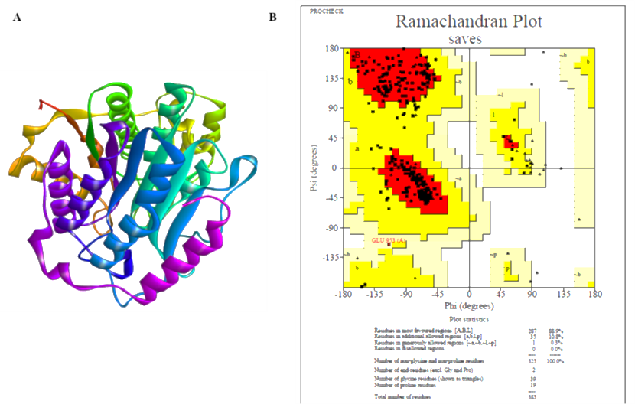
FIGURE 8: 3D model of hdac9 protein.

TABLE 4: PROCHECK Ramachandran plot analysis result of hdac9 protein.
Amino acid residues | Favoured regions | Additional allowed regions | Generously allowed regions | Disallowed regions
Protein- hdac9 | 88.9% | 10.3% | 0.3% | 0%

Molecular Docking of ATRA and Compound 3 with RARA and RXRα
We made an attempt to dock ATRA and Compound 3 with RARA and RXRα, since ATRA is used as a promising therapeutic agent in AML. Interestingly, with respect to minimum H-bond distance, the zinc finger domains of RARA and RXRα docked best with C3 (H-bond residue: Tyr1169; Distance: 3.04Ǻ) and ATRA (H-bond residue: Gln1306, Lys1260; Distance: 4.19Ǻ/2.64Ǻ) respectively. The ligand binding domains of RARA (H-bond residue: Asp323, Leu316; Distance: 4.07Ǻ, 4.41Ǻ /2.77Ǻ) and RXRα (H-bond residue: Arg316; Distance: 4.48Ǻ /3.24Ǻ), on the other, docked best with C3 (Table 5). The best docked complexes are depicted in Figure 9(A-B).

TABLE 5: Molecular Docking Results of ATRA and Compound 3 with rara and rxrα.

Ligand | rara (1DSZ)- Zinc finger domain
Ligand | BE | H-bond residue |  | H-bond distance |  | IC
Ligand | BE | DS | L | DS | L | IC
C3 | -5.93. | - | Tyr¹¹⁶⁹ | - | 3.04 | 44.9µM
ATRA | -6.57 | Cyc¹¹⁷¹ | Cys¹¹⁷¹ | 3.92 | 3.34 | 15.33µM
rxrα (1DSZ)- Zinc finger domain
C3 | -3.9 | Lys¹³⁰¹, Met¹³⁰⁰ | Arg¹³⁰², Met¹³⁰⁰ | 4.31, 5.58 | 2.76, 2.90 | 1.39mM
ATRA | -5.47 | Gln¹³⁰⁶ | Lys¹²⁶⁰ | 4.19 | 2.64 | 97.3µM
rara (3KMR)- Ligand binding domain
C3 | -4.41 | Asp³²³, Leu³¹⁶ | Asp³²³ | 4.07, 4.41 | 2.77 | 588.33µM
ATRA | -5.07 | Lys²⁰⁷ | Lys²⁰⁷ | 5.76 | 2.66 | 192.37µM
rxrα (1MZN)- Ligand binding domain
C3 | -4.64 | Arg³¹⁶ | Arg³¹⁶ | 4.48 | 3.24 | 496.63µM
ATRA | -4.79 | - | - | - | - | 308.29µM

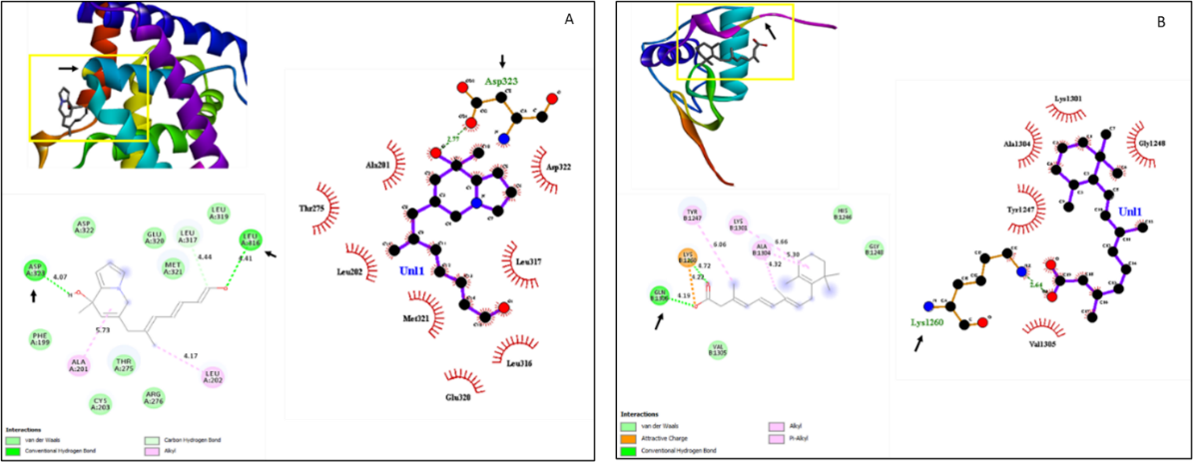
FIGURE 9: Docking results of (A) C3-RARA (3KMR), (B) C3-RXRα (1MZN); the arrows define the ligand binding sites and H-bond forming residues.

TABLE 6: Docking results of Compound 3 (C3) and ATRA with respect to minimum binding energy.

Compounds | Proteins | Binding energy (kcal/mol)
C3 | flt3 | -5.28
C3 | hdac9 | -4.92
C3 | Myc | -4.48
C3 | rad52 | -5.54
ATRA | flt3 | -5.09
ATRA | hdac9 | -5.63
ATRA | Myc | -6.03
ATRA | rad52 | -5.44
*Grey highlights- Complexes with best binding energy

