SUPPLEMENTARY TABLES LEGENDS

Table S1. Excel (supp_table1_data_raw)
Table S2. Excel (supp_table2_models_adequancy)
Table S3. Excel (supp_table3_scenarios_projections)
Table S4. Availability of climatically suitable areas and those with natural remnants for endemic anuran species from Araucaria Forest for different scenarios and projections
Model | Boana leptolineata | Melanophryniscus cambarensis | M. simplex | Proceratophrys brauni | Pseudis cardosoi | Rhienlla henseli | Sphaenorhynchus surdus
Current | 138,519 | 2,310 | 15,373 | 172,056 | 54,666 | 209,537 | 212,750
Current.b | 82,521 (40.4%) | 2,093 (9.4%) | 11,759 (23.5%) | 100,028 (41.9%) | 41,782 (23.5%) | 116,831 (44.24%) | 122,082 (42%)
2650 | 78,219 (43.5%) | 0 (100%) | 0 (100%) | 64,779 (62.4%) | 16,963 (69%) | 114,055 (45%) | 82,374 (61.3%)
2650.b | 55,472 (60%) | 0 (100%) | 0 (100%) | 47,059 (72.6%) | 15,193 (72.2%) | 75,721 (63.9%) | 60,889 (71.4%)
2670 | 84,264 (39.2%) | 0 (100%) | 0 (100%) | 69,792 (59.4%) | 18,701 (65.8%) | 115,320 (44%) | 88,268 (58.5%)
2670.b | 59,431 (57.1%) | 0 (100%) | 0 (100%) | 49,767 (71.1%) | 16,543 (69.7%) | 76,385 (63.5%) | 64,288 (69.8%)
8550 | 30,487 (78%) | 0 (100%) | 0 (100%) | 34,512 (79.9%) | 7,517 (86.2%) | 69,591 (66%) | 41,668 (80.4%)
8550.b | 25,601 (81.5%) | 0 (100%) | 0 (100%) | 27,921 (83.8%) | 6,809 (87.5%) | 53,108 (74.7%) | 33,834 (84.1%)
8570 | 22,324 (83.9%) | 0 (100%) | 0 (100%) | 18,032 (89.5%) | 3,329 (93.9%) | 47,238 (77%) | 18,164 (91.5%)
8570.b | 19,346 (86%) | 0 (100%) | 0 (100%) | 15,422 (91%) | 2,992 (94.5%) | 37,836 (81.9%) | 15,757 (92.6%)
Legend: the values outside the parentheses correspond to the climatically suitable areas (km2) and the values within the parentheses correspond to the percentage of the climatically suitable areas lost. The abbreviations followed by the letter B (e.g. Current.b, 2650.b) correspond to the climatically suitable areas together with areas of natural remnant present
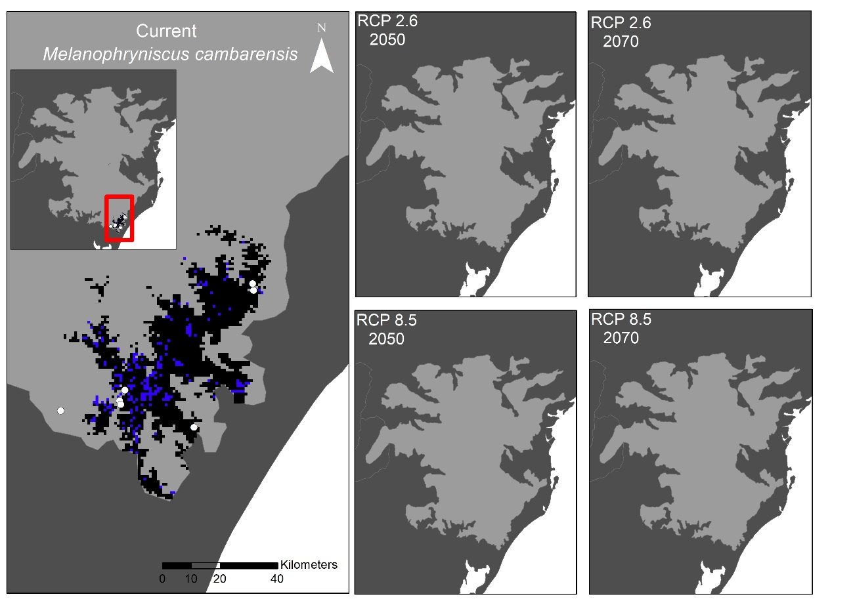
Supplementary Fig. S1. Records (white) and geographic distribution current and futures predicted to Melanophryniscus cambarensis. The maps above show the spatial congruence for 80% of our geographic distribution models. The black areas correspond to places with adequate climatic conditions plus the presence of natural remnants, while the areas in blue are only climatically suitable areas but without natural remnants.

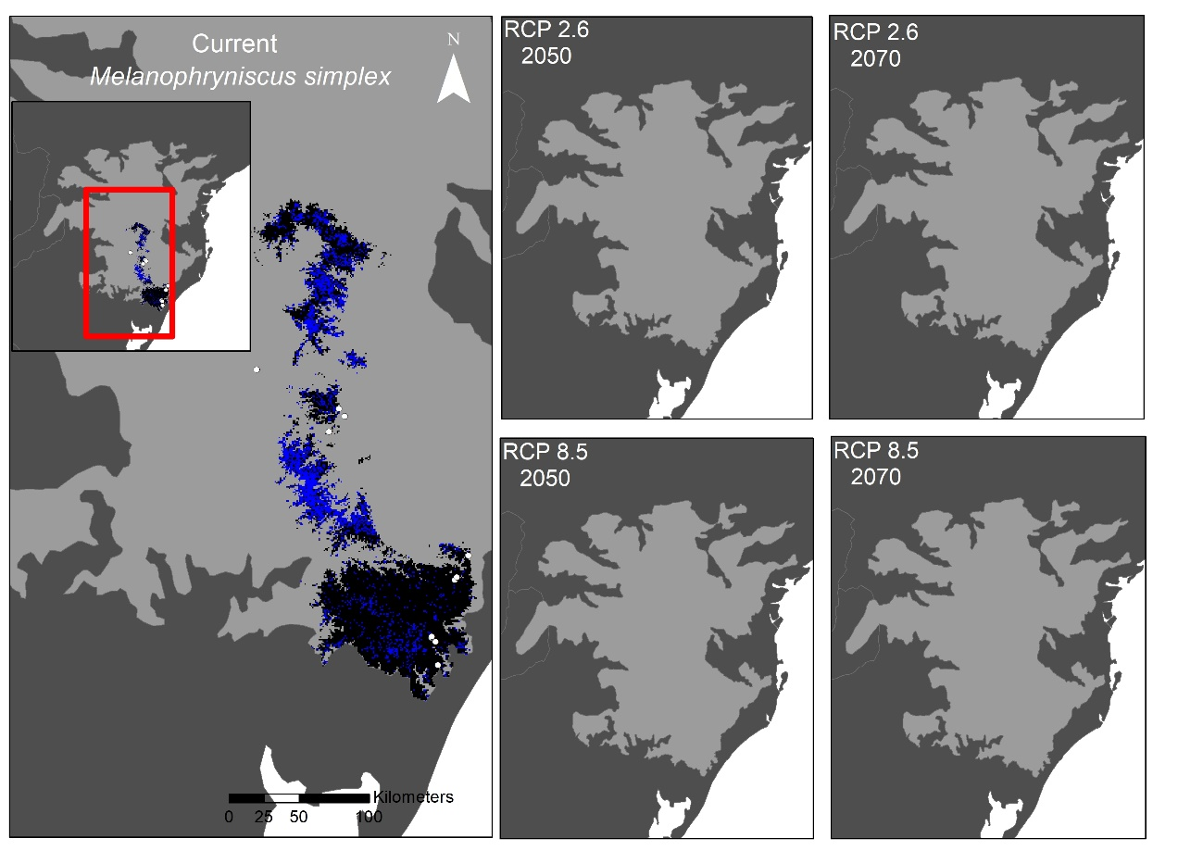
Supplementary Fig. S2. Records (white) and geographic distribution current and futures predicted to Melanophryniscus simplex. The maps above show the spatial congruence for 80% of our geographic distribution models. The black areas correspond to places with adequate climatic conditions plus the presence of natural remnants, while the areas in blue are only climatically suitable areas but without natural remnants.

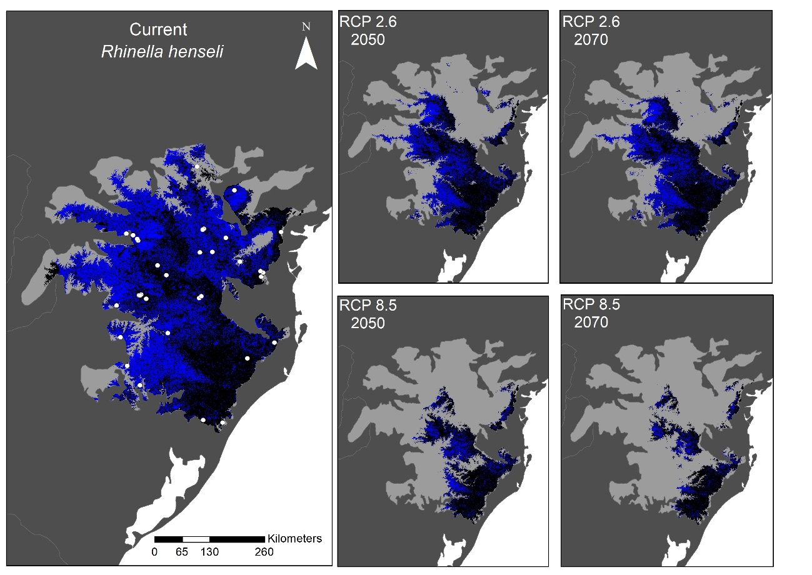
Supplementary Fig. S3. Records (white) and geographic distribution current and futures predicted to Rhinella henseli. The maps above show the spatial congruence for 80% of our geographic distribution models. The black areas correspond to places with adequate climatic conditions plus the presence of natural remnants, while the areas in blue are only climatically suitable areas but without natural remnants.

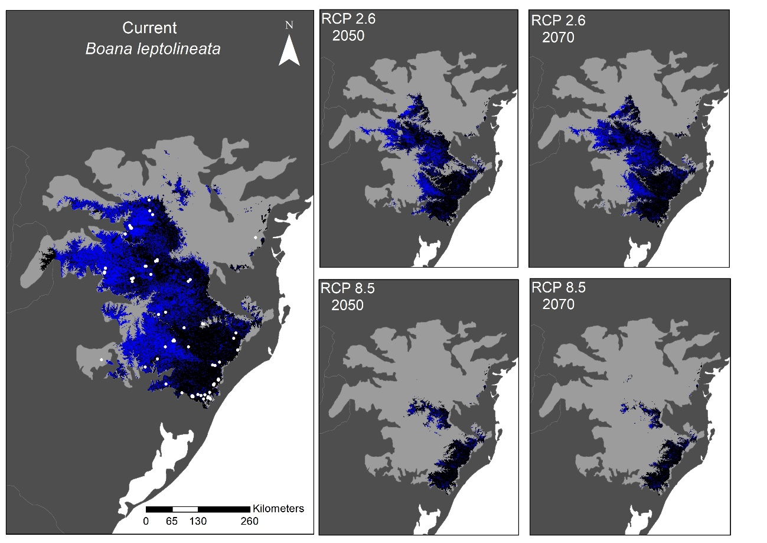
Supplementary Fig. S4. Records (white) and geographic distribution current and futures predicted to Boana leptolienata. The maps above show the spatial congruence for 80% of our geographic distribution models. The black areas correspond to places with adequate climatic conditions plus the presence of natural remnants, while the areas in blue are only climatically suitable areas but without natural remnants.

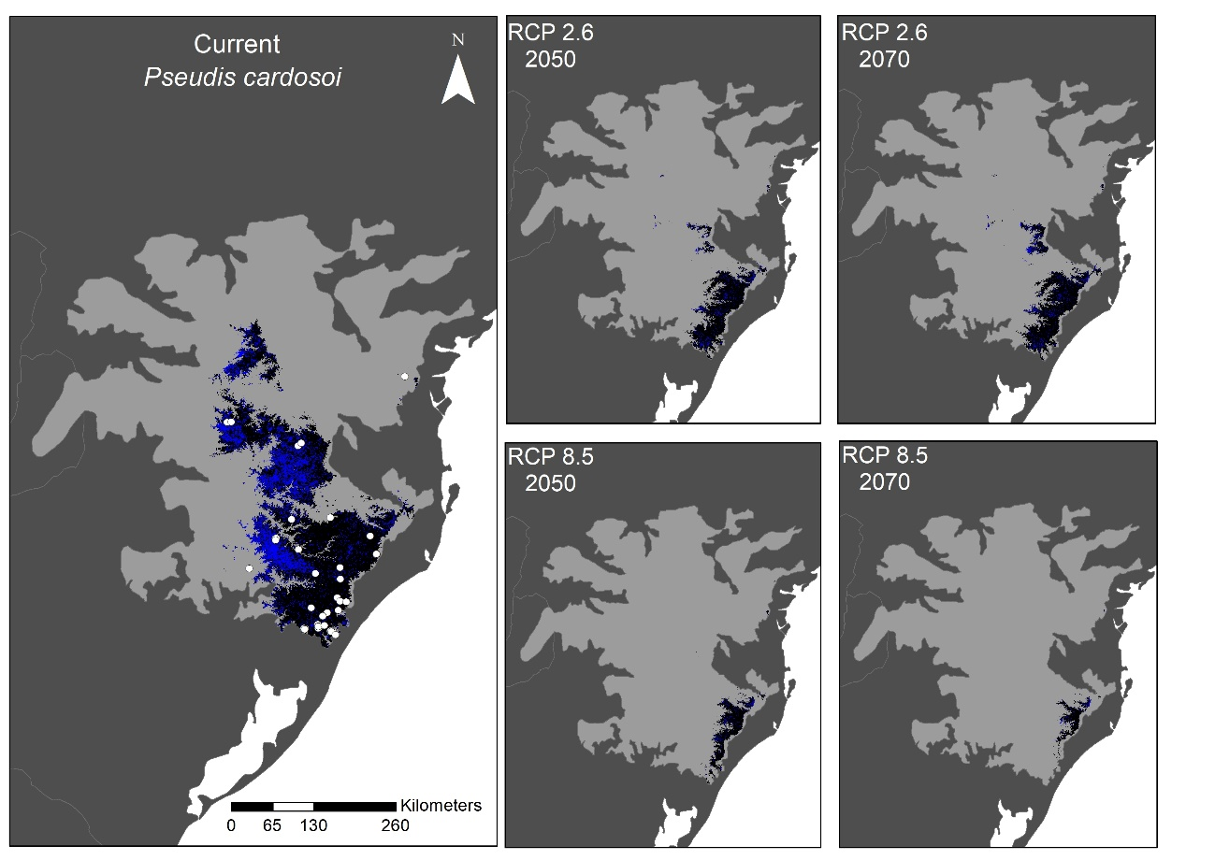
Supplementary Fig. S5. Records (white) and geographic distribution current and futures predicted to Pseudis cardosoi. The maps above show the spatial congruence for 80% of our geographic distribution models. The black areas correspond to places with adequate climatic conditions plus the presence of natural remnants, while the areas in blue are only climatically suitable areas but without natural remnants.

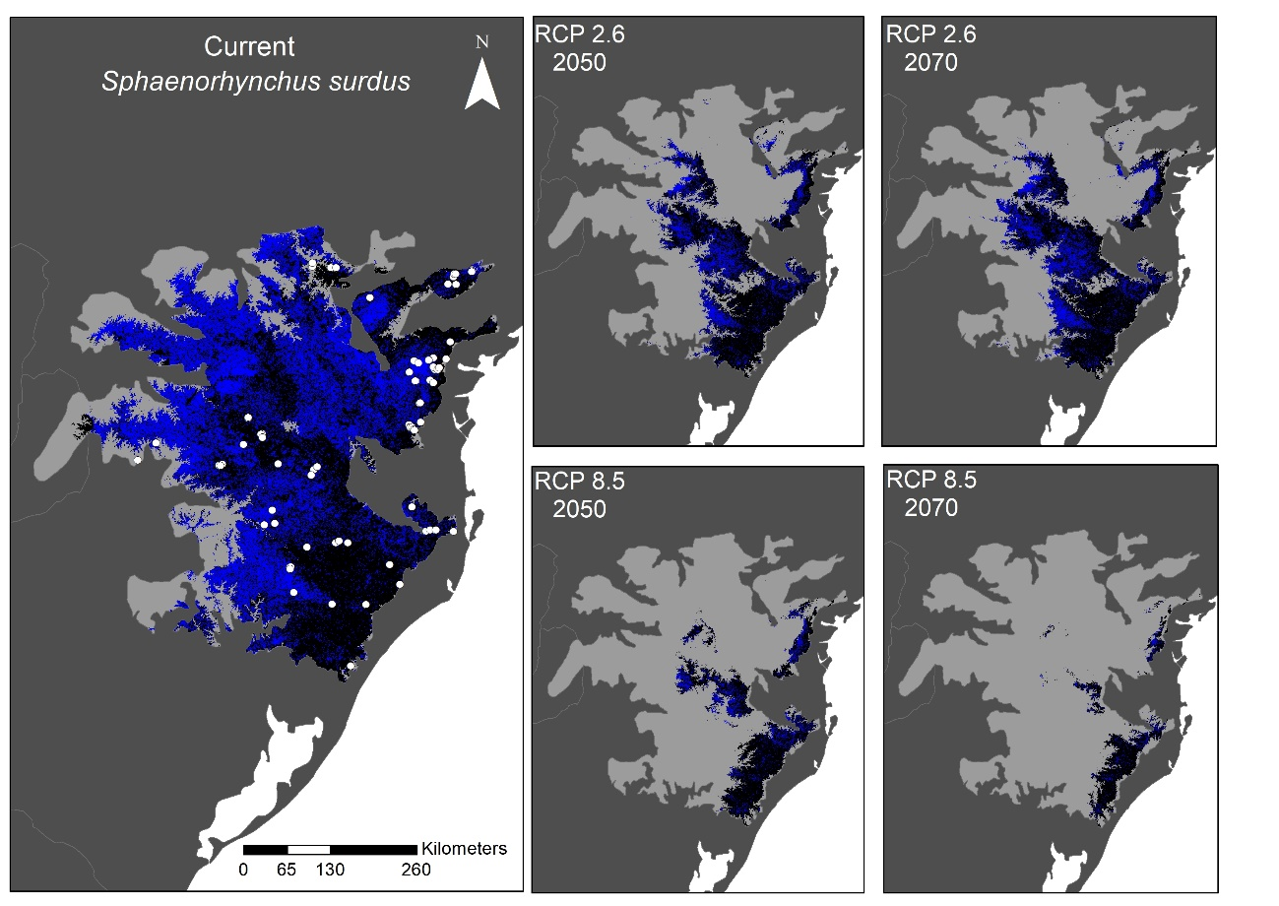
Supplementary Fig. S6. Records (white) and geographic distribution current and futures (blue) predicted to Sphaenorhynchus surdus. The maps above show the spatial congruence for 80% of our geographic distribution models. The black areas correspond to places with adequate climatic conditions plus the presence of natural remnants, while the areas in blue are only climatically suitable areas but without natural remnants.

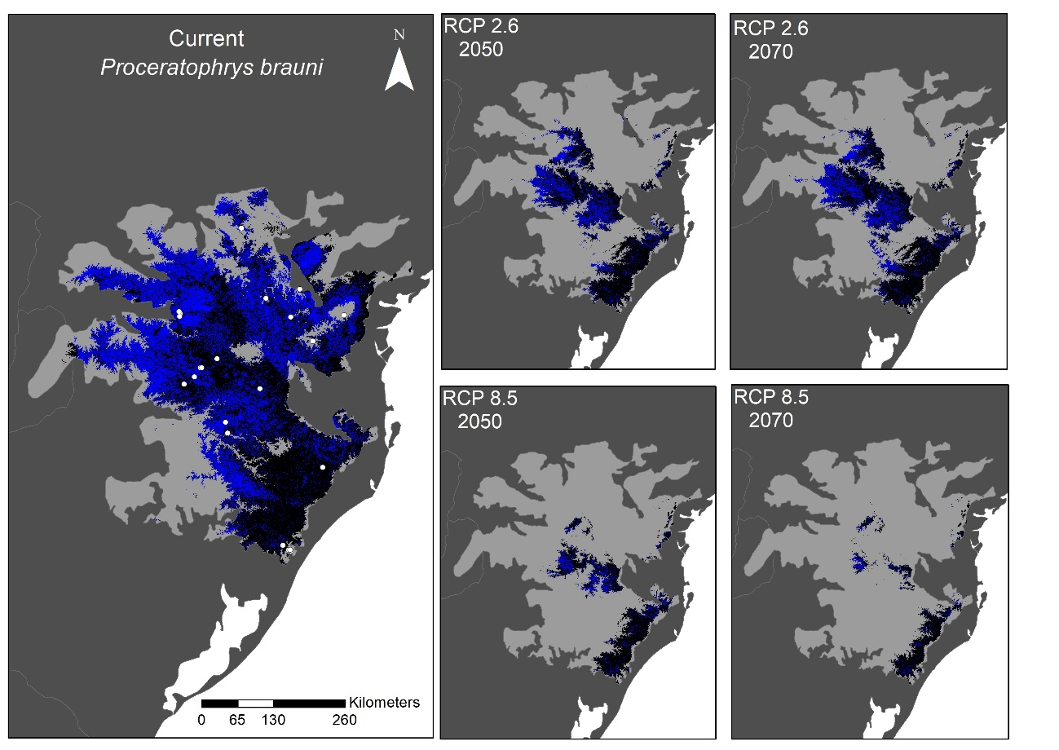
Supplementary Fig. S7. Records (white) and geographic distribution current and futures predicted to Proceratophrys brauni. The maps above show the spatial congruence for 80% of our geographic distribution models. The black areas correspond to places with adequate climatic conditions plus the presence of natural remnants, while the areas in blue are only climatically suitable areas but without natural remnants.

