Supplementary Appendix
Table S1. Treatment intervention for adult new smear-positive drug-sensitive pulmonary TB
Strategies | Drugs | Regimen | Duration | Population
Current strategy | Isoniazid (H) Rifampicin (R)  Pyrazinamide (Z)  Ethambutol (E) | 2HRZE₇/4RHE₇ | 6-months | Adult new smear-positive drug-sensitive pulmonary TB
Comparator | Moxifloxacin (M)  Isoniazid (H) Rifampicin (R)  Pyrazinamide (Z)  Ethambutol (E) | 2RHZEM₇/2RHM₇ | 4-months | Adult new smear-positive drug-sensitive pulmonary TB

Table S2. Definition for treatment outcome for adult new smear-positive drug-sensitive pulmonary TB
Treatment outcomes | Definition
Cure | The cure is a pulmonary TB patient with bacteriologically confirmed TB at the beginning of treatment who was smear or culture-negative in the last month of treatment and on at least one previous occasion
Lost to follow-up | Lost to follow-up are those TB patients whose treatment was interrupted for two consecutive months or more
Treatment failure | Treatment failure is considered when a patient is sputum smear or sputum culture-positive in the second and last month of treatment or later after the initiation of anti TB treatment
Death | Death is a TB patient who dies for any reason before starting or during treatment
Recurrent TB | Recurrent TB in patients who have previously been treated for TB were declared cured and are now diagnosed with a recurrent episode of TB (either a true relapse due to reactivation of the disease or a new episode of TB).

Table S3. Details of the study population from different studies

Patient Characteristics | No (%)
Total | 1329 (100%)
Gender  Male  Female | 1000 (75)  329 (25)
Age (Years)  <35  ≥35 | 641 (48)  688 (52)
Source: Velayutham B, Jawahar MS, Nair D, et al. 4-month moxifloxacin containing regimens in the treatment of patients with sputum-positive pulmonary tuberculosis in South India - a randomised clinical trial. Trop Med Int Health. (2020). 25(4): 483-495.
Patient Characteristics | No (%)
Total | 227 (100)
Gender  Male  Female | 133 (57)  94 (41)
Age (Years)  0-9  10-19  20-60  >60 | 3 (1)  46 (20)  164 (72)  14 (6)
Source: Sharma P, Verma M, Bhilwar M, et al. Epidemiological profile of tuberculosis patients in Delhi, India: A retrospective data analysis from the directly observed treatment short-course (DOTS) center. J Family Med Prim Care. (2019). 8(10): 3388-3392.
Patient Characteristics | Age (Year)
Patient Characteristics | Men  Mean ± (SD) | Women  Mean ± (SD | Average  Mean ± (SD
Center 1 | 29.29 ± (15.195) | 31.89 ± (16.193) | 30.50 ± (15.700)
Center 2 | 31.09 ± (13.552) | 23.00 ± (11.205) | 27.90 ± (13.209)
Center 3 | 34.00 ± (16.504) | 23.14 ± (10.518 | 28.38 ± (14.665)
Center 4 | 28.45 ± (14.873) | 25.00 ± (9.808) | 26.34 ± (12.973)
Center 5 | 33.40 ± (15.415) | 34.62 ± (15.538) | 33.88 ± (15.231)
Center 6 | 29.85 ± (8.732) | 39.14 ± (25.354) | 32.26 ± (14.875)
All Centers | 30.60 ± (14.435) | 27.57 ± (14.485) | 29.30 ± (14.514)
Source: Imam F, Sharma M, Khayyam KU, et al. Adverse drug reaction prevalence and mechanisms of action of first-line anti-tubercular drugs. Saudi Pharm J. (2020). 28(3):316-324.

Figure S1. Decision Tree
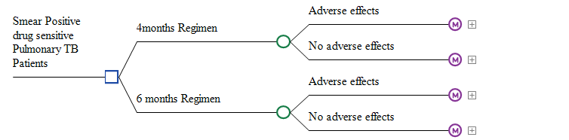

Figure S2. Markov Model
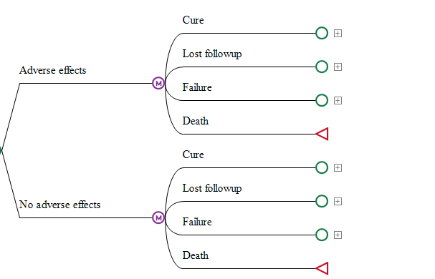

Figure S2a. Cure Node
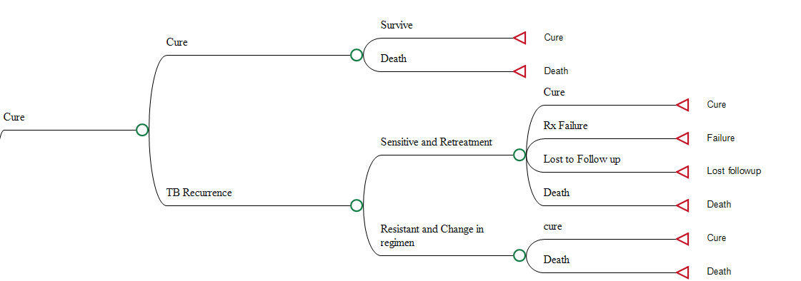

Figure S2b. Loss to follow up
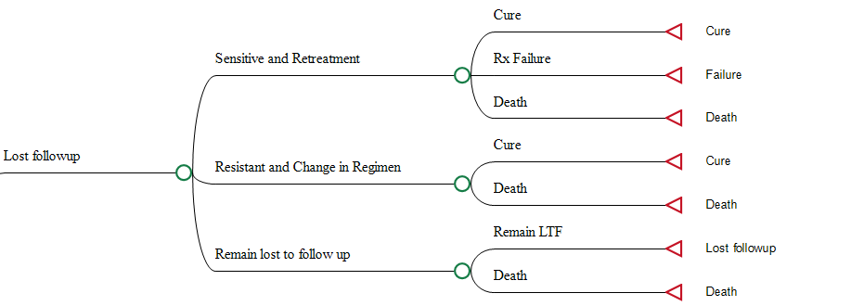
Figure S2c. Failure node
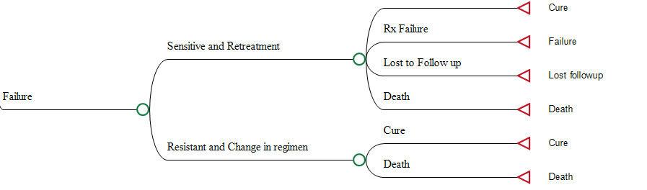
Rx=Treatment
LTF=Loss to Follow-up

Figure S3. The cost-effectiveness plane for treatment regimen of smear-positive drug-sensitive pulmonary TB

ICER
ICER=Incremental Cost Effectiveness Ratio
LY=Life Years
QALY=Quality Adjusted Life Years

Figure S4. Cost-Effectiveness Acceptability curve

Table S4. CHEERS checklist—Items to include when reporting economic evaluations of health interventions
Section/item | Item No | Recommendation | Reported on page No/ line No
Title and abstract
Title | 1 | Identify the study as an economic evaluation or use more specific terms such as “cost-effectiveness analysis”, and describe the interventions compared. | Page 1
Abstract | 2 | Provide a structured summary of objectives, perspective, setting, methods (including study design and inputs), results (including base case and uncertainty analyses), and conclusions. | Page 2
Introduction
Background and objectives | 3 | Provide an explicit statement of the broader context for the study. | Page 3
Background and objectives | 3 | Present the study question and its relevance for health policy or practice decisions. | Page 3
Methods
Target population and subgroups | 4 | Describe characteristics of the base case population and subgroups analysed, including why they were chosen. | Page 4
Setting and location | 5 | State relevant aspects of the system(s) in which the decision(s) need(s) to be made. | Page 4
Study perspective | 6 | Describe the perspective of the study and relate this to the costs being evaluated. | Page 4
Comparators | 7 | Describe the interventions or strategies being compared and state why they were chosen. | Page 4
Time horizon | 8 | State the time horizon(s) over which costs and consequences are being evaluated and say why appropriate. | Page 4 & 5
Discount rate | 9 | Report the choice of discount rate(s) used for costs and outcomes and say why appropriate. | Page 5
Choice of health outcomes | 10 | Describe what outcomes were used as the measure(s) of benefit in the evaluation and their relevance for the type of analysis performed. | Page 7
Measurement of effectiveness | 11a | Single study-based estimates: Describe fully the design features of the single effectiveness study and why the single study was a sufficient source of clinical effectiveness data. | Not Applicable
Measurement of effectiveness | 11b | Synthesis-based estimates: Describe fully the methods used for identification of included studies and synthesis of clinical effectiveness data. | Page 7
Measurement and valuation of preference based outcomes | 12 | If applicable, describe the population and methods used to elicit preferences for outcomes. | Not Applicable
Estimating resources and costs | 13a | Single study-based economic evaluation: Describe approaches used to estimate resource use associated with the alternative interventions. Describe primary or secondary research methods for valuing each resource item in terms of its unit cost. Describe any adjustments made to approximate to opportunity costs. | Not Applicable
Estimating resources and costs | 13b | Model-based economic evaluation: Describe approaches and data sources used to estimate resource use associated with model health states. Describe primary or secondary research methods for valuing each resource item in terms of its unit cost. Describe any adjustments made to approximate to opportunity costs. | Page 5
Currency, price date, and conversion | 14 | Report the dates of the estimated resource quantities and unit costs. Describe methods for adjusting estimated unit costs to the year of reported costs if necessary. Describe methods for converting costs into a common currency base and the exchange rate. | Page 7
Choice of model | 15 | Describe and give reasons for the specific type of decision-analytical model used. Providing a figure to show model structure is strongly recommended. | Page 5
Assumptions | 16 | Describe all structural or other assumptions underpinning the decision-analytical model. | Page 5
Analytical methods | 17 | Describe all analytical methods supporting the evaluation. This could include methods for dealing with skewed, missing, or censored data; extrapolation methods; methods for pooling data; approaches to validate or make adjustments (such as half cycle corrections) to a model; and methods for handling population heterogeneity and uncertainty. | Page 5 & 6
Results
Study parameters | 18 | Report the values, ranges, references, and, if used, probability distributions for all parameters. Report reasons or sources for distributions used to represent uncertainty where appropriate. Providing a table to show the input values is strongly recommended. | Page 8 - 9
Incremental costs and outcomes | 19 | For each intervention, report mean values for the main categories of estimated costs and outcomes of interest, as well as mean differences between the comparator groups. If applicable, report incremental cost-effectiveness ratios. | Page 9
Characterising uncertainty | 20a | Single study-based economic evaluation: Describe the effects of sampling uncertainty for the estimated incremental cost and incremental effectiveness parameters, together with the impact of methodological assumptions (such as discount rate, study perspective). | Not Applicable
Characterising uncertainty | 20b | Model-based economic evaluation: Describe the effects on the results of uncertainty for all input parameters, and uncertainty related to the structure of the model and assumptions. | Page 9
Characterising heterogeneity | 21 | If applicable, report differences in costs, outcomes, or cost-effectiveness that can be explained by variations between subgroups of patients with different baseline characteristics or other observed variability in effects that are not reducible by more information. | Not Applicable
Study findings, limitations, generalisability, and current knowledge | 22 | Summarise key study findings and describe how they support the conclusions reached. Discuss limitations and the generalisability of the findings and how the findings fit with current knowledge. | Page 11
Source of funding | 23 | Describe how the study was funded and the role of the funder in the identification, design, conduct, and reporting of the analysis. Describe other non-monetary sources of support. | Page 12
Conflicts of interest | 24 | Describe any potential for conflict of interest of study contributors in accordance with journal policy. In the absence of a journal policy, we recommend authors comply with International Committee of Medical Journal Editors' recommendations. | Page 12

