Supplementatry materarial

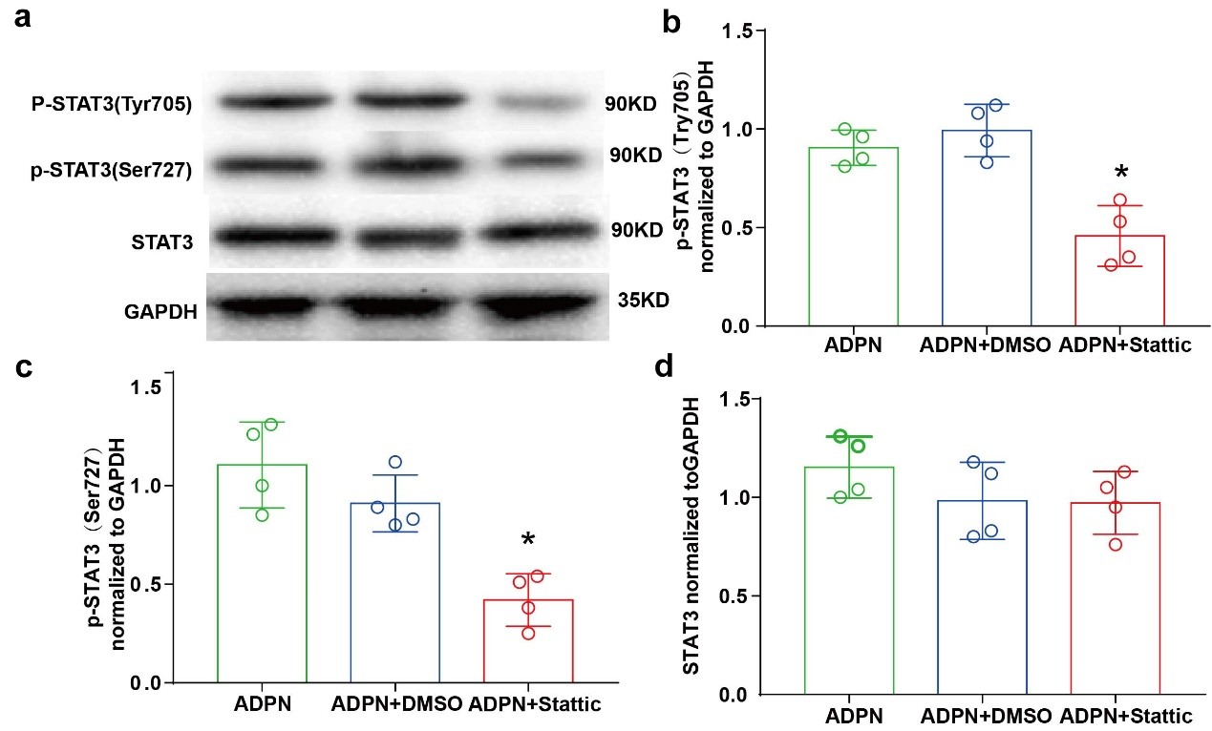
Fig S1. The verification of Stattic on the activation of STAT3 after MCAO. A, Representative images of western blotting. B, Quantification of p-STAT3(Tyr705) protein. C, Quantification of p-STAT3(Ser727) protein. D, Quantification of total STAT3 protein. Data were presented as mean±SD and analyzed by the one way ANOVA test by Tukey’s post hoc test. *P < 0.05 vs ADPN+DMSO.

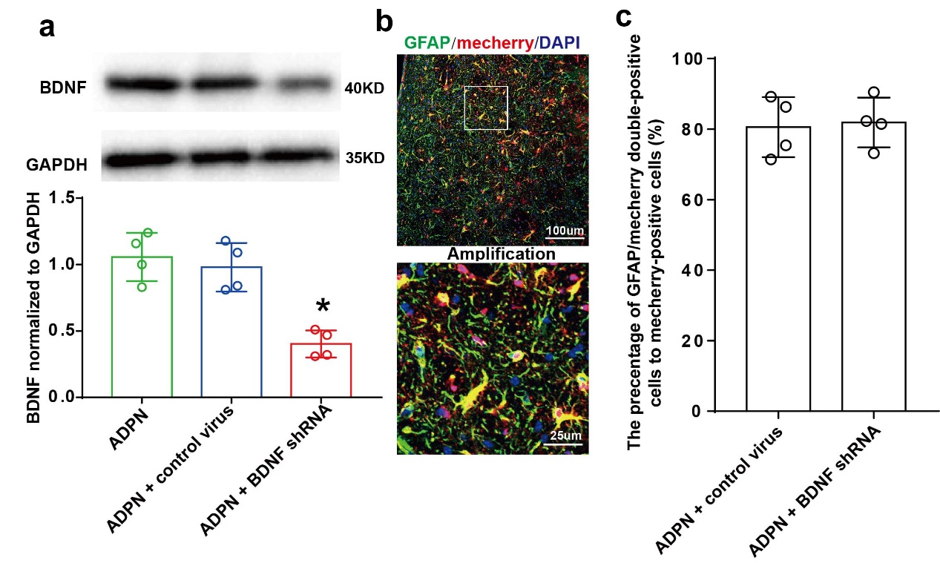
Fig S2. The interference efficiency of the virus encoding BDNF shRNA after MCAO. A, Western blotting analysis of BDNF. B, Representative images of mCherry/GFAP double positive cells.C, Quantification of mcCherry/GFAP double positive cells. Data were presented as mean ± SD and analyzed by the one way ANOVA test by Tukey’s post hoc test. *P < 0.05 vs ADPN+control virus.

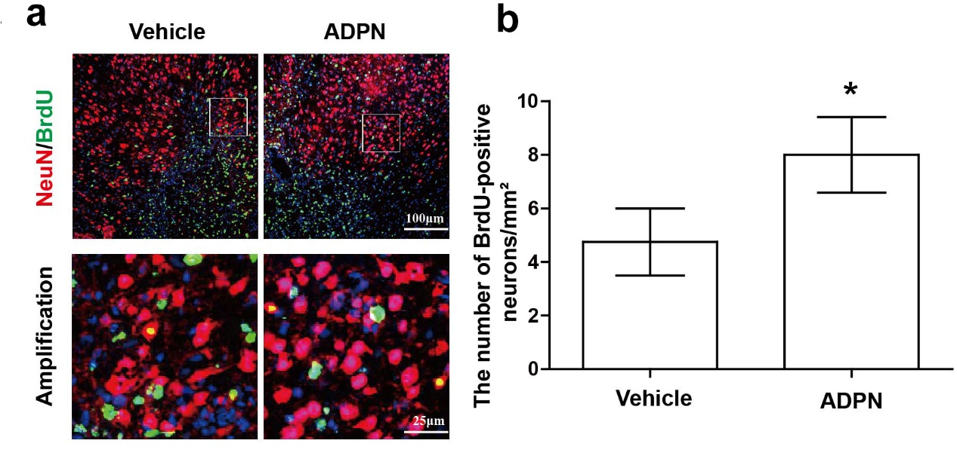
Fig S3. The effect of ADPN treatment on neurogenesis after stroke in cortex. A, The representative images of newborn neurons in cortex. B, Quantification of BrdU/NeuN double positive cells (n = 4). Data were presented as mean with standard deviation and analyzed by t test. *P < 0.05 vs. the vehicle group.

