Supplementary Data
​​
 | Staff | Resident | Total | % of total
Total participants | 220 (103+) | 268 (144+) | 488 | 100
Age >=80 | 2 (1+) | 207 (108+) | 209 (109+) | 42.8 (52.2+)
Age 65-79 | 30 (8+) | 57 (32+) | 87 (40+) | 17.8 (46+)
Age <= 64 | 188 (94+) | 4 (4+) | 192 (98+) | 39.3 (51+)
Median age in years (IQR) | 51 (39-61) | 87 (80-92) | 73 (55-87)
Female | 197 (88+) | 184 (100+) | 381 (188+) | 78.1 (49.3+)
Male | 23 (15+) | 84 (44+) | 107 (59+) | 21.9 (55.1+)
BNT162b2 recipients | 178 (83+) | 109 (61+) | 287 (144)+ | 58.8 (69.2+)
ChAdOx1 recipients | 42 (20+) | 159 (83+) | 201 (103+) | 41.2 (51.2+)
Total LTCFs | 74
Mean participants / LTCF (SD) | 6.59 (6.41)

Supplementary Table 1: Cohort demographics of post 2nd dose recipients
+ Indicates SARS-CoV-2 prior infection
published previously (4)

Antigen | Clone | Fluorophore | Supplier | Code
Viability | N/A | FVS575V | BD | 565694
CD14 | M5E2 | BV650 | Biolegend | 301836
CD19 | HIB19 | BV650 | Biolegend | 302238
CD3 | SK7 | AF700 | Biolegend | 344822
CD8 | SK1 | BUV805 | BD | 612889
CD4 | SK3 | BUV496 | BD | 612936
CD27 | L128 | BUV563 | BD | 748705
CD25 | 2A3 | BUV615 | BD | 612996
CD127 | HIL-7R-M21 | BUV737 | BD | 612794
CD45RA | HI100 | BV480 | BD | 566114
CCR7 | 2-L1-A | APC-Cy7 | Biolegend | 353212
CD69 | FN50 | BV711 | BD | 563836
HLA-DR | G46-6 | BV786 | BD | 564041
TCRgd | 11F2 | BB700 | BD | 745944
CD56 | B159 | PE-Cy5 | BD | 555517
CD28 | CD28.2 | BUV661 | BD | 741635

Supplementary table 2: Cell surface staining panel. Red indicates dump channel

Antigen | Clone | Fluorophore | Supplier | Code
IFNγ | B27 | BUV395 | BD | 563563
IL-2 | MQ1-17H12 | PE-Cy7 | Biolegend | 500326
IL-17A | BL168 | AF647 | Biolegend | 512310
TNF | MAB11 | BV750 | BD | 566359
GrzB | GB11 | FITC | BD | 560211
IL-4 | MP4-252D | PE-Dazzle | Biolegend | 500831
IL-10 | JES3-9D7 | PE | Biolegend | 501404
CD107-a | H4A3 | BV605 | Biolegend | 328634

Supplementary table 3: Intracellular cytokine staining panel

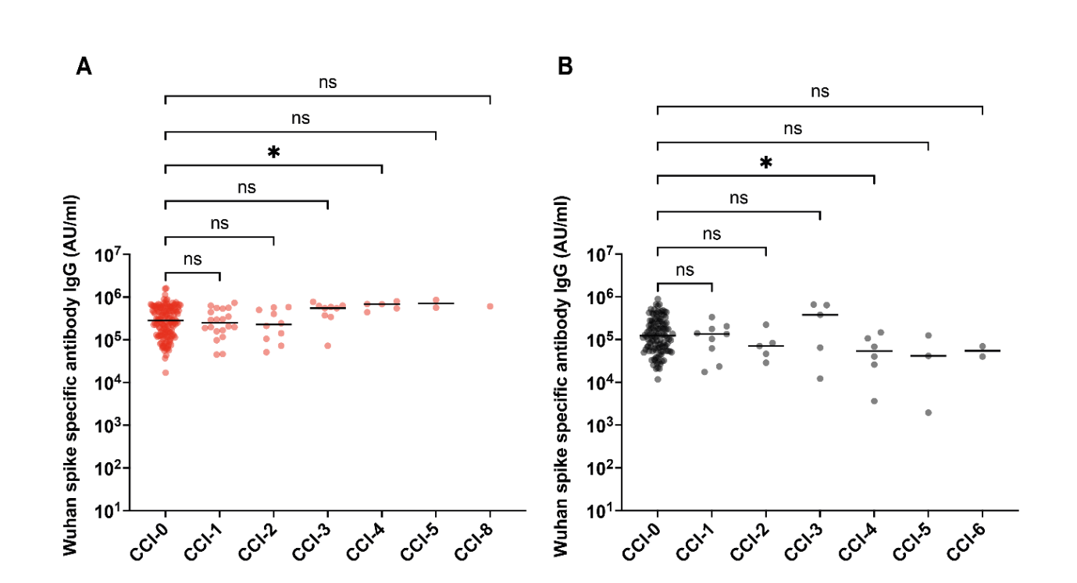

Supplementary Figure 1: Spike-specific antibody response is not influenced by Charlson Comorbidity Index (CCI). A. Prior infected donors B. infection-naive donors *p=0.04

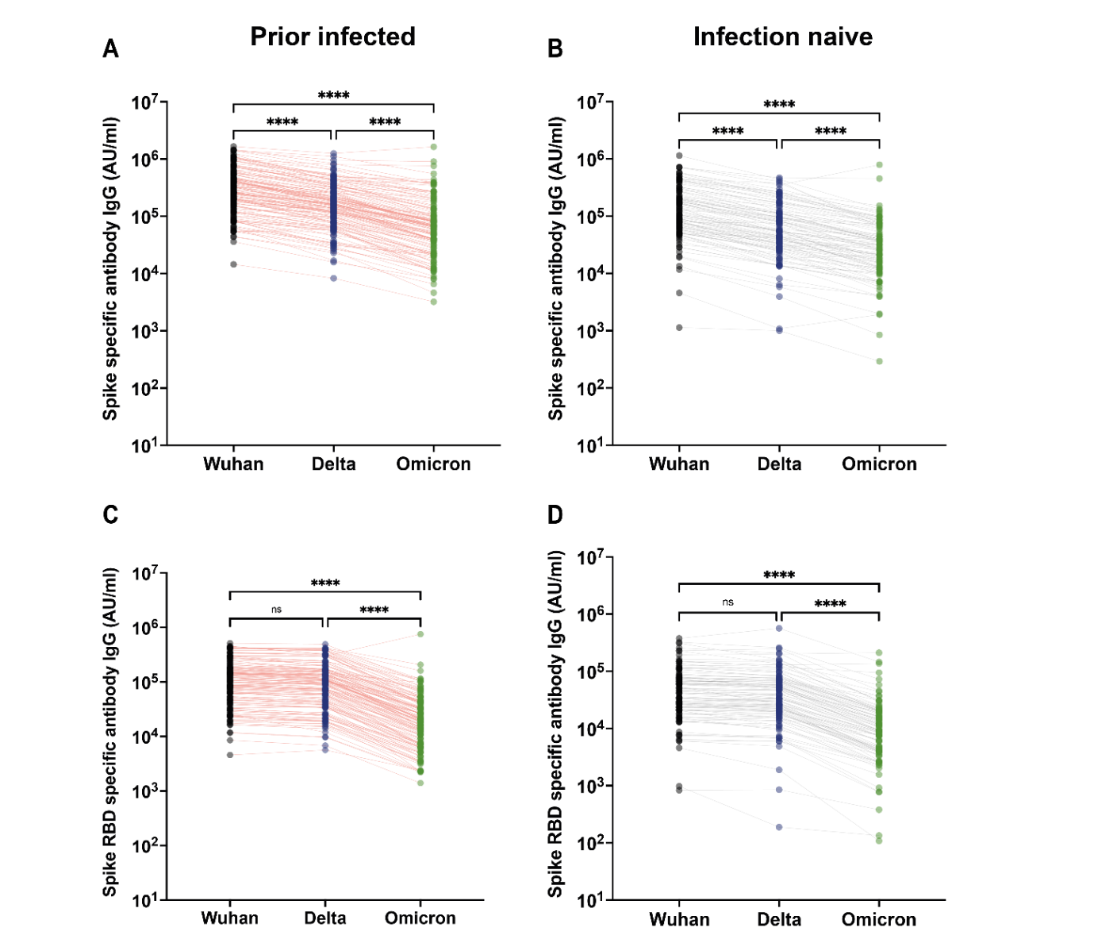

Supplementary Figure 2: Antibody binding to spike protein from Delta and Omicron partially suppressed after 3 vaccine doses
Post vaccine sera were applied to MSD plates containing whole spike protein of the RBD domain of the Wuhan, Delta or Omicron variants. Lines indicate responses from the same participant.
A) Whole spike-specific binding in prior infected donors. Kruskal-Wallis (Uncorrected Dunn’s test) **** p=<0.0001, n=145.
B) Whole spike-specific binding within infection-naive donors. Kruskal-Wallis (Uncorrected Dunn’s test) **** p=<0.0001, n=103.
C) RBD-specific binding in prior infected donors. Kruskal-Wallis (Uncorrected Dunn’s test) **** p=<0.0001 n.s=not significant n=145.
D) RBD-specific binding within infection-naive donors. Kruskal-Wallis (Uncorrected Dunn’s test) **** p=<0.0001 n.s=not significant n=103.

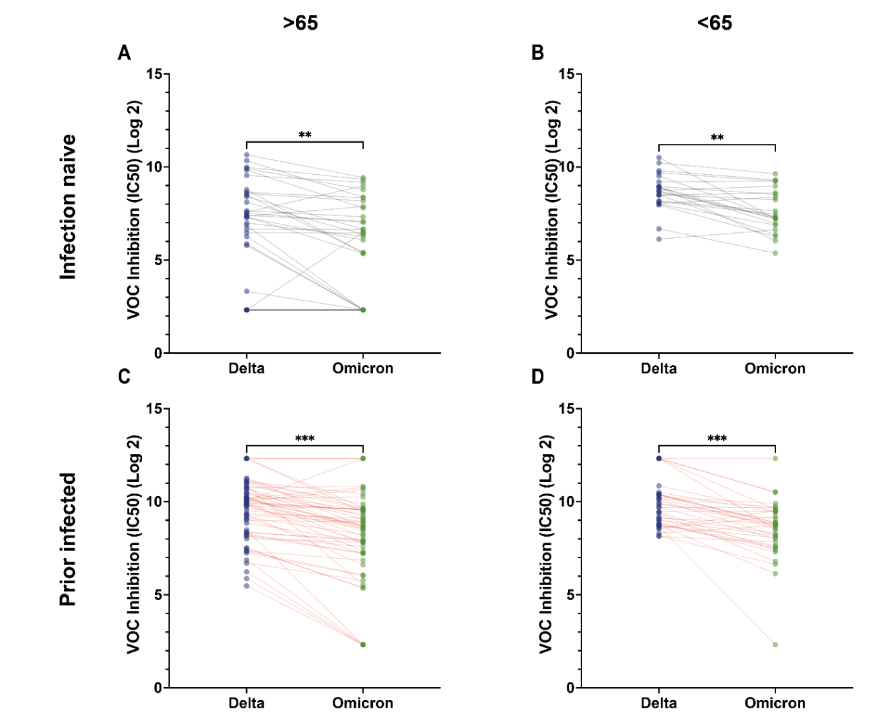

Supplementary Figure 3: Viral neutralisation of Omicron is lower than Delta regardless of age or infection status.
A) Paired viral neutralisation titres following a third vaccine in infection-naïve over 65s. Paired t-test, **p=0.0026
B) Paired viral neutralisation titres following a third vaccine in infection-naïve under 65s. Paired t-test, **p=0.0012
C) Paired viral neutralisation titres following a third vaccine in prior infected over 65s. Paired t-test, ***p=0.001
D) Paired viral neutralisation titres following a third vaccine in prior infected under 65s. Paired t-test, ***p=0.0005

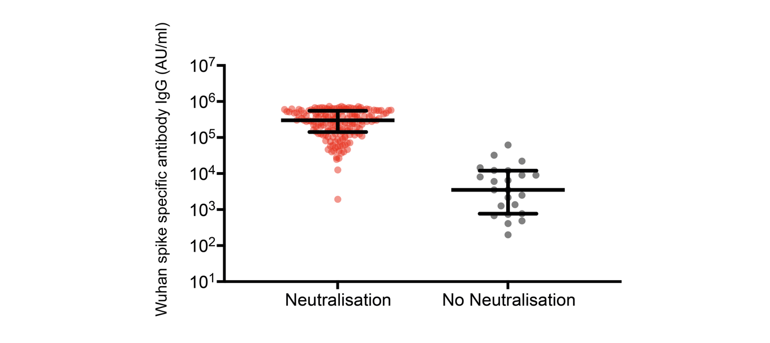

Supplementary Figure 4: Spike specific antibody levels in donors who showed detectable antibody neutralisation of Delta variant compared to those with no neutralisation
Neutralisation data was available on 195 donors of which 22 showed no detectable neutralisation against Delta varint (IC50=5). Median spike-specific antibody response was 3519 AU/ml (IQR: 768 -12025). Median value in those with neutralisation was 300789 AU/ml (IQR: 142710-550512).

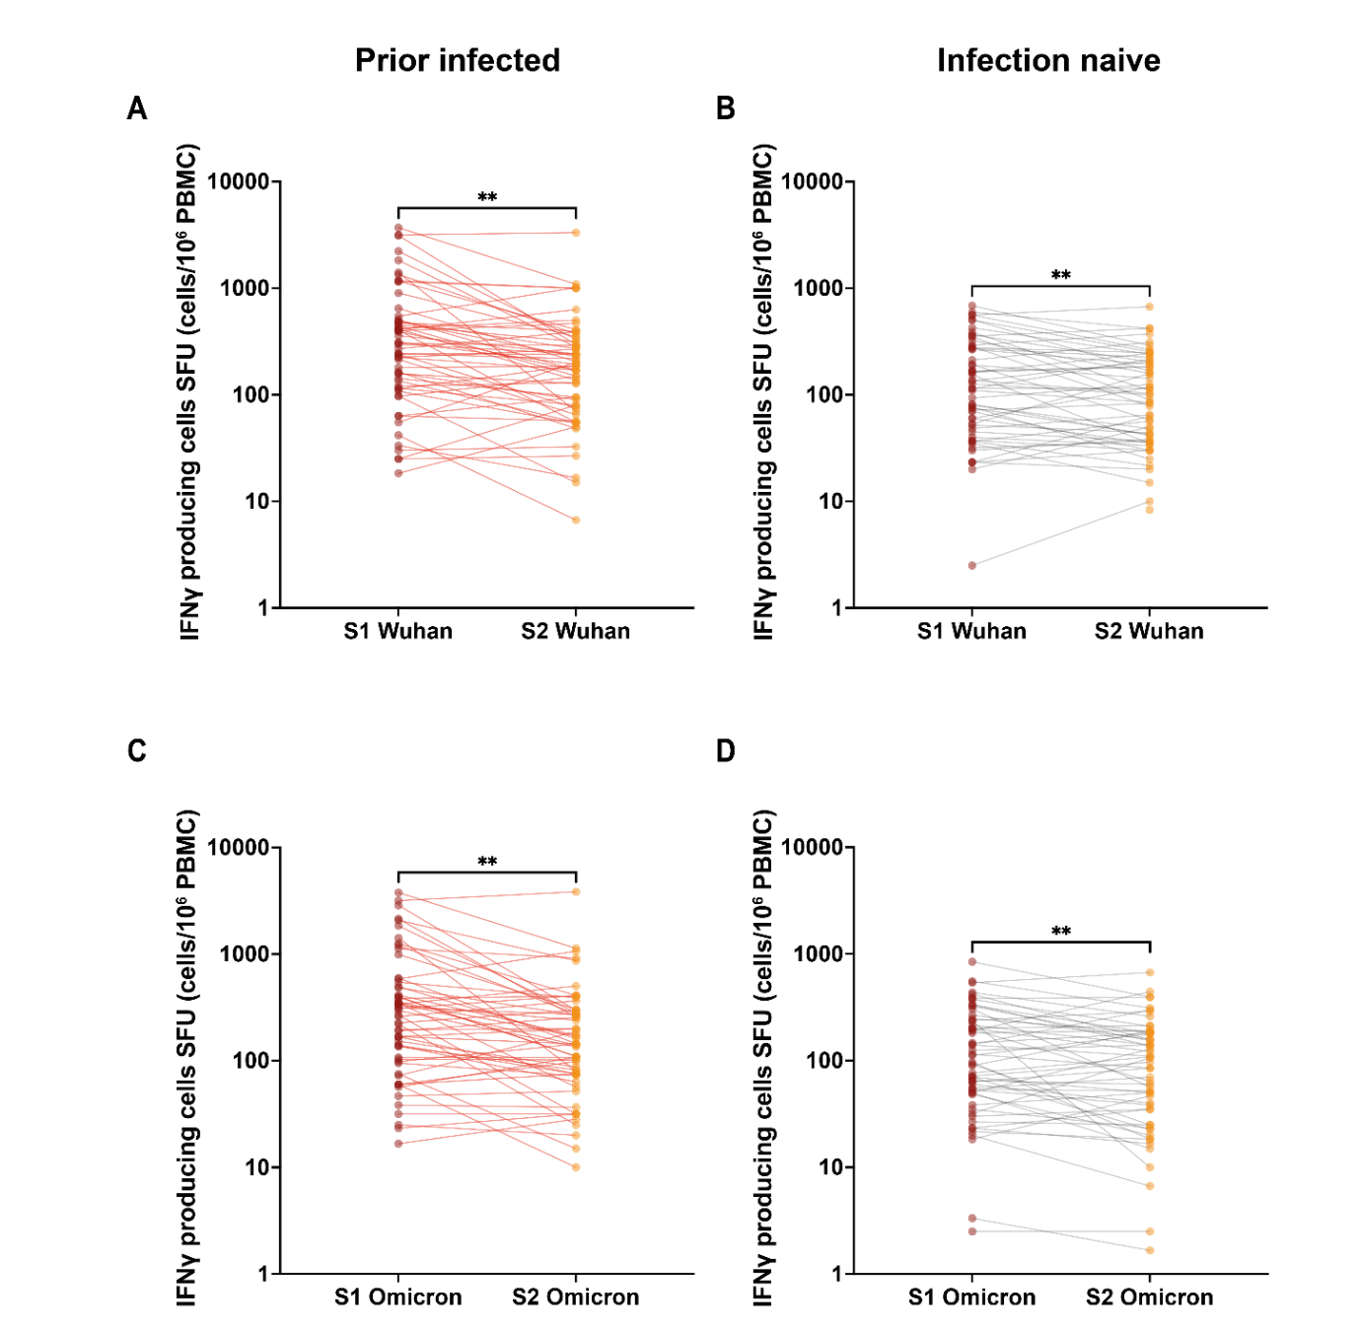

Supplementary Figure 5: IFN-γ ELISpot responses against Wuhan and Omicron S1 peptides are increased compared to Wuhan and Omicron S2 peptides.
A) Paired IFN-γ ELISpot responses to S1 and S2 Wuhan peptides in previously infected donors. Paired t-test, **p=0.0021.
B) Paired IFN-γ ELISpot responses to S1 and S2 Wuhan peptides in infection-naïve donors. Paired t-test, **p=0.0031.
C) Paired IFN-γ ELISpot responses to S1 and S2 Omicron peptides in infection-naïve donors. Paired t-test, **p=0.0016.
D) Paired IFN-γ ELISpot responses to S1 and S2 Omicron peptides in infection-naïve donors. Paired t-test, **p=0.0099.
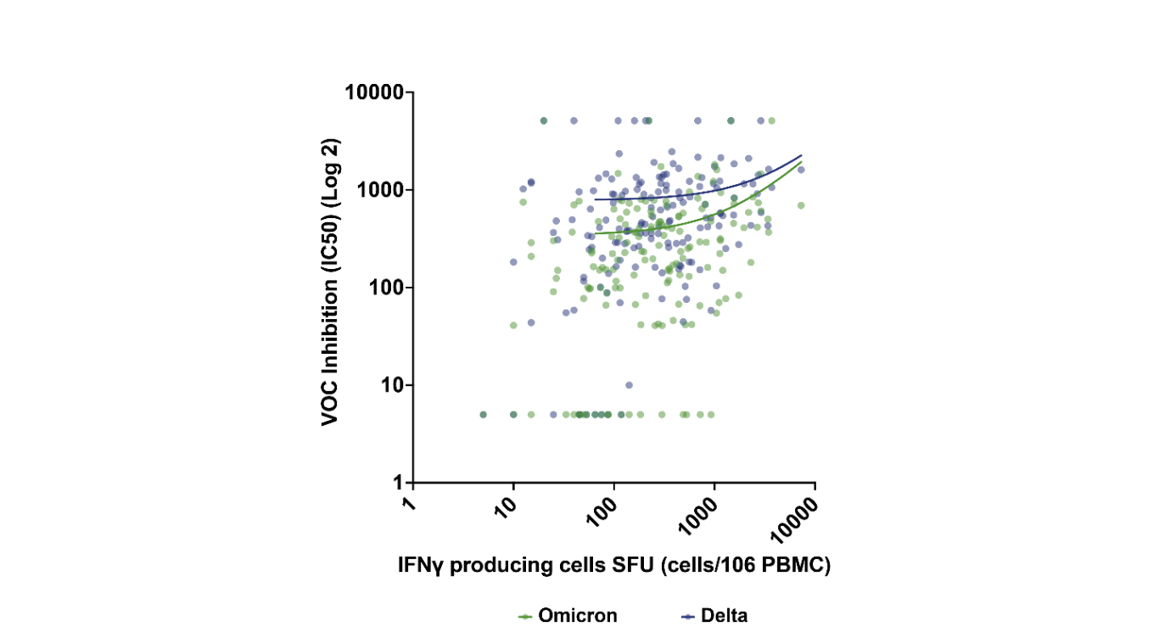

Supplementary Figure 6: Spike-specific cellular response correlates to inhibition of Delta and Omicron variants.
IFN-γ ELISpot spike-specific responses to total Wuhan spike correlated to VOC inhibition. Blue dots and line (Spearman's correlation r=0.32, p=<0.0001, n=162) indicate Delta neutralisation and green dots and line (Spearman's correlation r=0.33, p =<0.0001, n=162) indicate Omicron neutralisation.

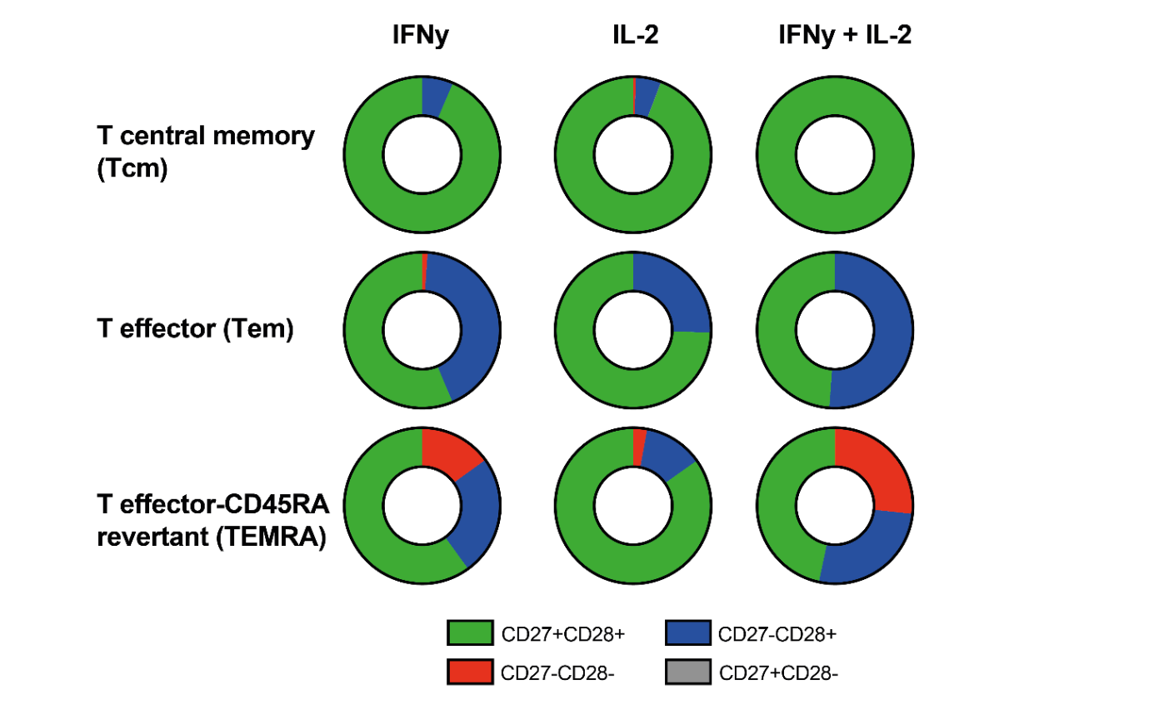

Supplementary figure 7: Distribution of CD27-CD28-, CD27+CD28-, CD27-CD28+ and CD27+CD28+ expressing cells within Central Memory (Tcm), Effector (Tem) and Effector-CD45RA (TemRA) memory pools in relation to single or dual IL-2 and IFN-γ cytokine production by spike-specific CD4+ T cells (n=22). (Tcm IFN-γ: CD27-CD28+ and CD27+CD28+ = 6.5% and 93.5% respectively. Tcm IL-2: CD27-CD28-, CD27+CD28-, CD27-CD28+ and CD27+CD28+ = 0.6%, 0.05%, 5.2% and 94.1% respectively. Tcm IL-2+IFN-γ+: CD27+CD28+ = 100%. Tem IFN-γ: CD27-CD28-, CD27-CD28+ and CD27+CD28+ = 1.1%, 42.5% and 56.3% respectively. Tem IL-2: CD27-CD28+ and CD27+CD28+ = 25.5% and 74.5% respectively. Tem IL-2+IFN-γ+: CD27-CD28+ and CD27+CD28+ = 51.2% and 48.8% respectively. TemRA IFN-γ: CD27-CD28-, CD27-CD28+ and CD27+CD28+ = 15%, 25% and 60% respectively. TemRA IL-2: CD27-CD28-, CD27-CD28+ and CD27+CD28+ = 2.9%, 12.3% and 84.8% respectively. TemRA IL-2+IFN-γ+: CD27-CD28-, CD27-CD28+ and CD27+CD28+ = 26.7%, 26.7% and 46.7% respectively.) Chi-Square p = 0.053 Tcm CD27-CD28+ IFNy, IL-2 and IFN-γ+IL-2+ vs Tcm CD27+CD28+ IFNy, IL-2 and IFN-γ+IL-2+. Chi-Square p = 0.0006 Tem CD27-CD28+ IFNy, IL-2 and IFN-γ+IL-2+ vs Tem CD27+CD28+ IFNy, IL-2 and IFN-γ+IL-2+. Chi-Square p <0.0001 TemRA CD27-CD28- IFNy, IL-2 and IFN-γ+IL-2+ vs TemRA CD27-CD28+ IFNy, IL-2 and IFN-γ+IL-2+ vs CD27+CD28+ IFNy, IL-2 and IFN-γ+IL-2+.

