Supplementary materials
Methods
General instrumental equipment, chemicals, and reagents
Microplate reader (infinite M1000 PRO TECAN); Fixed speed vortex mixer (VXMNFS OHAUS); High-speed freezing centrifuge (ST 16R Thermo); Water bath kettle (OBS-2100 EYELA); Enhanced BCA Protein Assay Kit (Lot: No.090120200929; Beyotime Biotechnology); 5% phenol aqueous solution (Lot: L02M12G140441; Shanghai yuanye Bio-Technology Co., Ltd); D-(+)-Glucose (Lot: LRAA8593; Sigma-aldrich); Vitriol (AR; Lot: 20210902; Soochow Qiangsheng); Ethyl alcohol is analytically pure, water is deionized water. Jiangan Powder (JGP).
UHPLC-Q-TOF-MS was performed on an Agilent 1290 - 6538 accurate-mass Q-TOF LC/MS system (Agilent Technologies, Inc. City of Santa Clara, USA). LC/MS data analysis was performed on Agilent Mass Hunter Workstation software qualitative analysis (version B.05.00, Build 4.0.479.5, Service Pack 3, Agilent Technologies, Inc. City of Santa Clara, USA). METTLER TOLEDO EL303 Electronic balance (METTLER TOLEDO Instruments Shanghai Co., LTD.); Sb-5200dt ultrasonic cleaner (power 240 W, frequency 40 kHz); High-speed refrigerated centrifuge (Eppendorf 5810 R); Jian Gan powder (JGP, Lot: 200106; Hai'an Hospital of Traditional Chinese Medicine). Paeoniflorin (Lot: AF20070752, 98% purity) and hesperidin (Lot: AF9061522, 98% purity) were purchased from Chengdu Aifa Biotechnology Co., Ltd. Acetonitrile and formic acid are chromatographic pure; water is ultrapure water.
Preparation of JGP water extract and reference materials
JGP (100 g) was soaked it in boiling water (500 mL) for 20 minutes, repeated twice. After filtration, the combined extracts were evaporated into the solution (100 mL) under vacuum at 60 °C, then added water to obtain JGP water extract (12.5 mg/mL). Reference compounds were solved in pure methanol solution, and the concentration of each standard solution was made as follows: paeoniflorin 104 μg/mL and hesperidin 80 μg/mL. All solutions were filtered through a membrane filter (0.22 μm) prior to analysis.
Ultra high-performance liquid chromatography-mass spectrometry (UHPLC-MS) analysis of JGP water extract
Chromatographic separations were performed on an Acquity UPLC®HSS T3 analytical column (2.1 mm × 100 mm, I.D. 1.8 μm, Waters, USA). The operating conditions were as follows: column temperature 30°C, the flow rate at 0.3 mL/min, and injection volume of 5.0 μL. The mobile phase was a mixture of water (A) and acetonitrile (B), both containing 0.1% formic acid, using gradient elution (0 min: 10% B, 2 min: 10% B, 20 min: 95% B, 25 min: 95% B) with 2 min of balance back to 10% B. Mass spectra were obtained in positive and negative mode, and the source parameters were set as follows: Gas Temp 350 °C, Gas Flow 10 L min-1, Nebulizer 40 psi, Vcap 3500 and Fragmentor 135. Reference Masses were used at: m/z 121.0509 and m/z 1221.9906. Results are shown by base peak chromatogram (BPC) with an m/z range of 50-2500.
Determination of polysaccharide content
JGP 30 g was soaked for 20 min with 150 mL deionized boiling water repeated twice. After filtration, the combined water extracts were supplemented with deionized water to a volume of 300 mL. Then 1 mL JGP water extract was mixed with 199 mL deionized water to obtain the concentration of 0.5 mg raw herb/mL. 5 mL JGP water extract was further mixed with ethanol to a final concentration of 80% (v/v) to precipitate overnight at 4 °C. Then centrifuged at 4900 r/min for 10 min at 4℃ to obtain JGP polysaccharide. Total polysaccharide content was determined at 490 nm by phenol-sulfuric method, calculated with linear regression equation (y = 6.8308 x - 0.0053, R2= 0.9995), whose linear range of glucose concentration was 0.005-0.1 mg/mL. Total polysaccharide content was 12.03 mg/g.
Determination of protein content
JGP 30 g was soaked for 20 min with 150 mL deionized boiling water repeated twice. After filtration, the combined water extracts were supplemented with deionized water to a volume of 300 mL. Accurately absorb 1 mL JGP water extract, add 19 mL deionized water, vortex mixing, get the test solution. The content of protein in JGP water extract was measured at 562 nm by BCA protein assay kits according to the manufacturer’s instructions with detection range 0.025 - 0.5 mg/mL (y = 1.0112 x + 0.023, R2 = 0.9998). Total protein content was 60.65 mg/g.

Table S1-1 Characterization of chemical constituents of JGP by UHPLC-Q-TOF-MS analysis (positive ion mode)
No. | tR(min) | Experimental mass (m/z) | Precursor ion | Identification | Formula | Source
1 | 0.954 | 381.0789, 543.1312 |  |  |  | G、R、S
2 | 1.104 | 191.1176, 205.1334
3 | 1.382 | 132.1017 |  |  |  | G、R、AS、B、C、GR、SF
 |  | 265.1906 | [M+H]⁺ | oxymatrine, oxysophoridine | C₁₅H₂₄N₂O₂ | SF
 |  | 281.1854 |  |  |  | SF
 |  | 245.1642 | [M+H]⁺ | anagyrine, sophoramine | C₁₅H₂₀N₂O | SF
4 | 1.661 | 249.1967 | [M+H]⁺ | sophoridine, matrine | C₁₅H₂₄N₂O | SF、R
5 | 2.043 | 265.1913 | [M+H]⁺ | oxymatrine, oxysophoridine | C₁₅H₂₄N₂O₂ | SF、R
6 | 2.867 | 265.1907 | [M+H]⁺ | oxymatrine, oxysophoridine | C₁₅H₂₄N₂O₂ | SF
7 | 5.083 | 922.0081
8 | 5.561 | 481.1697 | [M+H]⁺ | alibiflorin | C₂₃H₂₈O₁₁ | P
9 | 7.22 | 273.0755, 419.1341, 581.1871
10 | 7.386 | 340.2597, 679.5105, 701.4922
11 | 8.147 | 340.2599, 431.1326, 521.1065, 679.5104, 922.0074
12 | 8.2424 | 480.2777, 498.2881
13 | 8.475 | 480.2772, 498.2881
14 | 9.494 | 423.3642 | [M+H-Glc-Glc-H₂O]⁺ | Rg1、Rf、Re | C₄₂H₇₂O₁₄ | G
A stands for Aurantii Fructus Immaturus; AS stands for Artemisiae Scopariae Herba; B stands for Bupleuri Radix; C stands for Cyperi Rhizoma; G stands for Ginseng Radix et Rhizoma; GR stands for Glycyrrhizae Radix et Rhizoma; P stands for Paeoniae Radix; R stands for Astragali Radix; S stands for Salviae Miltiorrhizae Radix et Rhizoma; SF stands for Sophorae Flavescentis Radix.

Table S1-2 Characterization of chemical constituents of JGP by UHPLC-Q-TOF-MS analysis (negative ion mode)
No. | tR(min) | Experimental mass (m/z) |  | Precursor ion | Identification |  |  | Formula |  | Source
1 | 0.962 | 341.1105 | [M+COOH]⁻ |  |  | przewaquinone C, Danshenxinkun A | C₁₈H₁₆O₄ |  | S
 |  |  |  |  |  | isocryptotanshinone, cryptotanshinone | C₁₉H₂₀O₃ |  | S
 |  |  |  |  |  | saprorthoquinone, Aethiopinone | C₂₀H₂₄O₂ |  | S
 |  | 503.1644
2 | 2.209 | 255.0521 |  |  |  |  |  |  | R、SF
3 | 5.406 | 687.2164 | [M+COOH]⁻ |  |  | isomaltopaeoniflorin | C₂₉H₃₈O₁₆ |  | P
4 | 5.594 | 525.1641 | [M+COOH]⁻ |  |  | alibiflorin | C₂₃H₂₈O₁₁ |  | P
5 | 5.914 | 367.1061 |  |  |  |  |  |  | G
 |  | 525.1640 | [M+COOH]⁻ |  |  | paeoniflorin | C₂₃H₂₈O₁₁ |  | P
6 | 6.595 | 649.2538 |  |  |  |  |  |  | A
 |  | 549.1651 | [M-H]⁻ |  |  | isoliquiritin apioside, liquiritin apioside, isoglycyrrhizin glucose apigenin | C₂₆H₃₀O₁₃ |  | GR
7 | 7.232 | 537.1106 | [M-H]⁻ |  |  | Salvianolic acid H/I | C₂₇H₂₂O₁₂ |  | S
8 | 7.560 | 607.1702 | [M+COOH]⁻ |  |  | Kushenol O | C₂₇H₃₀O₁₃ |  | SF
 |  | 609.1861 | [M-H]⁻ |  |  | hesperidin | C₂₈H₃₄O₁₅ |  | A
9 | 8.138 | 137.0248 | [M-H]⁻ |  |  | salicylic acid | C₇H₆O₃ |  | AS
 |  | 717.1497 | [M-H]⁻ |  |  | Salvianolic acid B, Salvianolic acid E | C₃₆H₃₀O₁₆ |  | S
10 | 8.263 | 633.2573 |  |  |  |  |  |  | A
11 | 8.496 | 514.2872
12 | 8.953 | 255.0681 | [M-H]⁻ |  |  | liquiritigenin, isoliquiritigenin | C₁₅H₁₂O₄ |  | GR
 |  | 417.0828 | [M-H]⁻ |  |  | Natsudaidain | C₂₁H₂₂O₉ |  | A
13 | 9.522 | 845.4986 | [M+COOH]⁻ |  |  | Rg1, Rf, Rg7 | C₄₂H₇₂O₁₄ |  | G
14 | 10.117 | 271.0627 | [M-H]⁻ |  |  | naringenin | C₁₅H₁₂O₅ |  | A
15 | 10.890 | 821.4014 | [M-H]⁻ |  |  | glycyrrhizic acid, Uralum saponin B | C₄₂H₆₂O₁₆ |  | GR
A stands for Aurantii Fructus Immaturus; AS stands for Artemisiae Scopariae Herba; B stands for Bupleuri Radix; C stands for Cyperi Rhizoma; G stands for Ginseng Radix et Rhizoma; GR stands for Glycyrrhizae Radix et Rhizoma; P stands for Paeoniae Radix; R stands for Astragali Radix; S stands for Salviae Miltiorrhizae Radix et Rhizoma; SF stands for Sophorae Flavescentis Radix.

Supplementary Fig. 1. The BPC chromatograms of JGP water extract (A) JGP water extract in the positive ion mode, (B) JGP water extract in the negative ion mode, (C) Paeoniflorin in the negative ion mode, (D) hesperidin in the negative ion mode.

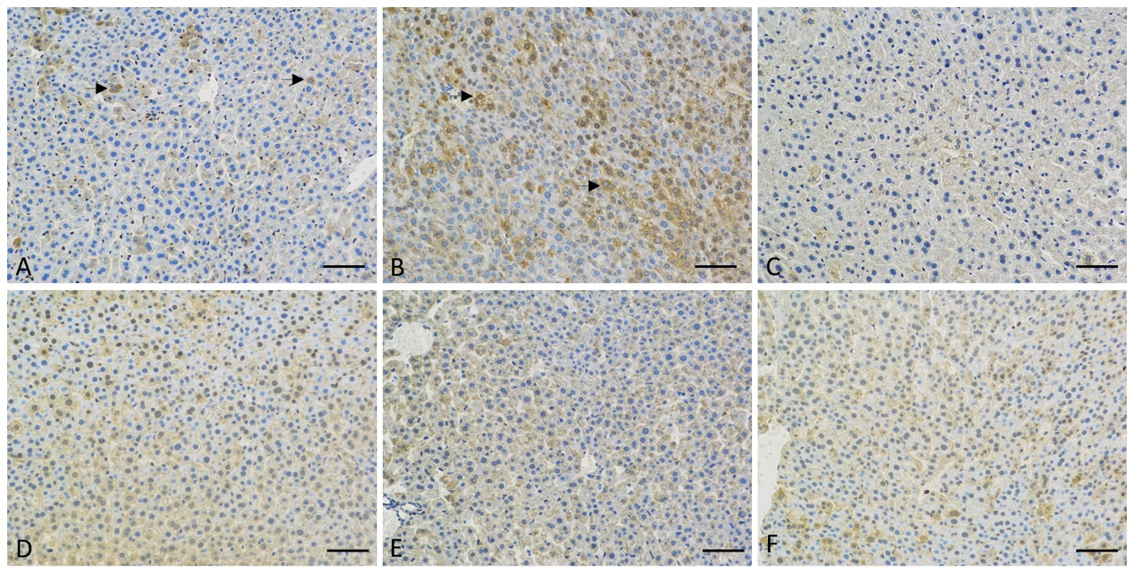
Supplementary Fig. 2. Representation images of STAT3 staining (×200). (A: normal group; B: induced group; C: control group; D: JGP-L group; E: JGP-M group; F: JGP-H group) Arrowhead: STAT3-positive cells. Bars=100 𝜇m. Data were analyzed by one-way ANOVA and presented as mean ± SEM. # indicates a significant change between the normal, induced and control groups (#P < 0.05, ##P < 0.01; ###P< 0.001); ∗ indicates significant change of different treatment groups vs Induced group (*P < 0.05; **P < 0.01; ***P < 0.001).

Supplementary Fig. 3. (A) Rarefaction curves of 16S rRNA gene sequencing analysis (A: normal group; B: induced group; C: control group; D: JGP-L group; E: JGP-M group; F: JGP-H group). (B) Venn diagram of OTUs in different groups.

Supplementary Fig. 4. Association between intestinal flora. (A) Network diagram of association among gut microbiota at the genus level. (B) Heatmap showed partial spearman correlation coefficients between genus-level microbiota.
Supplementary Fig. 5. Heatmap (A) and volcano plot (B) show fecal metabolites with significant variations and (C) shows the number of up-regulated and down-regulated fecal metabolites between the normal and induced groups, JGP-L, and induced groups, JGP-M and induced groups, JGP-H and induced groups.

