Sustainable production of hydrogen with high purity from methanol and water at low temperatures
Sai Zhang¹, Yuxuan Liu², Mingkai Zhang², Yuanyuan Ma¹, Jun Hu^{3,}* and Yongquan Qu^{1,}*
¹ School of Chemistry and Chemical Engineering, Northwestern Polytechnical University, Xi’an, 710072, China
² Center for Applied Chemical Research, Frontier Institute of Science and Technology, Xi'an Jiaotong University, Xi'an, 710049, China.
³ School of Chemical Engineering, Northwest University, Xi’an, 710069, China.

Correspondence and requests for materials should be addressed to Hu J. and Qu Y. Q. (Email: hujun@nwu.edu.cn and yongquan@nwpu.edu.cn)

Experimental Section.
Preparation of the nanorods of CeO₂ (NR-CeO₂) supports. The NR-CeO₂ supports were prepared by traditional hydrothermal process. Initially, aqueous solutions of Ce(NO₃)₃·6H₂O (1.736 g in 10 mL of deionized water) was added into the NaOH (19.2 g in 70 mL of deionized water) solutions for 0.5 h at room temperature by continuous stirring. After aging for another 1 h, the reaction was continued at 160 °C for 12 h. Finally, the reaction mixture was then cooled naturally to room temperature and intermittently washed with deionized water and ethanol for three times.
Preparation of nanoparticles of CeO₂ (NP-CeO₂). The NP-CeO₂ supports were obtained by calcination Ce(NO₃)₃∙6H₂O at 500 °C for 2 h.
Preparation of the Pt/PN-CeO₂ catalysts. Pt nanoparticles supported on the surface of PN-CeO₂ were obtained by traditional impregnation method. Initially, 300 mg PN-CeO₂ supports were dispersed in 10 mL ethanol. Then, 1 mL H₂PtCl₆ solution (Pt: 0.5 wt.%) was added in the mixture and stirred 1 h at room temperature. After that, the mixture was slowly heated to 90 °C to remove the ethanol. Finally, the Pt/PN-CeO₂ catalysts were reduced by 5 vol.% H₂/Ar at 300 °C for 2 h.
The Pt/NR-CeO₂ and Pt/NP-CeO₂ catalysts were obtained by the similar process only changing the PN-CeO₂ supports to the NR-CeO₂ or NP-CeO₂ supports.
Catalytic generation of hydrogen from methanol and H₂O. For a typical catalytic reaction, 40 mL methanol and 18 mL H₂O with 50 mg catalysts were mixed in a 500 mL autoclave with a temperature and pressure detector. The temperature of the reaction system quickly increased to the given temperature within 10 min. After reaction, the mixture was collected by a 1 L gas sampling bag. The gas products were analyzed by GC with TCD and FID detector.
DFT calculation.
CASTEP module of the Materials Studio software (Accelrys Inc.) was employed for the quantum chemistry calculations. Self-consistent periodic Density Functional Theory (DFT) was adopted to explore the electronic structure and catalytic activities. Perdew-Burke-Ernzerhof (PBE) approximation was selected as the Generalized Gradient Approximation (GGA) method to calculate the exchange-correlation energy.¹⁻³ The Broyden-Fletcher-Goldfarb-Shanno (BFGS) scheme was selected as the minimization algorithm.³ And ionic cores were represented by an ultrasoft pseudopotential in reciprocal space. CeO₂ (110) facets with 3×1 supercell was built from bulk CeO₂ (a=b=5.13 Å, c=3.64 Å, α=β=γ=90º) were used based on the XRD and TEM data. Vacuum region is set as 15 Å in order to neglect the electrostatic interactions between two sides of a slab. Based on the XPS results, one oxygen vacancy (Vo) and two Vo are generated on the CeO₂ (110) facets named as CeO₂ (110)+Vo and CeO₂ (110)+2Vo, respectively. The energy cutoff is 410 eV and the SCF tolerance is 0.5×10⁻⁷ eV/atom. And the k-points were set 1×2×1. The optimization is completed when the energy, maximum force, maximum stress and maximum displacement are smaller than 5.0×10⁻⁶ eV/atom, 0.01 eV/ Å, 0.02 GPa and 5.0×10⁻⁴ Å, respectively.
The vacancy formation energy (E_{Vo}) can be estimated by Eq. S1.⁴
E_{Vo}=E_{ds}+E_{o}-E_{ps} (S1)
Where E_{ds} is total energy of the defective surface; E_{ps} is total energy of perfect surface and E_{o} is the half energy of an O₂ molecule in the gas phase; $E_{o_{2}}$ is the energy of an O₂ molecule in the gas phase
The adsorption energy ($E_{ads}$) between a facet and adsorbed particles was computed by Eq. S2:
$E_{ads}=E_{*ads}-E_{ads}-E_{*}$ (S2)
Where $E_{*ads}$ is the total energy of the facet and adsorbent; $E_{ads}$ is the energy of adsorption molecules; and $E_{*}$ is the energy of facet. Zero-Point Energy (ZPE) correction were not considered during the above calculations.⁵
Based on previous experiments and simulations, a plausible pathway of WGS on CeO₂ (110) facet has been reported as the series of reactions 1 to 6 (R1 to R6), where the subscript of “*” represents the adsorbed species. Reaction free energy change is calculated for the energy of products plus reactions.
*+CH₃OH=*CH₃OH (R1)
*CH₃OH=*CH₃O+*H (R2)
*CH₃O+*H=*CH₂O+2*H (R3)
*CH₂O+2*H=*CHO+3*H (R4)
*CHO+2*H=*CO+4*H ( R5)
*CO+4*H=CO+4*H (R6)

Table S1. Summary of the H₂ generation from methanol and H₂O by various Pt catalysts
Entry | Catalysts | Pt loading  (wt.%) | Temperature  (℃) | H₂ generation rate  (mol_{H2} mol_{Pt}⁻¹ h⁻¹) | Sel. of CO  (%)
1 | Pt₁/PN-CeO₂ | 0.36 | 135 | 199 | 0.032
2 | Pt/Al₂O₃ | 0.5 | 135 | 2.6 | --
3 | Pt/TiO₂ | 0.5 | 135 | 3.8 | --
4 | Pt/C | 0.5 | 135 | 0.7 | --
5 | Pt₁/PN-CeO₂ | 0.36 | 165 | 1103 | 0.045
6 | Pt₁/PN-CeO₂ | 0.36 | 120 | 33 | 0.027
7 | Pt₁/PN-CeO₂ | 0.36 | 100 | 19.7 | 0.16
8 | PN-CeO₂ | 0 | 165 | 0 | --
9 | PN-CeO₂ | 0 | 120 | 0 | --
10 | Pt/PN-CeO₂ | 0.5 | 165 | 497 | 0.072
11 | Pt/NR-CeO₂ | 0.5 | 165 | 256 | 0.153
12 | Pt/NP-CeO₂ | 0.5 | 165 | 202 | 0.159
13 | Pt/PN-CeO₂ | 0.3 | 165 | 589 | 0.067
14 | Pt/PN-CeO₂ | 2 | 165 | 479 | 0.086
15 | Pt/PN-CeO₂ | 5 | 165 | 246 | 0.098
Reaction condition: catalyst (50 mg), n(CH₃OH):n(H₂O)=1:1, 58 mL total volume of liquid, 165 ºC and 1 h.

Table S2. Summary of H₂ generation from methanol and H₂O catalyzed by various homogeneous catalytic system.
Entry | Catalysts | Additive | n(CH₃OH)  /n(H₂O) | Temperature (ºC) | H₂ (mmol mmol_{M}⁻¹ h⁻¹) | Ref.
1 | 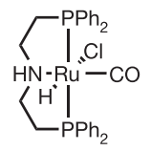 | 0.5 M NaOH | 9:1 | 72 | 124 | ⁶
1 |  | 8 M KOH | 9:1 | 91 | 1023 | ⁶
2 | Ru/2-hydroxypyridine | 1.2 Equiv. | 1:1 | 110 | 20 | ⁷
3 | 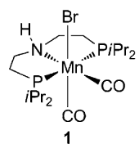 | 8 M KOH | 9:1 | 92 | 10 | ⁸
4 | 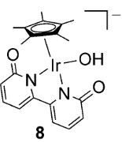 | -- | 1:4 | 90 | 2 | ⁹
4 |  | 1 mol% NaOH | 1:4 | 90 | 16 | ⁹
5 | 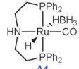 | -- | 4:1 | 93.5 | 24 | ¹⁰
6 | 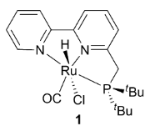 | 2 Equiv. | 1:5 | 100-105 | 17 | ¹¹
7 | 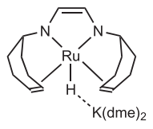 | -- | 1:1 | 100 | 16 | ¹²
8 | 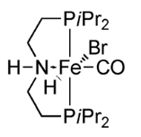 | 8 M KOH | -- | 91 | 702 | ¹³

Reference:
1 Perdew, J. P., Burke, K. & Ernzerhof, M. Generalized gradient approximation made simple. Phys. Rev. Lett. 77, 3865 (1996).
2 Lin, J. S., Qteish, A., Payne, M. C. & V. Heine. Optimized and transferable nonlocal separable ab initio pseudopotentials. Phys. Rev. B 47, 4174 (1993).
3 Hu, J., Chen, W., Zhao, X., Su, H. B. & Chen, Z. Anisotropic electronic characteristics, adsorption, and stability of low-index BiVO₄ surfaces for photoelectrochemical applications. ACS Appl. Mater. Interfaces 10, 5475-5484 (2018).
4 Wu, X., Selloni, A. & Nayak, S. K. First principles study of CO oxidation on TiO₂ (110): The role of surface oxygen vacancies. J. Chem. Phys. 120, 4512-4516 (2004).
5 Huang, Z. Q., Long, B. & Chang, C. R. A theoretical study on the catalytic role of water in methanol steam reforming on PdZn(111). Catal. Sci. Technol. 5, 2935-2944 (2015).
6 Nielsen, M. et al. Low-temperature aqueous-phase methanol dehydrogenation to hydrogen and carbon dioxide. Nature 495, 85-89 (2013).
7 Awasthi, M. K., Rai, R. K., Behrens, S. & Singh, S. K. Low-temperature hydrogen production from methanol over a ruthenium catalyst in water. Catal. Sci. Technol. 11, 136-142 (2021).
8 Andérez-Fernández, M. et al. AStable manganese pincer catalyst for the selective dehydrogenation of methanol. Angew. Chem. Int. Ed. 56, 559-562 (2017).
9 Fujita, K., Kawahara, R., Aikawa, T. & Yamaguchi, R. Hydrogen Production from a Methanol-Water Solution Catalyzed by an Anionic Iridium Complex Bearing a Functional Bipyridonate Ligand under Weakly Basic Conditions. Angew. Chem. Int. Ed. 54, 9057-9060 (2015).
10 Monney, A. et al. Base-free hydrogen generation from methanol using a bi-catalytic system. Chem. Commun. 50, 707-709 (2014).
11 Hu, P., Diskin-Posner, Y., Ben-David, Y. & Milstein, D. Reusable Homogeneous Catalytic System for Hydrogen Production from Methanol and Water. ACS Catal. 4, 2649-2652 (2014).
12 Rodriguez-Lugo, R. E. et al. A homogeneous transition metal complex for clean hydrogen production from methanol-water mixtures. Nat. Chem. 5, 342-347 (2013).
13 Alberico, E. et al. Selective hydrogen production from methanol with a defined iron pincer catalyst under mild conditions. Angew. Chem. Int. Ed. 52, 14162-14166 (2013).

The calculation of the number of atoms on the surface.
Table S3. Formulas to calculate the atom numbers at different positions for each Pt particle as well as the number of Pt particles.
Total atom number of each particle (N_{T}) | 16m³-33m²+24m-6
Surface atom number of each particle (N_{S}) | 30m²-60m+32
Corner atom number of each particle (N_{corner}) | 24
Edge atom number of each particle (N_{edge}) | 36(m-2)
100 atom number of each particle (N₁₀₀) | 6(m-2)²
111 atom number of each particle (N₁₁₁) | 8(3m²-9m+7)
Number of Pt particles (N_{P}) | n_{Pt}×N_{A}/N_{T}

The diameter of Pt atom (d_{Pt} atom) is 0.276 nm. Between the particle size (d) and the number of atoms involved in one cuboctahedron shaped Pt particle follows the relationship of 1.105×N_{T}^{1/3}×d_{Pt} atom. That is the Equation 1:
$d=1.105×{N_{T}}^{1/3}×d_{Pt}$ (1)
Thus, total atom number of each particle (N_{T}) can be calculated by the Equation 2:
$N_{T}={\left(\frac{d}{1.105×d_{Pt}}\right)}^{3}$ (2)
The total number of Pt nanoparticles (N_{P}) in various Pt/PN-CeO₂ can be obtained by the Equation 3.
$N_{P}={\left(\frac{m_{C}×w_{C}}{M_{Pt}}×6.02×{10}^{23}\right)}/{N_{T}}$ (3)
Where m_{C} is the quality of catalysts, w_{C} is the loading of Pt, M_{Pt} is the relative molecular mass of Pt, N_{T} is the total atom number of each particle.
Due to truncated cuboctahedron showing the half morphology of cuboctahedron (a highly symmetric atomic structure), the relative ratios of different site atoms for both shapes at the same particle size are the same. m is the number of atoms lying on an equivalent edge (corner atoms included).
The value of m of each catalyst can be calculated by the Equation 4.
$N_{T}=16×m^{3}-33×m^{2}+24×m-6$ (4)
And, the m value of each Pt/PN-CeO₂ catalysts were summarized in the Table S2.
Then, the number of various active of each type were obtained and summarized in Table S3.
Meanwhile, the number of interface Pt atoms in a Pt nanoparticle could be obtained by the following process.
As shown in Scheme S1, the interface Pt atoms in the Pt/PN-CeO₂ catalysts are defined as the surface Pt atoms, which are direct contact with PN-CeO₂ supports. The interface Pt atoms can be considered as a circle. Thus, the diameter of the formed circle is the size of supported Pt nanoparticles. And the particles size and the number of interface atoms in a Pt nanoparticle follows the Equation 5:
$π×d=N_{interface}×2×d_{Pt}$ (5)
Thus, the number of interface Pt atom were obtained and summarized in Table S3.
The total active sites of each type can be calculated by multiplying the number of nanoparticles (N_{T}) by the number of active sites on each particle, as shown in Table S4.
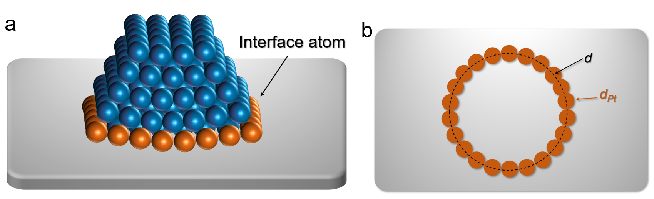
Scheme S1. (a) Schematic diagram of supported nanoparticles. (b) Schematic diagram of the interface Pt atom in the supported catalysts.

Table S4. Summary of the N_{T} and m of each Pt/PN-CeO₂ catalyst.
Pd loading (wt. %) | Pd size (d) | N_{T} | m
0.3 | 1.3 ± 0.29 | 77.45 | 2.30
0.5 | 1.39 ± 0.31 | 96.73 | 2.49
2.2 | 1.65 ± 0.44 | 158.36 | 2.82
5.5 | 2.15 ± 0.75 | 350.35 | 3.48

Table S5. Summary of the number active sites of each type
Pd size (d) | N_{S} | N_{corner} | N_{edge} | N₁₀₀ | N₁₁₁ | N_{interface}
1.3 ± 0.29 | 52.70 | 24 | 10.80 | 0.54 | 17.36 | 14.80
1.39 ± 0.31 | 68.96 | 24 | 17.78 | 1.46 | 25.71 | 15.93
1.65 ± 0.44 | 101.48 | 24 | 29.56 | 4.04 | 43.88 | 18.77
2.15 ± 0.75 | 185.77 | 24 | 53.10 | 13.06 | 95.62 | 23.73

Table S6. Summary of the total number active sites of each type
Pd size (d) | mmol
Pd size (d) | N_{S} | N_{corner} | N_{edge} | N₁₀₀ | N₁₁₁ | N_{interface}
1.3 ± 0.29 | 0.000518 | 0.000236 | 0.000106 | 5.31×10⁻⁶ | 0.000171 | 0.000145
1.39 ± 0.31 | 0.000905 | 0.000315 | 0.000233 | 5.31×10⁻⁵ | 0.000337 | 0.000209
1.65 ± 0.44 | 0.00358 | 0.000846 | 0.00104 | 0.000143 | 0.00155 | 0.000662
2.15 ± 0.75 | 0.00740 | 0.000956 | 0.00211 | 0.00052 | 0.00381 | 0.000945

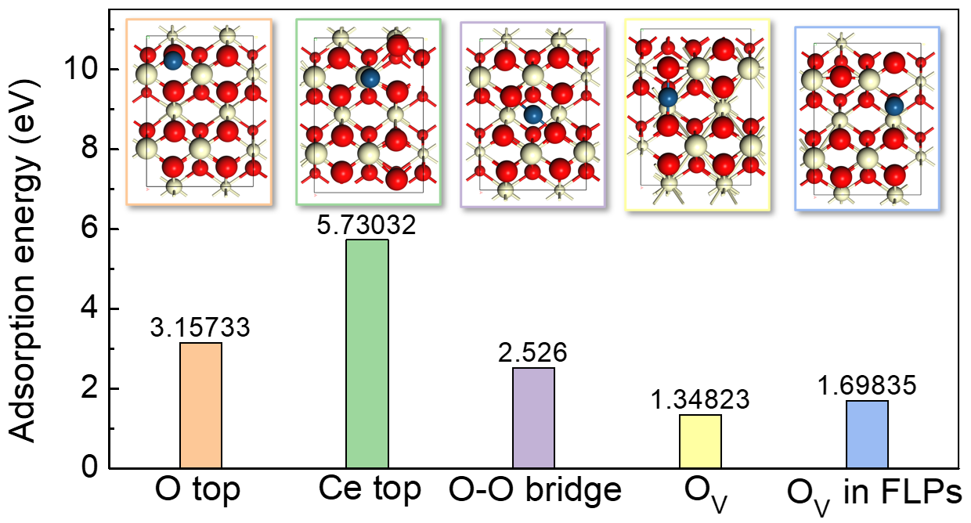
Figure S1 | Summary of the adsorption energy of Pt single-atom at various sites on CeO₂(110) surface.

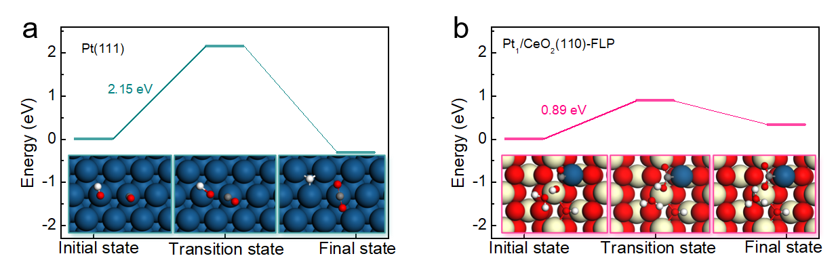
Figure S2 | The reforming of *CO on the (a) Pt(111) surface and (b) Pt₁-FLP dual-active site.

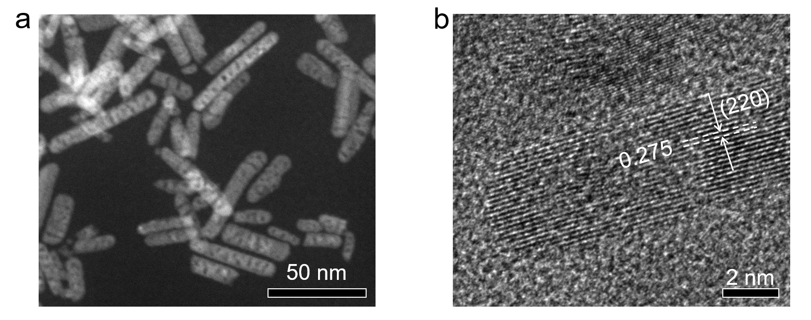
Figure S3 | Morphology characterization of PN-CeO₂. (a) Dark field TEM and (b) HRTEM images of the PN-CeO₂ catalysts.

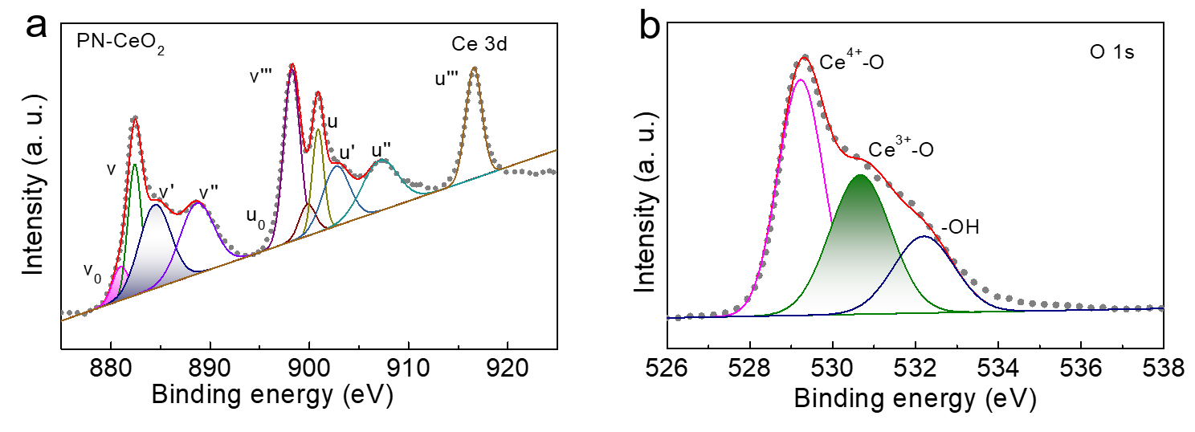
Figure S4 | Surface properties of PN-CeO₂ supports. XPS analysis of (a) Ce 3d and (b) O 1s peaks for the PN-CeO₂ catalysts.

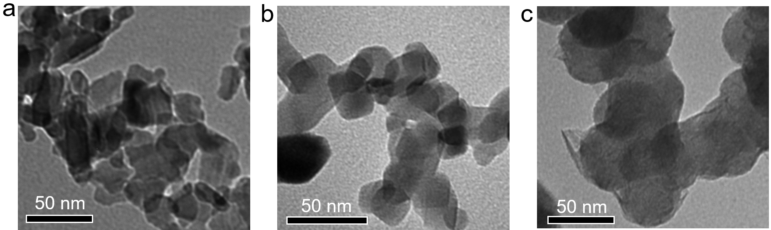
Figure S5 | Morphology characterization of various Pt catalysts. TEM images of (a) Pt/Al₂O₃, (b) Pt/TiO₂ and (c) Pt/C catalysts.

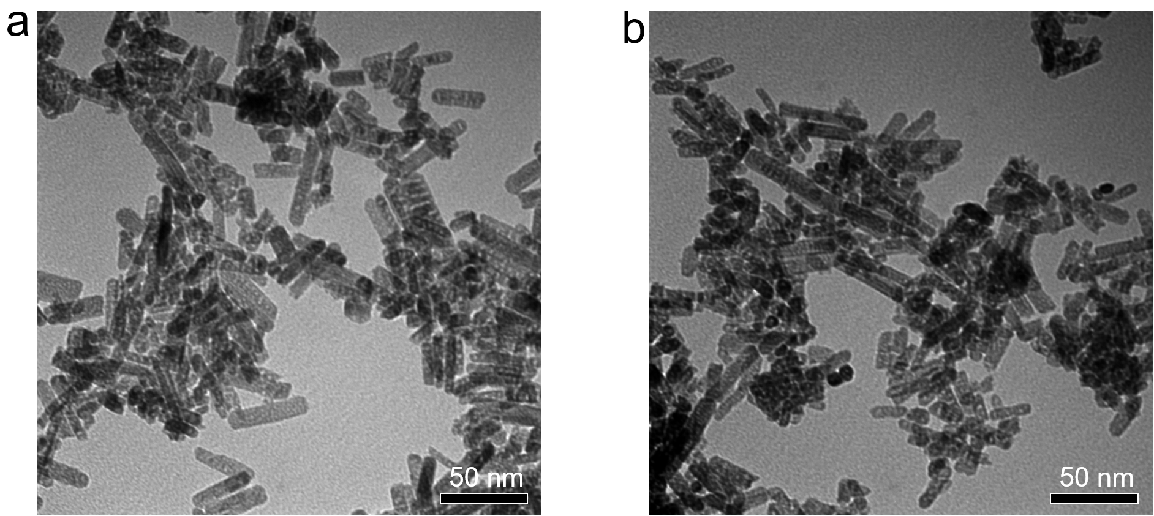
Figure S6 | Morphology characterization of used Pt₁/PN-CeO₂. TEM images of the used Pt₁/PN-CeO₂ catalysts at (a) 165 ºC and (b) 120 ºC, respectively.

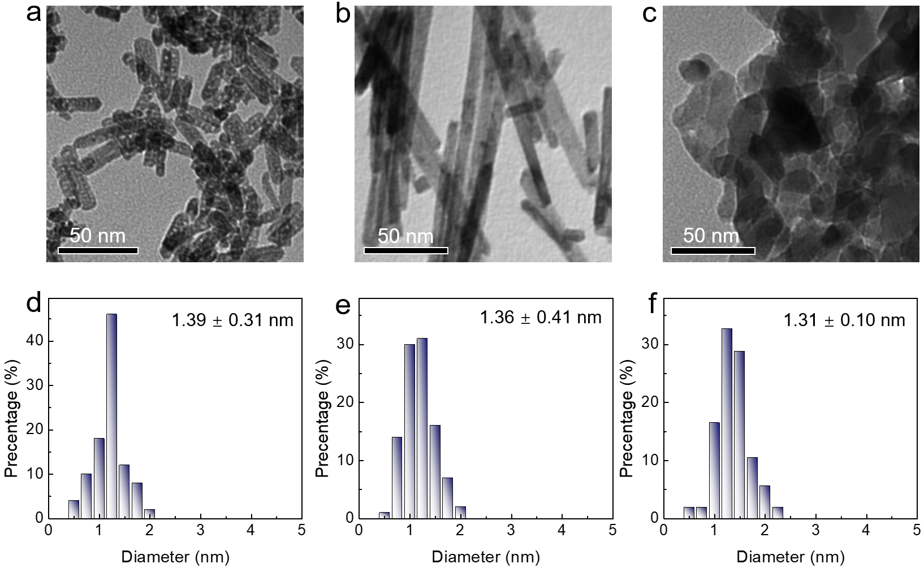
Figure S7 | Morphology and size characterization. TEM images of (a) Pt/PN-CeO₂, (b) Pt/NR-CeO₂ and (c) Pt/NP-CeO₂. The size distribution of Pt on the (d) Pt/PN-CeO₂, (e) Pt/NR-CeO₂ and (f) Pt/NP-CeO₂ catalysts.
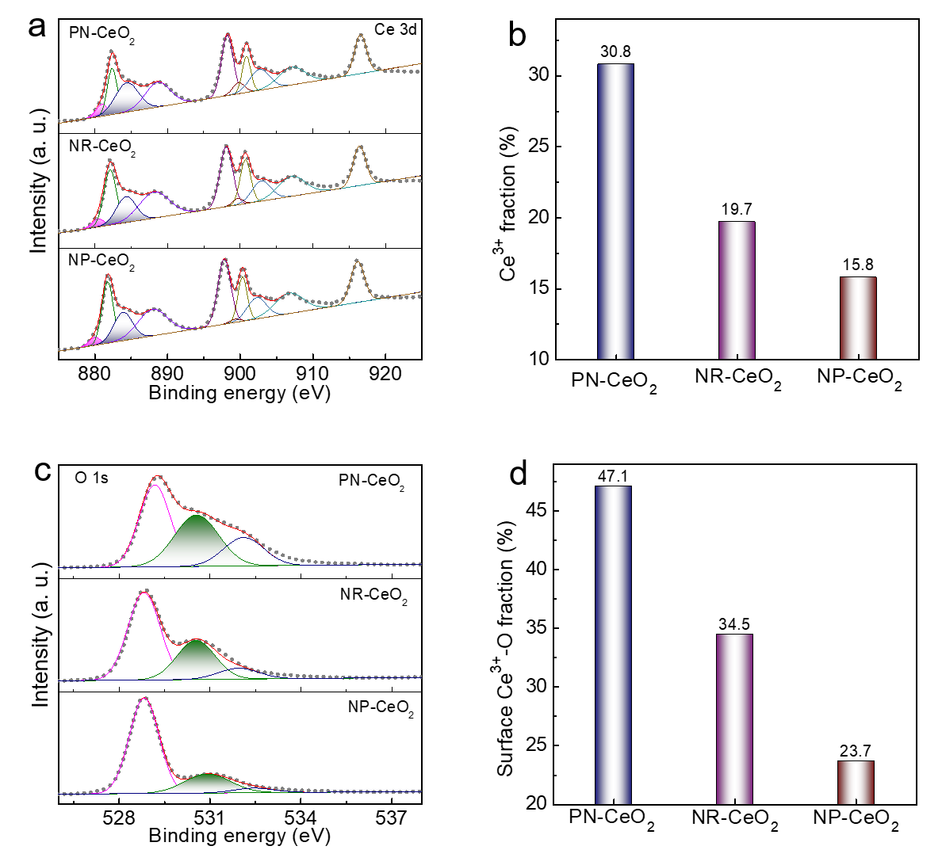
Figure S8 | Surface properties of various CeO₂ supports. (a) XPS analysis of Ce 3d peaks for various CeO₂ supports. (b) Surface Ce³⁺ fraction of various CeO₂ supports. (c) XPS analysis of O 1s peaks for various CeO₂ supports. (d) Surface Ce³⁺-O fraction of various CeO₂ supports.

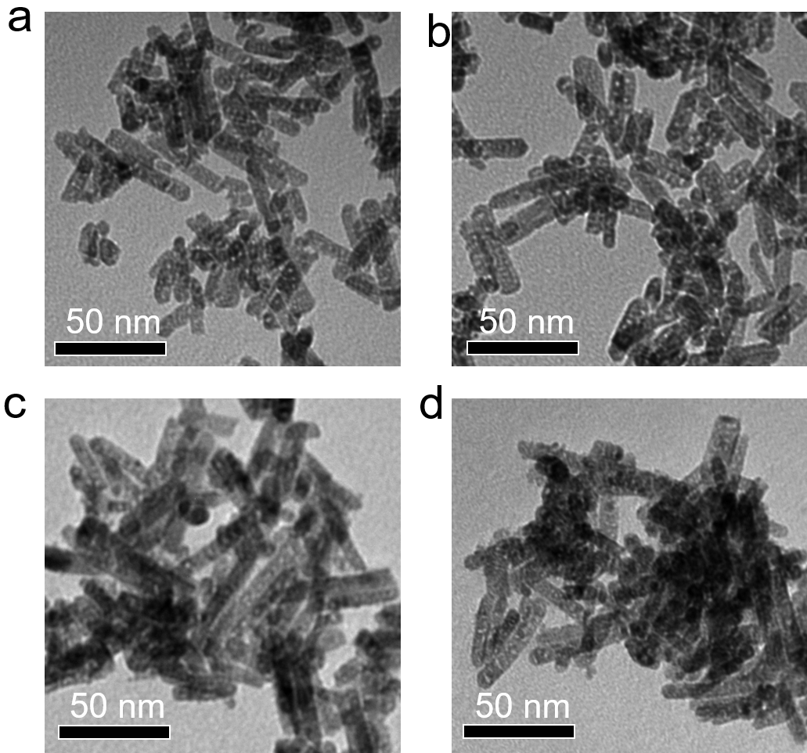
Figure S9 | Morphology characterization. TEM images of the Pt/PN-CeO₂ catalysts with Pt loading of (a) 0.3 wt.%, (b) 0.5 wt.%, (c) 2.2 wt.% and (d) 5.5 wt.%.

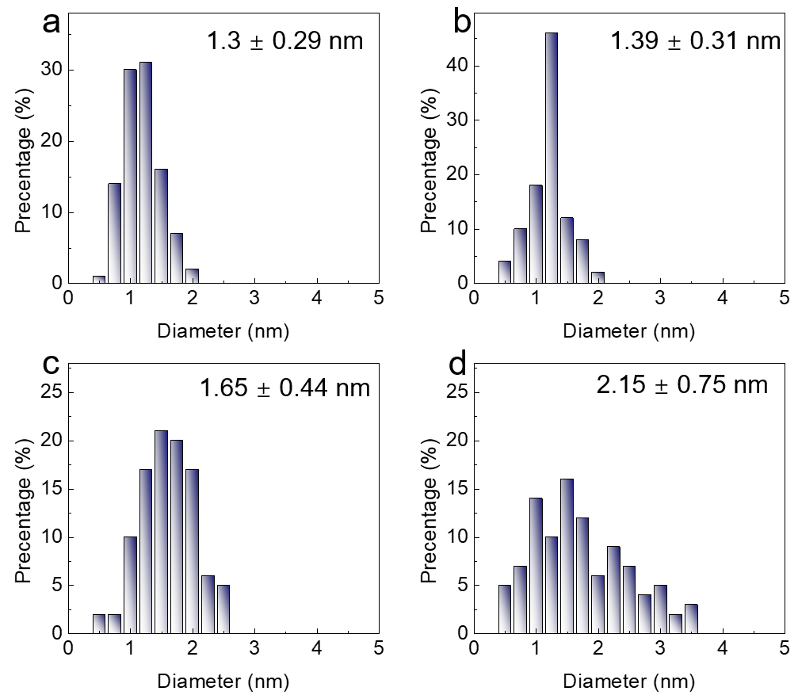
Figure S10 | Size characterization. Size distributions of the Pt/PN-CeO₂ catalysts with Pt loading of (a) 0.3 wt.%, (b) 0.5 wt.%, (c) 2.2 wt.% and (d) 5.5 wt.%.

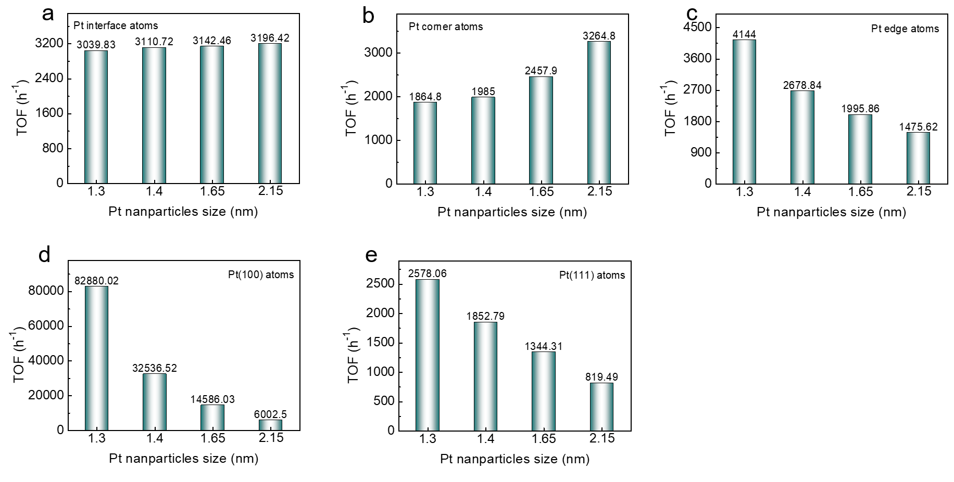
Figure S11 | TOF values. The calculated TOF values based on (a) interfacial, (b) corner, (c) edge, (d) (100) and (e) Pt(111) Pt atoms.
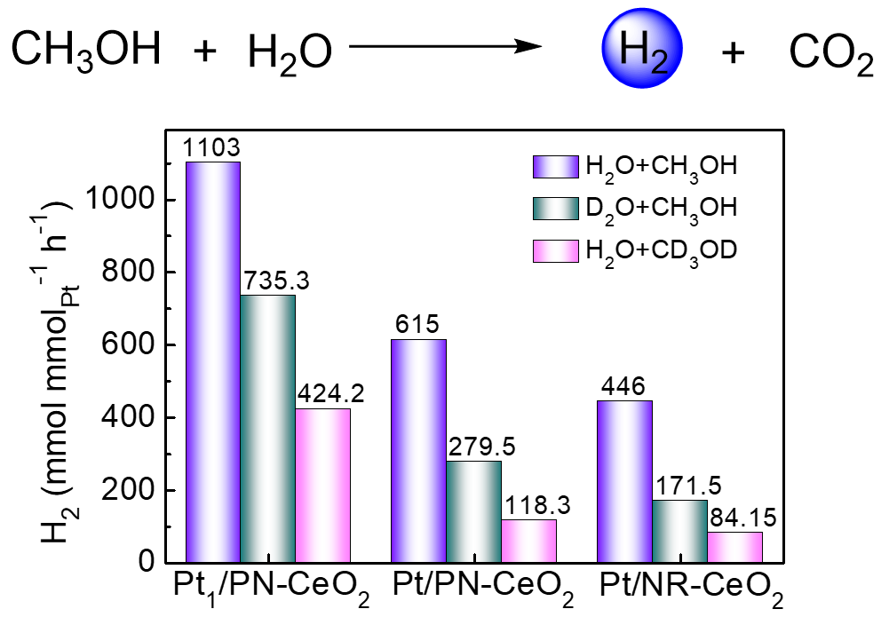
Figure S12 | Kinetic isotope effect for H₂ generation from methanol and H₂O. Summary of the H₂ generation rates from CH₃OH/CD₃OD and H₂O/D₂O catalyzed by Pt₁/PN-CeO₂, Pt/PN-CeO₂ and Pt/NR-CeO₂. Reaction conditions: catalysts (50 mg), CH₃OH/CD₃OD (40 mL), H₂O/D₂O (18 mL), n(CH₃OH):n(H₂O)=1:1, 165 ℃ and N₂ (0.4 MPa).

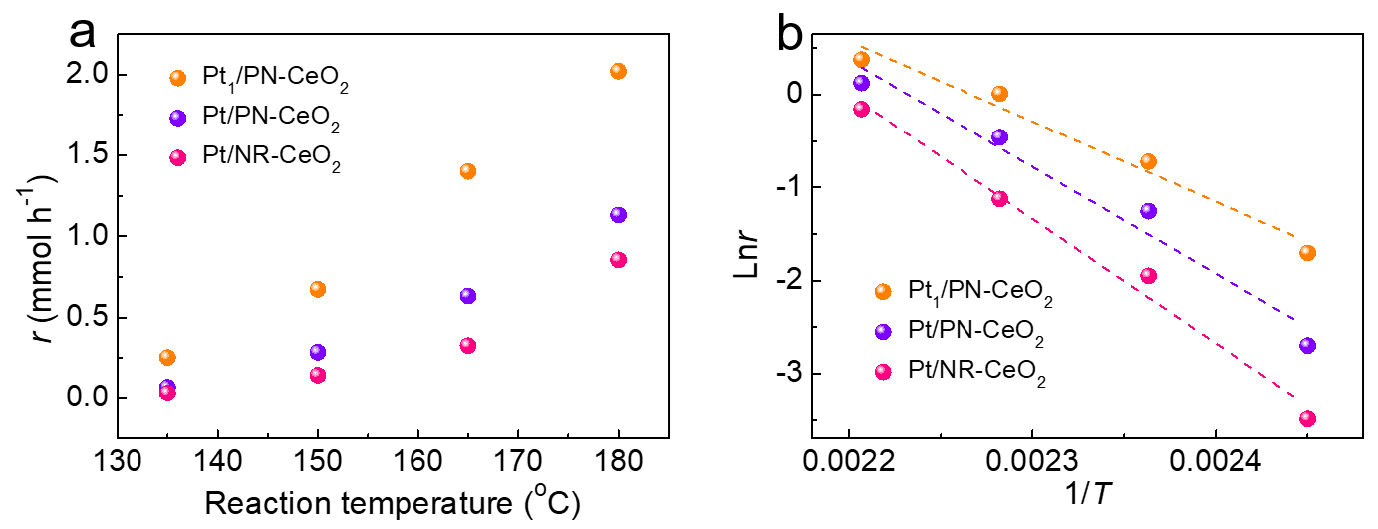
Figure S13 | H₂ generation at various reaction temperature. (a) H₂ generation rate at various reaction temperature. Reaction conditions: catalysts (50 mg), CH₃OH (40 mL), H₂O (18 mL), n(CH₃OH):n(H₂O)=1:1, and N₂ (0.4 MPa). (b) Lnr, derived from H₂ generation rate versus reaction time, as a function of 1/T over various Pt/CeO₂ catalysts.

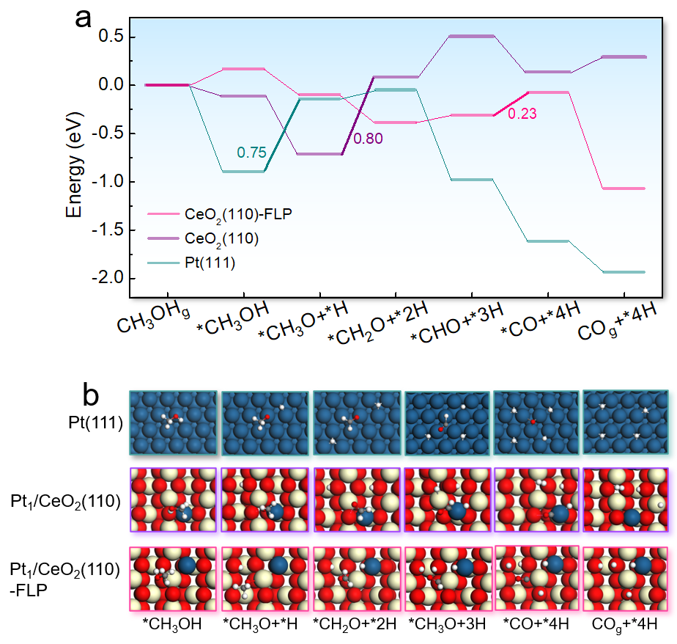
Figure S14 | Methanol decomposition on Pt. (a) Energy barrier of methanol decomposition on Pt(111), Pt₁/CeO₂(111) and Pt₁/CeO₂(111)-FLP. (b) The adsorption configuration of various intermediates on Pt(111), Pt₁/CeO₂(110) and Pt₁/CeO₂(110)-FLP during the methanol decomposition.

