Supplementary Information for
Improving crop-livestock integration in China using numerical experiments at two scales
Lei Chen¹, Yiwen Wang¹, Nian Yang¹, Kaihang Zhu¹, Xiaoman Yan¹, Zhaohai Bai², Limei Zhai³, Zhenyao Shen^{1,*}
1 State Key Laboratory of Water Environment Simulation, School of Environment, Beijing Normal University, Beijing 100875, China;
2 Key Laboratory of Agricultural Water Resources, Hebei Key Laboratory of Soil Ecology, Center for Agricultural Resources Research, Institute of Genetic and Developmental Biology, Chinese Academy of Sciences, Shijiazhuang 050021, China;
3 Key Laboratory of Nonpoint Source Pollution Control, Ministry of Agriculture/Institute of Agricultural Resources and Regional Planning, Chinese Academy of Agricultural Sciences, Beijing 100081, China.
* Corresponding authors:
L.Chen: chenlei1982bnu@bnu.edu.cn; Z.Shen: zyshen@bnu.edu.cn
This PDF file includes:
Supplementary Text;
Figs S1-2;
Tables S1 to S5.

Setup of watershed model
In this study, SWAT model provides basic support for the simulation of crop yield and agricultural non-point source pollution. The specific processes of SWAT model calibration are as follows.
In this study, the local actual agricultural tillage measures and the river phosphorus load in the agricultural source emission characteristics were considered. Combined with the meteorological data from 2006 to 2018, the SWAT model of the Liaohe River watershed was constructed. The calibration and validation data were derived from water quality monitoring data from 2016 to 2018. Furthermore, SWAT-CUP software was used for sensitivity analysis of model parameters and calibration and verification of model results. Among them, the selection of parameters was obtained from literature review and field investigation. In this study, Nash efficiency coefficients (NSE) and R² were used as evaluation indexes for the fitting degree of simulated and observed values, and the calculation equation was shown in Equation S1 and S2.
$NSE=1-\frac{\sum_{i=1}^{n}{{(O_{i}-P_{i})}^{2}}}{\sum_{i=1}^{n}{{(O_{i}-\overline{O})}^{2}}}$ （1）
$R^{2}=\frac{\left[\sum_{i}{(Q_{m,j}- \overline{Q_{m}})(Q_{s,j}- \overline{Q_{s}})}\right]}{\sum_{i}{{(Q_{m,j}- \overline{Q_{m}})}^{2}\sum_{i}{{(Q_{s,j}- \overline{Q_{s}})}^{2}}}}$ （2）
where O_{i} and P_{i} are the ith monitored value and simulated value respectively; n is the total number of data points; $\overline{O}$is the average value of the monitored value; Q is a variable (such as flow); m is the measured data; s is the simulated data; j is the jth measured or simulated data.
Calibration of crop parameters. Based on the chemical fertilizer application scenario and the actual crop yield in the watershed of the statistic yearbook, the simulated rice yield from 2014 to 2018 was obtained by calibrating the related crop parameters of SWAT model (Table S2). And the error analysis was carried out. The measured yield from 2014 to 2018 was 5.634×10⁵ - 5.853×10⁵ t, showing a downward trend. Compared with the multi-year average yield, the measured yield fluctuated from -1.61% to 2.22% during 2014-2018 (Table S2). The simulation effect of multi-year average crop yield between simulated values and measured values was good, and the error was only 0.15%. This indicated that the simulation results of crop yield were acceptable.
Calibration of total phosphorus. The evaluation of hydrological and water quality simulation in the Liao River watershed indicated that the simulation of SWAT model was acceptable, the R² value was all above 0.65, and the Ens coefficient was basically above 0.54 (Table S3). The SWAT model was calibrated and validated based on the monthly total phosphorus data of the Liaohe River watershed water quality monitoring station from 2016 to 2018. The simulation results of total phosphorus were good. The values of R² and Ens were greater than 0.5 in the calibration and verification periods (Table S4). On the whole, the values of R² and Ens met the basic requirements of simulation accuracy, indicating that SWAT model had good applicability in the Liaohe River watershed.

Scenarios settings
Scenario I: Chemical fertilizer and manure reduction. The fertilizer reduction scenario in this study was 0-60%, sequentially reduction treatment by 10% gradient. In the setting of manure input, each treatment was based on the same amount of nitrogen, and chemical fertilizer was added when phosphorus was deficient, and converted to the manure amount under the corresponding scenario. The calibration crop parameters of rice yield from 2014 to 2018 were obtained based on the statistical yearbook. The multi-year average rice yield and the river phosphorus load at the outlet section of the watershed from 2014 to 2018 were further identified to explore the impact of chemical fertilizer and manure reduction on non-point source pollution and rice yield in the watershed.
Scenario II: Replacing chemical fertilizer with manure. In Liaohe River watershed, the application of phosphorus in chemical fertilizer was 2.035×10³ t, and the total phosphorus produced by returning manure to the field was 2.311×10³ t, which was basically consistent with the phosphorus content in chemical fertilizer. In this study, the main source of organic fertilizer is livestock and poultry manure. In the double-cropping rice planting area of Jiangxi province, the replacement rate of manure instead of chemical fertilizer is as high as 70%. Therefore, in this study, the proportion range of manure replacing chemical fertilizer was set as 10%-70%.

Grain yield, poultry breeding and fertilizer application in Liaohe River watershed

Current status of grain yield
The main food crop in Liaohe River watershed is rice, and the dry crop is peanut. By referring to the statistic yearbook of Jiangxi Province from 2014 to 2018, the grain output in the Liaohe River watershed from 2014 to 2018 is shown in Fig. S1. From 2014 to 2018, the distribution range of rice yield is 5.634×10⁵ - 5.853×10⁵ t, and the annual average rice yield is 5.726×10⁵ t. The distribution range of peanut yield is 1.091×10⁴ - 1.150×10⁴ t, with an average annual peanut yield is 1.119×10⁴ t. The total planting area of rice and peanut is about 827.5 km² and 40.62 km², respectively. Peanut is the main economic crop in dryland in the watershed, and the planting area is less than 10% of the total cultivated area in the watershed. In addition, there is also some vegetable fields in dryland with less fertilizer application. Therefore, this study does not consider the fertilizer amount of vegetable land.

Current status of manure production and chemical fertilizer application
Based on the comparison between the actual application amount of phosphorus in chemical fertilizer and the supply of manure in 2017 (Table S5), the application amount of phosphate fertilizer (calculated by P₂O₅) in planting industry in Liaohe River watershed is 5.279×10³ t, in which the content of phosphorus is 2.305×10³ t. The total amount of phosphorus in manure from rural population and livestock manure in the watershed is 2.311×10³t, which is basically consistent the phosphorus content in chemical fertilizer. This indicates that the phosphorus content in manure from agricultural production process in the watershed can fully cover the demand for phosphorus in chemical fertilizer for crop growth. The spatial distribution characteristics of total phosphorus in manure and chemical fertilizer are relatively consistent (Fig. S2). The content of phosphorus is high in the middle and lower reaches of the sub-watershed, while it is lower in the upper reaches of the sub-watershed. The land use in the upper reaches are mainly woodland, with less cultivated land, low fertilizer application and fewer livestock and poultry breeding. The middle and lower reaches of the watershed have high population density, fertile soil, developed planting industry and large application of chemical fertilizer. Manure is mainly distributed in the south and east of Liaohe River watershed, which is the main distribution of many piggeries with overall high stocking density.

Simulation method for phosphorus nutrient supply.

Nutrient supply of manure.
The nutrient supply of manure is calculated according to Equation S3. Among them, livestock and poultry inventory data was obtained from statistical yearbook of Jiangxi Province, and excretion coefficient was obtained from references¹⁻³. According to literature review and field investigation, the manure utilization rate was set to be 87.8 %, and the phosphorus retention rate was 72 %.
$M_{s}=\sum_{i=1}^{n}{A_{i}*E_{i}}*G_{r}*S_{r}$ （3）
where M_{s} is the manure nutrient supply from livestock and poultry breeding in the region (t·a⁻¹), A_{i} is the inventory of the ith livestock species, E_{i} is the annual phosphorus excretion coefficient of the ith livestock species (kg·d⁻¹), Gr is the collection coefficient in the region (%), and S_{r} is the nutrient retention rate, which is related to the treatment methods (%).

The land carrying capacity of livestock and poultry breeding.
It refers to the largest stock of livestock and poultry that can be carried by cultivated land, woodland, and grassland in regions with conditions suitable for sustaining terrestrial ecosystems. The theoretical maximum breeding quantity based on crop nutrient demands being met by manure (manure nutrient supply per pig equivalent) can be calculated by Equation S4. In this study, the ratio of the actual number of livestock and poultry breeding to the maximum breeding number was used to characterize the carrying capacity, as shown in Equation S5. Among them, the maximum breeding number was based on crops demand for phosphorus nutrient in manure. When the ratio is larger than 1.0, the number of livestock and poultry breeding in the region is above carrying capacity. When the ratio is less than 1.0, it indicates that there is still space for development of the breeding industry in the region.
$R=\frac{{NU}_{r,m}}{{NS}_{r,a}}*1000$ （4）
$I=\frac{Q}{R}$ （5）
where R is the theoretical maximum breeding quantity based on the crop nutrient demand being met by manure (pig equivalent) and I is the index of the land carrying capacity of livestock and poultry breeding.

References:
1. Wang, B. et al. Returning excrement from livestock, poultry, and humans to farmland as nutrient resources for crop growth: Assessment of rural China. PROCESS SAF ENVIRON 146, 412-423 (2021).
2. Wang, Q. et al. Data-driven estimates of global nitrous oxide emissions from croplands. NATL SCI REV 7, 441-452 (2020).
3. Jia, W. et al. Evaluation of crop residues and manure production and their geographical distribution in China. J CLEAN PROD 188, 954-965 (2018).

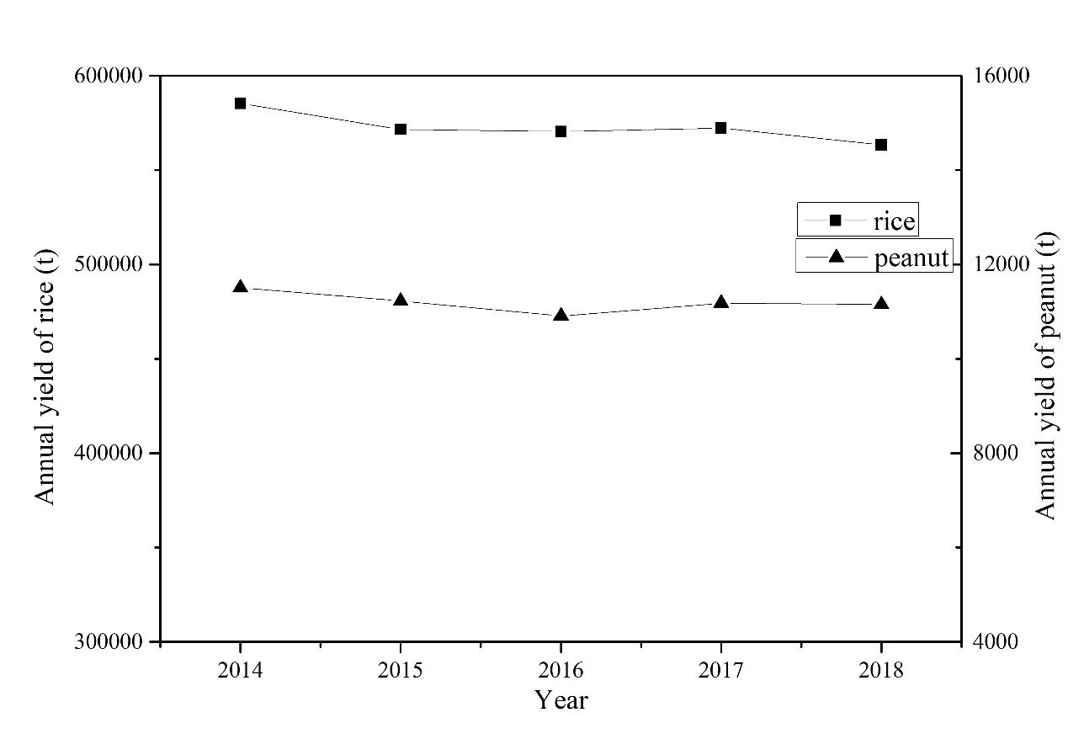
Fig. 1 Crop yields in 2014-2018

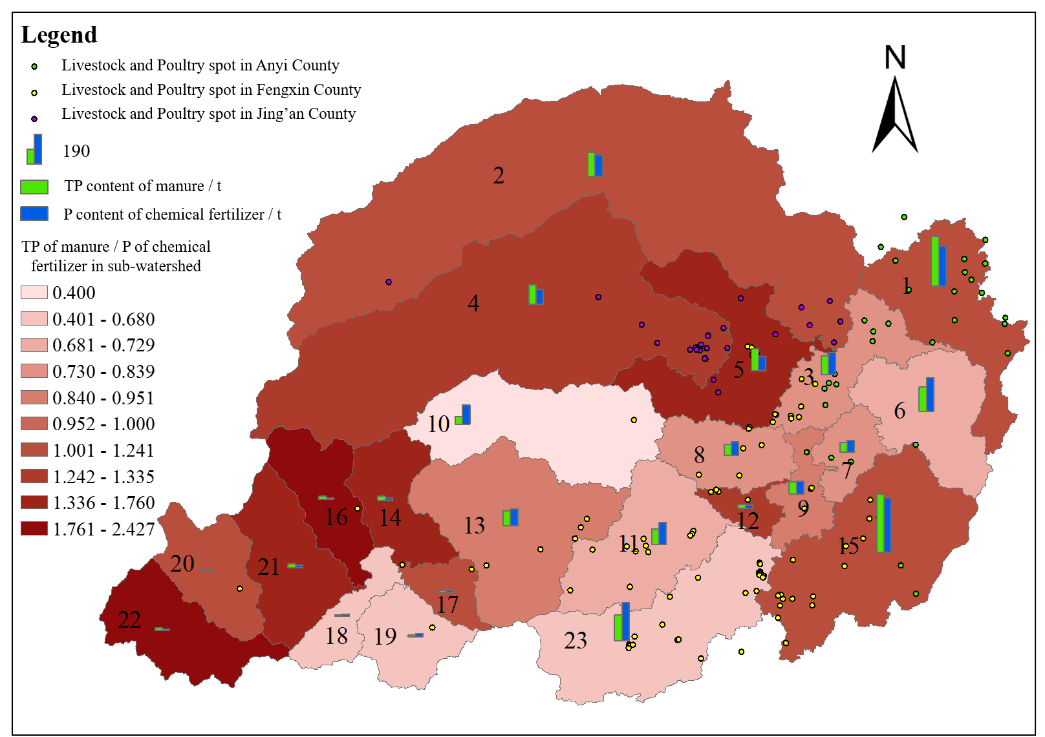
Fig. 2 Distribution map of manure and chemical fertilizer application

Table 1 Main crop parameter types
 | Parameter | Description | Optimum value
Crop parameter | BIO_E | Photosynthetic radiation utilization rate [kg/ha/(MJ/m²)] | 26.0
Crop parameter | HVSTI | Harvest index of optimum growth conditions (kg/ha)/(kg/ha) | 0.5
Crop parameter | BLAI | Potential maximum leaf area index (m²/m²) | 5.0
Crop parameter | FRGRW1 | Cumulative temperature ratio corresponding to the first point of optimum leaf area index curve | 0.3
Crop parameter | DLAI | Maximum potential leaf area index | 0.8
Crop output | BIOM | Total biomass (mt/ha) | --
Crop output | LAI | Leaf area index at the end of the period | --
Crop output | YLD | Harvest yield (mt/ha) | --
Note: -- represents no optimal value.

Table 2 Crop yield simulation results
 | 2014 | 2015 | 2016 | 2017 | 2018 | Multi-year average
Simulated values | 561113 | 576508 | 479241 | 578420 | 671666 | 573390
Observed values | 585263 | 571499 | 570412 | 572247 | 563361 | 572556
Fluctuation of observed values | 2.22% | -0.18% | -0.37% | -0.05% | -1.61% | 0%
Error (%) | -4.13 | 0.88 | -15.98 | 1.08 | 19.22 | 0.15

Table 3 The parameter of calibration and validation
 | Parameter | Description | Optimum value
Runoff parameters of Wanjibu hydrological station | CN2 | Runoff curve number | 0.22
Runoff parameters of Wanjibu hydrological station | ALPHA_BF | Base-flow segmentation coefficient (days) | 0.50
Runoff parameters of Wanjibu hydrological station | GW_DELAY | Groundwater delay coefficient (days) | 80.38
Runoff parameters of Wanjibu hydrological station | GWQMN | Replenishment depth of diving layer (mm H₂O) | 13.96
Runoff parameters of Wanjibu hydrological station | ESCO | Compensation coefficient of soil evaporation | 0.28
Runoff parameters of Wanjibu hydrological station | CANMX | Maximum canopy water storage (mm H₂O) | 36.61
Runoff parameters of Wanjibu hydrological station | SOL_AWC() | Available soil moisture (mmH₂O/mmsoil) | 0.31
Runoff parameters of Wanjibu hydrological station | SOL_Z() | Soil thickness (mm) | 0.27
Runoff parameters of Wanjibu hydrological station | SOL_K() | Soil saturation hydraulic conductivity (mm/hr) | 0.51
Runoff parameters of Wanjibu hydrological station | REVAPMN | Limit evaporation depth of diving (mmH₂O) | 259.12
Runoff parameters of Wanjibu hydrological station | GW_REVAP | Groundwater evaporation coefficient | 0.16
Runoff parameters of Wanjibu hydrological station | CH_K2 | Hydraulic conductivity of main river (mm/hr) | 0.08
Runoff parameters of Wanjibu hydrological station | CH_K1 | Effective hydraulic conductivity of tributary sedimentation layer (mm/hr) | 169.71
Runoff parameters of Wanjibu hydrological station | EPCO | Water absorption compensation coefficient of vegetation | 0.69
Runoff parameters of Wanjibu hydrological station | SURLAG | Surface runoff delay coefficient | 9.08
Runoff parameters of Wanjibu hydrological station | SMFMX | Snowmelt coefficient on June 21 (mm H₂O/℃-day) | 12.25
Runoff parameters of Wanjibu hydrological station | SMTMP | Snow melting base temperature (℃) | 5.33
Runoff parameters of Wanjibu hydrological station | TRNSRCH | River-deep groundwater loss rate | 0.02
Runoff parameters of Wanjibu hydrological station | EVRCH | Regulation factors of river evapotranspiration | 0.92
Runoff parameters of Wanjibu hydrological station | ALPHA_BNK | Base flow factor α for riparian water storage (days) | 0.51
Runoff parameters of Wanjibu hydrological station | OV_N | Manning value of land currents | 23.69
Runoff parameters of Wanjibu hydrological station | HRU_SLP | average slope | 0.44

(continuation of Table 3)
 | Parameter | Description | Optimum value
Sediment parameters of Wanjiabu hydrological station | USLE_P | Factors of soil and water conservation measures in USLE equation | 0.18
Sediment parameters of Wanjiabu hydrological station | USLE_K() | Soil Erosion Factor K of USLE Equation | 0.01
Sediment parameters of Wanjiabu hydrological station | CH_COV1 | River cover factor | 0.40
Sediment parameters of Wanjiabu hydrological station | SPCON | Linear parameters for calculating maximum remigration of sediment during river migration | 0.01
Sediment parameters of Wanjiabu hydrological station | USLE_C{1} | Minimum USLE C factor value for land cover/crop water erosion | 0.31
Sediment parameters of Wanjiabu hydrological station | USLE_C{4} | Minimum USLE C factor value for land cover/crop water erosion | 0.37
Sediment parameters of Wanjiabu hydrological station | USLE_C{6} | Minimum USLE C factor value for land cover/crop water erosion | 0.51
Sediment parameters of Wanjiabu hydrological station | USLE_C{9} | Minimum USLE C factor value for land cover/crop water erosion | 0.39
Sediment parameters of Wanjiabu hydrological station | USLE_C{12} | Minimum USLE C factor value for land cover/crop water erosion | 0.20
Sediment parameters of Wanjiabu hydrological station | USLE_C{33} | Minimum USLE C factor value for land cover/crop water erosion | 0.37
Sediment parameters of Wanjiabu hydrological station | CH_ERODMO() | River erosion factor | 0.90
Sediment parameters of Wanjiabu hydrological station | SPEXP | Calculation of index parameters of sediment remigration in river | 1.03
Sediment parameters of Wanjiabu hydrological station | RSDCO | Stubble decomposition coefficient | 0.09

(continuation of Table 3)
 | Parameter | Description | Optimum value
TP parameters of water quality monitoring station in Sanhong village and Xifang village | PHOSKD | Soil phosphorus partition coefficient (m³/ Mg) | 180.000
 | PPERCO | Phosphorus leaching coefficient (10 m³/Mg) | 14.206
 | K_P | Phosphorus semi-saturation constant (mg P/L) | 0.010
 | RS2 | Rate of soluble phosphorus release from river sediments at 20°C (mg DP/(m²·day)) | 0.002
 | RS5 | Sedimentation rate coefficient of organic phosphorus in river at 20°C (day⁻¹) | 0.004
 | ERORGP | Enrichment rate of organic phosphorus in sediment | 1.822
 | SOL_ORGP() | Initial organic phosphorus concentration in soil layer (mg·kg⁻¹) | 16.460
 | SOL_LABP() | Initial dissolved phosphorus concentration in soil layer (mg·kg⁻¹) | 19.714
 | PSP | Available phosphorus index | 0.425
 | BC4 | Rate constant of river organic phosphorus mineralization into soluble phosphorus at 20℃ (day⁻¹) | 0.345
 | BIOMIX | Biological mixing effect | 0.989

Table 4 Calibration and verification of hydrological and water quality stations
 | Type | Year | R² | NSE
calibration | runoff | 2009-2013 | 0.88 | 0.86
calibration | sediment | 2009-2013 | 0.65 | 0.54
calibration | TP in Xifang village | 2016 | 0.74 | 0.72
calibration | TP in Sanhong village | 2016-2017 | 0.66 | 0.65
verification | runoff | 2014-2018 | 0.87 | 0.81
verification | sediment | 2014-2018 | 0.87 | 0.76
verification | TP in Xifang village | 2017 | 0.81 | 0.64
verification | TP in Sanhong village | 2018 | 0.85 | 0.75

Table 5 The total amount of manure and chemical fertilizer in 2017
 | TP content of human manure returning to field /t | TP content of livestock and poultry manure returning to field/t | Application amount of phosphate fertilizer (calculated by P₂O₅) /t | Phosphorus content in chemical fertilizer /t
Liaohe River watershed | 116.67 | 2193.87 | 5279.74 | 2305.24

