Supplementary Information

Yinjie Lv^{1, 3}, Lei Dong^{1, 3}, Lvyang Cheng¹, Tianyi Gao¹, Cong Wu¹, Xin Chen¹, Yuanyuan Cui^{2,✉} and Wei Liu^{1,✉}

¹School of Physical Science and Technology, ShanghaiTech University, Shanghai 201210, China.
²School of Materials Science and Engineering, Shanghai University, Shanghai 200444, China.
³These authors contributed equally: Yinjie Lv, Lei Dong.
✉E-mail: cui-yy@shu.edu.cn. liuwei1@shanghaitech.edu.cn

Supplemental Figure

Fig S1. Schematic of the membrane preparation process.

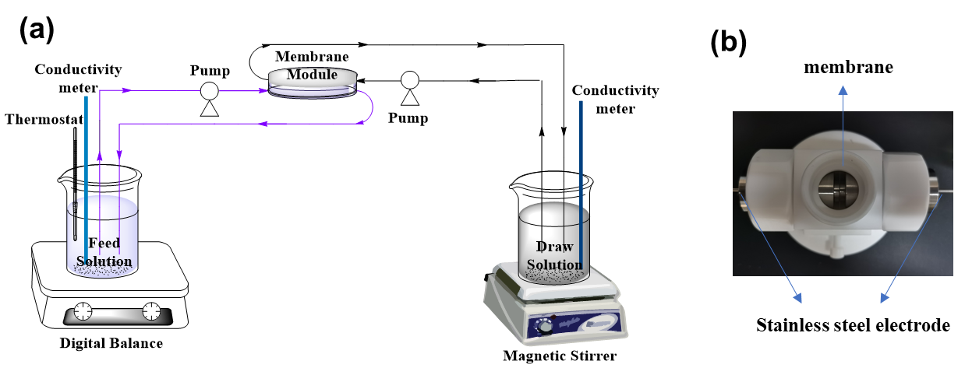
Fig S2. Schematic diagram of (a) FO system and (b) Electrochemical cell.

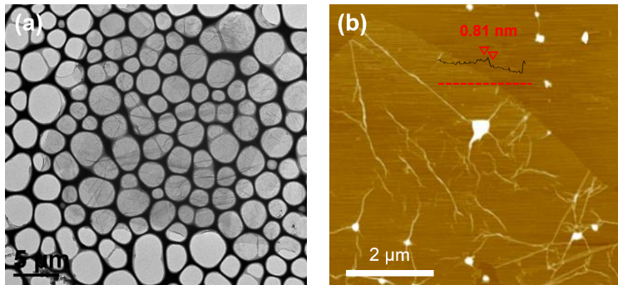
Fig S3. (a-b) TEM and AFM of GO sheet. The height of 0.81 nm in b indicates its single layer.

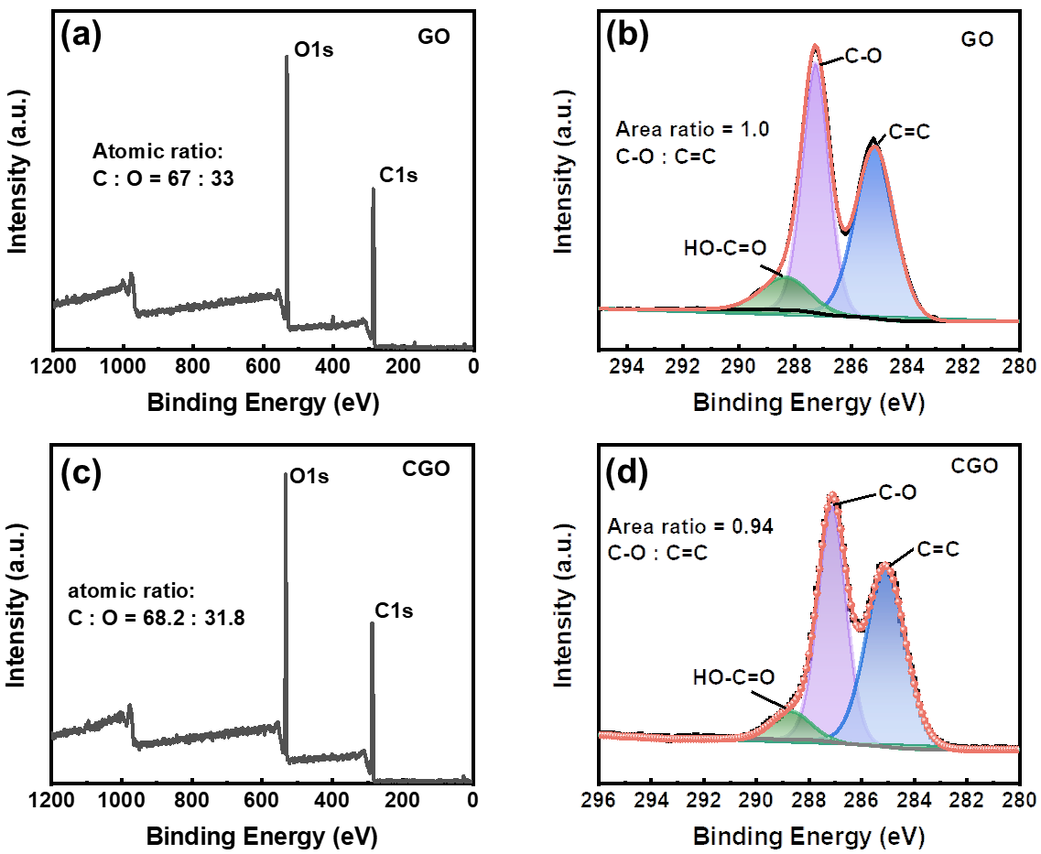
Fig S4. Component characterization: (a-d) XPS spectra of GO and CGO membrane.

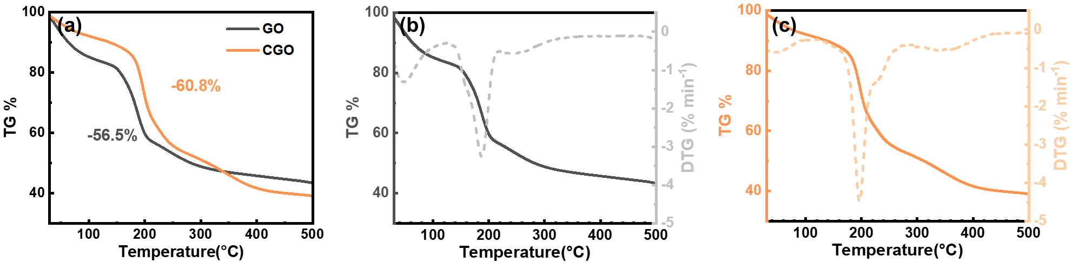
Fig S5. (a-c) TG curves of GO and CGO membrane, recorded at 5 K min⁻¹ under constant N₂ flow of 20 ml min⁻¹.

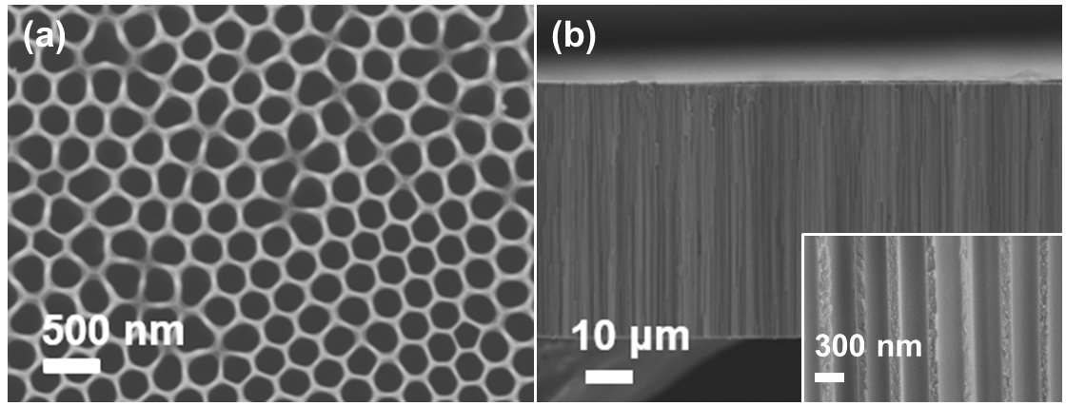
Fig S6. (a) Top view SEM of AAO. (b) Cross-sectional SEM of CGO@AAO, the total thickness is ~50 μm, and pore size of AAO is ~350nm.

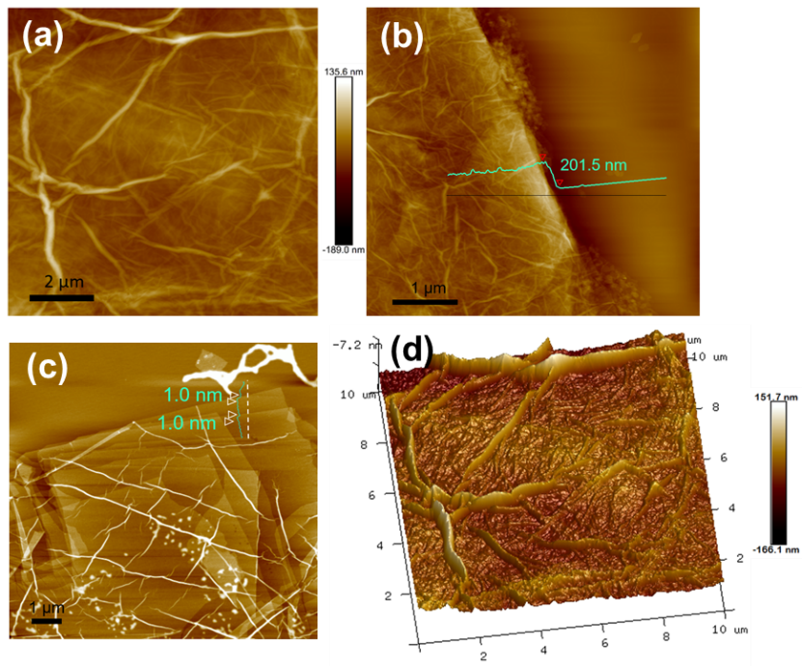
Fig S7. AFM of CGO membrane. (a) Surface view. (b) Height image. (c) Interlayer spacing between mono-sheets. (d) Surface roughness.

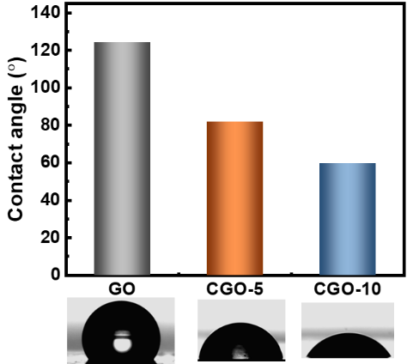
Fig S8. Contact angle of three membrane, unmodified GO membrane, CGO-5@AAO membrane and CGO-10@AAO membrane.

Fig S9. Monitor the integrity of active layer.

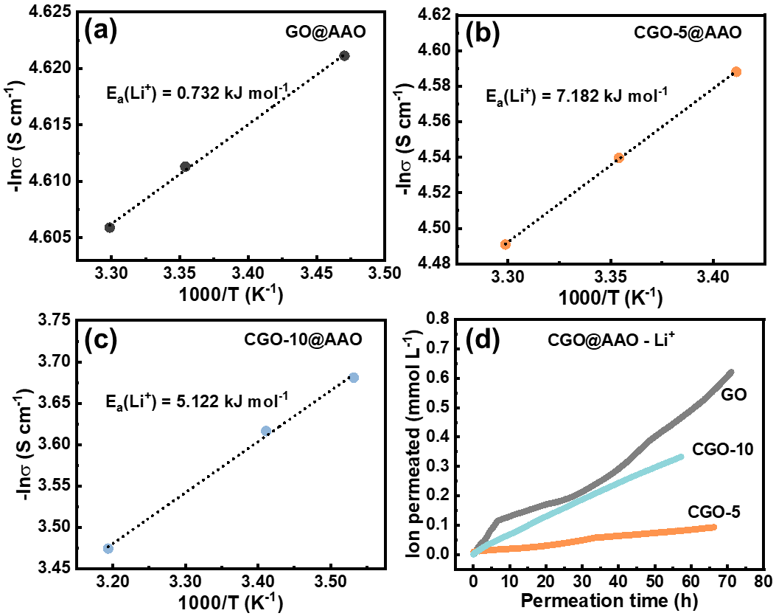
Fig S10. (a-c) The active energy for three membranes. (d) The ion transport rate of three membranes.
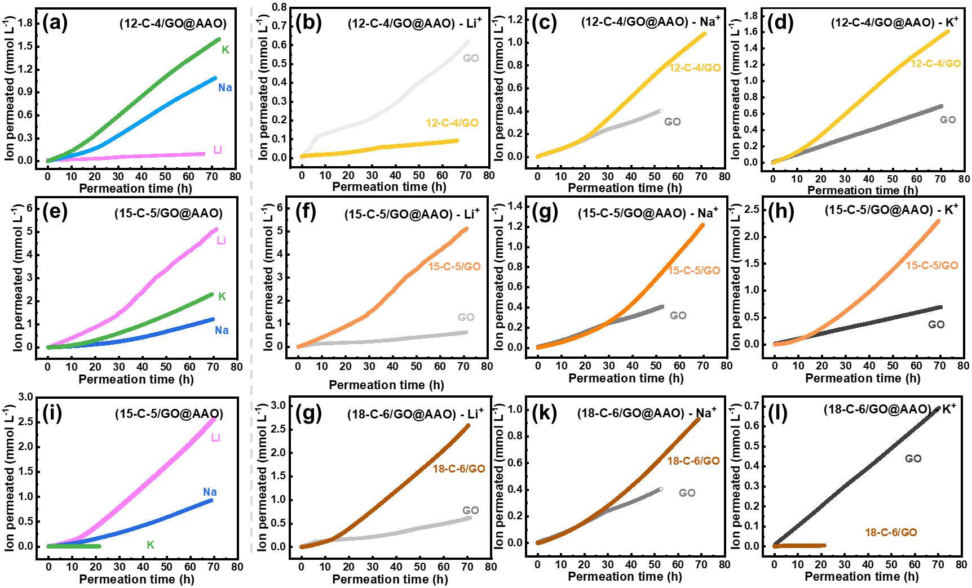
Fig S11. Ion permeation rate of different membrane for alkali metal ions (Li⁺, Na⁺, K⁺). (a-d) Ion permeation rate of 12-C-4/GO@AAO membrane. (e-h) Ion permeation rate of 15-C-5/GO@AAO membrane. (i-l) Ion permeation rate of 18-C-6/GO@AAO membrane.

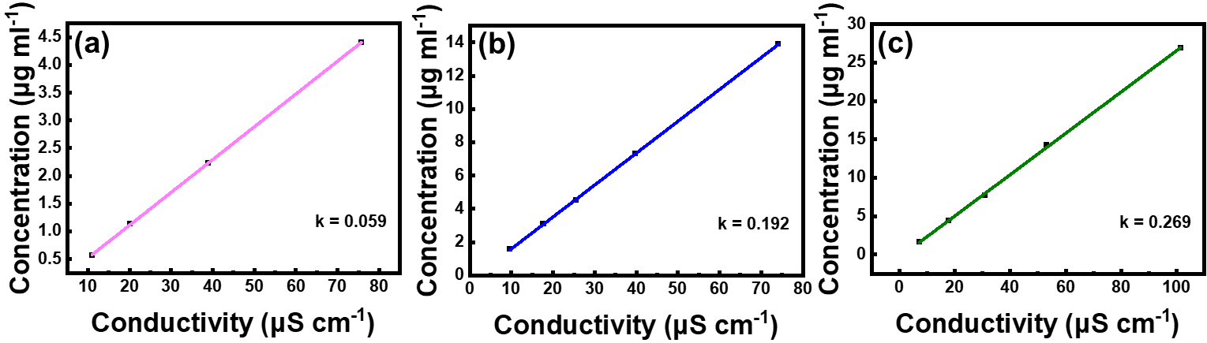
Fig S12. The relationship plots between ionic concentration and conductivity in single-ionic
solution. (a-c) Li⁺, Na⁺ and K⁺, respectively.

Table S1. Physical properties of ions studied in our work¹⁻³
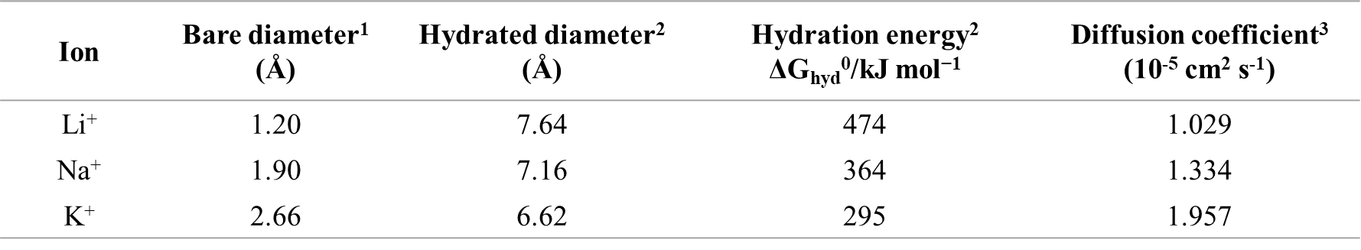

Reference
1. Binder, H. & Zschornig, O. The effect of metal cations on the phase behavior and hydration characteristics of phospholipid membranes. Chem. Phys. Lipids 115, 39-61 (2002).
2. Nightingale, E. R. Phenomenological theory of ion solvation. Effective radii of hydrated ions. The Journal of Physical Chemistry 63, 1381-1387 (2002).
3. Vanýsek, P. CRC handbook of chemistry and physics. (CRC Press, 2000).

