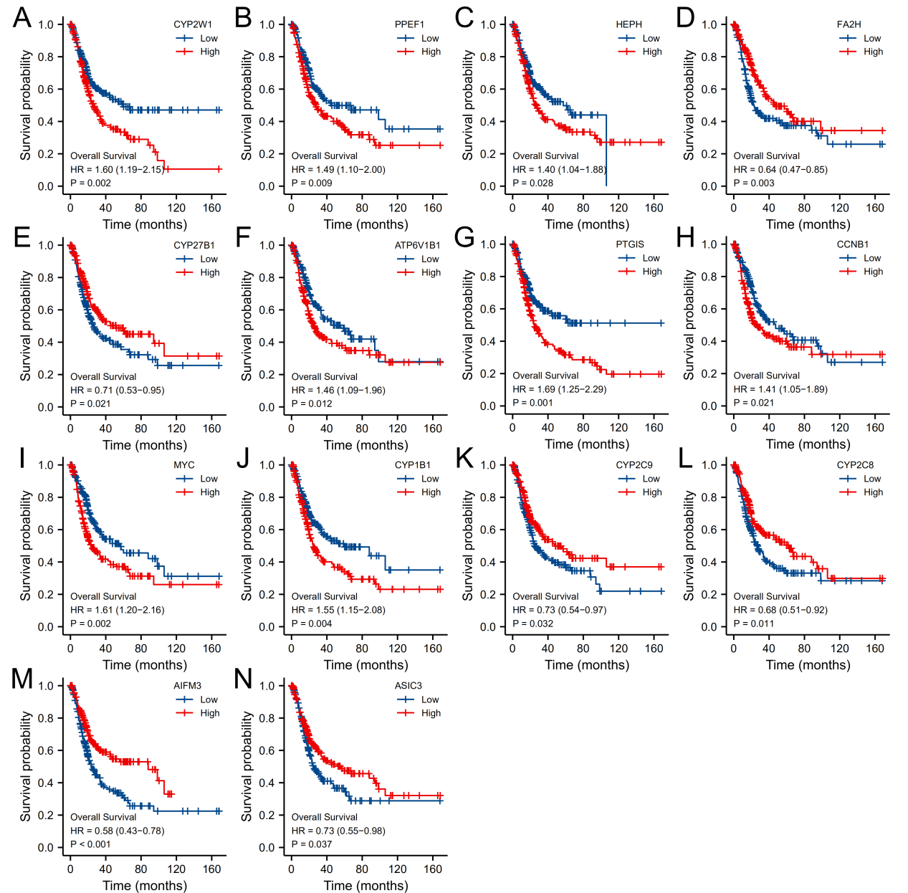
Supplementary Figure 1: K-M analysis of the 14 genes finally identified for construction of the risk scoring system. (A) CYP2W1; (B) PPEF1; (C) HEPH; (D) FA2H; (E) CYP27B1; (F) ATP6V1B1; (G) PTGIS; (H) CCNB1; (I) MYC; (J) CYP1B1; (K) CYP2C9; (L) CYP2C8; (M) AIFM3; (N) ASIC3.

