Supplementary Information

1. ¹H-NMR, ¹³C-NMR and HPLC spectra of the synthesized compounds

2. Supplementary Figures 1-8

3. Supplementary Tables 1-5

1. ¹H-NMR, ¹³C-NMR and HPLC spectra of representative compounds

ethyl (2S,4aR,5S,8aR)-2-(2-cyclohexyl-2-oxoethyl)-5-(m-tolyl)-8-tosyl-3,4, 4a,5,8,8a-hexahydro-2H-pyrano[2,3-b]pyridine-7-carboxylate (15-4-26): 60% yield; 92% ee, determined by HPLC analysis [Daicel chiralcel IA, n-hexane/iPrOH ＝ 40/60, 1.0 mL/min, λ = 220 nm, t(major) = 5.52 min, t(minor) = 6.49 min; ¹H-NMR (600 MHz, CDCl₃) δ: 7.90 (d, J = 7.8 Hz, 2H), 7.33 (d, J = 7.8 Hz, 2H), 7.18 (t, J = 7.8 Hz, 1H), 7.06 (d, J = 7.2 Hz, 1H), 6.91-6.85 (m, 3H), 6.15 (d, J = 3.0 Hz, 1H), 4.21 (q, J = 7.2 Hz, 2H), 4.09 - 4.04 (m, 1H), 3.47 (dd, J = 10.8, 3.2 Hz, 1H), 3.07 (dd, J = 10.2, 6.0 Hz, 1H), 2.73 (dd, J = 10.2, 6.6 Hz, 1H), 2.44 (s, 3H), 2.33 (s, 3H), 2.25-2.20 (m, 4H), 1.80-1.60 (m, 9H), 1.50-1.25 (m, 4H), 1.21 (t, J = 7.2 Hz, 3H); ¹³C-NMR (150 MHz, CDCl3) δ: 198.3, 164.5, 143.7, 140.9, 140.8, 139.4, 138.4, 136.8, 129.5, 129.1, 128.5, 128.3, 128.0, 127.4, 126.1, 125.8, 84.8, 75.9, 61.4, 43.3, 39.4, 38.7, 36.9, 29.7, 26.1, 25.6, 24.5, 23.0, 21.9, 21.6, 21.5, 21.4, 13.9; ESI-HRMS calcd for [C₃₃H₄₁NO₆S + K]⁺ 602.2547, found 602.2543.

¹H-NMR spectrum
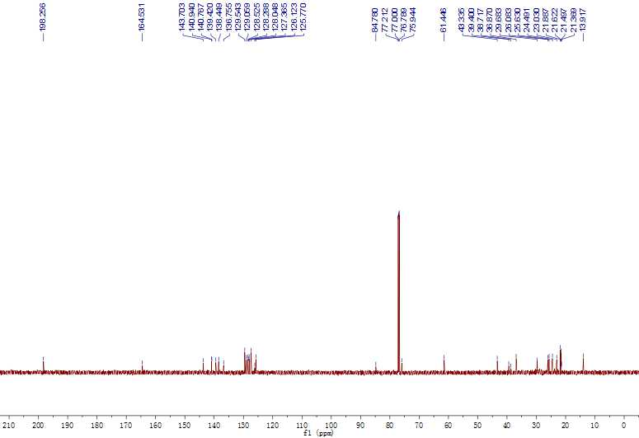
¹³C-NMR spectrum

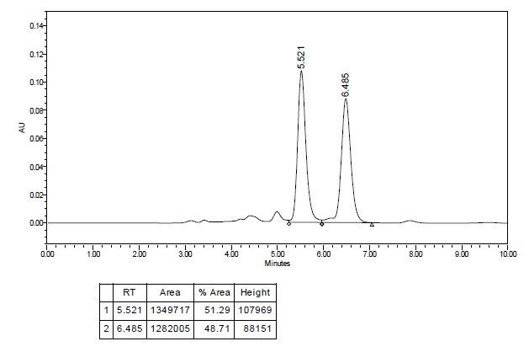
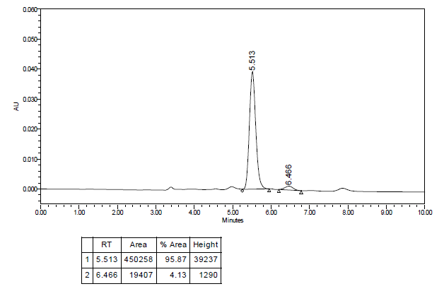
HPLC spectrum

ethyl (1S,2R,3R,4S,E)-6-(furan-3-ylmethylene)-1'-methyl-2',5-dioxospiro [bicyclo[2.2.1]heptane-2,3'-indoline]-3-carboxylate (14-5-18): 83% yield; ¹H-NMR (600 MHz, CDCl₃): δ (ppm) 7.54 (s, 1H), 7.39-7.30 (m, 3H), 7.07 (t, J = 7.2 Hz,1H), 6.94 (d, J = 7.2 Hz, 1H), 6.17 (s, 1H), 3.76-3.64 (m, 2H), 3.35 (s, 1H), 3.29 (m, 1H), 3.26 (m, 1H), 3.18 (s, 3H), 2.88 (d, J = 10.8 Hz, 1H), 2.04 (d, J = 10.8 Hz, 1H), 0.66 (t, J = 7.2 Hz, 3H).
¹H-NMR spectrum

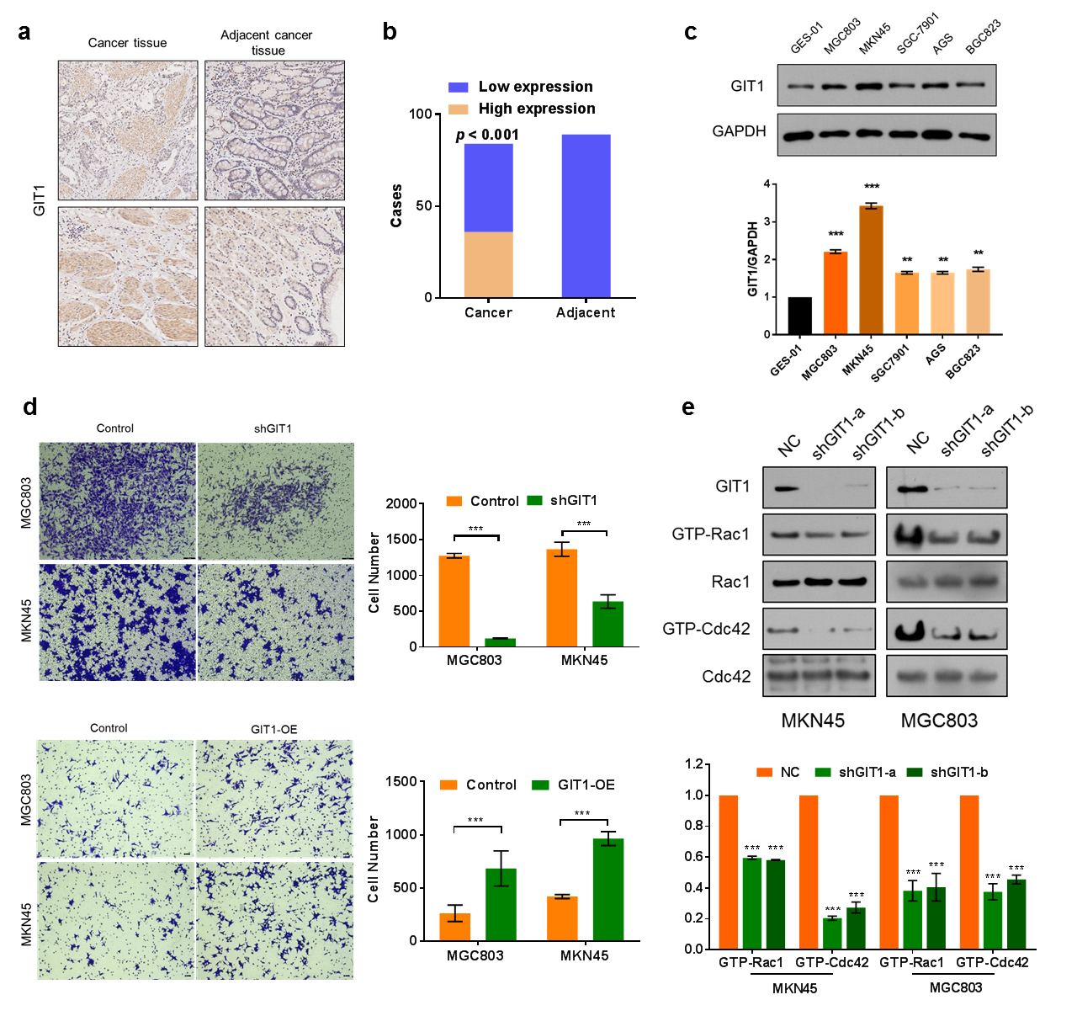
2. Supplementary Figures 1-8

Supplementary Fig. 1 GIT1 is a vital regulating factor in the metastasis of gastric cancer. a & b GIT1 protein expression on a tissue microarray constructed from patients’ cancer tissues and adjacent cancer tissue (n = 173). The representative images of IHC staining (a) and statistic graph of expression level (b). c GIT1 expression in epithelial cell (GES-01) and cancer cell lines (MGC803, MKN45, SGC-7901, AGS, BGC823) and the expression level was compared. d Transwell assay to detect the invasion abilities of MGC803 and MKN45 cells after GIT1 overexpression (GIT1-OE) or knock down using shRNA (shGIT1). Right columns show the quantification. e The cellular activity of Rac1 and Cdc42 was assessed by quantification of the amount of GTP-loaded Rac1/Cdc42 from cellular lysates using GTP-pull down assay, after GIT1 knockdown using two different shRNA (shGIT1-a/b). The lower column shows the quantification. Otherwise noted, n = 3, *p < 0.05, **p < 0.01, ***p < 0.001.

a | b

Supplementary Fig. 2 Binding curves of 14-5-18 and 15-4-26 in FP assay. The Ki values were calculated according to IC₅₀ values of balance (n = 3).

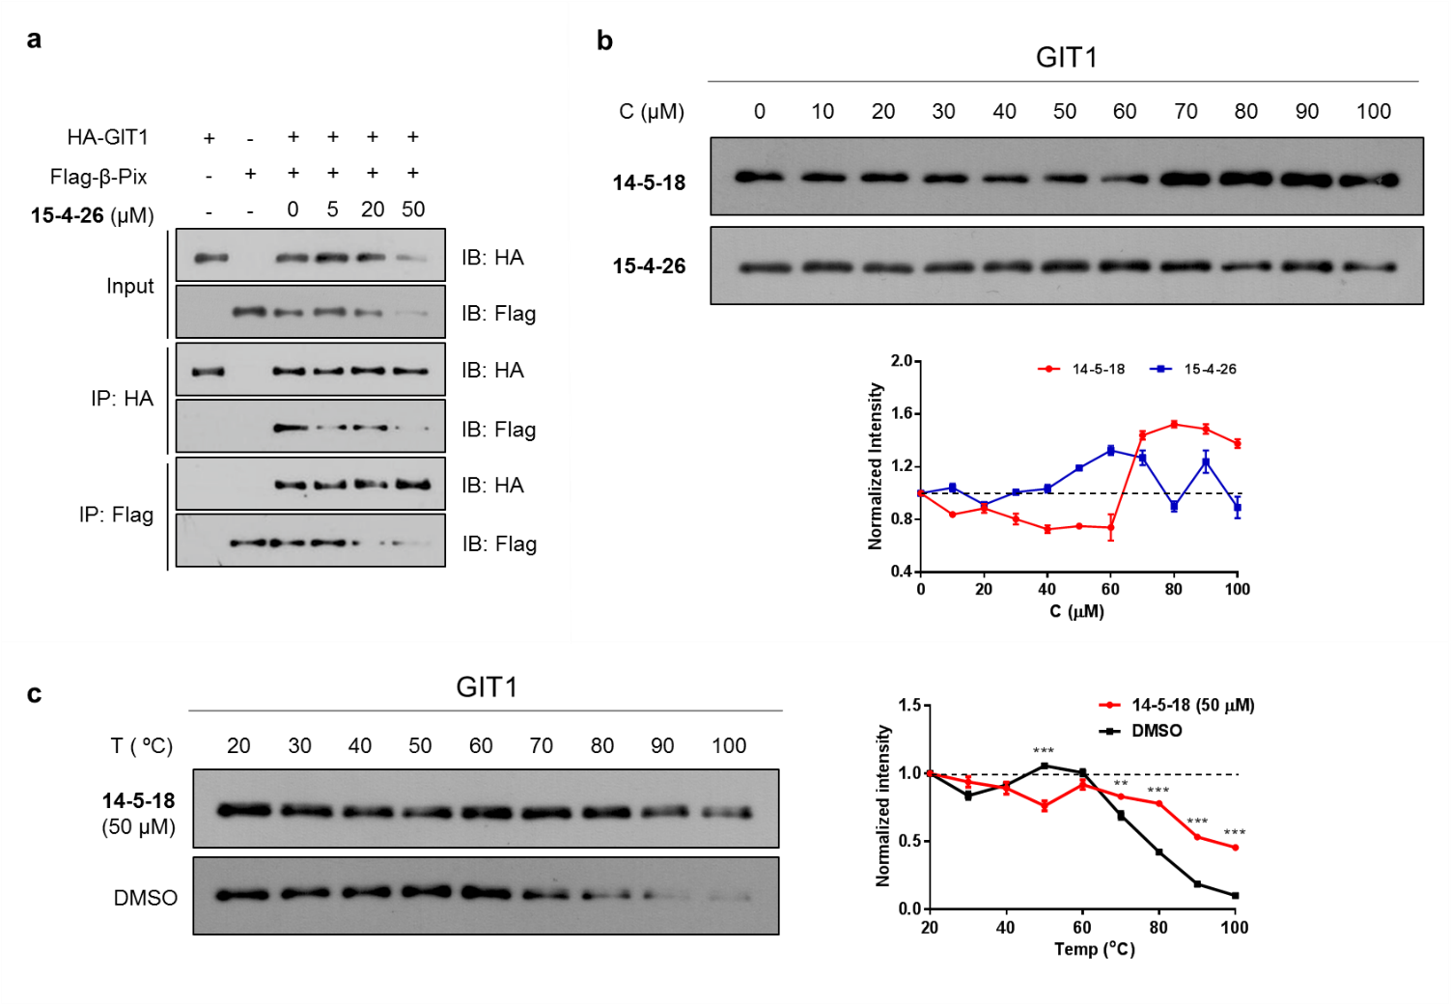
Supplementary Fig. 3 14-5-18 and 15-4-26 interacted with GIT1 and interrupted the interaction of GIT1/β-PIX. a co-IP experiments to indicate the interaction of GIT1 and β-PIX, and the inhibition effects of 15-4-26. b & c CETSA assay to verify the interaction between GIT1 and the compounds. Immunoblotting of cell lysates was used to measure the stability of GIT1 protein, when adding the compounds at 0, 10, 20, 30, 40, 50, 60, 70, 80, 90, 100 μM under 65 ºC (b), or adding 14-5-18 at 50 μM under 20, 30, 40, 50, 60, 70, 80, 90 ºC (c). The graphs in right columns show the quantified results, respectively.

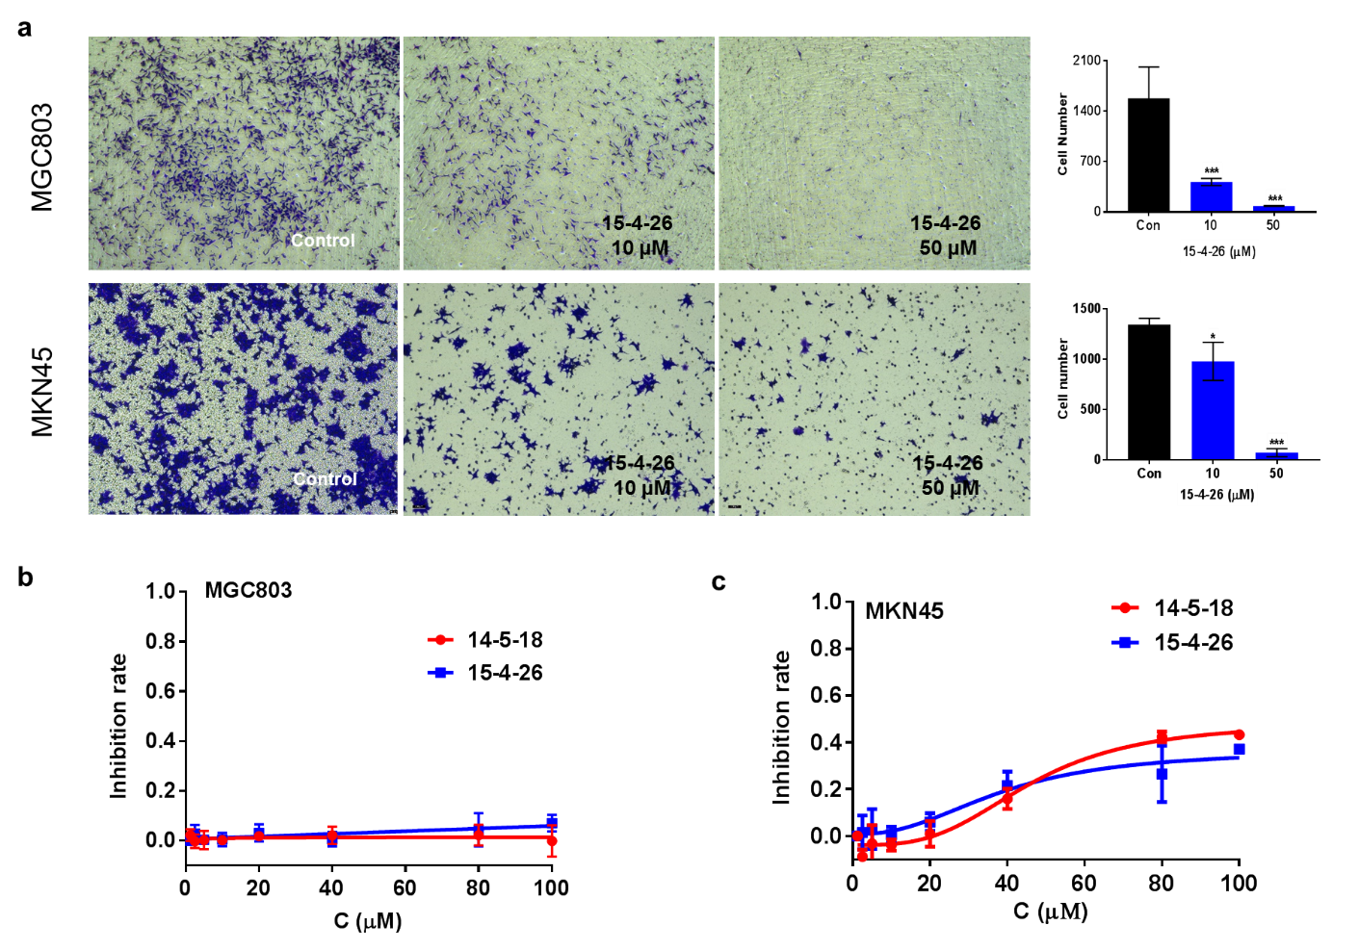
Supplementary Fig. 4 a Transwell assay to detect the anti-invasion abilities of 15-4-26 towards MGC803 (upper) and MKN45 (lower) cell lines at 10 and 50 μM for 24 h. The right columns show the respective quantification. b & c CCK8 assay was performed to evaluate the anti-proliferation effects of 14-5-18 and 15-4-26 to MGC803 (b) and MKN45 (c) cell line, at 1.25, 2.5, 5, 10, 20, 40, 80, 100 μM for 24 h.

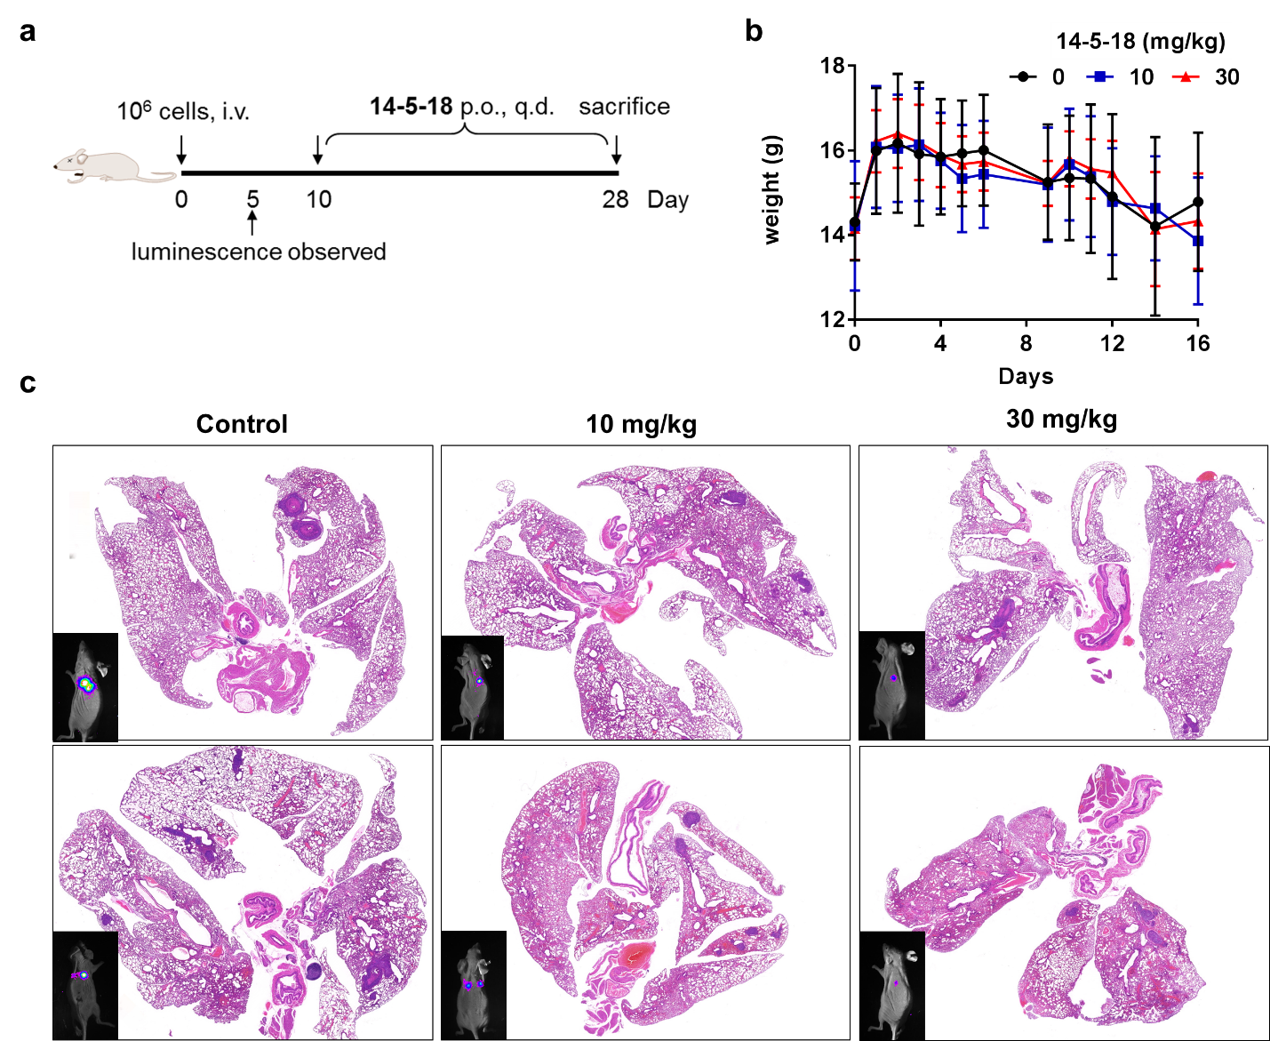
Supplementary Fig. 5 Animal experiments. a Scheme of modelling and drug administrating. b Curves to show the weight change of mice during experiments (n = 6). c H & E staining of lung tissues removed from mice at endpoint of the animal experiment.

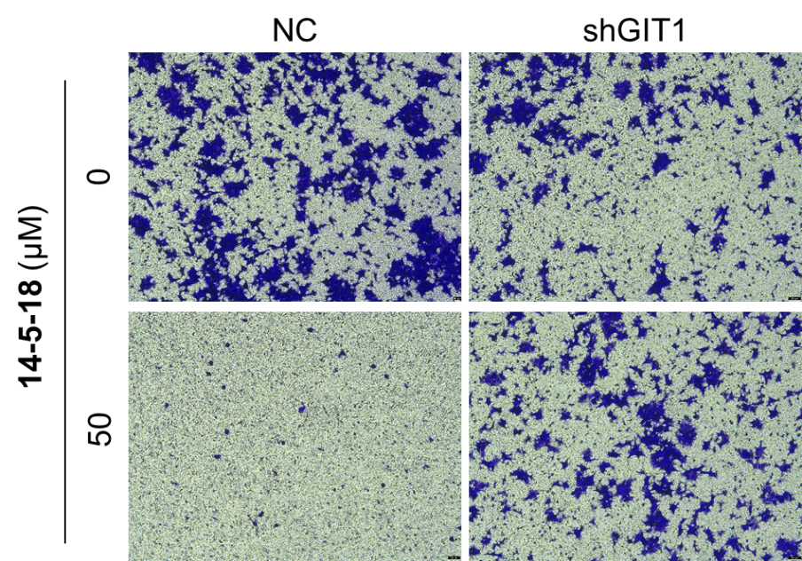 | 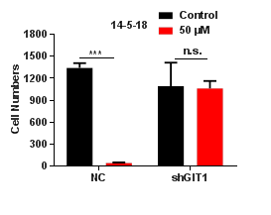

Supplementary Fig. 6 Transwell assay to detect the anti-invasion ability of 14-5-18 (50 μM) in MKN45 and MKN45-shGIT1 cell line. The right column shows the respective quantification.

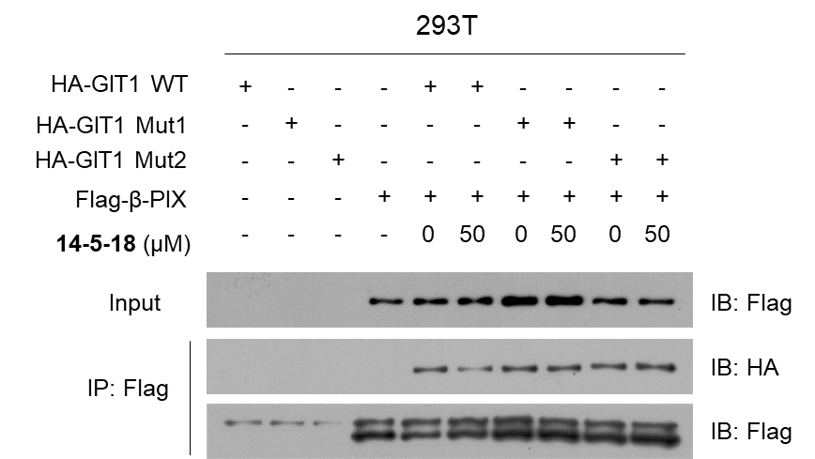
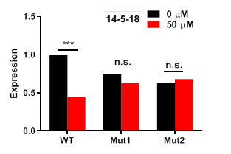

Supplementary Fig. 7 Co-IP experiments to detect the binding of β-Pix with GIT1 mutants, and the inhibition effects of 14-5-18. Plasmids expressing HA-GIT1 (wide-type and mutant types GIT1^{Mut1} and GIT1^{Mut2}) and Flag-β-Pix were transfected into HEK-293T and the cell lysates were collected to perform the co-IP assay, at 0, 50 μM concentration of 14-5-18. The lower column shows the respective quantification.

a
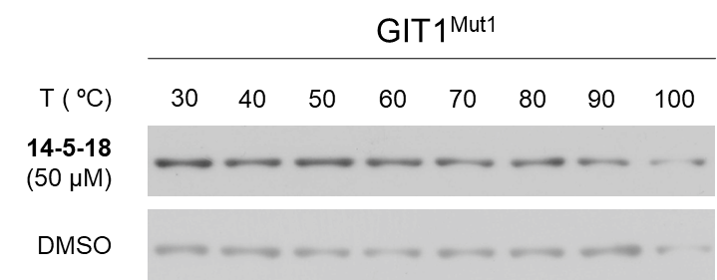 | 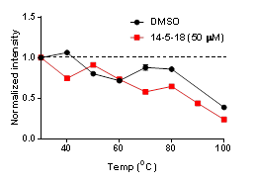
b
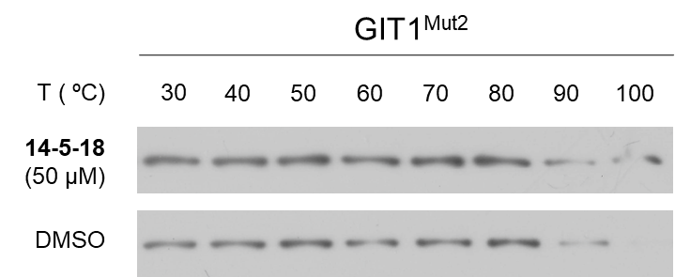 | 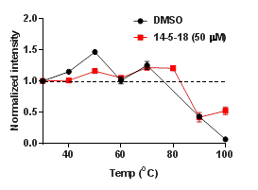
c
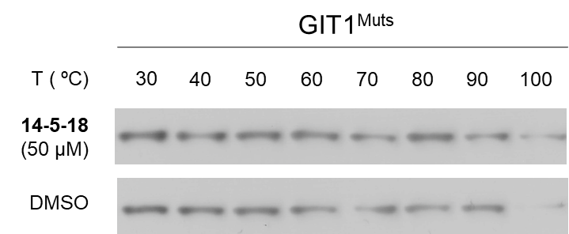 | 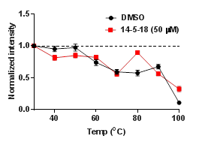

Supplementary Fig. 8 CETSA assay to verify the interaction between mutant GIT1 and compound 14-5-18. Immunoblotting of cell lysates was used to measure the thermostability of mutant GIT1 protein when adding 14-5-18 at 50 μM under 30, 40, 50, 60, 70, 80, 90 ºC. For a-c, GIT^{Mut1}, GIT1^{Mut2} or GIT1^{Muts} was expressed at MKN45-shGIT1 cell line, respectively. The graphs in right columns show the quantified results.

3. Supplementary Tables 1-5
Supplementary Table 1. List of the published articles contributing to construct the entity (Year 2012-2021) and virtual library (Year 2008-2021).
The incoming compound quantity of the entity library each year during 2012-2021
Library source articles
Year 2021
- Ben-Xian Xiao, Bo Jiang, Ru-Jie Yan, Jian-Xiang Zhu, Ke Xie, Xin-Yue Gao, Qin Ouyang,* Wei Du,* and Ying-Chun Chen,* “Palladium complex as asymmetric π-Lewis base catalyst for activating 1,3-dienes”, J. Am. Chem. Soc. 2021, 143, 12, 4809–4816
- Bao-Xin Liu, Ru-Jie Yan, Xiao-Xun Li, Wei Du,* and Ying-Chun Chen,* “Asymmetric [3+2] annulations of thioaurone and aurone derivatives for the construction of spiroheterocycles”, Asian J. Org. Chem. 2021, DOI: 10.1002/ajoc.202100078.
- Jian-Bin Lu, Chong-Hui Shi, Di Hu, Xin-Yue Gao, Zhi-Chao Chen,* Wei Du, and Ying-Chun Chen,* “Regioselectivity umpolung in asymmetric Diels−Alder reaction of ortho-formyl-substituted cinnamates and dienals via double aminocatalysis”, Org. Lett. 2021, 23, 145.
- Yang Gao, Xue Song, Ru-Jie Yan, Wei Du, and Ying-Chun Chen,* “Asymmetric β,γ′-regioselective [4+3] and [4+2] annulations of α-vinylenals via cascade iminium ion−dienamine catalysis”, Org. Biomol. Chem. 2021, 19, 151.
Year 2020
- Cui-Xia Hu, Lin Chen, Di Hu, Xue Song, Zhi-Chao Chen,* Wei Du, and Ying-Chun Chen,* “Construction of enantioenriched 9H-fluorene frameworks via cascade reaction involving remote vinylogous dynamic kinetic resolution”, Org. Lett. 2020, 22, 8973.
- Xue Song, Ru-Jie Yan, Wei Du,* and Ying-Chun Chen,* “Asymmetric dearomative cascade multiple functionalizations of activated N-alkylpyridinium and N-alkylquinolinium salts”, Org. Lett. 2020, 22, 7617.
- Qing He, Zhen-Hong Yang, Jing Yang,* Wei Du, and Ying-Chun Chen,* “Enantioselective formal arylation of (7-aza)isatylidene malononitriles with α′-alkylidene-2-cyclohexenones”, Adv. Synth. Catal. 2020, 362, 4438.
- Shu-Yuan Liang, Bo Jiang, Ben-Xian Xiao, Zhi-Chao Chen, Wei Du, and Ying-Chun Chen,* “Phosphine catalyzed enantioselective cascade reaction initiated by intermolecular cross Rauhut–Currier reaction of electron-deficient ortho-formyl styrenes”, ChemCatChem 2020, 12, 5374.
- Ying Jiang, Yang Yang, Qing He, Wei Du,* and Ying-Chun Chen,* “Asymmetric intramolecular Rauhut−Currier reaction and its desymmetric version via double thiol/phase-transfer catalysis”, J. Org. Chem. 2020, 85, 10760.
- Chang-Jiang Xu, Wei Du, Łukasz Albrecht, and Ying-Chun Chen,* “Lewis basic amine-catalyzed aza-Michael reaction of indole- and pyrrole-3-carbaldehydes”, Synthesis 2020, 52, 2650.
- Guang-Yao Ran, Chen Chen, Xing-Xing Yang, Zhi Zhao, Wei Du,* and Ying-Chun Chen,* “Cu(I)-catalyzed asymmetric α-allenylation of activated ketimines with 3-butynoates”, Org. Lett. 2020, 22, 4732.
- Bo Jiang, Wei Du,* and Ying-Chun Chen,* “Modified cinchona alkaloid‐catalysed enantioselective [4 + 4] annulations of cyclobutenones and 1-azadienes”, Chem. Commun. 2020, 56, 7257.
- Ru-Jie Yan, Bao-Xin Liu, Ben-Xian Xiao, Wei Du, and Ying-Chun Chen,* “Asymmetric (4 + 3) and (4 + 1) annulations of isatin-derived Morita−Baylis−Hillman carbonates to construct diverse chiral heterocyclic frameworks”, Org. Lett. 2020, 22, 4240.
- Peng Chen, Yue Li, Zhi-Chao Chen,* Wei Du, and Ying-Chun Chen,* “Pseudo-stereodivergent synthesis of enantioenriched tetrasubstituted alkenes via cascade 1,3-oxo-allylation/Cope rearrangement”, Angew. Chem. Int. Ed. 2020, 59, 7083.
- Di Hu, Yang Gao, Xue Song, Wei Du, and Ying-Chun Chen,* “Asymmetric remote addition reactions of heterocycle-based dearomative dienamine or trienamine species to 1-azadienes: Application to construct chiral azocanes and azecanes”, Eur. J. Org. Chem. 2020, 514.
- Yang Yang, Ying Jiang, Wei Du, and Ying-Chun Chen,* “Asymmetric cross [10+2] cycloaddtions of 2-alkylidene-1-indanones and activated alkenes under phase-transfer catalysis”, Chem. Eur. J. 2020, 26, 1754.
Year 2019
- Peng-Fei Zheng, Rong Zeng, Kun Jiang, Hong-Wei Li, Ying Ye, Chao Mu, Li Shuai, Qin Ouyang,* Ying-Chun Chen,* “(3 + 1) Annulation/rearrangement cascade of C,N-cyclic azomethine imines and 3-chlorooxindoles: Construction of hexahydroindeno[2,1-c]pyrazole spirooxindole frameworks”, Org. Lett. 2019, 21, 10052.
- Xin-Yue Gao, Ru-Jie Yan, Ben-Xian Xiao, Wei Du, Łukasz Albrecht, and Ying-Chun Chen,* “Asymmetric formal vinylogous iminium ion activation for vinyl-substituted heteroaryl and aryl aldehydes”, Org. Lett. 2019, 21, 9628.
- Ben-Xian Xiao, Chong-Hui Shi, Shu-Yuan Liang, Bo Jiang, Wei Du, and Ying-Chun Chen,* “Remote Friedel−Crafts reaction with α-heteroaryl-substituted cyclic ketones via HOMO-activation of Lewis bases”, Org. Lett. 2019, 21, 7554.
- Zhi Zhou, Qing He, Ying Jiang, Qin Ouyang, Wei Du,* and Ying-Chun Chen,* “Double thiol-chiral Brønsted base catalysis: Asymmetric cross Rauhut−Currier reaction and sequential [4 + 2] annulation for assembly of different activated olefins”, Org. Lett. 2019, 21, 7184.
- Zhi-Chao Chen, Zhi Chen, Zhen-Hong Yang, Li Guo, Wei Du,* and Ying-Chun Chen,* “Cooperative tertiary amine/chiral iridium complex catalyzed asymmetric [4+3] and [3+3] annulation reactions”, Angew. Chem. Int. Ed. 2019, 58, 15021.
- Chong-Hui Shi, Ben-Xian Xiao, Wei Du, Ying-Chun Chen,* “Phosphine-catalyzed formal [6 + 2] cycloadditions of α′-methylene 2-cyclopentenones”, Chin. J. Org. Chem. 2019, 39, 2218.
- Lin Chen, Ben-Xian Xiao, Wei Du, and Ying-Chun Chen,* “Quaternary phosphonium salts as active Brønsted acid catalysts for Friedel−Crafts reactions”, Org. Lett. 2019, 21, 5733.
- Guang-Yao Ran, Xing-Xing Yang, Jing-Fei Yue, Wei Du,* and Ying-Chun Chen,* “Asymmetric allylic alkylations with deconjugated carbonyl compounds: Direct vinylogous umpolung strategy”, Angew. Chem. Int. Ed. 2019, 58, 9210.
- Chang-Jiang Xu, Hong-Wei Li, Xiao-Long He, Wei Du, and Ying-Chun Chen,* “Asymmetric direct remote Michael addition reactions of allyl furfurals via dearomative trienamine and tetraenamine catalysis”，Asian J. Org. Chem. 2019, 8, 1037.
- Bo Jiang, Ben-Xian Xiao, Qin Ouyang, Hua-Ping Liang,* Wei Du, and Ying-Chun Chen,* “Sequential assembly of Morita−Baylis−Hillman carbonates and activated ortho-vinylbenzaldehydes to construct chiral methanobenzo[7]annulenone frameworks”, Org. Lett. 2019, 21, 3310.
- Xiao-Long He, Hui-Ru Zhao, Xue Song, Bo Jiang, Wei Du,* and Ying-Chun Chen,* “Asymmetric Barton−Zard reaction to access 3-pyrrole-containing axially chiral skeletons”, ACS Catal. 2019, 9, 4374.
- Rong Zeng, Changyu Shan, Ming Liu, Kun Jiang,* Ying Ye, Tian-Yu Liu, Ying-Chun Chen,* “[4 + 1 + 1] Annulations of α-bromo carbonyls and 1-azadienes towards fused benzoazaheterocycles”, Org. Lett. 2019, 21, 2312.
- Ben-Xian Xiao, Bo Jiang, Xue Song, Wei Du, and Ying-Chun Chen,* “Phosphine-catalysed asymmetric dearomative formal [4 + 2] cycloadditions of 3-benzofuranyl vinyl ketones”, Chem. Commun. 2019, 55, 3097.
- Peng Chen, Zhi-Chao Chen, Yue Li, Qin Ouyang, Wei Du,* and Ying-Chun Chen,* “Auto-tandem cooperative catalysis using phosphine/palladium: Reaction of Morita−Baylis−Hillman carbonates and allylic alcohols”, Angew. Chem. Int. Ed. 2019, 58, 4036.
- Qian-Qian Yang, Xiang Yin, Xiao-Long He, Wei Du,* and Ying-Chun Chen,* “Asymmetric formal [5 + 3] cycloadditions with unmodified Morita−Baylis−Hillman alcohols via double activation catalysis”, ACS Catal. 2019, 9, 1258.
- Ben-Xian Xiao, Xin-Yue Gao, Wei Du,* and Ying-Chun Chen,* “Asymmetric reactions involving Lewis Base catalyst-tethered dearomatizative intermediates”, Chem. Eur. J. 2019, 25, 1607.
Year 2018
- Ru-Jie Yan, Ben-Xian Xiao, Qin Ouyang, Hua-Ping Liang,* Wei Du, and Ying-Chun Chen,* “Asymmetric dearomative formal [4 + 2] cycloadditions of N,4-dialkylpyridinium salts and enones to construct azaspiro[5.5]undecane frameworks”, Org. Lett. 2018, 20, 8000.
- Zhi-Chao Chen, Peng Chen, Zhi Chen, Qin Ouyang, Hua-Ping Liang,* Wei Du, and Ying-Chun Chen,* “Organocatalytic enantioselective 1,3-difunctionalizations of Morita−Baylis−Hillman carbonates”, Org. Lett. 2018, 20, 6279.
- Wei Xiao, Zhi Zhou, Qian-Qian Yang, Wei Du,* and Ying-Chun Chen,* “Organocatalytic asymmetric four-component [5+1+1+1] cycloadditions via a quintuple cascade process”, Adv. Synth. Catal. 2018, 360, 3526.
- Chuan-Qi Duan, Xiao-Long He, Wei Du,* and Ying-Chun Chen,* “Asymmetric [4 + 2] cycloadditions with 3-furfural derivatives and α-cyano-α,β-unsaturated ketones”, Org. Chem. Front. 2018, 5, 2057.
- Xiao-Long He, Hui-Ru Zhao, Chuan-Qi Duan, Xu Han, Wei Du, and Ying-Chun Chen,* “Asymmetric benzylic allylic alkylation reaction of 3-furfural derivatives via dearomatizative dienamine activation”, Chem. Eur. J. 2018, 24, 6277.
- Jing Gu, Ben-Xian Xiao, Yu-Rong Chen, Qing-Zhu Li, Qin Ouyang,* Wei Du, and Ying-Chun Chen,* “Interrupted Morita−Baylis−Hillman-type reaction of α-substituted activated olefins”, Org. Lett. 2018, 20, 2088.
- Xiao-Long He, Hui-Ru Zhao, Chuan-Qi Duan, Wei Du and Ying-Chun Chen,* “Remote asymmetric oxa-Diels−Alder reaction of 5-allylic furfurals via dearomatizative tetraenamine catalysis”, Org. Lett. 2018, 20, 804.
- Qian-Qian Yang, Wei Xiao, Wei Du, Qin Ouyang, and Ying-Chun Chen,* “Asymmetric [4 + 2] annulations to construct norcamphor scaffolds with 2-cyclopentenone via double amine-thiol catalysis”, Chem. Commun. 2018, 54, 1129.
- Wei Xiao, Qian-Qian Yang, Zhi Chen, Qin Ouyang,* Wei Du, and Ying-Chun Chen,* “Regio- and diastereodivergent [4 + 2] cycloadditions with cyclic 2,4-dienones”, Org. Lett. 2018, 20, 236.
Year 2017
- Qing He, Wei Du, and Ying-Chun Chen,* “Asymmetric [3+2] annulations to construct 1,2-bispirooxindoles incorporating a dihydropyrrolidine motif”, Adv. Synth. Catal. 2017, 359, 3782.
- Ben-Xian Xiao, Ru-Jie Yan, Xin-Yue Gao, Wei Du, and Ying-Chun Chen,* “Asymmetric benzylic functionalizations of 3-vinyl benzofurans via cascade formal trienamine−vinylogous iminium ion activation”, Org. Lett. 2017, 19, 4652.
- Zhou-Xiang Wang, Zhi Zhou, Wei Xiao, Qin Ouyang, Wei Du, and Ying-Chun Chen,* “Double activation catalysis for α′-alkylidene cyclic enones with chiral amines and thiols”, Chem. Eur. J. 2017, 23, 10678.
- Chao Li, Kun Jiang, Tian-Yu Liu,* and Ying-Chun Chen,* “Asymmetric [4+1] cycloadditions of N-thioacyl Imines and sulfur ylides”, Adv. Synth. Catal. 2017, 359, 2530.
- Xiao-Ru Zhang, Su-Lan Zhou, Yi Yuan, Wei Du, and Ying-Chun Chen,* “Chemo- and regioselective asymmetric Friedel−Crafts reaction of furans and thiophenes with α,β-unsaturated aldehydes through dual activation”, Synlett 2017, 28, 1771.
- Gu Zhan, Ming-Lin Shi, Wei-Jia Lin, Qin Ouyang, Wei Du,* and Ying-Chun Chen,* “Direct asymmetric aza-vinylogous-type Michael additions of nitrones from isatins to nitroalkenes”, Chem. Eur. J. 2017, 23, 6286.
- Guang-Yao Ran, Ming Gong, Jing-Fei Yue, Xing-Xing Yang, Su-Lan Zhou, Wei Du, and Ying-Chun Chen,* “Asymmetric cascade assembly of 1,2-diaza-1,3-dienes and α,β-unsaturated aldehydes via dienamine activation”, Org. Lett. 2017, 19, 1874.
- Ben-Xian Xiao, Wei Du, and Ying-Chun Chen,* “Asymmetric dearomatizative Diels−Alder reaction for the construction of hydrodibenzo[b,d]furan frameworks with tetrasubstituted stereogenic centers”, Adv. Synth. Catal. 2017, 359, 1018.
- Wei-Jia Lin, Gu Zhan, Ming-Lin Shi, Wei Du,* and Ying-Chun Chen,* “[3+3] formal cycloadditions of nitrones from isatins and azaoxyallyl cations for construction of spirooxindoles”, Chin. J. Chem. 2017, 35, 857.
- Zhi Zhou, Zhou-Xiang Wang, Qin Ouyang, Wei Xiao, Wei Du, and Ying-Chun Chen,* “Cross-conjugated trienamine catalysis with α′-alkylidene 2-cyclohexenones: application in β,γ-regioselective aza-Diels−Alder reaction”, Chem. Eur. J. 2017, 23, 2945.
- Zhi Zhou, Zhou-Xiang Wang, Yuan-Chun Zhou, Wei Xiao, Qin Ouyang,* Wei Du, Ying-Chun Chen,* “Switchable regioselectivity in amine-catalysed asymmetric cycloadditions”, Nat. Chem. 2017, 9, 590.
- Kai-Kai Wang, Wei Du, Jin Zhu, Ying-Chun Chen,* “Construction of polycyclic spirooxindoles through [3+2] annulations of Morita−Baylis−Hillman carbonates and 3-nitro-7-azaindoles”, Chin. Chem. Lett. 2017, 28, 512.
Year 2016
- Ming-Lin Shi, Gu Zhan, Su-Lan Zhou, Wei Du, and Ying-Chun Chen,* “Asymmetric inverse-electron-demand oxa-Diels−Alder reaction of allylic ketones through dienamine catalysis”, Org. Lett. 2016, 18, 6480.
- Yu-Rong Chen, Gu Zhan, Wei Du,* and Ying-Chun Chen,* “Regioselective asymmetric formal (3+2) cycloadditions of nitrone ylides from isatins and enals”, Adv. Synth. Catal. 2016, 358, 3759.
- Guang-Jun Yang, Wei Du, and Ying-Chun Chen,* “Construction of furan derivatives with a trifluoromethyl stereogenic center: Enantioselective Friedel–Crafts alkylations via formal trienamine catalysis”, J. Org. Chem. 2016, 81, 10056.
- Kai-Kai Wang, Pan Wang, Qin Ouyang,* Wei Du, and Ying-Chun Chen,* “Substrate-controlled switchable asymmetric annulations to access polyheterocyclic skeletons”, Chem. Commun. 2016, 52, 11104.
- Xin Yuan, Shan-Jun Zhang, Wei Du, and Ying-Chun Chen,* “Asymmetric Diels–Alder cycloadditions of trifluoromethylated dienophiles via trienamine catalysis”, Chem. Eur. J. 2016, 22, 11048.
- Chao Li, Kun Jiang, Qin Ouyang, Tian-Yu Liu,* and Ying-Chun Chen,* “[3 + 1]- and [3 + 2]-Cycloadditions of azaoxyallyl cations and sulfur ylides”, Org. Lett. 2016, 18, 2738.
- Guang-Yao Ran, Pan Wang, Wei Du, and Ying-Chun Chen,* “α-Regioselective [3 + 2] annulations with Morita−Baylis−Hillman carbonates of isatins and 2-nitro-1,3-enynes”, Org. Chem. Front. 2016, 3, 861.
- Qing He, Gu Zhan, Wei Du and Ying-Chun Chen,* “Application of 7-azaisatins in enantioselective Morita–Baylis–Hillman reaction”, Beilstein J. Org. Chem. 2016, 12, 309.
- Kai-Kai Wang, Tian Jin, Xin Huang, Qin Ouyang,* Wei Du, and Ying-Chun Chen,* “α-Regioselective asymmetric [3 + 2] annulations of MoritaBaylisHillman carbonates with cyclic 1-azadienes and mechanism elucidation”, Org. Lett. 2016, 18, 872.
- Jing Gu, Ben-Xian Xiao, Yu-Rong Chen, Wei Du, and Ying-Chun Chen,* “Asymmetric Diels−Alder and cascade reaction of quinone imine ketals and 2,4-dienals: Construction of chiral benzo[de]quinolone derivatives”, Adv. Synth. Catal. 2016, 358, 296.
- Gu Zhan, Ming-Lin Shi, Qing He, Wei-Jia Lin, Qin Ouyang,* Wei Du, and Ying-Chun Chen,* “Catalyst-controlled switch in chemo- and diastereoselectivities: Annulations of Morita−Baylis−Hillman carbonates from isatins”, Angew. Chem. Int. Ed. 2016, 55, 2147.
- Wei Xiao, Xiang Yin, Zhi Zhou, Wei Du, and Ying-Chun Chen,* “Asymmetric α,γ-regioselective [3 + 3] formal cycloadditions of α,β-unsaturated aldehydes via cascade dienamine−dienamine catalysis”, Org. Lett. 2016, 18, 116.
Year 2015
- Gu Zhan, Ming-Lin Shi, Qing He, Wei Du, and Ying-Chun Chen,* “[4 + 3] Cycloadditions with bromo-substituted Morita−Baylis−Hillman adducts of isatins and N-(ortho-chloromethyl)aryl amides”, Org. Lett. 2015, 17, 4750.
- Jing Peng, Guang-Yao Ran, Wei Du, and Ying-Chun Chen,* “Divergent cyclization reactions of Morita−Baylis−Hillman carbonates of 2-cyclohexenone and isatylidene malononitriles”, Org. Lett. 2015, 17, 4490.
- Chao Li, Kun Jiang,* and Ying-Chun Chen,* “Diastereodivergent and enantioselective [4+2] annulations of γ-butenolides with cyclic 1-azadienes”, Molecules 2015, 20, 13642.
- Peng-Fei Zheng, Qin Ouyang, Sheng-Li Niu, Li Shuai, Yi Yuan, Kun Jiang, Tian-Yu Liu,* and Ying-Chun Chen,* “Enantioselective [4+1] annulation reactions of α-substituted ammonium ylides to construct spirocyclic oxindoles”, J. Am. Chem. Soc. 2015, 137, 9390.
- Jing Peng, Guang-Yao Ran, Wei Du, and Ying-Chun Chen,* “Tertiary amine-catalyzed asymmetric [3 + 2] annulations of Morita−Baylis−Hillman carbonates of isatins with nitroolefins to construct spirooxindoles”, Synthesis 2015, 47, 2538.
- Xiao-Long He, You-Cai Xiao, Wei Du, and Ying-Chun Chen,* “Enantioselective formal [3 + 3] cycloadditions of ketones and cyclic 1-azadienes via cascade enamine-enamine catalysis”, Chem. Eur. J. 2015, 21, 3443.
Year 2014
- Gu Zhan, Qing He, Xin Yuan, and Ying-Chun Chen,* “Asymmetric direct vinylogous Michael additions of allyl alkyl ketones to maleimides through dienamine catalysis”, Org. Lett. 2014, 16, 6000.
- Gu Zhan, Qing-Qing Zhou, Wei Du, and Ying-Chun Chen,* “Enantioselective N-allylic alkylation of propargyl sulfonamides with Morita−Baylis−Hillman carbonates and sequential electrophilic cyclization”, Synthesis 2014, 46, 3383.
- Xin Feng, Zhi Zhou, Xiang Yin, Rui Li,* and Ying-Chun Chen,* “Enantioselective direct bisvinylogous 1,6-additions of β-allyl 2-cyclohexenone to α,α-dicyanodienes through trienamine catalysis”, Eur. J. Org. Chem. 2014, 5906.
- Qing-Zhu Li, Jing Gu, and Ying-Chun Chen,* “Organocatalytic asymmetric [4+2] formal cycloadditions of cyclohexenylidenemalononitriles and enals to construct chiral bicyclo[2.2.2]octanes”, RSC Adv. 2014, 4, 37522.
- Jing Gu, Chao Ma, Qing-Zhu Li, Wei Du, and Ying-Chun Chen,* “β,γ-Regioselective inverse-electron-demand aza-Diels−Alder reactions with α,β-unsaturated aldehydes via dienamine catalysis”, Org. Lett. 2014, 16, 3986.
- Rong Zhou, Wei Xiao, Xiang Yin, and Ying-Chun Chen,* “Diastereo- and enantioselective [4+2] cycloadditions of cyclic enones with cyclic 1-azadienes”, Acta Chim. Sinica 2014, 72, 862.
- You-Cai Xiao, Cai-Zhen Yue, Peng-Qiao Chen, and Ying-Chun Chen,* “Asymmetric dearomatic Diels−Alder reactions of diverse heteroarenes via π-system activation”, Org. Lett. 2014, 16, 3208.
- Xiang Yin, Yi Zheng, Xin Feng, Kun Jiang, Xue-Zhen Wei, Ning Gao,* and Ying-Chun Chen,* “Asymmetric [5 + 3] formal cycloadditions with cyclic enones through cascade dienamine-dienamine catalysis”, Angew. Chem. Int. Ed. 2014, 53, 6245.
- Jun-Long Li, Cai-Zhen Yue, Peng-Qiao Chen, You-Cai Xiao, and Ying-Chun Chen,* “Remote enantioselective Friedel−Crafts alkylations of furans via HOMO-activation”, Angew. Chem. Int. Ed. 2014, 53, 5449.
- Zhi Zhou, Xin Feng, Xiang Yin, and Ying-Chun Chen,* “Direct remote asymmetric bisvinylogous 1,4-additions of cyclic 2,5-dienones to nitroalkenes”, Org. Lett. 2014, 16, 2370.
- Peng-Qiao Chen, You-Cai Xiao, Cai-Zhen Yue, and Ying-Chun Chen,* “Trienamine catalysis with linear deconjugated 3,5-dienones”, Org. Chem. Front. 2014, 1, 490.
- Qing-Qing Zhou, You-Cai Xiao, Xin Yuan, and Ying-Chun Chen,* “Asymmetric Diels−Alder reactions of 2,4,6-trienals via tetraenamine catalysis”, Asian J. Org. Chem. 2014, 3, 545.
Year 2013
- Xin Feng, Zhi Zhou, Chao Ma, Xiang Yin, Rui Li,* Lin Dong, and Ying-Chun Chen,* “Trienamines derived from interrupted cyclic 2,5-dienones: remote δ,ɛ-C=C bond activation for asymmetric inverse-electron-demand aza-Diels−Alder reaction”, Angew. Chem. Int. Ed. 2013, 52, 14173.
- Chao Ma, Jing Gu, Bin Teng, Qing-Qing Zhou, Rui Li,* and Ying-Chun Chen,* “1-Azadienes as regio- and chemoselective dienophiles in aminocatalytic asymmetric Diels–Alder reaction”, Org. Lett. 2013, 15, 6206.
- Qing-Qing Zhou, Xin Yuan, You-Cai Xiao, Lin Dong, and Ying-Chun Chen* “Aminocatalytic asymmetric Diels-Alder reaction of phosphorus dienophiles and 2,4-dienals”, Tetrahedron 2013, 69, 10369.
- Jing-Xin Liu, Qing-Qing Zhou, Jin-Gen Deng, and Ying-Chun Chen,* “An asymmetric normal-electron-demand aza-Diels– Alder reaction via trienamine catalysis”, Org. Biomol. Chem. 2013, 11, 8175.
- Jing Peng, Xin Huang, Peng-Fei Zheng, and Ying-Chun Chen,* “Rauhut−Currier-type reaction with Morita−Baylis−Hillman carbonates of 2-cyclohexenone and alkylidenemalononitriles to access chromene derivatives”, Org. Lett. 2013, 15, 5534.
- Quan-Gang Wang, Qing-Qing Zhou, Jin-Gen Deng, and Ying-Chun Chen,* “An asymmetric allylic alkylation-Smiles rearrangement-sulfinate addition sequence to construct chiral cyclic sulfones”, Org. Lett. 2013, 15, 4786.
- Zhi-Jun Jia, Kun Jiang, Qing-Qing Zhou, Lin Dong, Ying-Chun Chen*, “Amine/N-heterocyclic carbene cascade catalysis for asymmetric synthesis of fused indane derivatives with multiple chiral centres, Chem. Commun. 2013, 49, 5892.
- Yuan Yao, Jun-Long Li, Qing-Qing Zhou, Lin Dong, Ying-Chun Chen,* “Enantioselective aza-Morita−Baylis−Hillman reaction with ketimines and acrolein catalyzed by organic assemblies”, Chem. Eur. J. 2013, 19, 9447.
- Shan-Jun Zhang, Jun Zhang, Qing-Qing Zhou, Lin Dong, and Ying-Chun Chen,* “Aminocatalytic asymmetric exo-Diels−Alder reaction with methiodide salts of Mannich bases and 2,4-dienals to construct chiral spirocycles”, Org. Lett. 2013, 15, 968.
- Chao Ma, Zhi-Jun Jia, Jing-Xin Liu, Qing-Qing Zhou, Lin Dong, and Ying-Chun Chen,* “A concise assembly of electron-deficient 2,4-dienes and 2,4-dienals: regio- and stereoselective exo-Diels−Alder and redox reaction via sequential amine and carbene catalysis”, Angew. Chem. Int. Ed. 2013, 52, 948.
Year 2012
- You-Cai Xiao, Qing-Qing Zhou, Lin Dong, Tian-Yu Liu, and Ying-Chun Chen,* “Asymmetric Diels−Alder reaction of 2-methyl-3-indolylmethanols via in situ generation of ortho-quinodimethanes”, Org. Lett. 2012, 14, 5940.
- Xin Feng, Zhi Zhou, Rong Zhou, Qing-Qing Zhou, Lin Dong, and Ying-Chun Chen,* “Stereodivergence in amine-catalyzed regioselective [4+2] cycloadditions of beta-substituted cyclic enones and polyconjugated malononitriles”, J. Am. Chem. Soc. 2012, 134, 19942.
- Xiang Yin, Qingqing Zhou, Lin Dong, Yingchun Chen,* “Asymmetric sequential aza-Diels-Alder and O-Michael addition: Efficient construction of chiral hydropyrano[2,3-b]pyridines”, Chin. J. Chem. 2012, 30, 2669.
- Xunhao Sun, Jing Peng, Shuyang Zhang, Qingqing Zhou, Lin Dong, Yingchun Chen,* “Asymmetric allylic alkylation of cyclic N-sulfonylimines with Morita–Baylis–Hillman carbonates of isatins”, Acta Chimi. Sinica 2012, 70, 1682.
- Hang Zhang, Shan-Jun Zhang, Qing-Qing Zhou, Lin Dong, and Ying-Chun Chen*, “Organocatalytic asymmetric allylic amination of Morita−Baylis−Hillman carbonates of isatins”, Beilstein J. Org. Chem. 2012, 8, 1241.
- Qing-Zhu Li, Lei Ma, Lin Dong, and Ying-Chun Chen,* “Asymmetric aza-Diels−Alder and cation-olefin cyclization sequence: A concise way to fused chiral cyclopenta[b]piperidines”, ChemCatChem 2012, 4, 1139.
- Jun-Long Li, Si-Li Zhou, Peng-Qiao Chen, Lin Dong, Tian-Yu Liu, and Ying-Chun Chen,* “Asymmetric Diels−Alder reaction of β,β-disubstituted enals and chromone-fused dienes: construction of collections with high molecular complexity and skeletal diversity”, Chem. Sci. 2012, 3, 1879.
- Xiao-Feng Xiong, Quan Zhou, Jing Gu, Lin Dong, Tian-Yu Liu, and Ying-Chun Chen,* “Trienamine catalysis with 2,4-dienones: development and application in asymmetric Diels−Alder reaction”, Angew. Chem. Int. Ed. 2012, 51, 4401.
- Xin Huang, Jin Peng, Lin Dong, and Ying-Chun Chen,* “Asymmetric assembly of 2-oxindole and α-angelica lactone units to construct vicinal quaternary chiral centers”, Chem. Commun. 2012, 48, 2439.
Year 2011
- Hai-Lei Cui, Xun-Hao Sun, Lin Jiang, Lin Dong, and Ying-Chun Chen,* “Lewis base-assisted Brønsted base catalysis: direct asymmetric allylic alkylation of indenes”, Eur. J. Org. Chem. 2011, 7366.
- Si-Li Zhou, Jun-Long Li, Lin Dong, and Ying-Chun Chen,* “Organocatalytic sequential hetero-Diels−Alder and Friedel−Crafts reaction: constructions of fused heterocycles with scaffold diversity”, Org. Lett. 2011, 13, 5874.
- You-Cai Xiao, Chao Wang, Yuan Yao, Jian Sun,* and Ying-Chun Chen,* “Direct asymmetric hydrosilylation of indoles: Combined Lewis base and Brønsted acid activation”, Angew. Chem. Int. Ed. 2011, 50, 10661.
- Jing Peng, Xin Huang, Lin Jiang, Hai-Lei Cui, and Ying-Chun Chen,* “Tertiary amine-catalyzed chemoselective and asymmetric [3 + 2] annulation of Morita−Baylis−Hillman carbonates of isatins with propargyl sulfones”, Org. Lett. 2011, 13, 4584.
- Zhi-Jun Jia, Quan Zhou, Qing-Qing Zhou, Peng-Qiao Chen, and Ying-Chun Chen,* “Exo-selective asymmetric Diels−Alder reaction of 2,4-dienals and nitroalkenes via trienamine catalysis”, Angew. Chem., Int. Ed. 2011, 50, 8638.
- Lin Jiang, Qian Lei, Xin Huang, Hai-Lei Cui, Xue Zhou, and Ying-Chun Chen,* “Lewis base assisted Brønsted base catalysis: direct regioselective asymmetric vinylogous alkylation of allylic sulfones”, Chem. Eur. J. 2011, 17, 9489.
- Zhi-Jun Jia, Hao Jiang, Jun-Long Li, Björn Gschwend, Qing-Zhu Li, Xiang Yin, Julie Grouleff, Ying-Chun Chen,* and Karl Anker Jørgensen,* “Trienamines in asymmetric organocatalysis: Diels-Alder and cascade reactions”, J. Am. Chem. Soc. 2011, 133, 5053.
- Ji-Rong Huang, Hai-Lei Cui, Jie Lei, Xun-Hao Sun, and Ying-Chun Chen,* “Organocatalytic chemoselective asymmetric N-allylic alkylation of enamides”, Chem. Commun. 2011, 47, 4784.
- Jing Peng, Hailei Cui, and Yingchun Chen,* “Organocatalytic asymmetric allylic alkylation of sulfonylimidates with Morita-Baylis-Hillman carbonates”, Science China: Chemistry 2011, 54, 81.
- Xiao-Feng Xiong, Hang Zhang, Jing Peng, and Ying-Chun Chen,* “Direct asymmetric Michael addition of cyclic N-sulfonylimines to α,β-unsaturated aldehydes”, Chem. Eur. J. 2011, 17, 2358.
Year 2010
- Bo Han, You-Cai Xiao, Yuan Yao, Ying-Chun Chen,* “Lewis acid-catalyzed intramolecular direct ene reaction of indoles”, Angew. Chem., Int. Ed. 2010, 49, 10189.
- Jing Peng, Xin Huang, Hai-Lei Cui, Ying-Chun Chen,* “Organocatalytic and electrophilic approach to oxindoles with C3-quaternary stereocenters”, Org. Lett. 2010, 12, 4260.
- Jun-Long Li, Tai-Ran Kang, Si-Li Zhou, Rui Li, Li Wu, Ying-Chun Chen,* “Organocatalytic asymmetric inverse-electron-demand Diels−Alder reaction of electron-deficient dienes and crotonaldehyde”, Angew. Chem., Int. Ed. 2010, 49, 6418.
- Zhao-Quan He, Quan Zhou, Li Wu, and Ying-Chun Chen,* “Asymmetric organocatalytic tandem reaction to chiral pyrimidinone derivatives using urea as dinitrogen source”, Adv. Synth. Catal. 2010, 352, 1904.
- Xin Feng, Hai-Lei Cui, Shi Xu, Li Wu, and Ying-Chun Chen,* “Organocatalytic direct vinylogous Michael addition of α,β-unsaturated γ-butyrolactam to α,β-unsaturated aldehydes and an illustration to scaffold diversity synthesis”, Chem. Eur. J. 2010, 16, 10309.
- Hailei Cui, Kun Jiang, Yankai Liu, Wei Du, Yingchun Chen,* “Enantioselective direct aldol-type reaction of 4-hydroxycoumarin with ethyl trifluoropyruvate catalyzed by modified cinchona alkaloids”, Chin. Sci. Bull. 2010, 55, 1732.
- Kun Jiang, Zhi-Jun Jia, Xiang Yin, Li Wu, and Ying-Chun Chen,* “Asymmetric quadruple aminocatalytic domino reactions to fused carbocycles incorporating a spirooxindole motif”, Org. Lett. 2010, 12, 2766.
- Jie Lei, Hai-Lei Cui, Rui Li,* Li Wu, Zheng-Yu Ding and Ying-Chun Chen,* “Tributyltin hydride-mediated radical cyclisation reactions: efficient construction of multiply substituted cyclopentanes”, Org. Biomol. Chem. 2010, 8, 2840.
- Jun-Long Li, Si-Li Zhou, Bo Han, Li Wu, and Ying-Chun Chen,* “Aminocatalytic asymmetric inverse-electron-demand aza-Diels–Alder reaction of N-Ts-1-aza-1,3-butadienes based on coumarin cores”, Chem. Commun. 2010, 46, 2665.
- Hai-Lei Cui, Ji-Rong Huang, Jie Lei, Zhao-Feng Wang, Shi Chen, Li Wu, and Ying-Chun Chen,* “Direct asymmetric allylic alkylation of butenolides with Morita-Baylis-Hillman carbonates”, Org. Lett. 2010, 12, 720.
- Kun Jiang, Zhi-Jun Jia, Shi Chen, Li Wu, and Ying-Chun Chen,* “Organocatalytic tandem reaction to construct six-membered spirocyclic oxindoles with multiple chiral centres via a formal [2+2+2] annulation”, Chem. Eur. J. 2010, 16, 2852.
- Zhao-Quan He, Bo Han, Rui Li,* Li Wu, and Ying-Chun Chen,* “Enantioselective construction of lactone[2,3-b]piperidine skeletons via organocatalytic tandem reactions”, Org. Biomol. Chem. 2010, 8, 755.
Year 2009
- Xiao-Feng Xiong, Zhi-Jun Jia, Wei Du, Kun Jiang, Tian-Yu Liu, and Ying-Chun Chen,* “Merging chiral organocatalysts: enantio- and diastereoselective direct vinylogous Mannich reaction of alkylimines”, Chem. Commun. 2009, 6994.
- Bo Han, You-Cai Xiao, Zhao-Quan He, and Ying-Chun Chen,* “Asymmetric Michael addition of γ,γ-disubstituted α,β-unsaturated aldehydes to nitroolefins via dienamine catalysis”, Org. Lett. 2009, 11, 4660.
- Shan-Jun Zhang, Hai-Lei Cui, Kun Jiang, Rui Li,* Zhen-Yu Ding, and Ying-Chun Chen,* “Enantioselective allylic amination of Morita-Baylis-Hillman carbonates catalyzed by modified cinchona alkaloids”, Eur. J. Org. Chem. 2009, 5804.
- ZeKai Hu, HaiLei Cui, Kun Jiang, YingChun Chen*, “Enantioselective O-allylic alkylation of Morita-Baylis-Hillman carbonates with oxime”, Sci. China Ser. B: Chem. 2009, 52, 1309.
- Xin Feng, Yu-Qing Yuan, Hai-Lei Cui, Kun Jiang, and Ying-Chun Chen,* “Organocatalytic peroxy-asymmetric allylic alkylation”, Org. Biomol. Chem. 2009, 7, 3660.
- Hai-Lei Cui, Xin Feng, Jing Peng, Jie Lei, Kun Jiang, and Ying-Chun Chen,* “Chemoselective asymmetric N-allylic alkylation of indoles with Morita-Baylis-Hillman carbonates”, Angew. Chem., Int. Ed. 2009, 48, 5737.
- Bo Han, Zhao-Quan He, Jun-Long Li, Rui Li, Kun Jiang, Tian-Yu Liu, and Ying-Chun Chen,* “Organocatalytic regio- and stereoselective inverse-electron-demand aza-Diels-Alder reaction of α,β-unsaturated aldehydes and N-Tosyl-1-aza-1,3-butadienes”, Angew. Chem., Int. Ed. 2009, 48, 5474.
- Yan-Kai Liu, Chao Ma, Kun Jiang, Tian-Yu Liu, and Ying-Chun Chen,* “Asymmetric tandem Michael addition-Wittig reaction to cyclohexenone annulation”, Org. Lett. 2009, 11, 2848.
- Kun Jiang, Jing Peng, Hai-Lei Cui, and Ying-Chun Chen,* “Organocatalytic asymmetric allylic alkylation of oxindoles with Morita-Baylis-Hillman carbonates”, Chem. Commun. 2009, 3955.
- Hai-Lei Cui, Ying-Chun Chen,* a Feature Article, “alfa,alfa-Dicyanoalkenes: versatile vinylogous nucleophiles for organic synthesis”, Chem. Commun. 2009, 4479.
- Jun-Long Li, Bo Han, Kun Jiang, Wei Du, and Ying-Chun Chen,* “Organocatalytic enantioselective hetero-Diels-Alder reaction of aldehydes and o-benzoquinone diimide: Synthesis of optically active hydroquinoxalines”, Bioorg. Med. Chem. Lett. 2009, 19, 3952.
- Hai-Lei Cui, Jing Peng, Xin Feng, Wei Du, Kun Jiang, and Ying-Chun Chen,* “Dual organocatalysis: Asymmetric allylic-allylic alkylation of α,α-dicyanoalkenes and Morita-Baylis-Hillman carbonates”, Chem. Eur. J. 2009, 15, 1574.
Year 2008
- Bo Han, Jun-Long Li, Chao Ma, Shan-Jun Zhang, and Ying-Chun Chen,* “Organocatalytic asymmetric inverse electron demand aza Diels-Alder reaction of N-sulfonyl-1-aza-1,3-butadienes and aldehydes”, Angew. Chem., Int. Ed. 2008, 47, 9971.
- Wei Du, Yan-Kai Liu, Lei Yue, and Ying-Chun Chen,* “Organocatalytic asymmetric 1,3-dipolar cycloaddition of nitrones to nitroolefins”, Synlett 2008, 2997.
- Yan-Kai, Liu, Hao Liu, Wei Du, Lei Yue, and Ying-Chun Chen,* “Reaction control in the organocatalytic asymmetric one pot, three-component reaction of aldehydes, diethyl α-aminomalonate and nitroalkenes: toward diversity-oriented synthesis”, Chem. Eur. J. 2008, 14, 9873.
- Bo Han, Qing-Ping Liu, Rui Li, Xu Tian, Xiao-Feng Xiong, Jin-Gen Deng, and Ying-Chun Chen,* “Discovery of bifunctional thiourea-secondary amine organocatalysts for the highly stereoselective nitro-Mannich reaction of α-substituted nitroacetates”, Chem. Eur. J. 2008, 14, 8094.
- Xu Tian, Kun Jiang, Jing Peng, Wei Du, and Ying-Chun Chen,* “Organocatalytic stereoselective Mannich reaction of 3-oxindoles”, Org. Lett. 2008, 10, 3583.
- Tai-Ran Kang, Jian-Wu Xie, Wei Du, Xin Feng, and Ying-Chun Chen,* “Stereoselective desymmetrisation of prochiral α,α-dicyanoalkenes via domino Michael-Michael addition reactions”, Org. Biomol. Chem. 2008, 6, 2673.
- Ying-Chun Chen,* an account, “The development of asymmetric primary aminocatalysts based on cinchona alkaloids”, Synlett 2008, 1919.
- Lei Yue, Wei Du, Yan-Kai Liu, Y Ying-Chun Chen,* “Organocatalytic asymmetric direct Michael addition of aromatic ketones to alkylidenemalononitriles”, Tetrahedron Lett. 2008, 49, 3881.
- Yan Zhang, Yan-Kai Liu, Tai-Ran Kang, Ze-Kai Hu, Ying-Chun Chen,* “Organocatalytic enantioselective Mannich-type reaction of phosphorus ylides: Synthesis of chiral N-Boc-β-amino-α-methylene carboxylic esters”, J. Am. Chem. Soc. 2008, 130, 2456.
- Wei Chen, Wei Du, Yong-Zheng Duan, Yong Wu, Sheng-Yong Yang, Ying-Chun Chen,* “Enantioselective 1,3-dipolar cycloaddition of cyclic enones catalyzed by multifunctional primary amine: beneficial effects of hydrogen bonding”, Angew. Chem., Int. Ed. 2007, 46, 7667.

Supplementary Table 2. 2D Fingerprints similarity results for comparison of the commercial libraries and SMBL.
Libraries | Mean Tc (stdev) | % compounds Tc <0.75 | Tc max
SMBL-E vs chembridge | 0.45 (0.07) | 99.93 | 0.84
SMBL-V vs chembridge | 0.49 (0.08) | 99.61 | 0.91
targetmol vs chembridge | 0.66 (0.10) | 79.80 | 1.00
specs vs chembridge | 0.70 (0.12) | 13.49 | 1.00
SMBL-V vs targetmol | 0.47 (0.10) | 99.29 | 0.92
SMBL-V vs specs | 0.50 (0.09) | 99.10 | 0.94
SMBL-E vs targetmol | 0.52 (0.10) | 99.82 | 0.83
SMBL-E vs specs | 0.46 (0.08) | 99.88 | 0.85

Supplementary Table 3. Compounds in SMBL-V ranking top 100 in docking and their docking scores. Top 20 of them were selected and synthesized (1 representative compound for each scaffold type) for further evaluation.
No | Serial Number | Structure (in smiles) | Docking score for Sybyl | Binding Energy (kcal/mol) for Autodock | Total score | Original article | synthesized
1 | 48OL_2015_17_4490-5-22524 | c12cc(cc(c2N(C(=O)[C@@]21c1cccc(c1OC(=C2C#N)N)C/C=C/c1ccccc1C(C)(C)C)CC=C)C(F)(F)F)CCc1ccccc1 | 9.6415 | -9.2 | 18.8415 | Org. Lett. 2015, 17, 4490 | √
2 | 48OL_2015_17_4490-5-5558 | c12cc(cc(c2N(C(=O)[C@]21c1cccc(c1OC(=C2C#N)N)C/C=C/c1ccccc1C)Cc1ccccc1)Cc1ccccc1)CCc1ccccc1 | 8.2888 | -10 | 18.2888 | Org. Lett. 2015, 17, 4490
3 | 48OL_2015_17_4490-5-86798 | c12cc(cc(c2N(C(=O)[C@]21c1cccc(c1OC(=C2C#N)N)C/C=C\c1cc(cc(c1)C(F)(F)F)C(F)(F)F)Cc1ccccc1)OS(O)(O)c1ccc(C)cc1)OC(F)(F)F | 8.9032 | -9.2 | 18.1032 | Org. Lett. 2015, 17, 4490
4 | 30Chin_J_Chem_2017_35_857-1-19945 | c1(cc2[C@@]3(N(O[C@@H](ON3c3cc(ccc3)C(C)(C)C)c3cc4c(cccc4)o3)OCc3ccccc3)C(=O)N(C)c2cc1)C | 9.6338 | -8.4 | 18.0338 | Chin. J. Chem. 2017, 35, 857 | √
5 | 30Chin_J_Chem_2017_35_857-1-18573 | c1(cc2[C@@]3(N(O[C@@H](ON3c3cc(ccc3)N(=O)=O)c3cc4c(cccc4)o3)OCc3ccccc3)C(=O)N(C)c2cc1)C | 9.3673 | -8.6 | 17.9673 | Chin. J. Chem. 2017, 35, 857
6 | 48OL_2015_17_4490-5-54999 | c12cc(cc(c2N(C(=O)[C@@]21c1cccc(c1OC(=C2C#N)N)C/C=C/Cc1ccccc1)CC=C)CC)CC=C | 9.3435 | -8.6 | 17.9435 | Org. Lett. 2015, 17, 449
7 | 30Chin_J_Chem_2017_35_857-2-31812 | c1cc2[C@@]3(N(O[C@](C)(ON3c3cn(C)c4ccccc34)c3cc(ccc3)C(F)(F)F)OCc3ccccc3)C(=O)N(C)c2cc1F | 8.4302 | -9.5 | 17.9302 | Chin. J. Chem. 2017, 35, 857
8 | 58OL_2014_16_3986-1-45031 | c1(cc2S(=O)(=O)N3[C@H]([C@@H]([C@H](C=C3c2cc1)c1cc(ccc1)C(F)(F)F)c1ccc(cc1)OCl)CCO)Cc1ccccc1 | 8.6597 | -9.2 | 17.8597 | Org. Lett. 2014, 16, 3986 | √
9 | 87Chem_Commun_2012_48_2439-189352 | c1(cc2[C@@](C(=O)N(C)c2c(c1)CCc1ccccc1)([C@@]1(C=CC(=O)O1)c1cc(ccc1)N(=O)=O)C(=C)P(=O)(c1ccccc1)c1ccccc1)Cc1ccccc1 | 9.2475 | -8.6 | 17.8475 | Chem. Commun. 2012, 48, 2439 | √
10 | 48OL_2015_17_4490-5-23961 | c12cc(C)cc(c2N(C(=O)[C@@]21c1cccc(c1OC(=C2C#N)N)C/C=C/c1cccc(C)c1)CC=C)C(F)(F)F | 8.9223 | -8.7 | 17.6223 | Org. Lett. 2015, 17, 449
11 | 48OL_2015_17_4490-5-57806 | c12cc(cc(c2N(C(=O)[C@]21c1cccc(c1OC(=C2C#N)N)C/C=C/c1cc(ccc1)N(=O)=O)Cc1ccccc1)C(C)C)CC(=C)C | 8.5963 | -9 | 17.5963 | Org. Lett. 2015, 17, 449
12 | 70Org_Biomol_Chem_2013_11_8175-2-14802 | c1cc2C(=O)[C@@]3([C@H](C)C[C@@H](C)[C@@H](N3c2cc1OS(O)(O)c1ccc(C)cc1)CCO)c1cc2c(cccc2)o1 | 9.0692 | -8.5 | 17.5692 | Org. Biomol. Chem. 2013, 11, 8175 | √
13 | 64Org_Chem_Front_2014_1_490-189861 | c1(cc2[C@@]3([C@@H](C(=C[C@@H]([C@H]3C(=O)c3ccccc3)CC)CC)CC(=O)C)C(=O)N(C(=O)C)c2c(c1)OS(O)(O)c1ccc(C)cc1)C(C)(C)C | 9.0925 | -8.3 | 17.3925 | Org. Chem. Front. 2014, 1, 490 | √
14 | 79Chin_J_Chem_2012_15-4-26 | [C@@H]1(CC[C@H]2[C@@H](N(C(=C[C@H]2c2cc(C)ccc2)C(=O)OCC)S(=O)(=O)c2ccc(C)cc2)O1)CC(=O)C1CCCCC1 | 8.4697 | -8.9 | 17.3697 |  | √
15 | 48OL_2015_17_4490-4-25345 | c12cc(cc(c2N(C(=O)[C@]21c1cccc(c1OC(=C2C#N)N)Cc1cn(C)c2ccccc12)COC)C(F)(F)F)C1CCCCC1 | 8.5482 | -8.8 | 17.3482 | Org. Lett. 2015, 17, 449
16 | 48OL_2015_17_4490-5-25220 | c12cc(cc(c2N(C(=O)[C@@]21c1cccc(c1OC(=C2C#N)N)C/C=C/Cc1ccccc1)Cc1ccccc1)C(F)(F)F)CCc1ccccc1 | 8.5976 | -8.7 | 17.2976 | Org. Lett. 2015, 17, 449
17 | 58OL_2014_16_3986-1-106783 | c1(cc2S(=O)(=O)N3[C@@H]([C@@H]([C@H](C=C3c2cc1)c1cc(ccc1)C(F)(F)F)c1cc2c(cccc2)o1)CCO)C(=O)c1ccccc1 | 7.3755 | -9.9 | 17.2755 | Org. Lett. 2014, 16, 3986
18 | 51Synthesis_2015_47_2538-40966 | c1(cc2[C@@]3(C(=CC=C3C(=O)OC)c3cc4ccccc4n3C)C(=O)N(C)c2c(c1)P(=O)(c1ccccc1)c1ccccc1)P(=O)(c1ccccc1)c1ccccc1 | 7.9336 | -9.3 | 17.2336 | Synthesis 2015, 47, 2538 | √
19 | 30Chin_J_Chem_2017_35_857-2-32162 | c1cc2[C@@]3(N(O[C@](C)(ON3c3cn(C)c4ccccc34)c3ccccc3)OCc3ccccc3)C(=O)N(C)c2cc1F | 7.8202 | -9.4 | 17.2202 | Chin. J. Chem. 2017, 35, 857
20 | 40Org_Chem_Front_2016_3_861-3-272263 | c1cc2[C@]3([C@]([C@H](C[C@@H]3C(=O)OC(C)(C)C)c3cc(cc(c3)C(F)(F)F)C(F)(F)F)(N(=O)=O)C#Cc3ccccc3Cl)C(=O)N(c2c(F)c1)Cc1ccccc1 | 8.3156 | -8.9 | 17.2156 | Org. Chem. Front. 2016, 3, 861 | √
21 | 120Chem_Commun_2009_3955-2-74947 | [C@@H]([C@@H]1c2cc(ccc2NC1=O)C1CCCCC1)(c1cc(C)c(C)cc1)[C@@H](c1cc2c(OCO2)cc1)C(=C)C(=O)OC | 7.9651 | -9.2 | 17.1651
22 | 32Nat_Chem_2017_9_590-2-3108 | C1(=O)[C@H]2[C@@H]([C@@]3(c4cccc(Cl)c4NC3=O)[C@@H]([C@@H]2[C@H](C1)c1ccccc1C(F)(F)F)C(=O)c1ccccc1)c1ccc(cc1)C(C)(C)C | 7.9568 | -9.2 | 17.1568
23 | 38Chem_Eur_J_2016_22_11048-1-2486 | C1C[C@@H]2C(=C(C[C@@H]([C@H]2[C@@H](N1Cc1ccccc1)c1cc2ccccc2cc1)C(F)(F)F)C)c1cn(C)c2ccccc12 | 7.5431 | -9.5 | 17.0431
24 | 38Chem_Eur_J_2016_22_11048-2-2486 | C1C[C@@H]2C(=C(C[C@@H]([C@H]2[C@@H](N1Cc1ccccc1)c1cc2ccccc2cc1)C(F)(F)F)C)c1cn(C)c2ccccc12 | 7.5431 | -9.5 | 17.0431
25 | 51Synthesis_2015_47_2538-16890 | c1(cc2[C@@]3([C@@H](C=C[C@H]3C(=O)OC)c3cc(ccc3)C(C)(C)C)C(=O)N(C)c2c(c1)C(=O)c1ccccc1)C1CCCCC1 | 8.0233 | -9 | 17.0233
26 | 40Org_Chem_Front_2016_3_861-3-369997 | c1cc2[C@]3([C@@]([C@H](C[C@@H]3C(=O)OC(C)(C)C)c3cn(C)c4ccccc34)(N(=O)=O)C#CCc3ccccc3)C(=O)N(c2c(c1)OC)Cc1ccccc1 | 8.818 | -8.2 | 17.018
27 | 106Ol_2010_12_2766-4315 | c1(cc2[C@]3([C@@H](C(=C[C@H]4[C@H]([C@@H](C(=O)[C@@H]34)C(=O)OC(C)(C)C)c3cc4c(cccc4)o3)C=O)c3cc(Br)ccc3)C(=O)N(C)c2cc1)C | 8.097 | -8.9 | 16.997
28 | 30Chin_J_Chem_2017_35_857-1-14608 | c1(cc2[C@@]3(N(O[C@@](C)(ON3c3cc(ccc3)C#N)c3ccccc3C)OCc3ccccc3)C(=O)N(C)c2cc1)Br | 8.5887 | -8.4 | 16.9887
29 | 38Chem_Eur_J_2016_22_11048-1-9758 | C1C[C@@H]2[C@H](C(=C[C@H]([C@H]2[C@@H](N1Cc1ccccc1)c1cn(C)c2ccccc12)C(F)(F)F)C)Cc1ccccc1 | 8.1196 | -8.8 | 16.9196
30 | 38Chem_Eur_J_2016_22_11048-2-9758 | C1C[C@@H]2[C@H](C(=C[C@H]([C@H]2[C@@H](N1Cc1ccccc1)c1cn(C)c2ccccc12)C(F)(F)F)C)Cc1ccccc1 | 8.1196 | -8.8 | 16.9196
31 | 48OL_2015_17_4490-4-24876 | c12cc(Cl)cc(c2N(C(=O)[C@@]21c1cccc(c1OC(=C2C#N)N)Cc1cc(C)c(C)cc1)CC=C)C(F)(F)F | 8.2833 | -8.6 | 16.8833
32 | 64Org_Chem_Front_2014_1_490-126850 | c1(cc2[C@@]3([C@H](C(=C(C)C[C@H]3C(=O)C)c3ccccc3)CC(=O)C)C(=O)N(C(=O)C)c2c(c1)C1CCCCC1)C(C)(C)C | 8.6774 | -8.1 | 16.7774
33 | 48OL_2015_17_4490-5-82020 | c12cc(cc(c2N(C(=O)[C@]21c1cccc(c1OC(=C2C#N)N)C/C=C/c1cc2ccccc2cc1)CC=C)OS(O)(O)C(F)(F)F)OCOC | 8.7773 | -8 | 16.7773
34 | 48OL_2015_17_4490-5-5509 | c12cc(cc(c2N(C(=O)[C@@]21c1cccc(c1OC(=C2C#N)N)C/C=C\c1ccccc1C)COC)Cc1ccccc1)C(F)(F)F | 7.5288 | -9.2 | 16.7288
35 | 38Chem_Eur_J_2016_22_11048-1-1860 | C1C[C@@H]2C(=CC[C@@H]([C@@H]2[C@H](N1Cc1ccccc1)c1ccccc1F)C(F)(F)F)c1cc2ccccc2n1C | 7.9172 | -8.8 | 16.7172
36 | 38Chem_Eur_J_2016_22_11048-2-1860 | C1C[C@@H]2C(=CC[C@@H]([C@@H]2[C@H](N1Cc1ccccc1)c1ccccc1F)C(F)(F)F)c1cc2ccccc2n1C | 7.9172 | -8.8 | 16.7172
37 | 64Org_Chem_Front_2014_1_490-140061 | c1(cc2[C@]3([C@H](C=C(C[C@@H]3C(=O)C)c3ccccc3)CC(=O)c3ccccc3)C(=O)N(C(=O)C)c2c(c1)OS(O)(O)c1ccc(C)cc1)C(C)C | 7.7118 | -9 | 16.7118
38 | 48OL_2015_17_4490-4-22647 | c12cc(cc(c2N(C(=O)[C@@]21c1cccc(c1OC(=C2C#N)N)Cc1cc(Cl)c(Cl)cc1)CC=C)C(F)(F)F)CC(=C)C | 8.1819 | -8.5 | 16.6819
39 | 38Chem_Eur_J_2016_22_11048-1-12330 | C1C[C@@H]2C(=C(C[C@@H]([C@@H]2[C@H](N1Cc1ccccc1)c1ccncc1)C(F)(F)F)C)c1cc2ccccc2cc1 | 7.1626 | -9.5 | 16.6626
40 | 38Chem_Eur_J_2016_22_11048-2-12330 | C1C[C@@H]2C(=C(C[C@@H]([C@@H]2[C@H](N1Cc1ccccc1)c1ccncc1)C(F)(F)F)C)c1cc2ccccc2cc1 | 7.1626 | -9.5 | 16.6626
41 | 48OL_2015_17_4490-4-1718 | c12cc(cc(c2N(C(=O)[C@@]21c1cccc(c1OC(=C2C#N)N)Cc1cc(ccc1)OC)Cc1ccccc1)CC=C)CCc1ccccc1 | 8.7427 | -7.9 | 16.6427
42 | 35Adv_Synth_Catal_2016_358_3759-1-32008 | c1(cc2[C@]3(N([C@H]([C@H](F)[C@@H]3CO)c3ccc(cc3)C(F)(F)F)O)C(=O)N(C)c2cc1)c1ccccc1C(F)(F)F | 8.3297 | -8.3 | 16.6297
43 | 87Chem_Commun_2012_48_2439-310593 | c1(cc2[C@](C(=O)N(C)c2c(c1)C(=O)OC(C)(C)C)([C@]1(C=CC(=O)O1)c1cn(C)c2ccccc12)C(=C)C(=O)OC(C)(C)C)C1CCCCC1 | 8.4941 | -8.1 | 16.5941
44 | 85Chem_Sci_2012_3_1879-3-17914 | c1(cc2C(=O)[C@@]34C=C([C@@]5(CCCC[C@H]5[C@]4(C)Oc2cc1C1CCCCC1)C[C@H]3O)C(=O)OC(C)(C)C)OS(O)(O)c1ccc(C)cc1 | 8.1794 | -8.4 | 16.5794
45 | 64Org_Chem_Front_2014_1_490-382352 | c1(cc2[C@@]3([C@@H]([C@H](C[C@H](C)[C@@H]3C(=O)CC)c3ccccc3)CC(=O)CC)C(=O)N(C(=O)C)c2c(c1)Cc1ccccc1)OS(O)(O)c1ccc(C)cc1 | 7.6969 | -8.8 | 16.4969
46 | 30Chin_J_Chem_2017_35_857-2-9648 | c1cc2[C@]3(N(O[C@@](C)(ON3c3ccccc3C)c3cc4c(cccc4)o3)OCc3ccccc3)C(=O)N(C)c2cc1OC | 7.2665 | -9.2 | 16.4665
47 | 48OL_2015_17_4490-6-102599 | c12cc(cc(c2N(C(=O)[C@]21c1cccc(c1OC(=C2C#N)N)CC#Cc1cc2c(cccc2)o1)Cc1ccccc1)C=C)CC(=C)C | 7.8413 | -8.6 | 16.4413
48 | 48OL_2015_17_4490-5-56078 | c12cc(cc(c2N(C(=O)[C@@]21c1cccc(c1OC(=C2C#N)N)C/C=C\c1c(F)cc(Br)cc1)Cc1ccccc1)C(C)C)CC | 7.8149 | -8.6 | 16.4149
49 | 58OL_2014_16_3986-2-221462 | c1c(F)c2S(=O)(=O)N3[C@@H]([C@@H]([C@H](C=C3c2cc1C)c1coc2ccccc12)c1cc(Cl)ccc1)CCO | 7.4788 | -8.9 | 16.3788
50 | 64Org_Chem_Front_2014_1_490-237861 | c1(cc2[C@]3([C@@H]([C@@H](C)[C@H]([C@@H]([C@@H]3C(=O)c3ccccc3)CC)CC)CC=O)C(=O)N(C(=O)C)c2c(c1)OS(O)(O)c1ccc(C)cc1)CCCC | 8.4754 | -7.9 | 16.3754
51 | 40Org_Chem_Front_2016_3_861-3-181329 | c1cc2[C@]3([C@]([C@H](C[C@H]3P(=O)(c3ccccc3)c3ccccc3)c3ccc(cc3)C(C)(C)C)(N(=O)=O)C#Cc3coc4ccccc34)C(=O)N(C)c2c(c1)CC | 7.3701 | -9 | 16.3701
52 | 38Chem_Eur_J_2016_22_11048-2-11914 | C1C[C@@H]2[C@H]([C@H](C[C@H]([C@@H]2[C@H](N1Cc1ccccc1)c1cnccc1)C(F)(F)F)C)c1cc2ccccc2cc1 | 6.7593 | -9.6 | 16.3593
53 | 48OL_2015_17_4490-4-51127 | c12cc(cc(c2N(C(=O)[C@]21c1cccc(c1OC(=C2C#N)N)C/C=C/c1ccccc1)COC)C(=O)c1ccccc1)OS(O)(O)C(F)(F)F | 8.6215 | -7.7 | 16.3215
54 | 48OL_2015_17_4490-5-50704 | c12cc(cc(c2N(C(=O)[C@]21c1cccc(c1OC(=C2C#N)N)C/C=C/c1ccccc1)COC)C(=O)c1ccccc1)OS(O)(O)C(F)(F)F | 8.6215 | -7.7 | 16.3215
55 | 48OL_2015_17_4490-4-117380 | c12cc(cc(Br)c2N(C(=O)[C@@]21c1cccc(c1OC(=C2C#N)N)Cc1cc(ccc1)SC)Cc1ccccc1)C(F)(F)F | 7.618 | -8.7 | 16.318
56 | 58OL_2014_16_3986-1-90025 | c1(cc2S(=O)(=O)N3[C@H]([C@@H]([C@H](C=C3c2cc1)c1c2ccccc2ccc1)c1cc2ccccc2n1C)CCO)CC(=C)C | 8.0167 | -8.3 | 16.3167
57 | 38Chem_Eur_J_2016_22_11048-1-11914 | C1C[C@@H]2[C@H]([C@H](C[C@H]([C@@H]2[C@H](N1Cc1ccccc1)c1cnccc1)C(F)(F)F)C)c1cc2ccccc2cc1 | 6.7593 | -9.5 | 16.2593
58 | 40Org_Chem_Front_2016_3_861-3-294039 | c1cc2[C@]3([C@@]([C@H](C=C3P(=O)(c3ccccc3)c3ccccc3)c3cn(C)c4ccccc34)(N(=O)=O)C#Cc3ccccc3C)C(=O)N(c2c(C)c1)Cc1ccccc1 | 7.1379 | -9.1 | 16.2379
59 | 64Org_Chem_Front_2014_1_490-181301 | c1(cc2[C@@]3([C@@H](C=C[C@H]([C@H]3C(=O)c3ccccc3)CC)CC(=O)c3ccccc3)C(=O)N(C(=O)C)c2c(c1)C#N)CC(=C)C | 8.307 | -7.9 | 16.207
60 | 118Angew_2009_48_5474-1-138361 | N1([C@@H]([C@H]([C@@H](C=C1c1coc2ccccc12)c1cc2ccccc2cc1)/C=C(\C)/CCC)O)S(=O)(=O)c1ccccc1 | 7.449 | -8.7 | 16.149
61 | 48OL_2015_17_4490-5-63796 | c12cc(cc(c2N(C(=O)[C@@]21c1cccc(c1OC(=C2C#N)N)C/C=C/c1ccc(cc1)OCl)COC)N(=O)=O)CC(CC)CC | 8.2002 | -7.9 | 16.1002
62 | 67Angew_2013_52_14173-1-671 | c1(cc2S(=O)(=O)N3[C@H]([C@H]([C@H](C=C3c2cc1)c1cccc2OCOc12)c1ccccc1)CC1=CC(=O)CCC1)C(F)(F)F | 6.8794 | -9.2 | 16.0794
63 | (32)Nat_Chem_2017_9_590-2-58199 | C1(=O)[C@H]2[C@@H]([C@]3(c4cccc(Br)c4N(C)C3=O)[C@H]([C@@H]2[C@H](C1)c1ccc(cc1)C(F)(F)F)C(=O)c1ccccc1)c1cc(cc(c1)C(F)(F)F)C(F)(F)F | 6.6283 | -9.4 | 16.0283
64 | 64Org_Chem_Front_2014_1_490-419079 | c1(cc2[C@@]3([C@@H]([C@@H](C)[C@H]([C@@H](C)[C@@H]3C(=O)c3ccccc3)CC)CC(=O)c3ccccc3)C(=O)N(C(=O)C)c2c(c1)CC(=C)C)N(=O)=O | 8.2845 | -7.7 | 15.9845
65 | 35Adv_Synth_Catal_2016_358_3759-1-11036 | c1(cc2[C@]3(N([C@H]([C@@H](Cl)[C@@H]3CO)c3cc4c(cccc4)o3)O)C(=O)N(C)c2cc1)c1ccc(F)cc1 | 7.4321 | -8.5 | 15.9321
66 | 64Org_Chem_Front_2014_1_490-159571 | c1(cc2[C@@]3([C@H]([C@H](C)C(=C[C@@H]3C(=O)c3ccccc3)c3ccccc3)CC(=O)c3ccccc3)C(=O)N(C(=O)C)c2c(c1)CC=C)CC(CC)CC | 7.7042 | -8.2 | 15.9042
67 | 27Ol_2017_19_1874-1-1484 | [C@H]1(N2N(C(=O)OC(C)(C)C)[C@@H](C[C@]2(C=C1C(=O)c1ccccc1)c1c2ccccc2ccc1)OC(=O)OC(C)(C)C)CCC | 8.1828 | -7.7 | 15.8828
68 | 63-5-11084 | C(=C\C[C@H](c1ccccc1C)CN(=O)=O)(\C1=CC(=O)C[C@@](C1)(C)C(C)(C)C)/C1CCCCC1 | 7.8796 | -8 | 15.8796
69 | 32Nat_Chem_2017_9_590-2-51157 | C1(=O)[C@@H]2[C@@H]([C@@]3(c4cccc(F)c4N(C3=O)COC)[C@@H]([C@@H]2C(=C1)c1cc(ccc1)N(=O)=O)C(=O)c1ccccc1)c1ccc(cc1)C(F)(F)F | 7.3735 | -8.5 | 15.8735
70 | 48OL_2015_17_4490-5-16465 | c12cc(cc(c2N(C(=O)[C@@]21c1cccc(c1OC(=C2C#N)N)C/C=C\c1ccc(C)cc1)COC)CCCC)CCCC | 8.8689 | -7 | 15.8689
71 | 87Chem_Commun_2012_48_2439-311766 | c1(cc2[C@](C(=O)N(C)c2c(c1)C(F)(F)F)([C@@]1(C=CC(=O)O1)c1cn(C)c2ccccc12)C(=C)P(=O)(c1ccccc1)c1ccccc1)N(=O)=O | 7.2624 | -8.6 | 15.8624
72 | 111Org_Biomol_Chem_2010_8_755-2369 | C1(=C[C@H]([C@@H]2[C@@H](N1S(=O)(=O)c1ccc(C)cc1)OC(=O)CC2)c1c2ccccc2ccc1)c1ccc(I)cc1 | 6.9611 | -8.9 | 15.8611
73 | 48OL_2015_17_4490-6-63368 | c12cc(cc(c2N(C(=O)[C@@]21c1cccc(c1OC(=C2C#N)N)CC#Cc1ccc(C)cc1)Cc1ccccc1)N(=O)=O)C#N | 7.6486 | -8.2 | 15.8486
74 | 30Chin_J_Chem_2017_35_857-1-20242 | c1(cc2[C@]3(N(O[C@H](ON3c3cc(ccc3)C(C)(C)C)c3cc(F)ccc3)OCc3ccccc3)C(=O)N(C)c2cc1)Cl | 7.5205 | -8.3 | 15.8205
75 | 48OL_2015_17_4490-1-15734 | c1c2[C@]3(C([C@@H]4/C(=C\C#Cc5cc6c(cccc6)o5)/C(=O)[C@H]3CC4)(C#N)C#N)C(=O)N(C)c2c(cc1C)C(=O)c1ccccc1 | 7.3094 | -8.5 | 15.8094
76 | 64Org_Chem_Front_2014_1_490-481776 | c1(cc2[C@@]3([C@@H](C=C([C@@H](C)[C@H]3C(=O)CC)c3ccccc3)CC(=O)C)C(=O)N(C(=O)C)c2c(c1)C(F)(F)F)CC(CC)CC | 7.5868 | -8.2 | 15.7868
77 | 31Chem_Eur_J_2017_23_2945-1-395 | c1(cc2S3(OO3)N3[C@@H]4CC(=O)/C(=C\F)/C[C@H]4[C@H](C=C3c2cc1)c1cc(ccc1)C(F)(F)F)I | 6.6798 | -9.1 | 15.7798
78 | 38Chem_Eur_J_2016_22_11048-1-8518 | C1C[C@@H]2C(=C(C[C@@H]([C@H]2[C@@H](N1Cc1ccccc1)c1cc(C)c(C)cc1)C(F)(F)F)C)c1cn(C)c2ccccc12 | 6.6462 | -9.1 | 15.7462
79 | 38Chem_Eur_J_2016_22_11048-2-8518 | C1C[C@@H]2C(=C(C[C@@H]([C@H]2[C@@H](N1Cc1ccccc1)c1cc(C)c(C)cc1)C(F)(F)F)C)c1cn(C)c2ccccc12 | 6.6462 | -9.1 | 15.7462
80 | 48OL_2015_17_4490-4-32991 | c12cc(cc(C)c2N(C(=O)[C@@]21c1cccc(c1OC(=C2C#N)N)Cc1ccc(F)cc1)CC=C)C(F)(F)F | 7.3245 | -8.4 | 15.7245
81 | 38Chem_Eur_J_2016_22_11048-1-2138 | C1C[C@@H]2C(=C(C[C@@H]([C@@H]2[C@H](N1Cc1ccccc1)c1ccccc1SC)C(F)(F)F)C)c1cc2ccccc2cc1 | 6.7175 | -9 | 15.7175
82 | 38Chem_Eur_J_2016_22_11048-2-2138 | C1C[C@@H]2C(=C(C[C@@H]([C@@H]2[C@H](N1Cc1ccccc1)c1ccccc1SC)C(F)(F)F)C)c1cc2ccccc2cc1 | 6.7175 | -9 | 15.7175
83 | 30Chin_J_Chem_2017_35_857-2-975 | c1cc2[C@@]3(N(O[C@@H](ON3c3ccccc3C(F)(F)F)c3coc4ccccc34)OCc3ccccc3)C(=O)N(C)c2cc1OC | 7.6022 | -8.1 | 15.7022
84 | 70Org_Biomol_Chem_2013_11_8175-1-13819 | c1(cc2C(=O)[C@@]3([C@@H](C)C(=C([C@@H](N3c2cc1)CCO)CC)C)c1c2ccccc2ccc1)C(C)(C)C | 7.9002 | -7.8 | 15.7002
85 | 40Org_Chem_Front_2016_3_861-1-314181 | c1(cc2[C@@]3([C@]([C@H](C=C3P(=O)(c3ccccc3)c3ccccc3)c3ccc(cc3)C(F)(F)F)(N(=O)=O)C#CCCC)C(=O)N(c2cc1)Cc1ccccc1)Br | 7.5883 | -8.1 | 15.6883
86 | 64Org_Chem_Front_2014_1_490-456777 | c1(cc2[C@]3([C@@H]([C@H](C)[C@H](C)[C@@H](C)[C@@H]3C(=O)c3ccccc3)CC(=O)CC)C(=O)N(C(=O)C)c2c(F)c1)C#N | 7.6766 | -8 | 15.6766
87 | 64Org_Chem_Front_2014_1_490-118335 | c1(cc2[C@@]3([C@@H](C(=C(C)C[C@H]3C(=O)C)C)CC(=O)c3ccccc3)C(=O)N(C(=O)C)c2c(c1)N(=O)=O)C1CCCCC1 | 7.0765 | -8.6 | 15.6765
88 | 30Chin_J_Chem_2017_35_857-2-11462 | c1cc2[C@@]3(N(O[C@@H](ON3c3cc(cc(c3)OC)OC)c3ccc(Br)cc3)OCc3ccccc3)C(=O)N(C)c2cc1 | 7.466 | -8.2 | 15.666
89 | 85Chem_Sci_2012_3_1879-1-34974 | c1(cc2C(=O)[C@@]34CC[C@@](C)([C@H]([C@H]3O)c3ccccc3)C[C@]4(C)Oc2cc1C(C)(C)C)OS(O)(O)c1ccc(C)cc1.C#N | 7.0263 | -8.6 | 15.6263
90 | 87Chem_Commun_2012_48_2439-309486 | c1(cc2[C@](C(=O)N(C)c2c(c1)C(F)(F)F)([C@]1(C=CC(=O)O1)c1cn(C)c2ccccc12)C(=C)c1ccc(cc1)S(=O)(=O)C)CCCC | 7.0073 | -8.6 | 15.6073
91 | 30Chin_J_Chem_2017_35_857-1-11460 | c1cc2[C@@]3(N(O[C@@H](ON3c3cc(cc(c3)OC)OC)c3ccc(Br)cc3)OCc3ccccc3)C(=O)N(C)c2cc1 | 7.466 | -8.1 | 15.566
92 | 101Ol_2010_12_4260-1-2864 | [C@@H]1(C(=O)[C@](c2cc(ccc12)C(=O)c1ccccc1)(C(=C)C(=O)OC)[C@@H](OC)C(=C(C#N)C#N)c1c2ccccc2ccc1)C(=O)OC(C)(C)C | 8.6017 | -6.9 | 15.5017
93 | 38Chem_Eur_J_2016_22_11048-1-11318 | C1C[C@H]2C(=C(C[C@@H]([C@@H]2[C@@H](N1Cc1ccccc1)c1cn(C)cc1)C(F)(F)F)C)c1cc(ccc1)C(F)(F)F | 7.1557 | -8.3 | 15.4557
94 | 38Chem_Eur_J_2016_22_11048-2-11318 | C1C[C@H]2C(=C(C[C@@H]([C@@H]2[C@@H](N1Cc1ccccc1)c1cn(C)cc1)C(F)(F)F)C)c1cc(ccc1)C(F)(F)F | 7.1557 | -8.3 | 15.4557
95 | 30Chin_J_Chem_2017_35_857-2-39708 | c1cc2[C@@]3(N(O[C@](C)(ON3C3CCCCC3)c3ccccc3)OCc3ccccc3)C(=O)N(C)c2cc1F | 7.536 | -7.9 | 15.436
96 | 87Chem_Commun_2012_48_2439-20867 | c1(cc2[C@@](C(=O)N(C)c2c(c1)OC)([C@]1(C=CC(=O)O1)c1c2ccccc2ccc1)C(=C)C(=O)OC)C1CCCCC1 | 6.7049 | -8.7 | 15.4049
97 | 30Chin_J_Chem_2017_35_857-1-36756 | c1(cc2[C@@]3(N(O[C@@](C)(ON3C(F)(F)F)c3c(C)c(C)ccc3)OCc3ccccc3)C(=O)N(C)c2cc1)Br | 8.2686 | -7.1 | 15.3686
98 | 64Org_Chem_Front_2014_1_490-126841 | c1(cc2[C@@]3([C@H]([C@@H]([C@H](C)C[C@H]3C(=O)C)c3ccccc3)CC(=O)C)C(=O)N(C(=O)C)c2c(c1)CC=C)C(C)(C)C | 8.048 | -7.3 | 15.348
99 | 38Chem_Eur_J_2016_22_11048-1-6317 | C1C[C@@H]2[C@@H]([C@@H]([C@H](C)[C@H]([C@@H]2[C@@H](N1Cc1ccccc1)c1cccc(C)c1)C(F)(F)F)C)c1cc(cc(c1)OC)OC | 6.939 | -8.4 | 15.339
100 | 79Chin_J_Chem_2012_15-4-19 | [C@@H]1(CC[C@H]2[C@@H](C=C(N([C@H]2O1)S(=O)(=O)c1ccc(C)cc1)C(=O)OCC)c1cc(C)ccc1)CC(=O)CCCCCC | 8.1303 | -7.2 | 15.3303

Supplementary Table 4. ChemDiv compounds ranking top 20 in docking and their IC₅₀ values in FP assay. --: No FP response at C = 1 mM compound.
Catalog No. | Structure (in smiles) | IC₅₀ in FP assay
0443-0206 | n1c4c(c(cc1-c2nc3c(cc2)cccc3)C)c5c(cc4)cccc5 | --
2578-0155 | S(=O)(=O)(NC(C(=O)O)C)c1cc3c(cc1)-c2c(cc(cc2)S(=O)(=O)NC(C(=O)O)C)C3=O | --
3277-0083 | c81c(nc(c(n1)NC2C3CC4CC2CC(C3)C4)NC5C6CC7CC5CC(C6)C7)non8 | > 100 µM
3277-0261 | c71c(n(c(n1)Oc2cc(ccc2)C5C6=C(c3c(ccc4c3cccc4)N5)CC(CC6=O)(C)C)C)C(=O)N(C(=O)N7C)C | > 100 µM
4934-0001 | N1(C(=O)C2C(C1=O)CCCC2)C(C(=O)Oc3cc4c(cc3)NC(C=C4C)(C)C)Cc5ccccc5 | --
CM4573-7662 | S(=O)(=O)(N1C(CC(C1)(F)F)CN3Cc2c(cccc2)CC3)c4c(cccc4)F | --
CM4573-7205 | S(=O)(=O)(N1C(CC(C1)(F)F)CN3Cc2c(cccc2)CC3)c4cc(c(cc4)F)Cl | --
D272-0692 | C5(=O)N(c1c(ccc(c1)CNC32CC4(CC(C2)(CC(C3)C4)C)C)N5C)C | --
D470-0645 | S(=O)(=O)(N2c1nc3c(cc1CC2)ccc(c3)C)c4cc5c(cc4)OCCO5 | > 100 µM
D517-1064 | c61c([nH]c(c1C2C(=O)N(c3c2cccc3)C)-c4cc5c(cc4)cccc5)NC(=O)NC6=O | --
D638-0006F | c1(nc(nc(c1)Nc2ccc(cc2)NC(=O)Nc3cc(ccc3)SC)C)N(C)C | --
F052-0078 | S(=O)(=O)(N1CCCCC1)c4cc2c(nc(cc2)Nc3c(cc(cc3)Br)F)cc4 | > 100 µM
G756-2320 | N51C(=NC(=CC1=O)COc2cc(ccc2)NC(=O)Nc3cc4c(cc3)OCCO4)C=CC(=C5)Cl | > 100 µM
J030-0445 | S(=O)(=O)(c1c(cc3c(c1)C(=O)Nc2c(cccc2)O3)Oc4cc5c(cc4)OCO5)N6CCCC6 | --
L111-0329 | N2(c1cc(ccc1OCC2=O)S(=O)(=O)CC)Cc3nc(no3)-c4cc5c(cc4)OCO5 | --
L676-2486 | S(=O)(=O)(c1cc(cc(c1)C)C)N4CCC2(C(=NCCN2)NCc3ccc(cc3)C(F)(F)F)CC4 | > 100 µM
L705-0544 | S(=O)(=O)(c1cc2c(cc1)SCCC(=O)N2)C(CC(=O)Nc3cc4c(cc3)OCCO4)C | --
S030-1757 | N2(C(=O)c1sccc1)CC(C3(C2)CCCCC3)C(=O)NCc4oc(cc4)C | --
S322-0116 | c1(cn(c2c1cccc2)C)C7(c3cn(c4c3cccc4)C)CCN(CC5CN(C(=O)C5)c6ccccc6)CC7 | --
S646-0838 | N1(C(C2(C1)CCCCC2)c3ccncc3)C5CCN(Cc4cnccc4)CC5 | --

Supplementary Table 5. Components of the binding free energy (kcal/mol) of 14-5-18 docking with GIT1 by different poses calculated by MM/GBSA approach.*
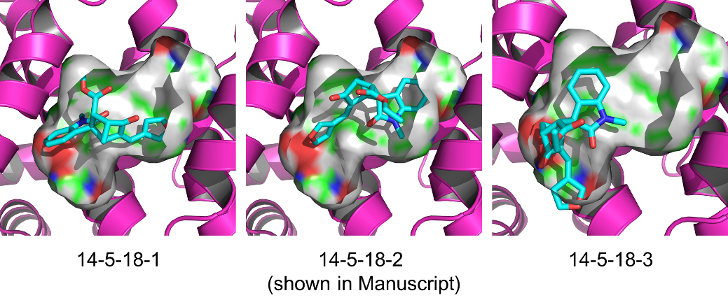
Poses | Evdw | Eele | Ggb | Gnp | ΔGcal
14-5-18-1 | -33.7 ± 2.8 | -9.4 ± 4.7 | 18.7 ± 4.6 | -4.1 ± 0.3 | -28.6 ± 2.7
14-5-18-2 | -37.5 ± 3.8 | -24.1 ± 7.0 | 34.6 ± 6.8 | -4.9 ± 0.5 | -32.0 ± 3.8
14-5-18-3 | -32.5 ± 3.3 | -18.3 ± 6.4 | 28.7 ± 5.5 | -4.4 ± 0.3 | -26.4 ± 3.7
*The statistical error was estimated based on stabilized 10 ns MD simulation trajectory. 1000 snapshots evenly extracted from the 10-20 ns MD trajectory of complex were used for MM/GBSA calculations and 100 snapshots for the entropy term calculations.

