ELECTRONIC SUPPLEMENTARY INFORMATION

Design, synthesis, and anti-bacterial activities of piperazine based phthalimide derivatives against superbug-MRSA
H. S. Nagendra Prasad ^{a*}, A. P. Ananda ^{b&c}, P.M.Amoghª, Navyatha Prashanth Gaonkar.ª,H. S. Jayanth^{d}.,S.Sumathi^{e}., N. B. Krishnamurthy ^{f}.,L.Mallesha^{g}and P.Malluª.
ªDepartment of Chemistry, Sri Jayachamarajendra College of Engineering, JSS Science and Technology University, Mysuru-570 006, Karnataka, India.
^{b}Centre for Research and Evaluation, Bharathiar University, Coimbatore, 641046, Tamil Nadu, India.
^{c}Ganesh Consultancy and Analytical Services, Hebbal Industrial Area, Mysuru, 570016, Karnataka, India.
^{d} Department of Microbiology, Yuvaraja’s, University of Mysore, Mysuru-57005, Karnataka, India.
^{e} Department of Biochemistry, Biotechnology and Bioinformatics, Avinashilingam institute for Homescience and higer education for Women, Coimbatore-641043.
^{f} Department of Biotechnology, Shridevi Institute of Engineering & Technology, Tumkur, 572106, Karnataka, India.
^{g}Department of Chemistry, JSS College of Arts, Commerce and Science (Autonomous)., Ooty Road, Mysuru

* Correspondence author: Email: nprasad@jssstuniv.in

1. NMRand LC-MS data of new compounds
[NOTE:A. ¹H NMR spectra,B.¹³C NMR spectra,C. FTIRandD.LC-MS]
Supplementary Fig S1: Compound (5a)
2-(2-(4-(phenylsulfonyl) piperazin-1-yl) ethyl) isoindoline-1, 3-dione

A
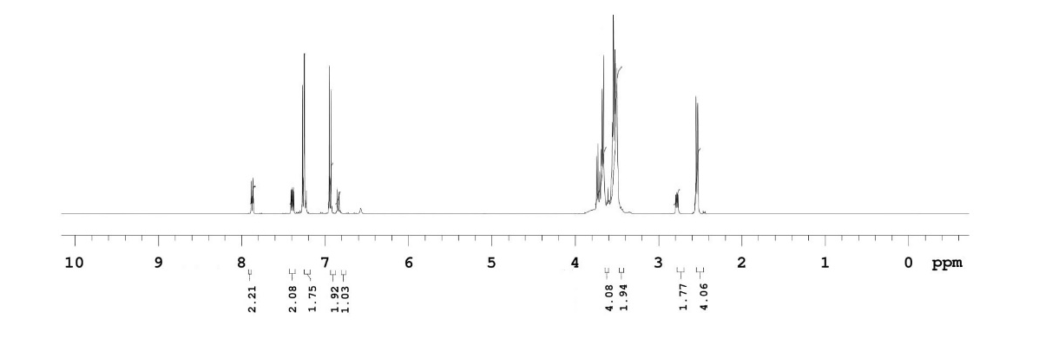

B

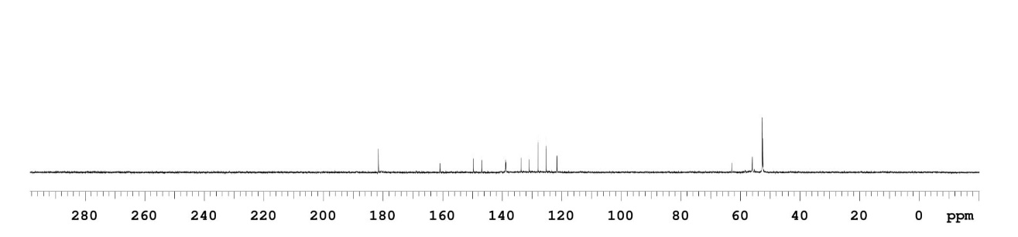

C

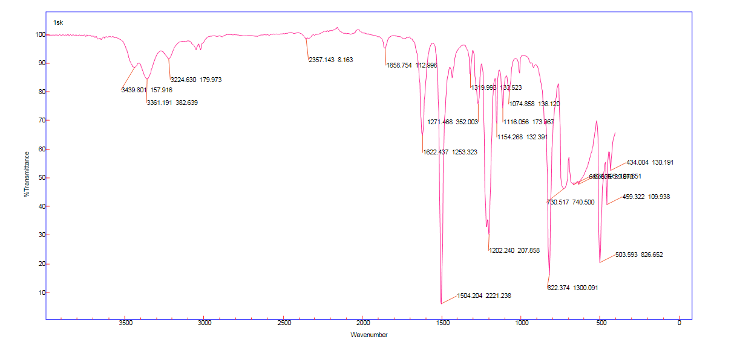

D
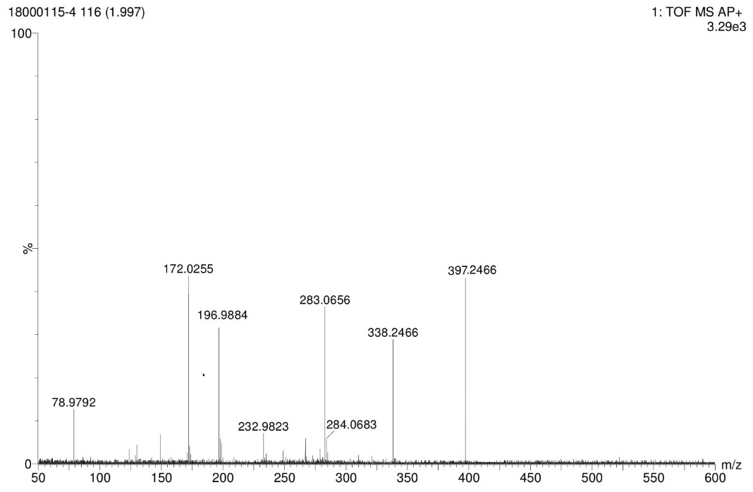

Supplementary Fig S2: Compound (5b)
(2-(2-(4-tosylpiperazin-1-yl) ethyl) isoindoline-1, 3-dione

A

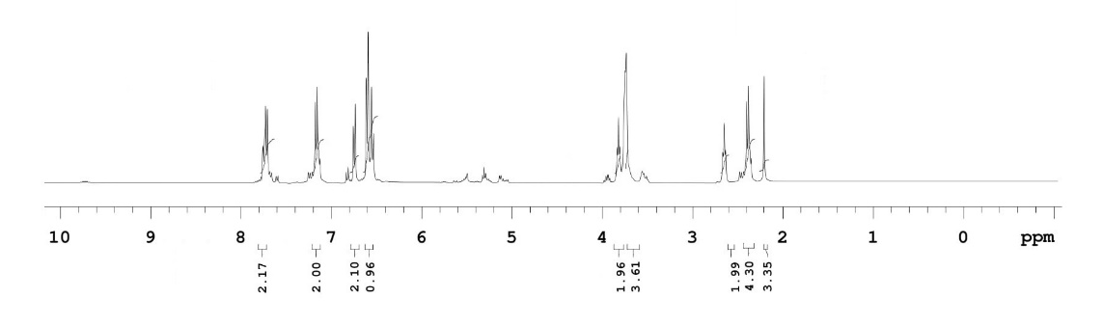

B

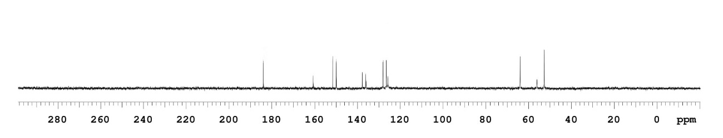

C

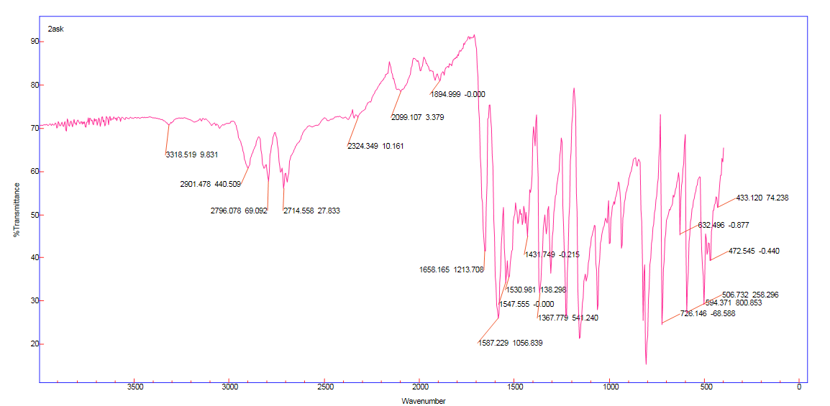

D

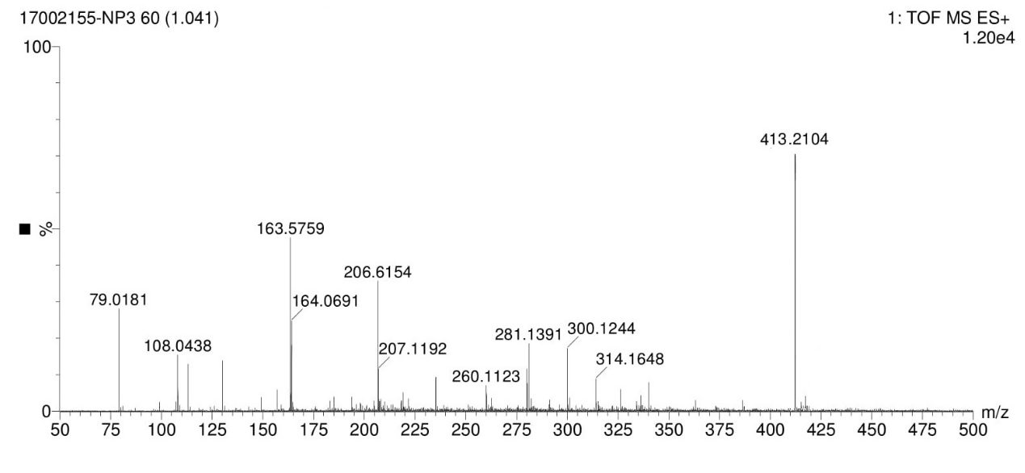

Supplementary Fig S3: Compound (5c)
2-(2-(4-((4-methoxyphenyl) sulfonyl) piperazin-1-yl) ethyl) isoindoline-1, 3-dione

A

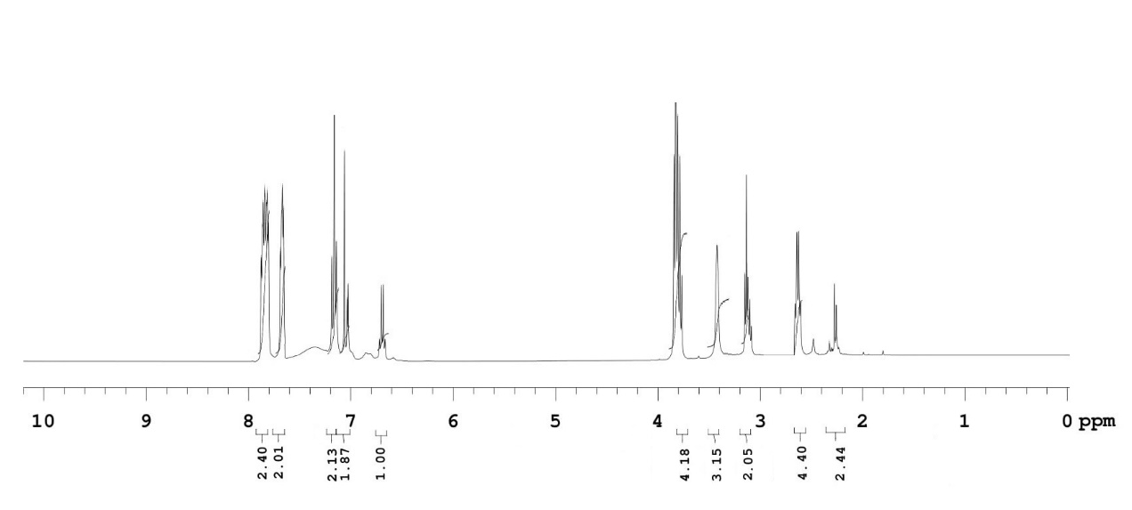

B

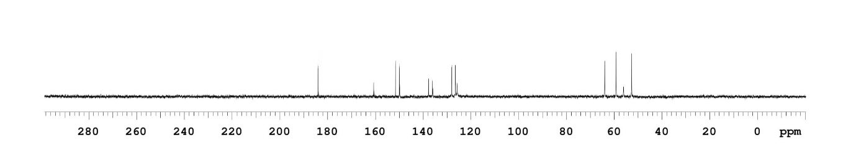

C

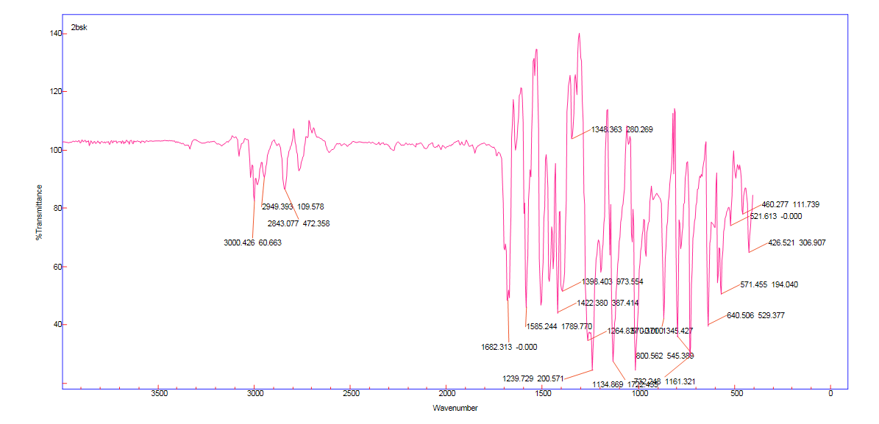

D

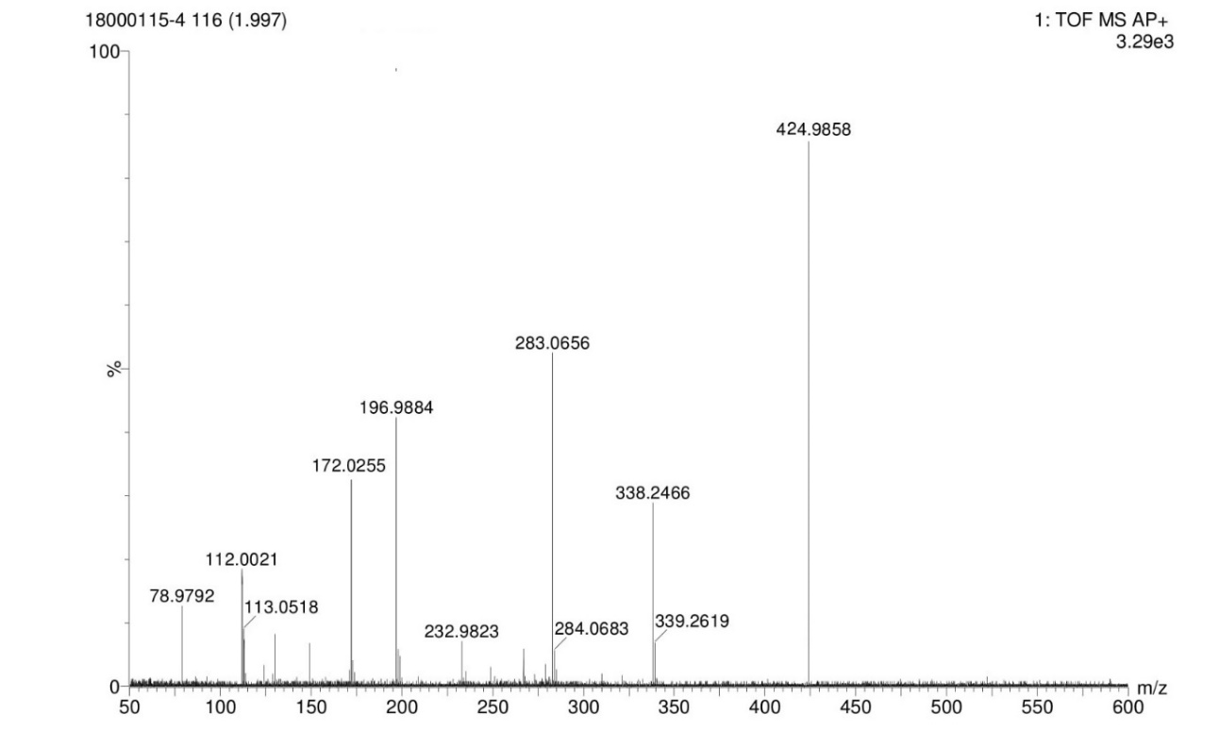

Supplementary Fig S4: Compound (5d)
2-(2-(4-((4-hydroxyphenyl) sulfonyl) piperazin-1-yl) ethyl) isoindoline-1, 3-dione
A

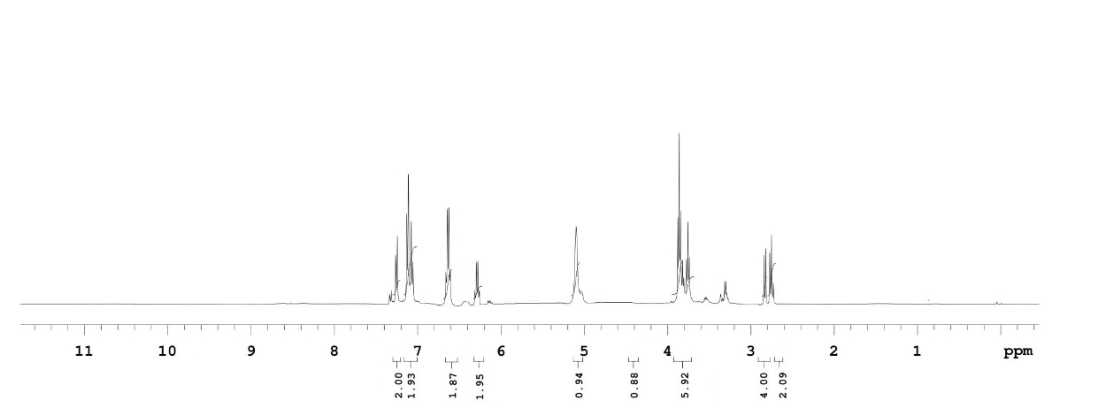

B

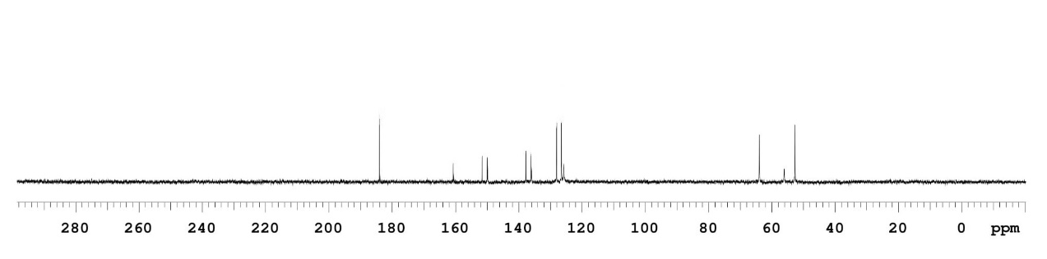

C

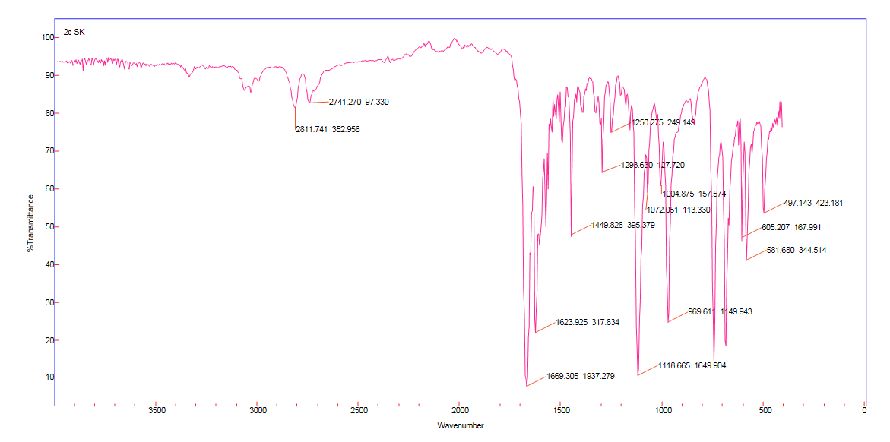

D

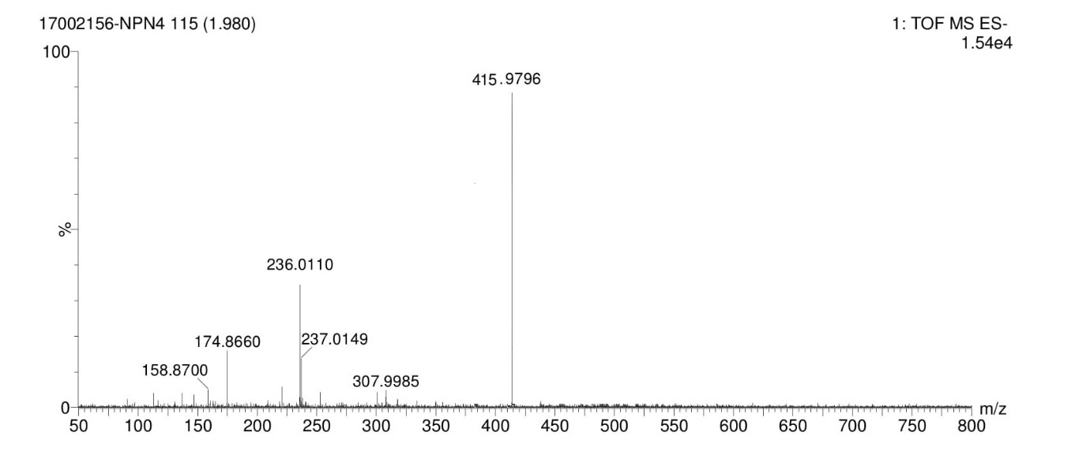

Supplementary Fig S5: Compound (5e)
2-(2-(4-((4-chlorophenyl) sulfonyl)piperazin-1-yl)ethyl)isoindoline-1,3-dione
A

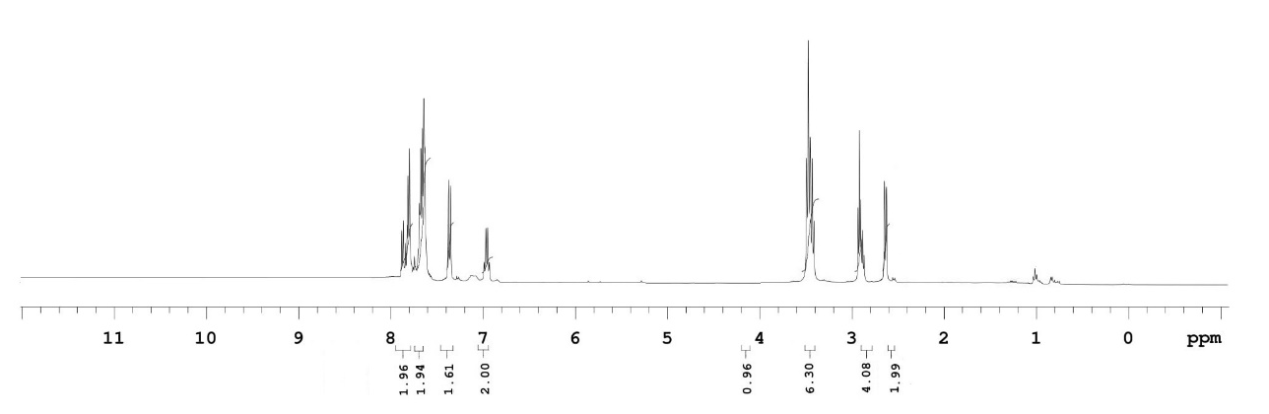
B

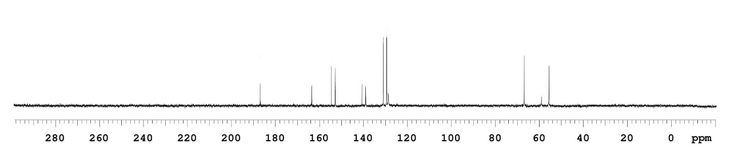

C

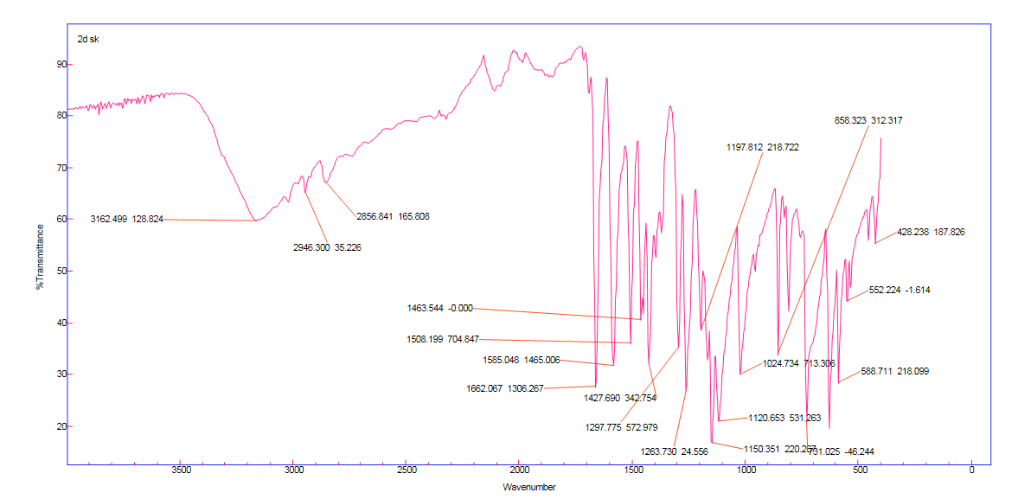

D

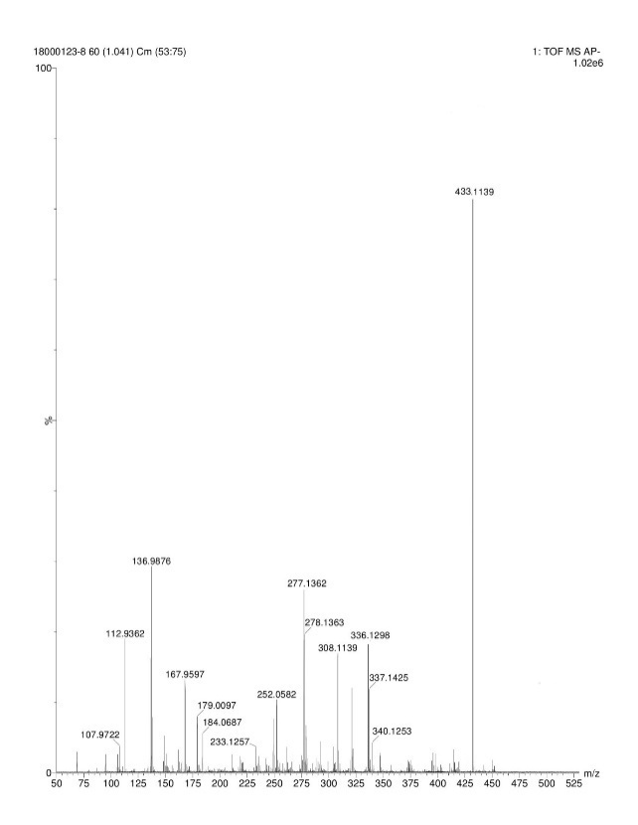
Supplementary Fig S6: Compound (5f)
2-(2-(4-((3-chlorophenyl) sulfonyl) piperazin-1-yl) ethyl) isoindoline-1, 3-dione

A

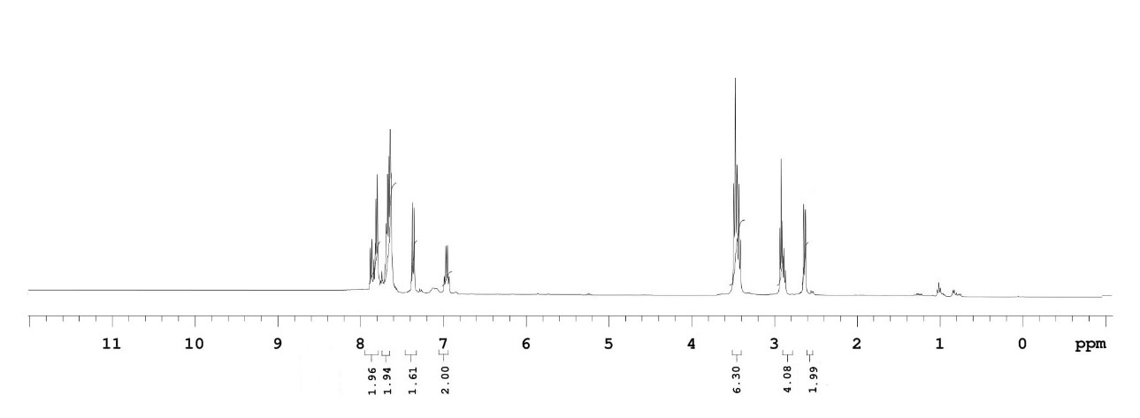

B

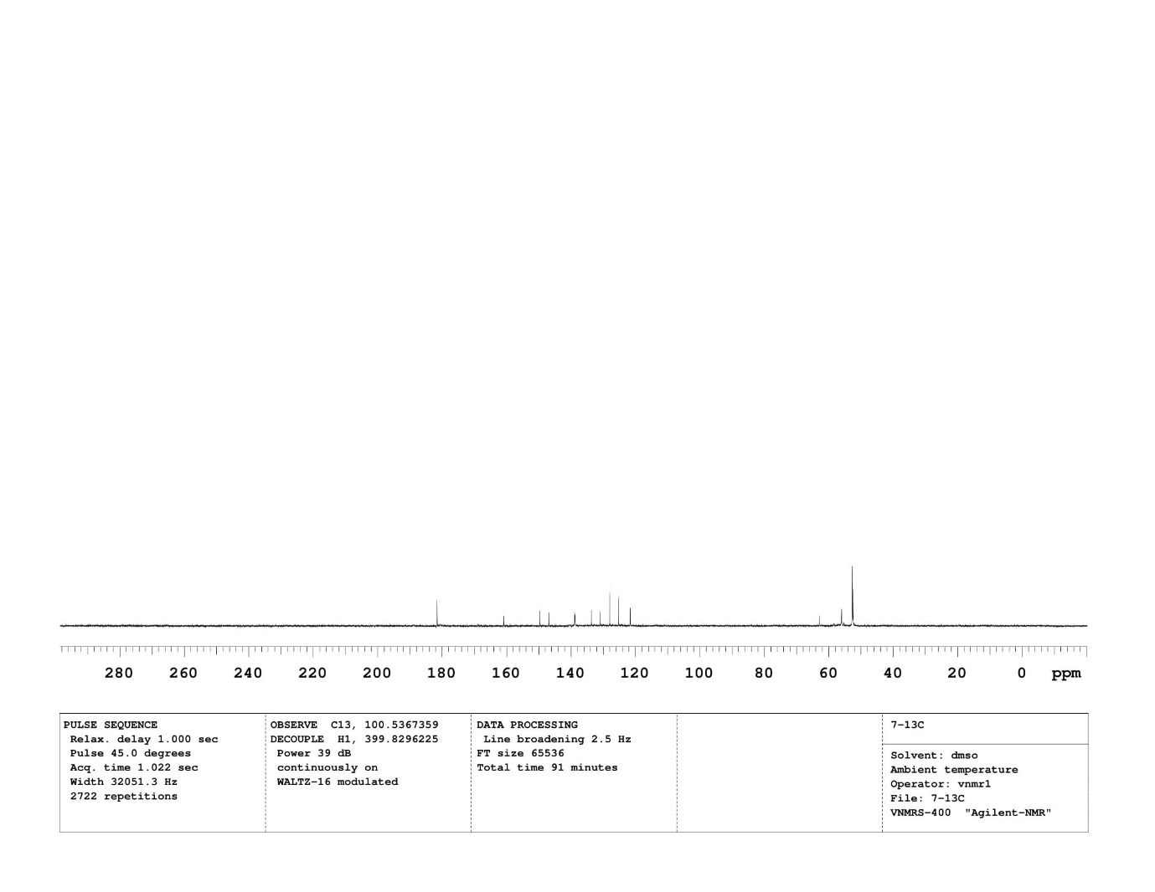
C
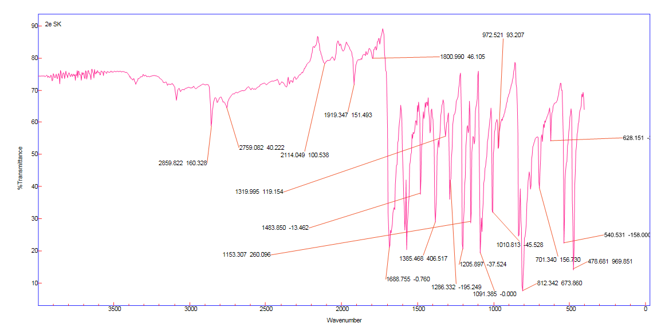

D

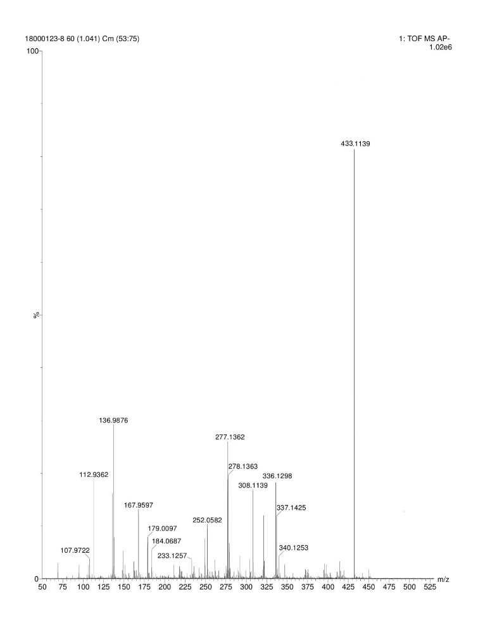

Supplementary Fig S7: Compound (5g)
2-(2-(4-((2-chlorophenyl) sulfonyl) piperazin-1-yl) ethyl) isoindoline-1,3-dione

A
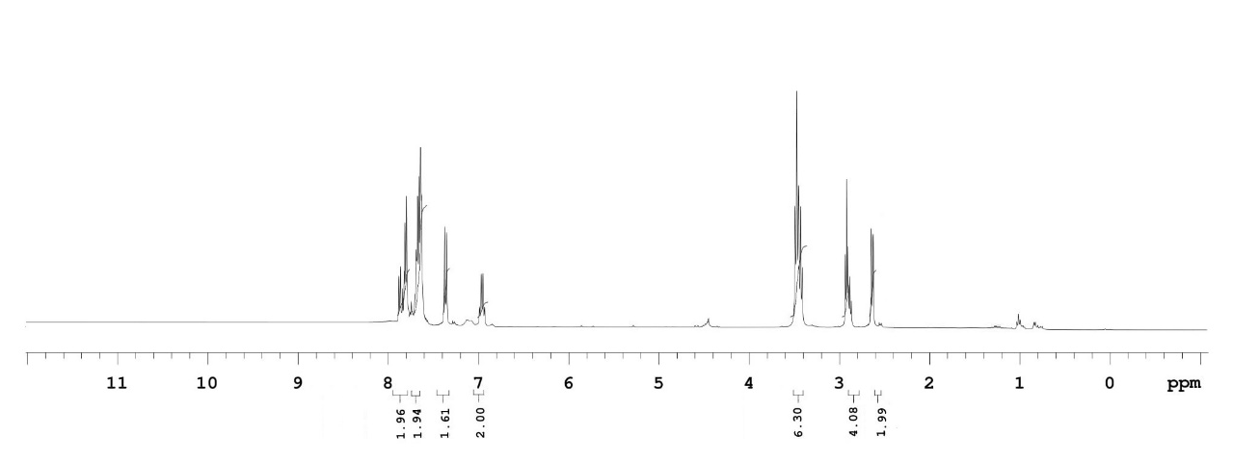

B

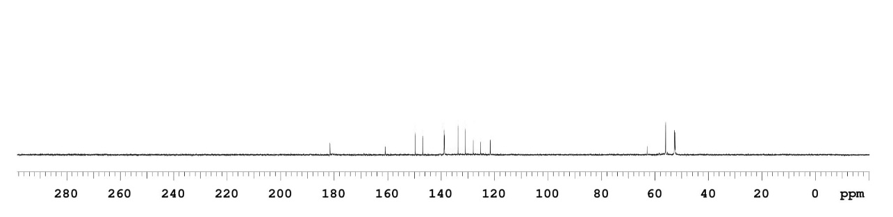

C

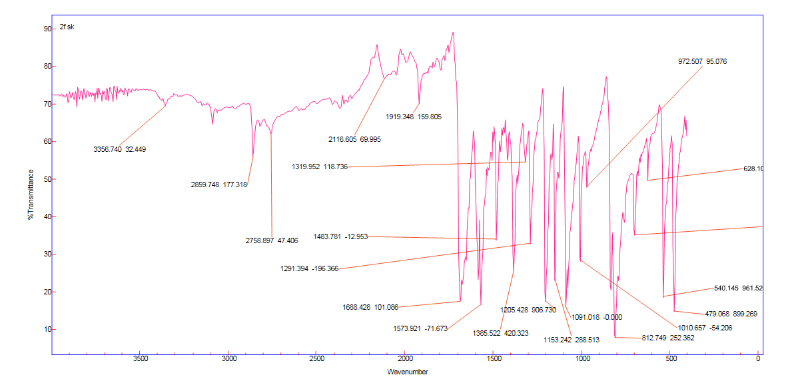
D

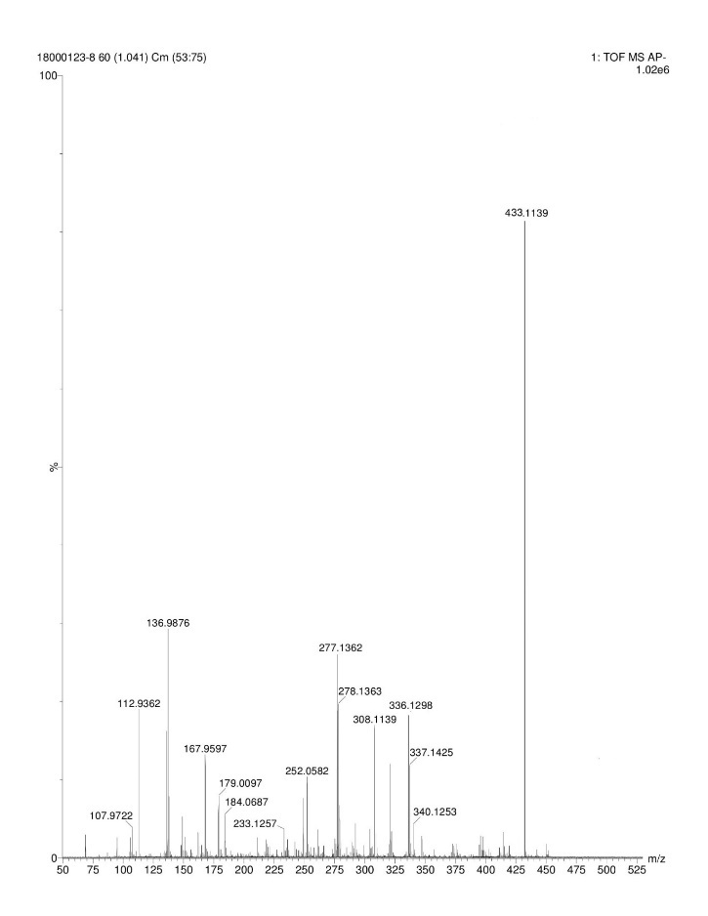

Supplementary Fig S8: Compound (5h)
22-(2-(4-((3,5-dichlorophenyl)sulfonyl)piperazin-1-yl)ethyl)isoindoline-1,3dione

A

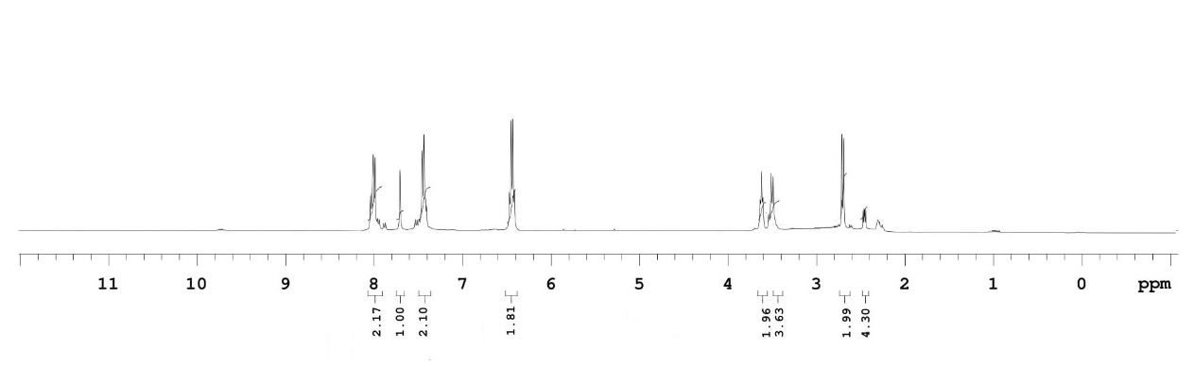
B

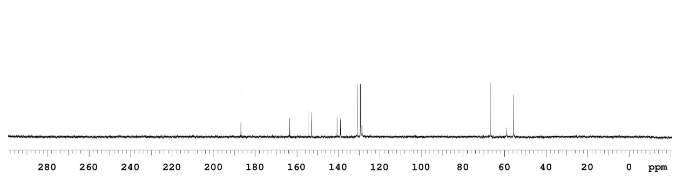

C
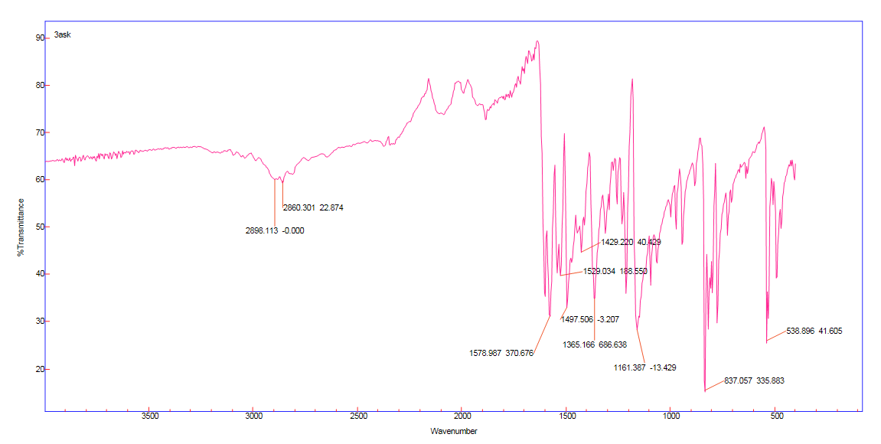

D

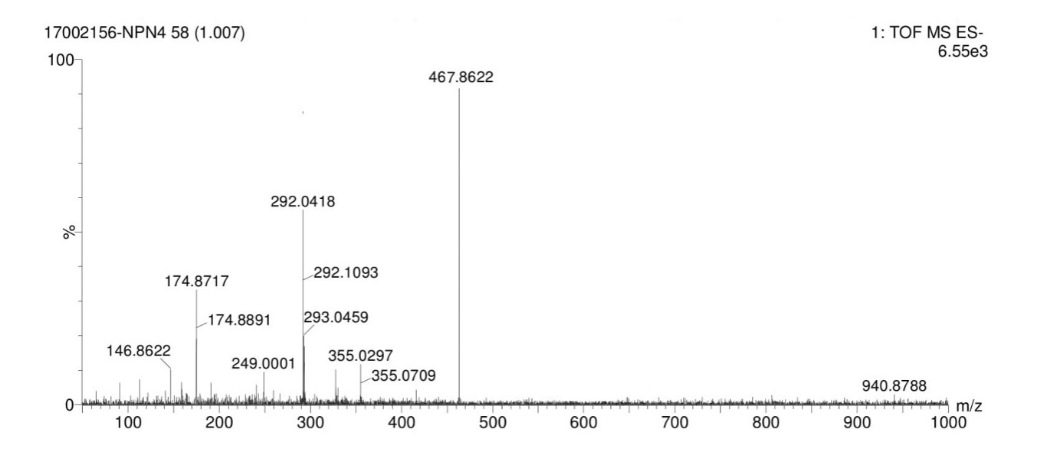

Supplementary Fig S9: Compound (5i)
2-(2-(4-((4-fluorophenyl)sulfonyl)piperazin-1-yl)ethyl)isoindoline-1,3-dione
A

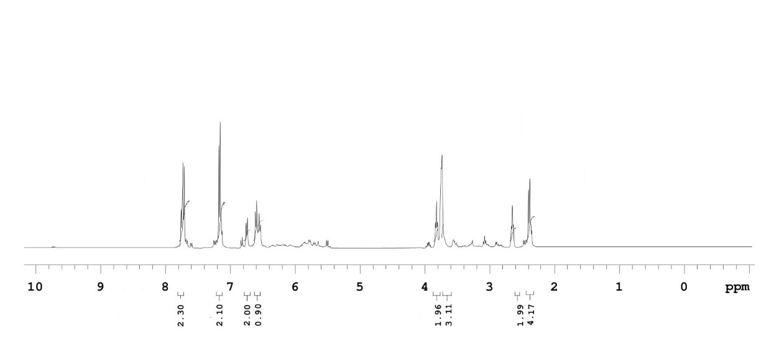

B

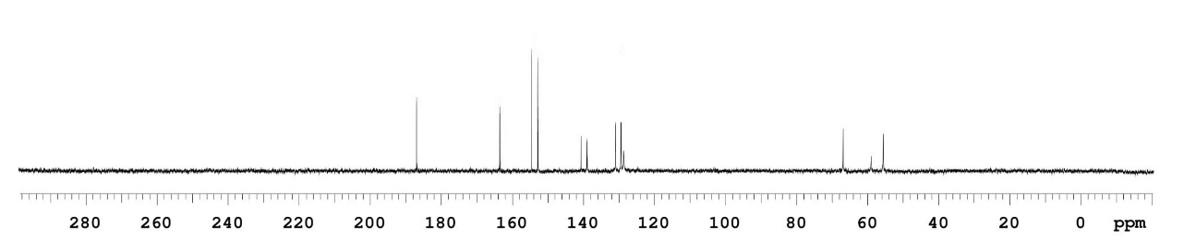
C

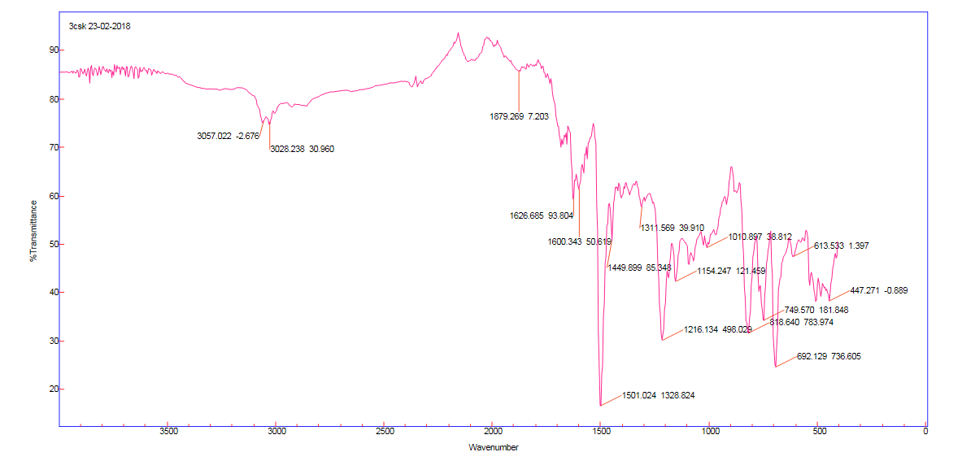

D
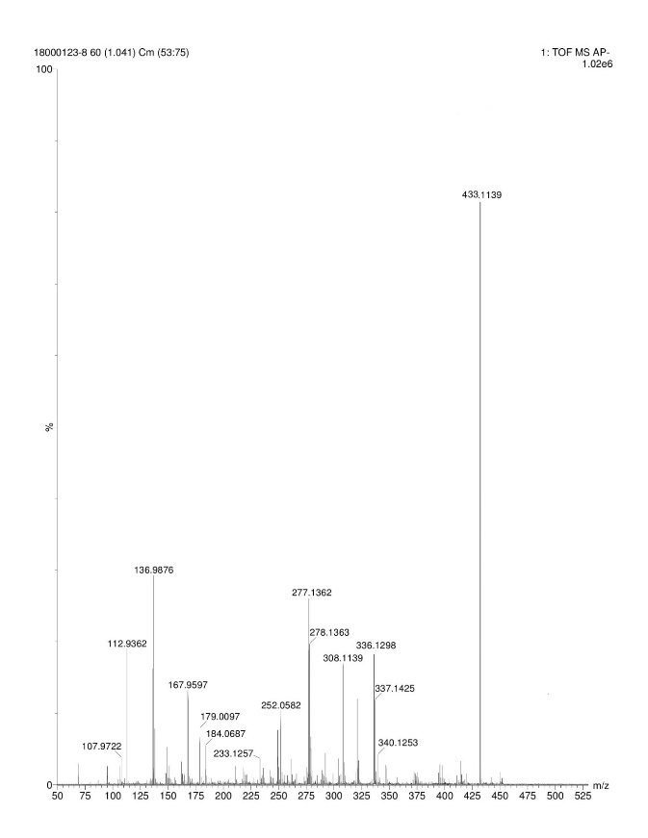

Supplementary Fig S10: Compound (5j)
2-(2-(4-((4-bromophenyl) sulfonyl) piperazin-1-yl) ethyl) isoindoline-1,3-dione

A
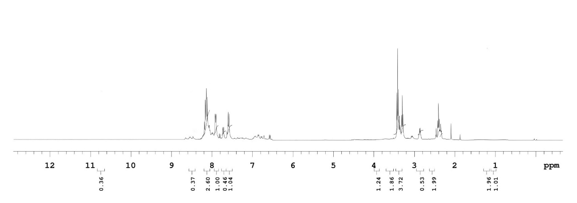

B
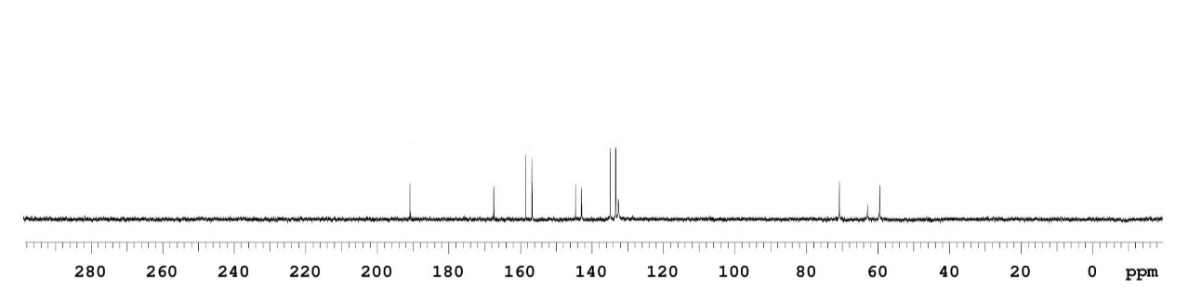

C
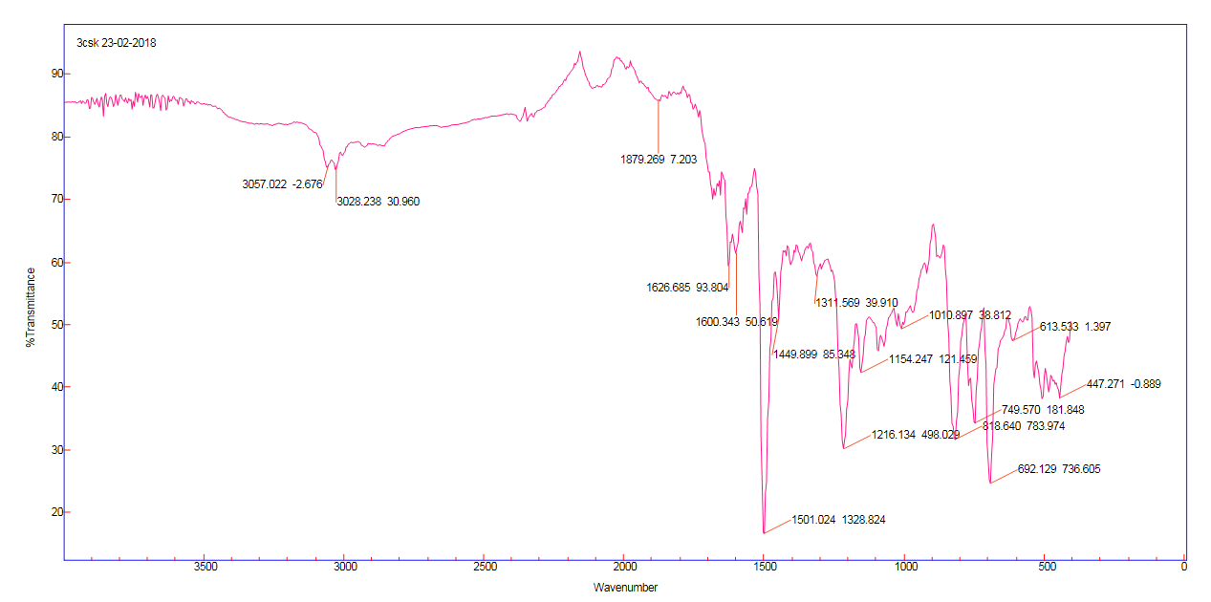

D

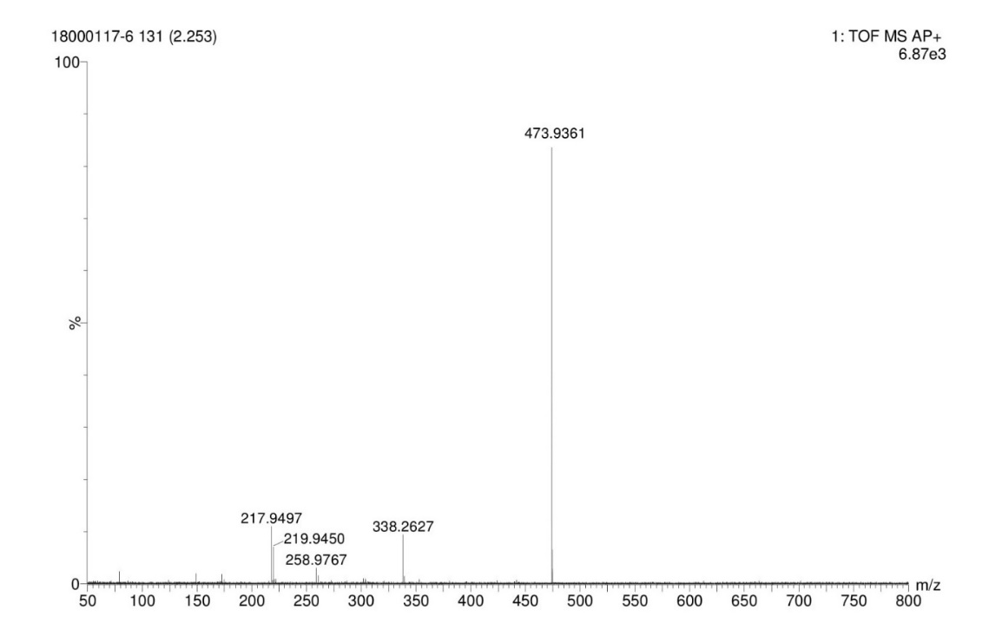
Supplementary Fig S11: Compound (5k)
2-(2-(4-((4-iodophenyl)sulfonyl)piperazin-1-yl)ethyl)isoindoline-1,3-dione
A
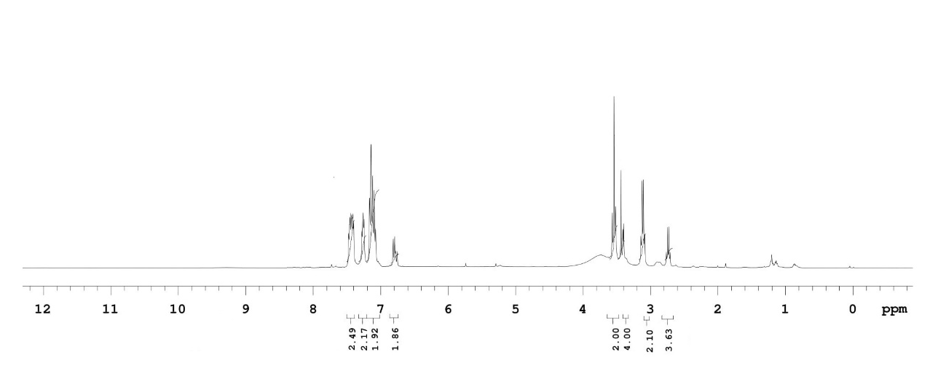

B

C

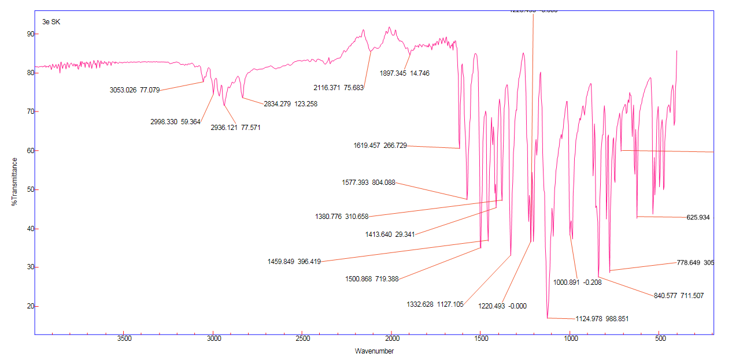

D

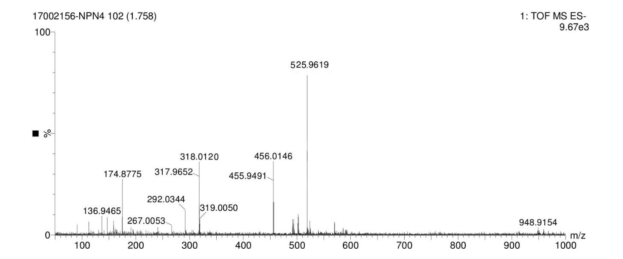

Supplementary Fig S12: Compound (5l)
2-(2-(4-((4-nitrophenyl)sulfonyl)piperazin-1-yl)ethyl)isoindoline-1,3-dione

A

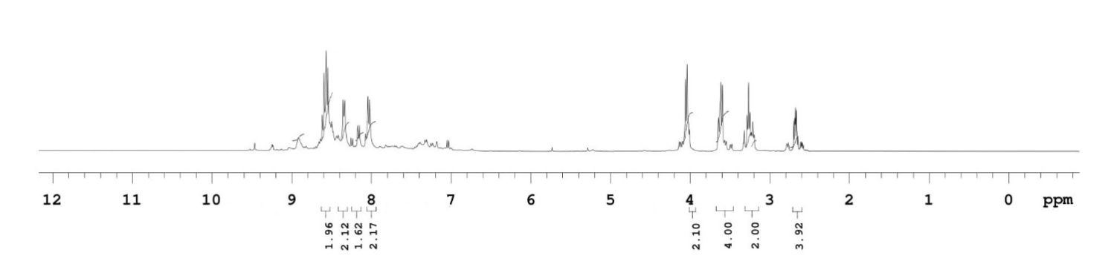

B

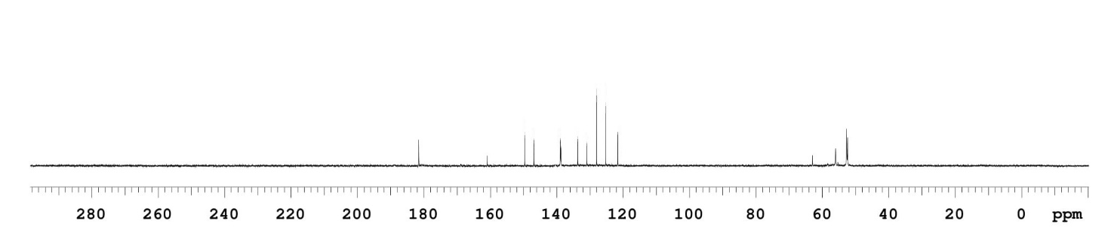

C

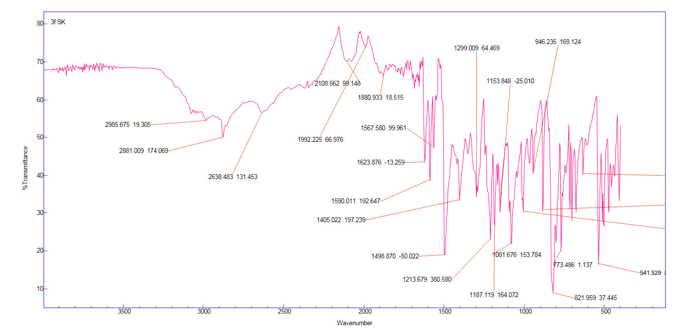

D

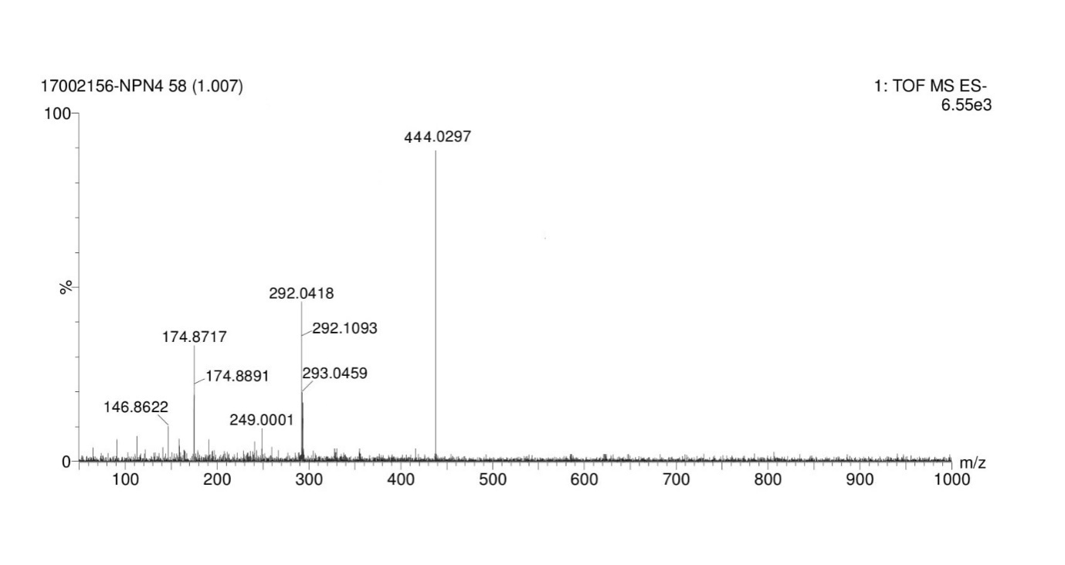
2. Supplementary fig. S13:Molecular docking interactive map of ligands5(a-l) and antibiotic streptomycin for 3VMTand6FTB of binding deep inside the active site, depicting the best docking pose showing 2D respectively.
Compound name | 3VMT | 6FTB
5a | 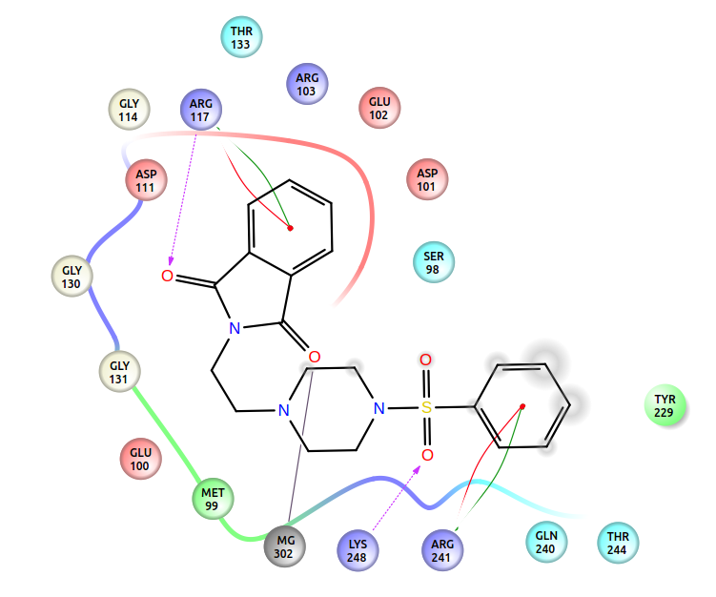 | 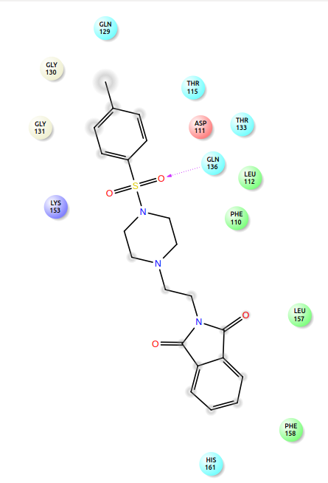
5b | 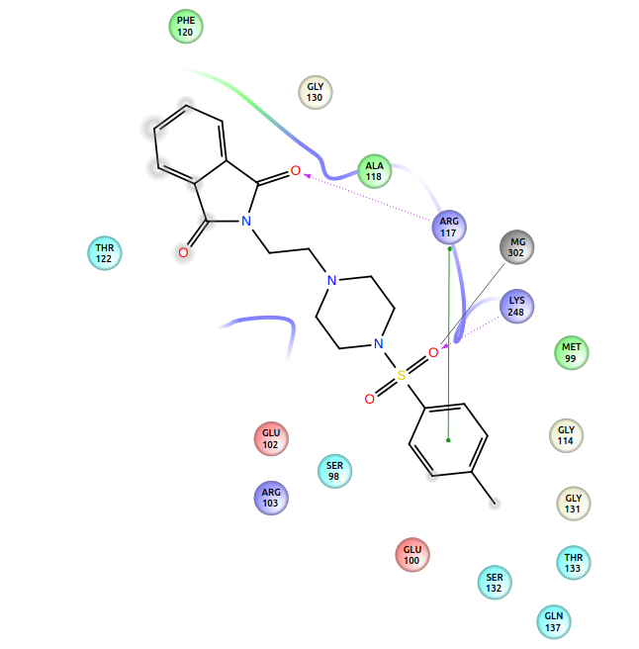 | 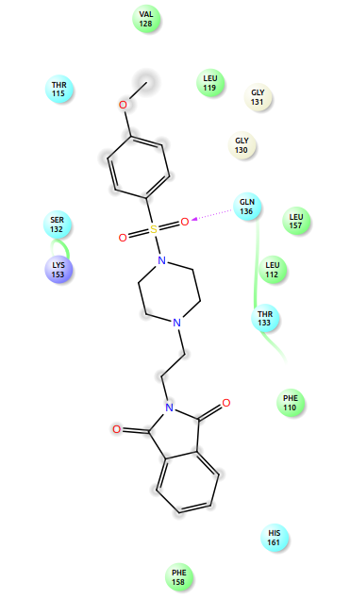
5c | 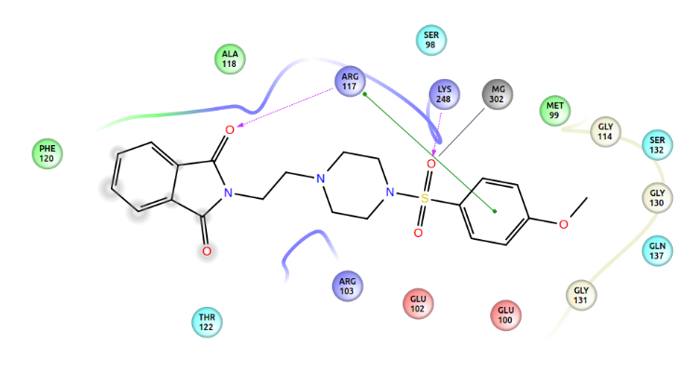 | 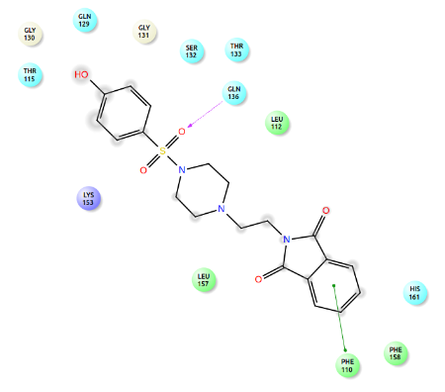
5d | 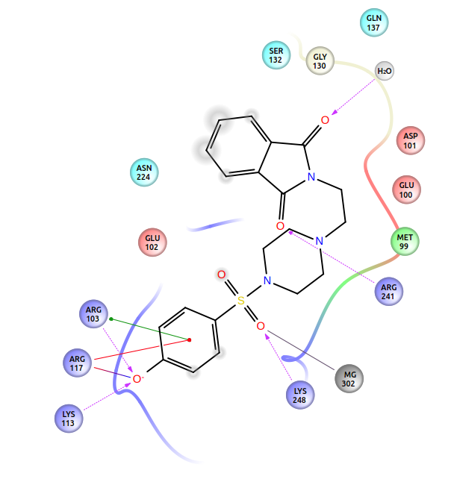 | 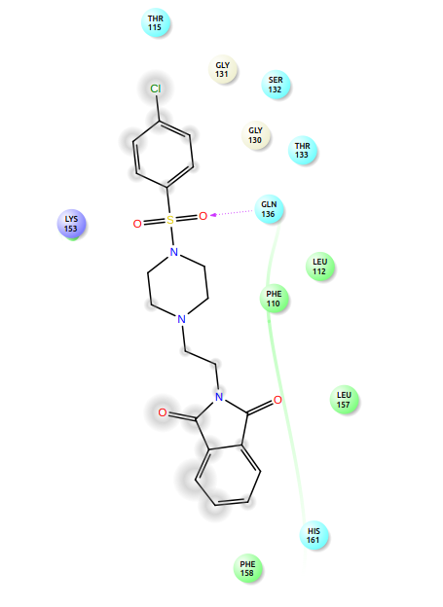
5e | 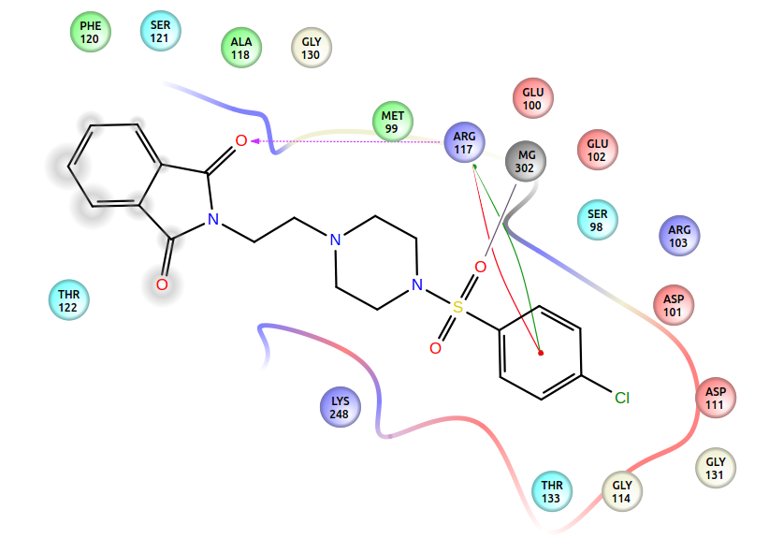 | 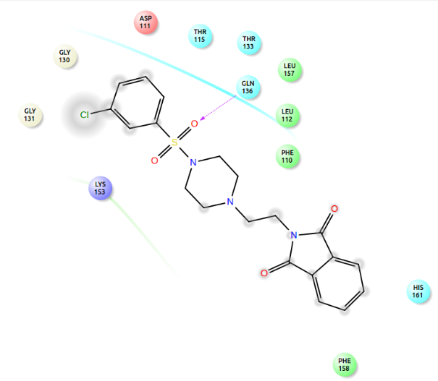
5f | 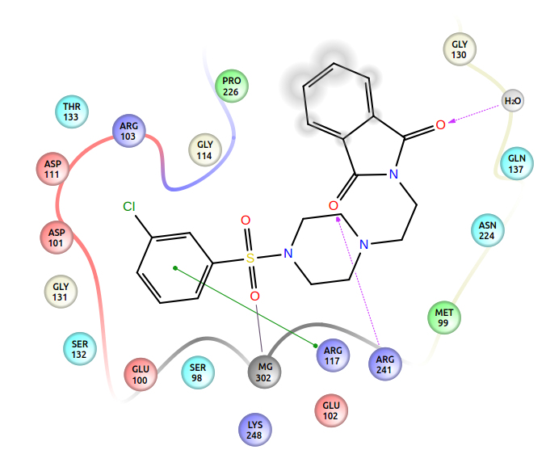 | 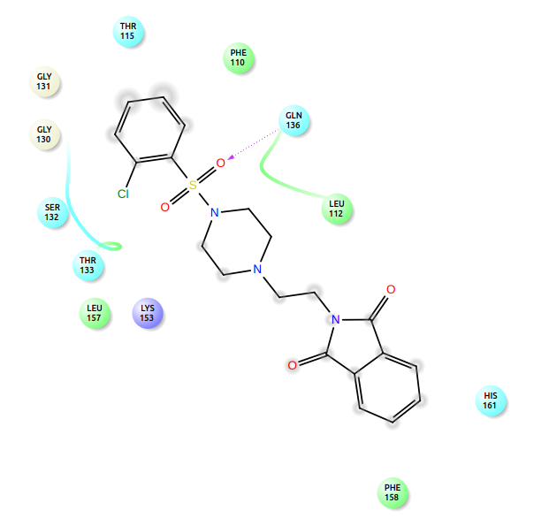
5g | 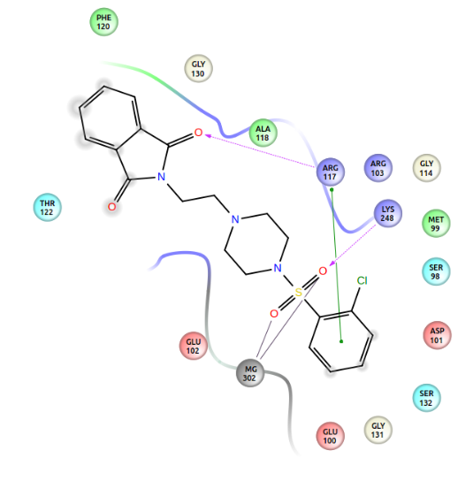 | 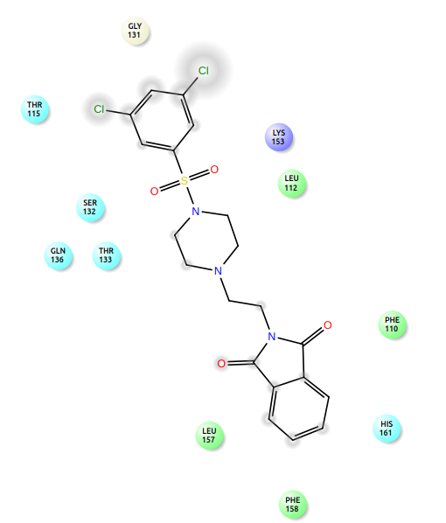
5h | 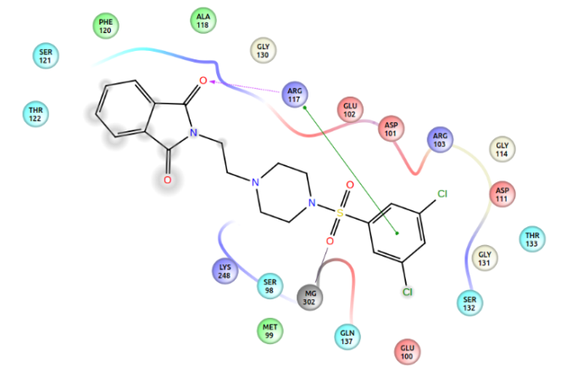 | 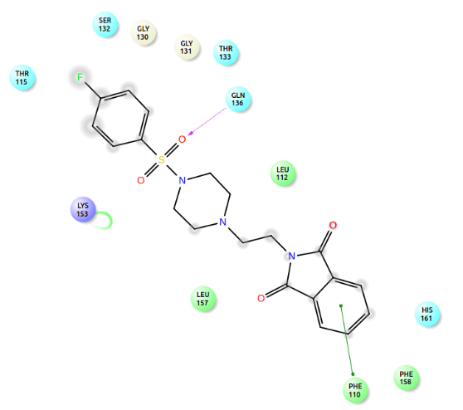
5i | 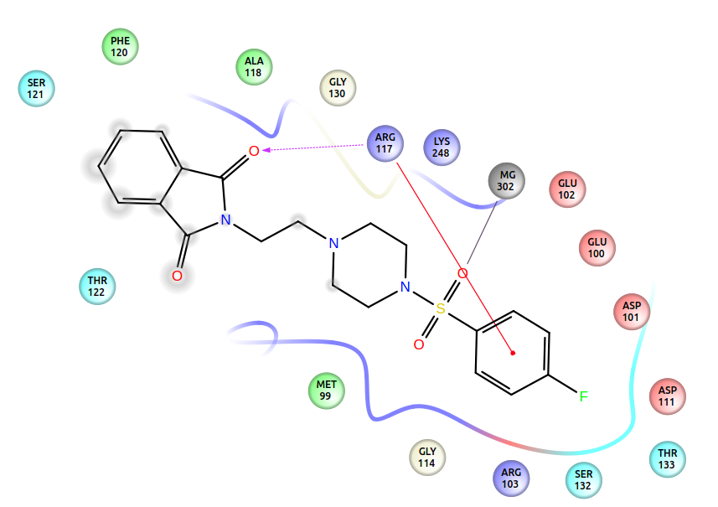 | 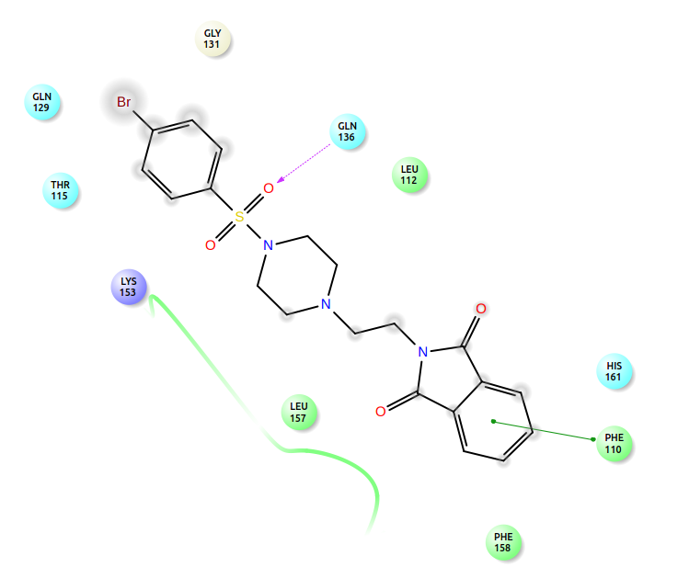
5j | 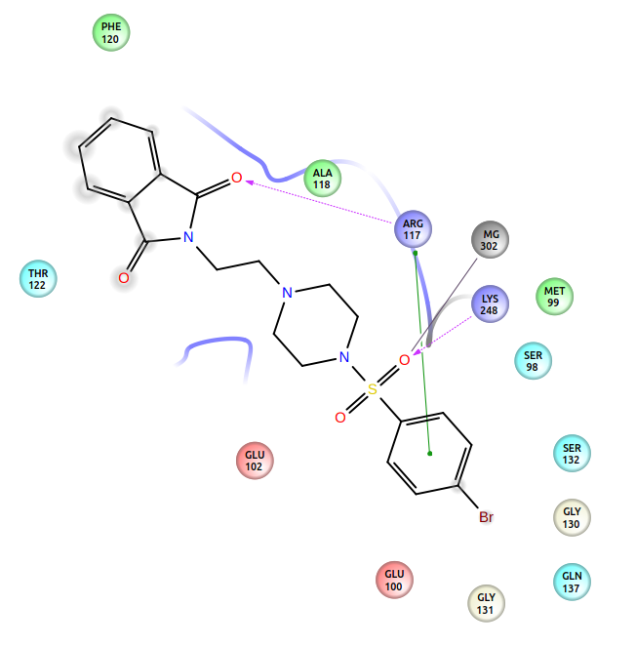 | 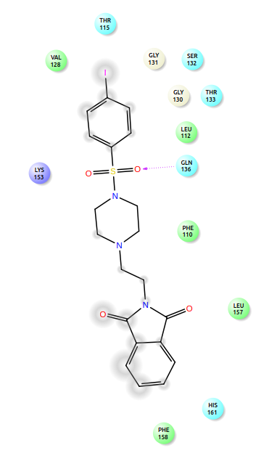
5k | 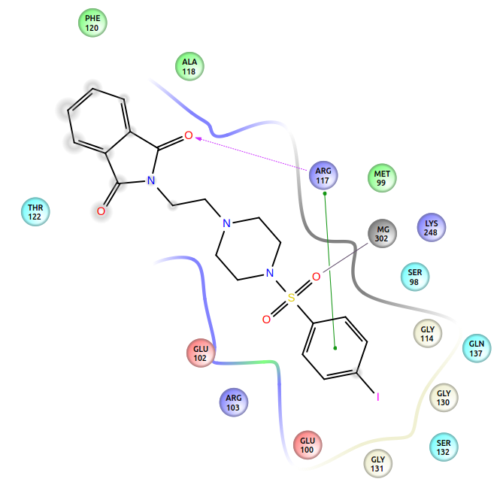 | 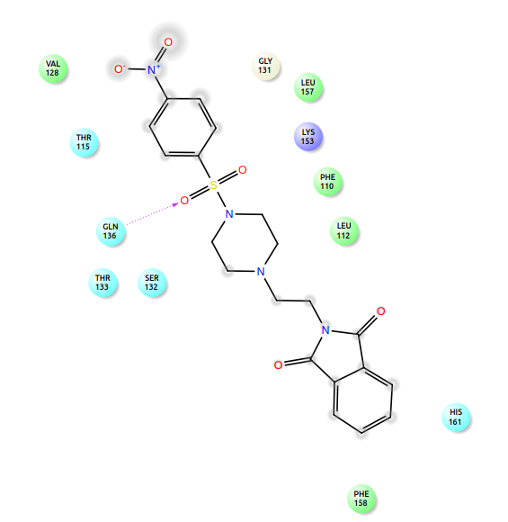
Streptomycin | 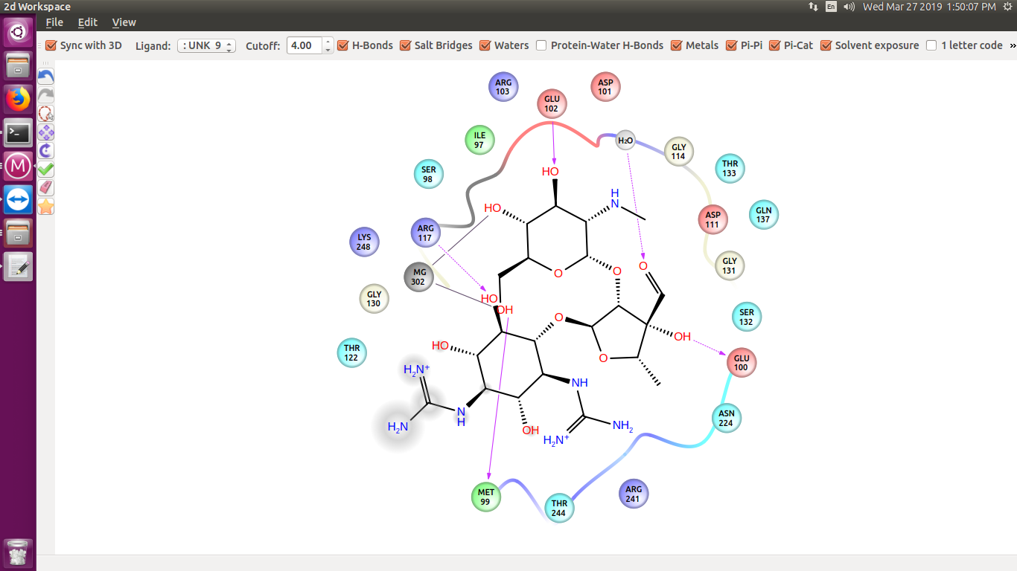 | 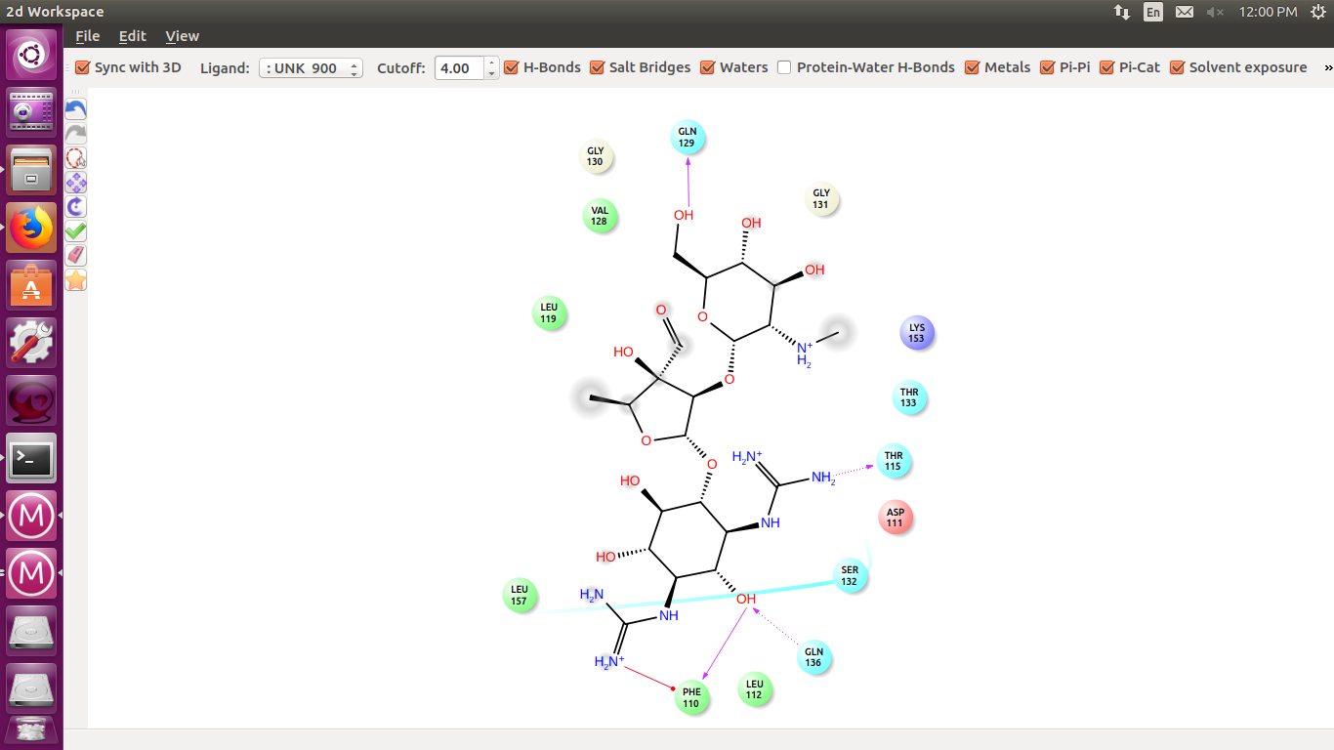

Activity | 5a |  | 5b |  | 5c |  | 5d |  | 5e |  | 5f
Activity | Pa | Pi | Pa | Pi | Pa | Pi | Pa | Pi | Pa | Pi | Pa | Pi
Antipsychotic | 0.599 | 0.012 | 0.465 | 0.024 | 0.436 | 0.028 | 0.333 | 0.044 | 0.584 | 0.013 | 0.593 | 0.013
Antidepressant | 0.385 | 0.037 | 0.297 | 0.059 | 0.325 | 0.050 | 0.201 | 0.107 | 0.377 | 0.038 | 0.384 | 0.037
Antiischemic, cerebral | 0.467 | 0.128 | 0.442 | 0.149 | 0.399 | 0.185 | 0.476 | 0.121 | 0.523 | 0.094 | 0.444 | 0.147
Antianginal | 0.397 | 0.087 | 0.388 | 0.094 | 0.417 | 0.074 | 0.359 | 0.119 | 0.364 | 0.114 | 0.341 | 0.137
Antiprotozoal (Amoeba) | 0.307 | 0.063 | 0.299 | 0.069 | 0.268 | 0.101 | 0.328 | 0.051 | 0.318 | 0.056 | 0.341 | 0.044
Antiadrenergic | 0.191 | 0.033 | 0.124 | 0.052 | 0.191 | 0.033 | 0.129 | 0.050 | 0.143 | 0.045 | 0.124 | 0.052
Antieczematic atopic | 0.227 | 0.090 | 0.214 | 0.107 | 0.223 | 0.095 | 0.198 | 0.131 | 0.233 | 0.083 | 0.232 | 0.084
Antidiuretic hormone antagonist | 0.066 | 0.018 | 0.063 | 0.019 | 0.049 | 0.029 | NE | NE | 0.065 | 0.018 | 0.057 | 0.024
Antipyretic | 0.198 | 0.116 | 0.207 | 0.107 | 0.233 | 0.086 | 0.249 | 0.073 | 0.187 | 0.127 | 0.178 | 0.138
Antiviral (Picornavirus) | 0.331 | 0.181 | NE | NE | NE | NE | NE | NE | 0.303 | 0.222 | 0.275 | 0.272
Antiarthritic | 0.315 | 0.123 | 0.293 | 0.137 | 0.320 | 0.120 | 0.264 | 0.160 | 0.320 | 0.121 | 0.341 | 0.108
Antiobesity | 0.325 | 0.059 | 0.292 | 0.072 | 0.231 | 0.104 | 0.203 | 0.124 | 0.436 | 0.032 | 0.431 | 0.032
3. Supplementary table S1: Predicted biological activities of compounds 5(a-f), Pa (probability “to be active”), Pi(probability “to be inactive”).

4. Supplementary table S1:Predicted biological activities of compounds 5(g-l), Pa (probability “to be active”), Pi(probability “to be inactive”).

Activity | 5g |  | 5h |  | 5i |  | 5j |  | 5k |  | 5l
Activity | Pa | Pi | Pa | Pi | Pa | Pi | Pa | Pi | Pa | Pi | Pa | Pi
Antipsychotic | 0.596 | 0.012 | 0.616 | 0.011 | 0.655 | 0.009 | 0.503 | 0.020 | 0.397 | 0.033 | 0.314 | 0.048
Antidepressant | 0.403 | 0.034 | 0.385 | 0.037 | 0.421 | 0.031 | 0.300 | 0.058 | 0.196 | 0.111 | 0.173 | 0.130
Antiischemic, cerebral | 0.370 | 0.213 | 0.456 | 0.137 | 0.502 | 0.104 | 0.330 | 0.260 | NE | NE | 0.444 | 0.148
Antianginal | 0.406 | 0.081 | 0.315 | 0.163 | 0.342 | 0.136 | 0.294 | 0.184 | 0.350 | 0.128 | 0.498 | 0.043
Antiprotozoal (Amoeba) | 0.286 | 0.080 | 0.365 | 0.035 | 0.257 | 0.116 | 0.334 | 0.048 | 0.317 | 0.057 | 0.446 | 0.017
Antiadrenergic | 0.121 | 0.053 | NE | NE | 0.205 | 0.030 | 0.097 | 0.065 | 0.162 | 0.040 | 0.118 | 0.054
Antieczematic atopic | 0.263 | 0.052 | 0.225 | 0.093 | 0.263 | 0.052 | 0.218 | 0.101 | NE | NE | 0.195 | 0.136
Antidiuretic hormone antagonist | 0.044 | 0.034 | 0.056 | 0.025 | 0.054 | 0.026 | 0.044 | 0.034 | 0.041 | 0.037 | 0.048 | 0.030
Antipyretic | 0.169 | 0.150 | 0.166 | 0.155 | NE | NE | 0.195 | 0.119 | 0.265 | 0.061 | 0.183 | 0.131
Antiviral (Picornavirus) | 0.285 | 0.253 | NE | NE | NE | NE | NE | NE | 0.330 | 0.182 | 0.380 | 0.127
Antiarthritic | 0.299 | 0.133 | 0.297 | 0.134 | 0.412 | 0.075 | NE | NE | NE | NE | NE | NE
Antiobesity | 0.450 | 0.029 | 0.468 | 0.026 | 0.355 | 0.050 | 0.344 | 0.053 | 0.189 | 0.135 | NE | NE

Table S2:Synthesized analogues 5(a-1) and their bio-activity score
Compound | GPCR ligand | Ion channel modulator | Kinase inhibitor | Nuclear receptor ligand | Protease inhibitor | Enzyme inhibitor
5(a) | -0.05 | -0.45 | -0.28 | -0.48 | -0.11 | -0.05
5(b) | -0.06 | -0.50 | -0.23 | -0.51 | -0.01 | -0.12
5(c) | -0.03 | -0.43 | -0.19 | -0.48 | 0.04 | -0.07
5(d) | 0.01 | -0.40 | -0.16 | -0.37 | 0.05 | -0.02
5(e) | -0.03 | -0.44 | -0.21 | -0.51 | 0.00 | -0.10
5(f) | -0.02 | -0.45 | -0.21 | -0.50 | 0.00 | -0.09
5(g) | -0.04 | -0.45 | -0.22 | -0.49 | -0.02 | -0.09
5(h) | -0.01 | -0.41 | -0.19 | -0.48 | -0.01 | -0.09
5(i) | -0.02 | -0.45 | -0.17 | -0.47 | 0.01 | -0.08
5(j) | -0.11 | -0.50 | -0.23 | -0.58 | -0.06 | -0.13
5(k) | -0.02 | -0.44 | -0.18 | -0.47 | -0.02 | -0.11
5(l) | -0.08 | -0.40 | -0.21 | -0.46 | -0.01 | -0.08

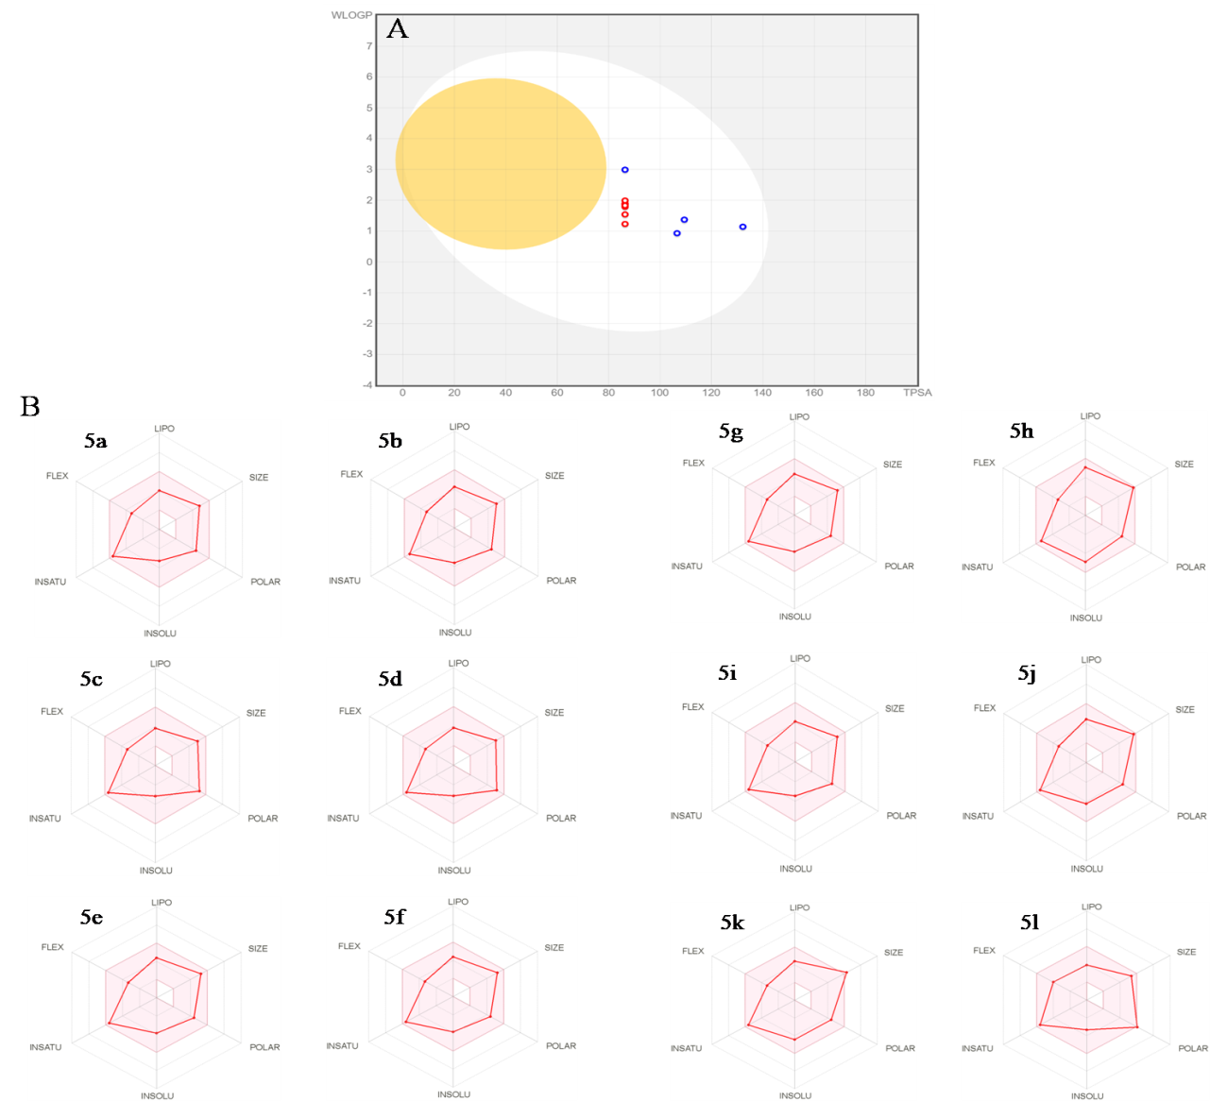
Supplementary Fig S14: Bioavailability radar graph of 5(a-l) (pink area reflects the allowed values of drug likeness properties ofthe molecule.
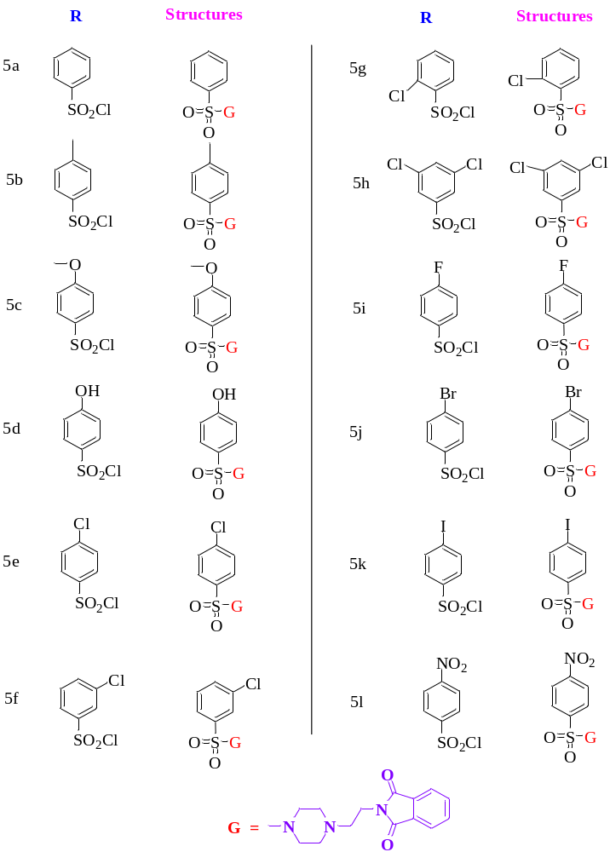
Supplementary Fig S15: Structures of synthesized compounds 5(a-l)

