Supplementary materials:
Figure S1. Representative chromatograph profiles of four bacterial species grown on tryptone soya broth (TSB), collected on Tenax for 24 h and solvent-extracted. From top to bottom: CF-Citrobacter freundii; EC-Enterobacter cloacae; KO-Klebsiella oxytoca; PA- Enterobacter (sy. Pantoea) agglomerans and TSB media.
Figure S2. Representative chromatograph profiles of four bacterial species grown on tryptone soya broth (TSB), collected with solid phase micro-extraction (SPME) fibre for 1 h and thermally desorbed. From top to bottom: CF-Citrobacter freundii; EC-Enterobacter cloacae; KO-Klebsiella oxytoca; PA- Enterobacter (syn. Pantoea) agglomerans and TSB media.

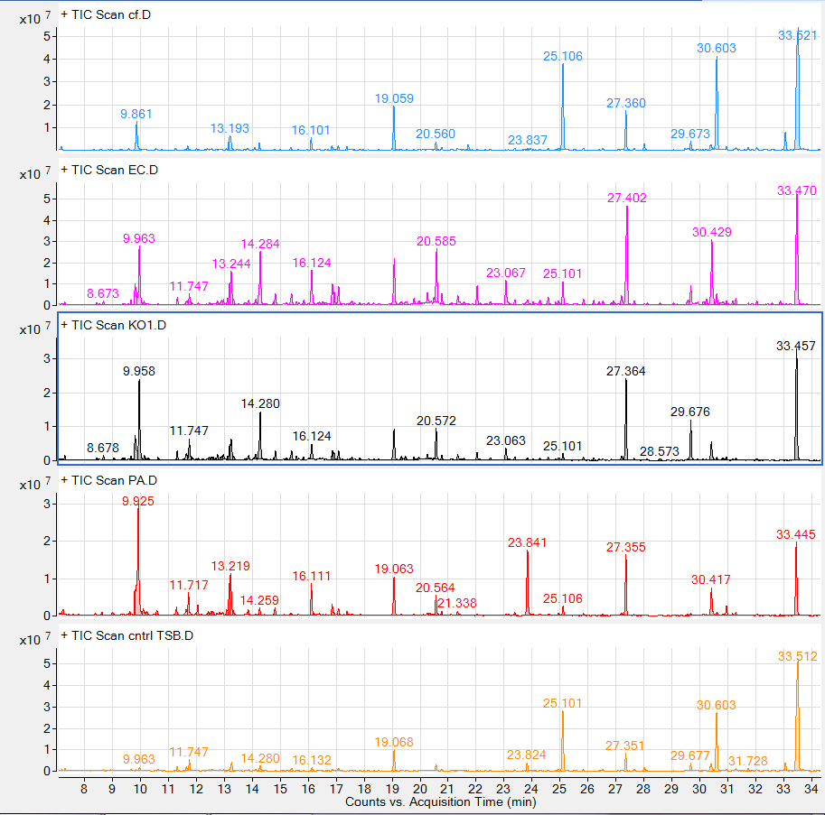
Figure S1.

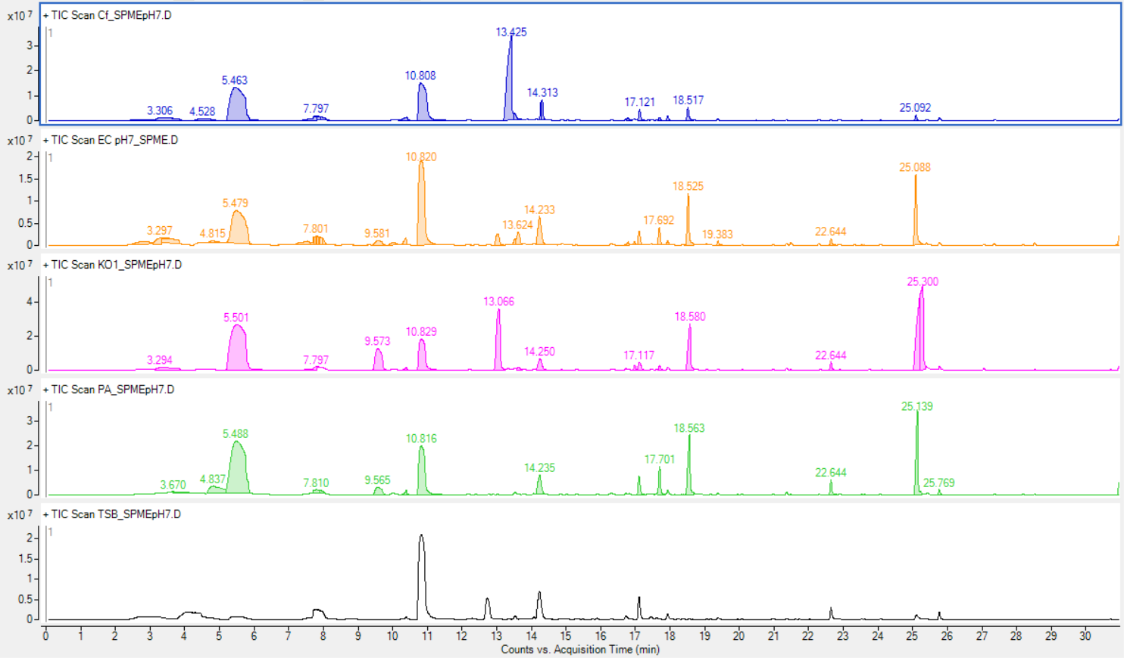
Figure S2.

