Contents

1.1) Maximum Relevance and Minimum Redundancy (mRMR) algorithm.
1.2) Code Maximum Relevance and Minimum Redundancy (mRMR).
1.3) Table S1. F-test Correlation Score (FCQ) according to selected features.
2.1) Random Forest training code and search hyperparameter with Optuna framework.
2.2)Random Forest confusion matrix, normalized confusion matrix and AUROC (performance).
2.3) Hyperparameter and slice plot of search hyperparameters in 50 trials.
3.1) TabNet training code and search hyperparameter with Optuna framework.
3.2) TabNet confusion matrix, normalized confusion matrix and AUROC (performance) after hyperparameter search withOptuna.
3.3) Hyperparameters and slice plot
4.1) Support Vector Machine code and search hyperparameter with Optuna framework
4.2) Hyperparameter and slice plot
5) SHAP Interaction plots applied to Random Forest
6) Table S2. General characteristics of the missing data

1.1) Maximum Relevance and Minimum Redundancy algorithm (mRMR)
FCQ(Xi)=F(Y,Xi) / [$\frac{1}{∣S∣}\sum_{Xn ϵS}{}ρ(Xs,Xi)],$
where Y is the response variable, S is the set of selected variable, |S| is the size of the feature set, Xs ∈ S is one feature out of the feature set S, ρ(Xs,Xi) is the Mathew's correlation, and F(Y, Xi) is the F-statistic.

1.2) Code implementation mRMR

F = pandas.Series(f__classif(X_data, y_data)[0], index = X_data.columns)
corr = X_data.corr().abs().clip(.001)
selected = [ ]
scores = [ ]
not_selected = list(X_data.columns)

# Select k variable most relevant (|S|=6)
for i in range(6):
score = F.loc[not_selected]/corr.loc[not_selected,selected].mean(axis =1).fillna(.001)
scores.append(score)
best = score.index[score.argmax()]
selected.append(best)
not_selected.remove(best)

1.3) Table S1. F-test Correlation Score (FCQ) according to selected features

FCQ  Selected feature | |S|=0  Dyspnea | |S|=1  Altered mental status | |S|=2  Diabetes
Demographics/Comorbidities (D/C)
Previous renal transplant | 7.90 | 0.2 | 0.2
Age, years | 54698.2 | 338.4 | 389.4
Diabetes | 429.6 | 271.8 | 442.1
Vascular access | 5068.8 | 284.3 | 159.7
Obesity (BMI > 30kg/m²) | 43518.4 | 52.6 | 97.4
Previous stroke | 2673.9 | 45.3 | 25.4
Hypertension | 4255.1 | 255.8 | 174.9
Positive HIV serology | 2.6 | 2.6 | 1.6
Heart failure | 9286.8 | 62.2 | 73.5
Chronic liver disease | 33.3 | 0.4 | 0.5
Chronic obstructive pulmonary disease (COPD) | 2621.7 | 23.3 | 21.0
Previous myocardial infarction | 5992.0 | 52.1 | 74.9
Previous or current neoplasia | 3388.1) | 83.2 | 54.1
Current smoking | 10.6 | 0.4 | 0.4
Previous smoking | 306.6 | 3.2 | 3.6
Use of RAAS inhibitors | 4702.2 | 133.5 | 135.4
Dementia | 3214.4 | 84.0 | 26.4
Clinical findings (CF)
Fever | 47.0 | 47.0 | 75.3
Cough | 10757.0 | 35.1 | 63.9
Dyspnea | 14019.4 | - | -
Fatigue and malaise | 2792.7 | 10.8 | 16.4
Myalgia | 421.6 | 3.5 | 7.1
Gastrointestinal symptoms | 46.6 | 0.4 | 0.4
Altered mental status | 51614.3 | 405.0 | XXXX
No signs or symptoms | 31958.6 | 108.1 | 173.9
RAAS: renin-angiotensin-aldosterone system
|S|: Number of features selected in the subset of the mRMR.

2.1) Random Forest training code and search hyperparameter with Optuna framework

def objective(trial):
criterion = trial.suggest_categorical("criterion", ["gini", "entropy"])
max_depth = trial.suggest_int("max_depth",2,10,log=True)
n_estimators = trial.suggest_int("n_estimators",100,1000)
class_weight = trial.suggest_categorical("class_weight",["balanced",
"balanced_subsample"])

rf_recall = RandomForestClassifier(criterion=criterion,
max_depth=max_depth,
n_estimators=n_estimators,
class_weight=class_weight)

score = cross_val_score(rf_recall, train, test, n_jobs=-1, cv = 5, scoring = "recall")
recall = score.mean()
return recall

study = optuna.create_study(direction="maximize")
study.optimize(objective, n_trials=50)

2.2) Random Forest performance with best hyperparameters from Optuna study
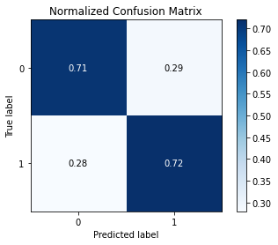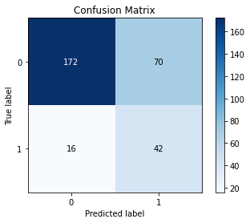
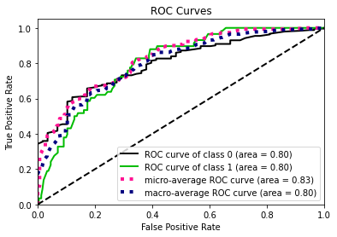

2.3) Hyperparameter and slice plot of search hyperparameters in 50 trials

hyperparameters: {'criterion': 'gini',
'max_depth': 3,
'n_estimators': 410,
'class_weight': 'balanced'}

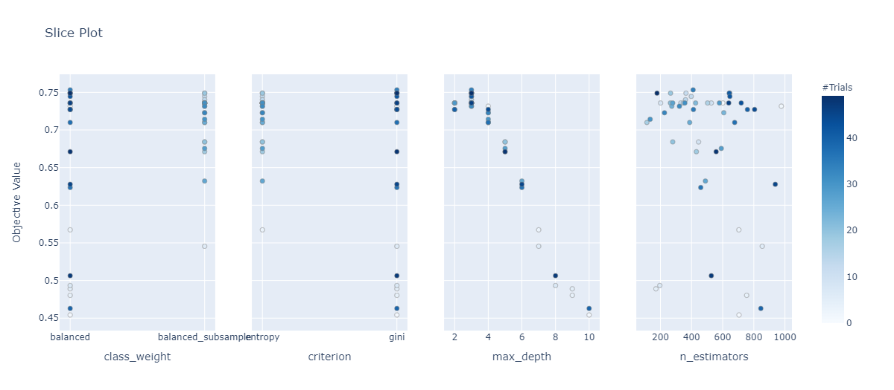

3.1) TabNet training code and search hyperparameter with Optuna framework

def Objective(trial):
mask_type = trial.suggest_categorical("mask_type", ["entmax"])
n_d = trial.suggest_int("n_d", 4, 16, step=2)
n_steps = trial.suggest_int("n_steps", 1, 8, step=1)
gamma = trial.suggest_float("gamma", 1., 1.8, step=0.2)
n_shared = trial.suggest_int("n_shared", 1, 2)
lambda_sparse = trial.suggest_float("lambda_sparse", 1e-3, 1e-1, log=True)
tabnet_params = dict(n_d=n_d, n_a=n_d, n_steps=n_steps, gamma=gamma,
lambda_sparse=lambda_sparse,
optimizer_fn=torch.optim.Adam, cat_idxs=[0,1,2,3,4],
optimizer_params=dict(lr=2e-2, weight_decay=1e-5),
mask_type=mask_type, n_shared=n_shared,
scheduler_params=dict(mode="min",

# changing scheduler patience to be lower than early stopping patience
patience=trial.suggest_int("patienceScheduler", low=3,high=10), min_lr=1e-5, factor=0.5,),
scheduler_fn=torch.optim.lr_scheduler.ReduceLROnPlateau,
verbose=0,
)
kf = StratifiedKFold(n_splits=5, random_state=42, shuffle=True)
CV_score_array = [ ]
for train_index, test_index in kf.split(X_train, y_train):
X_train, X_valid = X_train[train_index], X_train[test_index]
y_train, y_valid = y_train[train_index], y_train[test_index]
classifier = TabNetClassifier(**tabnet_params)
classifier.fit(X_train=X_train, y_train=y_train,
eval_set=[(X_valid, y_valid)],
patience=trial.suggest_int("patience",low=30,high=60),
max_epochs=trial.suggest_int('epochs', 100, 1000),
eval_metric=['recall',‘balanced_accuracy’],
loss_fn=nn.CrossEntropyLoss(weight=weight_balance))
CV_score_array.append(classifier.best_cost)
avg = np.mean(CV_score_array)
return avg

3.2) TabeNet performance with hyperparameters from Optuna study

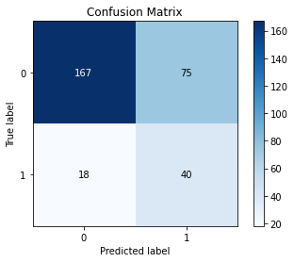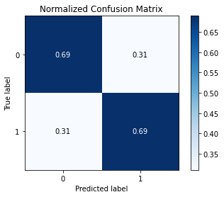
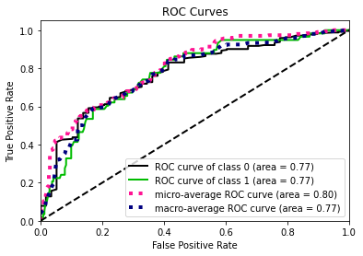

3.3) Hyperparameters and slice plot
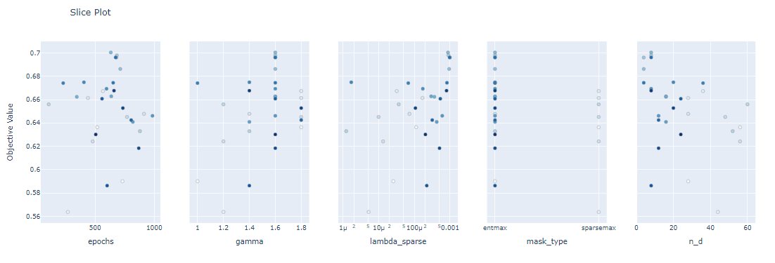
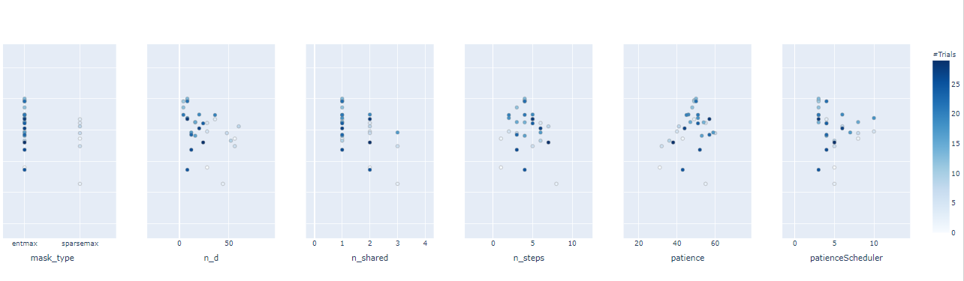
Hyperparameters: {'mask_type': 'entmax', 'n_d': 8, 'n_steps': 4, 'gamma': 1.6, 'n_shared': 1, 'lambda_sparse': 0.0008791354293180571, 'patienceScheduler': 3, 'patience': 50, 'epochs': 633}

4.1) Support Vector Machine code and search hyperparameter with Optuna framework

def objective(trial):
eta0 = trial.suggest_loguniform("eta0", 0.001, 1)
epsilon = trial.suggest_loguniform("epsilon", 0.01, 1)
class_weight = trial.suggest_categorical("class_weight",["balanced", None])
learning_rate = trial.suggest_categorical("learning_rate",
["optimal","invscaling","adaptive"])
svm = SGDClassifier(epsilon=epsilon,
class_weight=class_weight,
learning_rate=learning_rate,
eta0=eta0
)
score = cross_val_score(svm, X_train, y_train, cv = 5,
n_jobs=-1, scoring = "balanced_accuracy")
balanced_accuracy = score.mean()
return balanced_accuracy

study = optuna.create_study(direction="maximize")
study.optimize(objective, n_trials=50)

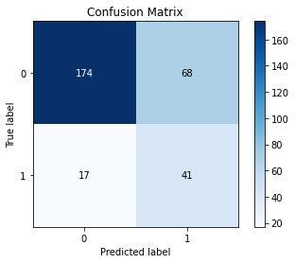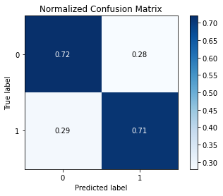
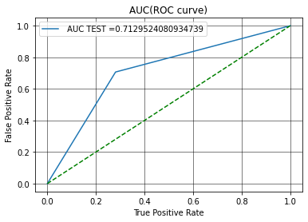

4.2) Hyperparameter and slice plot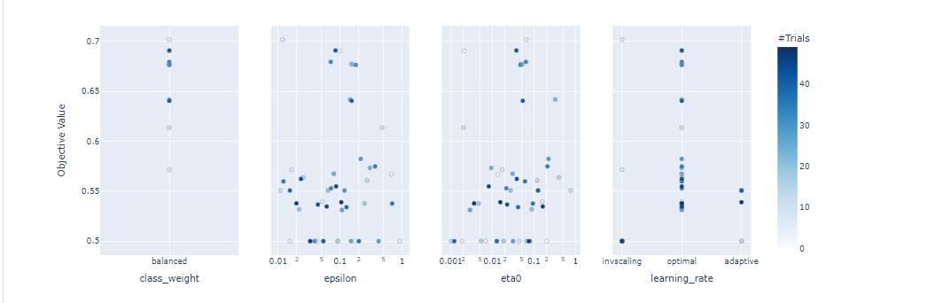

Best hyperparameters: {'eta0': 0.023409428851301886, 'epsilon': 0.01138213689986609, 'class_weight': 'balanced', 'learning_rate': 'adaptive'}

5) SHAP Interaction Plot applied to Random Forest

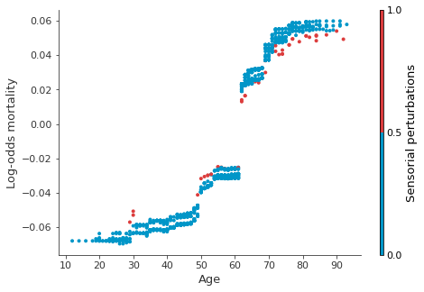

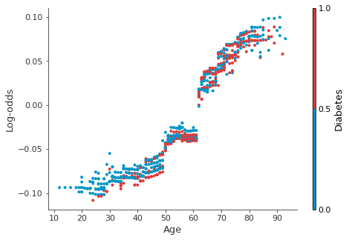
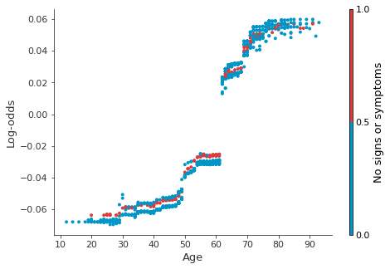
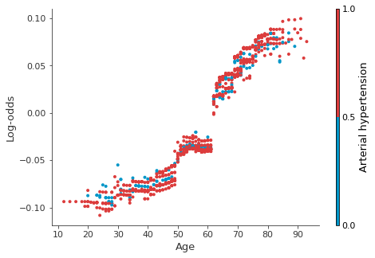

6) Table S2. General characteristics of the missing data

Variables | Training dataset  (n = 1196) | Test dataset  (n = 300) | Validation dataset  (n = 312)
Demographics/Comorbidities (D/C)
Age, years | 0.17 % | 1.33 % | 0.00%
Sex, male or female | 0.00 % | 0.00 % | 0.00 %
Skin color, white or non-white | 0.00 % | 0.00 % | 0.00 %
Diabetes | 0.00 % | 0.00 % | 0.00 %
Obesity (BMI > 30kg/m²) | 0.75 % | 0.33 % | 0.00 %
Previous stroke | 0.00 % | 0.00 % | 0.00 %
Hypertension | 0.00 % | 0.00 % | 0.00 %
Positive HIV serology | 0.00 % | 0.00 % | 0.00 %
Heart failure | 0.00 % | 0.00 % | 0.00 %
Chronic liver disease | 0.00 % | 0.00 % | 0.00 %
Chronic obstructive pulmonary disease (COPD) | 0.00 % | 0.00 % | 0.00 %
Peripheral arterial obstructive disease | 0.00 % | 0.00 % | 0.00 %
Previous myocardial infarction | 0.00 % | 0.00 % | 0.00 %
Previous or current neoplasia | 0.00 % | 0.00 % | 0.00 %
Current smoking | 0.00 % | 0.00 % | 0.00 %
Previous smoking | 0.00 % | 0.00 % | 0.00 %
Use of RAAS inhibitors | 4.85 % | 2.67 % | 0.00 %
Clinical findings (CF)
Fever | 0.00 % | 0.00 % | 0.00 %
Cough | 0.00 % | 0.00 % | 0.00 %
Dyspnea | 0.00 % | 0.00 % | 0.00 %
Fatigue and malaise | 0.00 % | 0.00 % | 0.00 %
Myalgia | 0.00 % | 0.00 % | 0.00 %
Gastrointestinal symptoms | 0.00 % | 0.00 % | 0.00 %
Altered mental status | 0.00 % | 0.00 % | 0.00 %
No signs or symptoms | 0.00 % | 0.00 % | 0.00 %
Values are n (%)
RAAS: renin-angiotensin-aldosterone system

