Molecular biogeochemistry of a poor fen. I. Seasonal effects of plant functional groups on dissolved organic matter composition in porewater

Zhimin Song¹, Maryam Khaksari², Erik A. Lilleskov^{3,4}, Evan S. Kane^{3,4}, and Paul V. Doskey^{4,5}

¹Department of Civil and Environmental Engineering, Michigan Technological University, Houghton, Michigan 49931, USA, ²Department of Chemistry, Michigan Technological University, Houghton, Michigan 49931, USA, ³USDA Northern Research Station, Houghton, MI 49931, USA, ⁴School of Forest Resources and Environmental Science, Michigan Technological University, Houghton, MI 49931, USA, ⁵Atmospheric Sciences Program, Michigan Technological University, Houghton, Michigan 49931, USA

Supplementary Information

References
Hedges JI (1990) Compositional indicators of organic acid sources and reactions in natural environments. In: Perdue EM, Gjessing ET (eds) Organic acids in aquatic ecosystems Wiley, New York, pp. 43-63

Grannas AM, Hockaday WC, Hatcher PG, Thompson LG, Mosley-Thompson E (2006) New revelations on the nature of organic matter in ice cores. J. Geophys. Res.-Atmos. doi:10.1029/2005JD006251

Ohno T, Parr TB, Gruselle MC, Fernandez IJ, Sleighter RL, Hatcher PG (2014) Molecular composition and biodegradability of soil organic matter: a case study comparing two new England forest types. Environ. Sci. Technol. doi:10.1021/es405570c

Table S1 Mixed-effects model of predictors of monosaccharides (MCHOs), polysaccharides (PCHOs), total phenolics (TPHs), and proteinaceous species (Protein) (Bolded values are significant at p <0.05.).

Source | Water table | ORP | Temperature | pH | Fe | Mn | TDN | DOC | MCHOs | PCHOs | TPHs | Protein
PTª | 0.4747 | 0.0151 | 0.0938 | 0.2799 | 0.5171 | 0.5138 | 0.0028 | 0.0046 | 0.2219 | 0.2199 | 0.0325 | 0.0477
Depth | 0.6338 | 0.0889 | 0.0067 | <0.0001 | <0.0001 | 0.3856 | 0.0002 | <0.0001 | <0.0001 | 0.0749 | <0.0001 | 0.2360
PT*Depth | 0.6691 | 0.6618 | 0.4140 | 0.0602 | 0.0272 | <0.0001 | 0.1535 | 0.0205 | 0.8306 | 0.4494 | 0.4017 | 0.7800
DOY | <0.0001 | <0.0001 | <0.0001 | <0.0001 | 0.0002 | <0.0001 | <0.0001 | <0.0001 | <0.0001 | 0.0016 | <0.0001 | <0.0001
PT*DOY | 0.0551 | 0.0473 | 0.1041 | 0.0103 | 0.0017 | 0.6848 | 0.0121 | 0.0273 | 0.8586 | 0.3038 | 0.7721 | 0.1671
Depth*DOY | 0.8679 | 0.9475 | 0.4373 | 0.6378 | 0.5612 | 0.8364 | 0.4612 | 0.3235 | 0.9097 | 0.5057 | 0.8908 | 0.2033
PT *Depth *DOY | 0.9686 | 0.9858 | 0.9988 | 0.3179 | 0.9950 | 0.9103 | 0.9013 | 0.9463 | 0.8580 | 0.5319 | 0.9218 | 0.9199
Block | 0.5057 | 0.0379 | 0.0196 | 0.5932 | 0.5345 | 0.4330 | 0.0130 | 0.0179 | 0.1304 | 0.2247 | 0.0107 | 0.0201

ªSedge-only, Ericaceae-only, Unmanipulated.

Table S2 Mixed-effects model of predictors of SUVA₂₅₄, E2/E3, HIX, and A/T indices (Bolded values are significant at p <0.05.).

Source | SUVA₂₅₄ | E2/E3 | HIX | A/T
PTª | 0.0006 | 0.196 | 0.2425 | 0.308
Depth | 0.9898 | 0.0005 | 0.2072 | 0.676
PT*Depth | 0.1182 | 0.0555 | 0.786 | 0.9832
DOY | <0.0001 | <0.0001 | <0.0001 | <0.0001
PT*DOY | 0.6587 | 0.0139 | 0.0050 | 0.0964
Depth*DOY | 0.1309 | 0.081 | 0.7418 | 0.4154
PT *Depth *DOY | 0.9597 | 0.7773 | 0.1061 | 0.2273
Block | 0.0702 | 0.2257 | 0.0156 | 0.2253
ªSedge-only, Ericaceae-only, Unmanipulated.

Table S3 Ranges of the ratios of the oxygen to carbon atoms (O/C) and hydrogen to carbon atoms (H/C) in the molecular formulas of various organic compound classes (Hedges 1990; Grannas et al. 2006; Ohno et al. 2014).

Compound class | Abbreviation | O/C | H/C
Lipid-like | Lipid | 0-0.29 | 1.6-2
Protein-like | Protein | 0.29-0.6 | 1.5-2
Amino sugar | AS | 0.6-0.67 | 1.5-2
Carbohydrate-like | Carb | 0.67-1 | 1.5-2
Unsaturated hydrocarbons | UH | 0-0.29 | 1-1.6
Condensed aromatics | CA | 0-0.4 | 0-0.7
Lignin-like | Lignin | 0.29-0.65 | 0.7-1.5
Tannin-like | Tannin | 0.65-1 | 0.5-1.5

Table S4 Summary of results from distance-based permutation matrices’ analysis of variance (PERMANOVA) for each day of the year (DOY) (Bolded values are significant at p <0.05.).

 |  |  | p(perm)
Source |  | df | DOY130 | DOY160 | DOY188 | DOY216 | DOY260 | DOY292
PTª |  | 2 | 0.015 | 0.024 | 0.012 | 0.003 | 0.007 | 0.108
Depth |  | 1 | 0.473 | 0.277 | 0.047 | 0.211 | 0.195 | 0.332
PT*Depth |  | 2 | 0.768 | 0.245 | 0.01 | 0.11 | 0.22 | 0.731

ªSedge-only, Ericaceae-only, Unmanipulated.

Figure Captions

Fig. S1 Variation of the temperature (a) and pH with sampling depth (b) and seasonal variation of the pH [with plot type (E; Ericaceae-only, S; Sedge-only, U; Unmanipulated) interaction] (c).

Fig. S2 Variation of the level of TDN with sampling depth (a), seasonal variation of the contributions of organic compound classes to the dissolved organic carbon (DOC) [with interaction between plot type (E; Ericaceae-only, S; Sedge-only, U; Unmanipulated) and sampling depth] (b), variations in the concentrations of monosaccharides (MCHOs) and total phenolics (TPHs) with sampling depth (c) and (d), respectively, variation in the level of TPHs with plot type (e), and seasonal variation of the contributions of organic nitrogen species (i.e., proteinaceous compounds and amino acids (AAs) and unidentified species) to the dissolved organic nitrogen (DON) [with interaction between plot type and sampling depth] (f).

Fig. S3 Variation of the SUVA₂₅₄ index with plot type (E; Ericaceae-only, S; Sedge-only, U; Unmanipulated) (a) and the E2/E3 index with sampling depth (b).

Fig. S4 Non-Metric multidimensional scale (NMDS) ordination for all the molecular formulae of the dissolved organic matter (n = 108 porewater samples). (The arrow in the ordination diagram represents the environmental variables fitted to the ordination (r > 0.2). Length of the arrow represents the correlation.)

Fig. S5 Contributions of the classes of organic compounds to the day of the year (DOY) indicators for all plot types (n = number of DOY indicators) (a), van Krevelen diagram showing the seasonal variation of the DOY indicators (b), and variation of the average values of the ratio of nitrogen to carbon (N/C) atoms, aromaticity index (AI), nominal oxidation state of carbon (NOSC), and molecular weight (MW) of the organic species for DOY with < 100 DOY indicators (c). (Data represents a composite of the 20 cm and 40 cm sampling depths).

Fig. S6 Contributions of the classes of organic compounds to the plot type (E; Ericaceae-only, S; Sedge-only, U; Unmanipulated) indicators (n = number of plot type indicators) for day of the year (DOY) 130, 160, and 188 (a), (b), and (c), respectively, at a sampling depth of 20 cm, and for DOY 188 at a sampling depth of 40 cm (d), and DOY 216, 260, and 292 (e), (f), and (g), respectively, at a sampling depth of 20 cm. (Missing data indicates no plot type indicators were observed).

Fig. S7 van Krevelen diagrams showing the plot type (E; Ericaceae-only, S; Sedge-only, U; Unmanipulated) indicators for day of the year (DOY) 160 (a), and DOY 188 at a sampling depth of 20 cm (b), and for DOY 188 at a sampling depth of 40 cm (c).

Fig. S8 Variation of the average values of the ratio of nitrogen to carbon atoms (N/C), aromaticity index (AI), nominal oxidation state of carbon (NOSC), and molecular weight (MW) of the organic species with plot type (E; Ericaceae-only, S; Sedge-only, U; Unmanipulated) for day of the year (DOY) 130, 160, and 188 (a), (b), and (c), respectively, at a sampling depth of 20 cm, and for DOY 188 at a sampling depth of 40 cm (d), and DOY 216, 260, and 292 (e), (f), and (g), respectively, at a sampling depth of 20 cm.
Fig S1
Fig S2

Fig S3
Fig S4

Fig. S5
Fig. S6
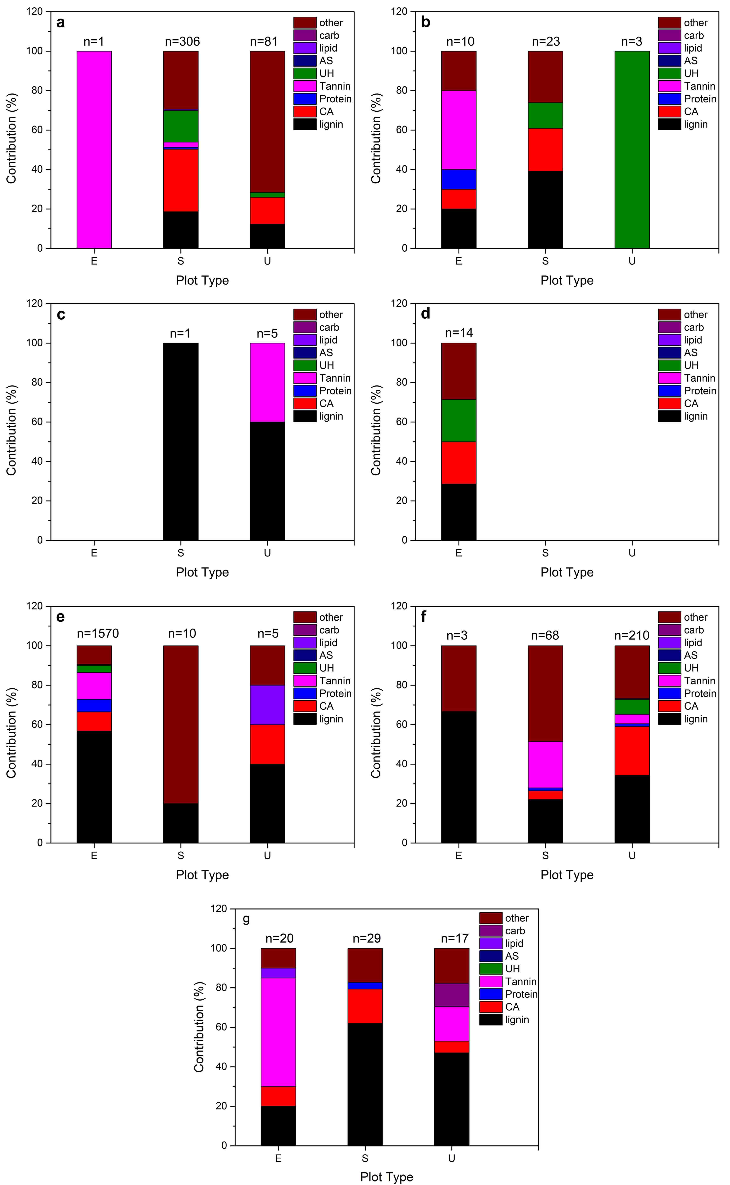
Fig. S7
Fig. S8

