Supplementary Tables:
Table S1 Metabolic fingerprint of strain CtC72^{T} generated using anaerobe identification test panel of Biolog AN MicroPlate™
No. | Substrate | Result | No. | Substrate | Result | No. | Substrate | Result
1 | N-Acetyl-D-Galactosamine | - | 36 | α-Methyl-D-Galactoside | + | 71 | Urocanic Acid | -
2 | N-Acetyl-D-Glucosamine | - | 37 | β-Methyl-D-Galactoside | + | 72 | L-Alaninamide | -
3 | N-Acetyl-D-Mannosamine | - | 38 | α-Methyl-D-Glucoside | + | 73 | L-Alanine | -
4 | Adonitol | - | 39 | β-Methyl-D-Glucoside | + | 74 | L-Alanyl-L-Glutamine | -
5 | Amygdalin | + | 40 | Palatinose | + | 75 | L-Alanyl-L-Histidine | -
6 | D-Arabitol | - | 41 | D-Raffinose | + | 76 | L-Alanyl-L-Threonine | -
7 | Arbutin | + | 42 | L-Rhamnose | + | 77 | L-Asparagine | -
8 | D-Cellobiose | + | 43 | Salicin | + | 78 | L-Glutamic Acid | -
9 | α-Cyclodextrin | + | 44 | D-Sorbitol | + | 79 | L-Glutamine | -
10 | β-Cyclodextrin | + | 45 | Stachyose | - | 80 | Glycyl-L-Aspartic Acid | -
11 | Dextrin | + | 46 | Sucrose | + | 81 | Glycyl-L-Glutamine | -
12 | Dulcitol | - | 47 | D-Trehalose | + | 82 | Glycyl-L-Methionine | -
13 | i-Erythritol | + | 48 | Turanose | + | 83 | Glycyl-L-Proline | -
14 | D-Fructose | + | 49 | Acetic Acid | + | 84 | L-Methionine | -
15 | L-Fucose | + | 50 | Formic Acid | - | 85 | L-Phenylalanine | -
16 | D-Galactose | - | 51 | Fumaric Acid | - | 86 | L-Serine | -
17 | D-Galacturonic Acid | - | 52 | Glyoxylic Acid | - | 87 | L-Threonine | -
18 | Gentibiose | + | 53 | α-Hydroxybutyric acid | - | 88 | L-Valine | -
19 | D-Gluconic Acid | - | 54 | β -Hydroxybutyric Acid | - | 89 | L-Valine plus L-Aspartic Acid | -
20 | D-Glucosaminic Acid | - | 55 | Itaconic Acid | - | 90 | 2’-Deoxy Adenosine | +
21 | α-D-Glucose | + | 56 | α-Ketobutyric acid | - | 91 | Inosine | -
22 | Glucose-1- Phosphate | - | 57 | α-Ketovaleric acid | - | 92 | Thymidine | +
23 | Glucose-6-Phosphate | - | 58 | D,L,-Lactic Acid | - | 93 | Uridine | -
24 | Glycerol | + | 59 | L-Lactic Acid | - | 94 | Thymidine-5’-Monophosphate | -
25 | D,L-α-Glycerol Phosphate | + | 60 | D-Lactic Acid Methyl Ester | - | 95 | Uridine-5’-Monophosphate | -
26 | m-Inositol | + | 61 | D-Malic Acid | -
27 | α-D-Lactose | + | 62 | L-Malic Acid | -
28 | Lactulose | - | 63 | Propionic Acid | -
29 | Maltose | + | 64 | Pyruvic Acid | -
30 | Maltotriose | + | 65 | Pyruvic Acid Methyl Ester | -
31 | D-Mannitol | + | 66 | D-Saccharic Acid | -
32 | D-Mannose | + | 67 | Succinamic Acid | -
33 | D-Melezitose | - | 68 | Succinic Acid | +
34 | D-Melibiose | - | 69 | Succinic Acid Mono-Methyl Ester | -
35 | 3-Methyl-D-Glucose | + | 70 | m-Tartaric Acid | -

Table S2 Comparison of the cellular fatty acid composition of Actinomyces ruminis sp. nov. with its nearest phylogenetic relatives in the genus Actinomyces
Strains: 1, CtC72^{T}; 2, Actinomyces qiguomingii DSM 106201^{T} (Zhu et al., 2020); 3, Actinomyces ruminicola DSM 27982^{T} (An et al., 2006); 4, Actinomyces procaprae JCM 33484^{T} (Kim et al., 2014); 5, Actinomyces succiniciruminis TISTR 2317 (Palakawong et al., 2016); 6, Actinomyces glycerinitolerans TISTR 2318 (Palakawong et al., 2016)
Fatty acid | 1 | 2 | 3 | 4 | 5 | 6
C_{10:0} | 3.1 | 0.9 | - | - | 1.3 | 2.9
C_{12:0} | 8.9 | 3.9 | - | 7.1 | 3.3 | 4.8
C_{14:0} | 6.6 | 4.7 | - | 3.9 | 3.4 | 4.4
C_{16:1} ω9c | 1.6 | 2.1 | - | 3.7 | - | -
C_{16:1} ω7c | 1.8 | - | - | - | - | -
C_{16:0} | 24.9 | 47.4 | 34.6 | 36.9 | 40.1 | 38.0
C_{16:1} cis7 | - |  | - | - | 3.0 | 3.7
C_{16:0} DMA | 1.9 | - | - | - | 0.6 | 0.6
C_{18:1} ω9c | 19.6 | 29.2 | - | 42.1 | - | -
C_{18:1}  cis9 | - | - | - | - | 31.2 | 33.5
C_{18:1}  cis9 DMA | - | - | - | - | 8.5 | 7.0
C_{18:1} ω9 | - | - | 25.3 | - | - | -
C_{18:1} ω7c | 2.1 | - | - | - | - | -
C_{18:0} | 2.9 | 6.0 | 15.9 | 2.2 | 1.7 | 1.3
C_{18:1} ω9c DMA | 17.1 | - | - | - | - | -
C_{18:0} DMA | 1.1 | - | - | - | 0.6 | 0.5
C_{18:2} ω6,9c/ anteiso-C_{18:0} | - | 3.0 | - | - | - | -
C_{19:0} iso | 1.2 | - | - | - | - | -
C_{19:0} CYC 9,10/:1 | - | - | - | - | 1.8 | 0.5
C_{19:0} CYC 9,10 DMA | 1.4 | - | - | - | 0.9 | 0.3
Values are percentages of total fatty acids, and major fatty acids (>5%) are highlighted in bold. Fatty acids present at <1% are not shown. Major fatty acids (>5%) are in bold.
Legends: -, not detected
Table S3 Comparison of MALDI-TOF-MS spectral profiles of Actinomyces ruminis sp. nov. with its nearest phylogenetic relatives in the genus Actinomyces Strains: 1, CtC72^{T}; 2, Actinomyces qiguomingii DSM 106201^{T}; 3, Actinomyces ruminicola DSM 27982^{T} (Palakawong et al., 2016); 4, Actinomyces procaprae JCM 33484^{T}; 5, Actinomyces succiniciruminis TISTR 2317 (Palakawong et al., 2016); 6, Actinomyces glycerinitolerans TISTR 2318 (Palakawong et al., 2016)
Sr. No. | 1 | 2 | 3 | 4 | 5 | 6
1 | 2616 | nd | nd | nd | nd | nd
2 | 2919 | nd | nd | nd | nd | nd
3 | 3371 | nd | nd | nd | nd | nd
4 | 3472 | nd | nd | nd | nd | nd
5 | - | nd | - | nd | 4093 | -
6 | 4267 | nd | - | nd | - | -
7 | - | nd |  | nd | - | 4329
8 | - | nd | 4490 | nd | - | -
9 | 4807 | nd | - | nd | - | -
10 | - | nd | - | nd | - | -
11 | 5881 | nd | 5880 | nd | - | -
12 | - | nd |  | nd |  | 6055
13 | - | nd | 6107 | nd | - | -
14 | - | nd | - | nd | - | 6135
15 | 6344 | nd | - | nd | - | -
16 | 6742 | nd | - | nd | - | -
17 | - | nd | - | nd | - | 7703
18 | 7739 | nd | - | nd | nd | -
19 | 8207 | nd | nd | nd | nd | -
20 | 8648 | nd | nd | nd | nd | nd
21 | 8680 | nd | nd | nd | nd | nd
22 | 9115 | nd | nd | nd | nd | nd
23 | 9615 | nd | nd | nd | nd | nd
Peak values highlighted in bold are specific to strain CtC72^{T,} and bold underline are similar in compared strains.
Legends: nd, no data; -, not detected

Supplementary figures:
Fig. S1 Scanning electron micrograph of strain CtC72^{T}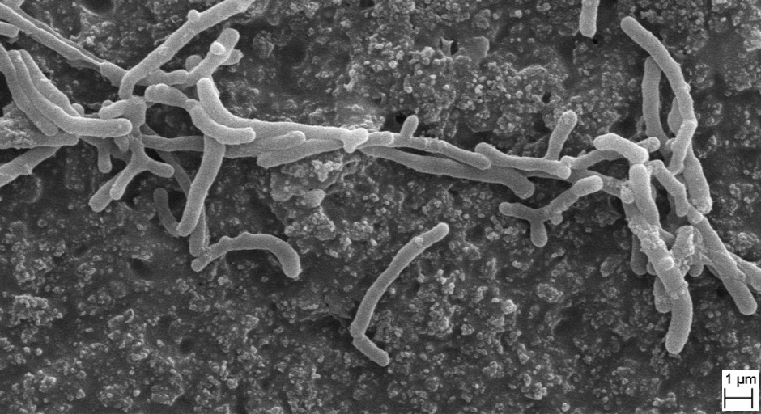

Fig. S2 Normalised MALDI-TOF-MS spectra of strain CtC72^{T}. The m/z ratio of dominant peaks is shown.
