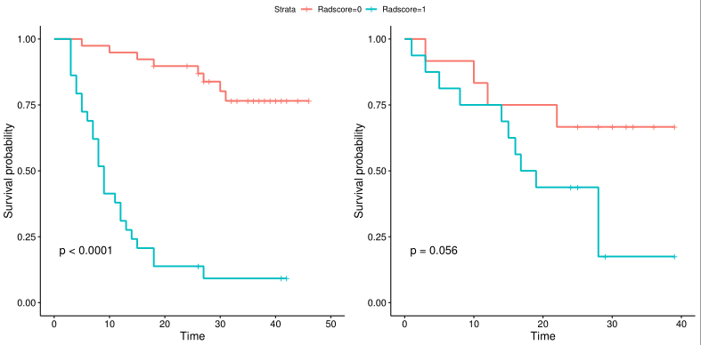
A B
Supplementary Fig. 1 Kaplan–Meier analysis for high- and low-risk group. The left figure is the training set (A, p < 0.01, log-rank test) and the right figure is the test set (B, p = 0.056, log-rank test).

