IFB short title: Ecology of D. solani phage resistant Tn5 mutants

Resistance of Dickeya solani strain IPO 2222 to lytic bacteriophage ΦD5 results in fitness tradeoffs for the bacterium during infection

Przemyslaw Bartnik ¹, Kinga Lewtak ², Marta Fiołka ³, Paulina Czaplewska ⁴, Magdalena Narajczyk ⁵ and Robert Czajkowski ¹ *
¹ Laboratory of Biologically Active Compounds, Intercollegiate Faculty of Biotechnology UG and MUG, University of Gdansk, Antoniego Abrahama 58, 80-307 Gdansk, Poland
² Department of Cell Biology, Institute of Biological Sciences, Maria Curie-Sklodowska University, Akademicka 19, 20-033 Lublin, Poland
³ Department of Immunobiology, Institute of Biological Sciences, Maria Curie-Sklodowska University, Akademicka 19, 20-033 Lublin, Poland
⁴ Laboratory of Mass Spectrometry‐Core Facility Laboratories, Intercollegiate Faculty of Biotechnology UG and MUG, University of Gdansk, Antoniego Abrahama 58, 80‐307 Gdansk, Poland
⁵ Laboratory of Electron Microscopy, Faculty of Biology, University of Gdansk, Wita Stwosza 59,
80‐308 Gdansk, Poland

* Correspondence:
Robert Czajkowski, robert.czajkowski@ug.edu.pl

Supplementary Information

Supplementary Results

Characterization of surface proteins with mass spectrometry (MS)
For all mutants, except for M61, the pattern in the m / z from the 6000 to 6600 range was similar. The most intense signals at 9534.6 m/z and two distinct ones at 6522.1 and 7203.2 m / z are visible in each of them as well. One can see changes between the intensity of the last two mentioned signals, but there is no regularity in the analyzed groups (one of them prevails in the group in each mutant). However, subtle differences can be found between individual groups or single variants versus wild-type cells. For example, the M22 and M25 variants have clearly distinguished two signals at 7266.9 and 7287.2 m / z, which have a much lower intensity (Supplementary Figure 1). Similarly, intense signals are distinguished for variants M177, M83 and M626. In all cases, proteins corresponding to signals above 10,000 m/z are hardly visible. Most of them are broad, low-intensity signals. Most variants present fewer peaks in this range than the wild variant. The signal at 10665.2 is present in every MS spectrum. The preceding 10,300 m / z signal seen by IPO2222 disappears in the remaining cells. It is visible only for variants from the M83/399/534 group. They also give relatively distinct remaining higher masses between 15,000 to 17,000. Of the remaining variants, the peak at 16,222.7 is higher for M61 and M177. In the range of about 12,000 m/z, two signals, 12 290.2 and 12345.0, are visible for the WT while only the first signal is visible for most mutants.

Supplementary Tables

Supplementary Table 1. Bacterial strains used in this study and their relevant characteristics
No. | Strain | Origin | Relevant characteristics | Reference
1 | IPO 2222 | potato, 2007, the Netherlands | Wild type (WT) | (van der Wolf et al., 2014)
2 | IPO 2254 | IPO 2222 | pPROBE-AT-gfp (Miller et al., 2000), amp^{R} | (Czajkowski et al., 2010)
3 | IPO 2222-dsRed | IPO 2222 | pRZ-T3-dsred (Bloemberg et al., 2000), tet^{R} | This study
4 | M22 | IPO 2222 | mini-Tn5-gusA (Xi et al., 1999), neo^{R} | This study
5 | M22-GFP | M22 | mini-Tn5-gusA, neo^{R}, pPROBE-AT-gfp, amp^{R} | This study
6 | M22-DsRed | M22 | mini-Tn5-gusA, neo^{R}, pRZ-T3-dsred, tet^{R} | This study
7 | M25 | IPO 2222 | mini-Tn5-gusA, neo^{R} | This study
8 | M25-GFP | M25 | mini-Tn5-gusA, neo^{R}, pPROBE-AT-gfp, amp^{R} | This study
9 | M25-DsRed | M25 | mini-Tn5-gusA, neo^{R}, pRZ-T3-dsred, tet^{R} | This study
10 | M61 | IPO 2222 | mini-Tn5-gusA, neo^{R} | This study
11 | M61-GFP | M61 | mini-Tn5-gusA, neo^{R}, pPROBE-AT-gfp, amp^{R} | This study
12 | M61-DsRed | M61 | mini-Tn5-gusA, neo^{R}, pRZ-T3-dsred, tet^{R} | This study
13 | M73 | IPO 2222 | mini-Tn5-gusA, neo^{R} | This study
14 | M73-GFP | M73 | mini-Tn5-gusA, neo^{R}, pPROBE-AT-gfp, amp^{R} | This study
15 | M73-DsRed | M73 | mini-Tn5-gusA, neo^{R}, pRZ-T3-dsred, tet^{R} | This study
16 | M83 | IPO 2222 | mini-Tn5-gusA, neo^{R} | This study
17 | M83-GFP | M83 | mini-Tn5-gusA, neo^{R}, pPROBE-AT-gfp, amp^{R} | This study
18 | M83-DsRed | M83 | mini-Tn5-gusA, neo^{R}, pRZ-T3-dsred, tet^{R} | This study
19 | M144 | IPO 2222 | mini-Tn5-gusA, neo^{R} | This study
20 | M144-GFP | M144 | mini-Tn5-gusA, neo^{R}, pPROBE-AT-gfp, amp^{R} | This study
21 | M144-DsRed | M144 | mini-Tn5-gusA, neo^{R}, pRZ-T3-dsred, tet^{R} | This study
22 | M177 | IPO 2222 | mini-Tn5-gusA, neo^{R} | This study
23 | M177-GFP | M177 | mini-Tn5-gusA, neo^{R}, pPROBE-AT-gfp, amp^{R} | This study
24 | M177-DsRed | M177 | mini-Tn5-gusA, neo^{R}, pRZ-T3-dsred, tet^{R} | This study
25 | M399 | IPO 2222 | mini-Tn5-gusA, neo^{R} | This study
26 | M399-GFP | M399 | mini-Tn5-gusA, neo^{R}, pPROBE-AT-gfp, amp^{R} | This study
27 | M399-DsRed | M399 | mini-Tn5-gusA, neo^{R}, pRZ-T3-dsred, tet^{R} | This study
28 | M534 | IPO 2222 | mini-Tn5-gusA, neo^{R} | This study
29 | M534-GFP | M534 | mini-Tn5-gusA, neo^{R}, pPROBE-AT-gfp, amp^{R} | This study
30 | M534-DsRed | M534 | mini-Tn5-gusA, neo^{R}, pRZ-T3-dsred, tet^{R} | This study
31 | M626 | IPO 2222 | mini-Tn5-gusA, neo^{R} | This study
32 | M626-GFP | M626 | mini-Tn5-gusA, neo^{R}, pPROBE-AT-gfp, amp^{R} | This study
33 | M626-DsRed | M626 | mini-Tn5-gusA, neo^{R}, pRZ-T3-dsred, tet^{R} | This study
34 | M720 | IPO 2222 | mini-Tn5-gusA, neo^{R} | This study
35 | M720-GFP | M720 | mini-Tn5-gusA, neo^{R}, pPROBE-AT-gfp, amp^{R} | This study
36 | M720-DsRed | M720 | mini-Tn5-gusA, neo^{R}, pRZ-T3-dsred, tet^{R} | This study
37 | M1004 | IPO 2222 | mini-Tn5-gusA, neo^{R} | This study
38 | M1004-GFP | M1004 | mini-Tn5-gusA, neo^{R}, pPROBE-AT-gfp, amp^{R} | This study
39 | M1004-DsRed | M1004 | mini-Tn5-gusA, neo^{R}, pRZ-T3-dsred, tet^{R} | This study
40 | M1026 | IPO 2222 | mini-Tn5-gusA, neo^{R} | This study
41 | M1026-GFP | M1026 | mini-Tn5-gusA, neo^{R}, pPROBE-AT-gfp, amp^{R} | This study
42 | M1026-DsRed | M1026 | mini-Tn5-gusA, neo^{R}, pRZ-T3-dsred, tet^{R} | This study

Supplementary Table 2. Predicted molecular functions of the D. solani IPO 2222 WT proteins involved in the interaction of the bacterium with phage vB_Dsol_D5 (ΦD5)

No | Insertion name, Tn5 locus | Localization in the D. solani IPO 2222 WT genome  (Genbank accession: CP015137.1) | Homologs in  Dickeya spp. ^{A} | Putative protein interaction partners according to STRING (https://string-db.org/) ^{B}
1 | p22, p25,  A4U42_09910, ANE75629.1 | 2 344 388 – 2 345 530 (positive strand) | D. dadantii,  D. fangzhongdai,  D. dianthicola,  D. zeae,  D. oryzae,  D. undicola,  D. chrysanthemi | 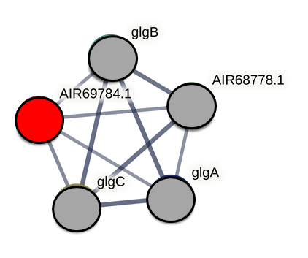  glgA- glycogen synthase; synthesizes alpha-1,4-glucan chains using ADP-glucose  glgB – 1,4-alpha-glucan branching enzyme GlgB; catalyzes the formation of the alpha-1,6-glucosidic linkages in glycogen by scission of a 1,4-alpha-linked oligosaccharide from growing alpha-1,4-glucan chains and the subsequent attachment of the oligosaccharide to the alpha-1,6 position  glgC - glucose-1-phosphate adenylyltransferase; Involved in the biosynthesis of ADP-glucose, a building block required for the elongation reactions to produce glycogen, catalyzes the reaction between ATP and alpha-D-glucose 1-phosphate (G1P) to produce pyrophosphate and ADP-Glc, belongs to the bacterial/plant glucose-1-phosphate adenylyltransferase family  AIR68778.1 – phosphoglucomutase catalyzes the interconversion of alpha-D-glucose 1-phosphate to alpha-D-glucose 6-phosphate;
2 | p61, p1026  cpsB, (manC)  A4U42_06115,  ANE74940.1 | 1 442 004 – 1 443 401 (positive strand) | D. dadantii  D. dianthicola,  D. fangzhongdai, | 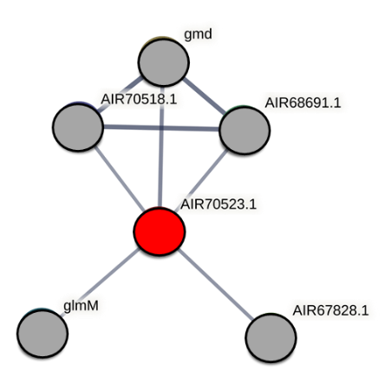  gmd – GDP-mannose 4,6-dehydratase; Catalyzes the conversion of GDP-D-mannose to GDP-4-dehydro-6- deoxy-D-mannose.  AIR70518.1 – epimerase domain-containing protein  AIR68691.1 – UDP-glucose 6-dehydrogenase catalyzes the formation of UDP-glucuronate from UDP-glucose  glmM – phosphoglucosamine mutase catalyzes the conversion of glucosamine-6-phosphate to glucosamine-1-phosphate, which belongs to the phosphohexose mutase family.  AIR67828.1 - PTS system, mannose-specific IID component, phosphoenolpyruvate-dependent sugar phosphotransferase system catalyzes the phosphorylation of incoming sugar substrates concomitant with their translocation across the cell membrane; IID with IIC forms the translocation channel
3 | p73, p144, p626, p720  wzt, (rbfB)  A4U42_06135, ANE74944.1 | 1 446 795 – 1 447 526 (positive strand) | D. dianthicola,  D. fangzhongdai,  D. dadantii,  D. chrysanthemi,  D. oryzae,  D. undicola | 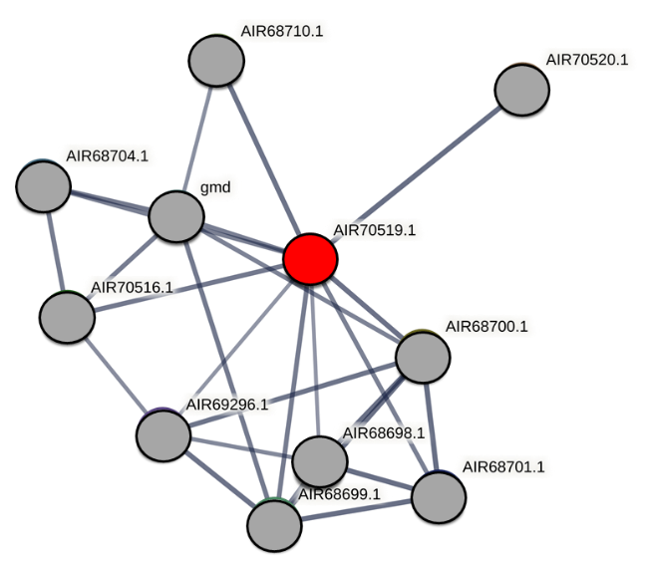  AIR68710.1 - polysaccharide export lipoprotein Wza, required for the translocation of capsular polysaccharide through the outer membrane  AIR70520.1 - ABC2 membrane domain-containing protein;  AIR68704.1 - mannosyltransferase;  gmd – GDP-mannose 4,6-dehydratase, catalyzes the conversion of GDP-D-mannose to GDP-4-dehydro-6- deoxy-D-mannose  AIR70516.1 – glycosyltransferase  AIR68700.1 – glucose-1-phosphate thymidylyltransferase, catalyzes the formation of dTDP-glucose, from dTTP and glucose 1-phosphate, as well as its pyrophosphorolysis  AIR69296.1 – UDP-N-acetylglucosamine 4,6-dehydratase  AIR68698.1 – dTDP-4-dehydrorhamnose reductase, catalyzes the reduction of dTDP-6-deoxy-L-lyxo-4-hexulose to yield dTDP-L-rhamnose, belongs to the dTDP-4-dehydrorhamnose reductase family  AIR68699.1 – dTDP-4-dehydrorhamnose 3,5-epimerase, catalyzes the epimerization of the C3' and C5'positions of dTDP-6-deoxy-D-xylo-4-hexulose, forming dTDP-6-deoxy-L-lyxo-4-hexulose, belongs to the dTDP-4-dehydrorhamnose 3,5-epimerase family  AIR68701.1 - dTDP-glucose 4,6-dehydratase
4 | p83, p399, p534,  wbeA,  A4U42_06145, ANE74946.1 | 1 448 472 – 1 449 671 (positive strand) | D. fangzhongdai,  D. dadantii,  D. dianthicola,  D. zeae,  D. oryzae | 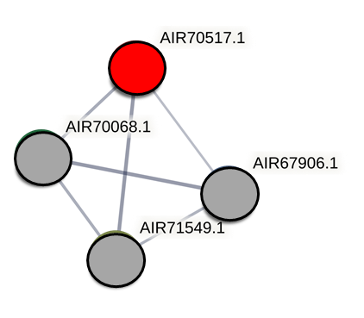  AIR70068.1 – maltose/maltodextrin ABC transporter, substrate binding periplasmic protein MalE  AIR67906.1 – putative ABC transporter, periplasmic substrate X binding protein;  AIR71549.1 - putative carbamoyl-phosphate-synthetase protein
5 | p177, p1004  fcl,  A4U42_06140, ANE74945.1 | 1 447 537 – 1 448 475 (positive strand) | D. fangzhongdai,  D. dadantii,  D. dianthicola,  D. zeae,  D. oryzae,  D. undicola,  D. chrysanthemi | 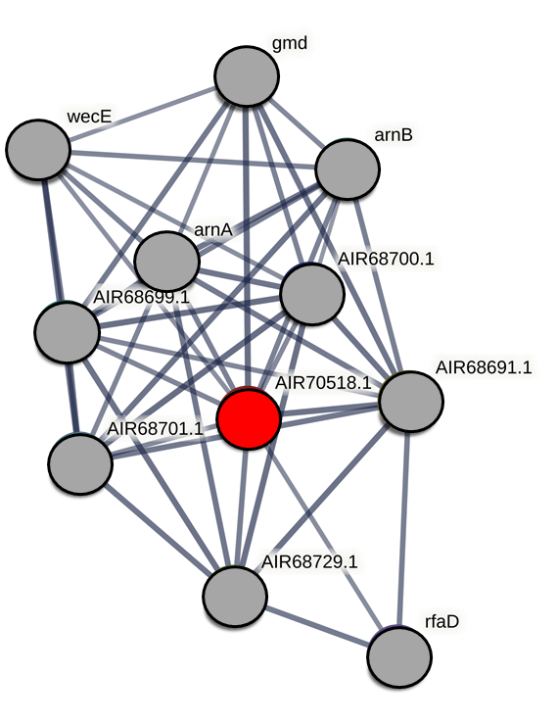  gmd – GDP-mannose 4,6-dehydratase, catalyzes the conversion of GDP-D-mannose to GDP-4-dehydro-6- deoxy-D-mannose  wecE - dTDP-4-amino-4,6-dideoxygalactose transaminase, catalyzes the synthesis of dTDP-4-amino-4,6-dideoxy-D- galactose (dTDP-Fuc4N) from dTDP-4-keto-6-deoxy-D-glucose (dTDP-D- Glc4O) and L-glutamate, belongs to the DegT/DnrJ/EryC1 family  arnB – UDP-4-amino-4-deoxy-L-arabinose--oxoglutarate aminotransferase; Catalyzes the conversion of UDP-4-keto-arabinose (UDP-Ara4O) to UDP-4-amino-4-deoxy-L-arabinose (UDP-L-Ara4N) (the modified arabinose is attached to lipid A and is required for resistance to polymyxin and cationic antimicrobial peptides), belongs to the DegT/DnrJ/EryC1 family, ArnB subfamily  arnA – UDP-glucuronic acid oxidase, UDP-4-keto-hexauronic acid decarboxylating, bifunctional enzyme that catalyzes the oxidative decarboxylation of UDP-glucuronic acid (UDP-GlcUA) to UDP-4-keto- arabinose (UDP-Ara4O) and the addition of a formyl group to UDP-4- amino-4-deoxy-L-arabinose (UDP-L-Ara4N) to form UDP-L-4-formamido- arabinose (UDP-L-Ara4FN) (the modified arabinose is attached to lipid A and is required for resistance to polymyxin and cationic antimicrobial peptides), in the N-terminal section; belongs to the Fmt family, UDP- L-Ara4N formyltransferase subfamily  AIR68699.1 – dTDP-4-dehydrorhamnose 3,5-epimerase, catalyzes the epimerization of the C3' and C5'positions of dTDP-6-deoxy-D-xylo-4-hexulose, forming dTDP-6-deoxy-L-lyxo-4-hexulose, belongs to the dTDP-4-dehydrorhamnose 3,5-epimerase family  AIR68700.1 – glucose-1-phosphate thymidylyltransferase, catalyzes the formation of dTDP-glucose, from dTTP and glucose 1-phosphate, as well as its pyrophosphorolysis  AIR68701.1 – dTDP-glucose 4,6-dehydratase, belongs to the NAD(P)-dependent epimerase/dehydratase family, dTDP-glucose dehydratase subfamily.  AIR68691.1 – UDP-glucose 6-dehydrogenase, catalyzes the formation of UDP-glucuronate from UDP-glucose  AIR68729.1 – UDP-glucose 4-epimerase  rfaD - ADP-L-glycero-D-manno-heptose-6-epimerase; Catalyzes the interconversion between ADP-D-glycero-beta-D- manno-heptose and ADP-L-glycero-beta-D-manno-heptose via an epimerization at carbon 6 of the heptose, belongs to the NAD(P)-dependent epimerase/dehydratase family, HldD subfamily

^{A} – Search done with NCBI BlastP (https://blast.ncbi.nlm.nih.gov/Blast.cgi) using amino acid sequences of the protein from D. solani IPO 2222 WT, cutoff was set to 70% protein identity
^{B} – Search Tool for Retrieval of Interacting Genes/Proteins v11.5 accessed via https://string-db.org/. D. solani IPO 2222 WT was used as a model to assess the putative interaction partners of bacterial proteins found in this study. Only high confidence (0.700 and above) scores are shown (Szklarczyk et al., 2019), line density between the nodes indicate the strength of data support, the protein of interest in marked in red circle and its interaction partners are marked with grey circles

Supplementary Figures

Supplementary Figure 1. Characterization of lipopolysaccharide (LPS) isolated from WT and phage-resistant D. solani mutants. SDS-PAGE was made using a gradient (4-20%) polyacrylamide gel (Biorad), and the LPS components were visualized using silver staining. The size marker (11-245 kDa, Perfect Tricolor Protein Ladder, EURx, Poland) is shown in the first lane of both gels.
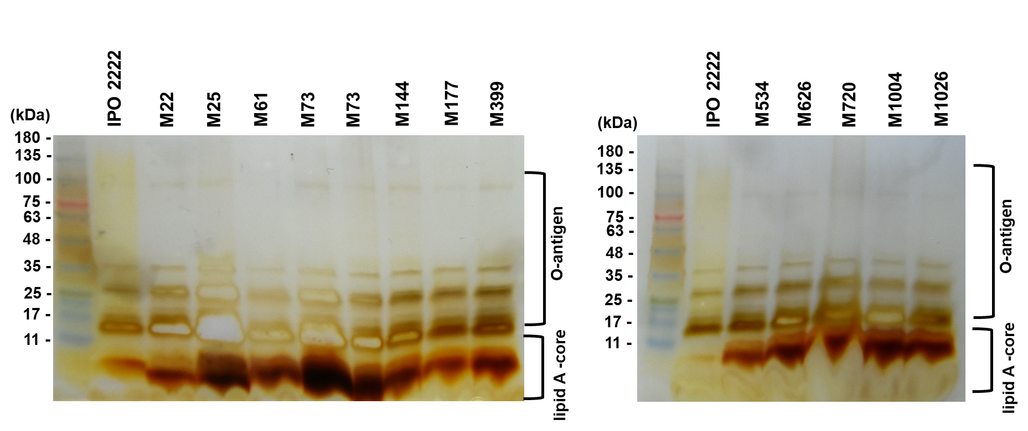

Supplementary Figure 2. Representative intact MALDI-TOF spectra of D. solani IPO 2222 WT and 13 phage-resistant mutants in a range from 5000 to 9400 m/z. The recorded spectra are organized according to Tn5 mutated loci: panel A) mutants M22 and M25; panel B) mutants M61 and M1026; panel C) mutants M73, M144, M626 and M720; panel D) mutants M83, M399 and M534 and panel E) mutants M177 and M1004. Average from two independent biological replicates, each containing three technical replicates are shown.
A)
B)

C)

D)

E)

