Appendix

Table A1: Timeline of RERDA, 2016 implementation and homebuyer-related provisions.
*Scheduled Banks in India refer to those banks which have been included in the Second Schedule of the Reserve Bank of India Act, 1934.
Provisions
Section 3: Promoters cannot deal with any plot or building without registering it with Real Estate Regulatory Authority (RERA) formed as per Section 20.
Section 4(2) l (D): Builder has to deposit 70% of collected amount from the allottees of specific project in Scheduled Bank* account for construction of that project only. Withdrawals have to be certified by an architect/ a practicing chartered accountant/an engineer based on proportion of the project's percentage of completion.
Section 8: If promoter cannot complete work, allottees' association might carry out remaining development works.
Sections 9: Real estate agents cannot facilitate sale or purchase of plot or building unless they register themselves. Registration cancellation Rule applies if real estate agents violate the Act's provisions or obtain registration by misrepresentation and fraud.
Section 10: Real estate agent must maintain books of accounts facilitating supply of all information and documents to the buyer when booking any plot or apartment and not involved in any unfair trade practices.
Section 11(1): The developer must enter all details of the proposed project on the authority's website.
Section 11 (4): Promoter is responsible for securing completion certificate, lease certificate, and executing registered deed.
Section 12: When any person advances money based on notice of advertisement's false statement, promoter has to compensate for loss caused.
Section 18: Developers’ failure to give possession of apartment or plot on time entitles homebuyer to get back amount provided at prescribed rate in case of withdrawing or entitled to interest for every month till handover of possession in case he does not want to retire.
Section 20: Concerned state government would establish RERA within one year from Act's commencement
Section 38: RERA authority can, suo motu, refer to Competition Commission of India, if issue relating to competition comes up before it having an appreciable effect on real estate sector.
Section 43: Respective state government has to establish real estate Appellate Tribunal within one year from the Act's commencement
Section 43 (5): Aggrieved can appeal before Appellate Tribunal if any person is unsatisfied with decision or order by authority or adjudicatory officer. If promoter files an appeal before, he has to deposit 30% of penalty or a higher percentage before hearing appeal petition
Section 58: If anyone is unsatisfied with Appellate Tribunal’s decision or order, he can appeal to High Court on grounds given in section100 of civil procedure code1908
Section 71: To determine compensation, RERA can appoint one or more judicial persons as adjudicating authority, who is or has been District Judge for holding inquiry
Section 84: State to prepare Rules for carrying out Act's implementation within six months of Act's commencement.

REDRA, 2016
25 March 2016.
[Greater openness, accountability, citizen focus, and financial discipline]

1May 2016 Implementation with 59 out of 92 provisions

1May 2017
Implementation of rest 33 provisions

4 September 2017
Constitutional validity of RERDA, 2016 upheld by
Indian Supreme Court

Table A2: Comparative analysis of legal options available to an aggrieved homebuyer.
Point of difference | RERA | Consumer Forum/ Court | NCLT
Legislation/ Law | Real Estate (Regulation and Development) Act, 2016 | Consumer Protection Act, 1986 | Insolvency and Bankruptcy Code, 2016
Establishment | Still in development phase | Well established | Well established
Appellate body | RERA Appellate Tribunal | District Forum to SCDRC* SCDRC to NCDRC** NCDRC to Supreme Court | National Company Law Appellate Tribunal (NCLAT)
Jurisdiction | All real estate matters. However, no complaint lies, if the occupancy certificate has been granted; it can be filed for any claim amount. | File in District forum – Claims up to Rs. 2 million; File in SCDRC – From Rs 2 to Rs. 10 million; File in NCDRC – more than Rs. 10 million | The bad financial condition of a registered company with a disputed amount above Rs.0. 1 million
Compensation | Refund of payment with interest OR Monthly interest till handing over of possession | Refund with interest OR possession with delay compensation for mental harassment, litigation costs, etc. | Dissolution of Company, and claiming your share upon liquidation
Time frame of judgment | Typically within 60 days | Typically within 1-2 years | Typically within 9-12 months
Implementation of orders | Weak (Execution can be filed in cases where orders are not implemented) | Strong | Strong
Court fee | Varies from Rs. 1,000 to Rs. 5,000 for different states | Rs. 2,000 to Rs. 5,000 | Rs. 25,000
Litigation cost | Rs. 25,000 - 75,000 (With Execution) | District: Rs. 10,000 - 20,000 SCDRC: Rs. 30,000 - 60,000 NCDRC: Rs. 60,000 - 2,00,000 | Individual: 60,000 - 1,50,000 NCLT Group (10+): 30k-50k per person
* SCDRC – State Consumer Dispute Resolution Commission
** NCDRC – National Consumer Dispute Resolution Commission

Source: Authors’ compilation

Table A3: Applicable sections, offenses and penalties.
Applicable sections | Offenses committed | Applicable penalties
Section 9 (7) | - Registration secured through misrepresentation or fraud  - Breach of terms for which registration obtained | Revocation of Agent Registration Number
Section 62 | - Contravention of Section-9 & Section 10 | Penalty of INR 10,000/-day during which the default continues extending up to 5% of cost of unit sold
Section 65 | - Contravention of orders of RERA authorities | Penalty up to 5% of cost of unit sold
Section 66 | - Contravention of orders of Appellate tribunal | Imprisonment for up to 1 year or with fine extending up to 10% of cost of unit sold
Source: Authors’ analysis of RERDA, 2016

Table A4: Profile of homebuyers and impact assessment (N=540).
Parameters | Percentage
Retired  Service holders  Businesspersons | 39.55  40.04  20.41
Cost of home (INR in million, Re 1= $ 0.013)  Less than 5  Between 5-10  Between 10-15  Between 15-20  Above 20 | 32.65  39.60  19.18  5.71  2.86
Payment till possession/ litigation time (%)  Up to 10  Between 10-25  Between 25-50  Between 50-75  Between 75-100 | 2.45  10.20  17.14  43.68  26.53
Delay in delivery (Months)  6-12  12-18  18-24  24-30  Above 30 | 3.67  12.65  22.86  32.25  28.57
Type of homebuyers  Loyal and yes- man  Go-getter/ Aggrieved | 25.71  74.29
Complaint status as on interview date (N=182)  Internal negotiation of grievance  Complaint filed in a legal forum(N=131)  - Completed  - Pending | 28.02  71.98
 | RERA | Others
 | 16.79  26.72 | 35.88  20.71
Effectiveness of regulatory mechanism  Outstanding  Very good  Good  Average | 17.14  56.74  22.04  4.08
Type of harassment by the builder
- Interest penalty for delay installment payment
- Cancellation
- Multiple sales
- Essential service (Power/ water supply) disconnection
- Abuse & threatening
Source: Authors’ field study

Table A5: Chi-square – opinion of various parameters with respect to zones (N= 540).
Important factors | Chi-square value | df | p-value | Asymp. Sig (2-sided)
Delay in delivery | 6.745 | 6 | 0.542  (p> 0.05) | Not Significant  H₀ accepted
View on harassment | 5.065 | 6 | 0.751  (p>0.05) | Not Significant  H₀ accepted
Awareness of the Act | 16.785 | 6 | 0.0003  (p< 0.05) | Significant  H₀ rejected
View on the effectiveness of the Act | 22.96 | 6 | 0.0001  (p< 0.05) | Significant  H₀ rejected

Figure
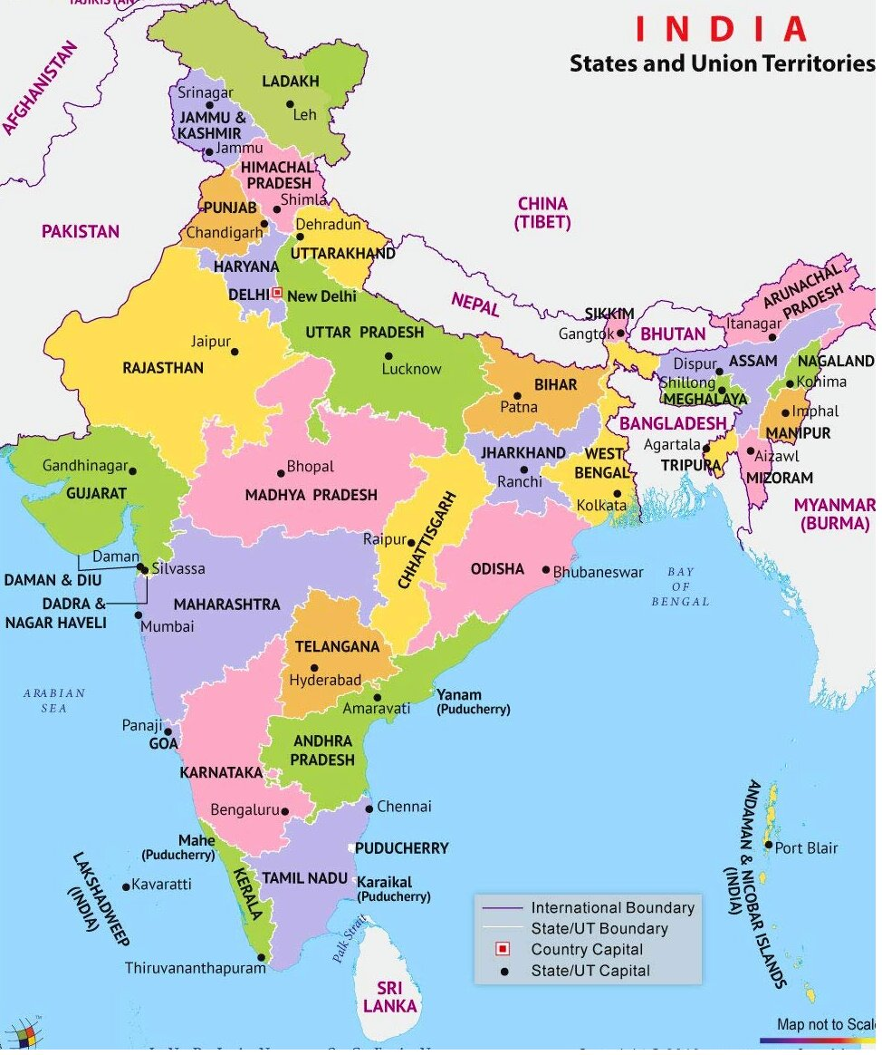
Note: Specific location of sample: Explosion in red; RERA implementation-Circle in green: full implementation; Yellow star in aqua background: partial implementation and/under process, Black star: not notified; Purple block arc: RERA Rules dilution.
Source: Authors’ preparation based on the Government of India notification (www.mohua.gov.in)
Figure A1: National footprint of RERA implementation as of 11 September 2021.

