Figure S1:
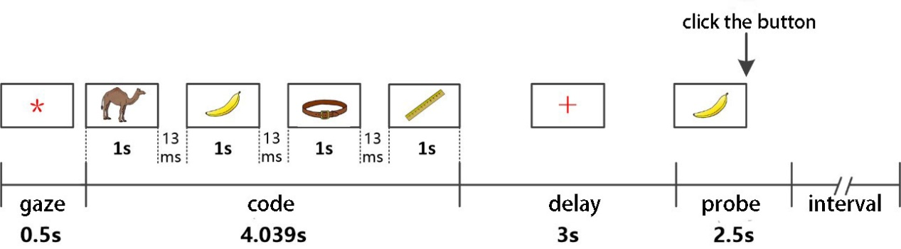
Figure S1: Diagram of visual working memory paradigm

