Supplementary Files
Supplementary File 1 – Extensive Search Strategy
Data Base | Search Terms | Results | Filters Applied
PubMED | (Anthracyclines OR Trastuzumab) AND (Cardiotoxicity OR cardiomyopathy) AND (Prevention OR Treatment OR Prophylaxis) | 262 | Randomized Controlled Trial
Embase | (Anthracyclines OR Trastuzumab) AND (Cardiotoxicity OR cardiomyopathy) AND (Prevention OR Treatment OR Prophylaxis) | 270 | Randomized Controlled Trial
Cochrane Library | (Anthracyclines OR Trastuzumab) AND (Cardiotoxicity OR cardiomyopathy) AND (Prevention OR Treatment OR Prophylaxis) | 9 | None

Supplementary File 2.1 – Quality Assessment and Risk of Bias
 | 1. Was true randomization used for assignment of participants to treatment groups? | 2. Was allocation to treatment groups concealed? | 3. Were treatment groups similar at the baseline? | 4. Were participants blind to treatment assignment? | 5. Were those delivering treatment blind to treatment assignment? | 6. Were outcomes assessors blind to treatment assignment? | 7. Were treatment groups treated identically other than the intervention of interest? | 8. Was follow up complete and if not, were differences between groups in terms of their follow up adequately described and analyzed? | 9. Were participants analyzed in the groups to which they were randomized? | 10. Were outcomes measured in the same way for treatment groups? | 11. Were outcomes measured in a reliable way? | 12. Was appropriate statistical analysis used? | 13. Was the trial design appropriate, and any deviations from the standard RCT design (individual randomization, parallel groups) accounted for in the conduct and analysis of the trial?
Janbabai, 2017 | N/A | N/A | YES | YES | NO | YES | YES | YES | YES | YES | YES | YES | YES
Nakamae, 2005 | N/A | N/A | YES | N/A | N/A | N/A | YES | YES | YES | YES | YES | YES | YES
Cadeddu, 2010 | N/A | N/A | YES | YES | NO | N/A | YES | YES | YES | YES | YES | YES | YES
Kalay, 2006 | N/A | N/A | YES | YES | NO | YES | YES | YES | YES | YES | YES | YES | YES
Elitok, 2014 | YES | N/A | YES | YES | NO | N/A | YES | YES | YES | YES | YES | YES | YES
Beheshti, 2016 | YES | YES | YES | YES | YES | YES | YES | NO | YES | YES | YES | YES | YES
Abuosa, 2018 | YES | YES | YES | YES | YES | YES | YES | YES | YES | YES | YES | YES | YES
Avila, 2018 | YES | YES | YES | YES | YES | YES | YES | NO | YES | YES | YES | YES | YES
Kaya, 2013 | N/A | N/A | YES | YES | YES | YES | YES | YES | YES | YES | YES | YES | YES
Venturini, 1996 | NO | N/A | YES | N/A | N/A | YES | YES | YES | YES | YES | YES | YES | YES
Swain, 1997 | YES | YES | YES | YES | YES | YES | YES | NO | YES | YES | YES | YES | YES
Marty, 2006 | YES | YES | YES | NO | NO | YES | YES | NO | YES | YES | YES | YES | YES

Supplementary File 2.2 – Quality Assessment and Risk of Bias
 | 1. Was true randomization used for assignment of participants to treatment groups? | 2. Was allocation to treatment groups concealed? | 3. Were treatment groups similar at the baseline? | 4. Were participants blind to treatment assignment? | 5. Were those delivering treatment blind to treatment assignment? | 6. Were outcomes assessors blind to treatment assignment? | 7. Were treatment groups treated identically other than the intervention of interest? | 8. Was follow up complete and if not, were differences between groups in terms of their follow up adequately described and analyzed? | 9. Were participants analyzed in the groups to which they were randomized? | 10. Were outcomes measured in the same way for treatment groups? | 11. Were outcomes measured in a reliable way? | 12. Was appropriate statistical analysis used? | 13. Was the trial design appropriate, and any deviations from the standard RCT design (individual randomization, parallel groups) accounted for in the conduct and analysis of the trial?
Akpek, 2014 | N/A | N/A | YES | YES | YES | N/A | YES | YES | YES | YES | YES | YES | YES
Milei, 1987 | N/A | N/A | NO | YES | YES | YES | YES | YES | YES | YES | YES | YES | YES
Zhang, 2012 | N/A | N/A | YES | YES | YES | YES | YES | YES | YES | YES | YES | YES | YES
Jo, 2013 | YES | N/A | YES | NO | NO | N/A | YES | NO | NO | YES | YES | YES | YES
Georgakopoulos, 2019 | N/A | N/A | YES | NO | NO | YES | YES | YES | YES | YES | YES | YES | YES
Farahani, 2018 | YES | N/A | YES | NO | NO | YES | YES | YES | YES | YES | YES | YES | YES
Boekhout,, 2016 | YES | YES | YES | YES | YES | YES | YES | NO | YES | YES | YES | YES | YES
Słowik, 2020 | YES | YES | YES | NO | NO | YES | YES | NO | YES | YES | YES | YES | YES
Gulati,2016 | N/A | N/A | YES | YES | YES | YES | YES | YES | YES | YES | YES | YES | YES
Nabati, 2018 | N/A | N/A | YES | YES | NO | YES | YES | NO | YES | YES | YES | YES | YES
Pituskin, 2017 | YES | YES | YES | YES | YES | YES | YES | YES | YES | YES | YES | YES | YES
Guglin, 2019 | YES | YES | YES | YES | YES | YES | YES | NO | YES | YES | YES | YES | YES

Supplementary File 3 – Cardiac Events Definition in Dexrazoxane Studies
Marty et al. | Reduction in LVEF ≥10% absolute percentage points by MUGA scan  Reduction in LVEF ≥15% by echocardiography,  LVEF<45%, as measured by Multiple Gated Acquisition scan or echocardiography  The appearance of clinical signs of cardiac insufficiency (graded by NYHA scale)
Swain et al. | Reduction in LVEF>10% below the institution's Lower Level of Normality;  A decline in LVEF > 20% from baseline;  The development of congestive heart failure while on study (defined by with two or more of the following: cardiomegaly established by radiography, basilar rales, S3 gallop, or paroxysmal nocturnal dyspnea, orthopnea, or significant dyspnea on exertion).
Venturini et al. | The appearance of clinical signs of congestive heart failure classified as II (grade by NYHA);  LVEF< 45% by Multiple Gated Acquisition scan;  A decrease from baseline resting LVEF of > 20 EF units.
EF: Ejection Fraction; LVEF: Left Ventricular Ejection Fraction; NYHA: New York Heart Association;

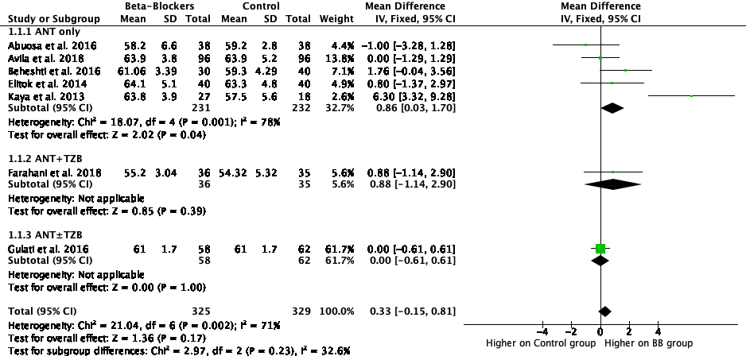
Supplementary File 4 - Forest Plot exhibiting the results for the meta-analysis of the impact of BB on LVEF. The results are divided in subgroups based on chemotherapy scheme. Parallelogram boxes for mean differences and horizontal lines represent 95% CI.

Supplementary File 5. Forest Plot exhibiting the results for the meta-analysis of the impact of different BB on LVEF. The results are divided in subgroups based on chemotherapy scheme and individual drug. Parallelogram boxes for mean differences and horizontal lines represent 95%CI
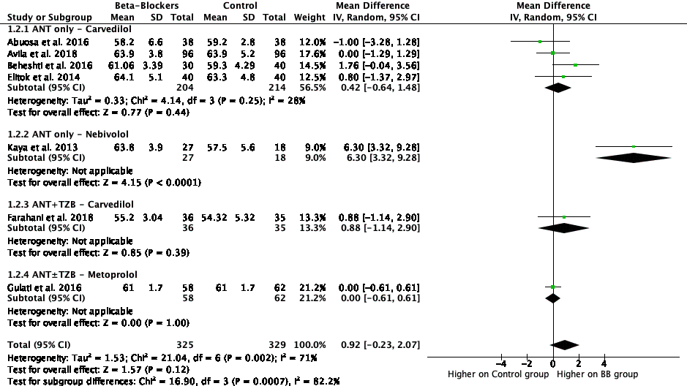

Supplementary File 6. Forest Plot exhibiting the results for the meta-analysis of the impact of BB on E/A ratio. The results are divided in subgroups based on chemotherapy scheme. Parallelogram boxes for mean differences and horizontal lines represent 95% CI.

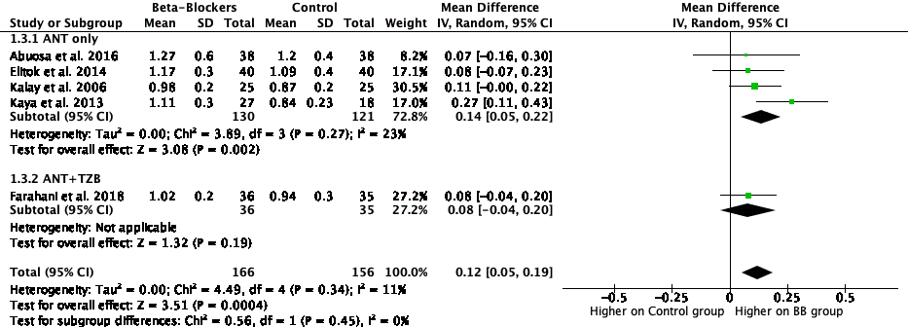

Supplementary File 7. Forest Plot exhibiting the results for the meta-analysis of the impact of BB on E/e’. The results are divided in subgroups based on chemotherapy scheme. Parallelogram boxes represent mean differences and horizontal lines represent 95% CI.
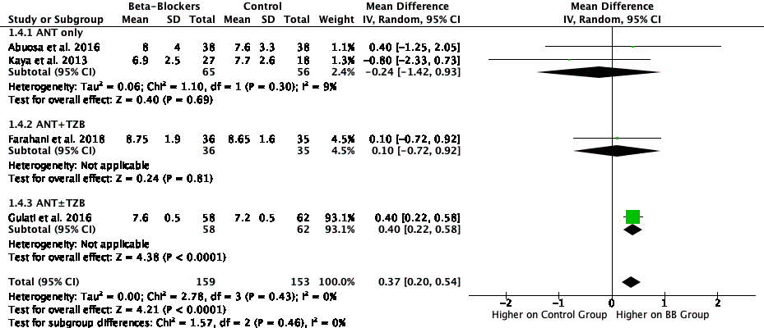

Supplementary File 8. Forest Plot exhibiting the results for the meta-analysis of the impact of BB on LA diameter. The results are divided in subgroups based on chemotherapy scheme. Parallelogram boxes for mean differences and horizontal lines represent 95% CI.
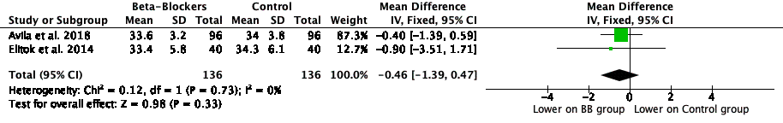

Supplementary File 9. Forest Plot exhibiting the results for the meta-analysis of the combined risk ratio of Dexrazoxane in the incidence of cardiac events
