Title: Divergence and Convergence of the Gut Microbiomes of Wild Insect Pollinators

Jilian Li^{1*#}, Daohua Zhuang^{2#}, Logan Sauers^{4#}, Haiqing Ren², Jun Guo⁶, Liuhao Wang⁷, Mingsheng Zhuang^{1,5}, Yulong Guo ¹, Zhengyi Zhang¹, Jie Wu¹, Jun Yao¹, Huipeng Yang¹, Chengrui Wang⁸，Qinghui Lin⁸, Ben M. Sadd^{4*}, Zhigang Zhang^{2*}

- Key Laboratory of Pollinating Insect Biology of the Ministry of Agriculture, Institute of Apicultural Research, Chinese Academy of Agricultural Science, Beijing, 100093, China
- State Key Laboratory for Conservation and Utilization of Bio-Resources in Yunnan, School of Life Sciences, Yunnan University, No.2 North Cuihu Road, Kunming, Yunnan, 650091, China
- State Key Laboratory of Genetic Resources and Evolution, Laboratory of Evolutionary & Functional Genomics, Kunming Institute of Zoology, Chinese Academy of Sciences, Kunming 650223, Yunnan, China
- School of Biological Sciences, Illinois State University, Normal, Illinois 61790, United States of America
- Shanghai Suosheng Biotechnology Co., Ltd. Shanghai 201700, China.
- Faculty of Life Science and Technology, Kunming University of Science and Technology, Kunming, Yunnan 650500, China
- College of Resources and Environmental Sciences, Henan Institute of Science and Technology, Xinxiang, Henan 453003, China
- Computer Network Information Center, Chinese Academy of Sciences, Beijing, 100083, China
*Correspondence:
Jilian Li
Key Laboratory of Pollinating Insect Biology of the Ministry of Agriculture, Institute of Apicultural Research, Chinese Academy of Agricultural Science, Beijing, China
Email: bumblebeeljl@hotmail.com
or
Ben M. Sadd
School of Biological Sciences, Illinois State University, Normal, Illinois 61790, United States of America
Email: bmsadd@ilstu.edu
or
Zhigang Zhang
State Key Laboratory for Conservation and Utilization of Bio-Resources in Yunnan, School of Life Sciences, Yunnan University, No.2 North Cuihu Road, Kunming, Yunnan, 650091, China
Email: zhangzhigang@ynu.edu.cn
Jilian Li, Daohua Zhuang and Logan Sauers contributed equally to this work.

Supplementary Figures
Figure S1. Biogeographical distribution of 861 individual samples in this study.

Figure S2. Quality scores for each base in the reads for the forward and reverse reads. Used to determine the assembly and filtering parameters in QIIME2.

Figure S3. Differential abundance analysis of the 69 most abundant ASVs making up 15 different microbial genera across host genera accounting for 15,485,841 (37.1%) of the total ASVs. Amegillia is used as a reference group for the effect sizes. Thus, blue shades correspond to negative effect sizes, or symbiotes more highly associated with Amegillia relative to the focal host genera, and red shades correspond to positive effect sizes signifying stronger associations with the focal host genera.

Figure S4. Phylogenetic tree from COI genes used for the Mantel test. The sequence for Trigona was datamined (ascension number KX174315.1). The tree was created with PhyML. Halyomorpha was used as an outgroup for the tree, but is not included in the Mantel test.

Supplementary Tables

Table S1. Sample information

Table S2. A) Average Bray-Curtis distance matrix between host genera. B) Host genetic distance matrix used for Mantel correlation test.

Table S3. Genes with statistically significant differential proportions from the metagenomic analysis of Gilliamella from flies and bees, after effect size filter of 0.2.

Table S4. Genes with statistically significant differential proportions from the metagenomic analysis of Snodgrassella vs. Lonsdalea, after effect size filter of 0.2.

Table S5. Genes with statistically significant differential proportions from the metagenomic analysis of Gilliamella vs. Lonsdalea, after effect size filter of 0.2.

Supplementary Figures

Figure S1.

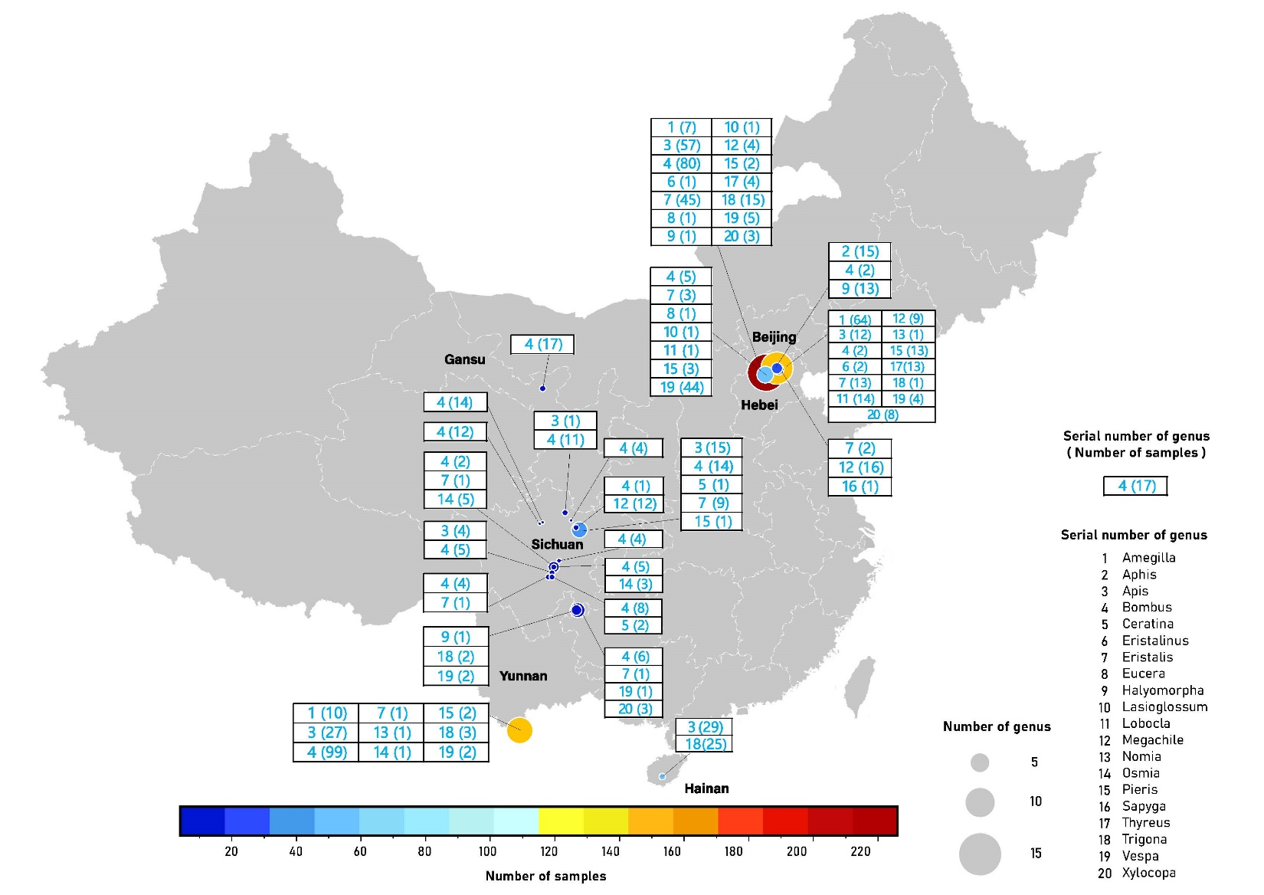

Figure S2.
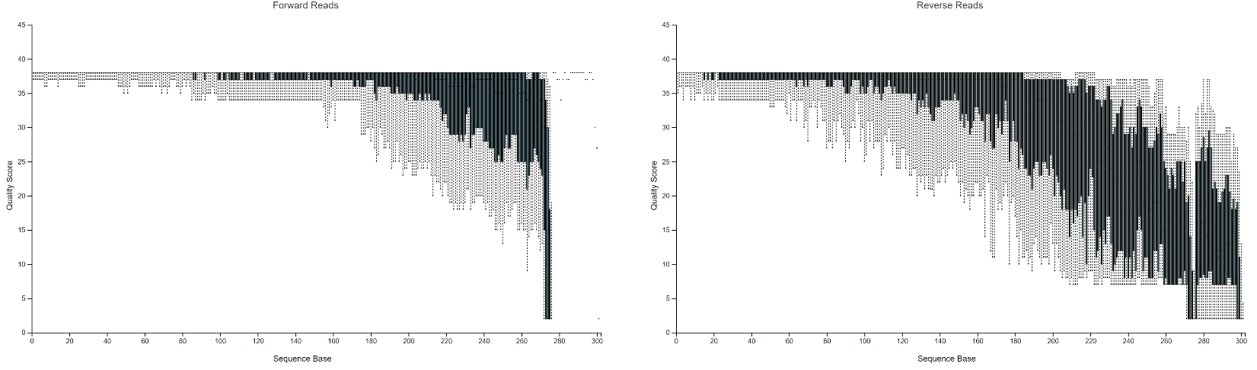
Figure S3.

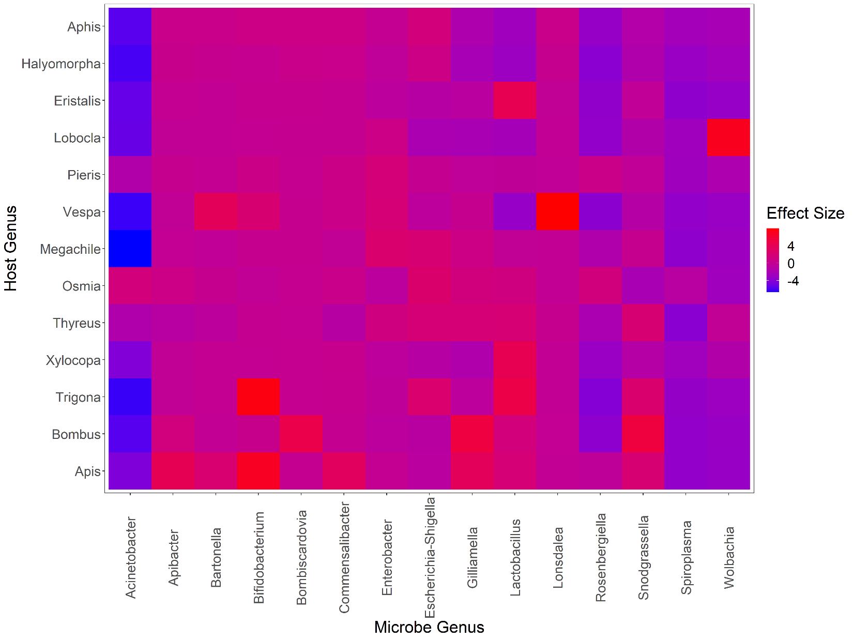

Figure S4.

