Supplementary materials

Immunogenicity, efficacy, and safety of SARS-CoV-2 vaccine dose fractionation: a systematic review and meta-analysis
Bingyi Yang¹, Xiaotong Huang¹, Huizhi Gao¹, Nancy H. Leung¹, Tim K. Tsang^{1,2}, Benjamin J. Cowling^{1,2}
Affiliations:
- WHO Collaborating Centre for Infectious Disease Epidemiology and Control, School of Public Health, Li Ka Shing Faculty of Medicine, The University of Hong Kong, Hong Kong, China
- Laboratory of Data Discovery for Health Limited, Hong Kong Science and Technology Park, New Territories, Hong Kong, China
Correspondence to:
Benjamin J. Cowling, (bcowling@hku.hk); Bingyi Yang (yangby@hku.hk)

Table of Contents
Supplementary Tables 4
Table S1. Search strategy and number of articles identified in each step. 4
Table S2. Summary of 38 studies that were included for systematic review analysis. 5
Table S3. Summary of 38 studies that were included for analyses of seroconversion and dose-response relationship of neutralizing antibodies. 9
Table S4. Summary of 17 studies that are included for cell-mediated response analysis by vaccine type. 14
Table S5. Factors associated with neutralizing antibody responses after receiving different fractional doses of vaccinations. 16
Table S6. Cross-validation of general additive model for dose-response relationship of neutralizing antibody after fractional doses. 16
Table S7. Fold of reduction in neutralizing antibodies against variants of concerns. 17
Table S8. Vaccine effectiveness against infections of variants of concern for standard dose. 18
Table S9. Factors associated with risk of experiencing seroconversion of neutralizing antibodies after receiving non-standard and standard doses. 19
Supplementary Figures 20
Figure S1. Flowchart of literature search and screening. 20
Figure S2. Risk of bias of 39 included studies. 21
Figure S3. Model predictions of dose-response relationship of neutralizing antibodies (nAbs) against ancestral strains introduced by COVID-19 vaccines. 22
Figure S4. Standardized neutralizing antibodies (nAbs) introduced by COVID-19 vaccines on day 0 since the complete vaccination. 23
Figure S5. Standardized neutralizing antibodies (nAbs) introduced by COVID-19 vaccines on day 14 since the complete vaccination. 24
Figure S6. Standardized neutralizing antibodies (nAbs) introduced by COVID-19 vaccines on day 28 or later since the complete vaccination. 25
Figure S7. Associations between time since complete vaccination and the standardized neutralizing antibodies (nAbs) against the ancestral strains elicited by fractioning dose of COVID-19 vaccines. 26
Figure S8. Dose-relationship between dose fractionation and predicted vaccine efficacy against symptomatic infections of variants of concern. 27
Figure S9. Correlation between predicted and observed vaccine efficacy against variants of concern for standard dose of COVID-19 vaccines. 28
Figure S10. Comparison of T-cell responses against the ancestral strains elicited by higher doses of COVID-19 vaccines. 29
Figure S11. Comparison of safety after vaccinated with lower doses (a) and higher doses (b) to standard doses of SARS-CoV-2 vaccines. 30
Figure S12. Pooled risk ratio (in log scale) of experiencing solicited local adverse events after vaccinated with fractional and standard dose groups. 31
Figure S13. Pooled risk ratio (in log scale) of experiencing solicited systemic adverse events after vaccinated with fractional and standard dose groups. 32
Figure S14. Pooled risk ratio (in log scale) of experiencing any solicited adverse events after vaccinated with fractional and standard dose groups. 33
Figure S15. Pooled risk ratio (in log scale) of experiencing any unsolicited adverse events after vaccinated with fractional and standard dose groups. 34
Figure S16. Pooled risk ratio (in log scale) of experiencing any adverse events after vaccinated with fractional and standard dose groups. 35
References 36

Supplementary Tables

Table S1. Search strategy and number of articles identified in each step.
Step | Search terms | Number of results
#1 | SARS-CoV-2 OR COVID-19 | 205,618
#2 | vaccine AND dose | 34,113
#3 | antibod* OR immun* | 4,574,287
#4 | #1 AND #2 AND #3 | 1,733
*Searches were conducted on 9 Dec 2021 in PubMed.

Table S2. Summary of 38 studies that were included for systematic review analysis.

Reference | Vaccine  (Manufacturers) | Phase | Age group  (years) | Vaccine schedule | Dose concentration | Safety
Inactivated virus (n = 11, 29%)
Xia, S, 2020, Lancet Infect Dis ¹ | BBIBP-CorV (Sinopharm (Beijing)) | 1/2 | 18-59,  60-80 | 1 dose;  2 doses, 0 days apart;  2 doses, 14 days apart;  2 doses, 21 days apart;  2 doses, 28 days apart | 2$ug$, 4 $ug$, 8 $ug$ | Available
Xia, S, 2021, Lancet Infect Dis ² | BBIBP-CorV (Sinopharm (Beijing)) | 1/2 | 3-5,  6-12,  13-17 | 3 doses, 28 days apart | 2 $ug$, 4 $ug$, 8 $ug$ | Available
Ella, R, 2021 (21:637-46),  Lancet Infect Dis ³ | BBV152 (Covaxin) | 1 | 18-55 | 2 doses, 14 days apart | 3 $ug$, 6 $ug$ | Available
Ella, R, 2021 (21:950-61),  Lancet Infect Dis ⁴ | BBV152 (Covaxin) | 1/2 | 12-65,  18-55 | 2 doses, 28 days apart | 3 $ug$, 6 $ug$ | Available
Che, Y, 2020, Clin Infect Dis ⁵ | Chinese Academy of Medical Sciences | 2 | 18-59 | 2 doses, 14 days apart;  2 doses, 28 days apart | 100EU, 150EU | Available
Han, B, 2021, Lancet Infect Dis ⁶ | CoronaVac (Sinovac) | 1/2 | 3-5,  3-17,  6-11,  12-17 | 2 doses, 28 days apart | 1.5 $ug$, 3 $ug$ | Available
Wu, Z, 2021, Lancet Infect Dis ⁷ | CoronaVac (Sinovac) | 1/2 | 60- | 2 doses, 28 days apart | 3 $ug$, 6 $ug$, 1.5 $ug$ | Available
Zhang, Y, 2021, Lancet Infect Dis ⁸ | CoronaVac (Sinovac) | 1 | 18-59 | 2 doses, 14 days apart;  2 doses, 28 days apart | 3 $ug$, 6 $ug$
Pan, H, 2021, Chin Med J ⁹ | KCONVAC  (Minhai BioTech) | 1/2 | 18-59 | 2 doses, 14 days apart;  2 doses, 28 days apart | 5 $ug$, 10 $ug$ | Available
Xia, S, 2020, JAMA ¹⁰ | Sinopharm (Wuhan) | 1/2 | 18-59 | 2 doses, 14 days apart;  2 doses, 21 days apart;  3 doses, 28 days apart | 2.5 $ug$, 5 $ug$ , 10 $ug$ | Available
Guo, W, 2021, EClinicalMedicine ¹¹ | Sinopharm (Wuhan) | 1/2 | 18-59,  60- | 1 dose;  2 doses, 14 days apart;  2 doses, 21 days apart;  2 doses, 28 days apart;  3 doses, 28 days apart | 5 $ug$, 10 $ug$ , 2.5 $ug$ | Available
Protein subunit (n = 10, 26%)
Goepfert, P, 2021, Lancet Infect Dis ¹² | Sanofi/GSK | 1/2 | 18-49,  50- | 2 doses, 21 days apart | 1.3 $ug$, 2.6 $ug$ | Available
Chappell, K, 2021, Lancet Infect Dis ¹³ | Sclamp (Queensland) | 1 | 18-55 | 1 dose;  2 doses, 28 days apart | 5 $ug$, 15 $ug$, 45 $ug$ | Available
Hsieh, S, 2021, EClinicalMedicine ¹⁴ | MVCCOV1901 (Medigen) | 1 | 20-49 | 2 doses, 28 days apart | 5 $ug$, 15 $ug$, 25 $ug$ | Available
Formica, N, 2021, PLoS Med ¹⁵ | NVX-CoV2373 (Novavax) | 2 | 18-55,  18-59,  60-84 | 1 dose;  2 doses, 21 days apart | 5 $ug$, 25 $ug$ | Available
Keech, C, 2020, N Engl J Med ¹⁶ | NVX-CoV2373 (Novavax) | 1 | 18-59 | 1 dose;  2 doses, 21 days apart | 5 $ug$, 25 $ug$ | Available
Richmond, P, 2021, Lancet ¹⁷ | SCB-2019 (Clover) | 1 | 18-54 | 2 doses, 21 days apart | 3 $ug$, 9 $ug$ , 30 $ug$ | Available
Meng, F, 2021,  Signal Transduct Target Ther ¹⁸ | Sf9 cells  (West China Hospital) | 1/2 | 18-55,  56- | 2 doses, 21 days apart;  2 doses, 28 days apart;  3 doses, 14 days apart;  3 doses, 28 days apart | 20 $ug$, 40 $ug$ | Available
Shu, Y, 2021, Chin Med J ¹⁹ | V-01  (Livzon Mabpharm) | 2 | 18-59,  60- | 1 dose;  2 doses, 21 days apart | 50 $ug$, 10 $ug$ , 25 $ug$ | Available
Zhang, J, 2021,  Emerg Microbes Infect ²⁰ | V-01  (Livzon Mabpharm) | 1 | 18-59, 60- | 2 doses, 21 days apart | 10 $ug$, 25 $ug$ , 50 $ug$ | Available
Yang, S, 2021, Lancet Infect Dis ²¹ | ZF2001 (Anhui Zhifei) | 1/2 | 18-59 | 2 doses, 30 days apart;  3 doses, 30 days apart | 25 $ug$, 50 $ug$ | Available
RNA (n = 9, 24%)
Li, J, 2021, Nat Med ²² | BNT162b1 (Pfizer/BioNTech) | 1 | 18-55,  56-85 | 2 doses, 21 days apart | 10 $ug$, 30 $ug$ | Available
Mulligan, M, 2020, Nature ²³ | BNT162b1 (Pfizer/BioNTech) | 1/2 | 18-55 | 1 dose;  2 doses, 21 days apart | 10 $ug$, 30 $ug$ , 100 $ug$ | Available
Sahin, U, 2020, Nature ²⁴ | BNT162b1 (Pfizer/BioNTech) | 1/2 | 18-55 | 1 dose;  2 doses, 21 days apart | 1u $ug$ 10 $ug$ , 30 $ug$, 50 $ug$,  60 $ug$ | Not available
Walsh, E, 2020, N Engl J Med ²⁵ | BNT162b1, BNT162b2 (Pfizer/BioNTech) | 1 | 18-55,  56-85 | 2 doses, 21 days apart | 10 $ug$, 20 $ug$ , 30 $ug$ | Available
Walter, E, 2021, N Engl J Med ²⁶ | BNT162b2 (Pfizer/BioNTech) | 1/2 | 5-11 | 2 doses, 21 days apart | 10 $ug$, 20 $ug$ | Available
Kremsner, P, 2021,  Wien Klin Wochenschr ²⁷ | CVnCoV (Curevac) | 1 | 18-60 | 2 doses, 28 days apart | 2 $ug$, 4 $ug$,  6 $ug$, 8 $ug$,  12 $ug$ | Available
Anderson, E, 2020, N Engl J Med ²⁸ | mRNA-1273 (Moderna) | 1 | 18-55,  56-70,  71- | 2 doses, 28 days apart | 25 $ug$, 100 $ug$ | Available
Chu, L, 2021, Vaccine ²⁹ | mRNA-1273 (Moderna) | 2 | 18-54,  55- | 2 doses, 28 days apart | 50 $ug$, 100 $ug$ | Available
Jackson, L, 2020, N Engl J Med ³⁰ | mRNA-1273 (Moderna) | 1 | 18-55 | 2 doses, 28 days apart | 25 $ug$, 100 $ug$ , 250 $ug$ | Available
Non-replicating viral vector (n = 5, 13%)
Sadoff, J, 2021, N Engl J Med ³¹ | Ad26.COV2.S (Janssen) | 1/2 | 18-55,  56- | 1 dose;  2 doses, 21 days apart | 5$×$10¹⁰ VP , 10$×$10¹⁰ VP | Available
Wu, S, 2021, Lancet Infect Dis ³² | Ad5-nCoV (AMMS) | 1 | 18- | 1 dose;  2 doses, 0 days apart | 5$×$10¹⁰ VP, 10$×$10¹⁰ VP | Available
Zhu, F, 2020 (395: 1845-54), Lancet ³³ | Ad5-nCoV (CanSino) | 1 | 18-60 | 1 dose | 5$×$10¹⁰ VP, 10$×$10¹⁰ VP, 15$×$10¹⁰ VP | Available
Zhu, F, 2020 (396: 479-88), Lancet ³⁴ | Ad5-nCoV (CanSino) | 2 | 18- | 1 dose | 5$×$10¹⁰ VP, 10$×$10¹⁰ VP | Available
Zhu, F, 2021, Clin Infect Dis ³⁵ | Ad5-nCoV (CanSino) | 2 | 56- | 2 doses, 56 days apart | 5$×$10¹⁰ VP, 10$×$10¹⁰ VP | Available
DNA (n = 2, 5%)
Tebas, 2021, EClinicalMedicine ³⁶ | INO-4800 (Inovio) | 1 | 18-50 | 2 doses, 28 days apart | 1 $mg$, 2 $mg$ | Available
Momin, T, 2021, EClinicalMedicine ³⁷ | ZyCoV-D  (Zydus Cadila) | 1 | 18-55 | 2 doses, 28 days apart | 1 $mg$, 2 $mg$ | Available
Virus-like particle (n = 1, 3%)
Ward, B, 2021, Nat Med ³⁸ | Plant-based VLP (Medicago) | 1 | 18-55 | 2 doses, 21 days apart | 3.75 $ug$, 7.5 $ug$, 15 $ug$ | Available

Table S3. Summary of 38 studies that were included for analyses of seroconversion and dose-response relationship of neutralizing antibodies.

Reference | Vaccine  (Manufacturers) | Assay antigen | Assay measurement | Positive  cut-off | Seroconversion | Seroconversion definition | Convalescent sera
Inactivated virus (n = 11, 29%)
Xia, S, 2020, Lancet Infect Dis ¹ | BBIBP-CorV (Sinopharm (Beijing)) | Live | MNT₅₀ | 1:2 | Available | $≥$ 4-fold rise | Not available
Xia, S, 2021, Lancet Infect Dis ² | BBIBP-CorV (Sinopharm (Beijing)) | Live | MNT₅₀ | 1:2 | Available | $≥$ 4-fold rise | Available
Ella, R, 2021 (21:637-46),  Lancet Infect Dis ³ | BBV152 (Covaxin) | Live | MNT₅₀, PRNT₅₀ | Not reported | Available | $≥$ 4-fold rise | Available
Ella, R, 2021 (21:950-61),  Lancet Infect Dis ⁴ | BBV152 (Covaxin) | Live | MNT₅₀, PRNT₅₀ | 1:20  1:20 | Available | $≥$ 4-fold rise | Available
Che, Y, 2020, Clin Infect Dis ⁵ | Chinese Academy of Medical Sciences | Live | MNT₅₀ | 1:4 | Available | Seronegative to seropositive | Not available
Han, B, 2021, Lancet Infect Dis ⁶ | CoronaVac (Sinovac) | Live | MNT₅₀ | Not reported | Available | Seronegative to seropositive | Not available
Wu, Z, 2021, Lancet Infect Dis ⁷ | CoronaVac (Sinovac) | Live | MNT₅₀ | 1:8 | Available | Seronegative to seropositive, or  $≥$ 4-fold rise for baseline seropositive | Not available
Zhang, Y, 2021, Lancet Infect Dis ⁸ | CoronaVac (Sinovac) | Live | MNT₅₀ | 1:8  1:30 | Available | Seronegative to seropositive, or  $≥$ 4-fold rise for baseline seropositive | Available
Pan, H, 2021, Chin Med J ⁹ | KCONVAC  (Minhai BioTech) | Live,  pseudo | Not reported,  sVNA IC₅₀ | 1:4  1:30 | Available | Seronegative to seropositive, or  $≥$ 4-fold rise for baseline seropositive | Available
Xia, S, 2020, JAMA ¹⁰ | Sinopharm (Wuhan) | Live | PRNT₅₀ | Not reported | Available | $≥$ 4-fold rise | Not available
Guo, W, 2021, EClinicalMedicine ¹¹ | Sinopharm (Wuhan) | Live | PRNT₅₀ | Not reported | Available | $≥$ 4-fold rise | Not available
Protein subunit (n = 10, 26%)
Goepfert, P, 2021, Lancet Infect Dis ¹² | Sanofi/GSK | Live | MNT₅₀ | 1:10 | Available | Seronegative to seropositive | Not available
Chappell, K, 2021, Lancet Infect Dis ¹³ | Sclamp (Queensland) | Live | MNT₅₀ | 1:20 | Not available | -- | Available
Hsieh, S, 2021, EClinicalMedicine ¹⁴ | MVCCOV1901 (Medigen) | Live,  pseudo | Not reported,  sVNA ID₅₀ | Not reported | Available | Not reported | Available
Formica, N, 2021, PLoS Med ¹⁵ | NVX-CoV2373 (Novavax) | Live | MNT₅₀ | 1:20 | Available | $≥$ 4-fold rise | Available
Keech, C, 2020, N Engl J Med ¹⁶ | NVX-CoV2373 (Novavax) | Live | MNT₅₀ | Not reported | Available | Not reported | Available
Richmond, P, 2021, Lancet ¹⁷ | SCB-2019 (Clover) | Live | MNT₅₀ | 1:20 | Available | $≥$ 4-fold rise | Available
Meng, F, 2021,  Signal Transduct Target Ther ¹⁸ | Sf9 cells  (West China Hospital) | Live,  pseudo | Not reported | Not reported | Available | $≥$ 4-fold rise | Not available
Shu, Y, 2021, Chin Med J ¹⁹ | V-01  (Livzon Mabpharm) | Live | MNT₅₀ | 1:10 | Available | Seronegative to seropositive, or  $≥$ 4-fold rise for baseline seropositive | Available
Zhang, J, 2021,  Emerg Microbes Infect ²⁰ | V-01  (Livzon Mabpharm) | Live | MNT₅₀ | 1:10 | Available | Seronegative to seropositive, or  $≥$ 4-fold rise for baseline seropositive | Not available
Yang, S, 2021, Lancet Infect Dis ²¹ | ZF2001 (Anhui Zhifei) | Live | MNT₅₀ | 1:4 | Available | Seronegative to seropositive | Available
RNA (n = 9, 24%)
Li, J, 2021, Nat Med ²² | BNT162b1 (Pfizer/BioNTech) | Live | MNT₅₀ | 1:10 | Available | $≥$ 4-fold rise | Available
Mulligan, M, 2020, Nature ²³ | BNT162b1 (Pfizer/BioNTech) | Pseudo | VNT₅₀ | Not reported | Not available | -- | Available
Sahin, U, 2020, Nature ²⁴ | BNT162b1 (Pfizer/BioNTech) | Pseudo | VNT₅₀ | Not reported | Not available | -- | Available
Walsh, E, 2020, N Engl J Med ²⁵ | BNT162b1, BNT162b2 (Pfizer/BioNTech) | Live | MNT₅₀ | 1:10 | Not available | -- | Available
Walter, E, 2021, N Engl J Med ²⁶ | BNT162b2 (Pfizer/BioNTech) | Live | MNT₅₀ | Not reported | Not available | -- | Not available
Kremsner, P, 2021,  Wien Klin Wochenschr ²⁷ | CVnCoV (Curevac) | Live | MNT₅₀ | 1:10 | Available | $≥$ 4-fold rise | Available
Anderson, E, 2020, N Engl J Med ²⁸ | mRNA-1273 (Moderna) | Pseudo | sVNA IC₅₀ | 1:20 | Available | $≥$ 4-fold rise | Available
Chu, L, 2021, Vaccine ²⁹ | mRNA-1273 (Moderna) | Live | MNT₅₀ | Not reported | Available | Seronegative to seropositive, or  $≥$ 4-fold rise for baseline seropositive | Available
Jackson, L, 2020, N Engl J Med ³⁰ | mRNA-1273 (Moderna) | Live,  pseudo | PRNT₈₀,  sVNA IC₅₀ | 1:8  1:20 | Not available | -- | Available
Non-replicating viral vector (n = 5, 13%)
Sadoff, J, 2021, N Engl J Med ³¹ | Ad26.COV2.S (Janssen) | Live | MNT₅₀ | Not reported | Available | Seronegative to seropositive, or  $≥$ 4-fold rise for baseline seropositive | Available
Wu, S, 2021, Lancet Infect Dis ³² | Ad5-nCoV (AMMS) | Live | PRNT₅₀ | 1:8 | Available | $≥$ 4-fold rise | Not available
Zhu, F, 2020 (395: 1845-54), Lancet ³³ | Ad5-nCoV (CanSino) | Live,  pseudo | Not reported,  sVNA IC₅₀ | Not reported | Available | $≥$ 4-fold rise | Not available
Zhu, F, 2020 (396: 479-88), Lancet ³⁴ | Ad5-nCoV (CanSino) | Live,  pseudo | Not reported,  sVNA IC₅₀ | Not reported | Available | $≥$ 4-fold rise | Not available
Zhu, F, 2021, Clin Infect Dis ³⁵ | Ad5-nCoV (CanSino) | Pseudo | sVNA IC₅₀ | Not reported | Available | $≥$ 4-fold rise | Not available
DNA (n = 2, 5%)
Tebas, 2021, EClinicalMedicine ³⁶ | INO-4800 (Inovio) | Live | PRNT₅₀ | Not reported | Available | Seronegative to seropositive, or  $≥$ 4-fold rise for baseline seropositive* | Not available
Momin, T, 2021, EClinicalMedicine ³⁷ | ZyCoV-D  (Zydus Cadila) | Live | PRNT₅₀ | Not reported | Available | Seronegative to seropositive, or  $≥$ 4-fold rise for baseline seropositive | Available
Virus-like particle (n = 1, 3%)
Ward, B, 2021, Nat Med ³⁸ | Plant-based VLP (Medicago) | Live,  pseudo | PRNT₅₀,  sVNA IC₅₀ | 1:10  1:10 | Available | Not reported | Available

Table S4. Summary of 17 studies that are included for cell-mediated response analysis by vaccine type.
Reference | Vaccine  (Manufacturers) | Days since full vaccination | Dose concentration |  | Assay  (Target) | T-cell type | Cytokines | Baseline available | Th1-biased
Reference | Vaccine  (Manufacturers) | Days since full vaccination | Standard | Examined
Inactivated virus (n = 3)
Ella, R, 2021 (21:637-46),  Lancet Infect Dis ³ | BBV152  (Covaxin) | 14 | 6 $μg$  Algel-IMDG | 3 $μg$  Algel-IMDG | ELISpot  (Antigen) | CD4+, CD8+ | IFN-$γ$ | Yes | Yes
Ella, R, 2021 (21:950-61),  Lancet Infect Dis ⁴ | BBV152  (Covaxin) | 14 | 6 $μg$  Algel-IMDG | 3 $μg$  Algel-IMDG | Luminex multiplex  (Antigen) | CD4+ | IFN-$γ$, TNF-$α$,  IL-2, IL-5, IL-10, IL-13 | No | Yes
Pan, H, 2021, Chin Med J ⁹ | KCONVAC  (Minhai BioTech) | 28 | 10 $μg$ | 5 $μg$ | ELISpot  (Antigen) | NS | IFN-$γ$ | Yes | Yes
Protein subunit (n = 4)
Hsieh, S, 2021,  EClinicalMedicine ¹⁴ | MVCCOV1901  (Medigen) | 28 | 15 $μg$ | 5 and 25 $μg$ | ELISpot  (Antigen) | NS | IFN-$γ$, IL-4 | Yes | Yes
Keech, C, 2020, N Engl J Med ¹⁶ | NVX-CoV2373  (Novavax) | 14 | 5 $μg$ | 25 $μg$ | ICS  (Antigen) | CD4+ | IFN-$γ$, TNF-$α$,  IL-2, IL-5, IL-13 | Yes | Yes
Meng, F, 2021,  Signal Transduct Target Ther ¹⁸ | Sf9 cells  (West China Hospital) | 28 | 20 $μg$ | 40 $μg$ | ELISpot  (Antigen) | NS | IFN-$γ$ | Yes | ND
Yang, S, 2021,  Lancet Infect Dis ²¹ | ZF2001  (Anhui Zhifei) | 14 | 50 $μg$ | 25 $μg$ | ELISpot  (Antigen) | NS | IFN-$γ$,  IL-2, IL-4, IL-5 | Yes | No
RNA (n = 4)
Li, J, 2021, Nat Med ²² | BNT162b1  (Pfizer/BioNTech) | 7 | 30 $μg$ | 10 $μg$ | ELISpot  (S1) | NS | IFN-$γ$ | Yes | ND
Sahin, U, 2020, Nature ²⁴ | BNT162b1  (Pfizer/BioNTech) | 7 | 30 $μg$ | 1, 10, 50 and 60 $μg$ | ELISpot  (RBD) | CD4+, CD8+ | IFN-$γ$ | Yes | Yes
Anderson, E, 2020, N Engl J Med ²⁸ | mRNA-1273  (Moderna) | 14 | 100 $μg$ | 25 $μg$ | ICS  (Spike) | CD4+, CD8+ | IFN-$γ$, TNF-$α$,  IL-2, IL-4, IL-13 | Yes | Yes
Jackson, L, 2020, N Engl J Med ³⁰ | mRNA-1273  (Moderna) | 14 | 100 $μg$ | 25 $μg$ | ICS  (Spike) | CD4+, CD8+ | IFN-$γ$, TNF-$α$,  IL-2, IL-4, IL-13 | Yes | Yes
Non-replicating viral vector (n = 4)
Sadoff, J, 2021, N Engl J Med ³¹ | Ad26.COV2.S  (Janssen) | 14 | 5$×$10¹⁰ VP | 1$×$10¹¹ VP | ICS  (Spike) | CD4+, CD8+ | NS | Yes | Yes
Zhu, F, 2020 (395: 1845-54), Lancet ³³ | Ad5-nCoV  (CanSino) | 28 | 5$×$10¹⁰ VP | 1$×$10¹¹ VP  1.5$×$10¹¹ VP | ELISpot  and ICS  (Spike) | CD4+, CD8+ | IFN-$γ$, TNF-$α$,  IL-2 | Yes | ND
Zhu, F, 2020 (396: 479-88), Lancet ³⁴ | Ad5-nCoV  (CanSino) | 28 | 5$×$10¹⁰ VP | 1$×$10¹¹ VP | ELISpot  (Spike) | NS | IFN-$γ$ | Yes | ND
Zhu, F, 2021, Clin Infect Dis ³⁵ | Ad5-nCoV  (CanSino) | 56 | 5$×$10¹⁰ VP | 1$×$10¹¹ VP | ELISpot  (Spike) | NS | IFN-$γ$, IL-2,  IL-4, IL-5, IL-13 | Yes | Yes
DNA (n = 1)
Tebas, 2021, EClinicalMedicine ³⁶ | INO-4800  (Inovio) | 14 | 1 $mg$ | 2 $mg$ | ELISpot  (Spike) | NS | IFN-$γ$ | Yes | Yes
Virus-like particle (n = 1)
Ward, B, 2021, Nat Med ³⁸ | Plant-based VLP  (Medicago) | 21 | 3.75 $μg$ | 7.5 and 15 $μg$ | ELISpot  (Spike) | NS | IFN-$γ$, IL-4 | Yes | No
*Abbreviation: ELISpot, enzyme-linked immune absorbent spot. ICS, intracellular cytokine staining. RBD, receptor-binding domain. NS, not specified. IFN-$γ$, Interferon gamma. TNF-$α$, tumor necrosis factor alpha. IL-2, -4, -5, -10, -13, Interleukin-2, -4, -5, -10, -13. ND, not determined.

Table S5. Factors associated with neutralizing antibody responses after receiving different fractional doses of vaccinations.
Variable | Fold of change*
Vaccine type
Inactivated | Ref
RNA | 9.3 (6.8, 12.8)
Protein subunit | 4.6 (3.4, 6.2)
Non-replicating vector | 7.4 (4.4, 12.4)
Virus-like particle | 10.0 (6.1, 16.5)
Assay antigen
Live virus | Ref
Pseudo virus | 1.3 (1.0, 1.6)
Age group
Adult
Children | 2.5 (1.5, 4.0)
Elderly | 0.9 (0.8, 1.2)
Total doses | 5.2 (3.8, 7.1)
* The model also adjusted for non-linear effects of days since full vaccination and dose-escalation relationship. Deviance explained by the model was 79%.

Table S6. Cross-validation of general additive model for dose-response relationship of neutralizing antibody after fractional doses.

Subset | Sample size of tested subset | Pearson correlation
1 | 39 | 0.906
2 | 42 | 0.853
3 | 48 | 0.915
4 | 47 | 0.883
5 | 50 | 0.841
6 | 43 | 0.898
7 | 46 | 0.787
8 | 46 | 0.883
9 | 53 | 0.890
10 | 36 | 0.906

Table S7. Fold of reduction in neutralizing antibodies against variants of concerns.
Variant  (Pango lineage) | Fold of change  (95% CI) | Reference
Alpha (B.1.1.7) | 1.6 (1.5, 1.7) | Cromer et al., 2022⁵⁰
Beta (B.1.351) | 8.8 (8.0, 9.7) | Cromer et al., 2022⁵⁰
Gamma (P.1) | 3.5 (3.1, 4.0) | Cromer et al., 2022⁵⁰
Delta (B.1.617.2) | 3.9 (3.5, 4.4) | Cromer et al., 2022⁵⁰
Omicron (B.1.1.529) | 22.8 (21.8, 23.8) | Carreno et al. 2021⁵¹

Table S8. Vaccine effectiveness against infections of variants of concern for standard dose.
Vaccine | Platform | Study design^ | Vaccine effectiveness  against infection |  | Reference
Vaccine | Platform | Study design^ | Symptomatic | Severe | Reference
Alpha (B.1.1.7)
BNT162b2 | RNA | TND | 89.5 (85.9, 92.3) | 100 (82, 100) | Abu-Raddad, 2021 ³⁹
BNT162b2 | RNA | TND | 93.7 (91.6, 95.3) | -- | Bernal, 2021 ⁴⁰
AZD1222 | Vector | TND | 74.5 (68.4, 79.4) | -- | Bernal, 2021 ⁴⁰
NVX-CoV2373 | Subunit | RCT | 86.3 (71.3, 93.5)* | -- | Heath, 2021 ⁴¹
BNT162b2 | RNA | TND | 92 (90, 93) | -- | Sheikh, 2021 ⁴²
AZD1222 | Vector | TND | 73 (66, 78) | -- | Sheikh, 2021 ⁴²
BNT162b2 | RNA | TND | 88 (86, 90) | 96 (94, 97) | Nasreen, 2022 ⁴³
AZD1222 | Vector | TND | 87 (47, 97) | 92 (41, 99) | Nasreen, 2022 ⁴³
RNA-1273 | RNA | TND | 92 (87, 95) | 95 (92, 97) | Nasreen, 2022 ⁴³
RNA-1273 | RNA | TND | 99.2 (95.3, 100) | -- | Chemaitelly, 2021 ⁴⁴
Beta (B.1.351)
BNT162b2 | RNA | TND | 75 (70.5, 78.9) | 100 (73, 100) | Abu-Raddad, 2021 ³⁹
AZD1222 | Vector | RCT | 10.4 (-76.8, 54.8) | -- | Madhi, 2021 ⁴⁵
NVX-CoV2373 | Subunit | RCT | 51 (-0.6, 76.2) | -- | Shinde, 2021 ¹⁶
BNT162b2 | RNA | TND | 86 (0, 98) | 92 (39, 99) | Nasreen, 2022 ⁴³
RNA-1273 | RNA | TND | 96.4 (94.3, 97.9) | -- | Chemaitelly, 2021 ⁴⁴
BNT162b2 | RNA | TND | 74.3 (70.3, 77.7) | 92.7 (82, 97) | Tang, 2021 ⁴⁶
RNA-1273 | RNA | TND | 80.8 (69, 88.2) | 100 (--,--) | Tang, 2021 ⁴⁶
Gamma (P.1)
BNT162b2 | RNA | TND | 90 (76, 96) | 94 (59, 99) | Nasreen, 2022 ⁴³
Delta (B.1.617.2)
BNT162b2 | RNA | TND | 88 (85.3, 90.1) | -- | Bernal, 2021 ⁴⁰
AZD1222 | Vector | TND | 67 (61.3, 71.8) | -- | Bernal, 2021 ⁴⁰
BNT162b2 | RNA | TND | 79 (75, 82) | -- | Sheikh, 2021 ⁴²
AZD1222 | Vector | TND | 60 (53, 66) | -- | Sheikh, 2021 ⁴²
CoronaVac/CNBG | Inactivated | TND | 59 (16, 81.6)* | 100 (--,--) | Li, 2021 ⁴⁷
BNT162b2 | RNA | TND | 92 (89, 94) | 95 (64, 99) | Nasreen, 2022 ⁴³
AZD1222 | Vector | TND | 88 (68, 96) | 90 (67, 97) | Nasreen, 2022 ⁴³
RNA-1273 | RNA | TND | 94 (90, 97) | 98 (93, 100) | Nasreen, 2022 ⁴³
BNT162b2 | RNA | TND | 44.4 (37, 50.9) | -- | Tang, 2021 ⁴⁶
RNA-1273 | RNA | TND | 73.9 (65.9, 79.9) | -- | Tang, 2021 ⁴⁶
RNA-1273 | RNA | TND | 80.2 (68.2, 87.7) | 84.5 (23, 96.9) | Tseng, 2022 ⁴⁸
Omicron (B.1.1.529)
RNA-1273 | RNA | TND | 44 (35.1, 51.6) | 99 (93.3, 99.9) | Tseng, 2022 ⁴⁸
BNT162b2 | RNA | TND | -- | 70 (62, 76) | Collie, 2022 ⁴⁹
^ TND: test negative design. RCT: randomized clinical trial.
* Outcomes were mostly symptomatic infections.

Table S9. Factors associated with risk of experiencing seroconversion of neutralizing antibodies after receiving non-standard and standard doses.
 | Lower vs. standard dose (%) | Higher vs. standard dose (%)
Vaccine platform
RNA | Ref. | Ref.
Inactivated | -3.1 (-5.7, -0.3) | -6.0 (-31.4, 28.8)
Protein subunit | -19.7 (-26.9, -11.8) | -7.4 (-32.5, 26.9)
Non-replicating vector | -- | -5.4 (-31.4, 30.4)
Virus-like particle | -- | -0.8 (-30.1, 40.8)
Age
Adult | Ref. | Ref.
Children | 3.9 (1.1, 6.8) | -1.8 (-3.9, 0.4)
Elderly | 0.6 (-1.7, 3.1) | -1.3 (-5.1, 2.6)
Assay antigen
Live virus | Ref. | Ref.
Pseudo virus | 0.5 (-11.8, 14.5) | -0.2 (-12.2, 13.5)
Dose fraction | 1.4 (-20.4, 29.3) | 0.1 (-1.6, 1.8)
Data are shown in Figure S3.

Supplementary Figures
Identification of studies via databases and registers

Records identified from*:
PubMed (n = 1,733)

44 duplicate records removed before screening
Identification

1,553 records excluded:
Non-human study (n = 192)
Non-original research (n = 113)
Not COVID-19 (n = 26)
Not COVID-19 vaccine (n = 88)
People with special conditions (n = 326)
No immunological response (n = 639)
No dose escalation (n = 106)
Vaccination after infections (n = 63)

Records screened
(n = 1,689)

Screening

97 records excluded:
Duplicate data (n = 2)
No dose escalation (n = 84)
No immunological response (n = 12)
Records assessed for eligibility
(n = 136)

Studies included in:
Review (n = 38)
Seroconversion analysis (n = 32)
Dose-relationship analysis (n = 24)
T-cell analysis (n = 17)
Safety analysis (n = 37)

Included

Figure S1. Flowchart of literature search and screening.
Among 32 studies which reported seroconversions, 14 compared seroconversion proportion between fractional and standard dose groups, which were shown in Figure 1. The rest 18 studies compared seroconversion proportions between standard and higher dose group, which results can be found in the shared data.
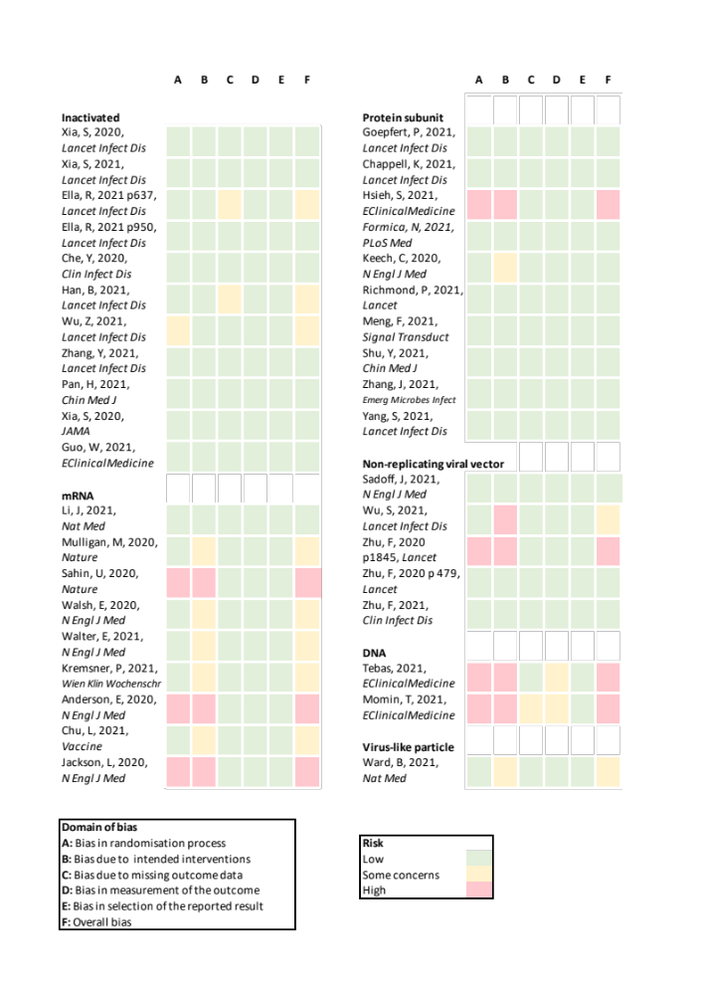

Figure S2. Risk of bias of 39 included studies.
The quality of included studies was assessed using the Cochrane Risk of Bias tool 2.0 for randomized trials ⁵⁰.

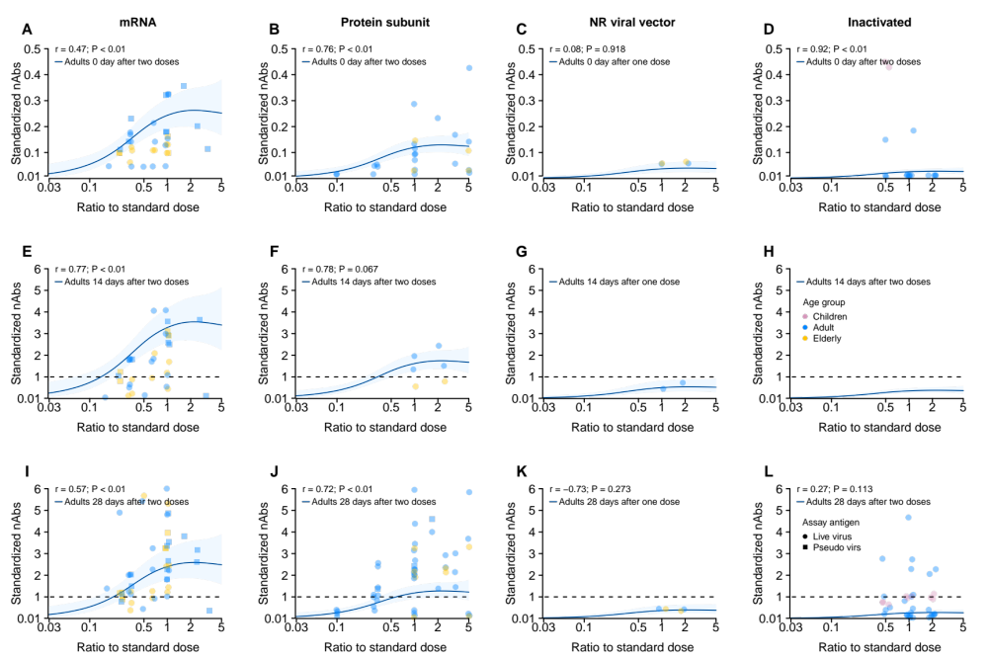

Figure S3. Model predictions of dose-response relationship of neutralizing antibodies (nAbs) against ancestral strains introduced by COVID-19 vaccines.
nAbs were standardized as the ratio to the convalescent sera. Model estimates were shown in Table S7. Dots indicates the raw data, which were shown in Figure S4-6. We show predictions of nAbs on day 0 (A-D), day 14 (E-H) and day 28 (I-L) since the complete vaccination.
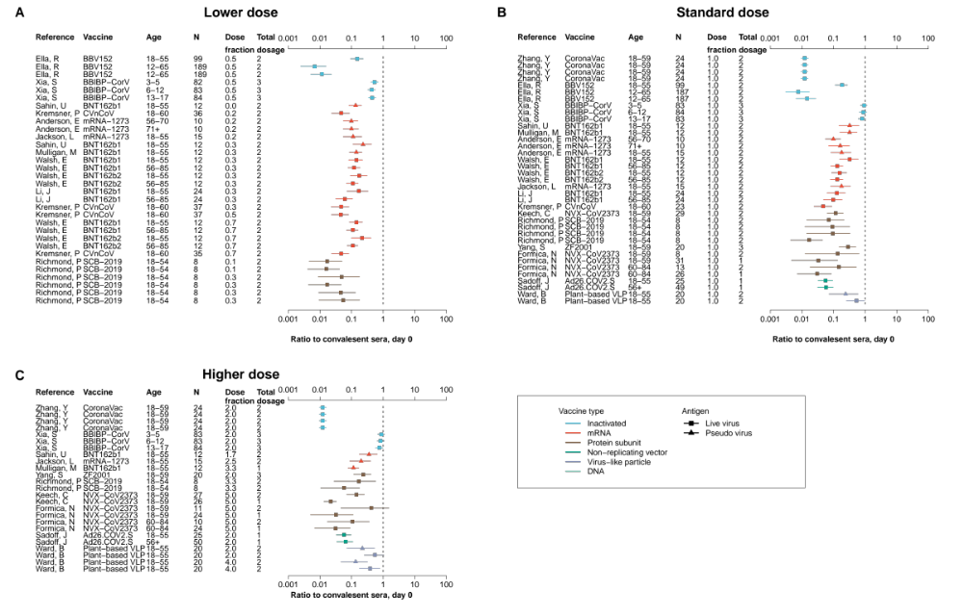

Figure S4. Standardized neutralizing antibodies (nAbs) introduced by COVID-19 vaccines on day 0 since the complete vaccination.
nAbs were standardized as the ratio to the convalescent sera. Estimates were classified as groups that received lower (A), the same (B), and higher (C) dose than the standard dose of that vaccine.
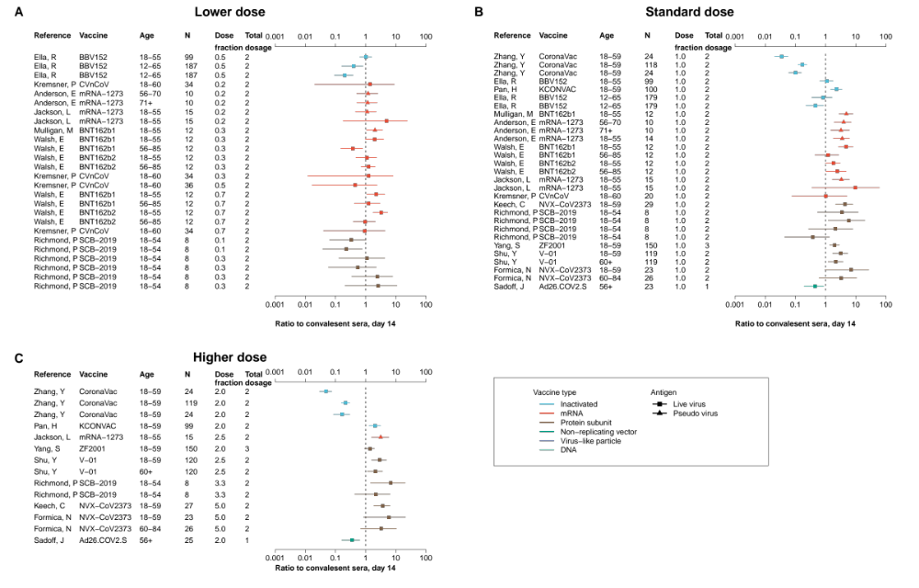

Figure S5. Standardized neutralizing antibodies (nAbs) introduced by COVID-19 vaccines on day 14 since the complete vaccination.
nAbs were standardized as the ratio to the convalescent sera. Estimates were classified as groups that received lower (A), the same (B), and higher (C) dose than the standard dose of that vaccine.
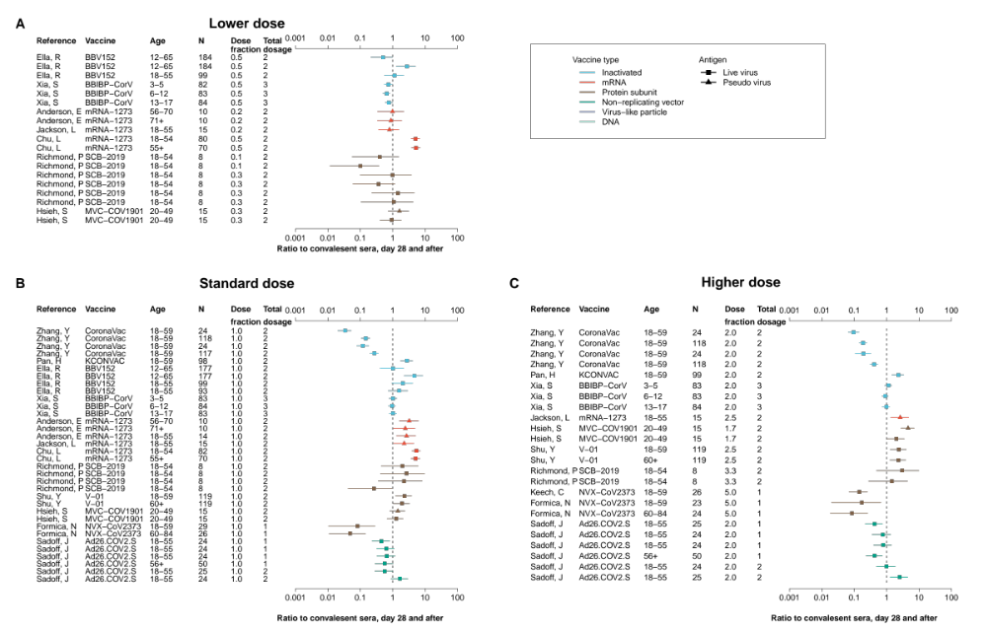

Figure S6. Standardized neutralizing antibodies (nAbs) introduced by COVID-19 vaccines on day 28 or later since the complete vaccination.
nAbs were standardized as the ratio to the convalescent sera. Estimates were classified as groups that received lower (A), the same (B), and higher (C) dose than the standard dose of that vaccine.

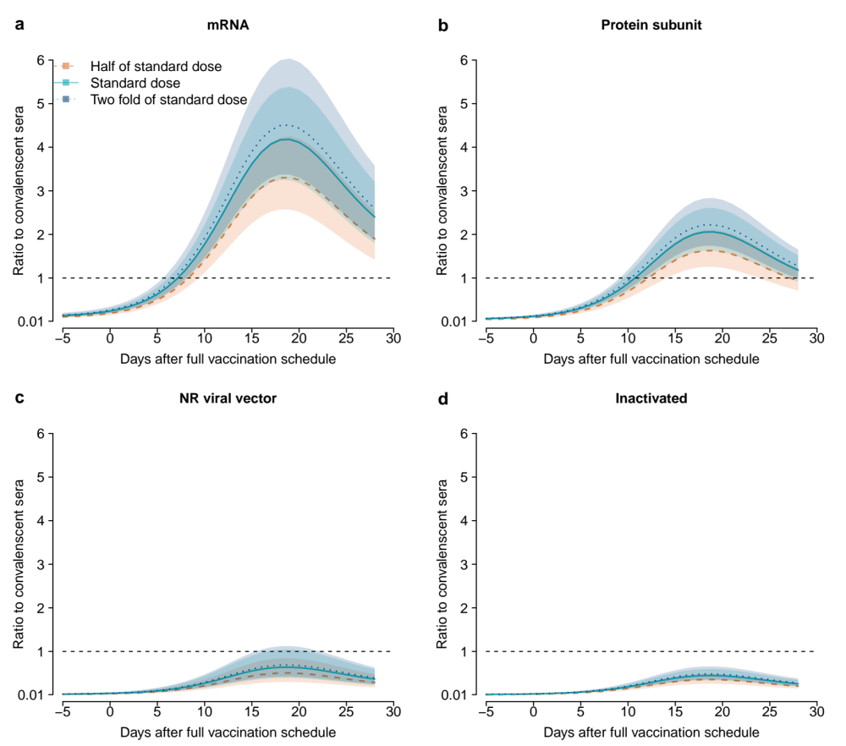

Figure S7. Associations between time since complete vaccination and the standardized neutralizing antibodies (nAbs) against the ancestral strains elicited by fractioning dose of COVID-19 vaccines.
Predictions on half, standard, and two-fold of the standard vaccine doses are shown. A 2-dose schedule was assumed for RNA, protein subunit and inactivated vaccines, while 1-dose schedule was assumed for non-replicating viral vector, which dose-relationship was driven by a 1-dose schedule vaccine (i.e., Ad26.COV2.S). Complete data that were used to derive these predictions were shown in Supplementary Figure 4 to 6. Dashed horizontal line indicates the average level of neutralizing antibodies against the wild-type strain in convalescent sera. (a) RNA. (b) Protein subunit. (c) Non-replicating viral vector. (d) Inactivated.
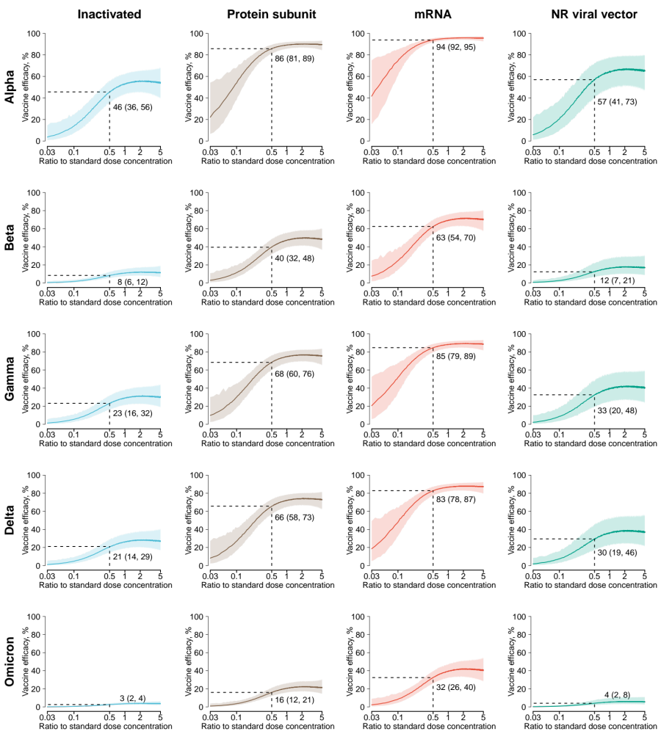

Figure S8. Dose-relationship between dose fractionation and predicted vaccine efficacy against symptomatic infections of variants of concern.

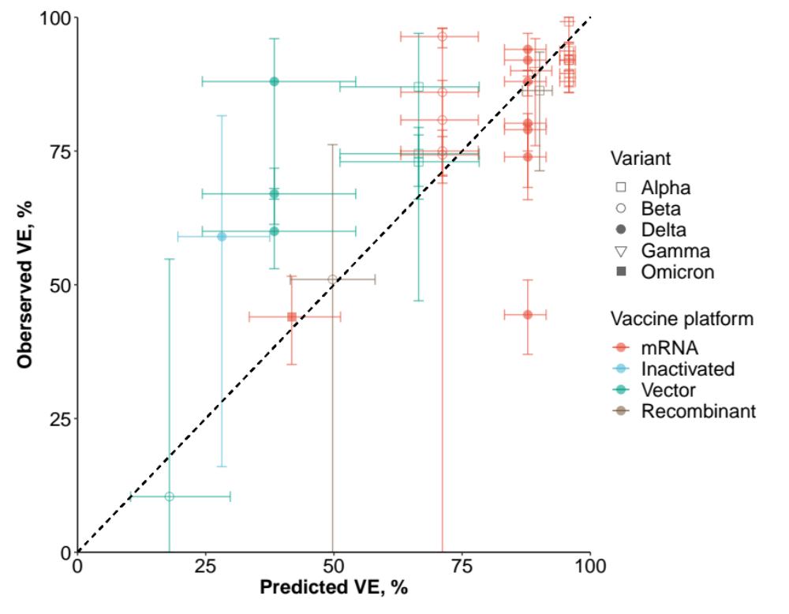

Figure S9. Correlation between predicted and observed vaccine efficacy against variants of concern for standard dose of COVID-19 vaccines.
Full model predictions (dose ratio = 1) were shown in Supplementary Figure S8. Observation data were shown in Supplementary Table 6. Pearson correlation coefficient is 0.705 (p < 0.05).

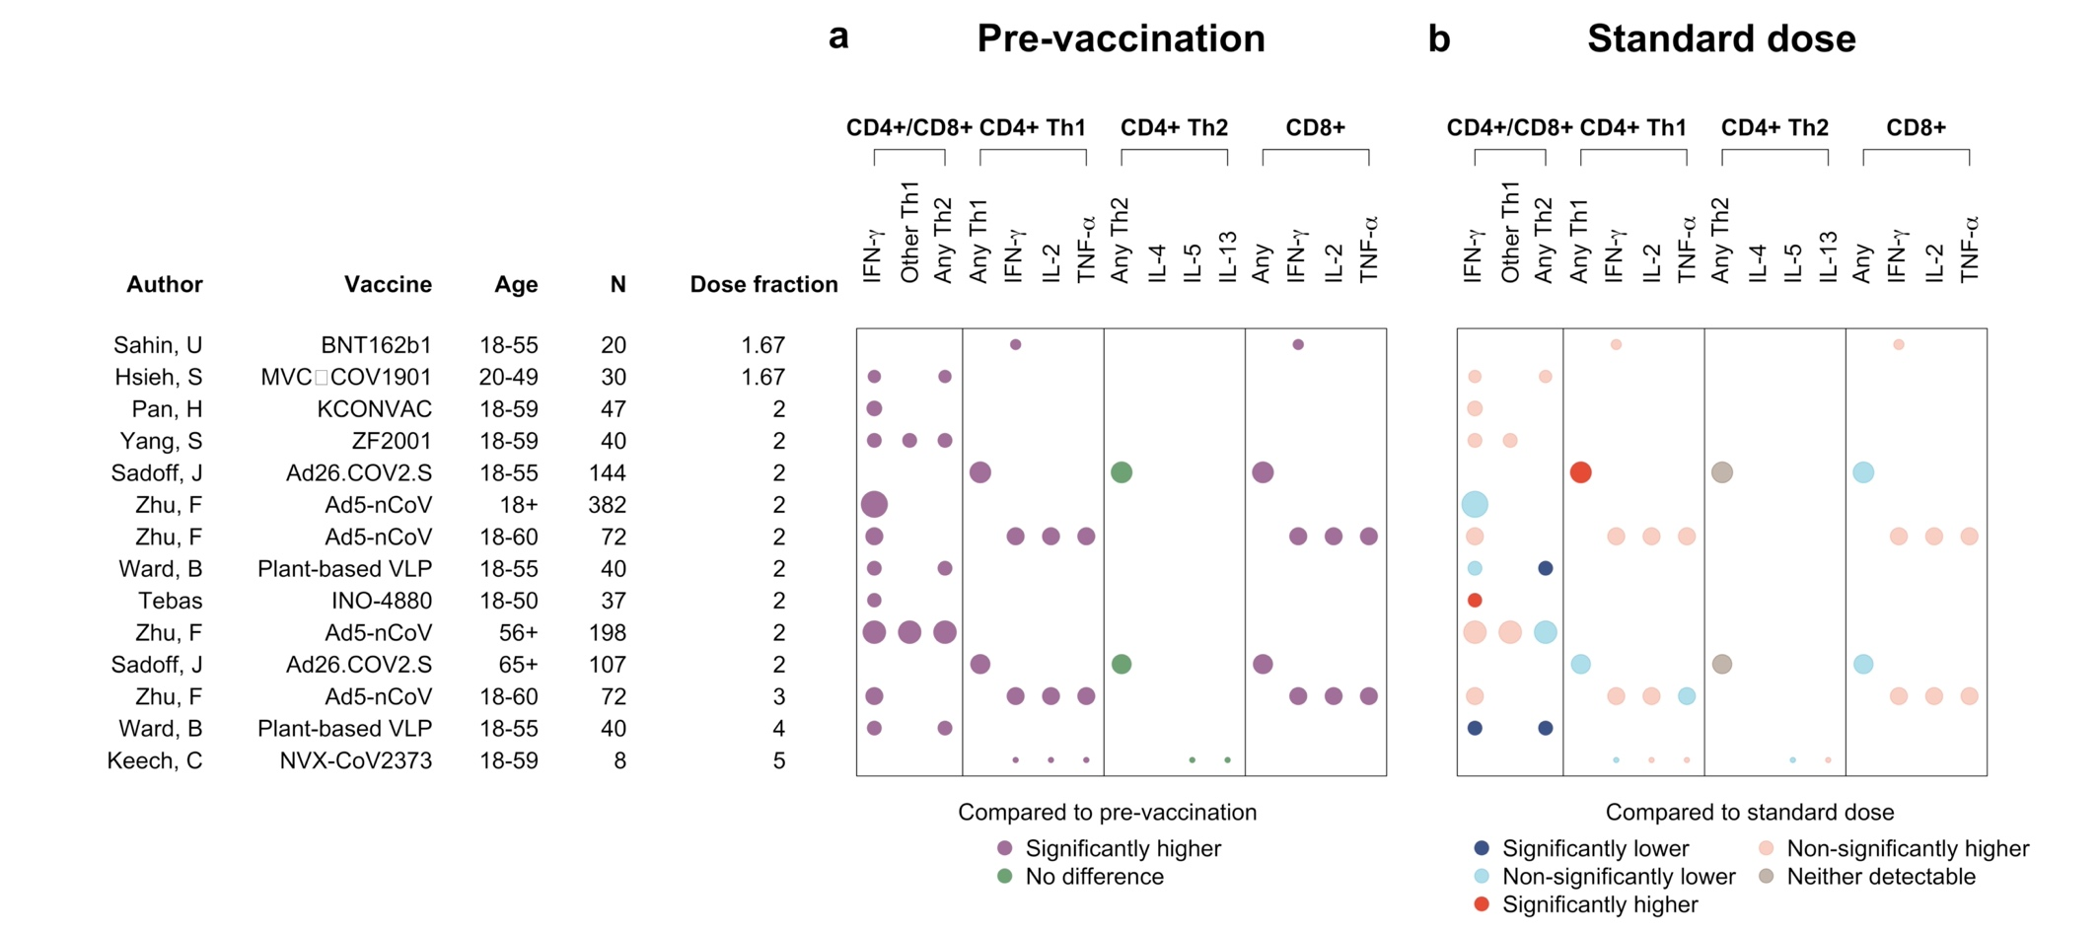

Figure S10. Comparison of T-cell responses against the ancestral strains elicited by higher doses of COVID-19 vaccines.
Size of dots represent the total sample sizes of the standard and non-standard dose groups. (a) Compared to pre-vaccination. If the mean and 95% CI of the difference in mean T-cell levels before and after the higher doses were all greater than 0, we determined T-cell responses were significantly higher between the groups. (b) Compared to people who received standard doses. If the mean and 95% CI of the difference in mean T-cell levels between the higher and standard dose groups were all greater or less than 0, we determined T-cell responses were significantly higher or lower than that elicited by the standard dose.

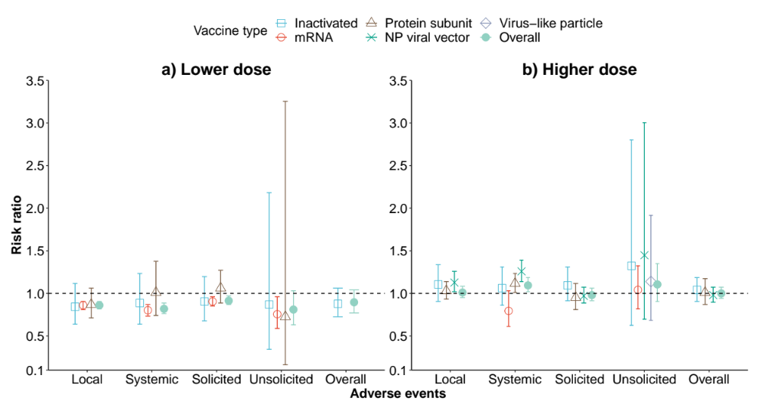

Figure S11. Comparison of safety after vaccinated with lower doses (a) and higher doses (b) to standard doses of SARS-CoV-2 vaccines.
Complete data that were used to derive the pooled estimates were shown in Figure S12-16. Dashed horizontal line indicates the average level of adverse events after vaccinated with standard doses of vaccines.
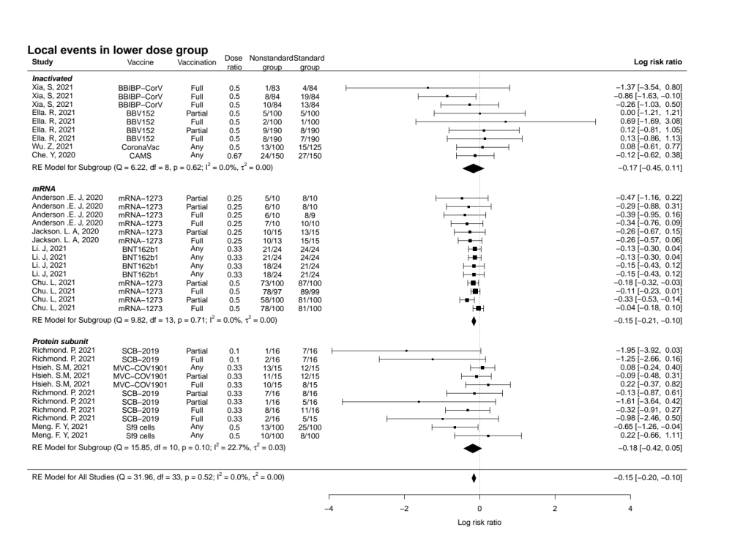

Figure S12. Pooled risk ratio (in log scale) of experiencing solicited local adverse events after vaccinated with fractional and standard dose groups.

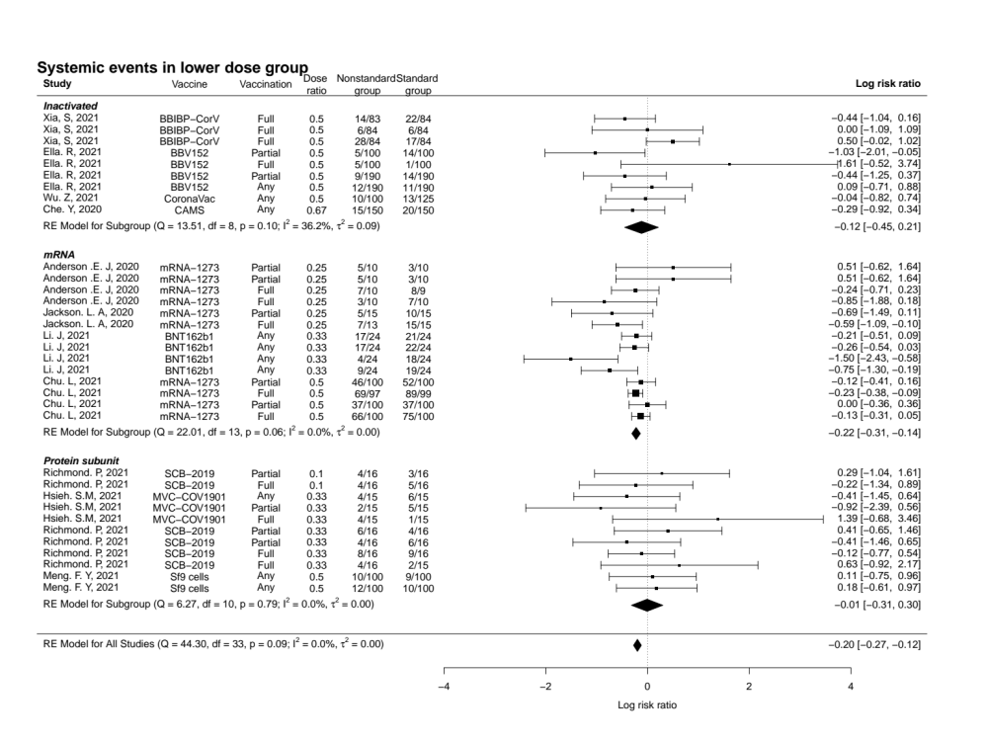

Figure S13. Pooled risk ratio (in log scale) of experiencing solicited systemic adverse events after vaccinated with fractional and standard dose groups.

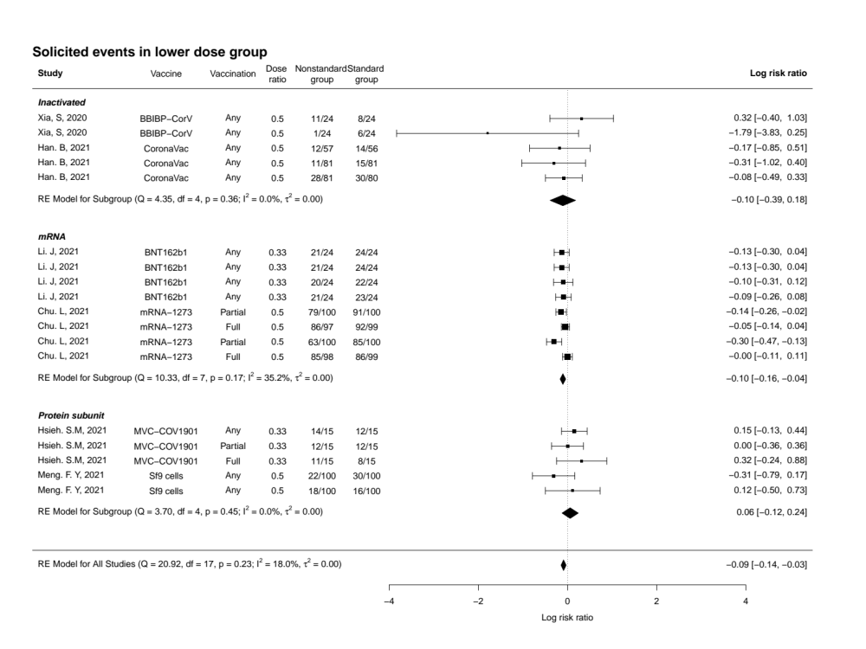

Figure S14. Pooled risk ratio (in log scale) of experiencing any solicited adverse events after vaccinated with fractional and standard dose groups.

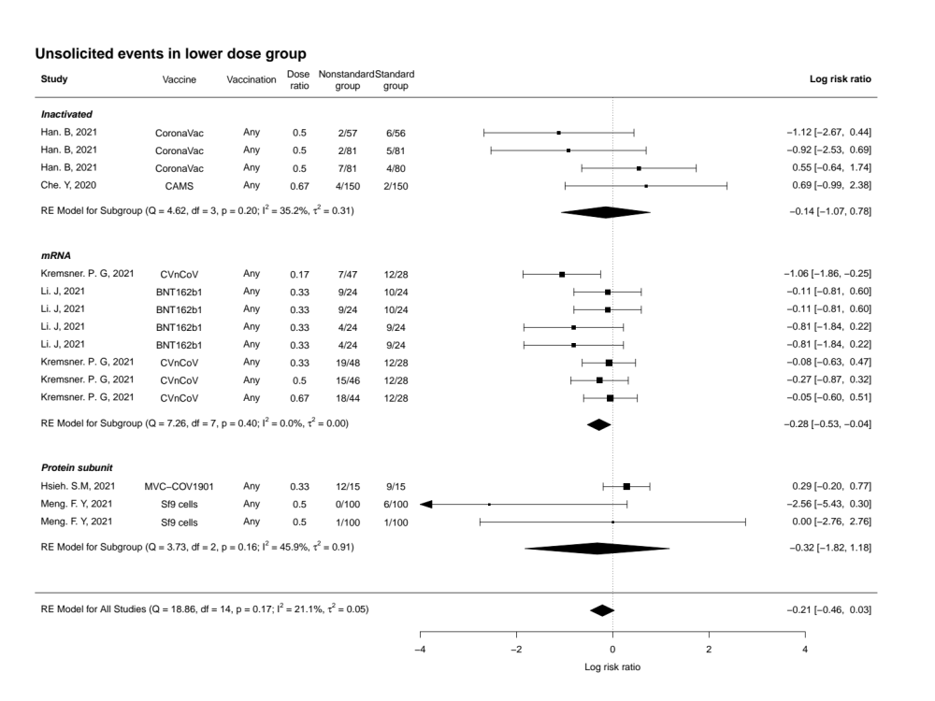

Figure S15. Pooled risk ratio (in log scale) of experiencing any unsolicited adverse events after vaccinated with fractional and standard dose groups.

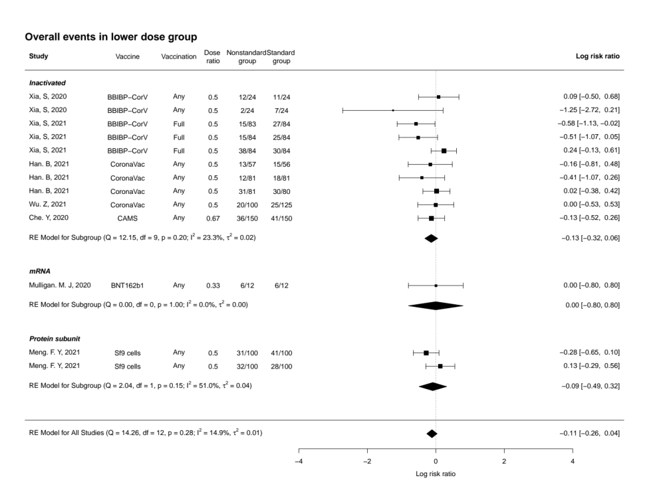

Figure S16. Pooled risk ratio (in log scale) of experiencing any adverse events after vaccinated with fractional and standard dose groups.

References
1 Xia, S. et al. Safety and immunogenicity of an inactivated SARS-CoV-2 vaccine, BBIBP-CorV: a randomised, double-blind, placebo-controlled, phase 1/2 trial. Lancet Infect Dis 21, 39-51, doi:10.1016/s1473-3099(20)30831-8 (2021).
2 Xia, S. et al. Safety and immunogenicity of an inactivated COVID-19 vaccine, BBIBP-CorV, in people younger than 18 years: a randomised, double-blind, controlled, phase 1/2 trial. Lancet Infect Dis, doi:10.1016/s1473-3099(21)00462-x (2021).
3 Ella, R. et al. Safety and immunogenicity of an inactivated SARS-CoV-2 vaccine, BBV152: a double-blind, randomised, phase 1 trial. Lancet Infect Dis 21, 637-646, doi:10.1016/s1473-3099(20)30942-7 (2021).
4 Ella, R. et al. Safety and immunogenicity of an inactivated SARS-CoV-2 vaccine, BBV152: interim results from a double-blind, randomised, multicentre, phase 2 trial, and 3-month follow-up of a double-blind, randomised phase 1 trial. Lancet Infect Dis 21, 950-961, doi:10.1016/s1473-3099(21)00070-0 (2021).
5 Che, Y. et al. Randomized, double-blinded and placebo-controlled phase II trial of an inactivated SARS-CoV-2 vaccine in healthy adults. Clin Infect Dis, doi:10.1093/cid/ciaa1703 (2020).
6 Han, B. et al. Safety, tolerability, and immunogenicity of an inactivated SARS-CoV-2 vaccine (CoronaVac) in healthy children and adolescents: a double-blind, randomised, controlled, phase 1/2 clinical trial. Lancet Infect Dis, doi:10.1016/s1473-3099(21)00319-4 (2021).
7 Wu, Z. et al. Safety, tolerability, and immunogenicity of an inactivated SARS-CoV-2 vaccine (CoronaVac) in healthy adults aged 60 years and older: a randomised, double-blind, placebo-controlled, phase 1/2 clinical trial. Lancet Infect Dis 21, 803-812, doi:10.1016/s1473-3099(20)30987-7 (2021).
8 Zhang, Y. et al. Safety, tolerability, and immunogenicity of an inactivated SARS-CoV-2 vaccine in healthy adults aged 18-59 years: a randomised, double-blind, placebo-controlled, phase 1/2 clinical trial. Lancet Infect Dis 21, 181-192, doi:10.1016/s1473-3099(20)30843-4 (2021).
9 Pan, H. X. et al. Immunogenicity and safety of a severe acute respiratory syndrome coronavirus 2 inactivated vaccine in healthy adults: randomized, double-blind, and placebo-controlled phase 1 and phase 2 clinical trials. Chin Med J (Engl) 134, 1289-1298, doi:10.1097/cm9.0000000000001573 (2021).
10 Xia, S. et al. Effect of an Inactivated Vaccine Against SARS-CoV-2 on Safety and Immunogenicity Outcomes: Interim Analysis of 2 Randomized Clinical Trials. Jama 324, 951-960, doi:10.1001/jama.2020.15543 (2020).
11 Guo, W. et al. Safety and immunogenicity of an inactivated SARS-CoV-2 vaccine in healthy adults aged 18 years or older: A randomized, double-blind, placebo-controlled, phase 1/2 trial. EClinicalMedicine 38, 101010, doi:10.1016/j.eclinm.2021.101010 (2021).
12 Goepfert, P. A. et al. Safety and immunogenicity of SARS-CoV-2 recombinant protein vaccine formulations in healthy adults: interim results of a randomised, placebo-controlled, phase 1-2, dose-ranging study. Lancet Infect Dis 21, 1257-1270, doi:10.1016/s1473-3099(21)00147-x (2021).
13 Chappell, K. J. et al. Safety and immunogenicity of an MF59-adjuvanted spike glycoprotein-clamp vaccine for SARS-CoV-2: a randomised, double-blind, placebo-controlled, phase 1 trial. Lancet Infect Dis, doi:10.1016/s1473-3099(21)00200-0 (2021).
14 Hsieh, S. M. et al. Safety and immunogenicity of a Recombinant Stabilized Prefusion SARS-CoV-2 Spike Protein Vaccine (MVC-COV1901) Adjuvanted with CpG 1018 and Aluminum Hydroxide in healthy adults: A Phase 1, dose-escalation study. EClinicalMedicine 38, 100989, doi:10.1016/j.eclinm.2021.100989 (2021).
15 Formica, N. et al. Different dose regimens of a SARS-CoV-2 recombinant spike protein vaccine (NVX-CoV2373) in younger and older adults: A phase 2 randomized placebo-controlled trial. PLoS Med 18, e1003769, doi:10.1371/journal.pmed.1003769 (2021).
16 Keech, C. et al. Phase 1-2 Trial of a SARS-CoV-2 Recombinant Spike Protein Nanoparticle Vaccine. N Engl J Med 383, 2320-2332, doi:10.1056/NEJMoa2026920 (2020).
17 Richmond, P. et al. Safety and immunogenicity of S-Trimer (SCB-2019), a protein subunit vaccine candidate for COVID-19 in healthy adults: a phase 1, randomised, double-blind, placebo-controlled trial. Lancet 397, 682-694, doi:10.1016/s0140-6736(21)00241-5 (2021).
18 Meng, F. Y. et al. Safety and immunogenicity of a recombinant COVID-19 vaccine (Sf9 cells) in healthy population aged 18 years or older: two single-center, randomised, double-blind, placebo-controlled, phase 1 and phase 2 trials. Signal Transduct Target Ther 6, 271, doi:10.1038/s41392-021-00692-3 (2021).
19 Shu, Y. J. et al. Immunogenicity and safety of a recombinant fusion protein vaccine (V-01) against coronavirus disease 2019 in healthy adults: a randomized, double-blind, placebo-controlled, phase II trial. Chin Med J (Engl) 134, 1967-1976, doi:10.1097/cm9.0000000000001702 (2021).
20 Zhang, J. et al. Safety and immunogenicity of a recombinant interferon-armed RBD dimer vaccine (V-01) for COVID-19 in healthy adults: a randomized, double-blind, placebo-controlled, Phase I trial. Emerg Microbes Infect 10, 1589-1597, doi:10.1080/22221751.2021.1951126 (2021).
21 Yang, S. et al. Safety and immunogenicity of a recombinant tandem-repeat dimeric RBD-based protein subunit vaccine (ZF2001) against COVID-19 in adults: two randomised, double-blind, placebo-controlled, phase 1 and 2 trials. Lancet Infect Dis 21, 1107-1119, doi:10.1016/s1473-3099(21)00127-4 (2021).
22 Li, J. et al. Safety and immunogenicity of the SARS-CoV-2 BNT162b1 mRNA vaccine in younger and older Chinese adults: a randomized, placebo-controlled, double-blind phase 1 study. Nat Med 27, 1062-1070, doi:10.1038/s41591-021-01330-9 (2021).
23 Mulligan, M. J. et al. Phase I/II study of COVID-19 RNA vaccine BNT162b1 in adults. Nature 586, 589-593, doi:10.1038/s41586-020-2639-4 (2020).
24 Sahin, U. et al. COVID-19 vaccine BNT162b1 elicits human antibody and T(H)1 T cell responses. Nature 586, 594-599, doi:10.1038/s41586-020-2814-7 (2020).
25 Walsh, E. E. et al. Safety and Immunogenicity of Two RNA-Based Covid-19 Vaccine Candidates. N Engl J Med 383, 2439-2450, doi:10.1056/NEJMoa2027906 (2020).
26 Walter, E. B. et al. Evaluation of the BNT162b2 Covid-19 Vaccine in Children 5 to 11 Years of Age. N Engl J Med, doi:10.1056/NEJMoa2116298 (2021).
27 Kremsner, P. G. et al. Safety and immunogenicity of an mRNA-lipid nanoparticle vaccine candidate against SARS-CoV-2 : A phase 1 randomized clinical trial. Wien Klin Wochenschr, 1-11, doi:10.1007/s00508-021-01922-y (2021).
28 Anderson, E. J. et al. Safety and Immunogenicity of SARS-CoV-2 mRNA-1273 Vaccine in Older Adults. N Engl J Med 383, 2427-2438, doi:10.1056/NEJMoa2028436 (2020).
29 Chu, L. et al. A preliminary report of a randomized controlled phase 2 trial of the safety and immunogenicity of mRNA-1273 SARS-CoV-2 vaccine. Vaccine 39, 2791-2799, doi:10.1016/j.vaccine.2021.02.007 (2021).
30 Jackson, L. A. et al. An mRNA Vaccine against SARS-CoV-2 - Preliminary Report. N Engl J Med 383, 1920-1931, doi:10.1056/NEJMoa2022483 (2020).
31 Sadoff, J. et al. Interim Results of a Phase 1-2a Trial of Ad26.COV2.S Covid-19 Vaccine. N Engl J Med 384, 1824-1835, doi:10.1056/NEJMoa2034201 (2021).
32 Wu, S. et al. Safety, tolerability, and immunogenicity of an aerosolised adenovirus type-5 vector-based COVID-19 vaccine (Ad5-nCoV) in adults: preliminary report of an open-label and randomised phase 1 clinical trial. Lancet Infect Dis, doi:10.1016/s1473-3099(21)00396-0 (2021).
33 Zhu, F. C. et al. Safety, tolerability, and immunogenicity of a recombinant adenovirus type-5 vectored COVID-19 vaccine: a dose-escalation, open-label, non-randomised, first-in-human trial. Lancet 395, 1845-1854, doi:10.1016/s0140-6736(20)31208-3 (2020).
34 Zhu, F. C. et al. Immunogenicity and safety of a recombinant adenovirus type-5-vectored COVID-19 vaccine in healthy adults aged 18 years or older: a randomised, double-blind, placebo-controlled, phase 2 trial. Lancet 396, 479-488, doi:10.1016/s0140-6736(20)31605-6 (2020).
35 Zhu, F. et al. Safety and immunogenicity of a recombinant adenovirus type-5-vectored COVID-19 vaccine with a homologous prime-boost regimen in healthy participants aged 6 years and above: a randomised, double-blind, placebo-controlled, phase 2b trial. Clin Infect Dis, doi:10.1093/cid/ciab845 (2021).
36 Tebas, P. et al. Safety and immunogenicity of INO-4800 DNA vaccine against SARS-CoV-2: A preliminary report of an open-label, Phase 1 clinical trial. EClinicalMedicine 31, 100689, doi:10.1016/j.eclinm.2020.100689 (2021).
37 Momin, T. et al. Safety and Immunogenicity of a DNA SARS-CoV-2 vaccine (ZyCoV-D): Results of an open-label, non-randomized phase I part of phase I/II clinical study by intradermal route in healthy subjects in India. EClinicalMedicine 38, 101020, doi:10.1016/j.eclinm.2021.101020 (2021).
38 Ward, B. J. et al. Phase 1 randomized trial of a plant-derived virus-like particle vaccine for COVID-19. Nat Med 27, 1071-1078, doi:10.1038/s41591-021-01370-1 (2021).
39 Abu-Raddad, L. J., Chemaitelly, H., Butt, A. A. & National Study Group for, C.-V. Effectiveness of the BNT162b2 Covid-19 Vaccine against the B.1.1.7 and B.1.351 Variants. N Engl J Med 385, 187-189, doi:10.1056/NEJMc2104974 (2021).
40 Lopez Bernal, J. et al. Effectiveness of Covid-19 Vaccines against the B.1.617.2 (Delta) Variant. N Engl J Med 385, 585-594, doi:10.1056/NEJMoa2108891 (2021).
41 Heath, P. T. et al. Safety and Efficacy of NVX-CoV2373 Covid-19 Vaccine. N Engl J Med, doi:10.1056/NEJMoa2107659 (2021).
42 Sheikh, A. et al. SARS-CoV-2 Delta VOC in Scotland: demographics, risk of hospital admission, and vaccine effectiveness. Lancet 397, 2461-2462, doi:10.1016/S0140-6736(21)01358-1 (2021).
43 Nasreen, S. et al. Effectiveness of COVID-19 vaccines against symptomatic SARS-CoV-2 infection and severe outcomes with variants of concern in Ontario. Nat Microbiol 7, 379-385, doi:10.1038/s41564-021-01053-0 (2022).
44 Chemaitelly, H. et al. mRNA-1273 COVID-19 vaccine effectiveness against the B.1.1.7 and B.1.351 variants and severe COVID-19 disease in Qatar. Nat Med 27, 1614-1621, doi:10.1038/s41591-021-01446-y (2021).
45 Madhi, S. A. et al. Efficacy of the ChAdOx1 nCoV-19 Covid-19 Vaccine against the B.1.351 Variant. N Engl J Med 384, 1885-1898, doi:10.1056/NEJMoa2102214 (2021).
46 Tang, P. et al. BNT162b2 and mRNA-1273 COVID-19 vaccine effectiveness against the SARS-CoV-2 Delta variant in Qatar. Nat Med 27, 2136-2143, doi:10.1038/s41591-021-01583-4 (2021).
47 Li, X. N. et al. Effectiveness of inactivated SARS-CoV-2 vaccines against the Delta variant infection in Guangzhou: a test-negative case-control real-world study. Emerg Microbes Infect 10, 1751-1759, doi:10.1080/22221751.2021.1969291 (2021).
48 Tseng, H. F. et al. Effectiveness of mRNA-1273 against SARS-CoV-2 Omicron and Delta variants. Nat Med, doi:10.1038/s41591-022-01753-y (2022).
49 Collie, S., Champion, J., Moultrie, H., Bekker, L. G. & Gray, G. Effectiveness of BNT162b2 Vaccine against Omicron Variant in South Africa. N Engl J Med 386, 494-496, doi:10.1056/NEJMc2119270 (2022).
50 Sterne, J. A. C. et al. RoB 2: a revised tool for assessing risk of bias in randomised trials. BMJ 366, l4898, doi:10.1136/bmj.l4898 (2019).

