Additional files

Additional files 1: Table S1. Strains and plasmids were used in this study
Strain or plasmid | Feature | Source
Strains
B. subtilis | B. subtilis 168; G⁺ | FHSW ª
B. subtilisΔHfq | B. subtilis 168; G⁺; Hfq⁻; a fragment of erythromycin resistance gene (emr) amplified from plasmid pMG36e was inserted | This study
B. subtilisΔHfq-C | B. subtilis 168; G⁺; Hfq⁺; a fragment of erythromycin resistance gene (emr) amplified from plasmid pMG36e was inserted; contains pHYP43-Hfq plasmid which can express Hfq | This study
Escherichia coli DH5α | G⁻; competent cell | FHSW ª
Plasmids
pUC18 | cloning vector; Ap^{r} | FHSW ª
pUC18-emr | cloning vector; Ap^{r}, Em^{r} | This study
pUC18-emr-down | cloning vector; Ap^{r}, Em^{r}; contains Hfq downstream homologous arm down with 446 bp | This study
pUC18-up-emr-down | cloning vector; Ap^{r}, Em^{r}; contains Hfq downstream homologous arm down with 446bp; contains Hfq upstream homologous arm up with 910 bp | This study
pMG36e | constitutive expression plasmid of Lactococcus lactis; contains a complete gene fragment emr that can express erythromycin resistance (Em^{r}). | FHSW ª
pHY-P43 | B. subtilis expression vector; P43 promoter; Ap^{r}, Tc^{r} | FHSW ª
pHY-P43-Hfq | B. subtilis expression vector; P43 promoter; Ap^{r}, Tc^{r}; can express Hfq protein | This study
ª Hunan Fenghui Biotechnology Co., Ltd, China

Additional files 2: Table S2. Primers were used in this study
Primers | Sequence ^{b} | Restriction site | Source
Hfq-UP F | TCGGAGCTCGAACAGGAGATGGAGGGAGTG | SacI | This Study
Hfq-UP R | TCCCCCGGGGTGAAAGCCGTTCAGCAAA | SmaI | This Study
Hfq-DOWN F | TGCTCTAGAGTTGGAATCGGAAGGTAAG | XbaI | This Study
Hfq-DOWN R | TCGCCTGCAGGGTCAAGTGGAAACGAGGTG | sbfI | This Study
pMG36e-EMR F | TCCCCCGGGGATCATATCCCGAGGACCG | SmaI | This Study
pMG36e-EMR R | TGCTCTAGAGTCTCCCAATCAGGCTTGA | XbaI | This Study
Hfq-C F | GCGTCGACATGAAACCGATTAATATTCAGG | SalI | This Study
Hfq-C R | TCCCCCGGGCTATTCGAGTTCAAGCTGGAC | SmaI | This Study
pHYP43-MCS F | TACGGTTGATTTAATAACTGAC | None | This Study
pHYP43-MCS R | TGGAATGAGTTTGCTTAACT | None | This Study
RT-qPCR |  | Target gene
16S F | GCTTGCTCCCTGATGTTAGC | 16S rRNA | (18)
16S R | TTGCGGAAGATTCCCTACTG | 16S rRNA | (18)
HFQ F | GGGCCAGGTGAAAGGCTTTGATAA | Hfq | This Study
HFQ R | GCGGCGCAAACGTTGAGATC | Hfq | This Study
CCPA F | CAGTGCCGATTGTACTTGCC | ccpA | This Study
CCPA R | TCAACCAAAAGCTTCACGGC | ccpA | This Study
BGLP F | TGCGGCACAGCAATCTCA | bglP | This Study
BGLP R | AGGAGCGGCAGGAAGTAGAA | bglP | This Study
LICA F | TCACGGAGGAAACGGTAG | licA | This Study
LICA R | GTCTGATAATGATGGGCTTT | licA | This Study
LICB F | GGTCCGCAAGTCCGTTAC | licB | This Study
LICB R | CCCATTGCACGTTCCATA | licB | This Study
LICC F | ACCATGCCGCCGATCTTT | licC | This Study
LICC R | CAGCTTCTGCTTATCCCACA | licC | This Study
EGLS F | AAACATTCTCGGCACCAA | eglS | This Study
EGLS R | TGTTCATACTCCCATCCC | eglS | This Study
BGLA F | GTCGTGGACTTCTTCGTCA | bglA | This Study
BGLA R | CATAGGAACAGCGGATTGT | bglA | This Study
BGLC F | GAATTACAAGCCGCTATCA | bglC | This Study
BGLC R | TACAGTGCCGTCCTCAAC | bglC | This Study
SIGA F | AATCGCCTGTCTGATCCACC | sigA | This Study
SIGA R | TCGCAAAACGGTATGTCGGA | sigA | This Study
BSRA F | GTTTTGAACCCGCTCTCAGC | bsrA (6S-1 RNA) | This Study
BSRA R | ATTTGGGAGCCCGCATTTTT | bsrA (6S-1 RNA) | This Study
BSRB F | GGAAATGGCTTTCGCTACGTC | bsrB (6S-2 RNA) | This Study
BSRB R | TTGCAGAGGACGACAGGAAC | bsrB (6S-2 RNA) | This Study
^{b} Restriction enzyme sites are represented by underscores.

Additional files 3: 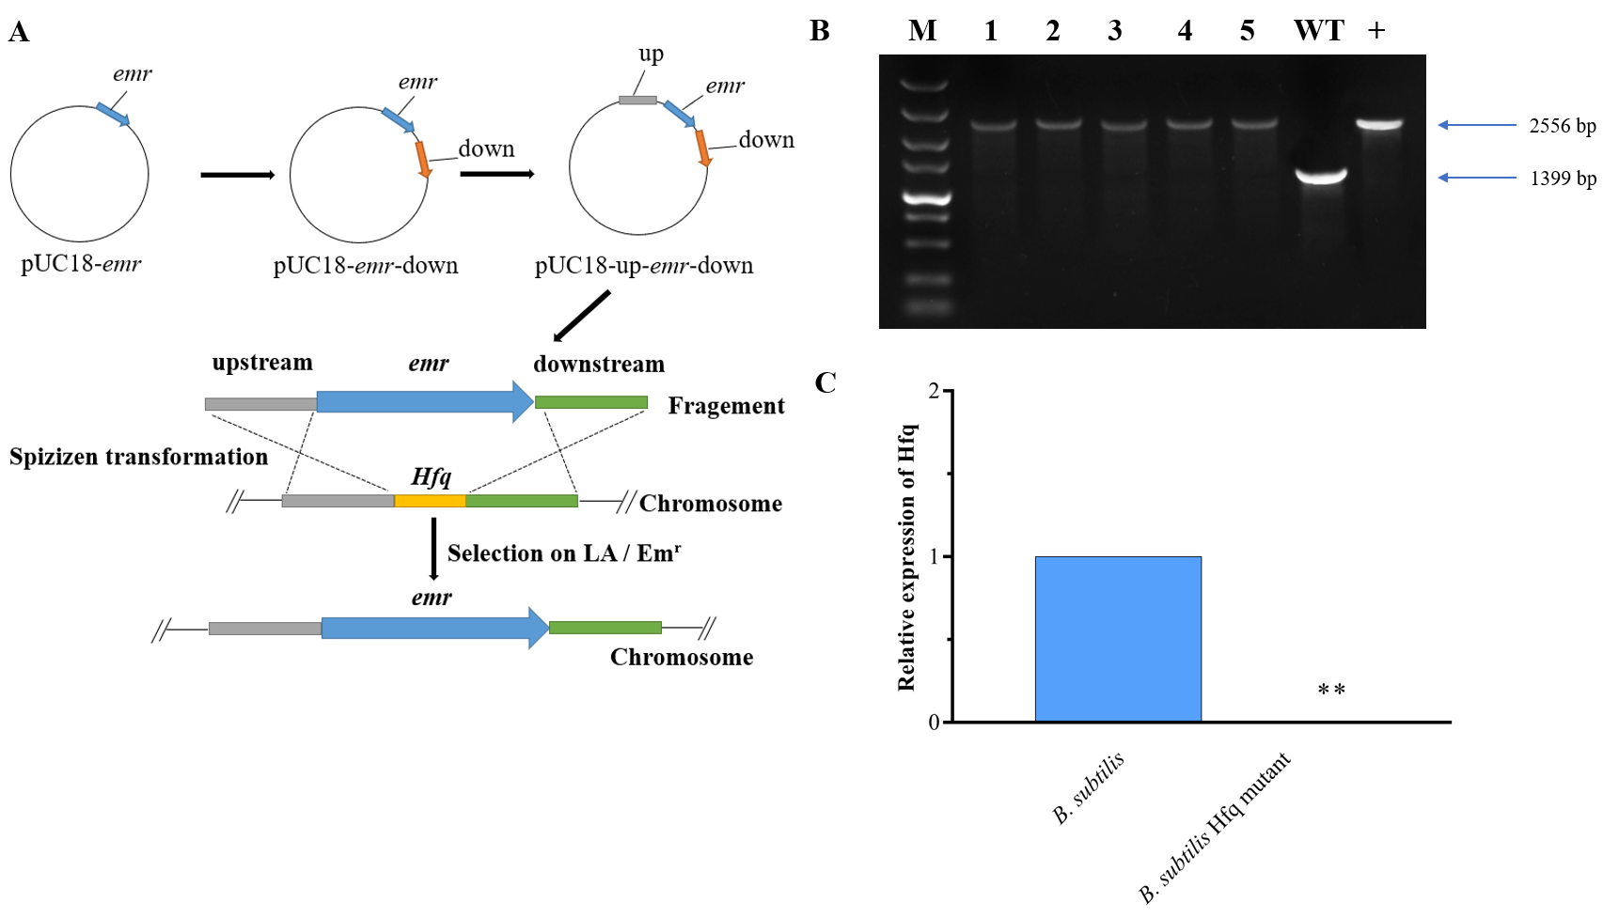
Figure S1. PCR and RT-qPCR confirmation of the Hfq mutant. (A) The gene knockout scheme. (B) PCR confirmation of the Hfq mutant. M, Mark; line 1-5, Hfq mutant; line 6, B. subtilis, WT control; line 7, up-emr-down fragment, positive control. (C) RT-qPCR analysis of the Hfq mutant. ANOVA results are marked above the error bars. ** indicates significant difference from control group B. subtilis of P < 0.01.

Additional files 4: Table S3. Cellulose hydrolysis ability of B. subtilis, B. subtilisΔHfq, and B. subtilisΔHfq-C.
Group | Number of samples | D/d (mean ±standard deviation) | Significant difference analysis
B. subtilis | 3 | 3.32 ± 0.06 | D
B. subtilisΔHfq | 3 | 2.06 ± 0.10 | B
B. subtilisΔHfq-C | 3 | 3.2 ± 0.03 | D
D/d indicates the ratio of the diameter of the hydrolysis circle (D) to the diameter of the colony (d) ; B indicates significant difference from control group B. subtilis of P < 0.01; D indicates significant difference from control group B. subtilisΔHfq of P < 0.01.

