Supplementary Fig. S1 to Fig. S11 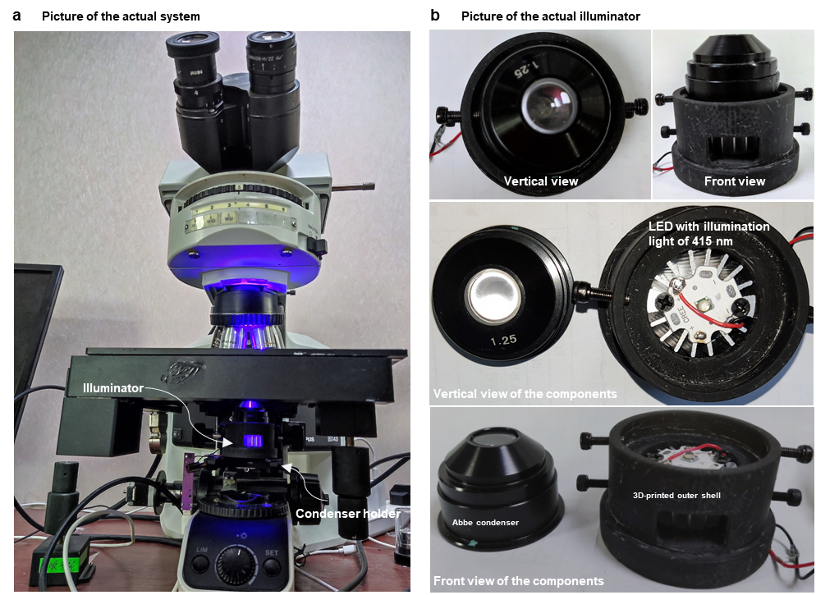
Fig. S1 Picture of the actual system and the homemade illuminator. a Diagram of the imaging system of HADI. A regular microscope was adopted. The microscope includes an objective lens (UPlanApo, 40X, 0.95 NA, SOPTOP) and a camera (MV-SUA202GM-T, sensor CMOS, image size 1920 x 1200, pixel size 4.8 μm x 4.8 μm, MindVision). A homemade illuminator is placed on the microscope condenser holder. b The picture of the homemade illuminator. The illuminator is composed of an Abbe condenser (NA = 1.25), a 3D-printed outer shell, and a LED (EPILEDS, XP-3535) with a center wavelength of 415 nm. The LED is fixed on the bottom center of the illuminator.
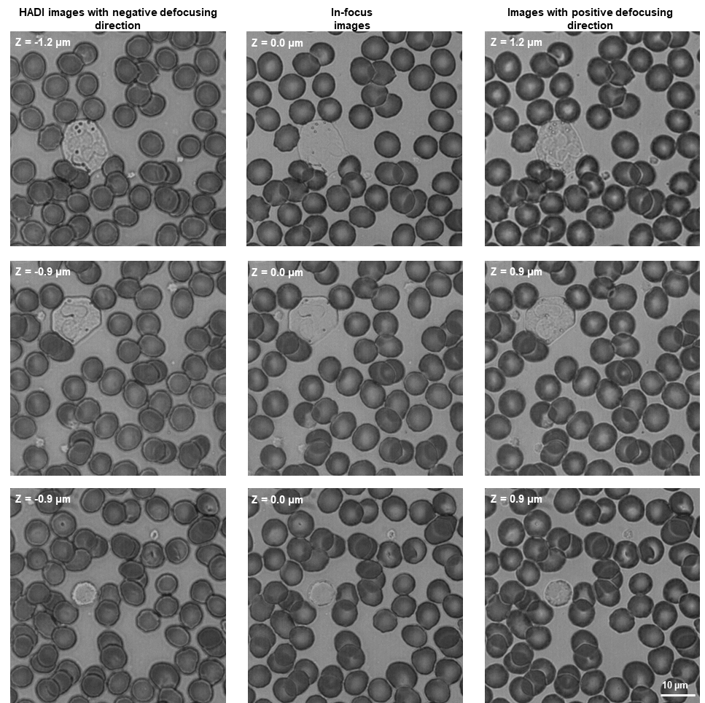
Fig. S2 The inner structures of the unstained blood cells become visible with defocusing. The HADI images were captured with negative defocusing directions and the defocusing distances are around 1 µm. The inner texture of the leukocytes in the in-focus images is flat. The blood images captured with positive defocusing directions reveal symmetric structure information as the HADI images but have different color styles which are consistent with the theory of the defocusing phase-contrast imaging.
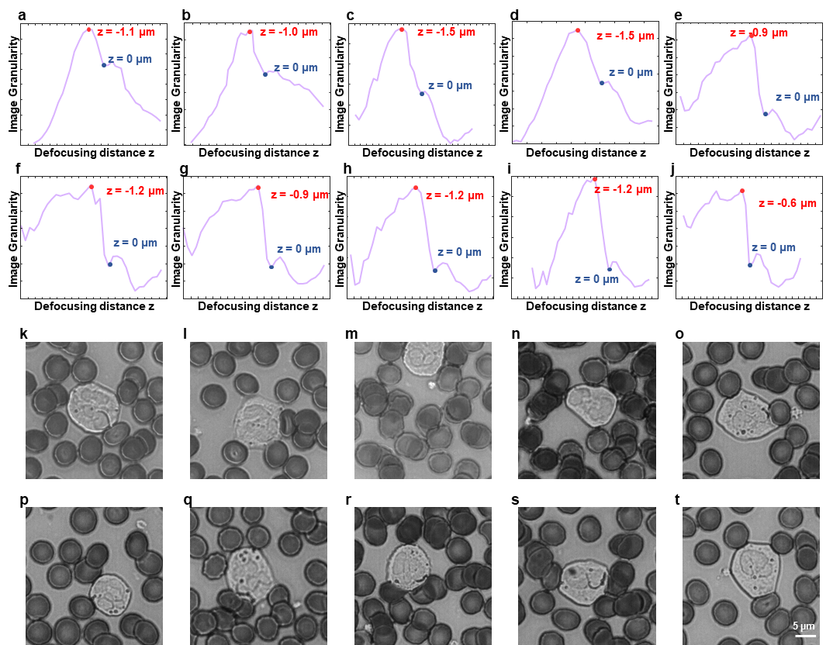
Fig. S3 Image granularity (IG) can be served as an autofocus criterion for the HADI. a-j IG curves for 10 different blood smear regions. Axial images of the 10 blood smear regions were captured to generate the IG curves. The axial interval is around 0.3 μm. The input image size is 1920 x 1200. The blue points that are the local minimum points of the IG curves correspond to the in-focus position (z = 0). The red points are the maximum points of the IG curves. k-t Local images (image size of 256 x 256) from the axial images with the maximum IG values (red points). From the results, the HADI images can be captured at the axial position where the IG value achieves the maximum. The IG can be used as the autofocusing criterion for the HADI.
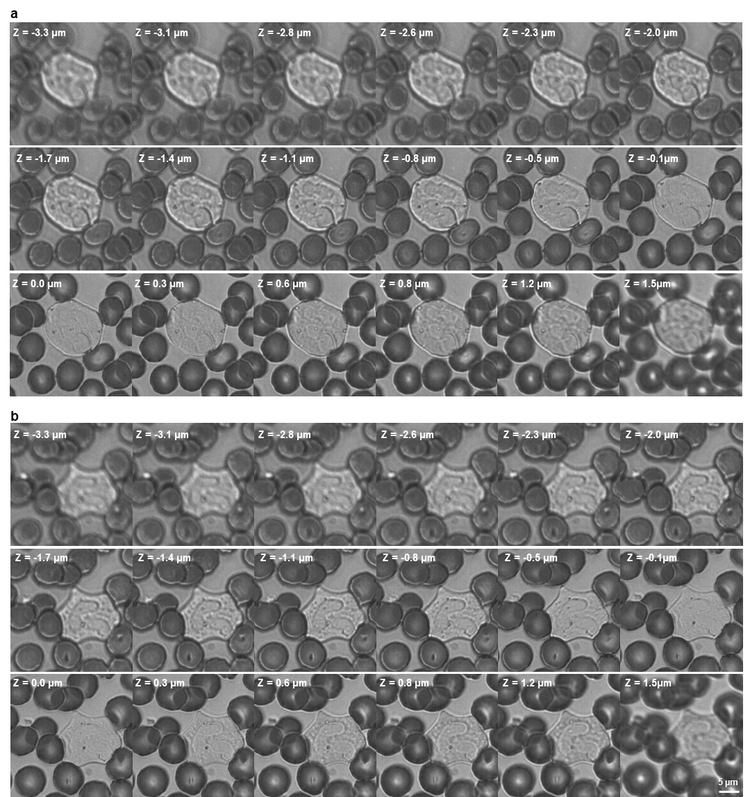
Fig. S4 Two local axial images from the same blood smear region corresponding to Fig. S3 a. a The first local axial image with a leukocyte. b The second local axial image with another leukocyte. The defocusing distance is varying from -3.3 μm to 1.5 μm. The IG value achieves the maximum with a defocusing distance of -1.1 μm.
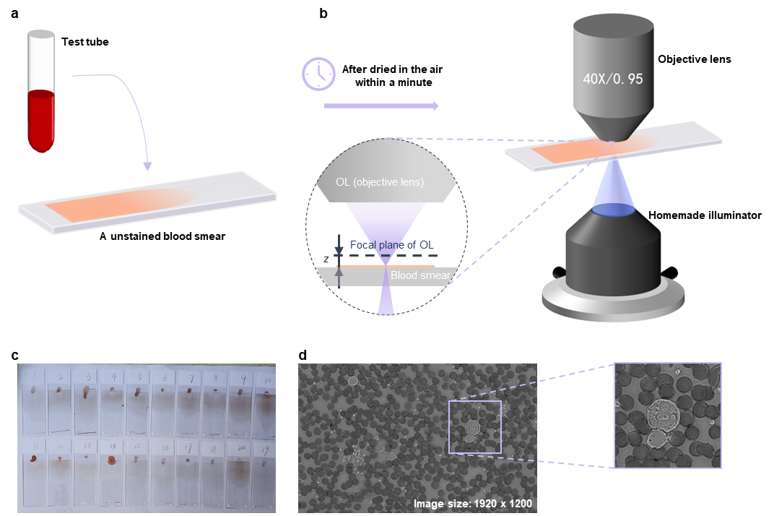
Fig. S5 Sample and data preparation. a About 10 µl of blood was used to make a blood smear without staining. b After the blood smear was dried in the air within a minute, the HADI images were captured with defocusing. c Picture for some unstained blood smears used in this work. d one of the HADI images with original image size 1920 x 1200.
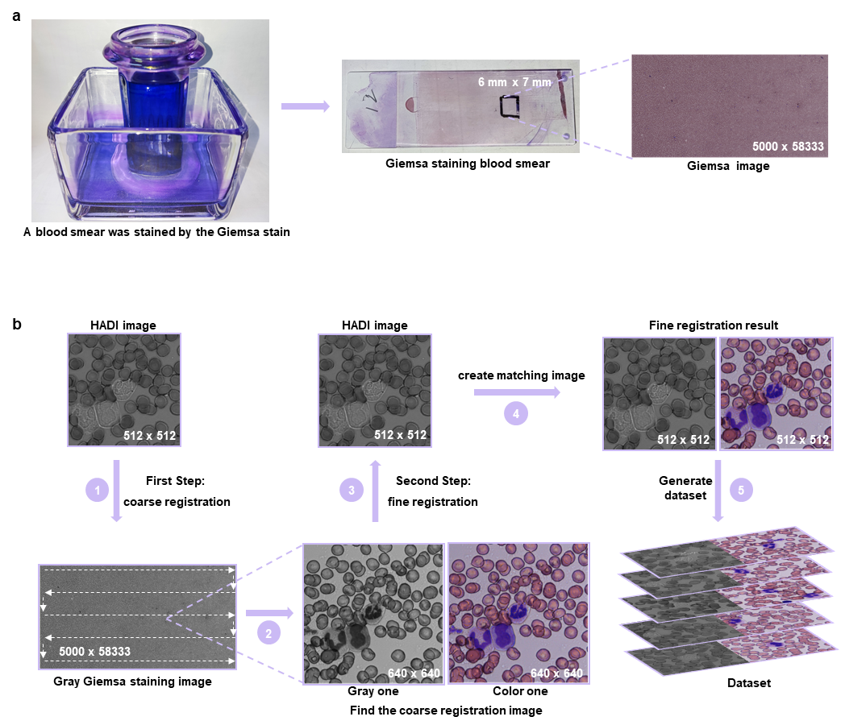
Fig. S6 Registration of the HADI images and the Giemsa images. a Obtaining the Giemsa staining blood smears and the Giemsa image. After the HADI was performed, the blood smear was stained by the Giemsa stain. And then the stained blood smear was scanned by a whole slide imaging system to obtain the Giemsa image. b Image registration contains a coarse registration step and a fine registration step. Before the registration, the original HADI images were cut into small image patches with image size of 512 x 512, and the Giemsa images were converted into gray style. The RMSE between the HADI image and the image patches (image size of 640 x 640) from the Gray Giemsa image was calculated. The coarse-matching image was cropped from the Giemsa image at the location where the RMSE achieve a minimum. The image patches from the Giemsa images were searched with a continuous path (shown in the figure). Then the fine registration was performed based on the multi-modal registration function supplied by the official website of MATLAB⁵⁴. After registration, the dataset contains the HADI images and their corresponding Giemsa staining images were obtained.

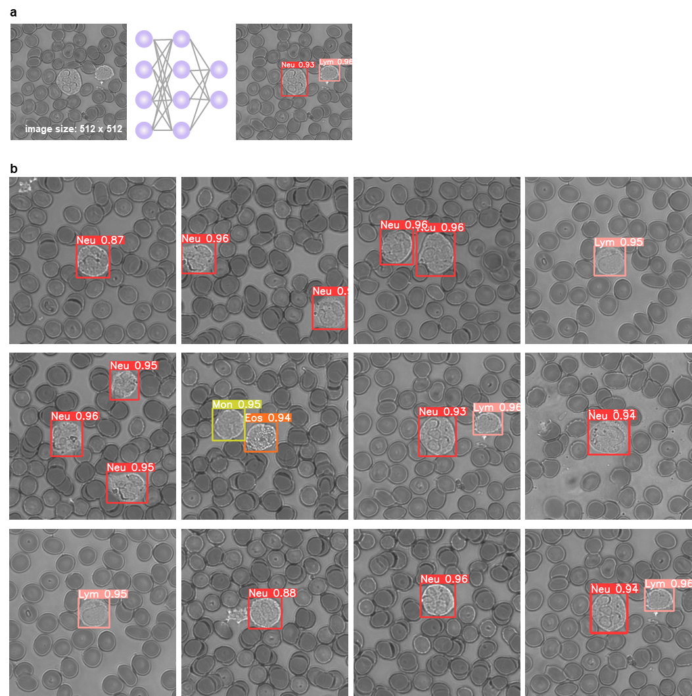
Fig. S7 Five-part leukocyte differential algorithm based on YOLO V5. a leukocyte identification and classification with YOLO V5 network. The input of the network is a HADI image with an image size of 512 x 512 and the output is the predicted leukocyte subtype labels, bounding boxes, and confidence coefficients. b Some other inference results on the testing dataset.

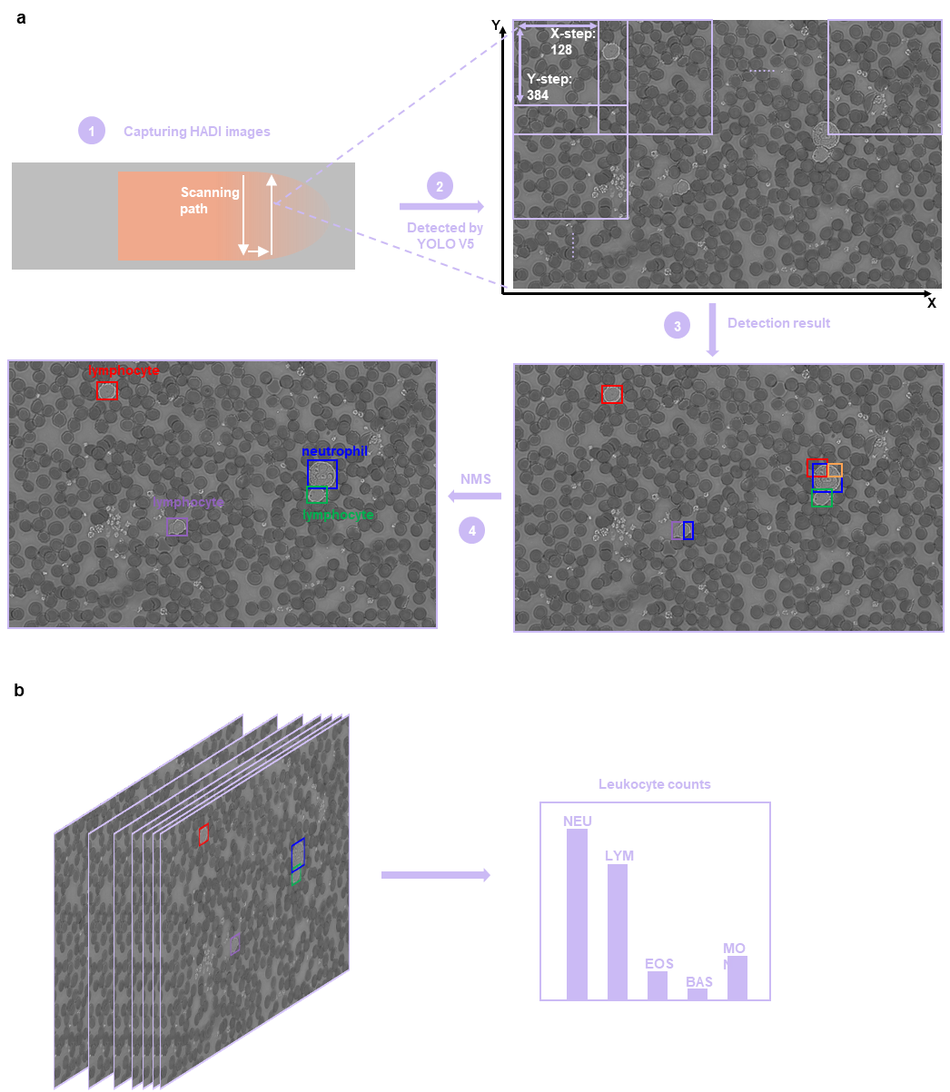
Fig. S8 Diagram of calculating leukocyte differential counts for blood samples from 14 patients with this technique. a A HADI image was detected by the trained YOLO V5 to find the containing leukocytes. The process contains four steps. First step: An unstained blood smear was scanned in a continuous path to obtain the HADI images. The mean amount of the HADI image for each patient is 101, which contains about 170 leukocytes. Second step: each HADI image was detected by the trained YOLO V5 in order. The X-step and Y-step are both 384. Third step: obtain detection results with redundancy. Fourth step: remove redundant boxes with NMS. b Leukocyte counts of all HADI images from one patient were calculated.

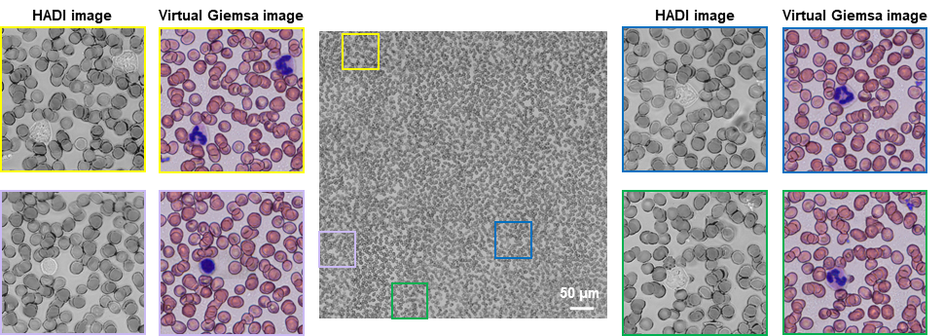
Fig. S9 Virtual staining of the HADI image (HADI images versus virtual Giemsa images). HADI images with an image size of 1920 x 1200 were captured and stitched into a HADI image with an image size of 5640 x 5640. The area of the corresponding blood smear region is 676.8 μm x 676.8 μm. Four local images of the HADI image and their corresponding virtual staining results were shown.
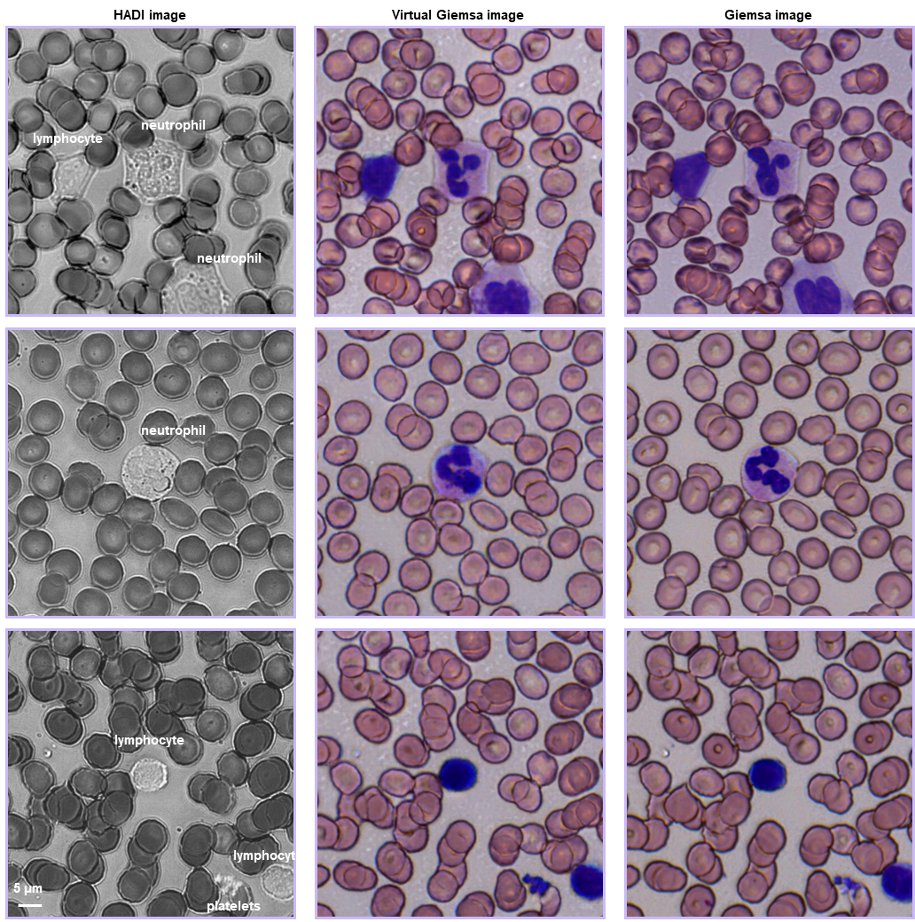
Fig. S10 Some other virtual staining results.

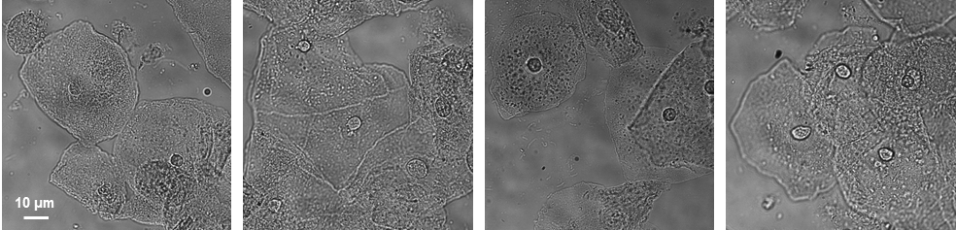
Fig. S11 Defocusing phase-contrast images for label-free cervical cells (Camera: MV-SUA230GM-T, pixel size 5.86 μm x 5.86 μm, MindVision; Objective lens: UPlanApo, 40X, 0.95 NA, SOPTOP).

Supplementary tables S1 to S2
Table S1:
Table S1. Experimental data for the image granularity curves (n= 10) in the manuscript (Fig. 1b) and supplementary figures (Fig. S3a-j). The table presents the IG values and the corresponding defocusing distances for each curve.

Table S2:

Table S2. Experimental data of the leukocyte differential counts and percentage for the 14 blood samples from the hospital. The table contains the counting results for the total leukocyte, neutrophil, lymphocyte, eosinophil, basophil, and monocyte. The automated counting results (HADI counts), manual counting results (manual count), and the leukocyte clinical percentages from the automatic hematology analyzer applied in the hospital are presented. The file supplies original data for Fig. 4 and Fig. 5 in the manuscript.

