Supplementary Table 2. Multivariate analysis regarding first-line PFS
Baseline Characters | HR (95%CI) |  |  |  | P value
Age of diganosis (Cutoff=45years) | 0.57 (0.35-0.92) |  |  |  | 0.023
Primary T stage | 1.05 (0.75-1.48) |  |  |  | 0.772
Primary N stage | 1.20 (0.98-1.47) |  |  |  | 0.071
Primary tumor grade | 0.89 (0.56-1.40) |  |  |  | 0.599
Liver metastasis | 0.69 (0.30-1.57) |  |  |  | 0.377
Lung metastasis | 0.70 (0.31-1.58) |  |  |  | 0.388
Brain metastasis | 1.77 (0.61-5.17) |  |  |  | 0.298
Bone metastasis | 0.75 (0.37-1.51) |  |  |  | 0.418
Lymph metastasis | 1.11 (0.57-2.17) |  |  |  | 0.758
Chest metastasis | 1.03 (0.47-2.24) |  |  |  | 0.941
Uncommon metastasis | 1.97 (0.86-4.52) |  |  |  | 0.108
Visceral metastasis | 1.52 (0.61-3.82) |  |  |  | 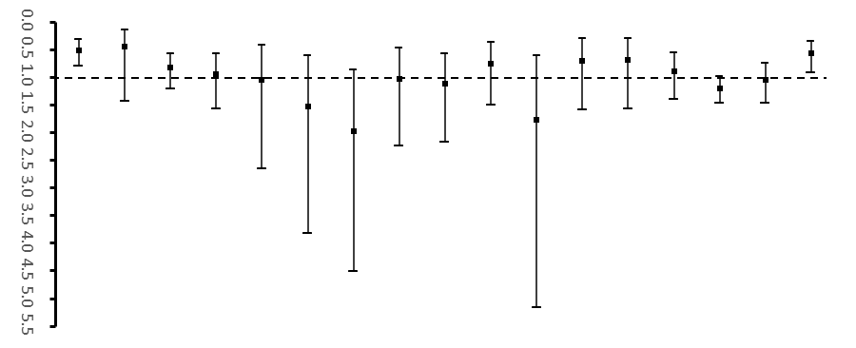  0.368
Number of metastatic sites | 1.05 (0.42-2.65) |  |  |  | 0.918
DFS (Cutoff=36.0 months) | 0.95 (0.57-1.57) |  |  |  | 0.825
First-line regimen | 0.83 (0.57-1.20) |  |  |  | 0.323
Application of anti-HER2 therapy | 0.45 (0.14-1.43) |  |  |  | 0.177
CD8+CD28- (Cutoff=18.0%) | 0.51 (0.32-0.80) |  |  |  | 0.003

