SUPPLEMENTARY INFORMATION

Sonicated Zeolitic Imidazolate Frameork-8 derived Nitrogen-doped hierarchical nanoporous carbon for efficient capture and reversible storage of radioiodine
Journal of Environmental Science and Pollution Research
Elvis Djam Miensahª, Jiuyu Chenª, Aotian Guª, Peng Wangª, Ying Liuª, Chunhui Gongª, Ping Mao^{b}, Kai Chen^{c}, Yan Jiao^{c}, Zongxiang Zhang^{d}, Yi Yang^{a,} ^{c, *}
ª Jiangsu Key Laboratory of Chemical Pollution Control and Resources Reuse, School of Environmental and Biological Engineering, Nanjing University of Science and Technology, Nanjing, 210094, China.
^{b} National & Local Joint Engineering Research Center for Mineral Salt Deep Utilization, Key Laboratory for Palygorskite Science and Applied Technology of Jiangsu Province, School of Chemical Engineering, Huaiyin Institute of Technology, Huaian 223003, China
^{c} Collaborative Innovation Center of Atmospheric Environment and Equipment Technology, Jiangsu Key Laboratory of Atmospheric Environment Monitoring and Pollution Control (AEMPC), Nanjing University of Information Science & Technology, Nanjing 210044, China.
^{d} Jiangsu Environmental Protection Key Laboratory of Monitoring for Organic Pollutants in Soil, Taizhou Environmental Monitoring Center, Taizhou, 225300, China.
* Corresponding author: yangyi@njust.edu.cn; Jiangsu Key Laboratory of Chemical Pollution Control and Resources Reuse, School of Environmental and Biological Engineering, Nanjing University of Science and Technology, Nanjing 210094, China. Tel/Fax: +86-25-8431-1956

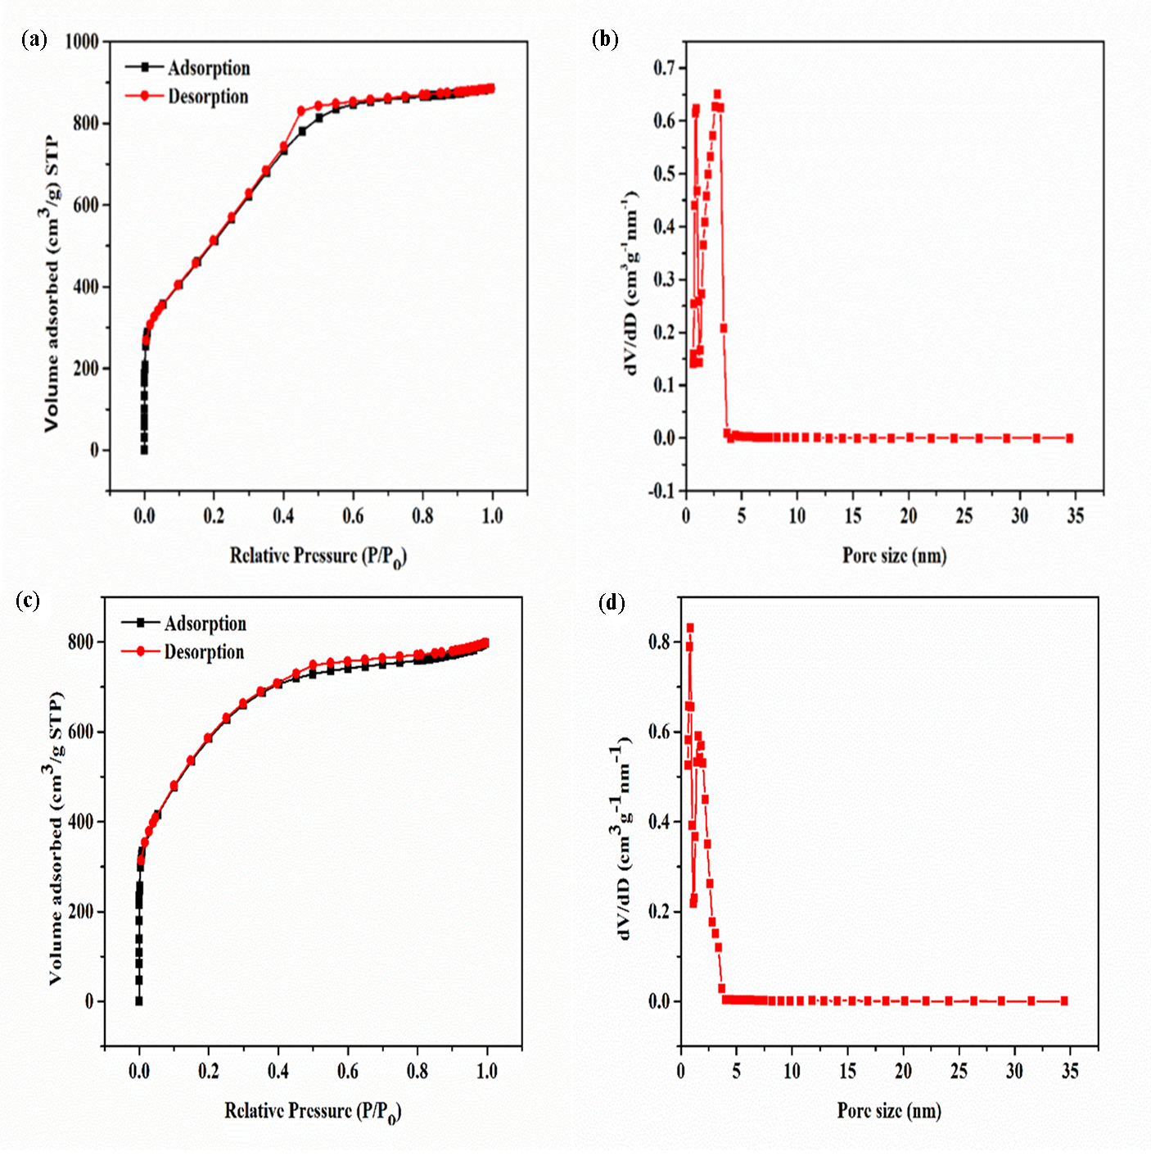
Fig. S1. N₂ adsorption/desorption at 77 K (a) isotherm of s-ZNPC showing hysteresis loop between relative pressure range 0.4-0.9, (b) the corresponding NL-DFT pore size distribution of s-ZNPC (c) isotherm of ZNPC showing narrow hysteresis loop between relative pressure range 0.4-0.9, (d) the corresponding NL-DFT pore size distribution of ZNPC
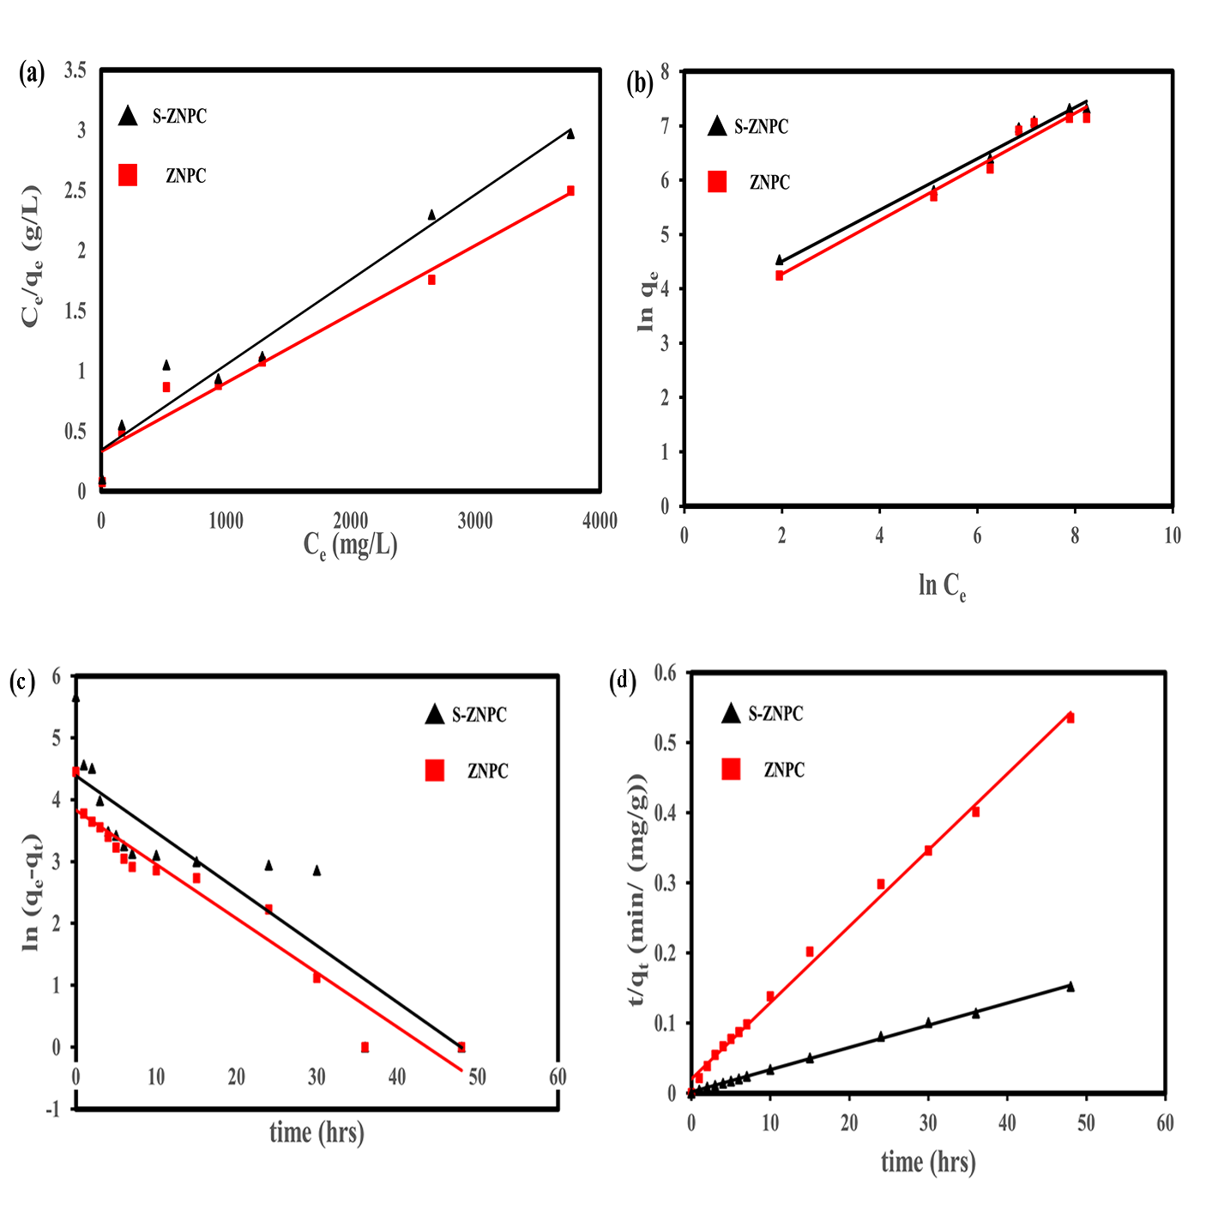
Fig. S2. Isotherm and kinetics models adopted to simulate experimental data (a) Langmuir isotherm model; (b) Freundlich isotherm model; (c) Pseudo-first-order kinetics model (b) Pseudo-second-order kinetics model
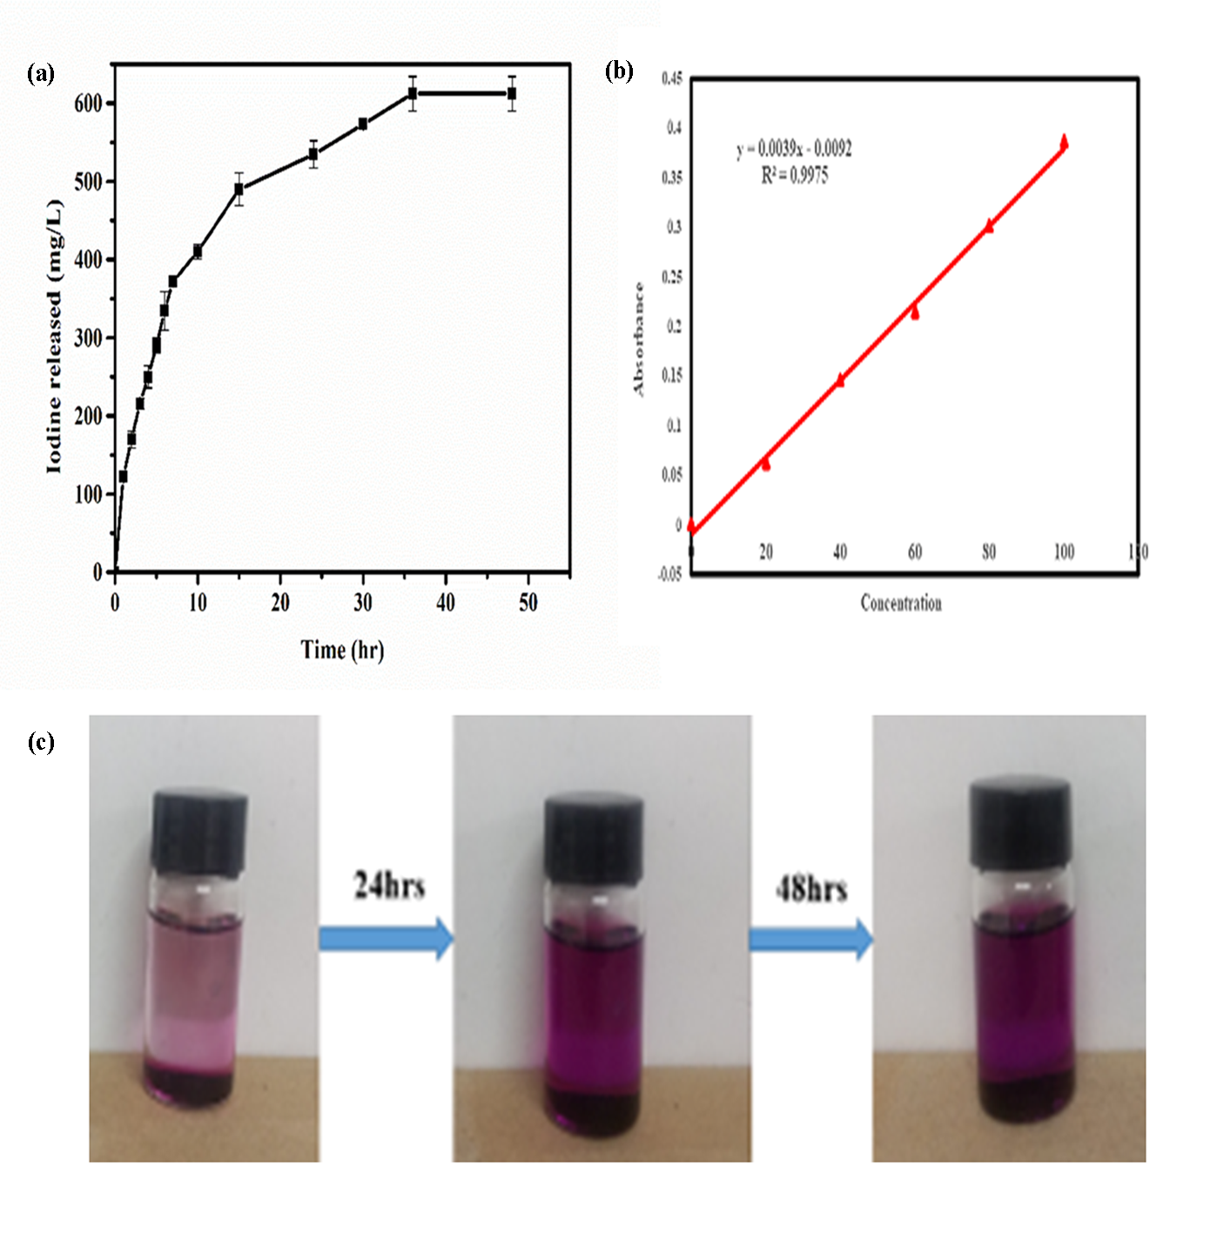
Fig. S3. Radioiodine release process: (a) delivery curve of I₂ released from I₂@s-ZNPC (b) I₂ calibration plot by UV-Vis spectra at 205 nm in ethanol; with a plot of absorbance vs. concentration showing good linearity, and satisfies Beer-Lambert law, (c) color change in I₂ release process. Error bars were calculated with the standard deviation of triplicate measurements at 95% confidence level

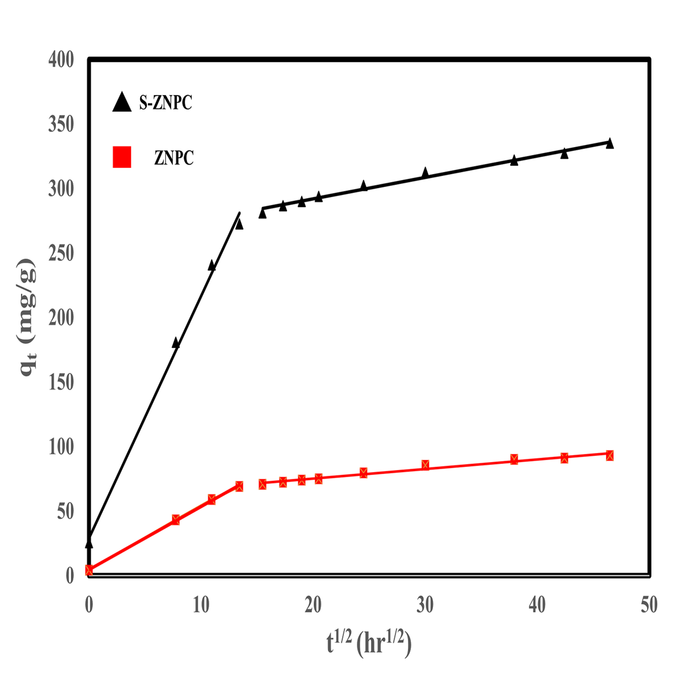
Fig. S4. Webber-Morris model plot showing multi-linearity

Tables
Table S1. Textural parameters of as-prepared carbon materials
Material | BET surface area (m²g⁻¹) | Pore volume (cm³g⁻¹)
s-ZNPC | 2350 | 1.40
ZNPC | 1899 | 1.12

Table S2. Parameters of the adsorption isotherm models
Material | Langmuir isotherm |  |  |  | Freundlich isotherm
 | q_{m} (mg/g) | K_{L} | R² |  | n | K_{F} | R²
s-ZNPC | 1598.9 | 1.8*10⁻³ | 0.977 |  | 4.45 | 33.97 | 0.998
ZNPC | 1329.5 | 2.1*10⁻³ | 0.961 |  | 3.20 | 29.99 | 0.998

Table S3. Adsorption kinetics model parameters of the samples
Material | C_{o (}mg/L) | q_{e}, exp | Pseudo-first-order |  |  |  | Pseudo-second-order |  |  |  | Weber-Morris
 |  |  | K₁ | q_{e} | R² |  | K₂ | qe | R² |  | Kd₁ | C₁ | R² | Kd₂ | C₂ | R²
s-ZNPC | 300 | 238 | 0.377 | 198 | 0.726 |  | 3.36*10⁻³ | 240.5 | 0.999 |  | 18.757 | 29.28 | 0.996 | 2.133 | 249 | 0.994
ZNPC | 300 | 211 | 0.084 | 80.2 | 0.792 |  | 5.12*10⁻³ | 312.5 | 0.999 |  | 4.867 | 4.760 | 0.996 | 1.033 | 54.2 | 0.997

