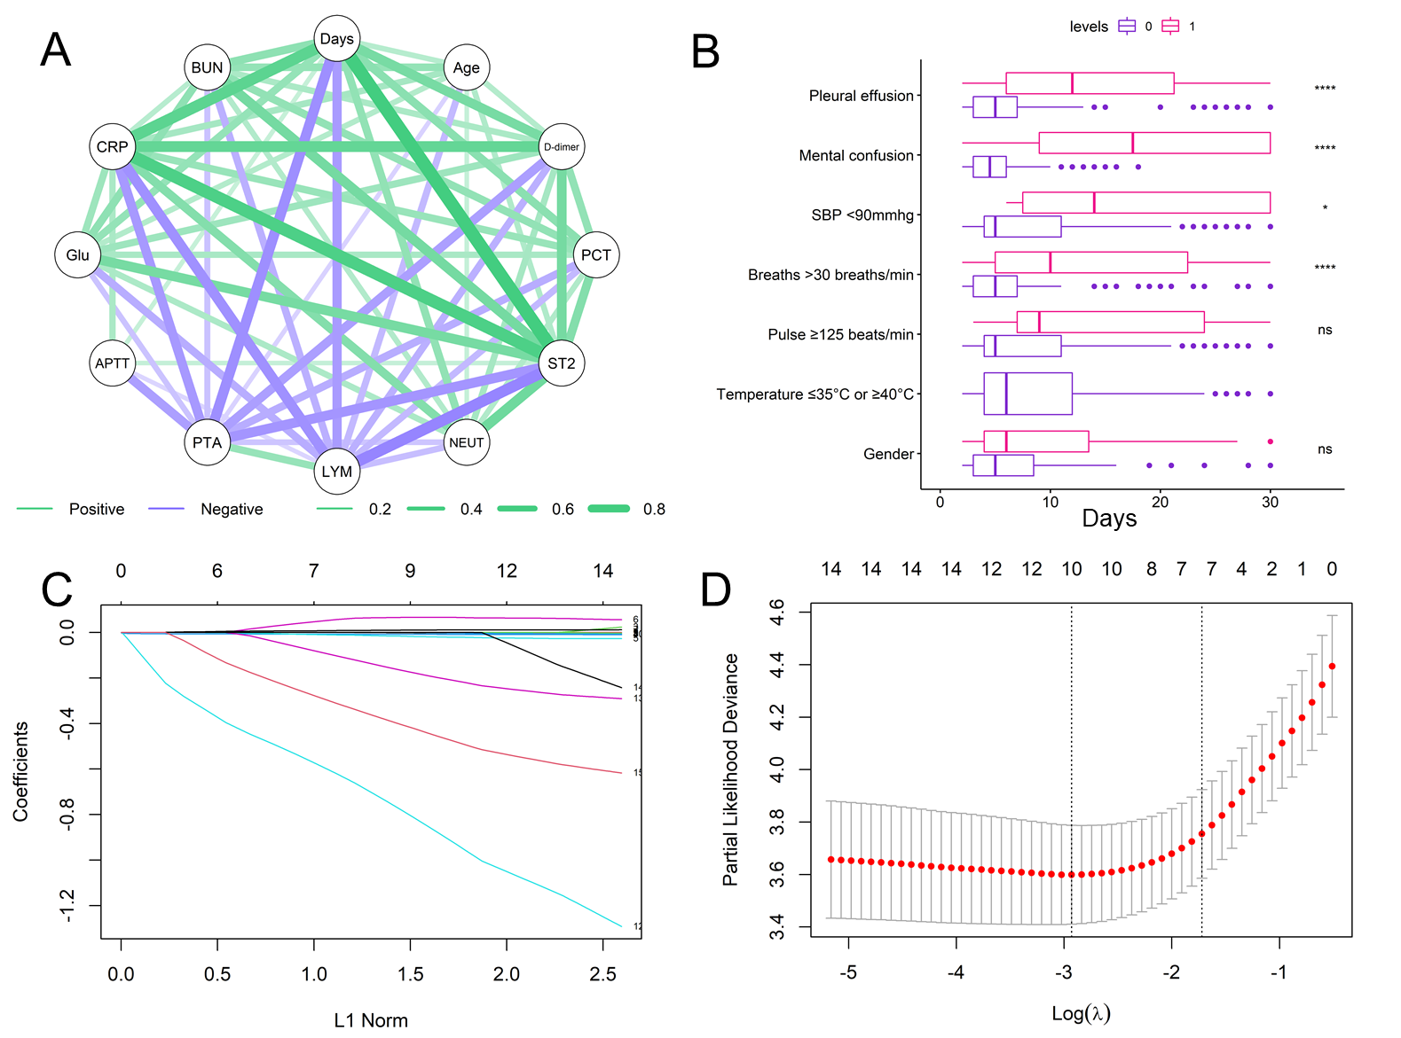
Figure S1. Feature selection of the prediction model. A The correlation network of selected variables as the variables correlated with clinical stability. B The time to clinical stability in different groups. C Lasso regression of the selected 15 variables. D The model performs best when the number of variables was 10. Days: days to clinical stability, PCT: Procalcitonin, NEUT: Neutrophils, LYM: Lymphocyte, PTA: Prothrombin activity, APTT: Activated partial thromboplastin time, Glu: glucose, CRP: C-reactive protein, BUN: Blood urea nitrogen.

