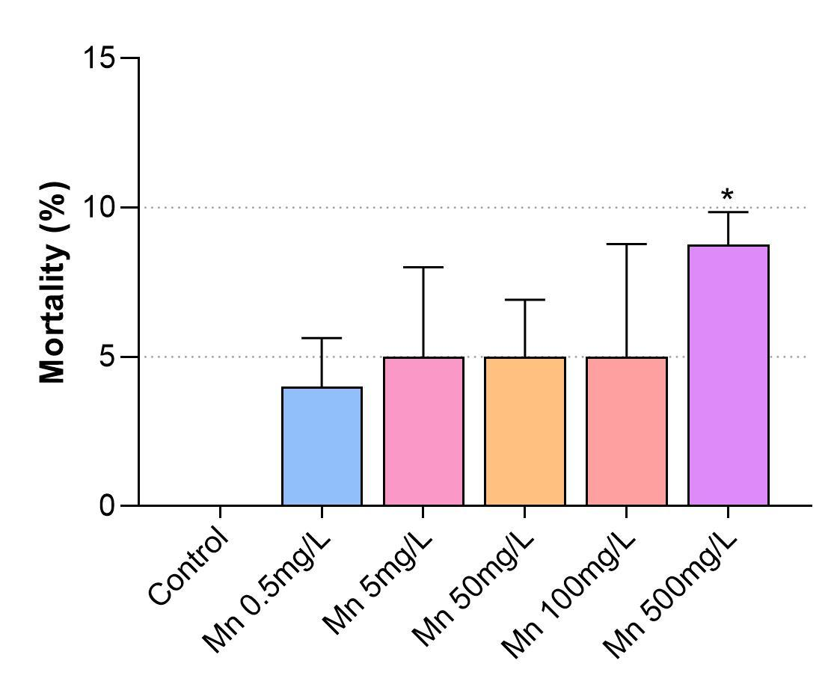

Supplemental Figure 1 – Analysis of zebrafish mortality after Mn treatment. Zebrafish larvae were treated with Mn at 0.5, 5, 50, 100 and 500 mg/L and their mortality rate were analyzed. Although slightly increased mortality rates were observed after treatment of zebrafish with all the Mn concentrations tested, only 500 mg/L of Mn showed a significant increase (10%) in mortality. The results are expressed as mean ± SEM. The groups were performed with n = 5, where *p < 0.05 vs. control group. Statistical analysis was performed using one-way ANOVA followed by Dunn’s post-test.
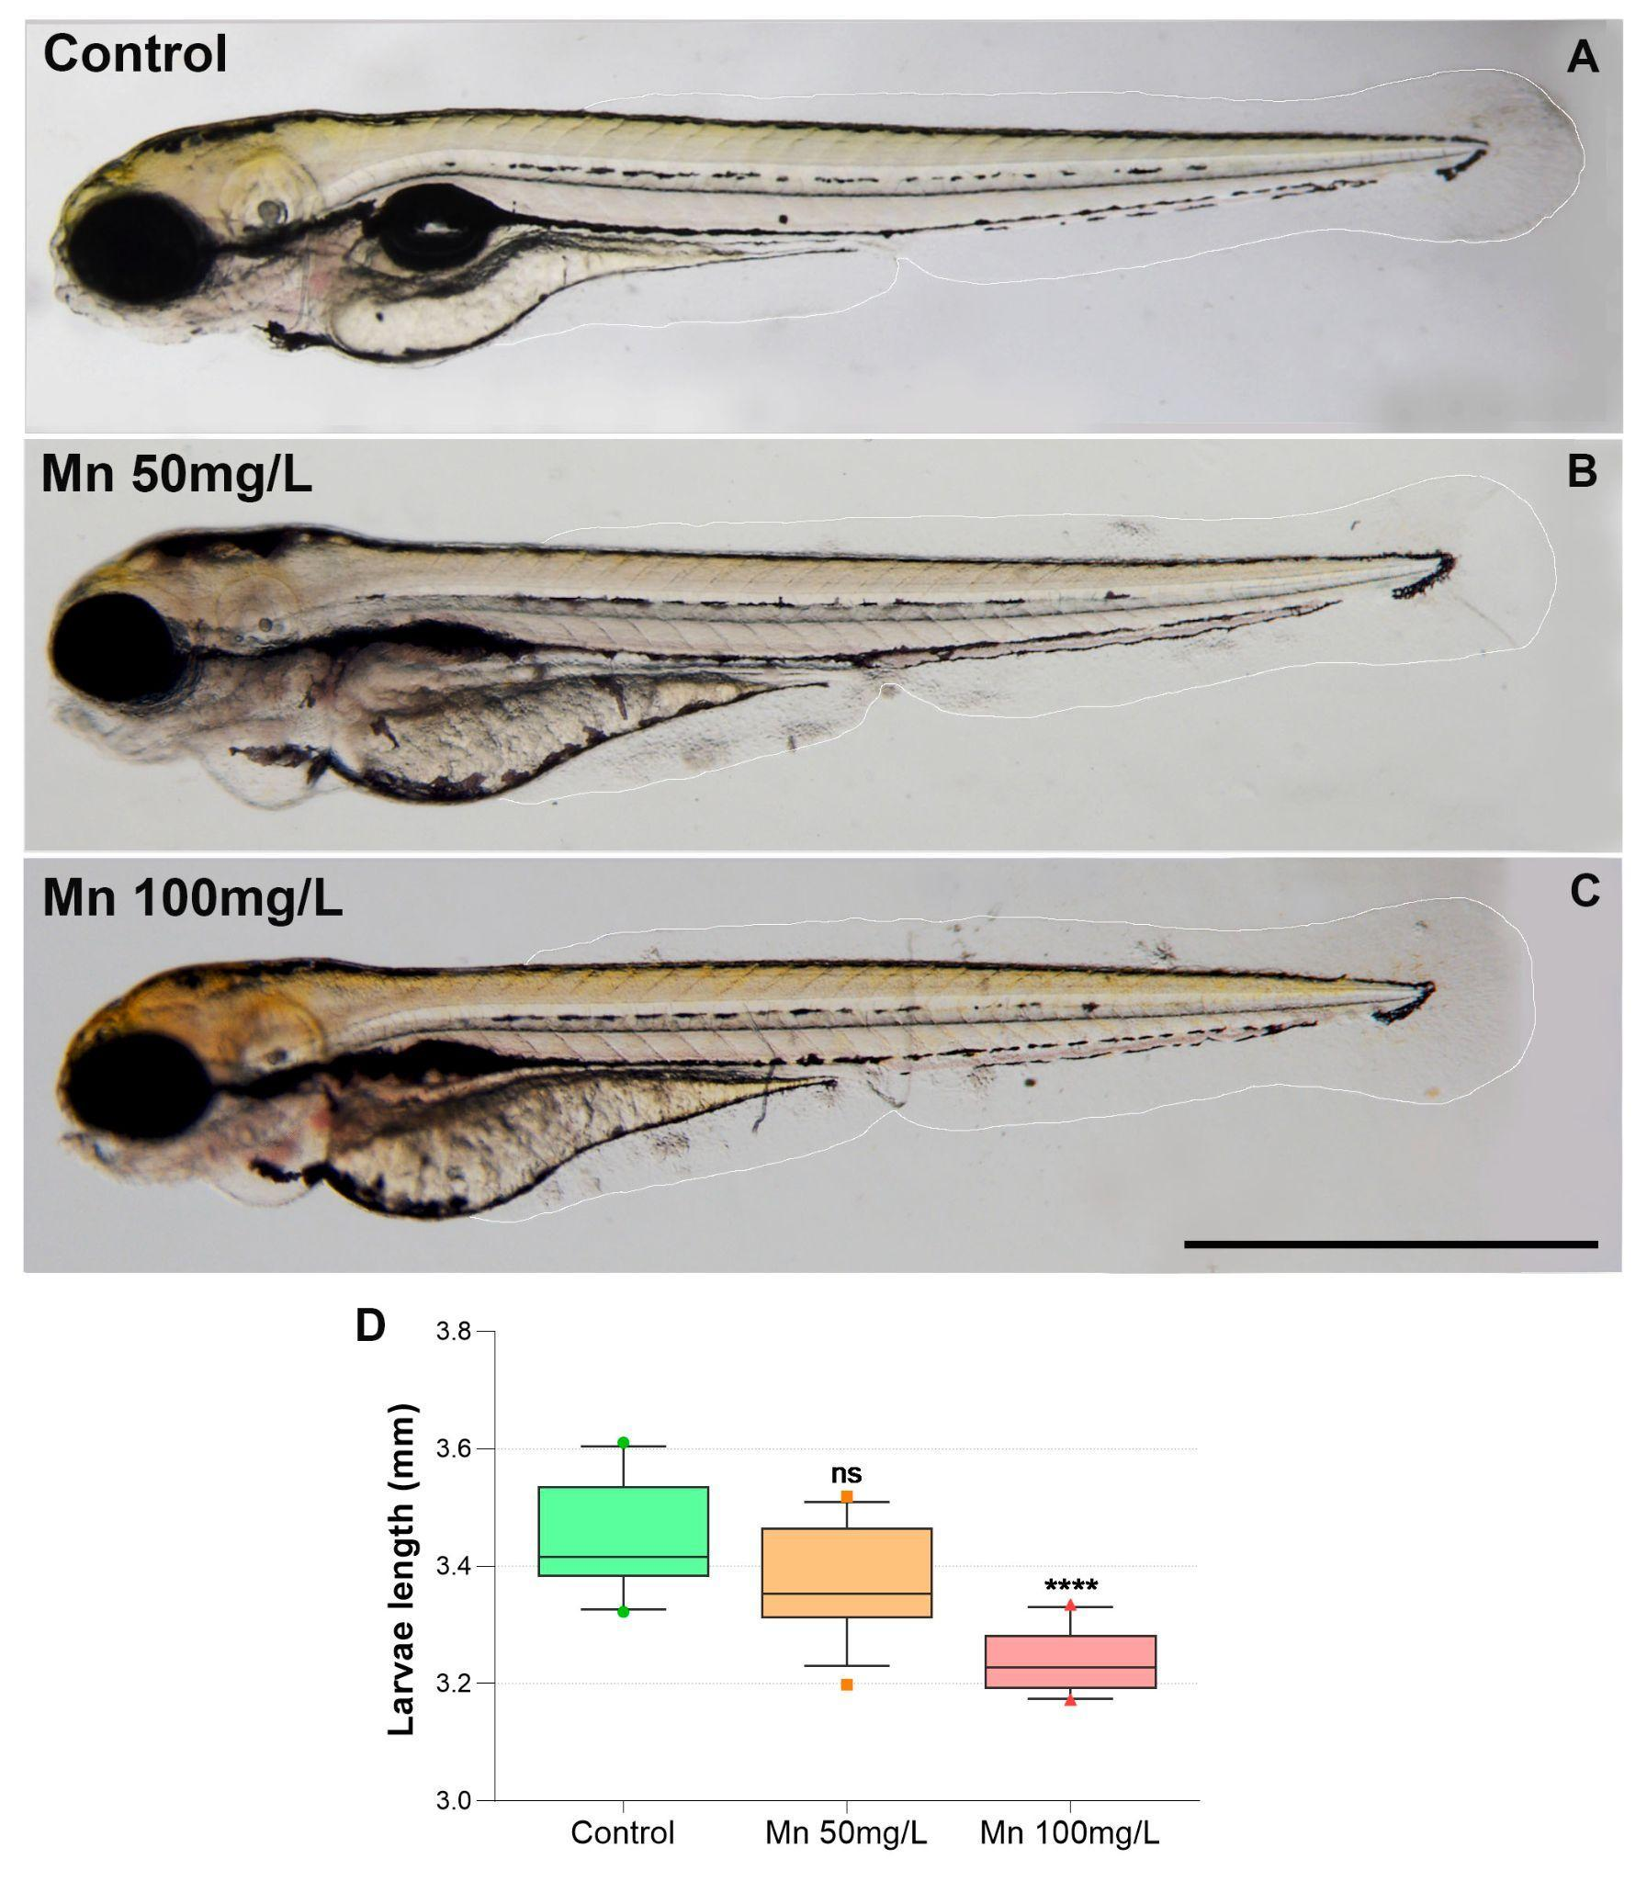

Suppl Figure 2 - Mn treatment induces a decrease in the size of zebrafish larvae. Zebrafish larvae were treated with Mn at 50 or 100 mg/L and analyzed under a light microscope (A-C). Quantification of total larval length shows a decrease in their size after Mn treatment (D). Scale bar in C = 1 mm. The results are expressed as mean ± percentile. The groups were performed with n = 5, where ****p < 0.0001 vs. control group. ns = non-significant. Statistical analysis was performed using one-way ANOVA followed by Dunnett’s post-test.

