p16
kDa
17
10

p21
kDa
25
17

p53
kDa
55
43

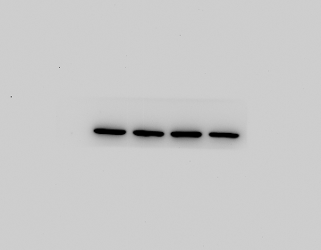
β-actin
kDa
43
34

Supplementary Figure 3. The original immunoblots of Figure 1E.

NLRP3
kDa
130
95

ASC
kDa
34
17

Caspase-1

kDa
25
17

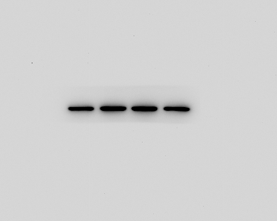
β-actin
kDa
43
34

Supplementary Figure 4. The original immunoblots of Figure 2A.

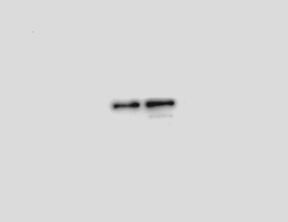
IP: NLRP3 WB: ASC

kDa
34
17

NLRP3
kDa
130
95

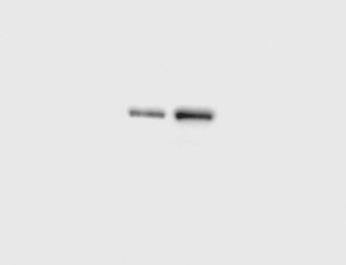
IP: ASC WB: NLRP3

kDa
130
95

ASC

kDa
34
17

Supplementary Figure 5. The original immunoblots of Figure 2E.

FOXO4

kDa
75
55

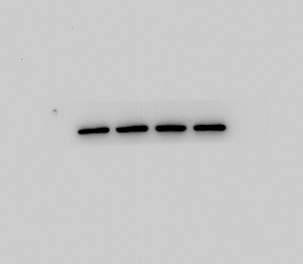
β-actin

kDa
43
34

Supplementary Figure 5. The original immunoblots of Figure 3D.

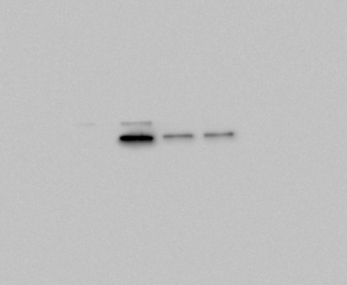
FOXO4

kDa
75
55

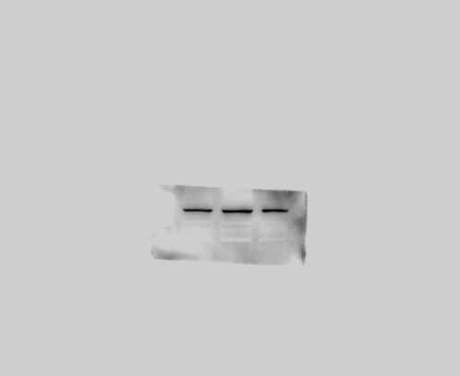
kDa
43
34
β-actin

Supplementary Figure 6. The original immunoblots of Figure 4B.

kDa
75
55
AKT

FOXO4

kDa
75
55

kDa
55
43
kDa
75
55
ERK

p-AKT

kDa
75
55
kDa
55
43
AMPK

p-ERK

kDa
130
95
kDa
75
55
Rb1

p-AMPK

kDa
130
kDa
130
95
mTOR

p-Rb1

kDa
43
34
kDa
130
β-actin

p-mTOR

Supplementary Figure 7. The original immunoblots of Figure 5A.

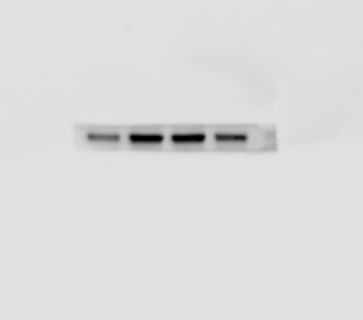
kDa
130
95
NLRP3

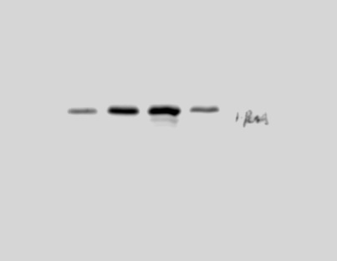
kDa
25
17
p21

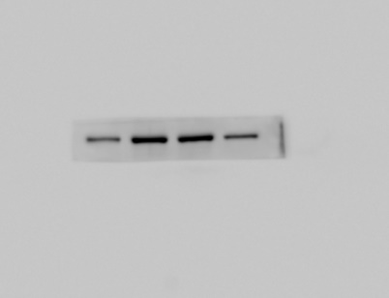
kDa
75
55
FOXO4

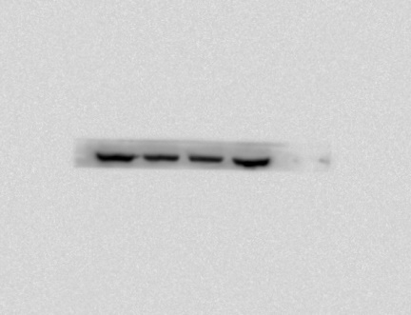
kDa
130
95
p-Rb1

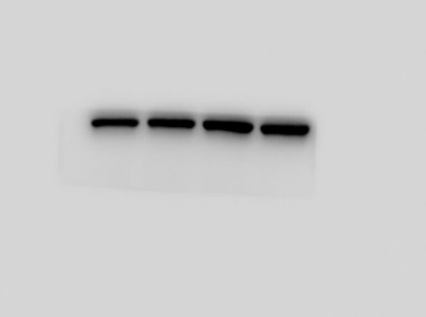
kDa
43
34
β-actin

Supplementary Figure 8. The original immunoblots of Figure 5C.

p-AMPK

kDa
75
55
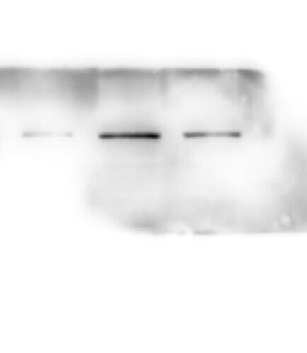
FOXO4

kDa
75
55

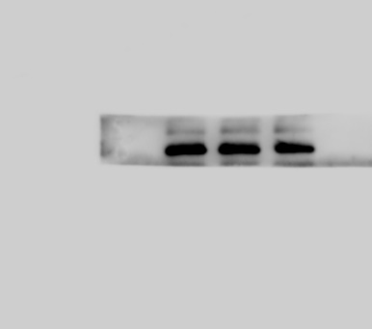
β-actin

kDa
43
34

Supplementary Figure 9. The original immunoblots of supplementary Figure 2.

