Supplementary Note 1: Characterization of circular dichroism (CD) properties using transmission ellipsometry
CD is typically assessed using CD spectrometers; however, an alternative methodology involves utilizing Mueller matrices (MM) derived from transmission ellipsometry experiments¹. Both of these strategies were employed in the current study. The transmission ellipsometry experiments were executed using an RC2 spectroscopic ellipsometer (J. A. Woollam), employing a 4x4 MM in transmission mode across the wavelength spectrum of 180-1800 nm.
The polarization response of an optical device or system can be elucidated by a MM, denoted as M. This matrix operates on input polarization states 𝑺_{𝒊𝒏} = (𝑆₀, 𝑆₁, 𝑆₂, 𝑆₃) and yields corresponding output polarization states 𝑺_{𝒐𝒖𝒕} = (𝑆₀′, 𝑆₁′, 𝑆₂′, 𝑆₃′):
. (1)
Here, 𝑆_{𝑖}, 𝑆′_{𝑖} are so-called Stokes parameters, and are defined with the intensity of light with four polarizations:
, (2)
where 𝐼_{𝑥}, 𝐼_{𝑦}, 𝐼_{+45o} and 𝐼_{−45o} correspond to the intensities of linearly polarized light along the x-axis, y-axis, +45°, and −45° directions, respectively, and I_{R} and I_{L} represent the intensities of right and left circular polarized light, respectively.
The normalized Stokes vectors 𝐒̂ and Muller matrix M̂ were derived by dividing 𝑆₀, 𝑆₁, 𝑆₂ and 𝑆₃ by 𝑆₀ and M_{xy} by M₁₁ as follows:
(3)
(4)
In this study, we employed Stokes and Mueller calculus to generate CD spectra that correspond to those obtained using the spectrometer.
For the calculation of the CD spectra, we determined the transmitted light intensities for left (I_{L}) and right (I_{R}), circularly polarized light. Our approach involved utilizing the normalized Stokes vectors associated with circularly polarized light, which were then multiplied by a normalized Mueller matrix
$\hat{M}⋅\hat{s_{RCP}}=\hat{s_{\text{out}}^{R}}$ (5)
which yields
(6)
The first value, 𝑆₀, within the resultant Stokes vector, 𝑆̂_{𝑜𝑢𝑡}^{𝑅}, signifies the light intensity in relation to the initial Stokes vector. Consequently, the intensity of a transmitted right circularly polarized light beam can be expressed as:
$I_{R}=I_{0}^{R}⋅\left(1+\hat{M_{14}}\right).$ (7)
Likewise, the intensity pertaining to left circularly polarized light is determined by the multiplication of a normalized Mueller matrix with the Stokes vector corresponding to left circularly polarized light,
$\hat{M}⋅\hat{s_{\text{LCP}}}=\hat{s_{\text{out}}^{L}}$ (8)
which yielded
(9)
The first value, 𝑆₀, of the resulting Stokes vector within the resultant Stokes vector, 𝑆̂_{𝑜𝑢𝑡}^{𝐿}, signifies the light intensity in relation to the initial Stokes vector. Consequently, the intensity of a transmitted left circularly polarized light beam can be expressed as:
$I_{L}=I_{0}^{L}⋅\left(1-\hat{M_{14}}\right).$ (10)
By combining Equations 7 and 10, we derived an equation that establishes a connection between normalized Mueller matrices and CD, expressed as:
$ΔExt_{LCP/RCP}=\log_{10}\left(\frac{I_{0}^{R}⋅\left(1+\hat{M_{14}}\right)}{I_{0}^{L}⋅\left(1-\hat{M_{14}}\right)}\right).$ (11)
Assuming an equivalence in the initial intensity of left and right circularly polarized light (𝐼₀^{𝑅}=𝐼₀^{𝐿}), we obtained
$ΔExt_{LCP/RCP}=\log_{10}\left(\frac{1+\hat{M_{14}}}{1-\hat{M_{14}}}\right)$ (12)
or as CD in degrees:
$CD=\left(\frac{\ln{1}0}{4}\right)\left(\frac{180}{π}\right)ΔE{xt}_{LCP/RCP}.$ (13)
Moreover, the dissymmetry factor can be calculated as
$g=\frac{CD}{32.982*Abs}=\frac{\log\left(\frac{M_{11}-M_{14}}{M_{11}+M_{14}}\right)}{\log{M_{11}}}.$ (14)
The rotation test was also conducted to eliminate the influence of the plasmonic lattice.
Ref 1. Querejeta-Fernández, A. et al. Circular Dichroism of Chiral Nematic Films of Cellulose Nanocrystals Loaded with Plasmonic Nanoparticles. ACS Nano 9, 10377-10385, doi:10.1021/acsnano.5b04552 (2015).

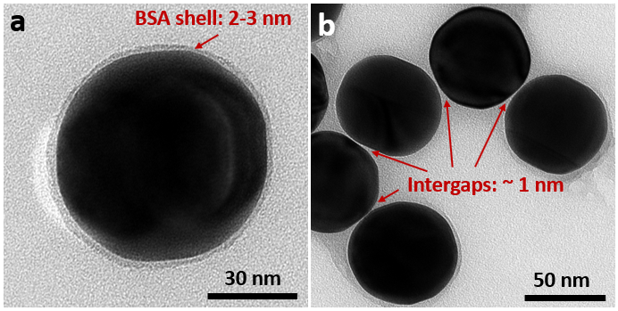
Supplementary Fig. 1 | TEM characterization of spherical BSA-coated Au NPs. a, The spherical Au NPs with BSA shell with a thickness of 2-3 nm. b, The aggregation of Au NPs. Due to the capillary force, after drying the BSA shells of adjacent NPs were intertwined and pressed. Thus, the size of the intergaps is smaller than the thickness of the isolated Au NP.

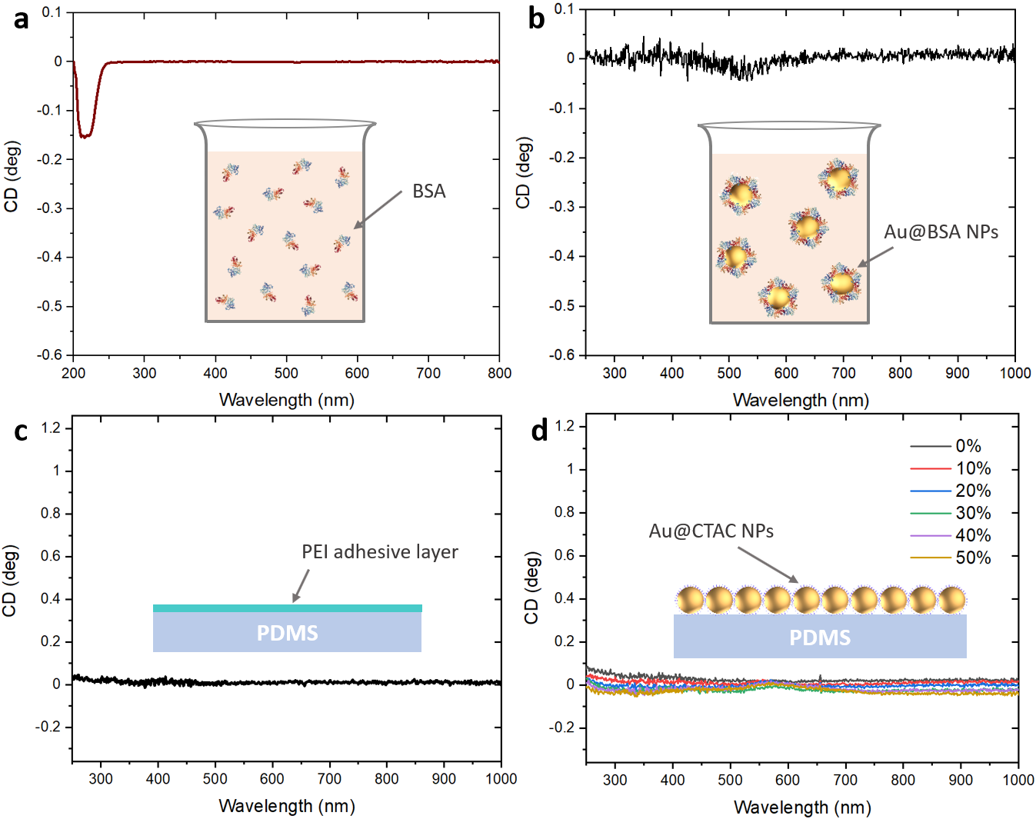
Supplementary Fig. 2 | Reference CD measurements to exclude the structural chirality and ensure the pure PCCD in 1D BSA-coated Au NP assembly. a, CD spectrum of 1 mg/mL BSA solution, featuring typical CD peaks of alpha-helix in the UV region. This spectrum was taken from a CD spectrometer with a shorter wavelength range but a higher resolution in UV region compared with the spectra taken from ellipsometer. b, CD spectrum of BSA-coated Au NP solution, imparting negligible PCCD and molecular CD of BSA. c, CD spectrum of PDMS substrate coated with a PEI adhesion layer, showing no chiral signals. d, CD spectrum of 1D CTAC-coated Au NP assembly during stretching, showing its achirality. Because CTAC is not chiral, the PCCD cannot be triggered in this nanocomplex.


Supplementary Fig. 3 | Sketch of home-made stretching device. The PDMS substrate was clapped on the home-made stretching device. By turning the screw, the PDMS substrate will be gradually stretched.

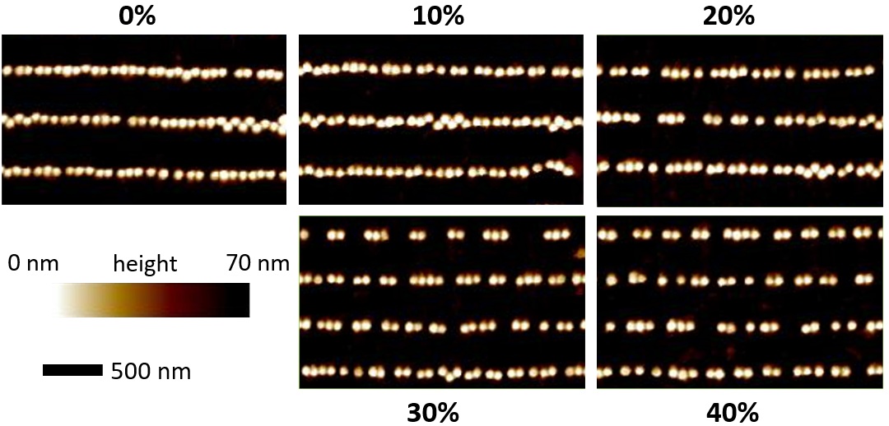
Supplementary Fig. 4 | AFM characterization of the 1D NP assembly array during stretching process. When the external strain is gradually applied along the NP chain direction, the NP chains split into oligomers and then to trimers and dimers with 40% strain.

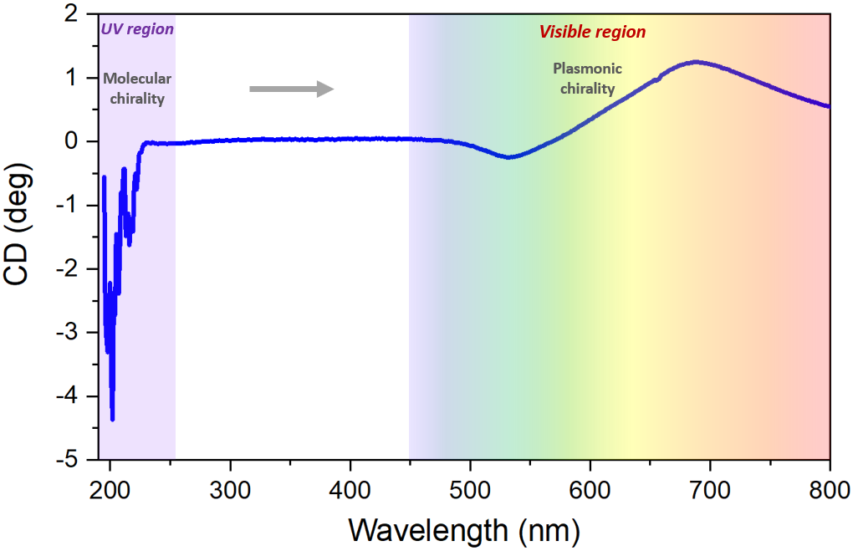
Supplementary Fig. 5 | The full CD spectrum of 1D BSA-coated Au NP assembly. In the UV region it shows the typical BSA molecular CD sign in left-handedness with the two characteristic peaks located around 205 nm and 220 nm. While in the visible region, it exhibits a right-handed plasmonic chirality.

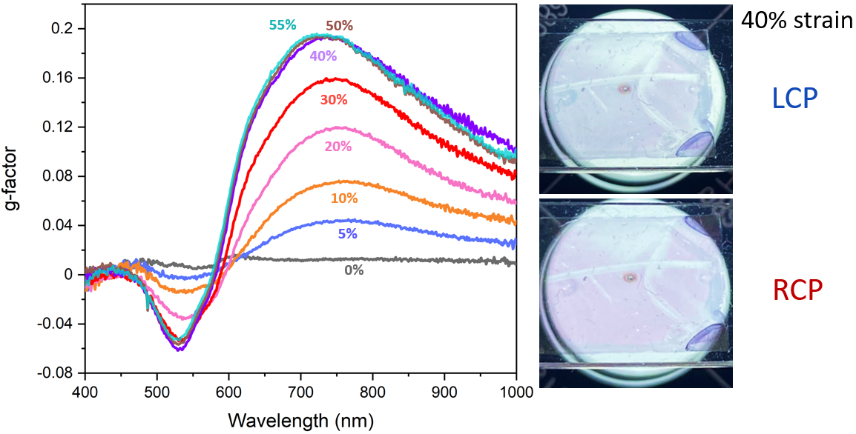
Supplementary Fig. 6 | g-factor of the 1D BSA-coated Au NP assembly during stretching process. With stretching, the g-factor also increases as the CD does, finally reaching a plateau at 50-55% strain with a value of ~0.2. The high g-factor allows the assembly for a color difference in transmission when illuminated with LCP and RCP light.

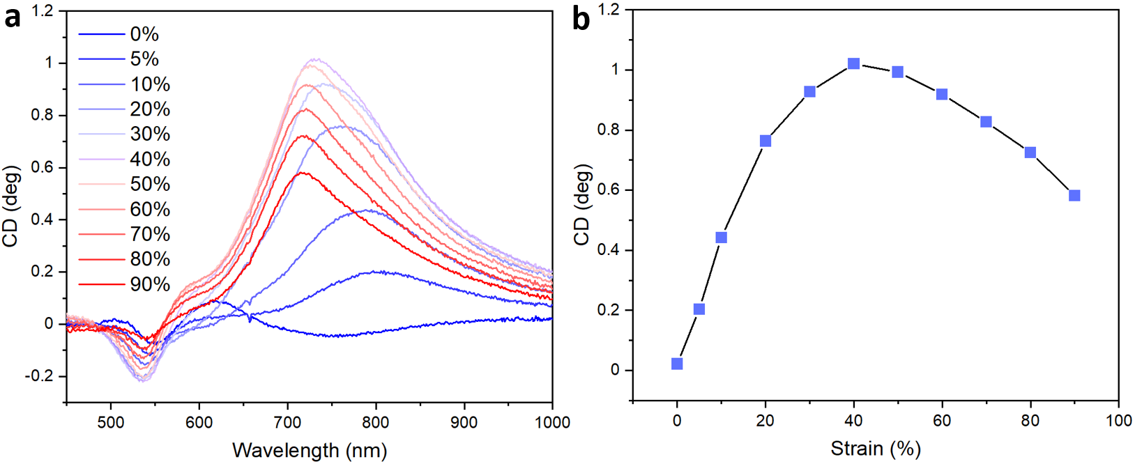
Supplementary Fig. 7 | Overstretching of BSA-coated Au NP (70 nm in diameter) assembly. With overstretching, the PCCD decreased slowly together with a gradual blue-shifted longitudinal peak.

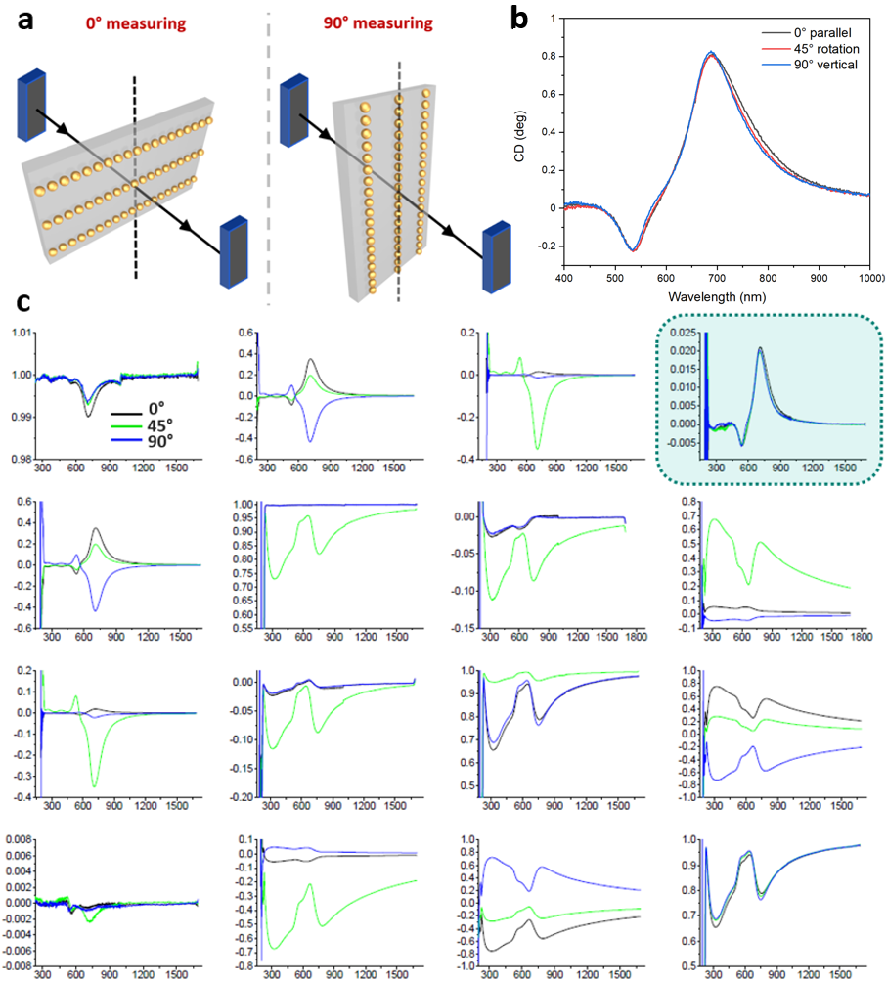

Supplementary Fig. 8 | Excluding the effect of linear dichroism in the stretching-induced PCCD leap by monitoring the Mueller matrix of the assembly under different rotation angles. a, Sketch of the rotation experiment through ellipsometer. b, Rotating the stretched assembly by 0°, 45° and 90°, the CD values kept always constant. c, Full Mueller matrices of the stretched assembly rotated by 0°, 45°, and 90°.

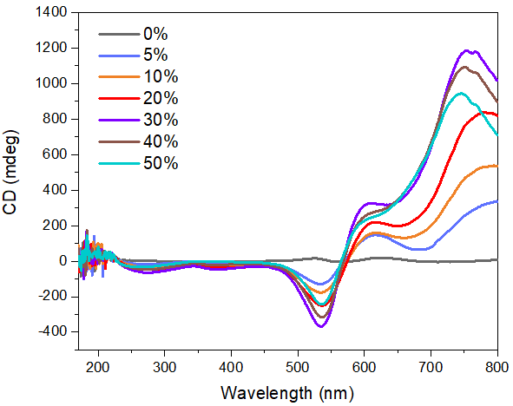

Supplementary Fig. 9 | CD spectra of the BSA@Au nanosphere assembly during stretching taken through conventional CD spectrometry. Compared with the CD spectra taken from ellipsometry, nearly the same CD values were also presented here. Due to the limited measuring range of the CD spectrometer, only half of the longitudinal peaks were presented.

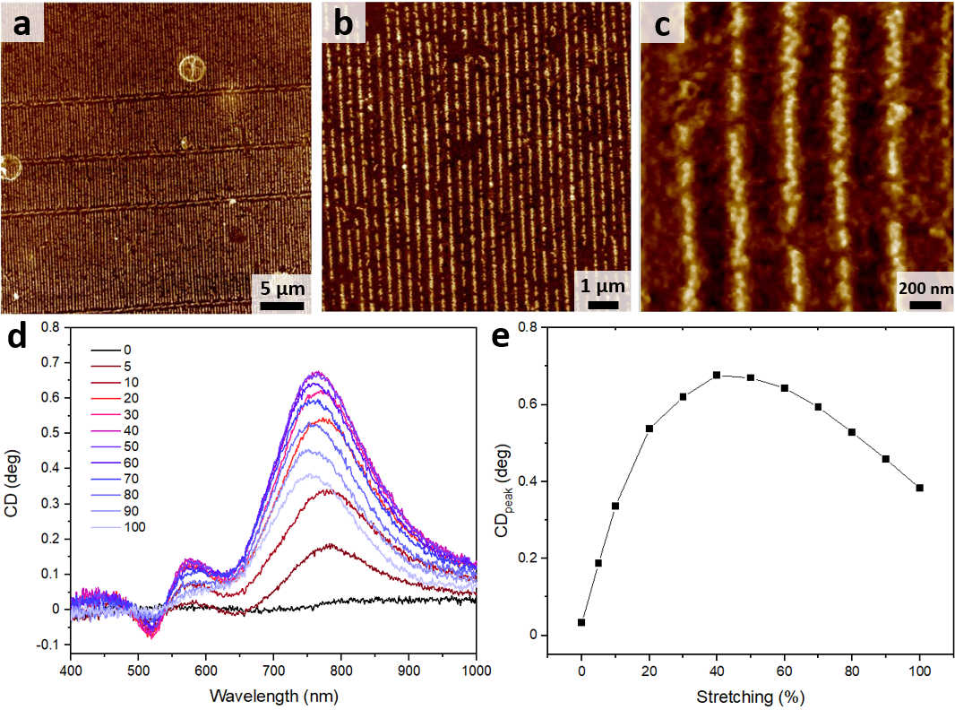
Supplementary Fig. 10 | Linear assembly of 50 nm NPs. a-c, AFM images of NP assembly with different magnifications. d, Stretching induced CD increase of the NP assembly. e, Trend of the CD peak values with continuous stretching.

-

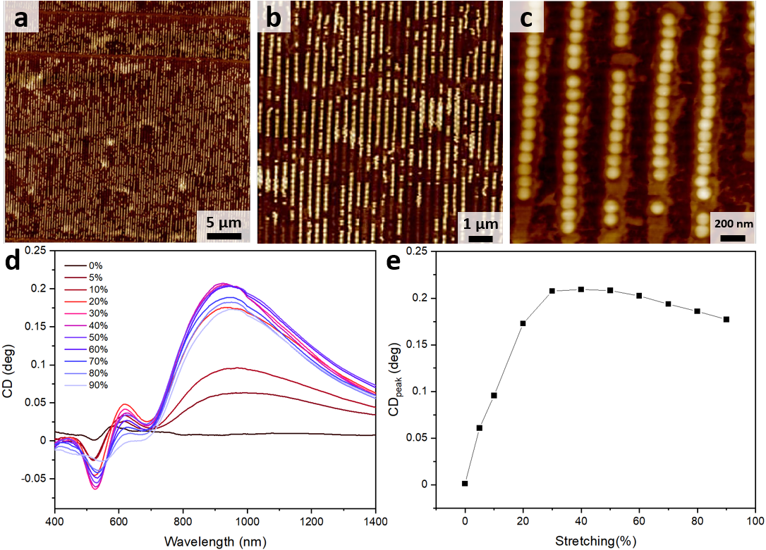
Supplementary Fig. 11 | Linear assembly of 90 nm NPs. a-c, AFM images of NP assembly with different magnifications. d, Stretching induced CD increase if the NP assembly. e, Trend of the CD peak values with continuous stretching.

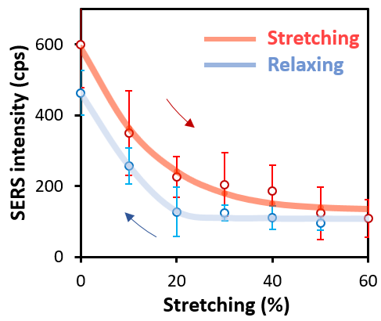
Supplementary Fig. 12 | Monitoring SERS performances during the stretching and relaxing states of the assembly. Upon stretching the SERS signals decreased as the nanogaps between the adjacent nanospheres enlarged; while during relaxing, the nanogaps narrowed together with gradually restored SERS signals.

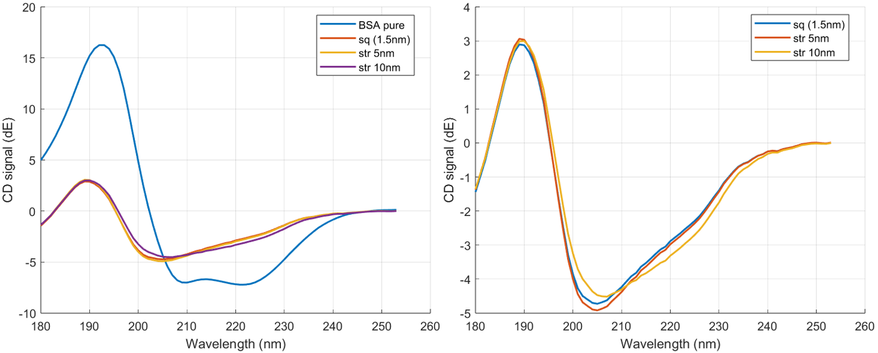
Supplementary Fig. 13 | Calculated CD spectra of a BSA molecule with different conformations during squeezing and stretching states.

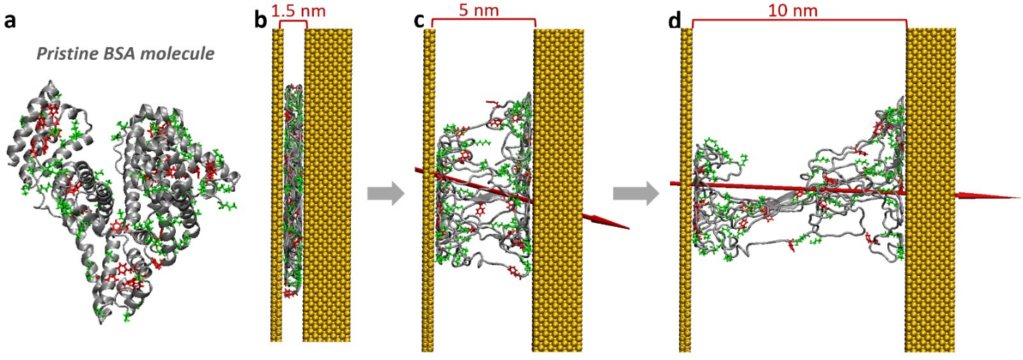
Supplementary Fig. 14 | Aminoacidic residues reorientation of Lys and Phe with loss of direct interactions with gold. Lys and Phe aminoacidic residues on a-d are detected by green and red respectively to demonstrate their reorientation during stretching.

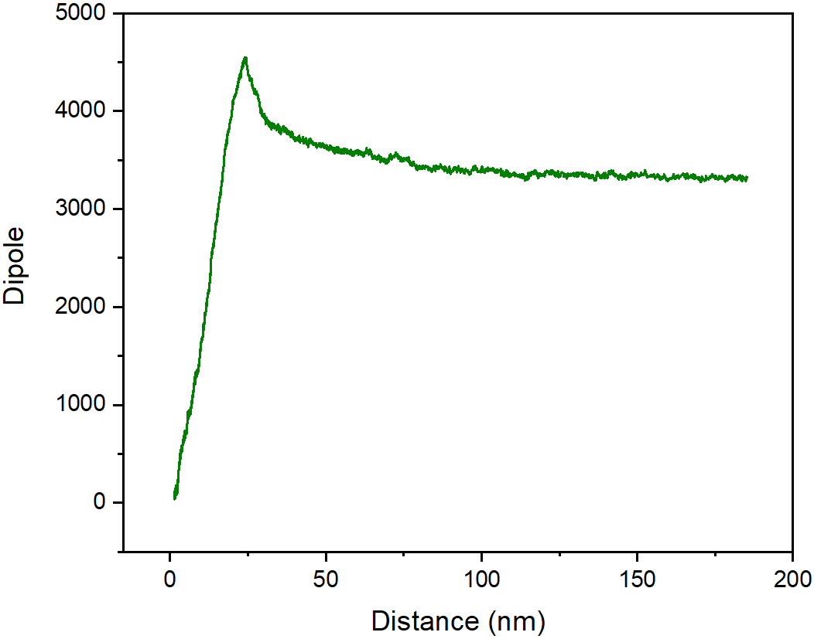
Supplementary Fig. 15 | Simulated strength of the molecular dipole along nanochain direction during continuous stretching.

.

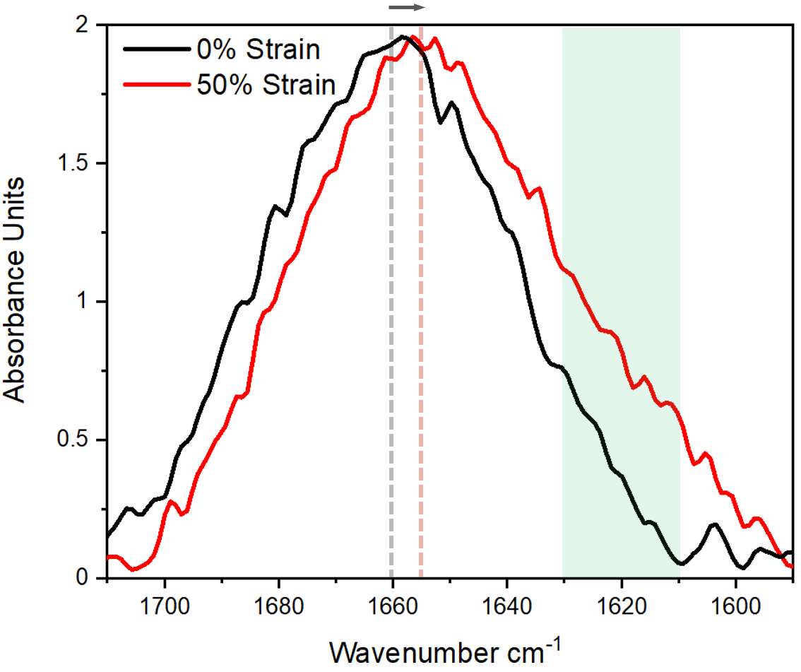
Supplementary Fig. 16 | IR spectra of the unstretched and 50% stretched nanochain array.

Supplementary Note for COMSOL-computed PCCD spectra
Chiro-optical effects and CD spectra: We consider here two models, anisotropic-stretched and isotropic-unstretched. This will allow us to understand that role of hot spots and to see that the hot spots contain strongly amplified x-fields.

- Anisotropic model for stretched bio-medium. Figure 4j, k in the main text show the computed CDs for the gaps of 5 and 10nm. We now supplement these CD data with the corresponding extinction spectra as shown in Figure SI-Ext-Stretched. What we observed that the stretching effect in the optical sensors create the red shift indicating the role of the hot spots, i.e., the small “neck” regions concentrate the EM field. Therefore, an increased x-component of the dielectric function tensor in the small hot-spot volumes plays an important role, leading to the red-shifts under the stretching. Simultaneously, as we see in Figure 4j, k, the CD strength with an increase of the x-component of the chiro-optical tensor .
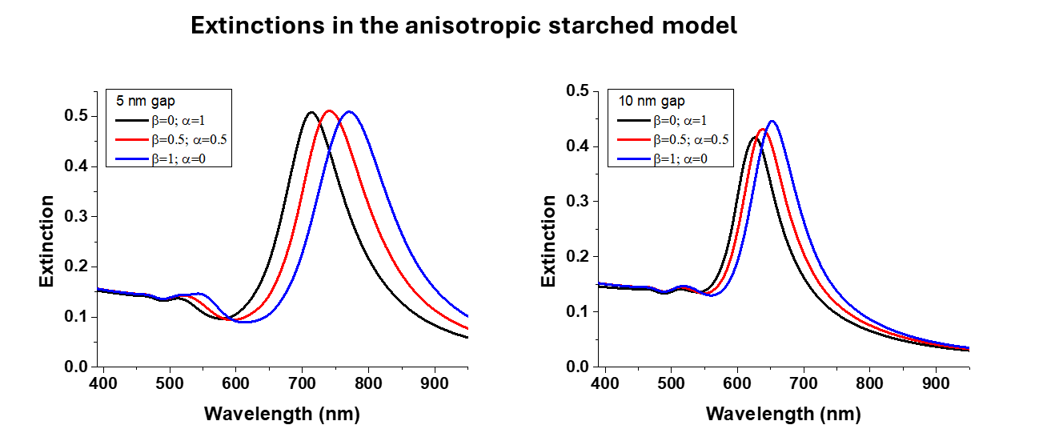

Supplementary Fig. 17 | The COMSOL-computed extinction spectra for the chains (5-nm and 10 nm gaps) under the stretching effect.

- Isotropic model for the stretched bio-medium: We also observed the stretching effect by using isotropic chiro-optical tensor for the neck region (Supplementary Fig. 18). We can see that the hot-spot volume (i.e., the biomolecular “neck”) dominates the CD signal as we increase the parameters since the CD strength grows fast with the increase of the chirality of the neck hot-spot region. Again, we see a characteristic bisignate CD shape with a positive band at the T-plasmon and a smaller negative band at the T-plasmon.

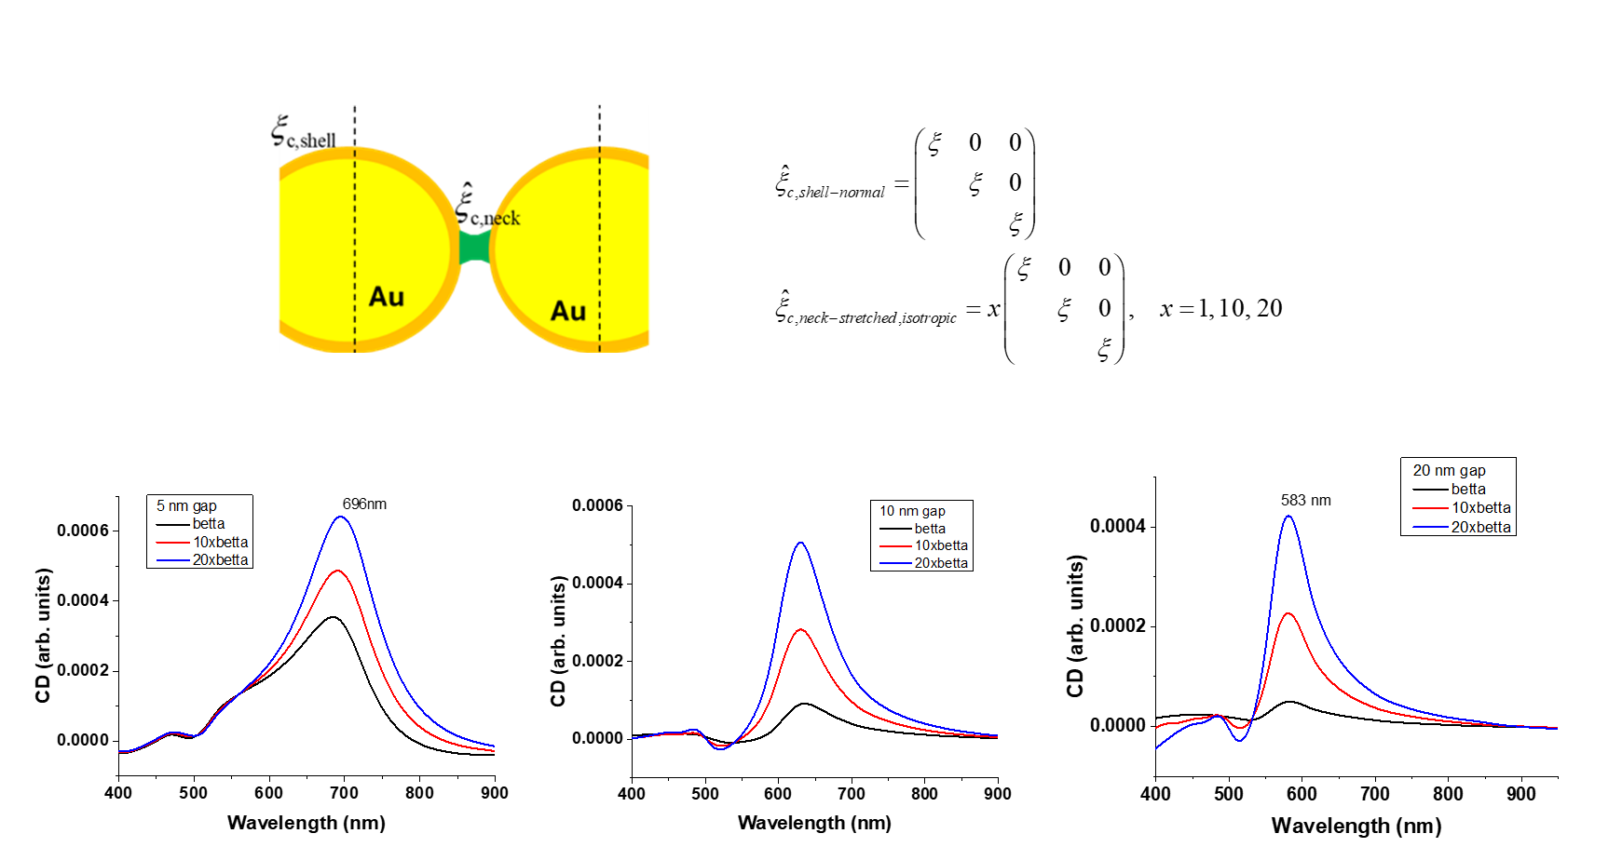

Supplementary Fig. 19 | The COMSOL-computed CD spectra for the chains (5, 10, and 20-nm gaps) under the stretching effect with isotropic chiro-optical tensors.

Supplementary Note for Cohesive Debonding Simulation
The Finite Element numerical modeling presented in this study aims to simulate the classical cohesive traction-separation behavior of spherical particles subjected to tensile stretching. To provide a general understanding of the constitutive law, a brief theoretical foundation is introduced herein. We define a term, T to represent the cohesive traction at the debonding surface, which is oriented outward from the surface. In addition, we use the term u to denote the displacement jump between the pair of faces bonded. The directions of T and u are exactly opposite. In this context, we consider a classical traction-separation law, as outlined in Ref 1, with the pseudo- potential functional defined as follows:
where W is a model parameter representing the work or energy of separation, and ∆ is another parameter corresponding to the characteristic opening length. The maximum traction, T_{max}, can be indirectly calculated using the relation . Through variational derivation, the surface traction can be determined
The aforementioned traction characterizes the path-independent traction-separation formulation, which models the crack-healing phenomenon during the unloading and reloading processes. Furthermore, an algorithmic approach is proposed to implement a general damage-like formulation that distinguishes between the loading and unloading paths. A representative method involves comparing the current separation to the maximum separation U_{max} attained throughout the entire loading history. The loading case is assumed when the current separation equals the maximum value. In contrast, unloading or reloading is identified when the current separation is smaller than the maximum, at which point the linear traction law is applied. The maximum separation is updated and stored as an internal variable at each loading step. Subsequently, the surface traction is recalculated as
This classical model is implemented in several commercial FE software packages, allowing for direct and straightforward application.
To ensure computational efficiency, we model a limited number of spherical particles in the numerical simulations, treating this as a localized investigation within the broader system. The simulation animation reveals that debonding occurs at the relatively weakened regions, ultimately leading to the formation of clusters where three particles are grouped together and pairs of two particles are also formed occasionally. This behavior closely aligns with the experimental findings in our research.
Ref 1. M.J. van den Bosch, P. Schreurs, M. G. D. Geers, On the development of a 3D cohesive zone element in the presence of large deformations, Comput. Mech. 42 (2008) 171–180.

Supplementary Video 1. PEI layer to act as a matrix that transfers strain from the PDMS substrate to the NP chains and subsequently to the BSA molecules between the NPs.
Supplementary Video 2. MD simulation of stretching induced molecular dipole increase.

