Extended Data

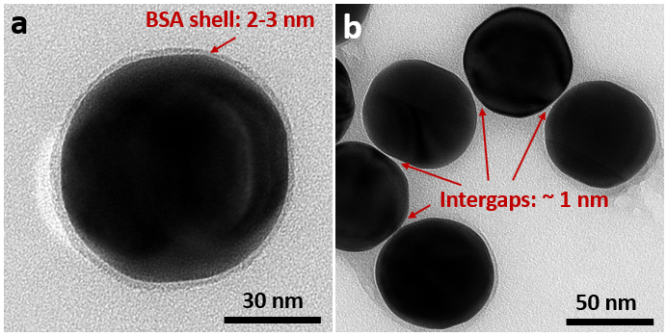
Extended Data Fig. 1 | TEM characterization of spherical Au@BSA nanoparticles. a, The highly spherical Au nanosphere with BSA shell, whose thickness is about 2-3 nm. b, The aggregation of Au nanospheres. Due to the capillary force, after drying the BSA shells of adjacent nanospheres were intertwined and pressed. Thus, the size of the intergaps is smaller than the thickness of the isolated Au nanosphere.

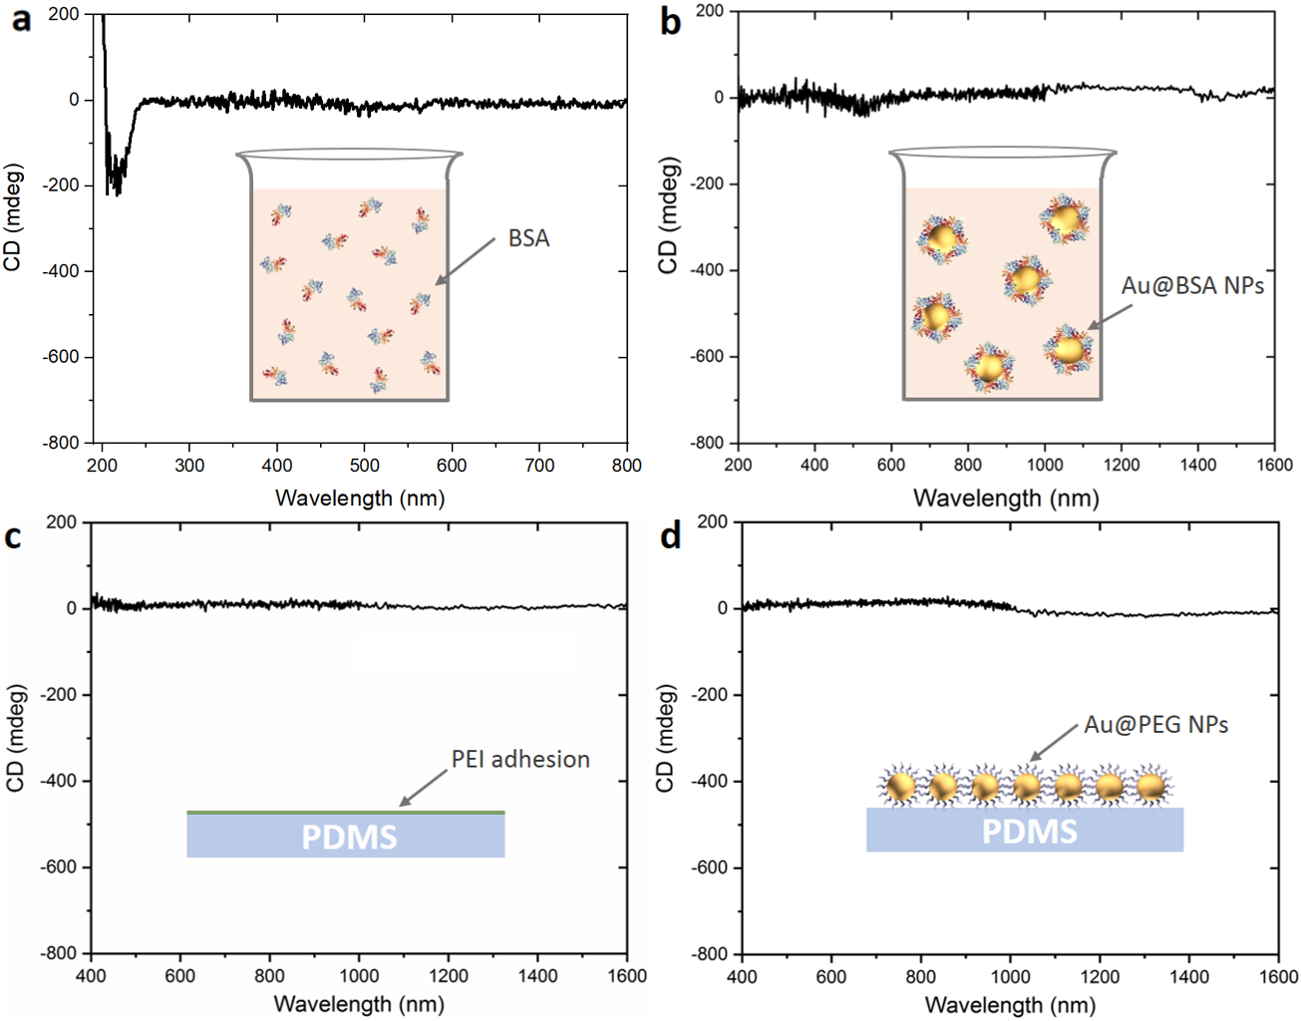
Extended Data Fig. 2 | Reference CD measurements to exclude the structural chirality and ensure the pure PCCD in 1D Au@BSA nanosphere assembly. a, CD spectrum of 1 mg/mL BSA solution, featuring typical CD peaks of alpha-helix in the UV region. b, CD spectrum of Au@BSA nanosphere solution, imparting negligible PCCD and molecular CD of BSA. c, CD spectrum of PDMS substrate coated with a PEI adhesion layer, showing no chiral signals. d, CD spectrum of 1D Au@PEG nanosphere assembly reveals its achirality. Due to PEG is not chiral, the PCCD cannot be triggered in this nanocomplex.

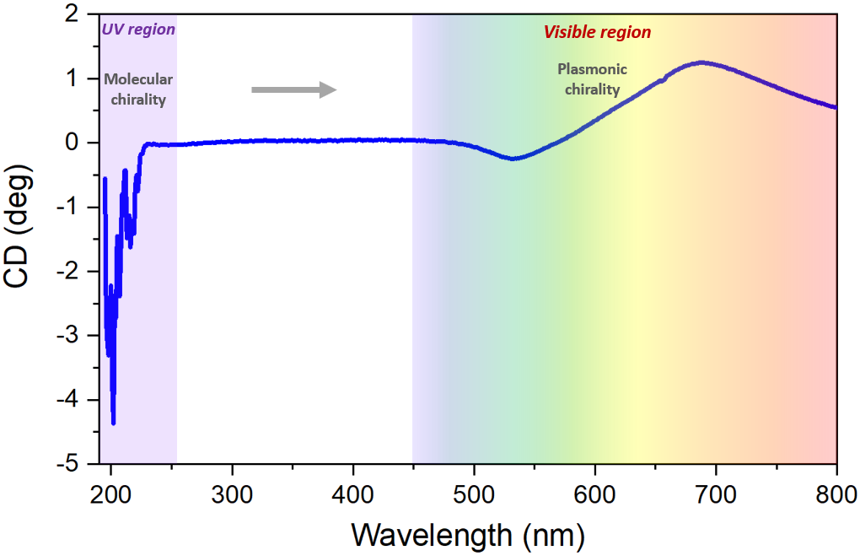
Extended Data Fig. 3 | The full CD spectrum of 1D Au@BSA nanosphere assembly. In the UV region it shows the typical BSA molecular CD sign in left-handedness with the two characteristic peaks located around 205 nm and 220 nm. While in the visible region, it exhibits a right-handed plasmonic chirality.

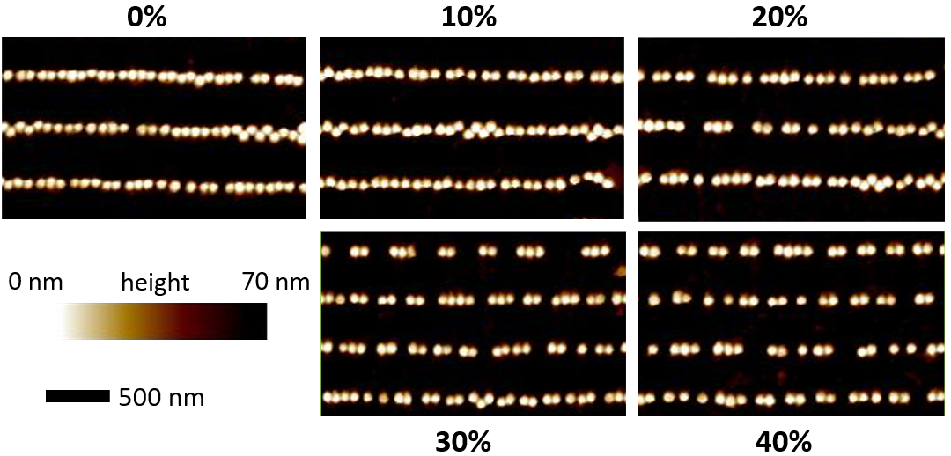
Extended Data Fig. 4 | AFM characterization of the 1D nanoparticle assembly array during stretching process. When the external strain is applied along the nanosphere chain direction gradually, the nanosphere chains split into oligomers and then to trimers and dimers in the end.

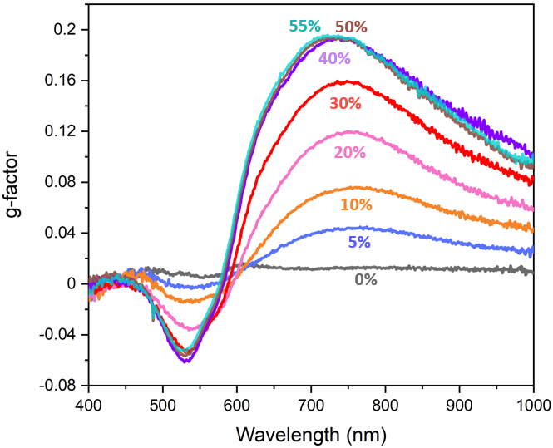
Extended Data Fig. 5 | g-factor of the 1D Au@BSA nanosphere assembly during stretching process. With stretching the g-factor also increases as the CD does, finally reaching a plateau at 50-55% strain with a value of ~0.2.

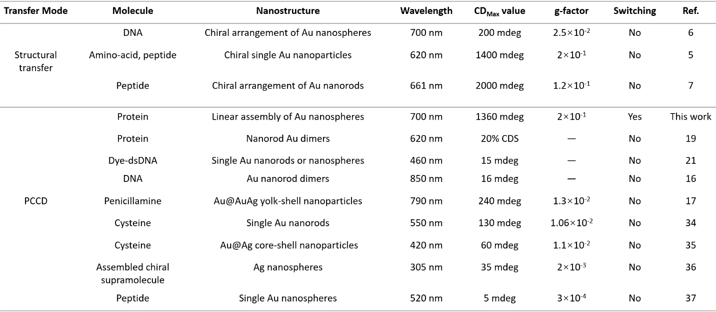

Extended Data Table 1 | Performance comparison of various chirality transfer systems comprising chiral molecules and plasmonic nanostructures. We can see that with the conventional hotspot-strategy, the g-factor can be increased to the level of 1×10⁻². Our molecule-stretching strategy can break through the bottleneck, lifting the g-factor of PCCD to a level of 2×10⁻¹, enabling efficient chirality transfer directly from biomolecules.

